Q1: You got the alert regarding <http://www.company.com/>, and you never solved issues before for this website. What do you do and how do you troubleshoot?  
  
As a background for the task: it's known that website is running in exact AWS account, the website uses classical 2-3 layer architecture.

Answer:

whole website and resources will be in VPC (Virtual private Cloud) associated with API Gateway, load balancer and webtier and backend

API Gateway 🡪 Application load balancer 🡪 Web tier 🡪 Application tier 🡪 Back end

Depending on type of error corresponding layer logs will be checked. Let say suppose the error is website not reachable, then check the traffic and error logs in APIGateway ( Cloud watch logs).

If no error here, then check if any error in Elastic load balancer logs. (Amazon S3)

If the error is specific to Web tier or application tier, then check the respective tier errors in Cloudwatch

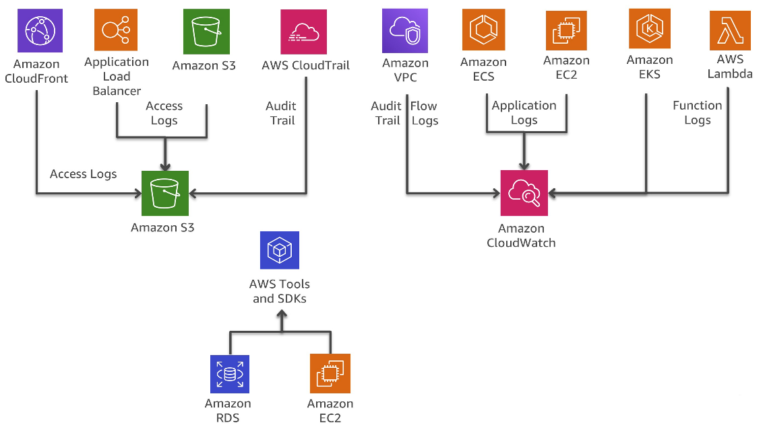

If the issue id due to recent change, if the issue is in lower environments, inform the stakeholders about the issue and fix it. If its in higher environments then revert the changes, and fix in dev and move the changes to higher environments.