Applications of NLP to Instant Messaging
Brad Hunter and Ryan Barrett
Stanford University, Computer Science Dept.
{krazo, rbarrett}@stanford.edu

ABSTRACT
--------

Instant messaging (IM) has grown sharply in popularity over the last five years. Currently, over 200 million people use IM regularly to talk with friends, family, and coworkers. However, the NLP community has not yet analyzed IM data in much depth, perhaps because it is relatively new and unconventional.

This paper covers a few preliminary steps we have taken toward toward applying NLP techniques to IM conversations. First, we composed a small corpus of IM conversations that is appropriate for NLP research. We then chose an example application, classification of messages by emotion, and measured human performance at this task. We then built a classification engine to perform this task and optimized it for IM corpora. We report on the results of this system, and give a brief analysis of linguistic features of IM conversations.

OUTLINE
-------
I. Introduction
II. Building an Emotion-Tagged Corpus
A. Source Material
B. Filtering for Emotional Content
C. Formatting
D. Tagging
III. Performance Bounds
A. Lower Bound
B. Survey
C. Upper Bound and Other Results
IV. EmotIM Implementation
A. Classification Engine
B. Naive Bayes
C. N-gram and Other Features
D. Discourse Feature
V. Results
VI. Future Directions
VII. Conclusion

I. INTRODUCTION
---------------

Historically, computational linguistics research has used essays, articles, and other single-speaker written text as test data for its algorithms. There are many reasons for this. First, there is a large body of written text available to researchers. Second, many of the available corpora are pre-processed to include information such as part-of-speech tags, word sense tags, and parse trees. Third, most of the data in written text corpora is "correct," formal language, so it is suitable for deep linguistic analysis.

However, other types of data are also available, such as transcripts of spoken language, transcripts of interviews, and recently, instant messaging (IM) logs. A few corpora of interviews and spoken language exist that are targeted toward the computational linguistics community, but since the instant messaging phenomenon is relatively recent, there are no comparable instant messaging corpora.

We believe that IM conversations may have fundamentally different linguistic features from written and spoken text. In this paper, we first discuss a corpus of IM conversations that we have composed. We give an overview of a system we built to solve two small but nontrivial tasks: emotion identification and classification. These were both approached as classification problems.

We then show the results of the system, as well as analyzing its performance with regard to different linguistic features and algorithmic parameters. We identify a few of the features of IM conversations that are generally interesting from a computational linguistics point of view. Finally, we discuss possible improvements and future directions for work in this area.

II. BUILDING AN EMOTION-TAGGED CORPUS
-------------------------------------

A. Source Material

Since there are no IM corpora available that are appropriate for NLP research, we built a corpus ourselves. Both of the authors use IM clients that log all conversations by default, so we had more than enough raw source material. However, we were still a long way from a well-formatted, tagged corpus suitable for training and testing. As a reference point, this is an extract from one author's original logs (names have been changed to protect the innocent):

---- New Conversation @ Sat Apr 26 17:26:28 2003 ----
(20:49:48) jillster: O:-)
(20:50:00) jillster: hehe
(20:50:25) jack123: what's that? smiling jill with a yamulka?
(20:51:15) jack123: (sp?)
(20:51:24) jillster: duh, it's a halo!
(20:51:45) jillster: yarmulke
(20:53:33) jack123: wow
(20:53:38) jack123: that's a mouthful
(23:49:23) jillster: it's yiddish, it's supposed to be.
(23:49:28) jack123: of course
(23:49:53) jillster: i think i'm reaching the end of my patience rope. grr...
(23:50:00) jack123: no way, with nasser?
(23:50:02) jillster: yup
(23:50:11) jack123: just go bang on his head
(23:50:17) jillster: not that simple when his thesis is due in two days...
(00:19:42) jillster: it's not that he doesn't *want* to
(00:28:22) jillster: i think

B. Filtering for Emotional Content

We first extracted small snippets of conversations that had emotional content. Surprisingly, this was one of the most time-intensive tasks. IM conversations are similar to verbal conversations in many ways, which unfortunately for us includes the amount of emotional content. Worse, the vast majority of IM conversations are not very emotional. Content with and without emotions usually looks identical. For lack of a better method, we spent a significant amount of time reading through our logs line-by-line. In the end, we extracted 1115 messages with high emotional content, comprising 61KB of usable data.

C. Formatting

Next, we munged the messages so that they were easy to parse programmatically. We stripped the timestamps and conversation headers, and prefixed each message with the neutral emotion tag, "none." In all outwardly visible parts of the dataset, we replaced screen names with "speaker1" and "speaker2" to protect the innocent. However, most of the dataset was not made available publicly, so this was only done on a small fraction of the dataset.

D. Tagging

Finally, we tagged each of the messages with its corresponding emotion. The six base emotions we used are joy, sadness, fear, anger, surprise, and contempt, which are slightly condensed from the seven base emotions identified by Ekman et al. (Ekman, P. (1992). An argument for basic emotions. Cognition and Emotion, 6, 169-200. ) Disgust and contempt were combined. Even after extracting snippets with high emotional content, over half of the messages were tagged as "none." The rest were tagged according to the primary emotion that motivated the message, according to our best judgment. Following this step, the above excerpt was reduced to:

anger speaker1 i think i'm reaching the end of my patience rope. grr..
surprise speaker2 no way, with nasser?
none speaker1 yup
none speaker2 just go bang on his head
anger speaker1 not that simple when his thesis is due in two days...
In the end, the representation of emotions in the corpus was 40% none, 19% joy, 12% sadness, 3% fear, 8% anger, 13% surprise, and 5% contempt.

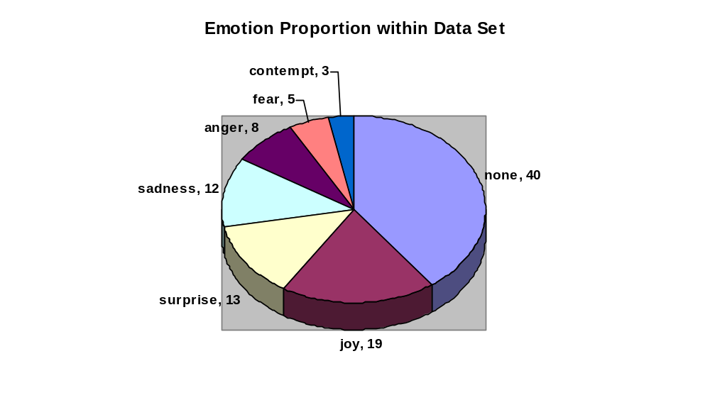

III. PERFORMANCE BOUNDS
-----------------------

What bounds on performance can we expect for classifying emotions? More specifically, is there a baseline, and is there a point beyond which we should not expect to improve? To answer these questions, we performed a few simple experiments.

A. Lower Bound

The most obvious lower bound on performance is simply flipping a coin. With six emotions and "none," this results in a baseline of 17%. However, the majority of messages in our corpus are tagged as "none," so we can increase our baseline to 40% by picking "none" every time. So, we shouldn't do worse than that.

B. Survey

To find a reasonable upper bound, we asked a number of people to complete a short survey. The subjects were asked to classify 67 messages in seven small discourses into one of the six emotions or "none." Except for "none," the emotions were present in the survey in roughly equal proportions, according to our tags. We received 18 complete responses, which we considered more than enough to give an accurate (but informal) indication of human performance.

Since there is arguably no "correct" emotion for a message, we considered the survey a measurement of how consistently people identify and classify emotions. Accordingly, instead of using our tagged corpus as the "correct" emotion, we used the emotion that the majority of the subjects picked for each message. This measurement would be independent of any irregularities in our own judgment, so we hoped it would be more accurate. It was also higher than scoring against our tags, so we had a more challenging upper bound to shoot for.

In the results, for every message except one, the majority emotion was chosen by over half of the people. This implied that people often agreed on the emotion of a given message, which validated our decision that the majority emotion would be the "correct" emotion.

C. Upper Bound and Other Results

The aggregate human performance against our tagged corpus was 63%, and the performance against the majority emotion was 70%. We used 70% as an upper bound for the classification task, and a good performance mark to aim for.

If the identification task is considered - i.e., a response is considered correct if it and the answer are both none or both an emotion - the human performance was 75%.

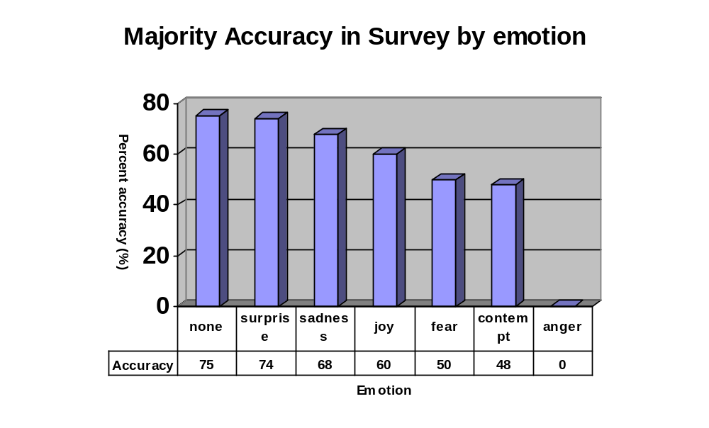

There were a few other interesting results and statistics from the survey. Performance varied widely across emotions - none was highest at 75%, then surprise 74%, sadness 68%, joy 60%, fear 50%, and contempt 47%. Surprisingly, anger was not a majority emotion for any message, although according to our tags, it accounted for roughly 6% of the messages in the survey.

Since the values aren't numeric, we cannot calculate standard deviation. However, we can substitute other measurements of variation. Seven messages were unanimously classified as "none." The rest were mostly split between two or three emotions each, with only a small number split between more than three. "None" was usually one of the represented choices, but not always. This implies that people may not agree on the emotion, or even whether an emotion is present, but they usually agree on a small number of possibilities. This makes sense intuitively - a frustrated message might seem to fit "anger" or "contempt," or maybe "none," but probably not "joy" or "surprise."

IV. EMOTIM IMPLEMENTATION
-------------------------

Our test classification problems were to identify whether a message in an IM conversation reflects an emotion, and if so, which single emotion was most likely. We analyzed and implemented solutions for both the classification problem and the pure identification problem (i.e. whether or not an emotion is present).

This problem is not highly visible in the research community, and admittedly, it is more than a little subjective. For these reasons, we stress that our goal was not solely to build a system to perform well on emotion classification. Instead, we hoped to identify linguistic features unique to IM conversations and features strongly correlated with emotions. In the process, we hoped to build a classification system targeted toward IM corpora.

However, it is worth noting that there is a widely accepted real-world problem that emotion classification could address. Email and IM are often criticized for their lack of verbal cues and body language. This increases the likelihood that an email or IM may be misunderstood or, in the worst case, may offend the recipient unnecessarily. A successful emotion classifier would be one step toward reproducing cues in email and IM that might help avoid such conflicts.

A. Classification Engine

We designed and implemented a general-purpose classification engine targeted toward IM corpora, which we called EmotIM. The engine is highly data-driven and can be used for any classification problem.

The engine is notable primarily because of its feature plugin framework. Researchers can "plug in" a new linguistic feature simply by writing a Java class that implements a feature interface. For example, if the classification goal was to identify the speaker of each message, a programmer could write classes for features such as message length and question identification. They could then load these features and run the engine to quickly measure the impact of these features on classification.

The engine is also notable because it allows simple weighted aggregation of features. During testing, each feature analyzes each message and calculates the probability of each possible class. The engine then sums these probability masses according to a set of weights, applied per feature, and chooses the class with the highest total probability. The weights arespecified in a configuration file.

Finally, the engine can optionally be run in "threshold" mode. In threshold mode, for a message to be classified, the probability of a given class must be above a certain threshold. Otherwise, the message is classified as "none," instead of the class with the highest probability. We tested threshold mode by training only on messages that were tagged with emotions, and then testing on a dataset with both "none" and emotion-tagged messages.

B. Naive Bayes

To support many of the simple features, we wrote a highly tuned implementation of a Naive Bayes classifier. The Naive Bayes classifier learned a training set by counting frequencies of features along with the class they appeared with. After training, it calculated conditional probabilities for each class, given a feature. We used sum-of-logs to prevent the probability masses from becoming too small. We also used absolute smoothing to handle unseen instances of features, and tweaked the unseen-to-seen ratio and smoothing delta to improve performance on the IM corpus.

C. N-gram and Other Features

Many of the features we identified and ran with the engine were built on top of the Naive Bayes classifier. These included an N-gram model (unigram, bigram, and trigram), a punctuation feature, a "dictionary word" feature, a word length feature, and a message length feature.

The punctuation feature ran the Naive Bayes algorithm on all of the punctuation tokens in the message. Punctuation tokens were not separated into characters, so "?", "!", "?!?", "!!!", ":P", ":(", and ":/" were all considered to be distinct tokens. From empirical observation, it was determined that many punctuation tokens in IM have distinct meanings. If we had counted them character by character, instead of as complete tokens, we would have lost information.

Emoticons, or small sequences of punctuation that represent faces for a variety of emotions, were included in the punctuation feature. Unfortunately, the source material reflected that the authors only use a very small number of emoticons, and they use them in a wide range of contexts. Given this, we didn't expect emoticons to be very predictive in our corpus. This is definitely a failing of our corpus, though, as opposed to the feature itself.

The "dictionary word" feature ran Naive Bayes on tokens that were determined to be words, and not punctuation, IM slang or acronym, or proper names. We considered this to be important because we thought some words might be emotion-defining, similar to sense-defining words for word sense disambiguation. Such words included "grr" for anger, "wow" for surprise, and "cool" for happy.

The message length feature updated a conditional probability for each class based on the length of the message in words. We thought that some emotions (such as surprise) might lend themselves to shorter messages, while other emotions (such as anger) might lend themselves to longer messages.

The word length feature ran Naive Bayes on the length of each word in the message. We didn't have a concrete hypothesis for this, but we wanted to measure its effects to see if we could learn anything.

D. Discourse Feature

One interesting aspect of our corpus is that it consists of short dialogues between two speakers. This is a feature of all IM conversations and we attempted to use the additional information provided by the interaction between messages to help in our classification task. To this end, we created the discourse feature.

The dataset is segmented such that clear delineations are made between the different discourses. The discourse feature trains using maximum likelihood estimates to determine the probability of each sense given the senses of the previous messages in the discourse. There are four different modes to the discourse feature, each of which can be turned on and off by manipulating the weights for their aggregation in the weights file.

The four modes are differentiated by two parameters which they take. The first parameter tells the feature whether it should analyze all messages in the discourse or just the previous message in the discourse. The other parameter determines whether the feature analyzes the current speaker of the message or bases its probability estimation on the messages from the other member of the dialogue

During training, the feature takes each message and updates the probability of the sense of that message with the dominant sense of the discourse. In testing, the feature finds the probability of the sense of the current message by finding the dominant sense in the discourse and outputting the most likely probability given that dominant sense. The way it finds the dominant sense of the discourse is by analyzing the results for the testing on the previous messages in the discourse, so this feature is highly dependant on the success of the other features.

V. RESULTS
----------

A. Results

In order to analyze our implementation, we split the dataset into two sets. Our training set contained 943 messages and our testing set contained 173 messages. Each of the messages was tagged with an emotion as described above. We considered a classification to be successful if the algorithm chose an emotion which matched the tag.

We were able to analyze the success rate of each of our features individually by weighting all features to 0.0 but the one we were concerned with. Doing this gave us the following results:

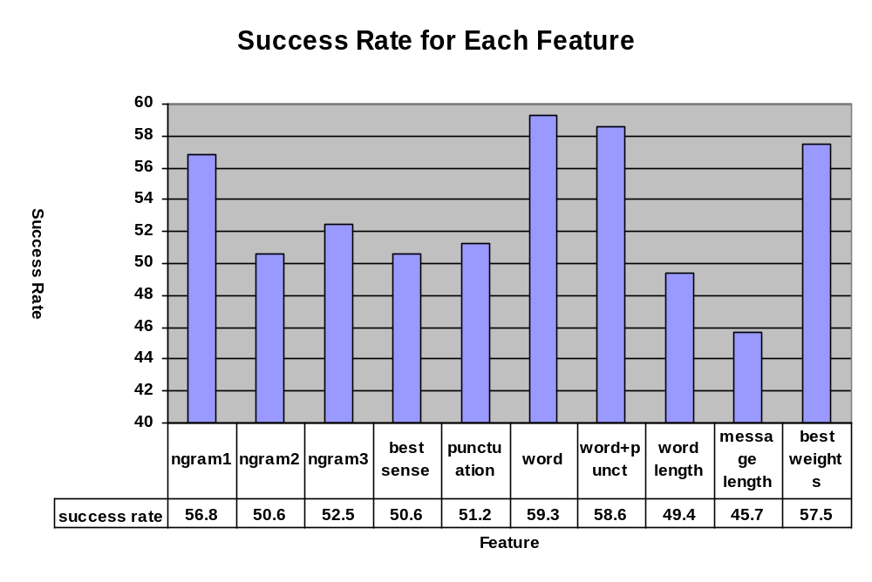As we can see, the word feature performed best initially. After performing these tests, we thought that perhaps our algorithm might perform better on messages which consisted only of emotions. We altered our datasets to contain only messages tagged with an emotion, removing all “none” messages. The results were as follows:

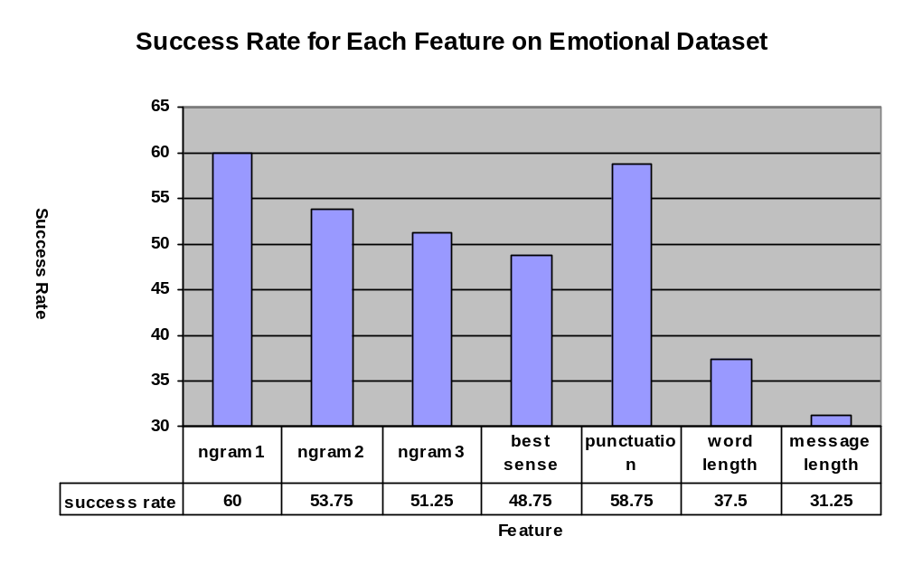
The results were dramatically more spread out, but turned out to be similar in relation to each other. An interesting note is that on both datasets it seems that the word length and message length features performed significantly worse than the best sense feature, which means that they are worse predictors than just choosing the most likely sense. Since the sense probabilities are a part of the calculation of word length and message length, it seems that those features actually cause us to guess incorrectly more often and thus would hamper our results if they are given a high weight for our overall results.

We realized that we could increase our success rate by altering the parameters for smoothing. Since we used absolute discounting, we could change the amount we discounted, effectively making us smooth more or less aggressively.
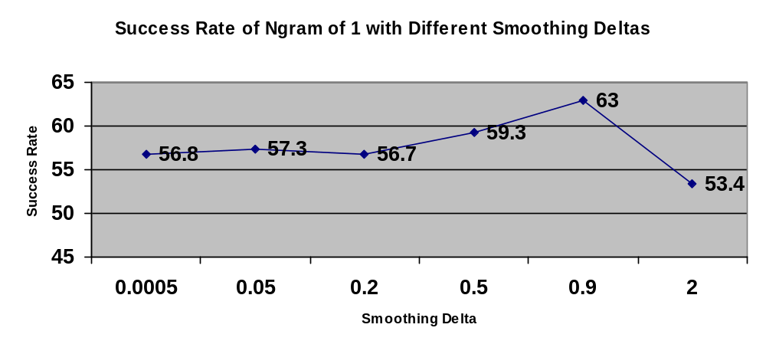
It seems that aggressive smoothing is the most effective. Any smoothing up to 1 is reasonable. Increasing the smoothing delta beyond that can reduce frequencies below zero, though, resulting in the drastic drop in success we found at a smoothing delta of 2. However, in the case of using a smoothing delta of .9, we are basically weighting unseen words higher than words seen only once. Although this seems illogical, it produces better results and can be justified when we consider the small size of our training set and the high number of unseen words likely to be seen in the testing set.

This graph incorporates another change as well. We realized that using sum of logs to combine the probabilities for each element in a feature was reducing the effectiveness of our weighting system. Here are the results for each feature with the best smoothing delta and standard probability multiplication.

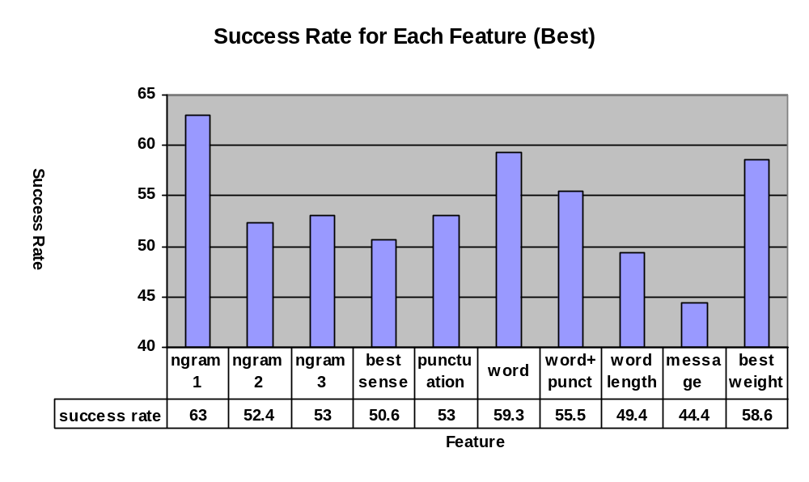

With the best smoothing, Ngram of 1 outperformed all of the other features. Also, in this case, we were unable to find a weighting of the features which resulted in a better result than Ngram of 1, though we found that the combination of features other than Ngram can produce better scores than some of them individually.

We have not included results on our discourse results up to this point. Since our discourse features require the help of the other features, we needed to find the best feature set. We tested with just our discourse feature and Ngram of 1 engaged.

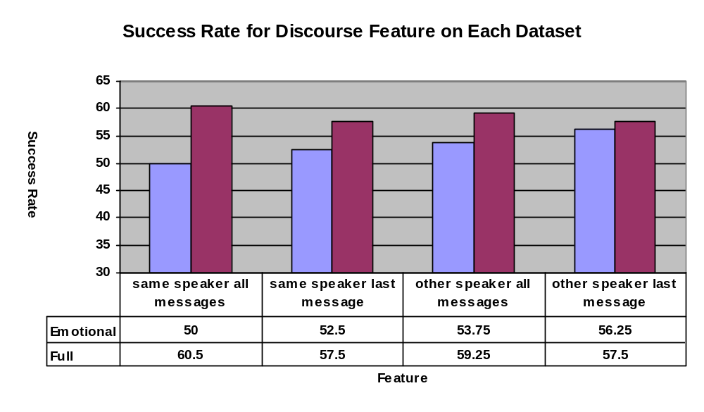

Our discourse feature was not all that effective. It reduced the success rate of our algorithm in all cases. Interestingly, the least effective mode on the emotional dataset was the most effective mode on the full dataset. It seems that for different kinds of datasets, different modes will be more effective. This makes sense and is the reason we chose to introduce several different kinds of discourse features.

The last series of tests we implemented involved changing our classification task from identifying the correct emotion to classifying a message as emotive or non-emotive. I methodology for doing this was described previously. We trained on both the emotional training set and the standard training set with “none” messages included. All testing was done on the full test set though.

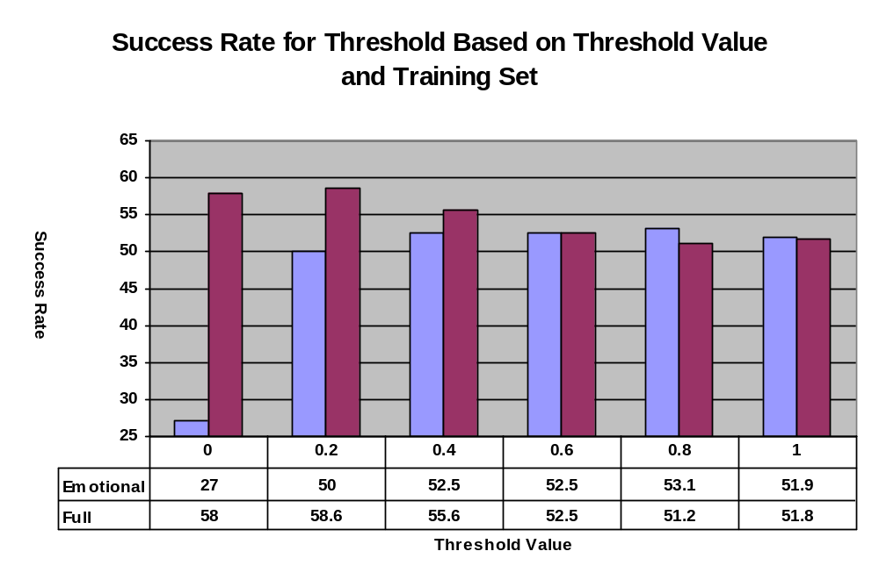
With our threshold implementation, our attempt to classify messages as emotional or non-emotional was less successful than our attempt to classify the actual emotion of the message. This seems to suggest that threshold was a poor choice of mechanism. When we ran our binary method for performing this classification task, we met with much greater success.
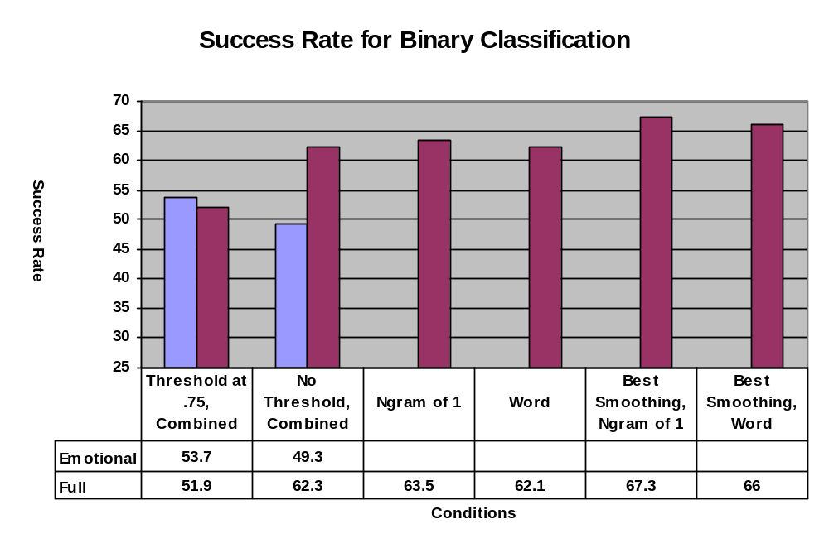
In fact, we were able to achieve significantly better results on this type of classification task, as it seemed we should be able.

B. Remarks

Aside from the main results, we learned a few interesting facts about our system and the problem in general.

Most notably, there is a significant difference between our performance on the identification task and on the classification task. The system is better at identifying the presence or absence of emotion than choosing a specific emotion. This is true for both threshold and non-threshold modes.

With a well-tuned set of weights, a set of features in aggregate can outperform a single feature. This is because many features are only successful at predicting certain emotions, or for certain types of messages. Aggregating features increases the likelihood that at least one feature will be predictive for any message. (Setting weights dynamically would be even more desirable; we discuss this in section VII.)

The performance of threshold mode was lower than we expected because the system only performs adequately at the classification task. Threshold mode is not as effective at the identification task, for which our system performs well.

Finally, IM conversations often have multiple threads happening at the same time. There are rarely more than two threads at the same time, but the threads are usually about distinct topics. This complicates the discourse feature's central assumption that each discourse is on one topic, and thus messages in a discourse are likely to have the same emotion.

VI. FUTURE DIRECTIONS
---------------------

The future development we'd like to see most is higher awareness of IM as a source of natural language. Similarly, we'd like to see more NLP work research on IM corpora. However, there is also plenty of room for improvement in our own work.

One development that we're sorely lacking is a way to apply weights to features dynamically. As discussed before, some features are only highly predictive of certain classes, or with certain types of messages. These features are often less successful with other classes or message types. Some of these feature orientations may be identified by manual inspection, but ideally, the weights should be adapted to each class or message type. This could be done with a simple hill-climbing algorithm, as a post-processing step after training.

We constructed a relatively successful corpus, but it's still deficient in a number of ways. First, it's very small. Second, it's drawn from a relatively narrow set of source material. We would prefer source material from more people, ideally varied across age, location, occupation, interests, etc. Finally, the subject domains and language use in the corpus are also narrow, and many features (notably emoticons) aren't represented. A larger, broader corpus would fix these problems.

Due to time constraints, we only implemented a small number of features. However, there are many more that we think might be significant. These include a lexicon for IM slang and acronyms, a parser that could handle the wide variety of sentence fragments in IM, an emoticon recognizer, an "emotion" lexicon, etc.

Finally, there are many framework improvements we'd like to make. First on the list is dynamic class loading for features, so that features can be added without recompiling the engine.

VII. CONCLUSION
---------------

In this paper we have outlined our approach to applying NLP techniques to IM corpora, which we consider to be underlooked in the field. Our example application is a classification task in which we classify messages into one of a set of emotions. We constructed a small corpus of IM conversations and tagged it with emotions. We designed and implemented a classification engine, optimized for IM corpora, and demonstrated moderate success at this task relative to humans. After analyzing the results, we identified a few features of conversations that were especially predictive of emotions. More importantly, we presented a few unique linguistic features of IM conversations. Above all, we hope that this project motivates further work with IM in the NLP community.

