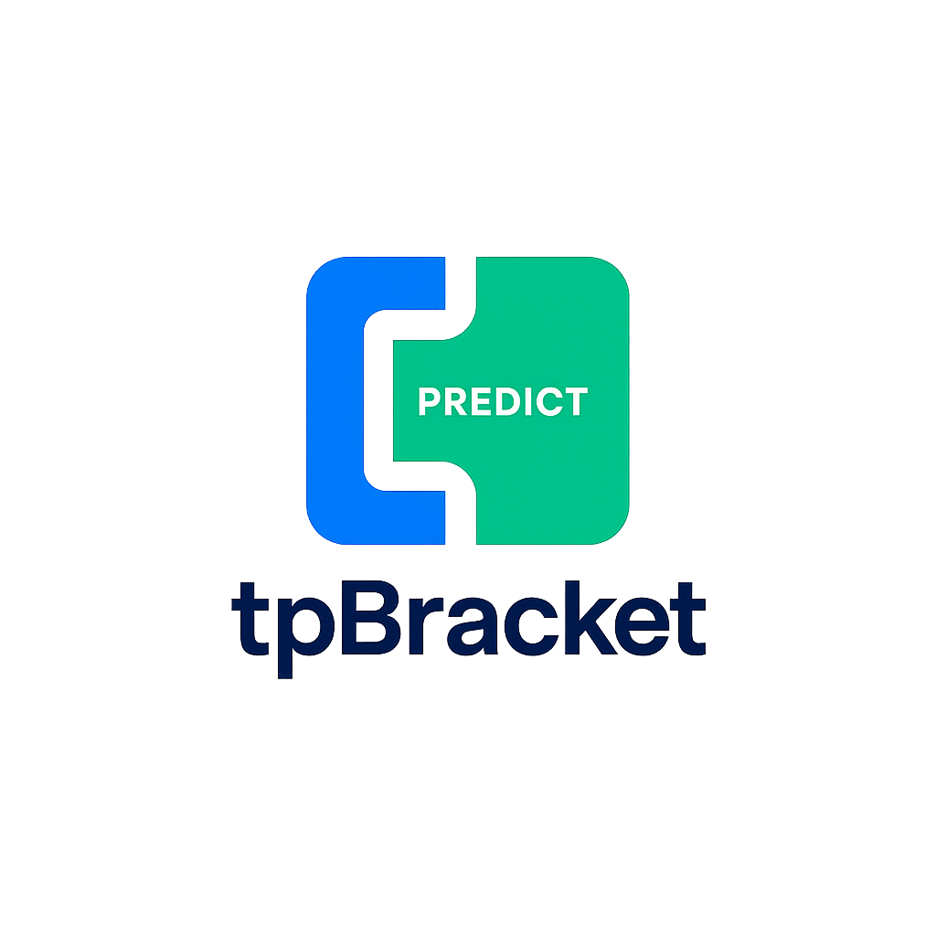

TourneyPredict Business Case
TourneyPredict is an innovative, AI-driven sports prediction platform set to launch during the 2026 FIFA World Cup in North America. By combining advanced AI, blockchain security, and engaging gamification, TourneyPredict transforms how fans interact with major sporting events, offering an immersive, low-barrier entry experience.
The web portal, iOS and Android will permit users on a worldwide basis to enter brackets (Pool) during sports tournaments such as the FIFA World Cup, UEFA Soccer Championships, Soccer Premierships in Europe and Super Bowl. Once tournament brackets are announced, AI will group them into groups as outlined by the governing body into tournament brackets. The goal is to emerge as the winner of any tournament.
Key Features
• Accurate, AI-Driven Insights: Smart Picks system uses real-time statistics, injury reports, and historical trends to provide data-driven prediction recommendations. An automated performance analysis enables users to compare their selections with AI-generated probability scores for smarter gameplay.
• Global Accessibility & Inclusivity: TourneyPredict’s platform is built for worldwide appeal. It offers multilingual support for dynamic tournament updates. Flexible payment options including cryptocurrency, mobile wallets, credit cards, and regional banking. Customizable private pools for social or institutional competitions. Supports over 10 languages with NLP-enabled translation and syncs game times across regions for a unified global experience.
• Blockchain-Powered Trust: Every transaction and prize payout is secured through blockchain technology. Smart contract automation ensures immediate and transparent prize distribution, safeguarding the integrity of each tournament. Implements Ethereum-compatible smart contracts to ensure transparent and tamper-proof prize distribution. Locks bracket entries to prevent manipulation and ensure fairness and finally eliminates dependency on manual administration, reinforcing trust in gameplay outcomes.
• Engaging, Scalable Model: With a low entry fee of only $1, users compete for 75% of the prize pool. The 75% prize pool less operating expenses would be awarded to the winner of the pool. In the event of a tie, a live TV audience raffle creates an exciting and democratic conclusion to each contest. Social sharing features, such as interactive AI-generated prediction graphics, further drive viral engagement.
Revenue Model and Growth Potential
• Sustainable Revenue: The platform generates recurring revenue from the $1 entry fees, ensuring a scalable financial model with every tournament. Custom pools for friends, institutions and influencers offer branded engagement opportunities.
• Exponential User Growth: With projections of over 500 million global participants during the 2026 FIFA World Cup and potential media partnerships (e.g., CNN, ESPN), TourneyPredict is positioned for rapid global adoption. It’s estimated that more than 6 billion would interact and watch the 2026 FIFA World Cup.
Investment Opportunity
By leveraging cutting-edge technology and a simple, user-centric design, TourneyPredict offers a disruptive solution in the sports prediction market. This investment opens the door to tapping into a massive, engaged user base during one of the world’s biggest sporting events. We invite you to join us as we redefine sports engagement for a global audience.
Detailed Roadmap & Platform Potential
Phased Rollout Strategy
Pre-Launch (Q1 2026):
• Beta Testing: Engage early adopters to finetune the platform and our AI algorithms using live sports data.
• Strategic Outreach: Build momentum with targeted influence partnerships and early media engagements.
Official Launch (Q2 2026):
• World Cup Debut: Go live during the 2026 FIFA World Cup in North America to capitalize on global viewership and peak engagement.
• Media Partnerships: Leverage collaborations with leading media outlets (e.g., CNN, ESPN) for extensive coverage and real-time audience interaction.
Global Scaling (Q3 2026 Onwards):
• Market Expansion: Roll out additional sporting events and tournaments, UEFA and Super Bowl.
• Localized Enhancements: Expand language support and payment integration to serve diverse global markets.
• Continuous Innovation: Use feedback and advanced analytics to evolve user experience and platform features.
Technical Requirements
• AI Model Development: NLP-based multilingual processing, predictive modeling via deep learning, and dynamic recommendation systems.
• Blockchain Integration: Smart contract implementation on Ethereum or Solana for instant transaction execution.
• Backend Architecture: Scalable microservices framework optimized for real-time user engagement.
• Frontend Design: Responsive web and mobile UI with interactive gamification elements.
Projected Launch: FIFA World Cup 2026
TourneyPredict aims for 100+ million global users during the 2026 FIFA World Cup. The AI company must ensure the platform architecture can support large-scale user traffic, secure transactions, and AI-driven match predictions.
Strategic Media Partnership: CNN
The TourneyPredict-CNN partnership is pivotal to the platform’s global visibility and trust.
Visibility & Legitimacy: CNN’s global reach spans over 200 countries via broadcast and digital platforms. 24/7 coverage, trusted journalistic standards, and real-time news updates align with TourneyPredict engagement model.
Operational Collaboration: CNN to feature TourneyPredict in live segments, sponsored match coverage, and digital banners. Joint campaigns to highlight bracket competitions, drive app downloads, and create conversion funnels. Interactive commentary and analytics integration to support TourneyPredict Smart Picks system.
Impact on Institutional Engagement: Partnership strengthens positioning for sponsor acquisition, investor interest, and public perception. Adds institutional credibility and journalistic validation to a gamified technology platform.
Prediction Scoring Model (Group Stage → Semis)
Base Structure: Each match has two prediction layers:
• Winner Prediction → 5 points for accuracy
• Scoreline Prediction (Margin) → 5 additional points for exact margin
Example:
• You predict USA to beat Canada 2–0
• Actual result: USA wins 2–0
• Total = 10 points (5 for winner + 5 for exact scoreline)
Bob picks 2–1 → earns 5 points for winner, 0 for scoreline = 5 points
Enhanced Final Match Mechanics
To maximize differentiation and break ties, the final match adds prediction complexity:
Question Points
Predict winner (standard) 10 pts
Predict exact final score margin 5 pts
Number of corners by the winning team 2 pts
Total fouls by both teams 2 pts
Number of offsides by the losing team 3 pts
Number of penalties committed by both teams 1 pts
Bonus accuracy (perfect score across all categories) 10 pts
Registration & User Experience
Registration is simple. Users download the app from Google Play or Apple App Store, agree to the Terms of Service and Privacy Policy, and enter their mobile number. A verification code is sent via SMS—once confirmed, users receive a unique six-digit TourneyPredict ID that securely links their profile to the platform.
To personalize the experience, users can then add their name, city, and country. The process is quick, intuitive, and built for global accessibility.
Conclusion
TourneyPredict is redefining digital sports engagement—merging predictive precision, blockchain-backed integrity, and socially immersive competition. As the countdown to 2026 begins, TourneyPredict is not just preparing to launch—it’s preparing to lead.

Sports Data Provider Strategy: Goalserve
Goalserve has been selected as the exclusive sports data provider for TourneyPredict. This decision aligns with our global strategy and IBM’s platform development partnership, ensuring seamless integration and real-time data delivery for AI-driven predictions.

Key Benefits of Goalserve
- Global Coverage: 20+ sports and 2,000+ competitions including FIFA, UEFA, and major leagues.
- Real-Time Updates: Live scores refresh every 2–5 seconds, ensuring timely AI predictions.
- Integration Ease: JSON/XML API formats for rapid deployment with IBM’s microservices architecture.
- Transparent Pricing: Predictable monthly cost for full sports coverage.
- Reliability: 99% uptime and 24/7 support for mission-critical events.

Integration Roadmap
- (Q1 2026): Integrate Goalserve API for live scores and match data into AI prediction engine.
- Include historical data for enhanced predictive modeling.
- Add in-play odds and advanced stats for gamification features.

Goalserve Technical Overview
The following table summarizes Goalserve’s key technical attributes:
Latency | Coverage | API & Integration | Best For
2–5 sec live score refresh | Global coverage: 20+ sports, 2,000+ competitions | JSON/XML API, easy integration with IBM microservices | Global multi-sport tournaments and real-time AI predictions

Blockchain Strategy

Subscribers download TPBracket, set up a Trust Wallet in minutes, and receive instant Polygon payouts. Entry is always $1, losers never pay more, and winners see transparent deductions for gas fees and taxes. This flow ensures simplicity, compliance, and scalability.

Blockchain is the default payment rail. Stripe/PayPal may appear only as optional fiat onboarding methods, not for prize payouts

Blockchain and tpBracket Onboarding

TPBracket Onboarding Flow (Trust Wallet + Polygon)
Code
[ Download TPBracket App ]
↓
[ Register Account ]
↓
[ Guided Prompt: "Set up your wallet" ]
↓
[ Download Trust Wallet (Free, iOS/Android) ]
↓
[ Create Wallet → Save Seed Phrase ]
↓
[ Connect Wallet Address to TPBracket ]
↓
[ Pay $1 Entry Fee ]
↓
[ Play Tournament ]
↓
[ If Lose → Cost = $1 ]
↓
[ If Win → Payout via Polygon Smart Contract ]
↓
[ Net Winnings = Prize – (Gas Fee + Taxes) ]
↓
[ Funds Available in Trust Wallet ]
↓
[ Optional: Cash Out via Exchange (Coinbase, Binance, Kraken)

Core items to be included in codebase:
Six-digit registration ID and PIN
Custom pools for institutions and individuals
Scoring Model as outlined in the business case
Payouts
Goalserve integration
Global Scale
Security: Key Vault, hashed PIN, rate-limited sensitive routes
CI/CD: Automated infra/app deploy via GitHub Actions

FIFA 2026 Mock WCQ
Panama
Algeria
Argentina
Australia
Austria
Belgium
Brazil
Jordan
Canada
Ghana
Colombia
Costa Rica
Croatia
Scotland
Ecuador
Egypt
Denmark
Poland
France
Spain
Switzerland
Tunisia
DR Congo
Turkey
Germany
Cape Verde
Iran
Mexico
Italy
Ivory Coast
Jamaica
Japan
England
Morocco
Netherlands
New Zealand
Norway
Paraguay
Portugal
Qatar
Saudi Arabia
Senegal
South Africa
South Korea
United States
Uruguay
Uzbekistan
Curaçao

