TourneyPredict Developer Business Case

Executive Summary
TourneyPredict is an AI-driven sports prediction platform launching during the 2026 FIFA World Cup. It combines advanced AI, blockchain security, and gamification to deliver a global, immersive experience. This document outlines the technical architecture, roadmap, and core development items for implementation.

Strategic Media Partnership (ESPN & CNN)
CNN will provide global visibility and legitimacy through live coverage, sponsored segments, and digital campaigns. This partnership strengthens institutional credibility and drives user engagement.

Key Features
- Accurate, AI-Driven Insights: Smart Picks system uses real-time statistics, injury reports, and historical trends.
- Global Accessibility & Inclusivity: Multilingual support, flexible payments (crypto, wallets, cards), private pools.
- Blockchain-Powered Trust: Ethereum-compatible smart contracts ensure transparent payouts and bracket integrity.
- Engaging, Scalable Model: $1 entry fee, 75% prize pool distribution, social sharing features.

Revenue Model & Growth Potential
- Recurring revenue from $1 entry fees.
- Custom pools for institutions and influencers.
- Projected 100M+ participants during FIFA 2026; 6B global viewers.

Roadmap

Pre-Launch (Q1 2026)
- Beta Testing
- Strategic Outreach

Official Launch (Q2 2026)
- World Cup Debut
- Media Partnerships

Global Scaling (Q3 2026+)
- Market Expansion
- Localized Enhancements
- Continuous Innovation

Strategic Partnerships
- Microsoft Azure: Cloud infrastructure and security.
- CNN: Global media visibility and engagement.
- Goalserve: Real-time sports data integration.

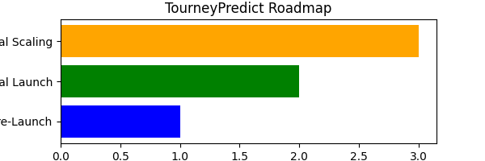

Technical Architecture Overview (Microsoft Azure)
Architecture Layers:
- Frontend: Web portal (React), Mobile apps (Flutter/React Native).
- API Gateway: Secure routing with OAuth2, JWT.
- Backend: Microservices for user, bracket, AI engine, payment, notifications.
- AI Layer: Predictive modeling, NLP.
- Blockchain Layer: Polygon smart contracts.
- Data Layer: Goalserve API, Azure Key Vault.
- Infrastructure: Microsoft Azure, Kubernetes, CI/CD via GitHub Actions.

AI Technology (AT)
Includes NLP-based multilingual processing, predictive modeling via deep learning, and dynamic recommendation systems.

Blockchain Strategy & tpBracket Onboarding Flow
Polygon (Matic) is the blockchain partner. Smart contracts ensure transparent payouts. Onboarding flow:

- Download TPBracket App
- Register Account
- Set up Trust Wallet (Free, iOS/Android)
- Create Wallet → Save Seed Phrase
- Connect Wallet Address to TPBracket
- Pay $1 Entry Fee
- Play Tournament
- If Win → Payout via Polygon Smart Contract
- Funds Available in Trust Wallet
- Optional: Cash Out via Exchange

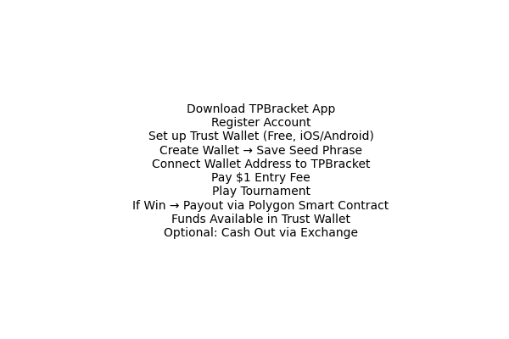

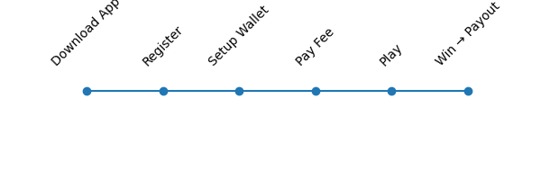

Prediction Scoring Model

Base Structure: Each match has two prediction layers:
- Winner Prediction → 10 points for accuracy
- Scoreline Prediction (Margin) → 5 additional points for exact margin

Example:
You predict USA to beat Canada 2–0; Actual result: USA wins 2–0 → Total = 10 points

Enhanced Final Match Mechanics:
Question | Points
Predict winner (standard) | 10 pts
Predict exact final score margin | 5 pts
Number of corners by the winning team | 2 pts
Total fouls by both teams | 2 pts
Number of offsides by the losing team | 3 pts
Number of penalties committed by both teams | 1 pts
Bonus accuracy (perfect score across all categories) | 10 pts

Registration & User Experience
Users download the app, agree to Terms, verify via SMS, and receive a unique six-digit TourneyPredict ID. Profile personalization includes name, city, and country but optional.

Sports Data Provider Strategy (Goalserve)
- Global Coverage: 20+ sports, 2,000+ competitions.
- Real-Time Updates: Live scores refresh every 2–5 seconds.
- Integration Ease: JSON/XML API formats for rapid deployment.
- Reliability: 99% uptime and 24/7 support.

Core Development Items
- Six-digit registration ID and PIN
- Custom pools for institutions and individuals
- Scoring Model implementation
- Blockchain payouts via Polygon
- Goalserve integration
- Global scale readiness
- Security: Key Vault, hashed PIN, rate-limited routes
- CI/CD: Automated deployment via GitHub Actions

