GraphRAG for Organizational Knowledge
GenAcademy · Project 3 submission
Comparing graph-based and vector-based retrieval on a company knowledge base

Author: Swaroop Nashikkar
Date: 23 October 2026
Repository: GenAcademy-P2-RAG-Pipeline

1. Summary
This project models the knowledge of a fictional software company, Halcyon Systems, as a graph of people, projects, skills, tools, decisions and documents. It answers the same set of questions two ways. Traditional vector RAG retrieves document chunks by semantic similarity. GraphRAG links the question to graph nodes and follows typed relationships.
- Knowledge graph: 57 nodes and 148 typed relationships across 6 node kinds.
- Result: GraphRAG scored 24/24 and vector RAG 14/24 on 12 questions (0–2 per question, graded by an LLM judge).
- Finding: GraphRAG won every question where the answer depends on relationships: aggregations, multi-hop chains, and facts never written in prose. Vector RAG matched it on every question whose answer is a passage of text.

Deliverables
Required deliverable | Delivered | Where
Knowledge graph with 20+ nodes | 57 nodes, 148 edges | Section 2; data/moc-data.json
GraphRAG vs vector RAG on 10 queries | 12 queries, both pipelines, judged | Section 5; results/
Analysis of when each approach wins | By question type, with examples | Section 6

2. The knowledge graph
The dataset holds entities and their connections separately. Entities carry only attributes, such as a person's title or a decision's date. Every connection is an explicit, typed relationship, and some carry properties, such as a person's role on a project or a skill level. The 11 documents (design docs, ADRs, runbooks, meeting notes, a retrospective) contain free text about the same entities. Both pipelines therefore draw on the same facts, and only the retrieval method differs.
Node kind | Count | Examples
Person | 10 | Maya Chen, Engineering Director
Skill | 12 | Python, LLM evaluation
Tool | 10 | Kafka, Weaviate, HashiCorp Vault
Project | 5 | Atlas, Beacon, Echo
Decision | 9 | Use Weaviate as the vector store
Document | 11 | ADR-007: Vector Store Selection
Total | 57

The 19 relationship types:
Relationship | Connects | Count
HAS_SKILL | person → skill (with level) | 24
AUTHORED_BY | document → person | 14
AFFECTS | decision → project | 13
EXPERIENCED_WITH | person → tool | 12
USES_TOOL | project → tool | 12
WORKS_ON | person → project (with role) | 10
PROPOSED | person → decision | 10
APPROVED | person → decision | 9
RECORDS | document → decision | 8
REPORTS_TO | person → person | 7
REQUIRES_SKILL | project → skill | 7
DESCRIBES | document → project | 6
LEADS | person → project | 5
SELECTS_TOOL | decision → tool | 4
DEPENDS_ON | project → project (with reason) | 3
CONSULTED_ON | person → decision | 1
SUPERSEDES | decision → decision | 1
REFINES | decision → decision | 1
CAUSED_BY | decision → project (with reason) | 1
Total |  | 148

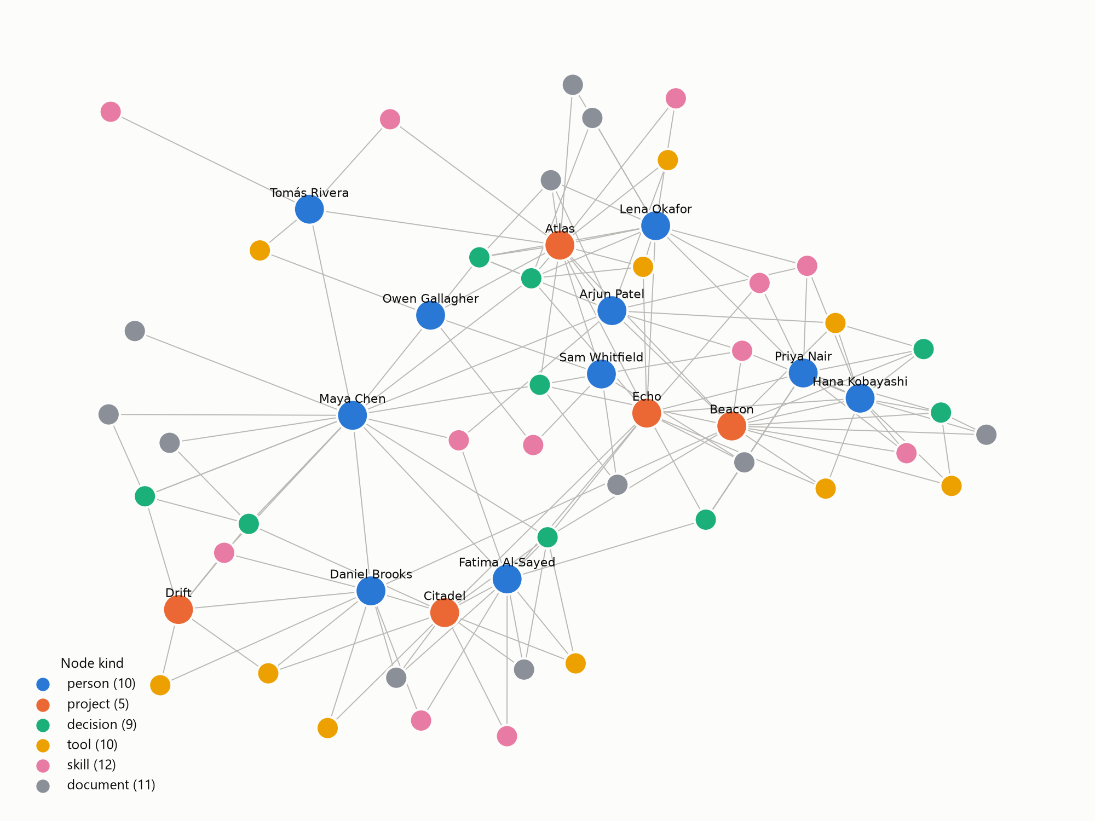
Figure 1. The Halcyon Systems knowledge graph. People and projects are labelled.

3. System design
Both pipelines use the same answering step. The retrieved context goes to Claude (claude-sonnet-5-5) with the instruction to answer only from that context and to say so when the answer is missing. Only the retrieval step differs.

3.1 Baseline: vector RAG
- Split the 11 documents into 33 overlapping chunks of three sentences, each prefixed with its document title.
- Embed each chunk locally with BAAI/bge-small-en-v1.5 (fastembed).
- Embed the question and retrieve the 4 chunks with the highest cosine similarity.

3.2 GraphRAG
GraphRAG answers in four steps:
- Query planning. Claude reads the question with a catalog of all entity names and relationship types, and returns structured output: the entities mentioned, the relationship types needed, and the kind of answer expected.
- Entity linking. Names are matched to graph nodes, exactly first and then fuzzily, and any entity name written verbatim in the question is also caught.
- Subgraph retrieval. A breadth-first walk goes up to 2 hops from the linked nodes in both directions. Edges of the planned relationship types come first. DEPENDS_ON and SUPERSEDES chains are always followed to the end, and the result is capped at 80 facts.
- Context assembly. The context combines the attributes of each node reached, the facts written as "Source -[RELATION]-> Target", and the full text of up to 3 documents linked to the subgraph.
For example, the subgraph for "Which projects are affected by decisions Fatima Al-Sayed proposed?" contains:
Fatima Al-Sayed -[PROPOSED]-> Mandate Vault for all service secrets
Mandate Vault for all service secrets -[AFFECTS]-> Citadel, Beacon, Echo

3.3 Technology
Component | Choice | Why
Graph store | NetworkX MultiDiGraph (in memory) | 57 nodes need no server; traversal code stays readable
Vector index | NumPy cosine similarity | 33 chunks score in under a millisecond; same top-k result as a vector database
Embeddings | fastembed, bge-small-en-v1.5 | Runs locally with no extra API key
LLM | Claude Sonnet 5.5 via the Anthropic SDK | Answers, query planning (structured output), judging
Interface | Python package, CLI, Jupyter notebook | Repeatable evaluation plus a guided walkthrough

A managed vector database such as Pinecone was not needed at this scale. It would return the same chunks and could not store the graph's relationships, so a graph store would still be needed alongside it.

4. Evaluation method
The evaluation runs both pipelines on 12 questions. Each question has a reference answer and the entities and documents that support it, and is tagged with one of five types:
- Single hop: one fact, here one recorded only in the graph.
- Multi-hop: the answer requires chaining two or more relationships.
- Aggregation: the answer combines facts about several entities.
- Temporal: the answer depends on which decision is current.
- Passage detail: the answer is a specific detail written in one document.
The evaluation measures three things:
- Answer score (0–2). Claude grades each answer against the reference: 2 = all key facts and no contradictions, 1 = partial, 0 = wrong or "not in context".
- Entity recall. The share of a question's supporting entities named anywhere in the retrieved context.
- Document recall. The share of a question's supporting documents present in the retrieved context.
ID | Type | Question
q01 | multi hop | Why was the Atlas launch moved to August?
q02 | passage detail | Why didn't the team use pgvector for Atlas?
q03 | multi hop | Who should I contact about Kafka consumer lag in the pipeline that Atlas depends on?
q04 | aggregation | Which projects are affected by decisions Fatima Al-Sayed proposed?
q05 | passage detail | How much did hybrid search improve relevance over vector-only search?
q06 | temporal | What is the current status of Drift?
q07 | aggregation | Which people have both Python and LLM evaluation skills?
q08 | passage detail | What incident happened during the Citadel rollout?
q09 | multi hop | Which tools does Echo rely on, directly or through its project dependencies?
q10 | passage detail | Can Echo answer questions about parental leave?
q11 | single hop | Who approved the move from RabbitMQ to Kafka?
q12 | multi hop | Which of Maya Chen's direct reports work on Atlas?

5. Results
Question type | Questions | Vector RAG | GraphRAG
aggregation | 2 | 0.0 | 2.0
multi hop | 4 | 1.0 | 2.0
single hop | 1 | 0.0 | 2.0
temporal | 1 | 2.0 | 2.0
passage detail | 4 | 2.0 | 2.0
All questions (total) | 12 | 14 / 24 | 24 / 24

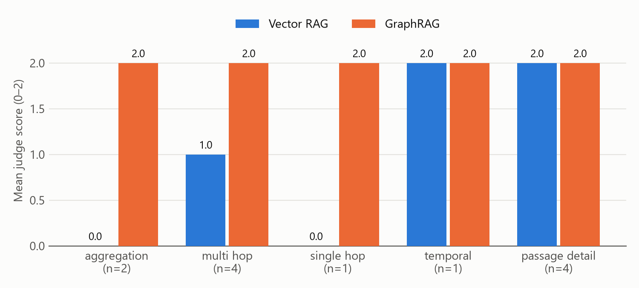
Figure 2. Mean judge score by question type (0 = wrong, 2 = fully correct).

Retrieval quality and cost
Metric (mean per question) | Vector RAG | GraphRAG
Supporting entities present in context | 53% | 100%
Supporting documents present in context | 88% | 87%
Context sent to the LLM (characters) | 1,084 | 10,658

Per-question scores
ID | Type | Question | Vector | Graph
q01 | multi hop | Why was the Atlas launch moved to August? | 1 | 2
q02 | passage detail | Why didn't the team use pgvector for Atlas? | 2 | 2
q03 | multi hop | Who should I contact about Kafka consumer lag in the pipeline that Atlas depends on? | 2 | 2
q04 | aggregation | Which projects are affected by decisions Fatima Al-Sayed proposed? | 0 | 2
q05 | passage detail | How much did hybrid search improve relevance over vector-only search? | 2 | 2
q06 | temporal | What is the current status of Drift? | 2 | 2
q07 | aggregation | Which people have both Python and LLM evaluation skills? | 0 | 2
q08 | passage detail | What incident happened during the Citadel rollout? | 2 | 2
q09 | multi hop | Which tools does Echo rely on, directly or through its project dependencies? | 1 | 2
q10 | passage detail | Can Echo answer questions about parental leave? | 2 | 2
q11 | single hop | Who approved the move from RabbitMQ to Kafka? | 0 | 2
q12 | multi hop | Which of Maya Chen's direct reports work on Atlas? | 0 | 2

6. Analysis: when each approach wins

6.1 GraphRAG wins when the answer lives in the relationships
Vector RAG scored 0 on four questions and 1 on two. Every one of them depends on structure:
- Facts never written in prose. Who approved the move from RabbitMQ to Kafka (q11), and who has both Python and LLM-evaluation skills (q07)? These exist only as APPROVED and HAS_SKILL edges. Vector RAG retrieved related-sounding chunks and correctly said the answer was not in its context. GraphRAG answered q07 with a set intersection: Lena Okafor and Priya Nair.
- Joins across entities. For Maya Chen's direct reports on Atlas (q12), vector RAG listed the Atlas team correctly but could not tell which of them report to Maya. For the projects affected by Fatima Al-Sayed's decisions (q04), it found her security policy but not the PROPOSED → AFFECTS chain to Citadel, Beacon and Echo.
- Facts scattered across documents. For which tools Echo relies on through its dependencies (q09), all 4 retrieved chunks came from the Echo product requirements, the single most similar document. The tools used by Atlas and Citadel were never retrieved. GraphRAG followed DEPENDS_ON → USES_TOOL directly to them.
- Causal chains. For why the Atlas launch moved to August (q01), vector RAG found the meeting notes but missed the Beacon slip dates that the graph's CAUSED_BY edge pointed to.

6.2 Vector RAG holds its own when the answer is a passage
Vector RAG scored 2/2 on all four passage-detail questions: a latency benchmark, a relevance metric, an incident and a policy exclusion. The question and the passage share meaning, which is exactly what embeddings capture. It also answered the temporal question on Drift's status correctly, because the newer meeting note states in plain text that it "replaces the March decision". When the text spells out the relationship, similarity search is enough.

6.3 Example: one question, two answers
q11: Who approved the move from RabbitMQ to Kafka?
Vector RAG (0/2): The context doesn't say who approved the move from RabbitMQ to Kafka. The Beacon Migration Runbook only describes how the cutover works, and it names Hana Kobayashi as primary contact, Arjun Patel as secondary for consumer lag issues, and Daniel Brooks as owner of the EKS deployment of the Kafka Connect workers. None of them is identified as the approver.
GraphRAG (2/2): Priya Nair approved the decision to migrate the event pipeline from RabbitMQ to Kafka on 2026-01-15. Hana Kobayashi proposed it.
q09: Which tools does Echo rely on, directly or through its project dependencies?
Vector RAG (1/2): Based on the Echo Product Requirements, Echo relies on:
- Atlas embedding service, which Echo reuses for embeddings.
- Weaviate, where Echo stores its index.
- Airflow, which runs the ingestion jobs.
- Vault, which issues Echo's model API keys under the Citadel standard.
The context doesn't say which tools Atlas itself depends on, so any indirect dependencies beyond these aren't covered.
GraphRAG (2/2): Echo uses two tools directly: Weaviate (vector store) and Airflow (ingestion jobs).
Through its project dependencies, it also relies on:
- Atlas, which Echo depends on for the embedding service. Atlas uses Weaviate and PostgreSQL.
- Citadel, which Echo depends on for model API keys issued through Vault. Citadel uses HashiCorp Vault, AWS EKS and GitHub Actions.
Atlas in turn depends on Beacon for click events, and Beacon uses Airflow. The Beacon Kafka topics are mentioned in the Atlas design doc, and Kafka and dbt are tied to Beacon through decisions, though the graph doesn't list them as Beacon's tools. That makes Kafka and dbt a looser, third-level link.
Altogether, the tools are Weaviate, Airflow, PostgreSQL, HashiCorp Vault, AWS EKS and GitHub Actions, with Kafka and dbt as indirect extras via Beacon.

6.4 Limitations
- This GraphRAG is a hybrid. It ties on passage questions only because it also passes the text of linked documents to Claude. A pure triple store would have lost them: the graph records that pgvector was rejected, not why (300 ms latency against an 80 ms budget).
- Higher cost. GraphRAG sends about 10× more context per question. That means more tokens and more room for distraction: on q09 it added loosely related tools (Kafka, dbt) with a caveat.
- Modelling effort. Someone has to build and maintain the nodes and edges, and the graph knows nothing that was not modelled. If entity linking fails to map the question to a node, GraphRAG retrieves nothing useful.
- Small evaluation. The evaluation uses 12 questions, a single run, and the same model family for answering and judging, on a dataset written so that both pipelines see the same facts. The results illustrate the pattern; they are not a benchmark.

7. Conclusion
Structure matters more than semantic similarity whenever the question is about connections between things. "Who", "which", "both", "affected by", "depends on" and "current" are signals that the answer is spread across relationships rather than written in one place. Semantic similarity remains the better tool for "why", "how much" and "what exactly happened", where the answer is a passage.
The practical recommendation is to combine them, as this project's GraphRAG does: walk the graph to find the right entities and relationships, then retrieve the linked documents for detail.

Appendix: reproducing the results
uv sync
# put ANTHROPIC_API_KEY in .env
uv run pytest
uv run genacademy-p2-rag-pipeline graph-stats
uv run genacademy-p2-rag-pipeline ask "Who approved the move from RabbitMQ to Kafka?" --mode both
uv run genacademy-p2-rag-pipeline eval

The eval command writes results/eval_results.csv and results/comparison.md, which hold every answer and the judge's rationale. The notebook notebooks/graphrag_vs_vector.ipynb walks through the same comparison with graph visualizations.

