Qt Project Tool

Table of Contents
1 Syntax 2
1.1 Syntax of qpt as wrapper for static analysis tools 2
1.2 Syntax of qpt to extract information from a Qt Project file 2
2 Examples 2
2.1 Simple Listing to extract information from a Qt Project file 2
2.1.1 Listing only sources ($$SOURCES content from Qt Project file) 2
2.1.2 Listing all files ($$SOURCES + $$HEADERS content from Qt Project file) 2
2.2 Code Counters 3
2.2.1 Example using "qpt" with “cloc” and “xargs” 3
2.2.2 Example using "qpt" with “cloc” generating a temporary output file 3
2.3 Using qpt as wrapper for Static Analysis tools 3
2.3.1 Example using “qpt” with “cppcheck” tool on the command line 3
2.3.2 Example using “qpt” with “krazy2” tool on the command line 4
3 Using “qpt” with QtCreator (qtcreator) 5
3.1 Configuring in QtCreator 5
3.1.1 Configurations for cppcheck 5
3.1.2 Configurations for krazy2 6
3.1.3 Configurations for cloc 6
3.2 Using “qpt” as External Tool 7
3.3 Cppcheck plugin in QtCreator 8
3.3.1 General Messages pane 8
3.3.2 Issues pane 8
3.4 Krazy2 plugin in QtCreator 9
3.4.1 General Messages pane 9
3.4.2 Issues pane 9

The “qpt” (“Qt Project Tool”) is a command line utility that aims to extract information from Qt projects (.pro files) making it easy to use project set of files and settings as input to other command line tools.
As example other tools can be: Static Analyzers, Code Counters and others.
When "qpt" is used with Static Analyzer tools it also can work as a Qt Creator plugin, making it easy and fast to change source code inside Qt Creator.
What "qpt" does is to generate a list of sources, headers, defines and include path that can be passed to other tools. The information is printed to stdout and can be linked with other tools through pipes.

Syntax
By typing qpt <ENTER> or qpt -h | --help <ENTER> the help appears:
There are two syntax set for qpt, the help show both sets.

Syntax of qpt as wrapper for static analysis tools
qpt 0.7 - sourceforge.net QtProjectTool
Usage: [To use as a wrapper to any tool (for example static analyzers)]:
qpt [switchs] [options] --tool=<val> qtProject
Options:
-m,--qmake-pathname=<val> Full path of qmake tool
default: $QTDIR/bin/qmake when $QTDIR exists or qmake found in the $PATH
-t,--tool=<val> tool to use (single name or full pathname), choices are:[cppcheck,krazy2]
-q,--qtc-plugin It must be set when using inside QtCreator as an External Tool
qtProject The Qt Project File (.pro)

Syntax of qpt to extract information from a Qt Project file
qpt 0.7 - sourceforge.net QtProjectTool
Usage: [To extract information from a Qt Project (useful in scripts)]:
qpt [switchs] [options] qtProject
Options:
-m,--qmake-pathname=<val> Full path of qmake tool, default: $QTDIR/bin/qmake when $QTDIR exists or qmake found in the $PATH
-S,--list-sources List the source files of the project
-H,--list-headers List the header files of the project
-A,--list-allSources List both sources and headers of the project
-D,--list-defines List the defines set in the project
-I,--list-includes List the include path of the project
-Q,--list-qtincludes List Qt include path
qtProject The Qt Project File (.pro)

Examples

Simple Listing to extract information from a Qt Project file

Listing only sources ($$SOURCES content from Qt Project file)
$ qpt -S /home/carlos/code_quality/doxyanalyzer/doxyanalyzer.pro

/home/carlos/code_quality/doxyanalyzer/extra_structure/extrautils.cpp
/home/carlos/code_quality/doxyanalyzer/libmd5/md5.c
/home/carlos/code_quality/doxyanalyzer/qtools/qbuffer.cpp
/home/carlos/code_quality/doxyanalyzer/qtools/qcollection.cpp

Listing all files ($$SOURCES + $$HEADERS content from Qt Project file)
$ qpt -A ../qprojtool/qprojtool.pro

/home/carlos/tmp/projects/projects/qprojtool/backendtool.cpp
/home/carlos/tmp/projects/projects/qprojtool/backendtool.h
/home/carlos/tmp/projects/projects/qprojtool/main.cpp
/home/carlos/tmp/projects/projects/qprojtool/manager.cpp
/home/carlos/tmp/projects/projects/qprojtool/manager.h
/home/carlos/tmp/projects/projects/qprojtool/qcommandline.cpp
/home/carlos/tmp/projects/projects/qprojtool/qcommandline.h
/home/carlos/tmp/projects/projects/qprojtool/qmake.cpp
/home/carlos/tmp/projects/projects/qprojtool/qmake.h
/home/carlos/tmp/projects/projects/qprojtool/qprojcommandline.cpp
/home/carlos/tmp/projects/projects/qprojtool/qprojcommandline.h
/home/carlos/tmp/projects/projects/qprojtool/tool.cpp
/home/carlos/tmp/projects/projects/qprojtool/tool.h

Code Counters

Example using "qpt" with “cloc” and “xargs”
$ qpt -A /home/carlos/code_quality/doxyanalyzer/doxyanalyzer.pro | xargs cloc

336 text files.
336 unique files.
0 files ignored.

http://cloc.sourceforge.net v 1.53 T=6.0 s (56.0 files/s, 73957.7 lines/s)
-------------------------------------------------------------------------------
Language files blank comment code
-------------------------------------------------------------------------------
C++ 125 33561 29699 284763
C/C++ Header 209 10744 25787 58855
C 2 51 55 231
-------------------------------------------------------------------------------
SUM: 336 44356 55541 343849
-------------------------------------------------------------------------------

Example using "qpt" with “cloc” generating a temporary output file

The same result as the above can be obtained with 2 commands:

$ qt -A /home/carlos/code_quality/doxyanalyzer/doxyanalyzer.pro >allsources.txt

$ cloc --list-file=allsources.txt

Using qpt as wrapper for Static Analysis tools
Qpt has a configuration file that keeps basic information about the allowed tools to use.
This allows to call qpt just passing the tool to use and the Qt project file.
So far the tools are cppcheck and the KDE Source Code Checker krazy2 which source code can be downloaded from krazy2 gitorious repository.

Example using “qpt” with “cppcheck” tool on the command line
$ qpt --tool=cppcheck qml-folderlistmodel.pro

[qpt running]: /usr/bin/cppcheck -I /home/carlos/qt_tests/common/inc -DCMNTRACE -DDEBUG -f -q --template '{file}:{line}:{message}' --inline-suppr --enable=style --enable=unusedFunction --inconclusive --file-list=/tmp/qpt.Lh6413
'
<error file="/home/carlos/qt_tests/quick2/qml-folderlistmodel/dirmodel.cpp" line="434" id="missingInclude" severity="style" msg="Include file: &quot;dirmodel.moc&quot; not found."/>
'dirmodel.h:125:Member variable 'DirModel::mShowDirectories' is in the wrong order in the initializer list.'
'/home/carlos/qt_tests/quick2/qml-folderlistmodel/ioworkerthread.cpp:70:Statements following return, break, continue, goto or throw will never be executed.'
'/home/carlos/qt_tests/quick2/qml-folderlistmodel/dirmodel.cpp:428:The function 'awaitingResults' is never used'

Example using “qpt” with “krazy2” tool on the command line
$ qpt --tool=/usr/local/Krazy2/bin/krazy2 /home/carlos/projects/qbiblioteca/qbiblioteca.pro

[qpt running]: /usr/local/Krazy2/bin/krazy2 --verbose --export textedit -

=>c++/captruefalse test in-progress.done
=>c++/constref test in-progress.done
=>c++/copyright test in-progress.done
=>c++/cpp test in-progress.done
=>c++/crashy test in-progress.done
=>c++/doublequote_chars test in-progress.done
=>c++/doxytags test in-progress.done
=>c++/dpointer test in-progress.done
=>c++/emptystrcompare test in-progress.done
=>c++/endswithnewline test in-progress.done
=>c++/explicit test in-progress.done
=>c++/foreach test in-progress.done
=>c++/i18ncheckarg test in-progress.done
=>c++/iconnames test in-progress.done
=>c++/includes test in-progress.done
=>c++/inline test in-progress.done
=>c++/license test in-progress.done
=>c++/normalize test in-progress.done
=>c++/nullstrassign test in-progress.done
=>c++/nullstrcompare test in-progress.done
=>c++/operators test in-progress.done
=>c++/passbyvalue test in-progress.done
=>c++/postfixop test in-progress.done
=>c++/qbytearray test in-progress.done
=>c++/qclasses test in-progress.done
=>c++/qmethods test in-progress.done
=>c++/qminmax test in-progress.done
=>c++/qobject test in-progress.done
=>c++/sigsandslots test in-progress.done
=>c++/spelling test in-progress.done
=>c++/staticobjects test in-progress.done
=>c++/strings test in-progress.done
=>c++/syscalls test in-progress.done
=>c++/typedefs test in-progress.done
/home/carlos/projects/qbiblioteca/src/src/acervo.cpp:39:using TRUE, TRUE and FALSE macros
/home/carlos/projects/qbiblioteca/src/src/acervo.cpp:40:using TRUE, TRUE and FALSE macros
/home/carlos/projects/qbiblioteca/src/src/mailCode/Common/ExecPathEnvironment.cpp:2 (:missing tags: email address, an acceptable copyright
/home/carlos/projects/qbiblioteca/src/src/mailCode/Common/ExecPathEnvironment.cpp:0:), an acceptable copyright
/home/carlos/projects/qbiblioteca/src/src/mailCode/Common/ExecPathEnvironment.h:2 (:missing tags: email address, an acceptable copyright
/home/carlos/projects/qbiblioteca/src/src/mailCode/Common/ExecPathEnvironment.h:0:), an acceptable copyright
/home/carlos/projects/qbiblioteca/src/src/mailCode/NetWork/Internet.cpp:2 (:missing tags: email address, an acceptable copyright
/home/carlos/projects/qbiblioteca/src/src/mailCode/NetWork/Internet.cpp:0:), an acceptable copyright
/home/carlos/projects/qbiblioteca/src/src/mailCode/NetWork/Internet.h:2 (**************************************************************************/:missing tags: email address, an acceptable copyright
/home/carlos/projects/qbiblioteca/src/src/pesquisa.cpp:224:code that should be considered crashy
/home/carlos/projects/qbiblioteca/src/src/acervo.cpp:493:single-char QString operations for efficiency
/home/carlos/projects/qbiblioteca/src/src/acervo.cpp:494:single-char QString operations for efficiency
/home/carlos/projects/qbiblioteca/src/src/acervo.cpp:495:single-char QString operations for efficiency
/home/carlos/projects/qbiblioteca/src/src/acervo.cpp:861:single-char QString operations for efficiency
/home/carlos/projects/qbiblioteca/src/src/acervo.cpp:862:single-char QString operations for efficiency
/home/carlos/projects/qbiblioteca/src/src/acervo.cpp:863:single-char QString operations for efficiency

Using “qpt” with QtCreator (qtcreator)
Inside QtCreator "qpt" works as an external tool, there is an option "-q" or "-qtc-plugin" that enable "qpt" act as a plugin for Static Analyzer tools.
To configure "qpt" in QtCreator use the menu Tools->External->Configure... then a dialog appears where we can enter new groups nd new tools. Basically only three fields are necessary:
- Executable: qpt
- Arguments: always the current project as variable %{CurrentProject:FilePath} plus “qpt” options
- Working directory: always the project working directory as variable %{CurrentProject:Path}

Configuring in QtCreator

Configurations for cppcheck
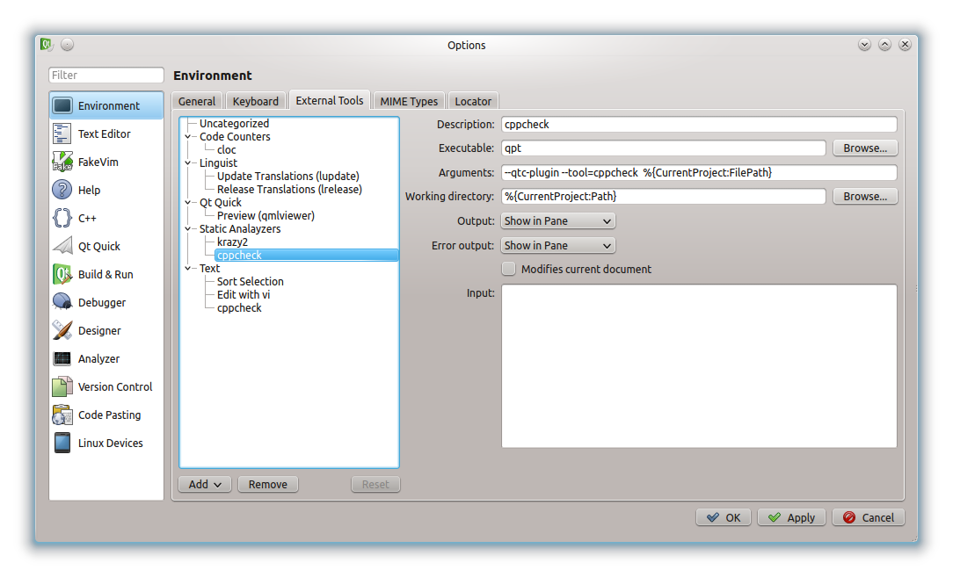

Configurations for krazy2

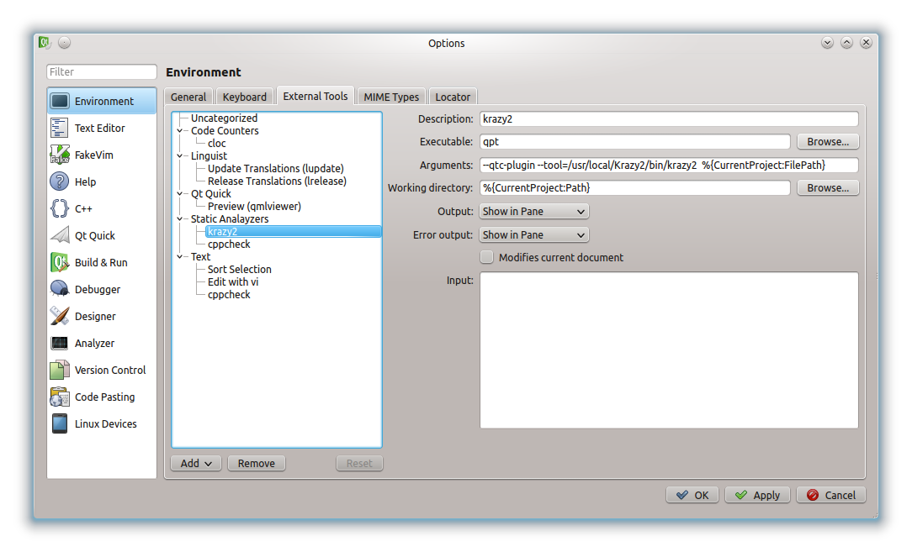

Configurations for cloc

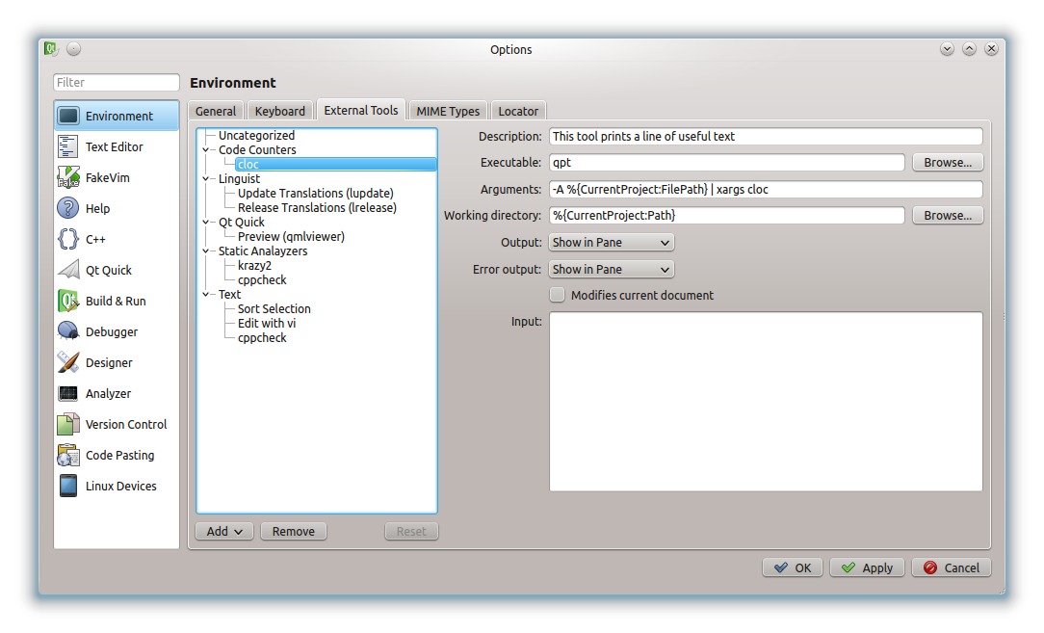

Using “qpt” as External Tool
Just use the menus over the current project.

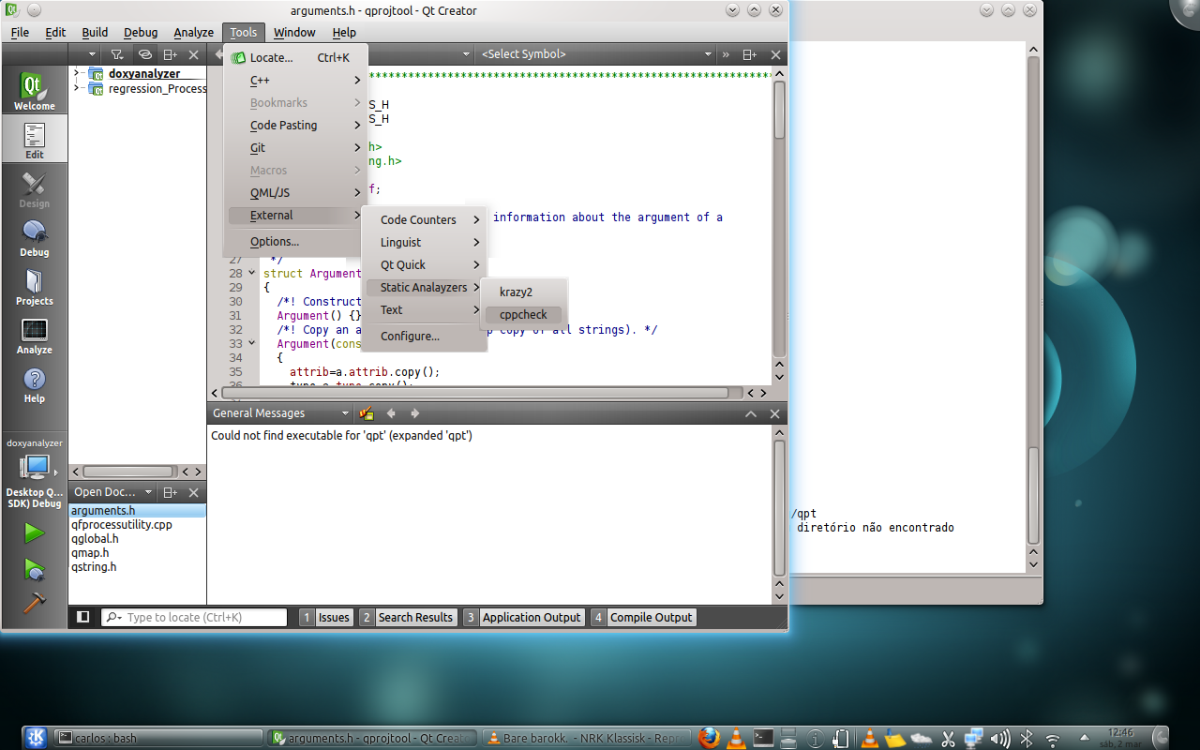

Cppcheck plugin in QtCreator

General Messages pane
The normal output from cppcheck goes to “General Messages” pane

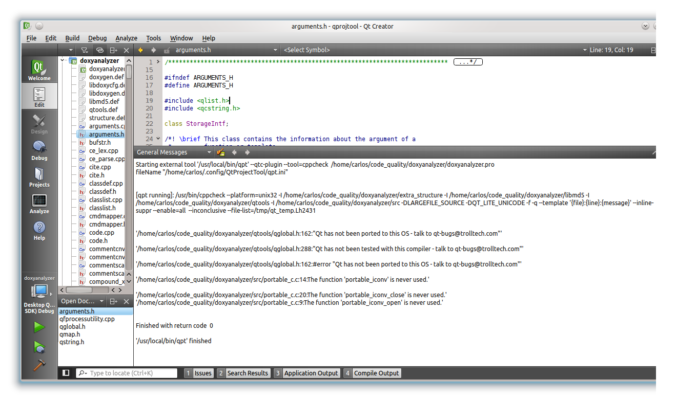
Issues pane
By clicking on a issue item, qtcreator allows fast code edition.
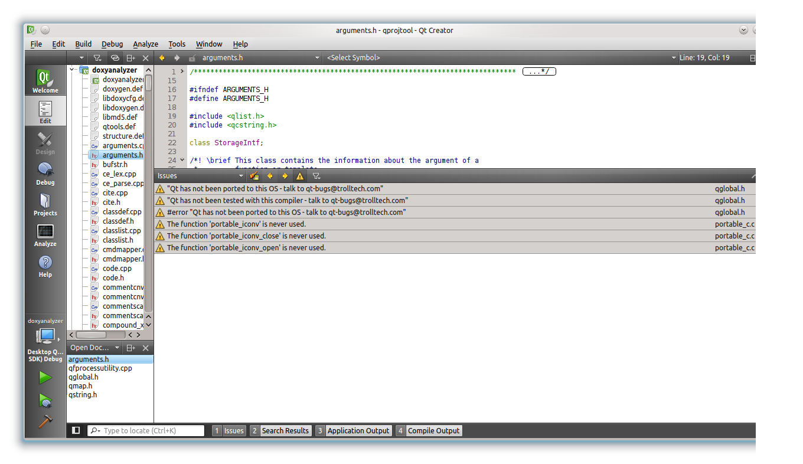

Krazy2 plugin in QtCreator

General Messages pane

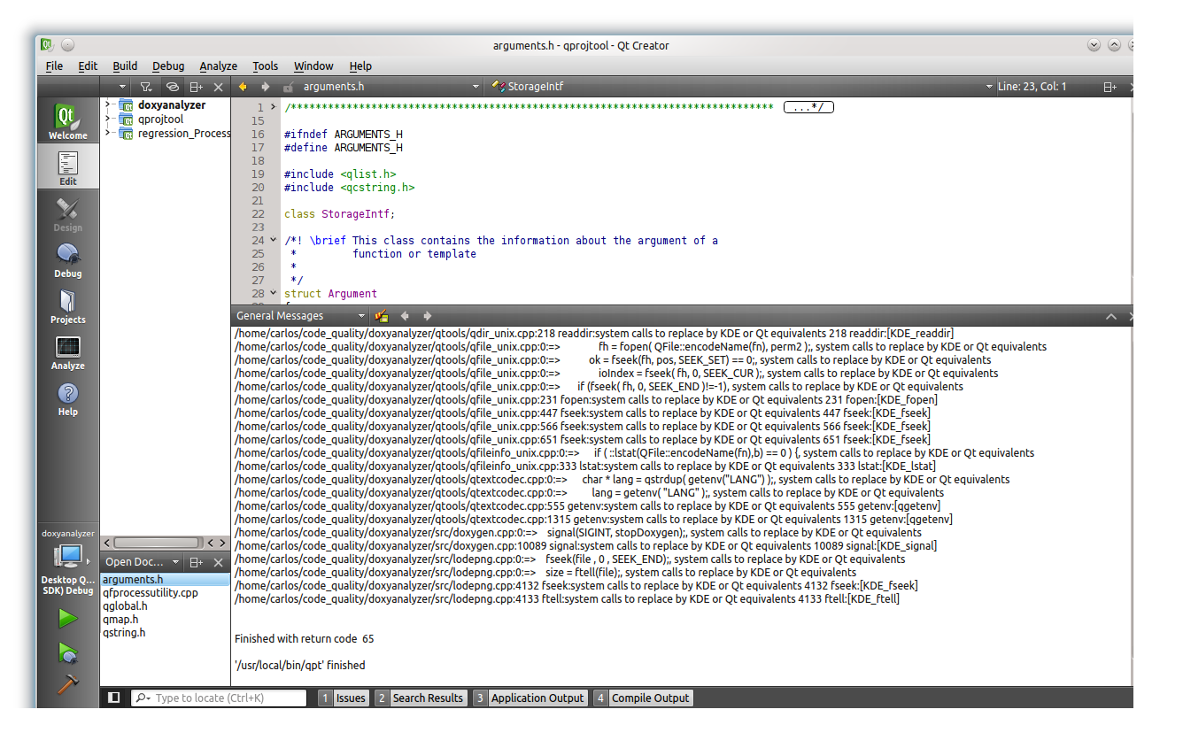
Issues pane
