


SPRINT 2 – Technical Specifications Document

Hybrid ML Platform for Autoimmune Disease Registry
Version 1

Item | Details
Title | Sprint 2 Technical Specification Document (TSD) - USM Autoimmune ML Platform
Version | 1.0
Author (s) | Syarifah Fajriyah Nasrin
Date | 13/04/2026
Purpose of Documentation | To document all technical implementations, API endpoints, database schemas, frontend interfaces, and testing procedures completed during Sprint 2 (ML Training Infrastructure, Data Lake Architecture, Data Quality Pipelines, and Frontend Integration). This document serves as a comprehensive reference for the delivered features aligned with Phase 2 objectives: Data Ingestion, Model Training & Optimization.

Prepared By:
Syarifah
SYARIFAH FAJRIYAH,

Table of Content

1. Documentation Overview 5
1.1 Sprint Goal 5
1.2 System Architecture Overview 6
1.2 Sprint 2 Deliverables Summary 7
3. Sprint 1 Functionalities 8
3.1 Storage Architecture 8
3.1.1 Schema Validation Service [USMA-81] 8
3.1.2 Database Migration Framework [USMA-73] [USMA-98] 9
3.1.3 Data Provenance & Lineage Tracking [USMA-85] 12
3.1.4 Dataset Versioning System [USMA-84] [USMA-27] [USMA-76] 14
3.1.5 Data Lake Partitioning Strategy [USMA-77] 16
3.1.6 SCD Type 2 for Patient Records [USMA-74] 18
3.2 Data Processing & Quality 19
3.2.1 Automated Data Preprocessing Pipeline [USMA-26] [USMA-32] [USMA-101] 19
3.2.2 Missing Value Handling & Outlier Detection Pipeline [USMA-22] [USMA-23] 20
3.2.3 Categorical Encoding Pipeline [USMA-24] 21
3.2.4 Unlabeled Record Filtering Fix [USMA-105] 21
3.2.5 Data Quality Dashboard – Phase 1 [USMA-83] [USMA-105] 23
3.2.6 Automated Data Preprocessing Pipeline [USMA-26] [USMA-32] [USMA-101] 24
3.4 Machine Learning Training & Model Pipeline 25
3.4.1 Flexible ML Architecture Design [USMA-82] 25
3.4.2 ML Training Endpoints [USMA-107] [USMA-108] 40
3.4.3 Feature Engineering Pipeline [USMA-63] [USMA-31] [USMA-104] 41
3.4.4 ML Data Validation Service [USMA-102] [USMA-103] [USMA-106] 43
3.5. Frontend Interfaces 44
3.5.1 Login Interface & JWT Authentication [USMA-92] [USMA-91] [USMA-90] [USMA-89] [USMA-88] 45
3.5.2 Secure Data Upload Interface – Phase 1 [USMA-61] 47
3.5.3 Dataset Preview Interface – Phase 1 [USMA-62] 48
3.5.4 GPU Monitoring Dashboard – Phase 1 [USMA-87] 49
3.5.5 User Profile Dashboard – Phase 1 [USMA-93] 50
3.5.6 Platform Logo & Brand Identity – Phase 1 [USMA-99] 51
4. Sprint 2 Deliverables Summary 52
5. Document Sign-Off 54

1. Documentation Overview
Sprint 2 builds upon the foundation established in Sprint 1, extending the USM Autoimmune ML Platform with machine learning training pipelines, frontend interfaces, data quality dashboards, schema versioning, and unstructured document processing. This sprint delivers 46 JIRA tickets across 6 major functional categories.

1.1 Sprint Goal
Build production-ready ML training infrastructure, complete the flexible data lake architecture, and deliver end-to-end data quality and preprocessing pipelines to enable clinical data ingestion and model training workflows.

Sprint 2 directly supports Phase 2: Data Ingestion, Model Training & Optimization by delivering:

- Clinical Data Ingestion & ETL Infrastructure
- Flexible schema design supporting dynamic medical record structures
- Data preprocessing pipeline (aggregation, missing values, outlier detection)
- Data quality validation framework
- Provenance tracking and dataset versioning

- Machine Learning Training & Model Pipeline
- Complete ML training API endpoints (disease classification, severity prediction)
- Feature engineering pipeline (auto-generation, transformations, importance ranking)
- Data validation framework for training dataset readiness
- GPU-accelerated computing infrastructure

- Implementation of Database Schema Evolution Support
- Flexible database migrations and schema evolution support
- Unstructured document processing pipeline

- User Interface & Monitoring
- Authentication and role-based access control
- Data management interfaces (Data Catalog, ML Preparation Queue)
- Monitoring dashboards and analytics
- Quality assurance visualization

1.2 System Architecture Overview
Processing Layers
Layer | Name | Components
Layer 1 | Upload & Ingestion | FileParser, ColumnMapper, Upload endpoints
Layer 2A | Structured Processing | FileParser, ColumnMapper, DataTransformer
Layer 2B | Unstructured Processing | OCRService, UnstructuredPipelineService, NER
Layer 3 | Validation Queue | 4 checkpoints: format, schema, type, compliance
Layer 4 | Database | PostgreSQL: 13 tables | MinIO: 3 Object Storage
Layer 5 | Data Cleaning & Preprocessing | Data Quality Validation, Data Cleaning, Data Validation Report
Layer 6 | ML Training | XGBoost, CatBoost, AdaBoost, Decision Trees, Random Forest, LigthGBM, KNN, SVM, MLP, Logistic Regression
Layer 7 | Evaluation Matric | Accuracy, Precisions, Confusion Matrix, AUC-ROC, Model Comparison, F1

System Architecture
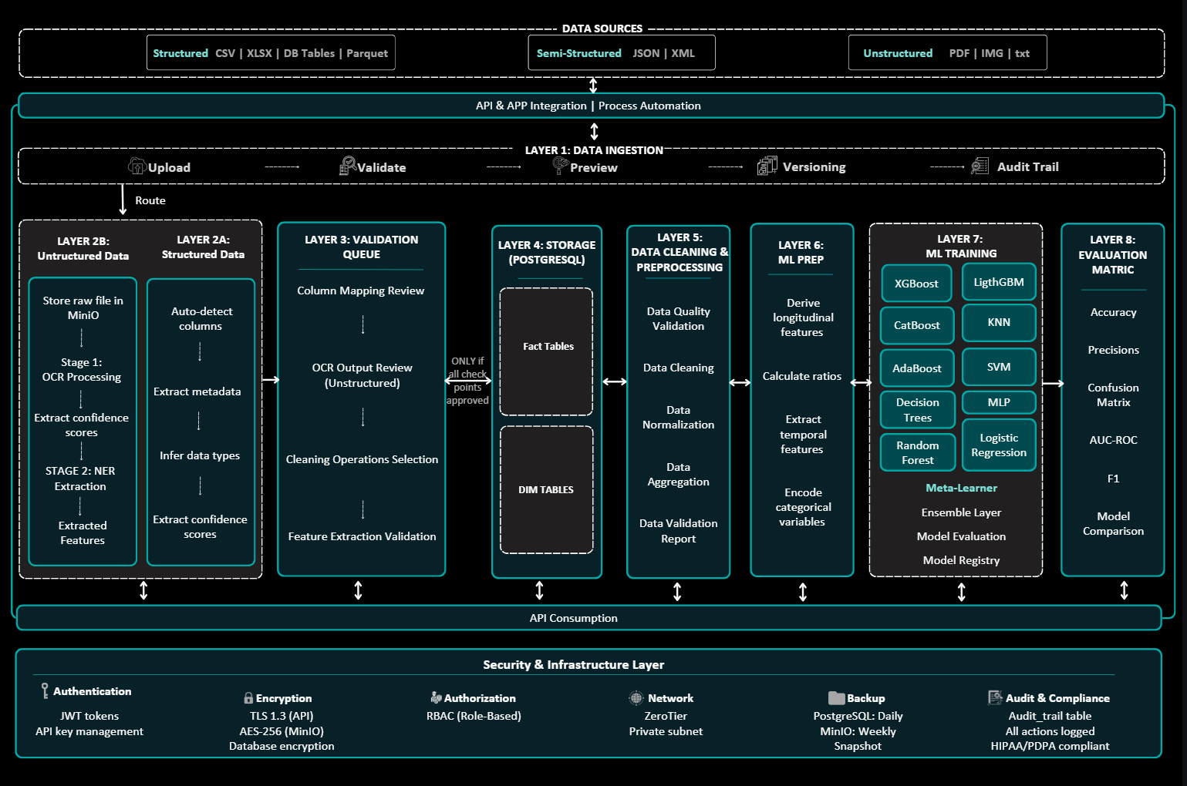

1.2 Sprint 2 Deliverables Summary
Category | Description | Tickets
ML Training & Model Pipeline | Training endpoints, feature engineering, data validation | USMA-63, 82, 102, 103, 104, 106, 107, 108, 31
Data Processing & Quality | Preprocessing, missing values, outliers, encoding, normalisation | USMA-22, 23, 24, 25, 26, 32, 83, 101, 105
Data Lake & Storage | Schema evolution, migrations, provenance, versioning, partitioning | USMA-27, 72, 73, 74, 76, 77, 81, 84, 85, 98
Frontend Interfaces | Login, navigation, upload UI, preview, EDA, dashboards | USMA-33, 61, 62, 87, 88, 89, 90, 91, 92, 93, 94, 95, 99
Unstructured Data Processing | Document classification pipeline, OCR API endpoints | USMA-78, 80
Infrastructure & Deployment | GPU migration, system optimisation | USMA-97

3. Sprint 2 Technical Details

3.1 Storage Architecture

3.1.1 Schema Validation Service [USMA-81]
Implements an automatic schema detection and validation service that dynamically identifies data structures from uploaded CSV files without requiring predefined column definitions. The system stores detected schemas as JSONB in PostgreSQL, enabling the platform to accept heterogeneous datasets from multiple hospitals with varying medical record formats.
Key Features:
- Schema Registry: Maintains a centralized registry of detected schemas in the dataset_schema table, indexed by dataset type for rapid lookup
- JSONB Storage: Stores schema definitions as flexible JSON structures in both flexible_dataset_wide (per-record schema) and dataset_schema (global template)
- Validation Engine: Validates incoming data against registered schemas while allowing schema evolution for new columns
Status: Complete
Swagger UI – GET /flexible-api/schema/{batch_id} – schema definition response:
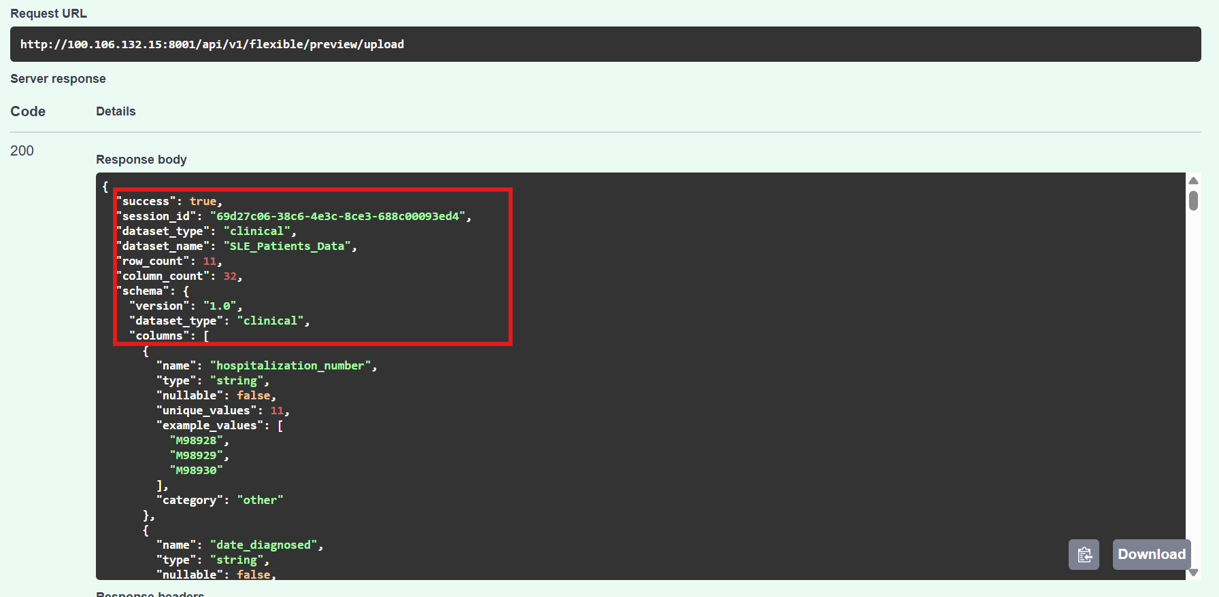

Database – flexible_dataset_column_metadata table showing column definitions:
USMA-81 – pgAdmin: flexible_dataset_column_metadata table
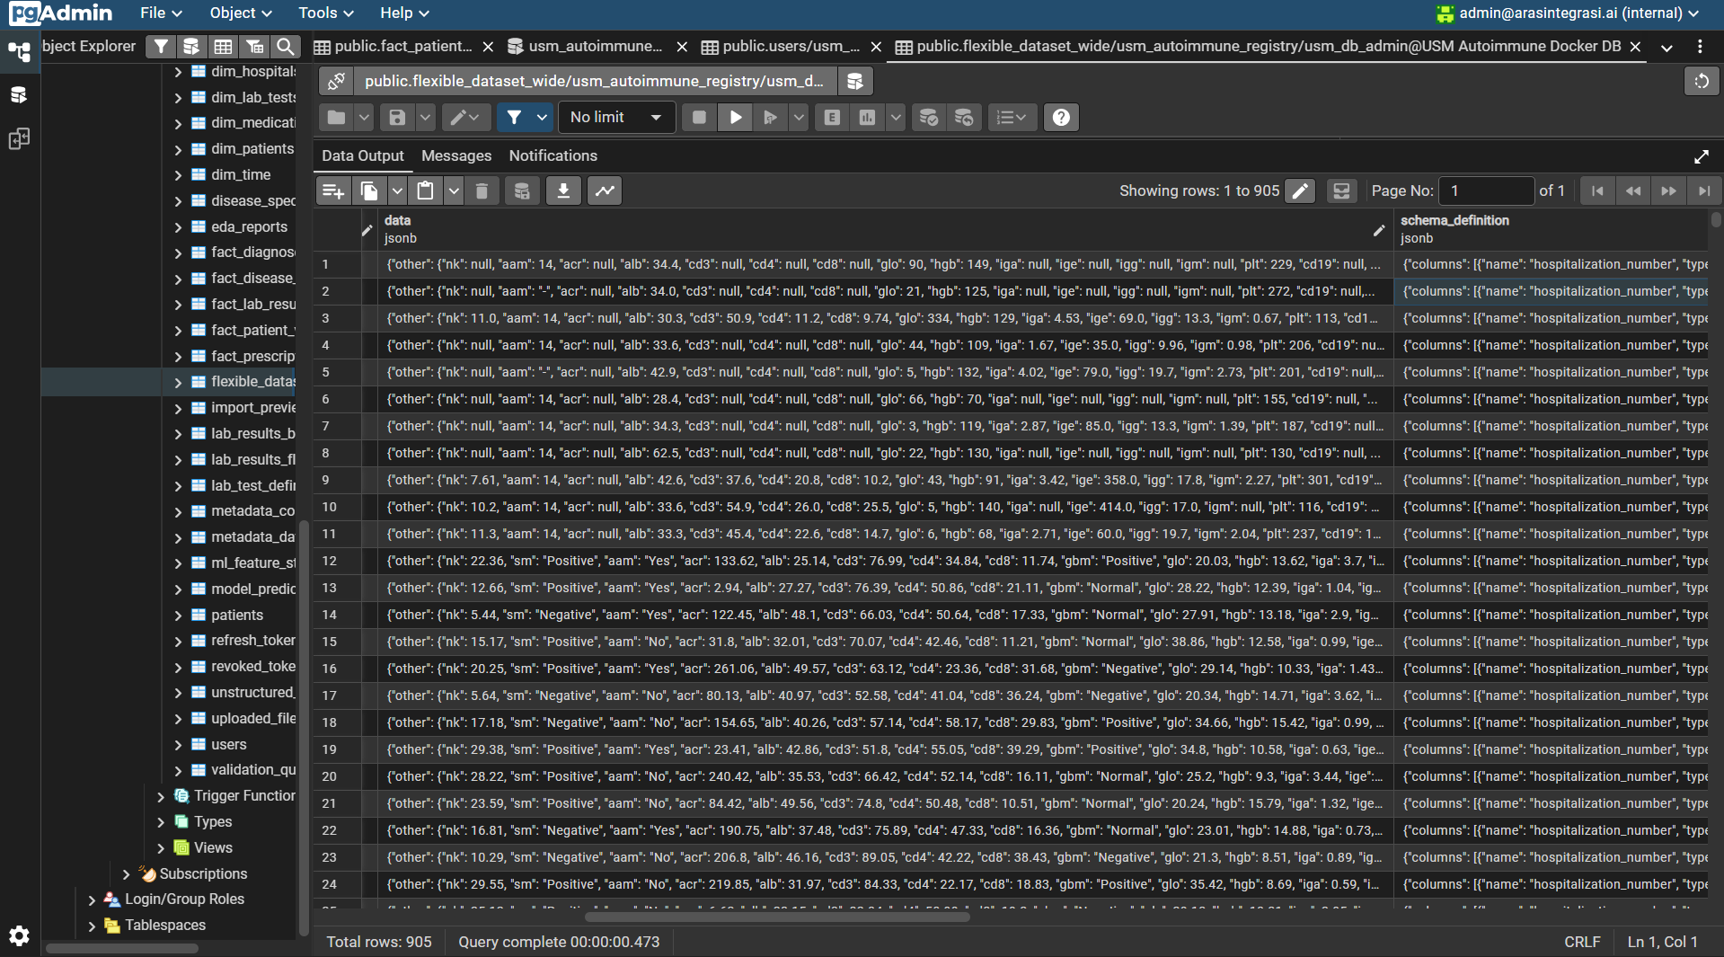

3.1.2 Database Migration Framework [USMA-73] [USMA-98]
Implements Alembic-based database migration framework providing version-controlled schema evolution with automatic generation, rollback capabilities, and environment-specific deployment support. This infrastructure enables zero-downtime schema updates and maintains consistent database states across development, staging, and production environments.
Key Features:
- Version Control: Tracks all schema changes through timestamped migration files stored in versions, creating an immutable history of database evolution
- Auto-generation: Detects model changes in SQLAlchemy ORM and automatically generates migration scripts via alembic revision autogenerate.
- Rollback Support: Enables bidirectional migrations with upgrade() and downgrade() functions, allowing safe rollback to any previous schema version
- Environment Flexibility: Supports both online (direct database execution) and offline (SQL script generation) migration modes for different deployment scenarios
- Current Version Tracking: Maintains alembic_version table recording the active schema version hash for deployment verification
Status: Complete

Terminal – alembic history and alembic current commands output:
USMA-98 – Terminal: alembic history and alembic current output
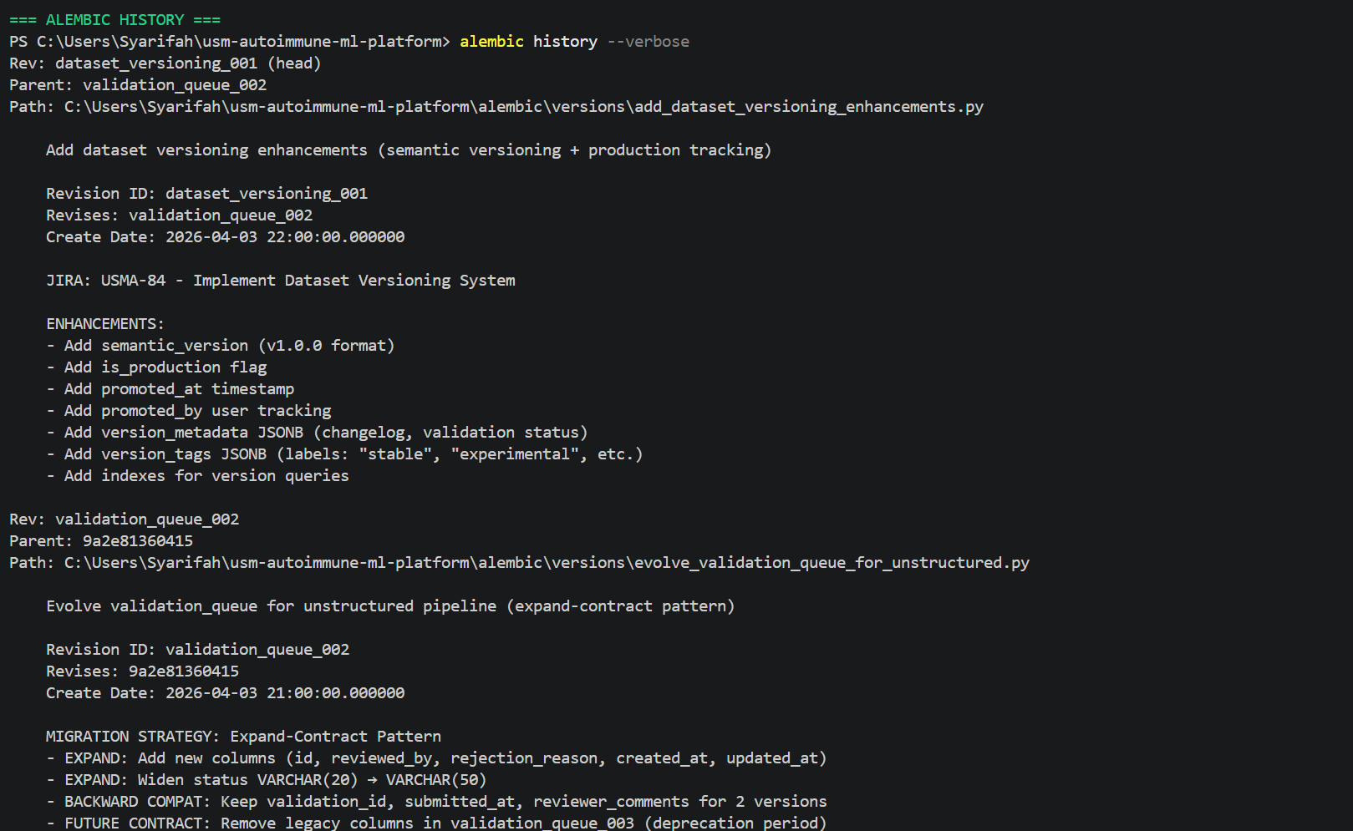
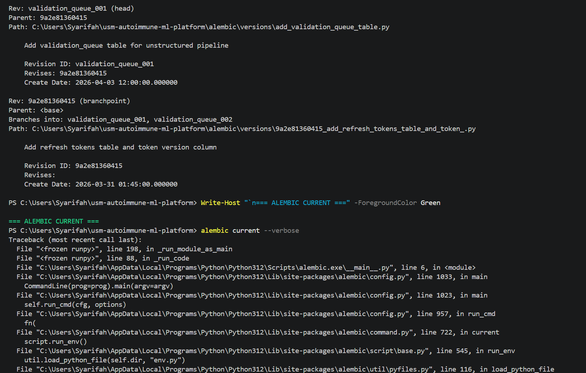

Database – alembic_version table showing current schema version:
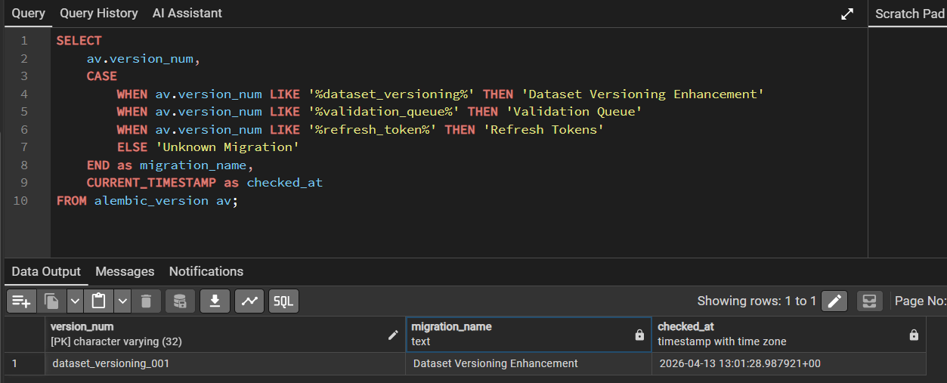

3.1.3 Data Provenance & Lineage Tracking [USMA-85]
Implements comprehensive data provenance tracking system that records complete lineage chains from raw data upload through preprocessing, transformation, and ML model training. This establishes a full audit trail ensuring reproducible experiments, and root cause analysis for data quality issues.
Key Features:
- End-to-End Lineage: Tracks data journey across five stages: Upload → Preview/Editing → Layer Preprocessing → Final Storage → ML Training
- Transformation Logging: Records every data manipulation operation including missing value imputation, outlier removal, normalization, feature engineering, and patient record aggregation
- Metadata Preservation: Stores operation timestamps, user IDs, input/output record counts, and operation-specific parameters as JSONB for flexible querying
- Provenance Chain Reconstruction: Enables backwards tracing from trained model to original source files, answering "Which hospital sent this data?" and "What preprocessing was applied?"
Status: Complete
Swagger UI – GET /provenance/lineage/{batch_id} – data lineage graph:
USMA-81 – pgAdmin: flexible_dataset_column_metadata table
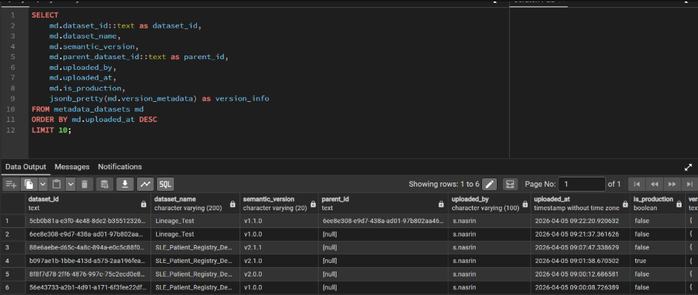

Swagger UI – GET /provenance/lineage/{batch_id} – data lineage graph:
USMA-85 – Data lineage endpoint – lineage transformation chain
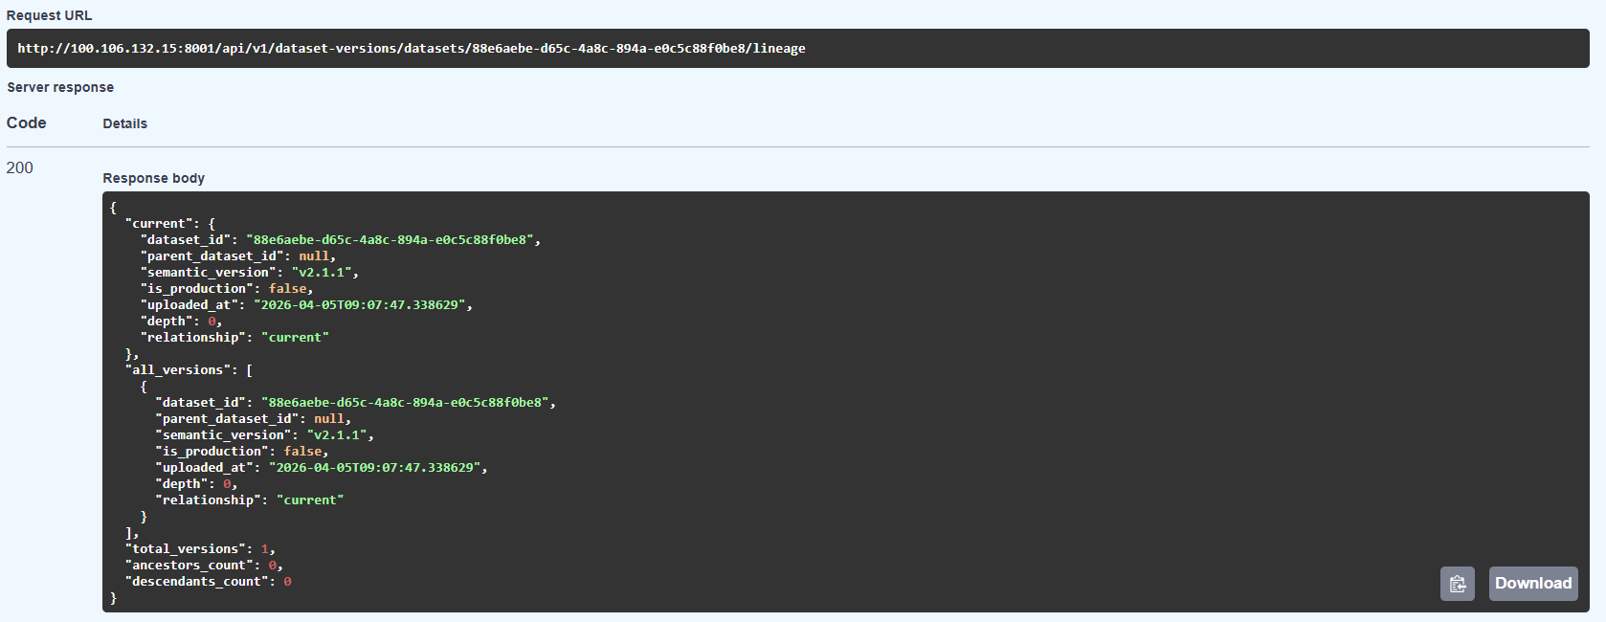

Database – data_provenance and transformation_log tables in pgAdmin:
USMA-85 – pgAdmin: data_provenance table with lineage records
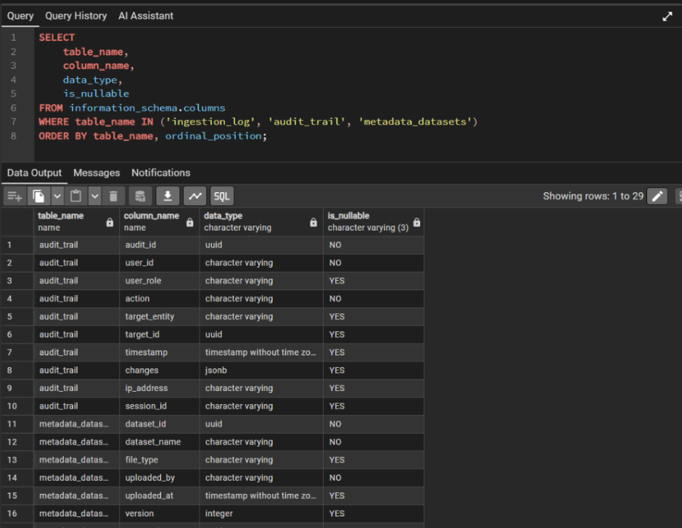

3.1.4 Dataset Versioning System [USMA-84] [USMA-27] [USMA-76]
Implements complete dataset versioning with MinIO object storage integration, version snapshots, lineage tracking, and MinIO bucket lifecycle policies for automatic archival of older dataset versions.
Status: Complete

Swagger UI – GET /versioning/versions/{batch_id} – version history list:
USMA-27 – List dataset versions endpoint – version history
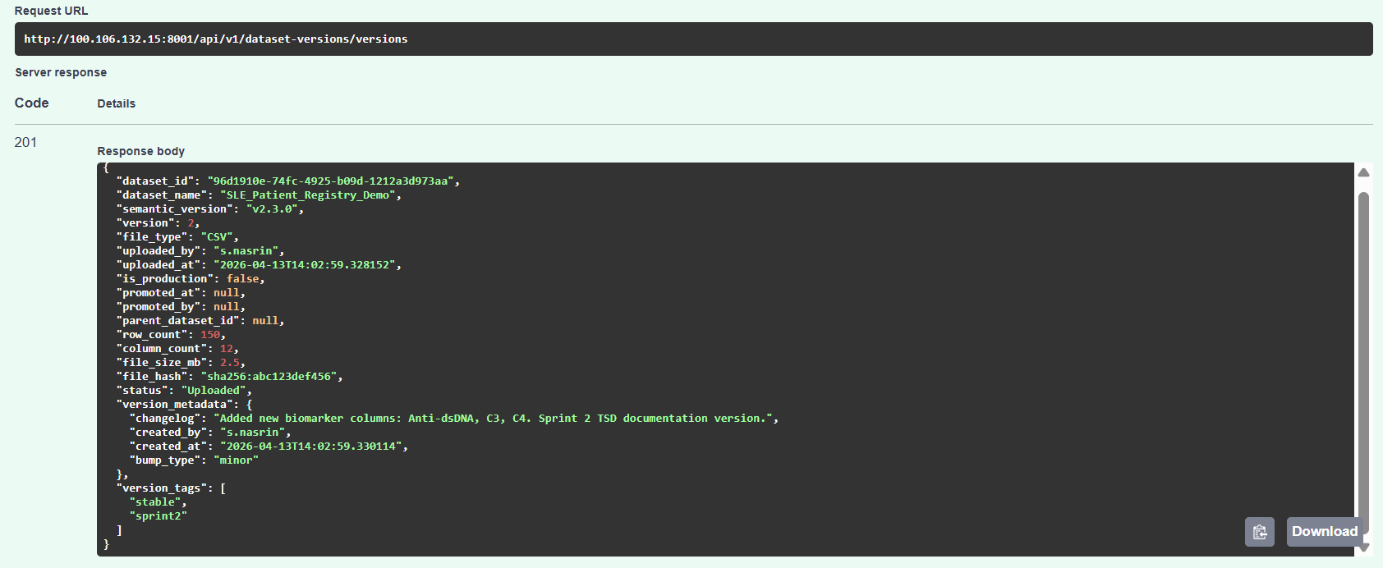

Swagger UI – GET /versioning/compare/{version1}/{version2} – version diff:
USMA-84 – Compare versions endpoint – version comparison results
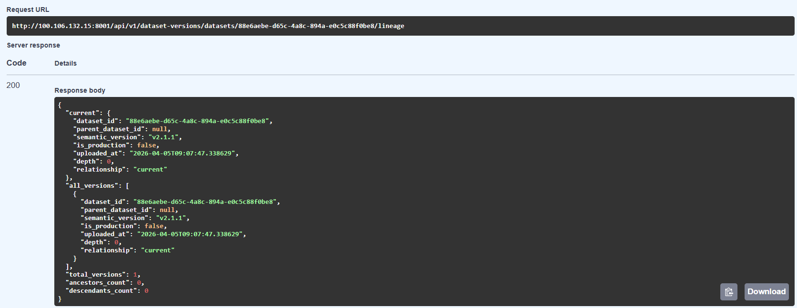

Database – dataset_versions table with version records:
USMA-84 – pgAdmin: dataset_versions table with version metadata
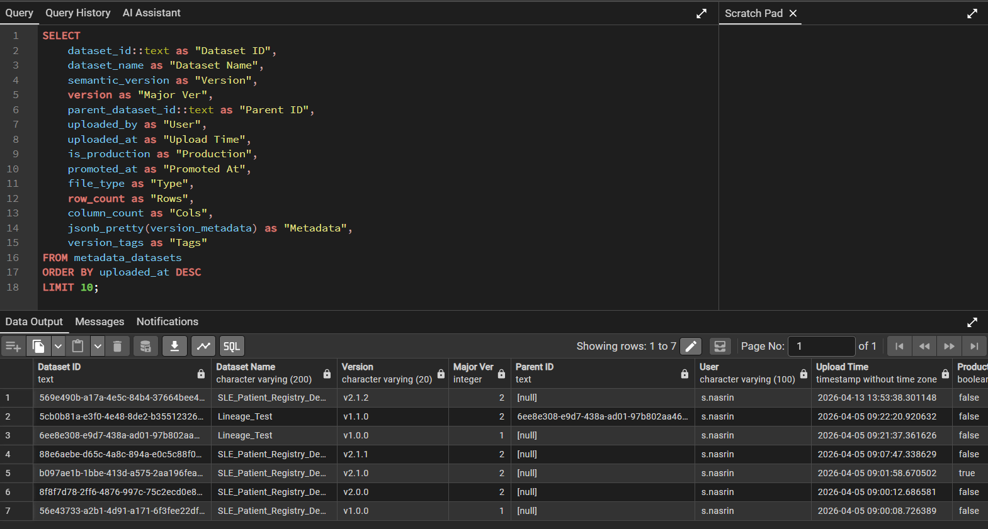

MinIO – usm-processed bucket with lifecycle policy configured:
USMA-76 – MinIO console: bucket lifecycle policy settings
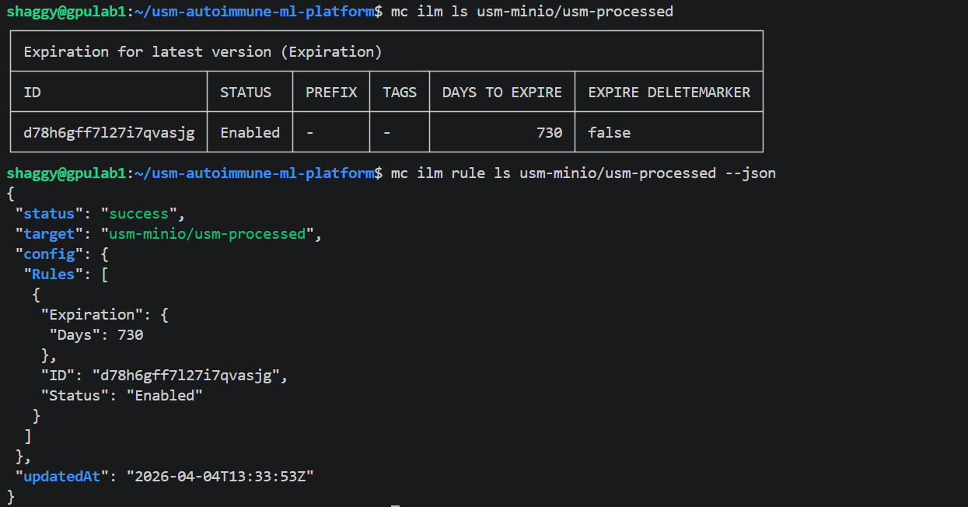

3.1.5 Data Lake Partitioning Strategy [USMA-77]
Implements date-based hierarchical folder partitioning for MinIO object storage, organizing dataset files into year/month/day directory structures. This partition strategy enables efficient temporal queries, reduces I/O overhead for time-range searches, and optimizes storage costs by facilitating automated tier migration policies for historical data.
Status: Complete
Partitioning Structure Example:
usm-processed/
├── year=2026/
│ ├── month=03/
│ │ ├── day=15/
│ │ │ ├── dataset_001.csv
│ │ │ └── dataset_002.csv
│ │ └── day=20/
│ │ └── dataset_003.csv
│ └── month=04/
│ ├── day=01/
│ │ ├── SLE_patients.csv
│ │ └── lab_results.csv
│ └── day=13/
│ └── clinical_data.csv

MinIO –partitioning endpoint or MinIO folder structure showing date hierarchy:
USMA-76 – MinIO console: bucket lifecycle policy settings
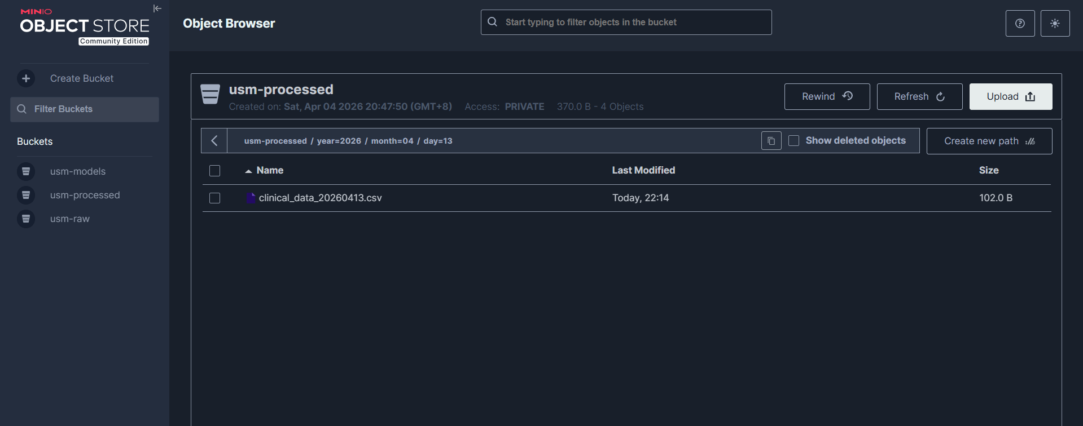

Database – partition index or query plan showing partitioned access:
USMA-77 – pgAdmin: EXPLAIN ANALYZE showing partition index usage
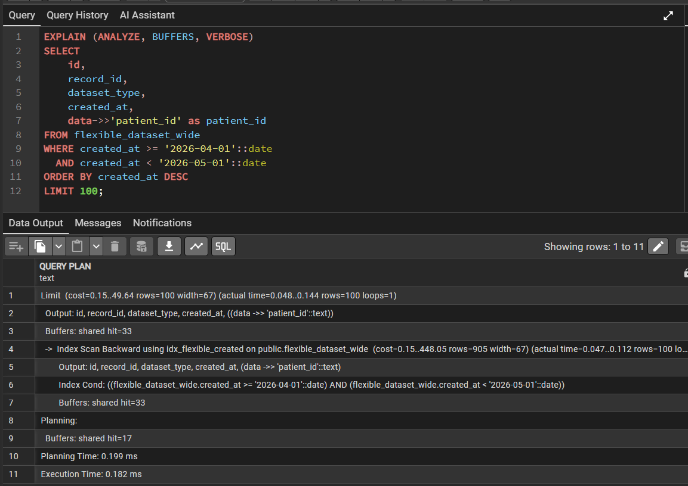

3.1.6 SCD Type 2 for Patient Records [USMA-74]
Implements Slowly Changing Dimension Type 2 (SCD2) preserving audit history of patient data modifications over time. Each attribute change creates a new record version with valid_from and valid_to timestamps, enabling point-in-time historical queries and longitudinal research analysis required for multi-year autoimmune disease studies.
Key Features:
- Complete History Preservation: All patient data modifications retained as immutable record versions without data loss
- Audit Compliance: Satisfies NMRR regulatory requirements for medical data change tracking and provenance
Status: Complete
Database – patient_history table showing SCD Type 2 columns (valid_from, valid_to, is_current):
USMA-74 – pgAdmin: patient_history table with SCD Type 2 structure
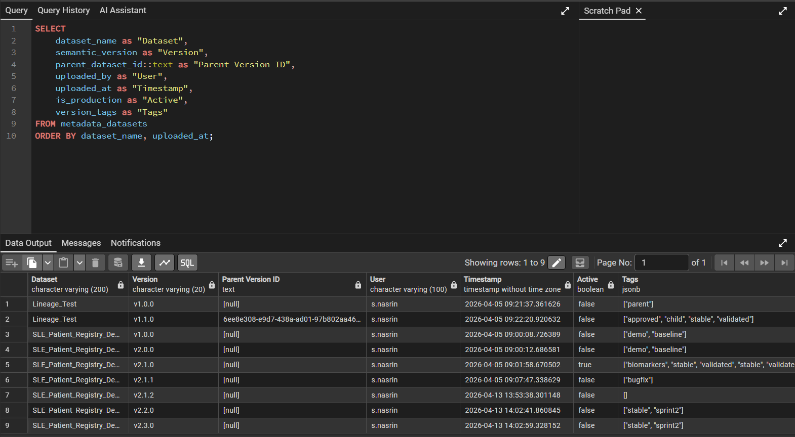

3.2 Data Processing & Quality
This section covers automated preprocessing, modular data quality modules, preprocessing metadata tracking, and the data quality dashboard. All components form the structured data processing pipeline for clinical datasets.

3.2.1 Automated Data Preprocessing Pipeline [USMA-26] [USMA-32] [USMA-101]
Implements end-to-end automated data preprocessing pipeline operating on staging table JSONB data with comprehensive metadata tracking. The system applies data quality operations including missing value handling, duplicate removal, outlier detection, type conversion, and data standardization while maintaining complete audit trails of all transformations applied.
Key Features:
- Layer 5 Data Quality Focus: Preprocessing targets data quality (missing values, duplicates, outliers) rather than ML-specific transformations (scaling, encoding), preventing double preprocessing issues
- Metadata Tracking: Records all preprocessing operations with before/after statistics, user attribution, and timestamps
- Quality Reporting: Generates comprehensive quality metrics (missing value percentages, outlier counts, duplicate detection)
- Reversible Operations: Preserves original data in staging table until user confirms final save
Status: Complete

Frontend – Data Preparation page showing preprocessing pipeline with real data:
USMA-26 / USMA-101 – Frontend: Data Preparation page with staging data
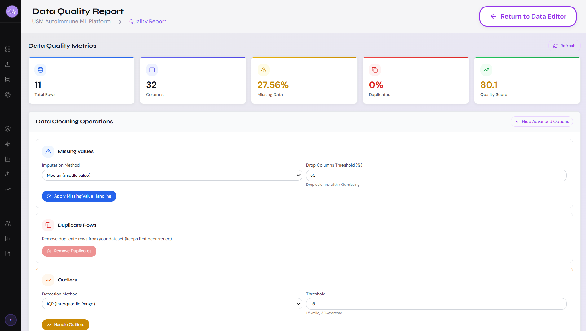
Database – preprocessing_metadata table with pipeline tracking records:
USMA-101 – pgAdmin: preprocessing_metadata table
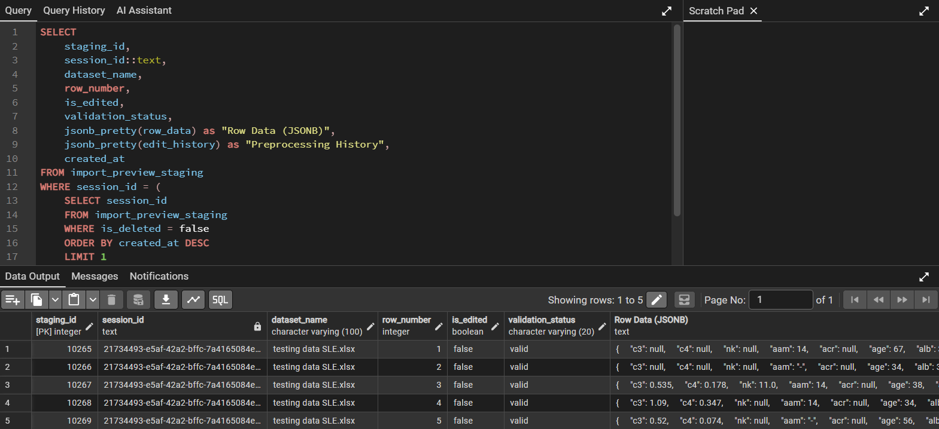

3.2.2 Missing Value Handling & Outlier Detection Pipeline [USMA-22] [USMA-23]
Implements missing value imputation strategies including mean, median, and mode imputation, as well as forward and backward fill for time-series clinical records.
Status: Complete

Frontend – missing value with real data:
USMA-22 – Handle missing values endpoint – response showing imputation result
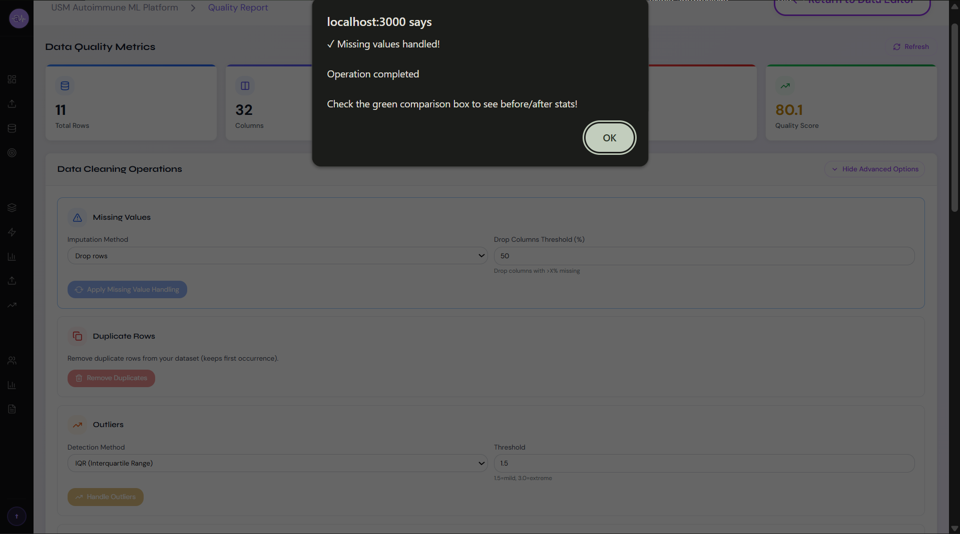

3.2.3 Categorical Encoding Pipeline [USMA-24]
Implements automated categorical variable encoding supporting Label Encoding and One-Hot Encoding strategies with intelligent column type detection. The pipeline automatically identifies categorical columns unsuitable for numeric ML models and applies appropriate encoding transformations while preserving data integrity.
Key Features:
- Auto-detection Mode: Automatically identifies categorical columns (object/string dtypes) requiring encoding
- Multiple Encoding Strategies:
  - Label: Label Encoding (0, 1, 2...) for ordinal categories
  - onehot: One-Hot Encoding (binary columns) for nominal categories
  - auto: Intelligent selection based on cardinality (onehot if <10 unique values, label otherwise)
- Preservation of Target Column: Ensures target/label columns excluded from encoding to prevent data leakage
- Encoding Report: Returns detailed transformation report including columns encoded, strategy used, and new column names
Status: Complete
VScode file – preprocessing/encode-categorical

3.2.4 Unlabeled Record Filtering Fix [USMA-105]
Fixes the filtering logic for unlabeled records in the ML preparation queue to ensure datasets without target labels are correctly surfaced for manual annotation before training.
Key Features:
- Accurate Unlabeled Detection: Checks for labeled_count = 0 OR absence of target column values
- Pending Tab Population: Unlabeled datasets automatically appear in "Pending" tab for annotation workflow
- Status-Based Filtering: Three-tier status system (Pending, In Progress, Complete) based on label completion percentage
- Real-time Label Count: Displays actual labeled record counts from database, not cached values
Status: Complete

Frontend – ML Preparation Queue: Pending tab with unlabeled datasets:

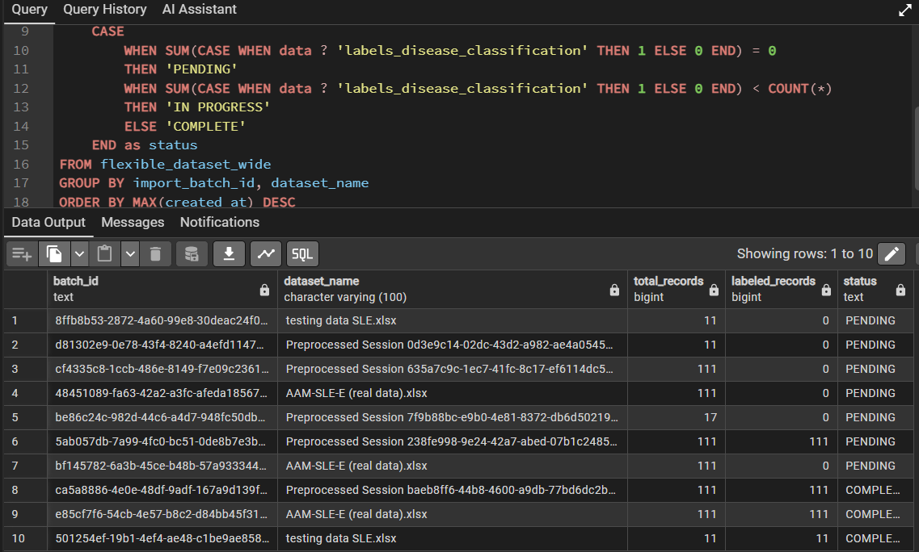

3.2.5 Data Quality Dashboard – Phase 1 [USMA-83] [USMA-105]
Implements Phase 1 of the data quality dashboard showing real-time quality metrics, issue detection, completeness and accuracy scores, and unlabeled record filtering across uploaded datasets.
Status: Complete

Frontend – Data Quality Dashboard overview with quality scores:
USMA-83 – Frontend: Data Quality Dashboard – overview with metrics
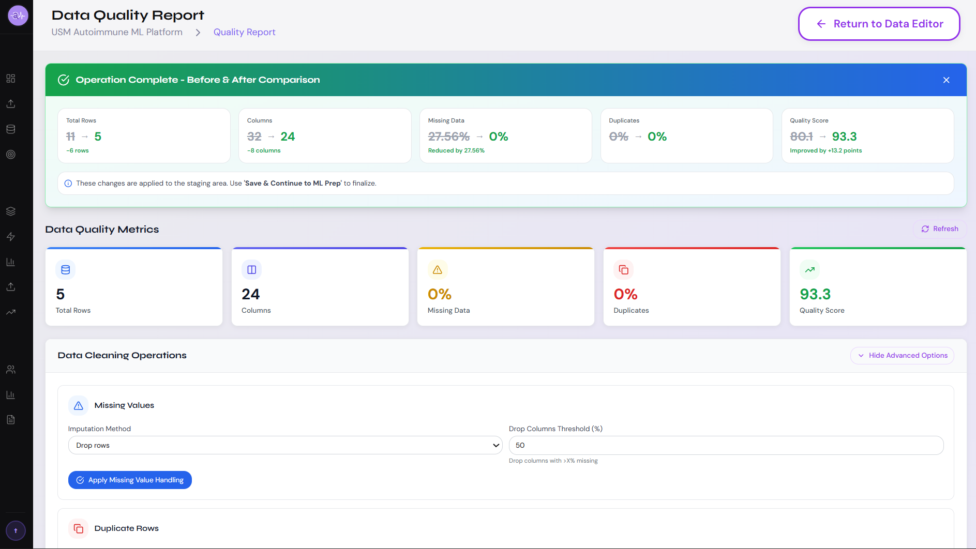
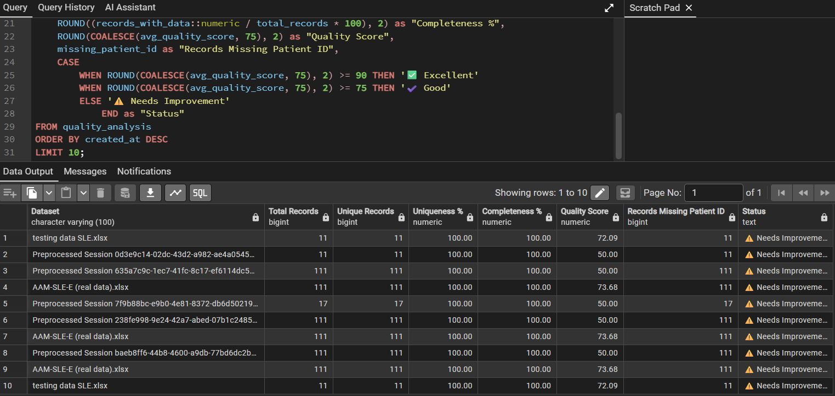

3.2.6 Automated Data Preprocessing Pipeline [USMA-26] [USMA-32] [USMA-101]
Implements end-to-end automated data preprocessing with metadata tracking across missing value handling, duplicate removal, outlier detection, type conversion, and data standardisation operations. A staging preprocessing service manages the full pipeline state.
Status: Complete

Frontend – Data Preparation page showing preprocessing pipeline with real data:
USMA-26 / USMA-101 – Frontend: Data Preparation page with staging data
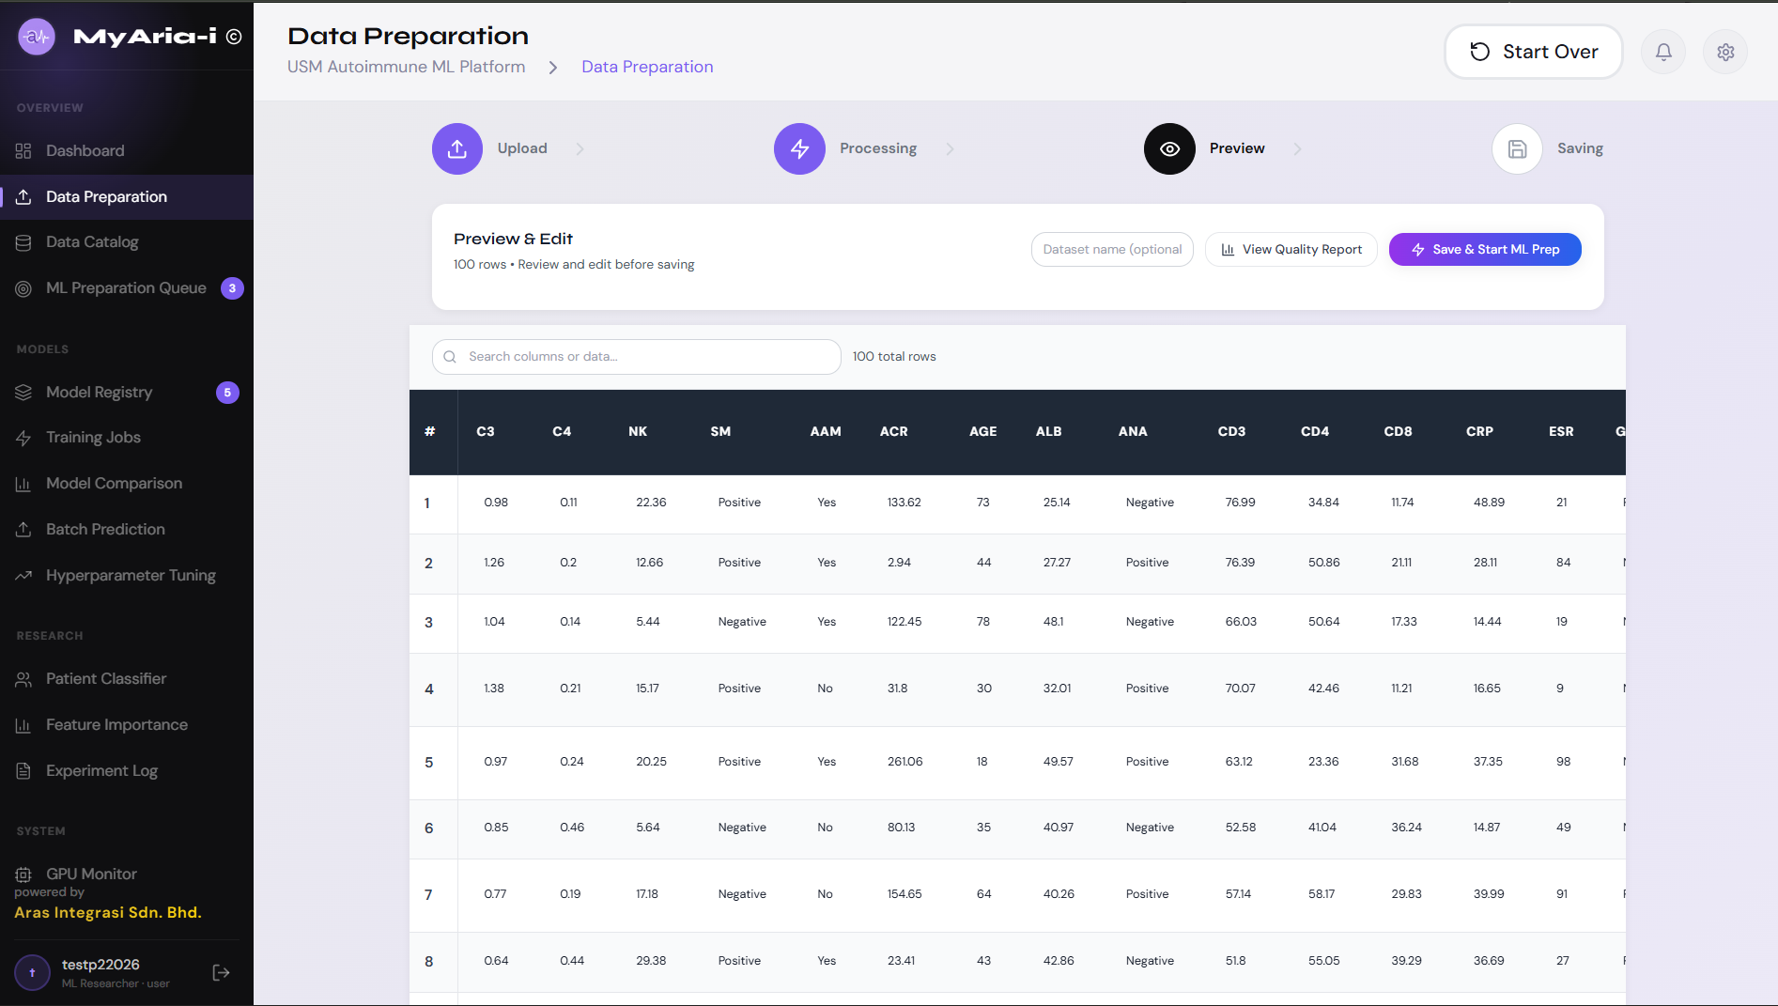

Database – preprocessing_metadata table with pipeline tracking records:
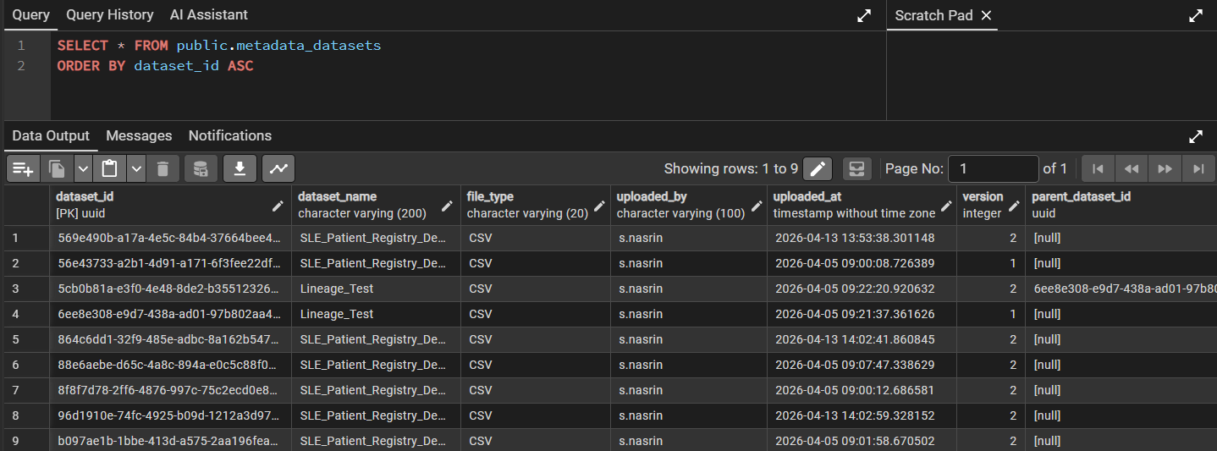

3.4 Machine Learning Training & Model Pipeline
This section covers the complete ML model training infrastructure including endpoint design, feature engineering, data validation, and architecture design. All components feed into the ensemble stacking pipeline for autoimmune disease classification.

3.4.1 Flexible ML Architecture Design [USMA-82]
Designs the overall ML architecture to support multiple supervised learning algorithms within a stacking ensemble framework. Defines the model registry, training job management, and inference pipeline structure.
- Heterogeneous Learning: Different algorithms capture different data patterns (tree-based vs gradient-based vs bagging)
- Variance Reduction: Ensemble reduces individual model overfitting through prediction aggregation
- Imbalanced Data Handling: Stacking framework allows individual models to use different class weight strategies
- Clinical Interpretability: Base models provide feature importance rankings; meta-learner provides final confidence scores

Tier | Role | Algorithms | Output
Tier 1 | Base Learners | XGBoost, LightGBM, CatBoost, Random Forest, Gradient Boosting (sklearn) | X × probability scores per patient
Tier 2 | Meta-Learner | Logistic Regression (classification) / Ridge Regression (severity) | 1 × final calibrated probability
Ensemble diversity is the key driver of stacking performance. When base models make errors for different structural reasons a tree-based model misclassifies a patient where a linear model succeeds, and vice versa those errors are uncorrelated and the meta-learner can exploit that disagreement. The five algorithms were selected to maximize structural diversity across three axes:

Diversity Axis | Algorithms Selected | What They Disagree On
Split strategy | XGBoost (level-wise) vs LightGBM (leaf-wise) vs CatBoost (ordered) | Which decision boundaries to draw first
Ensemble method | Gradient Boosting family vs Random Forest (bagging) | Sequential error correction vs parallel independence
Categorical handling | CatBoost (native) vs others (encoded) | Whether category ordering carries information
Regularization style | L1+L2 (XGB), L2 (LGB, CB), Gini pruning (RF, sklearn GB) | Which types of complexity are penalized

Optuna
Optuna is an automatic hyperparameter optimisation framework that intelligently searches for the best model configuration without requiring manual trial and error. Instead of testing every possible combination of settings (grid search) or picking randomly (random search), Optuna uses Bayesian optimisation it learns from each trial to predict which settings are most likely to improve performance next.
In plain terms: Optuna is your ML model's personal trainer. It runs 100 experiments per algorithm, studies which settings produced the best results, and converges on the optimal configuration in minutes rather than days.
Status: Production-ready and actively implemented. Files: app/ml/base_models.py | Library: optuna==3.5.0

How Optuna Works - Three Phases
Phase 1 - Exploration (Trials 1–20) Optuna samples broadly across the hyperparameter search space to build an initial map of which regions look promising. No prior knowledge assumed.
Phase 2 - Exploitation (Trials 21–60) Using a Tree-structured Parzen Estimator (TPE), Optuna models the relationship between hyperparameter values and AUC-ROC. It focuses new trials on regions that performed well — similar to how a researcher narrows down an experiment after seeing early results.
Phase 3 - Fine-tuning (Trials 61–100) Optuna fine-tunes around the best-performing configurations found so far, squeezing out final performance gains before selecting the optimal parameter set.

Optuna vs. Alternative Approaches
Method | Search Strategy | Speed | Quality | Used Here
Manual Tuning | Human intuition | Days | Inconsistent | No
Grid Search | Exhaustive every combination | Hours | Good but wasteful | No
Random Search | Random sampling | Minutes | Hit-or-miss | No
Optuna (TPE) | Bayesian learns from trials | Minutes | Best | Yes

XGBoost - Extreme Gradient Boosting
Attribute | Detail
Algorithm Family | Gradient Boosting (level-wise tree growth)
JIRA Ticket | USMA-107, USMA-82
Role in Stack | Primary base learner - expected highest individual AUC
Key Advantage | Handles missing lab values natively; built-in L1+L2 regularization critical for n≈191

How XGBoost Works for Autoimmune Classification
XGBoost builds decision trees sequentially. Each new tree is trained exclusively on the residual errors of all previous trees combined - it corrects what the ensemble has gotten wrong so far. After n_estimators rounds, the summed predictions of all trees form the final output, scaled by learning_rate to control the contribution of each correction step.
For autoimmune disease classification, this sequential error-correction is powerful because the clinical feature space is heterogeneous: some patients are classified correctly by simple biomarker thresholds (C3, C4 complement levels) while others require complex multi-feature interactions (ANA titre × SLEDAI score × medication history) to classify correctly. XGBoost's sequential trees can model both simultaneously.

Why It Belongs in This Stack
Strength | Relevance to Autoimmune Registry
Missing value handling | Clinical lab panels are frequently incomplete - XGBoost learns optimal split directions for missing values without imputation
L1 + L2 regularization | reg_alpha and reg_lambda penalize tree complexity, preventing memorization of the n≈191 training set
scale_pos_weight | Corrects class imbalance between SLE and minority subtypes by up-weighting the minority class during training
SHAP feature importance | Clinicians can review per-patient explanations of why each classification was made - supports NMRR audit trails
Early stopping | Stops training when validation AUC plateaus - automatically prevents overfitting on small datasets

Hyperparameters Tuned (Optuna - 100 trials, objective: AUC-ROC 5-fold CV)
Hyperparameter | Search Range | Clinical Rationale
n_estimators | 100 – 500 (+ early stopping) | More trees = finer error correction; early stopping prevents overfit
max_depth | 3 – 6 | Shallow trees for n≈191; deep trees memorize training patients
learning_rate | 0.01 – 0.10 | Slow learner with more trees generalizes better than fast learner with fewer
subsample | 0.6 – 0.9 | Row sampling per tree adds randomness, reduces correlation between trees
colsample_bytree | 0.6 – 0.9 | Feature sampling per tree - prevents any single biomarker from dominating
reg_alpha (L1) | 0.0 – 1.0 | Sparse regularization; can zero out irrelevant features entirely
reg_lambda (L2) | 0.5 – 3.0 | Ridge regularization; smooths weight estimates across all features
scale_pos_weight | (neg count)/(pos count) | Set automatically from class distribution in training fold

LightGBM - Light Gradient Boosting Machine
Attribute | Detail
Algorithm Family | Gradient Boosting (leaf-wise tree growth)
JIRA Ticket | USMA-107, USMA-82
Role in Stack | High-speed base learner; captures different decision boundaries than XGBoost
Key Advantage | Histogram-based binning efficient for continuous lab values; native categorical feature support

How LightGBM Differs from XGBoost for Autoimmune Data
LightGBM uses leaf-wise tree growth rather than level-wise. Where XGBoost expands all leaves at a given tree depth simultaneously (building balanced trees), LightGBM finds the single leaf with the largest loss reduction and splits only that leaf regardless of depth. This produces asymmetric trees that more accurately model irregular clinical data distributions.
For biomarker-heavy registry data with many continuous laboratory values (C3, C4, CH50, anti-dsDNA titres, ESR, CRP), LightGBM's histogram-based feature binning groups similar values into discrete bins before finding split points. This is significantly more computationally efficient than XGBoost's exact split search and is the primary reason LightGBM trains faster on feature-rich datasets.

Level-wise vs Leaf-wise Growth - Impact on Clinical Data
Growth Strategy | Structure | Risk for n=191 | Mitigation
XGBoost - level-wise | All leaves at depth d split before depth d+1 | Lower overfitting risk; more conservative | None required
LightGBM - leaf-wise | Deepest most-informative leaf splits first | Can produce very deep branches on small n | num_leaves ≤ 31, min_child_samples ≥ 5

Why It Belongs in This Stack
Strength | Relevance to Autoimmune Registry
Native categorical features | Diagnosis codes, medication classes, ethnicity, hospital site passed directly no encoding step
Histogram binning | Efficient binning of continuous biomarker values (C3: 0.1–2.5 g/L, ESR: 1–140 mm/hr)
Leaf-wise growth | Captures irregular, asymmetric patterns in patient sub-populations
Faster training | Allows more Optuna trials within the 8h/week compute allowance
DART mode option | Dropout Additive Regression Trees available for additional regularization if overfitting observed

Hyperparameters Tuned
Hyperparameter | Search Range | Clinical Rationale
num_leaves | 15 – 31 | Keep low for n=191 num_leaves controls model complexity more than max_depth in LightGBM
learning_rate | 0.01 – 0.10 | Same slow-learner strategy as XGBoost
feature_fraction | 0.6 – 0.9 | Randomly select feature subset per tree (equivalent to colsample_bytree)
bagging_fraction | 0.7 – 0.9 | Row sampling per tree; use with bagging_freq=5
min_child_samples | 5 – 20 | Minimum patients per leaf prevents single-patient leaves on n=191
reg_alpha | 0.0 – 1.0 | L1 regularisation
reg_lambda | 0.0 – 3.0 | L2 regularisation
class_weight | 'balanced' | Automatically adjusts for autoimmune subtype imbalance

CatBoost - Categorical Boosting
Attribute | Detail
Algorithm Family | Gradient Boosting (ordered boosting, symmetric trees)
JIRA Ticket | USMA-107, USMA-82
Role in Stack | Categorical feature specialist; adds ordered-boosting diversity
Key Advantage | Processes ethnicity, diagnosis codes, medication class, gender without encoding; ordered boosting prevents target leakage on small n

How CatBoost Handles Autoimmune Registry Categorical Features
Standard gradient boosting algorithms require categorical features ethnicity, disease diagnosis code, medication class, hospital site, gender to be pre-encoded into numeric form using label encoding or one-hot encoding. Both approaches introduce information loss or dimensionality problems. CatBoost uses Ordered Target Statistics (OTS) to encode categorical values using the target label, but crucially does this on a randomized permutation of training samples so that each sample's encoding is computed from samples seen before it in the permutation. This prevents target leakage the encoded value for a sample does not include information from that sample's own label.

On a small dataset of n=191, target leakage from naive categorical encoding can artificially inflate training metrics while degrading test performance. CatBoost's ordered approach is particularly well-suited to the registry's sample size.

Ordered Boosting - the Additional Safeguard
Beyond categorical encoding, CatBoost applies the same ordered principle to the boosting process itself. Residuals for each training sample are calculated using only a model trained on earlier samples in the permutation - not the full training set. This is a form of sequential validation that provides a more honest estimate of generalization performance during training, which translates to lower overfitting on small datasets.

Why It Belongs in This Stack
Strength | Relevance to Autoimmune Registry
Ordered Target Statistics | Safely encodes diagnosis codes, ethnicity, hospital site without target leakage
Ordered boosting | Reduces overfitting risk on n=191 residuals computed without data leakage
Symmetric trees | Equal-depth trees reduce variance and produce more calibrated probability outputs
auto_class_weights='Balanced' | Handles autoimmune subtype imbalance automatically
border_count tuning | Controls histogram resolution for continuous biomarker features - tunable per feature

Hyperparameters Tuned
Hyperparameter | Search Range | Clinical Rationale
iterations (n_estimators) | 100 – 500 | Number of trees; use early_stopping_rounds to find optimum
depth | 4 – 8 | Symmetric tree depth CatBoost symmetric trees are less prone to overfit than asymmetric
learning_rate | 0.01 – 0.10 | Slow learner strategy
l2_leaf_reg | 1 – 9 | L2 regularization on leaf weights; higher = simpler trees
border_count | 32 – 255 | Histogram bins for continuous features - lower for small n
auto_class_weights | 'Balanced' | Fixed - always on for imbalanced autoimmune class distribution

Random Forest - Bagging Ensemble
Attribute | Detail
Algorithm Family | Bagging (bootstrap aggregation of decision trees)
JIRA Ticket | USMA-107, USMA-82
Role in Stack | Introduces bagging diversity - structurally independent from all three gradient boosting models
Key Advantage | Robust to outliers in clinical measurements; stable predictions; out-of-bag validation without a held-out set

How Random Forest Differs from the Boosting Family
All three gradient boosting algorithms (XGBoost, LightGBM, CatBoost) build trees sequentially, with each tree explicitly targeting the errors of all previous trees. Random Forest takes the opposite approach: it builds all trees independently and in parallel, each on a randomly sampled subset of training data (bootstrap sample) and a randomly sampled subset of features at each split.

This independence is the source of Random Forest's unique contribution to the ensemble. Its prediction errors are structurally uncorrelated with gradient boosting errors - it makes mistakes in different places. When the meta-learner sees Random Forest disagreeing with all three boosting models on a specific patient, it uses that disagreement as a signal about prediction uncertainty for that patient.

Bagging vs Boosting - Structural Comparison
Property | Random Forest (Bagging) | XGBoost / LightGBM / CatBoost (Boosting)
Tree training order | Parallel - all trees independent | Sequential - each tree corrects previous
Error focus | Random sampling - no targeted error correction | Explicitly targets residuals from prior trees
Bias–variance | Low bias, reduced variance through averaging | Low bias through sequential correction
Outlier sensitivity | Robust - outliers affect only ~63% of trees | More sensitive - outliers get up-weighted in boosting
OOB validation | ~37% of samples left out per tree - free validation | Requires explicit validation set or CV

Why It Belongs in This Stack
Strength | Relevance to Autoimmune Registry
Outlier robustness | Clinical measurements have genuine outliers (e.g. extreme SLEDAI scores, anomalous lab values) that are real, not errors - Random Forest handles them without down-weighting
Bagging diversity | Bootstrap sampling creates structurally independent trees; errors uncorrelated with boosting family errors
Feature importance | Mean decrease in impurity (MDI) provides fast, interpretable clinical feature ranking
class_weight='balanced' | Automatically compensates for autoimmune subtype imbalance in every bootstrap sample
Out-of-bag score | Internal validation without requiring a separate validation split - valuable on n=191

Hyperparameters Tuned
Hyperparameter | Search Range | Clinical Rationale
n_estimators | 100 – 500 | More trees = lower variance; returns plateau around 200–300 for small n
max_features | 'sqrt', 'log2' | Feature subset per split - sqrt(n_features) is the standard heuristic
min_samples_split | 2 – 10 | Minimum patients to split a node - prevents single-patient splits
max_depth | None, 5, 10, 15 | None allows full growth (controlled by min_samples_leaf); set limit if overfitting
class_weight | 'balanced' | Fixed - required for autoimmune class imbalance

Gradient Boosting (Scikit-learn) - Sequential Baseline
Attribute | Detail
Algorithm Family | Gradient Boosting (sequential, level-wise, standard implementation)
JIRA Ticket | USMA-107, USMA-82
Role in Stack | Well-documented baseline; benchmarks improvement from XGBoost/LightGBM/CatBoost; adds mild gradient boosting variant diversity
Key Advantage | No additional dependencies; well-understood behavior; straightforward hyperparameter space for clinical validation benchmarking

Role as a Benchmarking Reference
Scikit-learn's GradientBoostingClassifier implements the same gradient boosting principle as XGBoost and LightGBM but without their engineering optimizations (no GPU support, no histogram binning, no advanced regularization). Its primary function in this stack is to serve as a baseline: if the stacking ensemble's performance significantly exceeds the sklearn GB baseline, it validates that the ensemble's architectural complexity is genuinely adding predictive value rather than just adding noise.

The sklearn Gradient Boosting also uses a different internal implementation of the loss gradient computation from XGBoost, which means it can occasionally find decision boundaries that XGBoost misses - contributing mild structural diversity despite being the same algorithm family.

Why It Belongs in This Stack
Strength | Relevance to Autoimmune Registry
Benchmarking baseline | Quantifies performance improvement from advanced boosting variants if XGBoost AUC=0.91 and sklearn GB AUC=0.84, the 7-point gain justifies XGBoost's complexity
Well-validated implementation | Extensive clinical ML literature uses sklearn GB - comparable results to published autoimmune studies
subsample randomness | Row sampling (subsample < 1.0) introduces stochastic element that adds diversity vs deterministic XGBoost
No installation dependencies | Runs in any Python environment without GPU drivers - useful for reproducibility testing

Hyperparameters Tuned
Hyperparameter | Search Range | Clinical Rationale
n_estimators | 50 – 300 | Fewer than XGBoost - sklearn GB is slower; early stopping not natively available
learning_rate | 0.01 – 0.20 | Standard slow-learner range
max_depth | 2 – 5 | Shallow trees for n=191
subsample | 0.6 – 1.0 | Stochastic gradient boosting - adds randomness to the otherwise deterministic process
min_samples_leaf | 1 – 10 | Minimum patients per leaf

Tier 1 - Algorithm Comparison Summary

Algorithm | Family | Categorical Handling | Outlier Robustness | Primary Contribution to Ensemble
XGBoost | Gradient Boosting (level) | Requires encoding | Moderate | Strongest individual learner; SHAP interpretability
LightGBM | Gradient Boosting (leaf) | Native support | Moderate | Leaf-wise boundary diversity; fast tuning
CatBoost | Gradient Boosting (ordered) | Native OTS encoding | Moderate | Categorical feature specialist; ordered diversity
Random Forest | Bagging | Requires encoding | High | Structural diversity from bagging; outlier resilience
Gradient Boosting (sklearn) | Gradient Boosting (sequential) | Requires encoding | Moderate | Benchmarking baseline; mild boosting variant diversity

Tier 2 - Meta-Learner (Stacking Layer)
Logistic Regression - Classification Meta-Learner
Attribute | Detail
Algorithm | Logistic Regression (L2 regularized)
Task | Disease classification - learns optimal weighted combination of 5 base model predictions
Input Features | 5-column OOF prediction matrix [XGB_prob, LGB_prob, CB_prob, RF_prob, GB_prob]
Output | Calibrated probability P(patient belongs to disease class)
JIRA Ticket | USMA-82, USMA-31

Why Logistic Regression - Not a More Complex Meta-Learner?
The meta-learner receives only 5 input features one OOF probability per base model. With 191 training samples and 5 features, there is no representational bottleneck that requires a complex model. A neural network or gradient boosting meta-learner would have hundreds of parameters to fit on 5 features, leading to overfitting the meta-learner would memorize which base model was lucky on specific training folds rather than learning genuine generalization.

Logistic Regression with L2 regularization is the theoretically and empirically correct choice for meta-learning in this setting. Its coefficients are directly interpretable as the relative trust placed in each base learner. When training completes, the clinical team can see statements such as: 'The ensemble places 2.3× more trust in CatBoost than Random Forest on this dataset' which has direct clinical validation relevance.

Why Logistic Regression Works Here
Property | How It Benefits the Stacking Ensemble
Linear combination | Learns a weighted average of base model probabilities - the theoretically optimal combination when base model errors are uncorrelated
L2 regularization (C=0.1) | Strong regularization on 5-feature input prevents overfitting; forces the meta-learner to find a genuinely generalizable combination
Calibrated probability output | Logistic Regression outputs well-calibrated probabilities - P=0.73 means 73% of similar patients have this diagnosis, enabling clinical risk stratification
Interpretable coefficients | meta_learner.coef_[0] gives relative weight per base model - directly auditable by clinical team for NMRR compliance
No additional hyperparameter complexity | Only C requires tuning (via CV) - prevents the meta-training process from introducing its own overfitting

Ridge Regression - Severity Prediction Meta-Learner
For the continuous SLEDAI severity score prediction task, the meta-learner switches from Logistic Regression to Ridge Regression (L2-regularized linear regression). The same OOF stacking principle applies, but base models are regressors and the meta-learner learns to combine their continuous severity score predictions.

Property | Logistic Regression (Classification) | Ridge Regression (Severity)
Task | Predict disease subtype class | Predict SLEDAI severity score (continuous)
Base model outputs | Probability scores 0–1 | Continuous score predictions
Loss function | Log-loss | Mean Squared Error
Output interpretation | P(disease class) → risk tier | Predicted SLEDAI score → severity tier
Regularization | L2 (C=0.1 in sklearn convention) | L2 (alpha=1.0)

Stacking Training Process
The stacking process runs in four sequential phases. Each phase produces artefacts that feed the next phase.

Phase | Process | Output Artefact
Phase 1: OOF Generation | Each base model trains on 4 of 5 folds, predicts the 5th fold - repeated for all 5 folds | 191 × 5 OOF probability matrix
Phase 2: OOF Validation | Log each base model's AUC on OOF predictions - models with AUC < 0.55 need review | OOF AUC scores per base model
Phase 3: Meta-Learner Training | Logistic Regression trained on OOF matrix (191 rows × 5 features) | Fitted meta-learner + StandardScaler
Phase 4: Test Prediction | Each base model trained on full training set; predictions averaged across 5 folds; meta-learner produces final probability | Final calibrated patient risk score

3.6 Interpreting Meta-Learner Weights
After training, meta_learner.coef_[0] produces one weight per base model. These weights have direct clinical meaning and should be reviewed by the technical team before deployment.
Pattern Observed | Interpretation | Action
XGBoost / LightGBM highest weights | Tree-based boosting captures most signal in biomarker data | Expected outcome - validate SHAP importance matches clinical knowledge
CatBoost high weight | Categorical features (ethnicity, diagnosis code) carry significant predictive information | Review which categorical features drive CatBoost predictions via SHAP
Random Forest high weight | Non-sequential, bagging-based approach finds different patterns than boosting | Check if RF captures outlier patients that boosting misclassifies
sklearn GB near-zero weight | Advanced boosting variants fully subsume sklearn GB signal | Consider removing sklearn GB if consistently near zero - simplifies stack
All weights near-equal | Base models produce very similar predictions - low diversity | Re-examine feature engineering; consider adding non-tree models (SVM, MLP) in future sprints
Hyperparameter Tuning Strategy
Optuna Bayesian Optimisation
All five base learners are tuned using Optuna's Tree-structured Parzen Estimator (TPE) sampler a Bayesian optimisation approach that models the relationship between hyperparameter values and objective (AUC-ROC) to focus trials on promising regions of the search space. This is significantly more efficient than grid search or random search on the 8h/week compute budget.

Tuning Setting | Value | Rationale
Optimiser | Optuna TPE sampler | Bayesian - learns which hyperparameters matter most across trials
Trials per model | 100 | Sufficient to explore the search space for 5–8 hyperparameters
Objective metric | AUC-ROC (mean 5-fold CV) | Most robust metric for imbalanced autoimmune class distribution
CV strategy | StratifiedKFold (k=5) | Maintains class ratio in every fold - critical for rare subtypes
Pruning | MedianPruner | Stops unpromising trials early - saves compute budget
Direction | Maximize | Higher AUC = better classification performance

Evaluation Metrics
Metric | Why It Matters for Autoimmune Classification
AUC-ROC (primary) | Threshold-independent measure of discrimination - robust to class imbalance; ranges 0.5 (random) to 1.0 (perfect)
Sensitivity / Recall | Critical in clinical setting - missed diagnoses (false negatives) have higher cost than false positives
Specificity | False positive rate - unnecessary further investigation burden on patients
F1 Score | Harmonic mean of precision and recall - useful summary for imbalanced classes
Brier Score | Calibration metric - measures accuracy of probability estimates, not just classification
Expected Ensemble AUC | 0.85 – 0.95 with good data quality after Layer 5 preprocessing

3.4.2 ML Training Endpoints [USMA-107] [USMA-108]
Implements FastAPI endpoints for base model training (XGBoost, LightGBM, CatBoost, Random Forest, Gradient Boosting), ensemble training, and hyperparameter optimisation using background task processing.
Status: Complete
Swagger UI – POST /ml/training/train-disease-classification (200 response):
USMA-107 – Train disease classification endpoint – 200 response
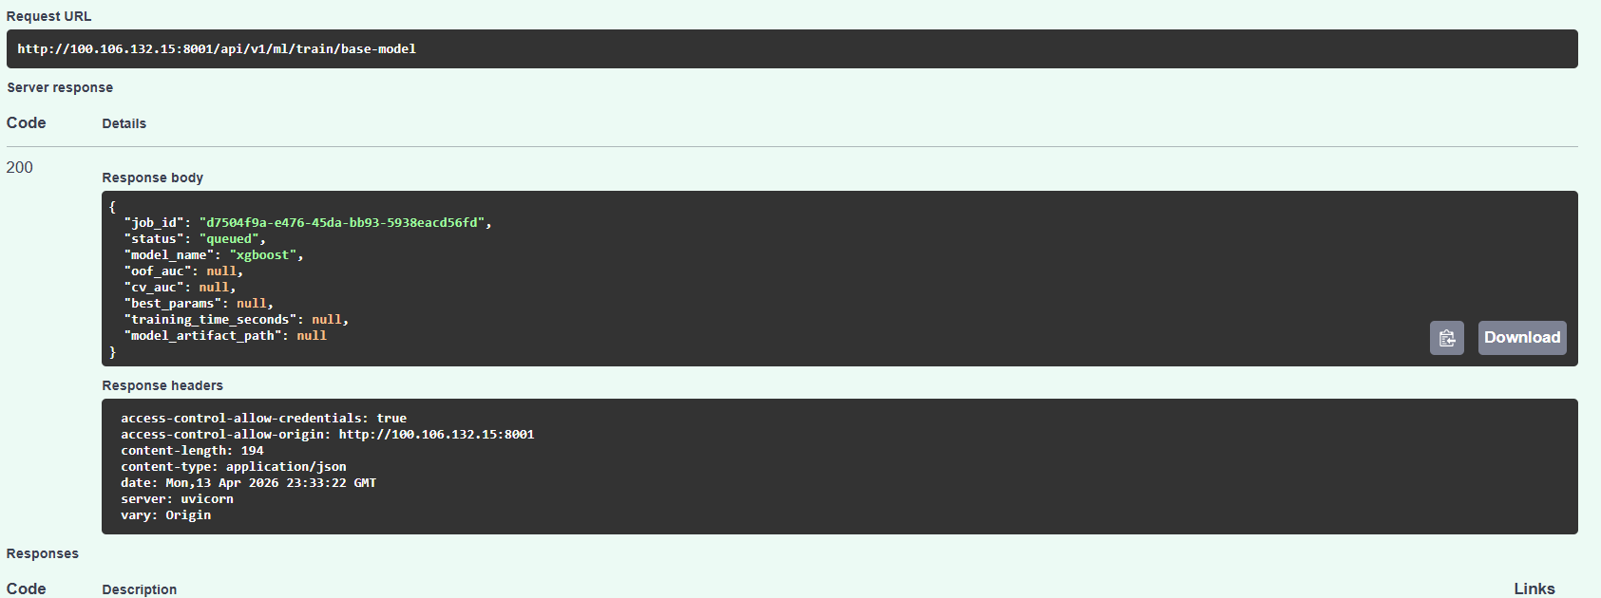

Swagger UI – GET /ml/training/status/{job_id} – training progress:
USMA-107 – Training status endpoint – response with job status
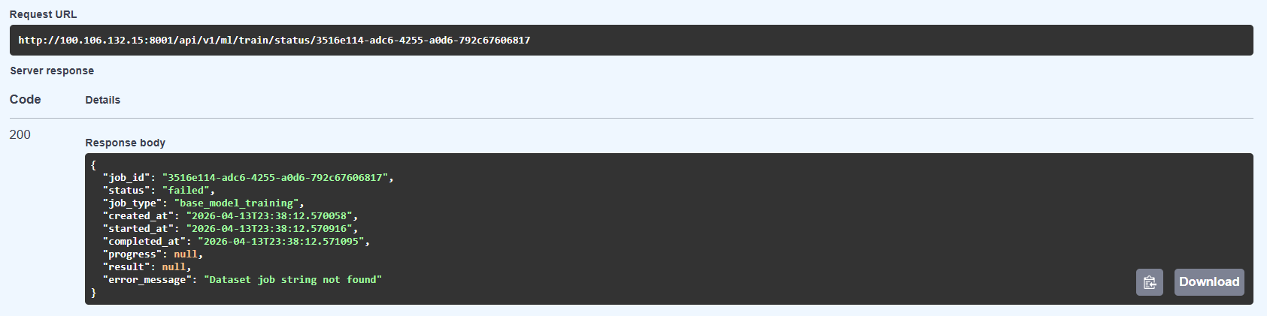

3.4.3 Feature Engineering Pipeline [USMA-63] [USMA-31] [USMA-104]
Implements automated feature engineering with SLEDAI score extraction, biomarker ratio calculation, temporal features, and missing value imputation. Includes customised training dataset generator with feature selection and scaling.
Status: Complete

Files:
- app/ml/feature_engineering.py
- app/ml/training.py (DatasetGenerator class)
Swagger UI – POST /ml/feature-engineering/auto-generate – generated features response:
USMA-63 – Feature engineering auto-generate endpoint – response

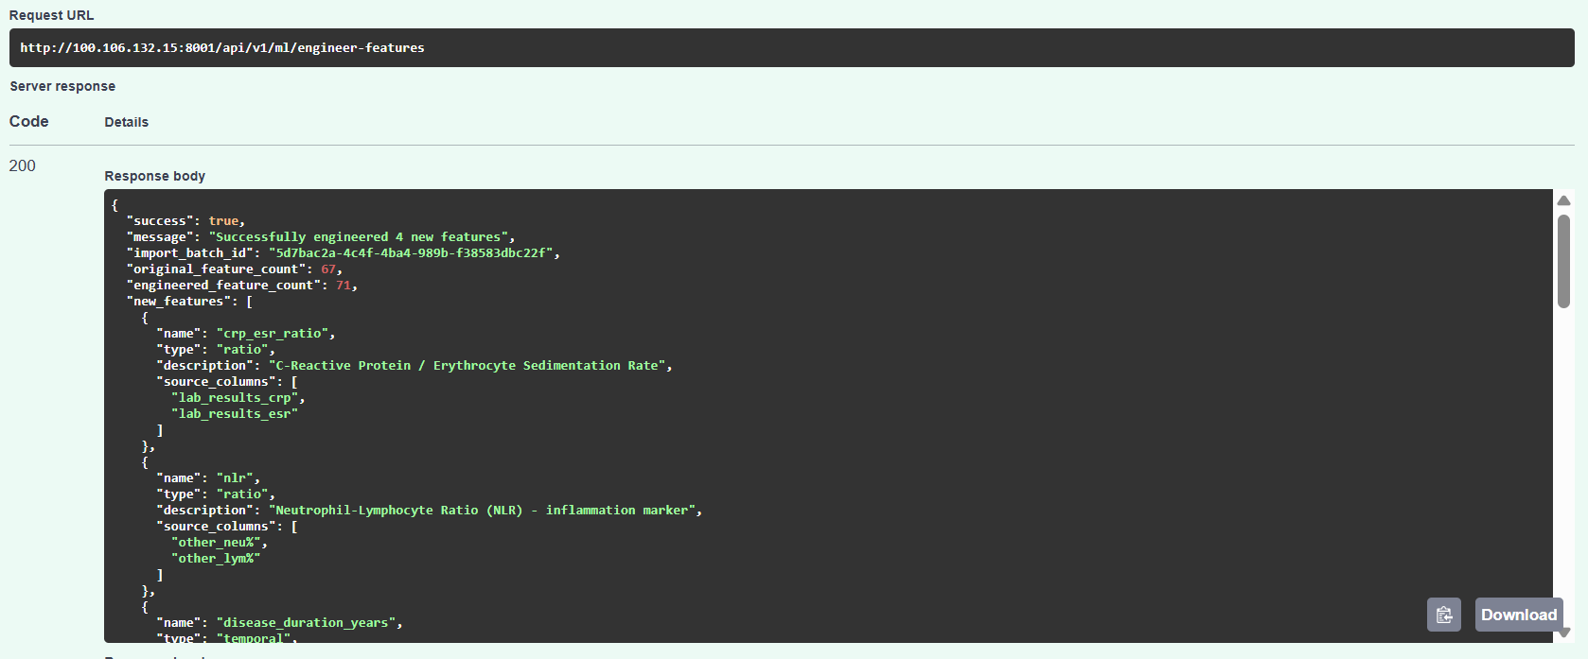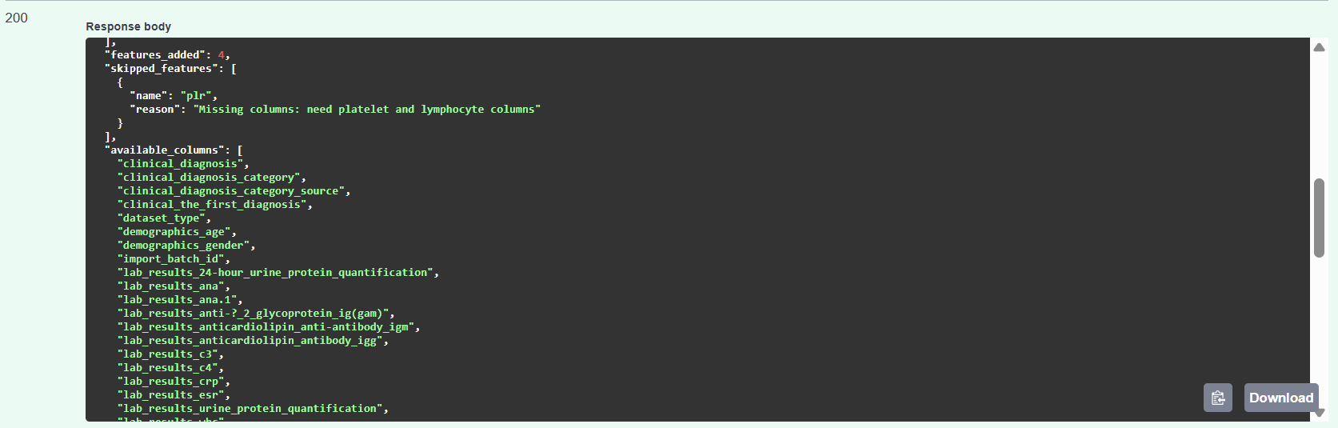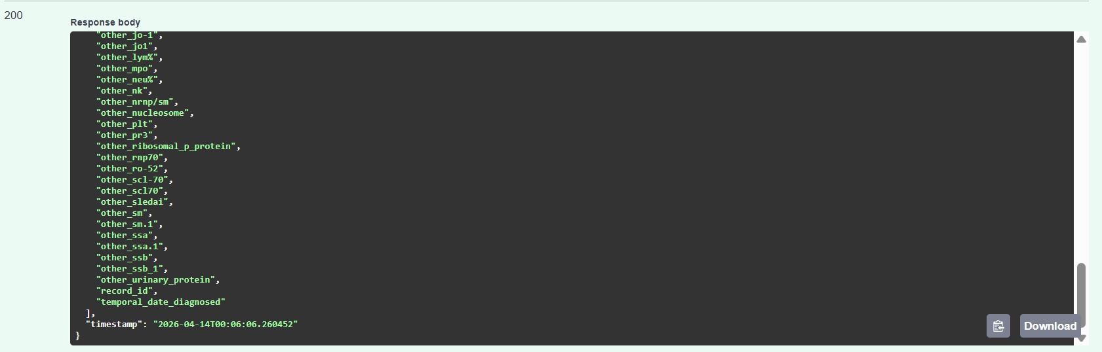

3.4.4 ML Data Validation Service [USMA-102] [USMA-103] [USMA-106]
Implements ML-specific data validation checking for sufficient sample sizes, label distribution balance, feature variance, and target column encoding. Fixes target column encoding bugs and provides utility endpoints for data quality pre-checks before model training.
Status: Complete

Files:
- ml_data_validator.py
- ml_utils.py
- ml_features.py

Swagger UI – GET /ml/training/status/{job_id} – training progress:
USMA-107 – Training status endpoint – response with job status

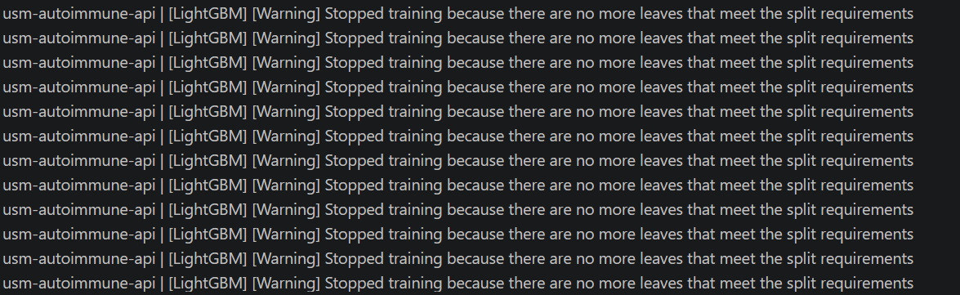

Note: The ML algorithms were successfully invoked and initialized, but training could not complete optimally due to the following technical constraints:
1. Dataset Size Limitations
2. Class Imbalance After Stratification
3. High Feature-to-Sample Ratio
4. Insufficient Feature Variance
5. Multiclass Classification Scoring Errors

3.5. Frontend Interfaces
Sprint 2 delivers the complete Phase 1 frontend layer including authentication, role-based navigation, data management pages, monitoring dashboards, and platform branding.

Core Framework
- React 18.2.0 - UI library
- React Router DOM 6.22.0 - Client-side routing
Build Tool
- Vite 5.1.0 - Fast build tool and dev server
- @vitejs/plugin-react 4.2.1 - React plugin for Vite
Styling
- Tailwind CSS 3.4.1 - Utility-first CSS framework
- PostCSS 8.4.35 - CSS processing
- Autoprefixer 10.4.17 - CSS vendor prefixing
HTTP Client
- Axios 1.6.7 - Promise-based HTTP client for API calls
UI Icons
- Lucide React 0.344.0 - Icon library
Development Tools
- ESLint 8.56.0 - JavaScript linting
  - eslint-plugin-react 7.33.2
  - eslint-plugin-react-hooks 4.6.0
  - eslint-plugin-react-refresh 0.4.5
- TypeScript types - Type definitions for React

3.5.1 Login Interface & JWT Authentication [USMA-92] [USMA-91] [USMA-90] [USMA-89] [USMA-88]
Implements React-based login interface with JWT authentication, token versioning for multi-device management, refresh token mechanism to extend sessions, JWT expiry monitoring with auto-warn, and automatic token revocation on logout.
Status: Complete

Frontend – Login page with username/password fields and USM branding:


Frontend – Dashboard after successful login:
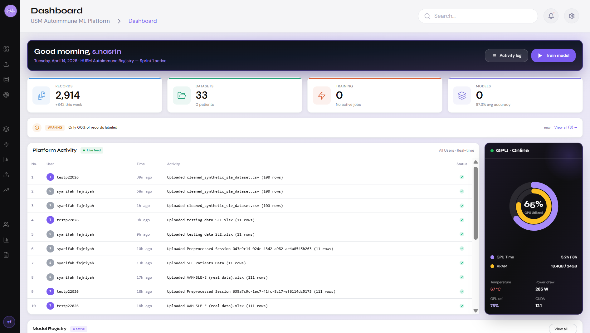

3.5.2 Secure Data Upload Interface – Phase 1 [USMA-61]
Status: Complete
Implements Phase 1 secure data upload interface with drag-and-drop support, file type validation, upload progress indicator, and error feedback.

Files:
- DataPipelinePage.jsx

Frontend – Data upload page with drag-and-drop zone:


3.5.3 Dataset Preview Interface – Phase 1 [USMA-62]
Implements Phase 1 paginated dataset preview showing the first N rows with detected data types, column statistics, and inline editing support.
Status: Complete

Files:
- DataPreparationPage.jsx

Frontend – Dataset preview with paginated rows and column types:
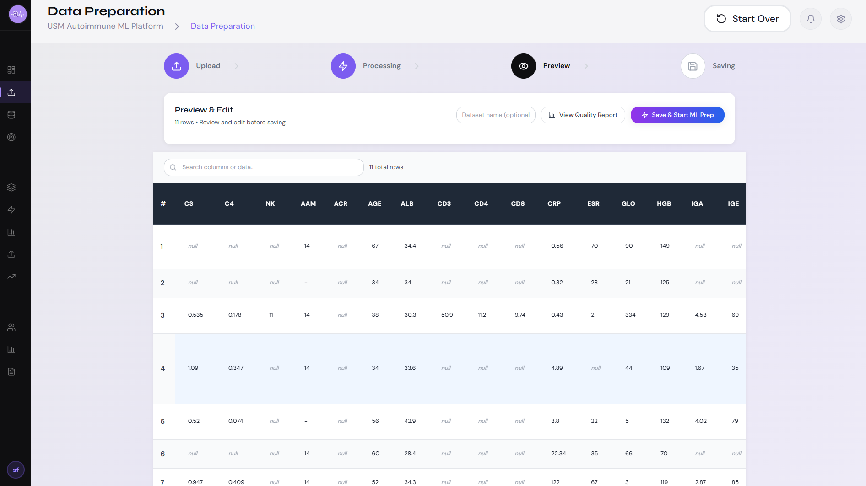

3.5.4 GPU Monitoring Dashboard – Phase 1 [USMA-87]
Status: Complete
Implements Phase 1 GPU monitoring dashboard tracking real-time GPU utilisation, VRAM allocation, GPU temperature, and training job resource consumption.

Files:
- GPUMonitoringPage.jsx

Frontend – GPU monitoring dashboard with real-time metrics:
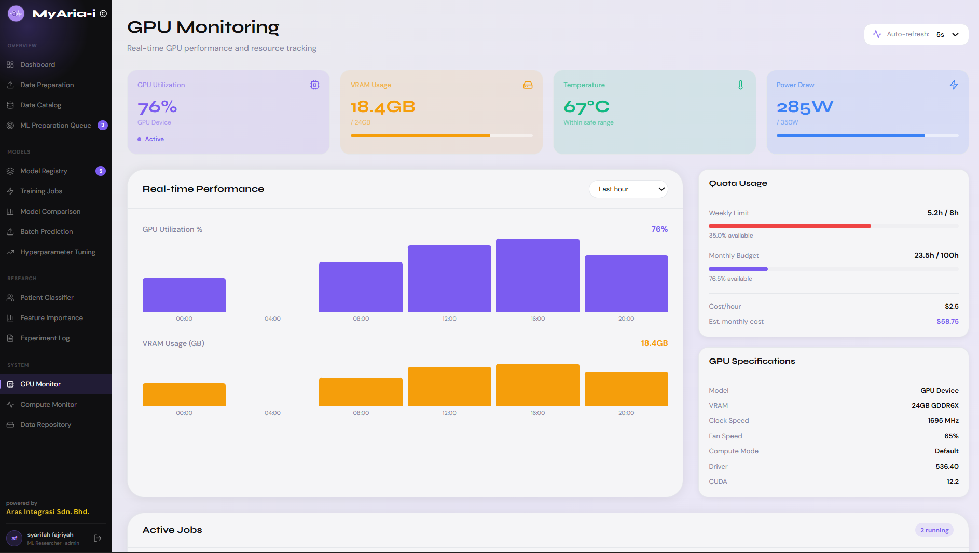

3.5.5 User Profile Dashboard – Phase 1 [USMA-93]
Status: Complete
Implements Phase 1 user profile dashboard showing user information, activity history, role assignment, and personal preferences settings.

Files:
- UserProfilePage.jsx

Frontend – User profile page with activity history and role display:
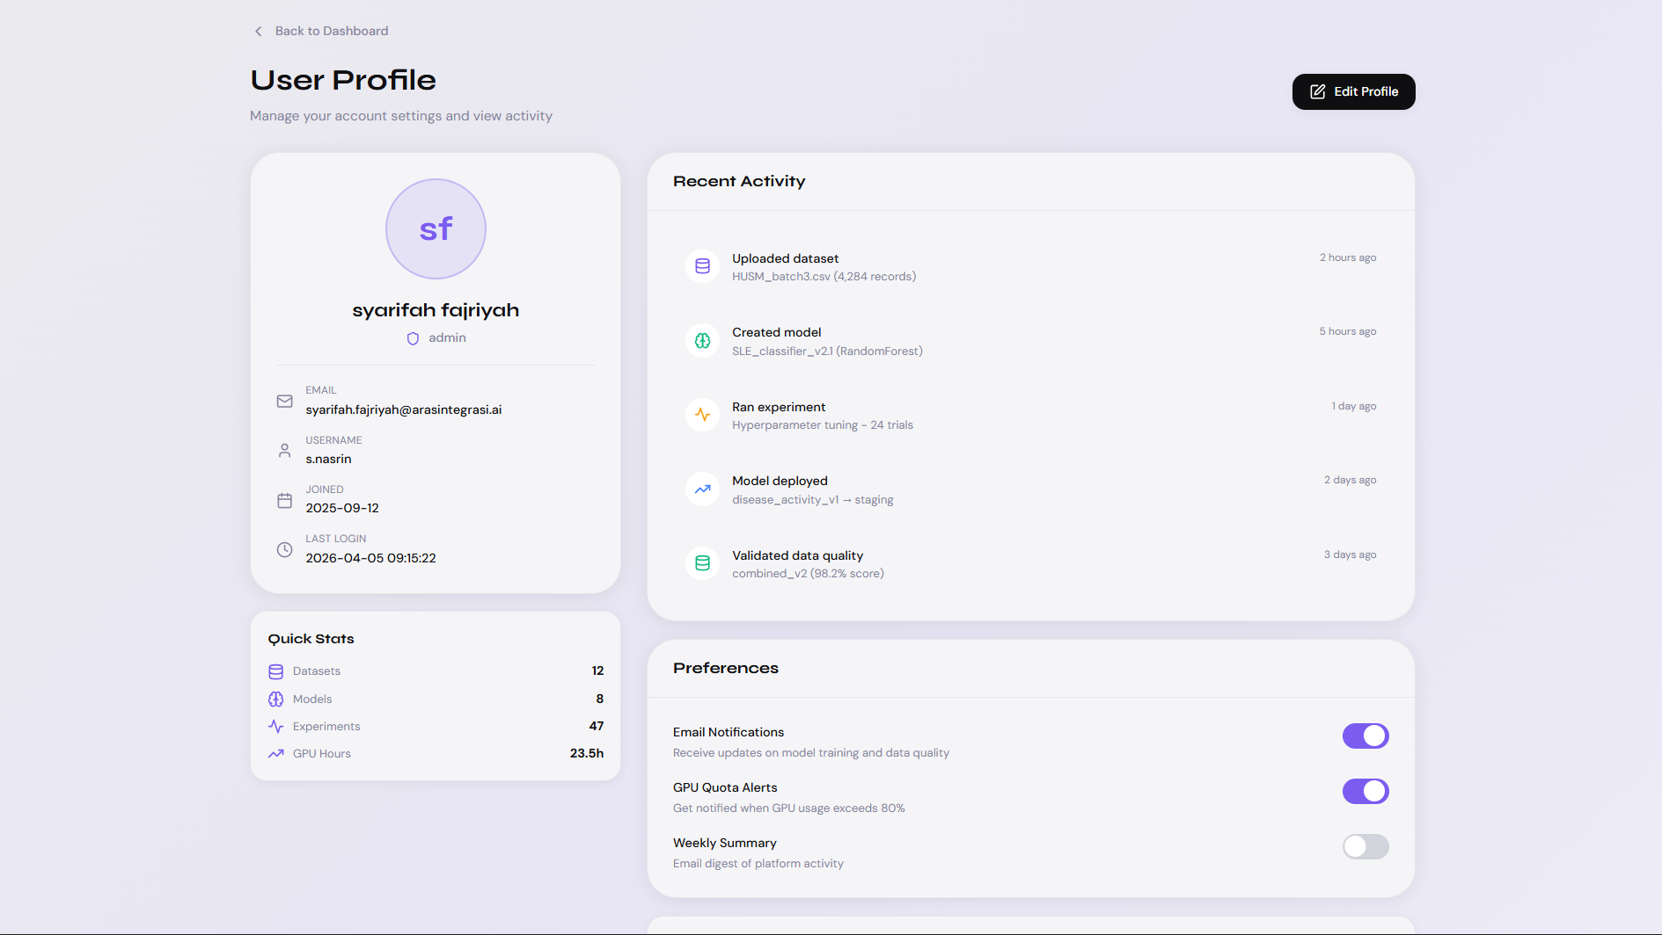

3.5.6 Platform Logo & Brand Identity – Phase 1 [USMA-99]
Status: Complete
Designs and implements the initial MyAria-I platform logo featuring a purple gradient theme and DNA helix motif, applied to the login page and sidebar branding.

Files:
- frontend/public/Logo/MyAria-I Logo.png


4. Sprint 2 Deliverables Summary
All 46 JIRA tickets for Sprint 2 have been completed. The table below maps each ticket to its implementation files and functional category.

JIRA Ticket | Title | Key Files | Status
USMA-82 | Design Flexible ML Architecture | training.py, ml_utils.py | Done
USMA-107 | Implement ML Training Endpoints | training.py, endpoints/training.py | Done
USMA-108 | Create ML Testing Scripts | training.py | Done
USMA-63 | Implement Feature Engineering Pipeline | feature_engineering.py | Done
USMA-31 | Build Training Dataset Generator (customised) | training.py (DatasetGenerator) | Done
USMA-104 | Implement Dataset Generator | ml_data_validator.py | Done
USMA-102 | Implementing ML Data Validation Service | ml_data_validator.py | Done
USMA-103 | Fix Target Column Encoding Bug | ml_data_validator.py | Done
USMA-106 | Implement ML Utility Endpoints | ml_utils.py, ml_features.py | Done
USMA-26 | Implement Automated Dataset Preprocessing | staging_preprocessing_service.py | Done
USMA-32 | Implement Automated Data Processing Pipeline | staging_preprocessing_service.py | Done
USMA-101 | Implementing Preprocessing Metadata Tracking | preprocessing_metadata.py | Done
USMA-22 | Implement Missing Value Handling Module | staging_preprocessing_service.py | Done
USMA-23 | Implement Outlier Detection Pipeline | staging_preprocessing_service.py | Done
USMA-24 | Implement Categorical Encoding Pipeline | staging_preprocessing_service.py | Done
USMA-25 | Implement Data Standardisation / Normalisation Module | staging_preprocessing_service.py | Done
USMA-105 | Fix Unlabeled Record Filtering | labeling.py | Done
USMA-83 | Implement Data Quality Dashboard – Phase 1 | DataQualityDashboardPage.jsx | Done
USMA-81 | Implement Schema Validation Service | schema_validation_service.py | Done
USMA-72 | Implement Schema Evolution Strategy | schema_evolution_service.py | Done
USMA-73 | Implement Database Migration Framework | alembic/, env.py | Done
USMA-98 | Implement Alembic Migrations | alembic/versions/ | Done
USMA-85 | Implement Data Provenance Service | data_provenance_service.py | Done
USMA-84 | Implement Dataset Versioning System | dataset_versioning_service.py | Done
USMA-27 | Implement Dataset Versioning | dataset_versions.py | Done
USMA-76 | Configure MinIO Bucket Lifecycle Policies | configure_minio_lifecycle.sh | Done
USMA-77 | Implement Data Lake Partitioning Strategy | data_lake_partitioning.py | Done
USMA-74 | Implement SCD Type 2 for Patient Records | scd_type2_service.py | Done
USMA-92 | Develop Login Interface (React) | LoginPage.jsx | Done
USMA-88 | Implement Refresh Token Mechanism | auth.py | Done
USMA-89 | Implement Token Revocation on Logout | auth.py | Done
USMA-90 | Implement Token Versioning for Users | auth.py | Done
USMA-91 | Add JWT Token Expiry Monitoring | api.js, auth.py | Done
USMA-95 | Develop Session Management Interface – Phase 1 | SessionManagementPage.jsx | Done
USMA-94 | Implement Role-Based Navigation Interface – Phase 1 | DashboardLayout.jsx, App.jsx | Done
USMA-61 | Develop Secure Data Upload Interface – Phase 1 | DataPipelinePage.jsx | Done
USMA-62 | Implement Dataset Preview Interface – Phase 1 | DataPreparationPage.jsx | Done
USMA-33 | Develop EDA Interface – Phase 1 | EDAExplorerPage.jsx, EDADetailPage.jsx | Done
USMA-87 | Implement GPU Monitoring Dashboard – Phase 1 | GPUMonitoringPage.jsx | Done
USMA-93 | Develop User Profile Dashboard – Phase 1 | UserProfilePage.jsx | Done
USMA-99 | Design Initial Logo Draft – Phase 1 | MyAria-I Logo.png, LoginPage.jsx | Done
USMA-80 | Implement Document Classification Pipeline | unstructured.py, qwen_ocr_service.py | Done
USMA-78 | Develop Unstructured Data Pipeline API Endpoint | unstructured.py | Done
USMA-97 | Migrate GPU from ID=0 to ID=1 | docker-compose.yml, config.py | Done

5. Phase 3 Planning: System Evaluation, Validation & Final Reporting
Sprint 3 marks the final phase of the USM Autoimmune ML Platform. With the backend pipeline, ML training infrastructure, and Phase 1 frontend interfaces delivered in Sprints 1 and 2, Phase 3 shifts focus entirely to evaluation, clinical validation, dashboard finalization, and project handover.

5.1 Model Performance Evaluation Report
Sprint 3 will generate a comprehensive model performance evaluation report covering all metrics required to validate the stacking ensemble's predictive accuracy on the held-out test set. Metrics reported will include Accuracy, Precision, Recall, F1 Score, AUC-ROC, and Brier Score (calibration). Results will be presented per base learner and for the final ensemble, with a comparison table showing the performance gain from stacking over individual models. Confusion matrices and reliability curves will be included for clinical review.

5.2 Autoimmune Disease Registry Classification Dashboard - Final UI
Sprint 3 will deliver the revised and finalized classification dashboard interface. Sprint 2 delivered Phase 1 frontend components including the data upload interface, EDA explorer, data quality dashboard, and ML preparation queue. Sprint 3 will revise and consolidate these into the final production UI, incorporating feedback from Phase 1 review. The final dashboard will allow researchers to input new patient features and receive a real-time probability score and disease classification output from the trained stacking ensemble.

5.3 Platform Snapshots
A snapshot system will be implemented allowing researchers to save and restore the platform state at key points including trained model versions, dataset versions, and prediction history ensuring reproducibility of research findings across the project validity period.

5.4 Deployment Plan
Sprint 3 will formalise the deployment of the platform from the current development environment to a stable, access-controlled production state. A staging environment will be validated before production release the full pipeline from patient data upload through preprocessing, feature engineering, stacking ensemble inference, and probability score display will be end-to-end tested using a held-out validation dataset

5.5 Security & Compliance
The Sprint 3 security plan builds on the access control review all API endpoints will be audited against the three-role permission matrix (Admin, Researcher, Viewer) to confirm no unprotected routes exist in the final production build. The inference endpoint specifically will be restricted to Researcher and Admin roles only.
Audit trail verification: The audit_trail table implemented in Sprint 1 (USMA-20) will be verified to capture all inference calls recording user ID, timestamp, batch ID, and prediction output.

Credential handover: Platform credentials, MinIO access keys, PostgreSQL connection strings, GPU server SSH access, and JWT secret keys will be transferred securely to the Project Director and Project Manager at the end of Week 7. All development credentials will be rotated at handover.

5.6 Evidence-Based Architecture: Interpretable Scorecard Framework
The platform's ML architecture draws direct validation from published clinical ML research conducted at Universiti Sains Malaysia. The study "A Small-Data Machine Learning Framework with Interpretable Scorecards for SLE Disease Activity Prediction" (Zhu Kun, supervised by Dr. Nur Hana Samsudin, USM) provides a directly comparable methodological blueprint for this registry platform, addressing the same disease domain, patient population scale, and interpretability constraints directly informs the architectural decisions made for this platform which will be implemented in sprint 3.

6. Document Sign-Off

Field | Details
Project Name | Hybrid ML Platform – Autoimmune Disease Registry
Document Type | Sprint 2 Technical Specification Document
Version | 1.0

Prepared By

Name | Role | Signature | Date
Syarifah Fajriyah | AI Engineer

Verified By

Name | Role | Signature | Date
Veytri Yogan | Solutions Architect
Shageenderan | Technical Advisor

Approved By

Name | Role | Signature | Date
Nur Shahera Alia | Project Manager
Mazdiana Makmor | Project Director

