# Project 3 Proposal

Salieu, Monique, Santiago

**A brief articulation of your chosen topic and rationale**

Our project will use data on the activity of fishing vessels worldwide to create an interactive dashboard that will allow users to visualize:

* Total fishing effort per country in 2020 (calculated as sum of total fishing hours for all vessels registered under each country’s flag)
* Breakdown of a country’s fishing fleet by vessel type
* Map of voyages taken by a country’s fishing vessels in a given month

User will be able to select country of interest from dropdown menu. Visualizations (bar chart showing vessel types, map of voyages) will change dynamically depending on country chosen.

**A link to your dataset(s) and a screenshot of the metadata, if it exists.**

We will use data from [Global Fishing Watch](https://globalfishingwatch.org/data-download/):

* **fishing-vessels-v2.csv**: each row corresponds to a unique fishing vessel and contains information regarding vessel type, length, tonnage, country, and total fishing hours for various years
* **voyages_202301.csv**: each row contains information on a unique voyage conducted by a given vessel (vessel id, trip start point id, trip end point id)
* **named_anchorages_v2_20221206.csv**: contains geospatial information for ports/anchorages worldwide (latitude and longitude, anchorage id, country code, basic name/label)

**Three or four screenshots of relevant, “inspiring” visualizations that show your creative ideas**

Voyages map inspo:

Bubble chart:

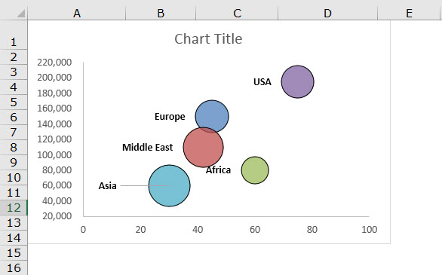

Bar Chart:

**A sketch of the final design**



**A link to the primary GitHub repository where you’ll be housing your work**

Link: https://github.com/snavarroroby/Project-3.git