**Automation Testing Software**

# Project Developers:

**Team Members:**

Naveen Andrew S

Swathiga Devi P

Suresh Kumar G

Rajamegam G

**Faculty Mentor:**

Mrs Pricilla Joy

**Industry Mentor:**

Ms Subhimol Thambi

**Automation Testing Software - Abstract**

My final year project is **Automation Testing Software**. Since it is a vast project I would like to constraint the topic to **Set-Top Box Automation Testing Software**. Only a very few software are available in the market for STB testing. My project is to develop a **freeware** for

STB Automation Testing.

**What we do?**

We are going to develop a software application which tests all the functionality of the Set-Top Box Software. To accomplish that, we are going to analyse the different testing solutions available in the market which supports automation testing and we compare them, find a better solution which meets the demands of the UI automation testers. To achieve this we have focused on the following scenarios:

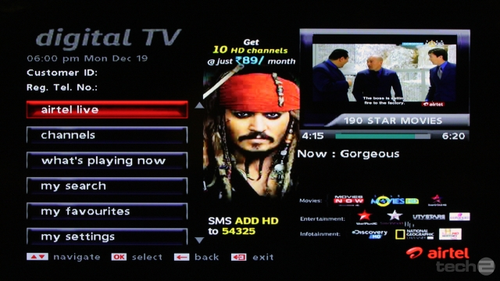

1.a Sample of a Set-Top Box [STB] screen

1. *Image comparison*
   * To check whether the menu bar is placed in the correct co-ordinates
2. *Colour comparison*
   * To check quality of the video signal
3. *Audio detection*
   * To check proper functioning of audio
4. *Video detection*
   * To check whether the video is receiving properly or not
5. *OCR string read and compare*
   * To check the list of menu that should appear when a button is pressed.
   * To check TV channel name. [ Using OCR we’ll extract text from the snapshot of the channel and from which we can check the channel name]

By analysing and comparing the various technologies that has been used in these scenarios, we will come up with the better solution implemented for our testing product. The entire project is going to be designed using Java technology.

**Upgrade Concepts:**

1. Performance testing for STB [calculate time taken for each process to be done]
2. UI testing for web application.
3. UI testing for android application.

**Available Software:**

1. [Stromtest](https://www.accenturestormtest.com/products-services-solutions-stormtest/cpe-screening-automation-stormtest/)
2. [STB-TESTER](https://stb-tester.com/)