Condo & Apartment Rental System
System architecture, process flow, and database design charts. Drawn from the Systems Analysis and Design project plan. This version has no deposit or payment step: the owner confirms a booking directly.

1. System Architecture
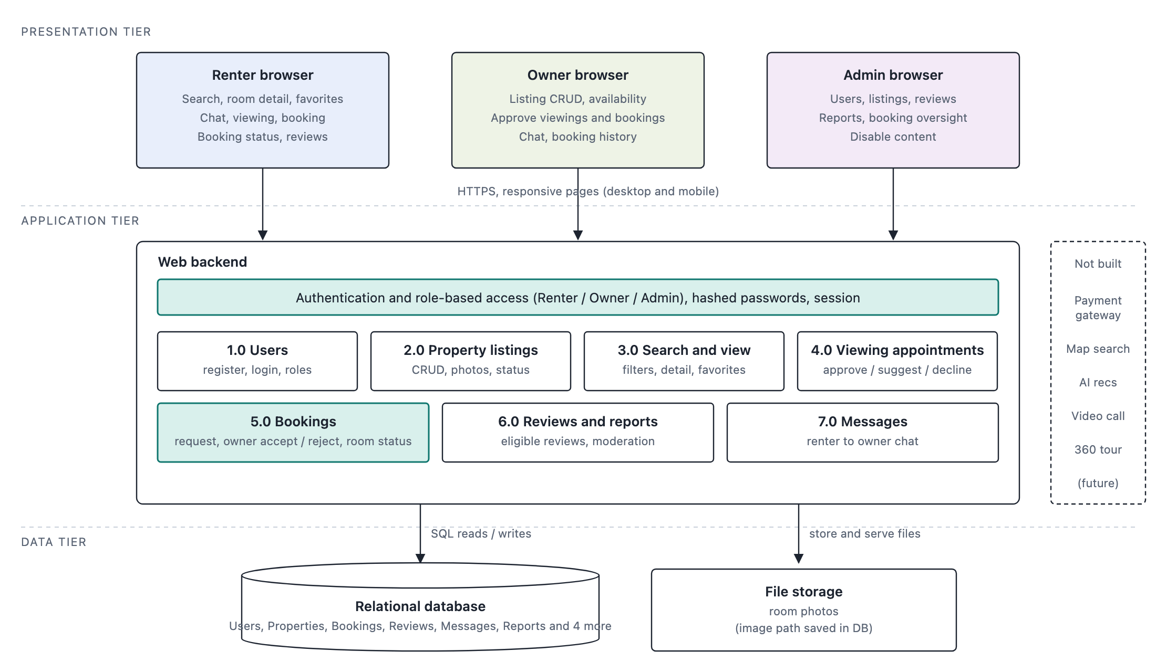
Three tier web application. Renter, Owner and Admin browsers talk to one web backend over HTTPS. The backend has authentication with role based access and seven process modules: Users, Property listings, Search and view, Viewing appointments, Bookings, Reviews and reports, Messages. Data is stored in one relational database plus a file store for room photos. Payment gateway, map search, AI recommendation, video call and virtual tour are future enhancements and are not built.

2. Process Flow (Search to Review)
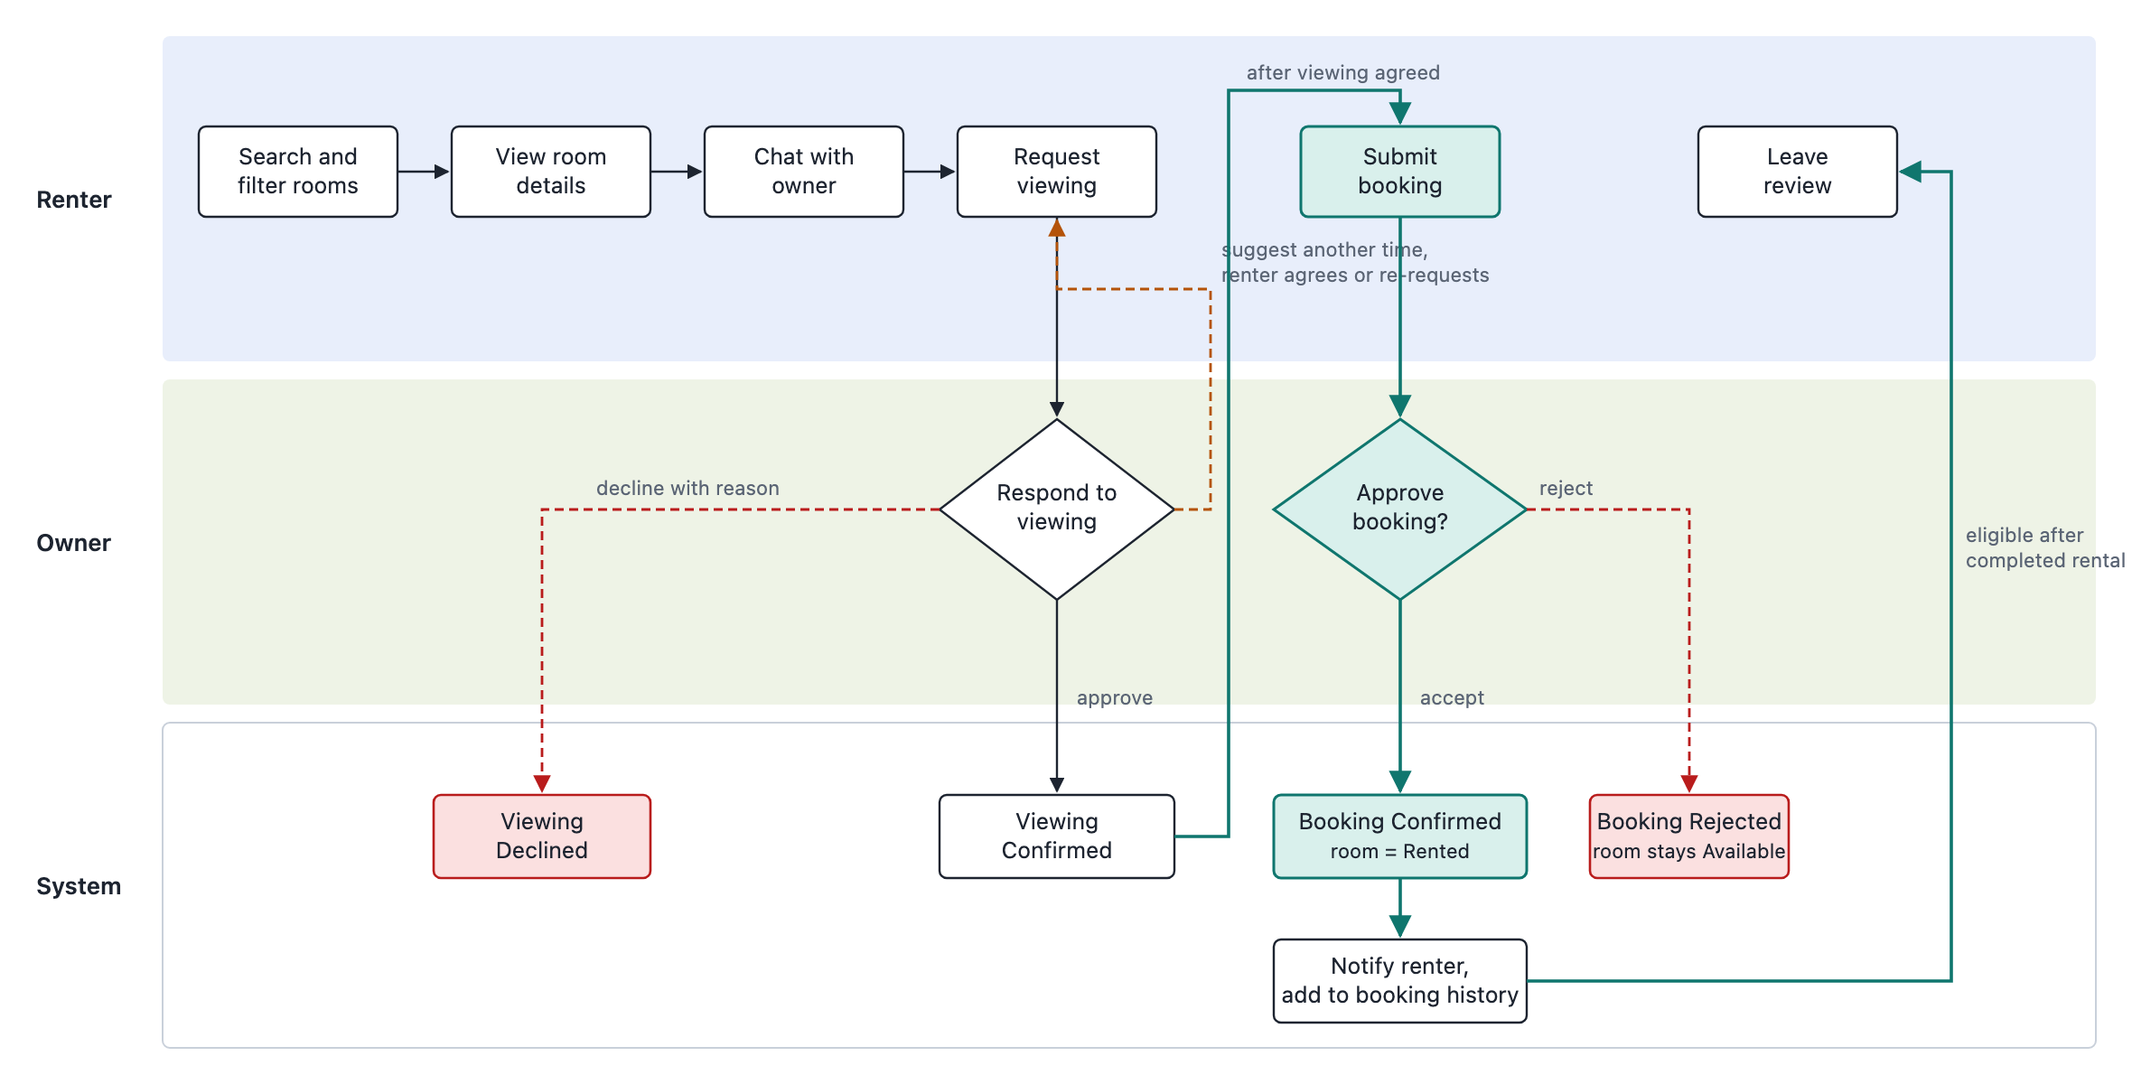
Swimlane flow with Renter, Owner and System lanes. Green path is the happy path: search, view details, chat, request viewing, owner approves, submit booking, owner accepts, booking confirmed and room set to Rented, then review after the rental is completed. Orange dashed edge is the loop back when the owner suggests another viewing time. Red dashed edges are terminal outcomes: viewing declined with reason, or booking rejected (room stays Available).

2.1 Booking Status Machine
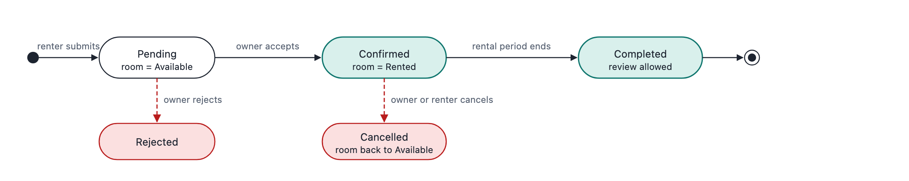
States of one Bookings row: Pending, Confirmed, Completed, Rejected, Cancelled. Owner accept sets the room to Rented. Reject keeps the room Available. Cancel returns the room to Available. Only Completed allows the renter to leave a review.

3. Database Design (ERD)
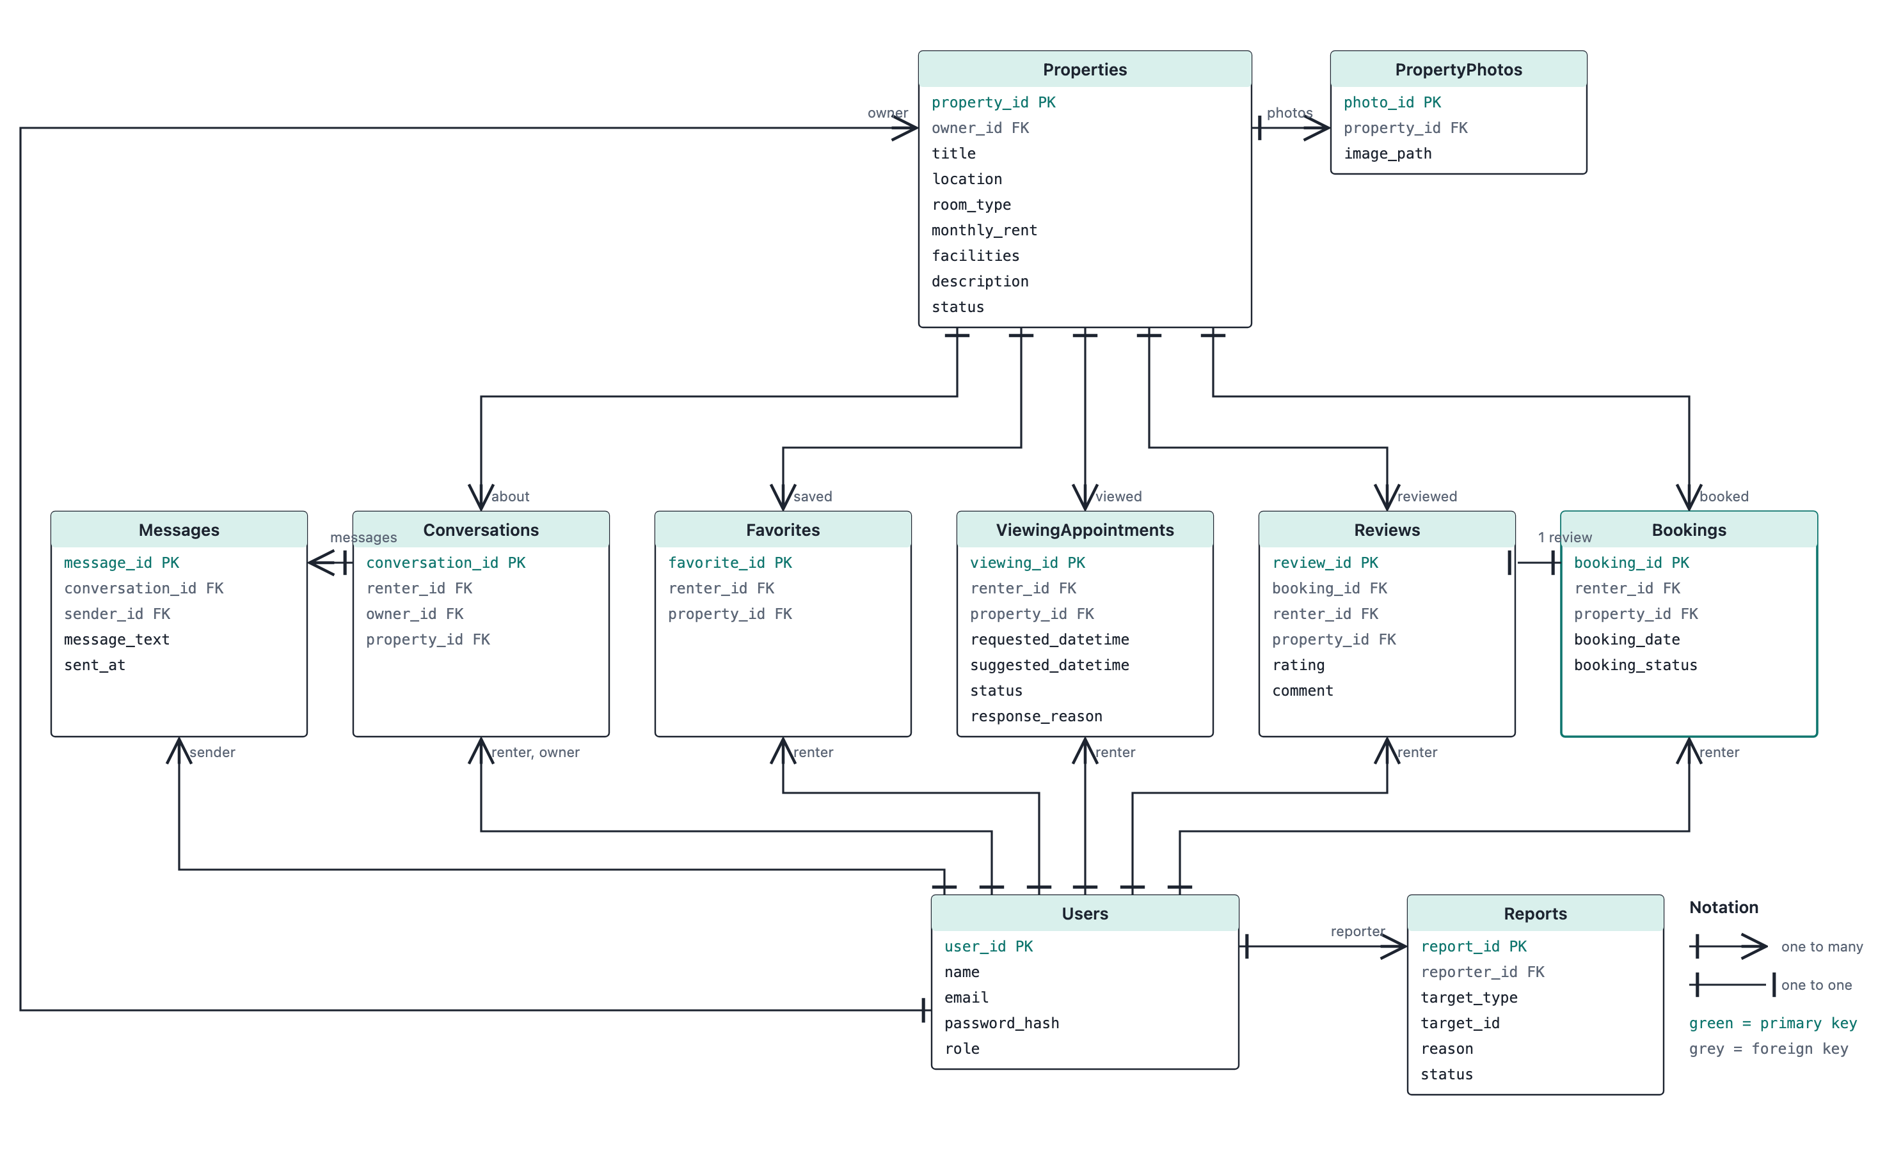
Ten tables, one field per line. Properties at the top fans down to Conversations, Favorites, ViewingAppointments, Reviews and Bookings. Users at the bottom fans up to the same tables plus Messages, and also links to Properties (owner) and Reports (reporter). Bookings links to Reviews one to one. Reports use target_type and target_id so one table covers reported users and reported listings.

Status Columns
Column | Values | Set by
Properties.status | Available, Reserved, Rented, Unavailable | Owner (manual), System (on accept, complete, cancel)
ViewingAppointments.status | Requested, Suggested, Confirmed, Declined | Owner response, renter agreement
Bookings.booking_status | Pending, Confirmed, Completed, Rejected, Cancelled | Owner decisions, rental period end
Reports.status | Open, Reviewed, Actioned | Admin

