Lab 4 Solution

**Submitted By:**

**Sana Naz**

**197631**

**BSCS-6B**

The network topology consists of 4 nodes namely A, B, C, D.

## Source:

Node A is the source node. It generates messages and send them to the Node B which is the load balancer.

## Load Balancer:

Node B is the load balancer. It receives messages from A and passes them to Nodes C and D through a random number generator.

## Sink:

Nodes C and D are sink nodes. They receive traffic from Node B and delete the message received. They do not bunce back traffic.

**To run the simulation, run net.ned in simulations folder.**

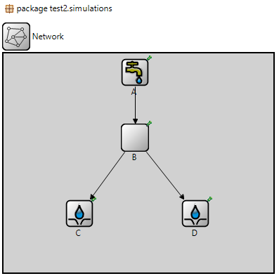

## The Simulation:

## 

The message is generated at Node A.

## 

The message is forwarded to the load balancer i.e. Node B.

## 

The load balancer sends the message to Node D.

## 

Another message is generated at Node A.

## 

The message is forwarded to the load balancer i.e. Node B.

## 

The load balancer sends the message to Node C.