Design
CCP-SAC-ARC-01

Version 1.0
[Draft 1]

Template: PM-QM-TPL-SYSA-C01 v01

Architecture Design
For
AI Chatbot Backend (Sachet Agent)

Released on: 18-Jun-2026

Any softcopy in a directory other than the process repository is an Uncontrolled Copy.
A hardcopy is an Uncontrolled Copy unless signed by an authorised signatory.
Issued to | C-DOT | on | 18-Jun-2026 |  | by | <Authorised Signatory>
CENTRE FOR DEVELOPMENT OF TELEMATICS
C-DOT Campus, Mehrauli, New Delhi 110030, India
Electronic City (phase-1), Hosur Road, Bengaluru 560100, India

Approval Block
Version | Approved by
Version | Role | Name | Signature | Date
1.0 | <Process Responsibility> | <Name> | [signed] | dd.mm.yyyy
Revision History
This document replaces
Document code : CCP-SAC-ARC-01[-V1] v1.0 [d1]
Document name : Architecture Design for AI Chatbot Backend (Sachet Agent)

Version, Draft | Dated | Author(s) | Summary of changes | Reference sections | Reason of change and remarks
v1.0 [d1] | 18-Jun-2026 | Carnot Research / C-DOT Team | Initial draft | All | First submission per client requirement

Participation

This document has been authored/modified by
<Primary Author Name(s)>
with contributions from
<Contributing Team Member(s)>

Comments, suggestions and queries pertaining to this document should be addressed to
<Custodian's designation>
Name: <Custodian's name>
e-mail: <E-mail address>

Table of Contents
<Generated table of contents>

List of Tables
<Generated list of tables>

List of Figures
<Generated list of figures>

Preface

This document presents the High Level Design (HLD) for the AI Chatbot Backend component of C-DOT's Sachet platform — a Retrieval-Augmented Generation (RAG) system enabling intelligent document Q&A in 23 Indian languages.

Purpose: To define the system architecture, retrieval pipeline, chunking and embedding strategy, model selection rationale, and scalability considerations for the Sachet AI Chatbot Backend.

Scope & Coverage: Backend REST API service only. Frontend applications consuming the API are out of scope. Covers component decomposition, data organisation, interfaces, and design decisions.

Conventions: In diagrams — rounded blue boxes: start/end; green boxes: processing steps; orange: decisions/parameters; red: data stores.

Intended Readers: Software architects, backend engineers, and technical reviewers from C-DOT and the implementing team.

Introduction

Objective and background

The Sachet AI Chatbot Backend is a Retrieval-Augmented Generation (RAG) platform built for C-DOT's Sachet initiative. It enables users to upload heterogeneous documents (PDF, DOCX, PPTX, TXT, CSV, XLSX) or web URLs and interact with the content through a conversational interface. The system retrieves relevant document chunks from an Elasticsearch vector store and feeds them to a GPU-hosted Large Language Model (LLM) to produce cited, grounded answers.

The backend was derived from Carnot Research's icarKno product and customised to run on C-DOT's internal GPU infrastructure, supporting 23 Indian languages via IndicTrans2 and on-premise TTS/STT via AI4Bharat models.

Scope

The following capabilities are in scope:

- Document ingestion: multi-format text extraction, chunking, vector embedding, Elasticsearch indexing.
- Query processing: intent classification, hybrid search (BM25 + vector), context retrieval, LLM response generation.
- Creative (adaptive) mode: iterative multi-step search with LLM evaluation, delivered via SSE streaming.
- Chat history management: multi-chat sessions persisted in MongoDB.
- Multilingual support: 23 Indian languages via IndicTrans2 translation.
- Speech services: TTS via ai4bharat/indic-parler-tts (vexyl-tts) and STT via ai4bharat/indic-conformer (vexyl-stt).
- Security guardrails: prompt injection, PII, and XSS detection.
- REST API for integration with frontend applications (web, WhatsApp bot, mobile).

References

[1] C-DOT Sachet Platform Requirements (internal document)
[2] Flask / FastAPI Documentation — https://fastapi.tiangolo.com
[3] Elasticsearch Reference — https://www.elastic.co/guide/
[4] LangChain Documentation — https://python.langchain.com
[5] Indic Parler TTS — ai4bharat/indic-parler-tts (HuggingFace)
[6] Indic Conformer STT — ai4bharat/indic-conformer-600m-multilingual (HuggingFace)
[7] IndicTrans2 — https://github.com/AI4Bharat/IndicTrans2
[8] BGE-M3 Embedding Model — https://huggingface.co/BAAI/bge-m3
[9] Distil-Whisper — distil-whisper/distil-medium.en (HuggingFace)

Definitions, acronyms and terminology

Definitions

Term | Definition
Knowledge Container | A named session grouping a set of user-uploaded documents and their associated Elasticsearch index.
Chunk | A fixed-size text segment extracted from a document, stored as a searchable unit in Elasticsearch.
Hybrid Search | Combination of BM25 keyword and vector similarity search merged via EnsembleRetriever with equal weights [0.5, 0.5].
Grounded Answer | An LLM response restricted to information present in the retrieved context, with source citations.
Creative Mode | Advanced query mode that iteratively refines searches (up to 3 rounds) until the LLM evaluates results as sufficient.
Guardrails | Input sanitisation layer checking for prompt injection, PII, and XSS before any LLM call.

Acronyms

Acronym | Expansion
RAG | Retrieval-Augmented Generation
LLM | Large Language Model
API | Application Programming Interface
JWT | JSON Web Token
BM25 | Best Match 25 (probabilistic keyword ranking)
ES | Elasticsearch
SSE | Server-Sent Events
TTS | Text-to-Speech
STT | Speech-to-Text
ASR | Automatic Speech Recognition
NLP | Natural Language Processing
GPU | Graphics Processing Unit
HLD | High Level Design
REST | Representational State Transfer

Introduction to the software subsystem

The Sachet AI Chatbot Backend is a stateless RESTful service built on FastAPI, exposing two router groups — query management and document management — each under the /api/ prefix. All business logic is encapsulated in singleton service classes with lazy initialisation. The system interfaces with Elasticsearch for document retrieval, MongoDB for session and chat persistence, and a C-DOT GPU server for LLM inference.

Properties

Property | Value
Language / Runtime | Python 3.10+
Web Framework | FastAPI + Slowapi (rate limiting) + Starlette CORS
Service Pattern | Singleton services with lazy initialisation
API Style | REST (JSON); StreamingResponse for creative mode SSE
Authentication | JWT (PyJWT 2.8.0) — Bearer token or form field
Rate Limiting | Slowapi: 20 req/min (trial), 10 req/min (TTS)
Deployment Port | 8000 (Uvicorn / configurable)
Supported File Formats | PDF, DOCX, DOC, TXT, PPTX, CSV, XLSX
Max File Size | 50 MB per file
Languages Supported | 23 (English + 22 scheduled Indian languages)
API Documentation | Auto-generated Swagger UI at /docs

Functionality

The subsystem provides six primary capabilities:
- Document Ingestion — Upload and process documents; extract text, chunk, embed, and index into Elasticsearch.
- Intelligent Query Processing — Classify query intent (5 types) and retrieve relevant context via hybrid search.
- LLM Response Generation — Generate grounded, cited answers using the C-DOT GPU-hosted language model.
- Adaptive (Creative) Mode — Iterative multi-step search with LLM-based sufficiency evaluation, streamed via SSE.
- Chat History Management — Multi-chat session persistence with rename, notes, and statistics in MongoDB.
- Multilingual & Speech — Translate responses to 23 Indian languages; TTS via indic-parler-tts; STT via indic-conformer.

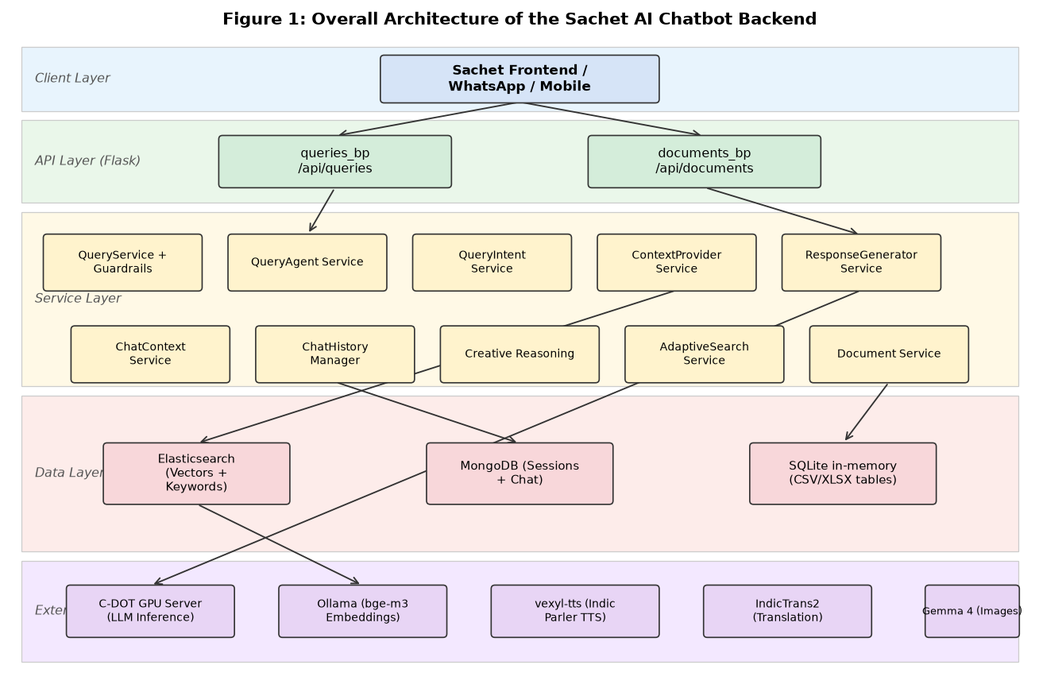
Figure 2-1: Sachet AI Chatbot Backend — System Architecture

Design considerations

Design goals

Goal | Description
Accuracy | Answers grounded strictly in retrieved context — no hallucination. Enforced via strict prompt engineering: 'Use ONLY information in the CONTEXT.'
Low Latency | Standard queries target < 10 seconds. Fast LLM variant (512 tokens, temp 0.3) used for classification and evaluation sub-calls to minimise overhead.
Multilingual | Accepts queries in 23 Indian languages and returns translated responses without retraining the LLM. Translation handled post-generation via IndicTrans2.
Scalability | Stateless FastAPI workers scalable horizontally; Elasticsearch scales via shard replication; MongoDB handles distributed session state.
Privacy / On-Premise | All LLM inference, embedding, TTS, STT, and translation services run on C-DOT infrastructure — no document data leaves the network.
Security | JWT authentication on all authenticated endpoints; GuardrailProcessor blocks prompt injection, PII, and XSS before any LLM call.
Extensibility | Service-oriented singleton pattern allows new services to be added without modifying existing routes. Skills and intents are data-configurable.

Constraints and limitations

- LLM inference depends on the C-DOT GPU server — unavailability halts all query responses; no local fallback configured.
- Embeddings require Ollama running with bge-m3:latest at document ingestion time.
- CSV/XLSX data loaded into SQLite in-memory tables — lost on server restart; users must re-upload structured data.
- Creative mode capped at 3 search iterations and 120 seconds maximum processing time.
- File types restricted to PDF, DOCX, TXT, PPTX, CSV, XLSX (max 50 MB each).
- Slowapi rate limiting uses per-worker in-memory store by default — Redis required for multi-worker deployments.
- No built-in document access control — all documents in a session are accessible to the session owner.

Assumptions

- The C-DOT GPU server is accessible from the backend host and supports OpenAI-compatible chat API format.
- An Elasticsearch 8.x cluster is available and reachable at ES_BASE_URL.
- MongoDB instance is running and accessible via MONGO_URL.
- Ollama is running on the backend host (or accessible network address) with bge-m3:latest loaded for embeddings.
- vexyl-tts and vexyl-stt WebSocket servers are running on-premise at configured URLs.
- IndicTrans2 translation server is running for multilingual query/response support.
- Users authenticate with JWT tokens issued by the parent Sachet application.

Alternate approaches

Options

Area | Option A (Rejected) | Option B (Selected)
Search Strategy | Pure keyword search (BM25 only) — fast but misses semantic matches on paraphrased queries. | Hybrid search: BM25 + vector similarity (EnsembleRetriever [0.5, 0.5]) — balances recall and precision.
LLM Hosting | Ollama on local server (7–13B models) — easy setup but limited GPU and lower quality. | C-DOT GPU server (70B model, OpenAI-compatible) — higher quality, centralised management.
TTS | ElevenLabs cloud API — high quality but external dependency, per-character cost, data egress. | ai4bharat/indic-parler-tts via vexyl-tts — on-premise, no API cost, native Indian language support.
STT | Whisper large-v3 (generic) — good English ASR but higher WER on Indian language accents. | ai4bharat/indic-conformer-600m-multilingual — purpose-built for Indian languages; distil-whisper for English.
Structured Data | Direct MySQL integration — requires schema migration per upload. | SQLite in-memory per session via SQLAlchemy — zero schema overhead, LLM-generated SQL.
Streaming Responses | Polling endpoint — client polls every N seconds for creative mode progress. | SSE via FastAPI StreamingResponse — real-time progress events, no polling overhead.

Criteria for evaluating the options

- Answer accuracy and recall — ability to find relevant content for paraphrased or ambiguous queries.
- Latency — total round-trip time from query to response.
- Data privacy — no document content leaving C-DOT infrastructure.
- Infrastructure cost and operational complexity.
- Multilingual capability for 23 Indian languages without model fine-tuning.
- Extensibility — ease of swapping components in future.

Selected approach and the rationale for its selection

Hybrid RAG with C-DOT GPU-hosted LLM was selected. The EnsembleRetriever combines BM25 keyword precision with vector semantic recall. The GPU server enables 70B-parameter models for answer quality unreachable by local 7–13B Ollama models. On-premise vexyl-tts and vexyl-stt replace cloud speech APIs, eliminating data egress. SQLite in-memory avoids per-user database schema management. SSE streaming delivers responsive UX for complex multi-iteration creative queries.

High level design decomposition

The subsystem is decomposed into seven logical modules. The table below summarises each module and its functionality.

Table 4-1: Software module / component summary

# | Software module / component name | Functionality provided
1 | API Layer | FastAPI routers (queries, documents). JWT dependency injection, Slowapi rate limiting, StreamingResponse for creative mode, auto-generated Swagger UI at /docs.
2 | Query Processing | QueryService (gateway + guardrails), QueryAgentService (orchestrator — routes standard vs creative), QueryIntentService (5-class LLM-based intent classifier).
3 | Retrieval Pipeline | ContextProviderService (hybrid search orchestrator), AdaptiveSearchService (iterative search, up to 3 rounds), ResultEvaluationService (LLM sufficiency scoring).
4 | Response Generation | ResponseGeneratorService (prompt engineering + LLM invocation), ResultSynthesisService (multi-source answer merging), CreativeReasoningService (adaptive pipeline + SSE events).
5 | Document Ingestion | DocumentService (orchestrator), extractText.py (PDF/DOCX/PPTX/TXT), upload.py (two-stage chunking), ElasticDocumentManager (bulk ES indexing), URLContentService (Selenium + BeautifulSoup + YouTube).
6 | Data & Session Layer | Elasticsearch (vector + keyword), MongoDB (chat + sessions via Beanie ODM), SQLite in-memory (CSV/XLSX), local filesystem (raw files).
7 | Utility Services | LLMService (GPUServerChatModel wrapper), vexyl-tts (indic-parler-tts), vexyl-stt (indic-conformer + distil-whisper), Gemma 4 (image captioning), GuardrailProcessor, IndicTrans2 (translation).

Decomposition description

4.1.1 API Layer
Attribute | Value
Identification | API Layer
Type | FastAPI APIRouter
Purpose | Routes HTTP requests to service methods. Enforces JWT authentication via dependency injection (get_current_user), Slowapi rate limiting, and CORS. Emits SSE events for creative-mode streams. Auto-generates Swagger UI documentation.

- POST /api/ask — authenticated document query
- GET /api/ask-stream — SSE creative mode stream
- POST /api/ask-tts — query with TTS audio response (WAV streaming)
- POST /api/upload — create knowledge container
- POST /api/add-upload — append files to existing container
- GET /api/get-containers — list user knowledge containers
- DELETE /api/delete-container — remove container + Elasticsearch index + files
- GET/PUT/DELETE /api/chat-history/* — full chat CRUD with pagination and notes

4.1.2 Query Processing
Attribute | Value
Identification | Query Processing
Type | Orchestration / Classification
Purpose | QueryService validates input and applies GuardrailProcessor checks before any LLM call. QueryAgentService decides routing: standard intent-based flow or creative adaptive flow. QueryIntentService classifies queries into one of five intents using a fast LLM call.

- Intents: GENERAL_CHAT, SUMMARY, DOCUMENT, DATA_QUERY, HYBRID
- Chat context detection: 3-tier (regex pattern → LLM → weighted combine: 70% pattern, 30% LLM)
- Creative mode guards: explicit mode flag, query ≥3 words, non-trial user, resources exist
- Guardrails check: prompt injection, PII (email/phone/SSN), XSS, SQL injection patterns

4.1.3 Retrieval Pipeline
Attribute | Value
Identification | Retrieval Pipeline
Type | Search & Evaluation
Purpose | ContextProviderService retrieves document chunks using a two-arm hybrid search. AdaptiveSearchService iterates up to 3 rounds for creative queries. ResultEvaluationService scores result sufficiency (0–1) via LLM or heuristic fallback.

- BM25 keyword retrieval: k=5, Elasticsearch BM25 ranking
- Vector retrieval: k=5, cosine similarity on bge-m3 embeddings
- EnsembleRetriever: Reciprocal Rank Fusion, weights [0.5, 0.5]
- Full table fetch: when partial table chunk in top-k, all chunks for that table_id fetched
- Adaptive threshold: starts 0.7, decreases 0.1 per iteration (floor 0.5)
- Deduplication: content fingerprint (first 50 + last 50 chars of normalised text)
- Max 5 text chunks + unlimited table chunks (up to 15 total per response)

4.1.4 Response Generation
Attribute | Value
Identification | Response Generation
Type | Prompt Engineering + LLM Invocation
Purpose | ResponseGeneratorService constructs specialised prompts per query type (document / data / hybrid / summary / chat) enforcing strict grounding. LLM always answers in English; IndicTrans2 translates post-generation. CreativeReasoningService orchestrates the full adaptive pipeline and yields SSE progress events.

- Prompt rule: 'Use ONLY information in the CONTEXT — do not use prior knowledge'
- LLM variants: fast (512 tok, 0.3 temp), standard (default, 0.7), comprehensive (2048, 0.5), creative (1500, 0.9), code/SQL (2048, 0.1)
- JSON response parsing with nested fallback (handles malformed LLM output)
- SSE events emitted: thinking_start → search_start → search_complete → analyzing → synthesis_start → answer_chunk → questions → complete
- Max creative mode time: 120 seconds

4.1.5 Document Ingestion
Attribute | Value
Identification | Document Ingestion
Type | File Processing + Indexing
Purpose | DocumentService classifies uploads, orchestrates extraction and indexing. Abstractive summarisation (BERT extractive → LLM abstractive) runs in a background thread. CSV/XLSX files loaded into SQLite in-memory tables for NL→SQL querying.

- Stage 1 chunking: MarkdownHeaderTextSplitter (respects #/##/### document structure)
- Stage 2 chunking: RecursiveCharacterTextSplitter (chunk_size=1500, overlap=300)
- Embedding: OllamaEmbeddings with bge-m3:latest → ElasticsearchStore (LangChain)
- Chunk metadata: source, filename, page, content_type (text/table), table_id
- URL ingestion: Selenium (dynamic pages) + BeautifulSoup (static) + YouTube transcript API
- Image captioning: Gemma 4 on C-DOT GPU server — captions injected into document context

Embedding approach

Dense vector embeddings convert document chunks and queries into high-dimensional vectors enabling semantic similarity search independent of exact wording.

Property | Value
Model | BAAI/bge-m3
Vector Dimensions | 1024
Max Input Tokens | 8192
Languages | 100+ (covers all 23 Indian languages used by Sachet)
Similarity Metric | Cosine similarity
Serving | Ollama (OLLAMA_BASE_URL) — on-premise GPU or CPU host
LangChain Wrapper | OllamaEmbeddings (langchain-ollama)
Ingestion Cost | One-time per chunk at upload — not on query critical path

Why BGE-M3 over alternatives:
Model | Multilingual | On-Premise | Why not selected
BAAI/bge-m3 ✓ (selected) | Yes — 100+ langs | Yes (Ollama) | Best MTEB multilingual score + 8K context + fully on-premise
all-MiniLM-L6-v2 | No (English only) | Yes | English-only; fails 23 Indian language requirement
OpenAI text-embedding-3-small | Yes | No (cloud) | Cloud dependency — violates C-DOT data privacy requirement
multilingual-e5-large | Yes | Yes | Good alternative but 512-token limit vs bge-m3's 8K for long PDF pages

Model selection rationale

Role | Selected Model | Alternatives Considered | Rationale
LLM (Inference) | C-DOT GPU Server  70B parameter model | Ollama 7B/13B local,  GPT-4 (cloud),  Llama 3 self-hosted | 70B model delivers higher quality answers. On-premise meets C-DOT data privacy. Cloud LLMs rejected for data privacy.
Embedding | BAAI/bge-m3  (Ollama) | all-MiniLM-L6-v2,  multilingual-e5-large,  OpenAI text-embedding-3-small | Only bge-m3 combines 100+ language support, 8K context, strong MTEB scores, and fully on-premise deployment.
TTS | ai4bharat/indic-parler-tts  (vexyl-tts) | ElevenLabs API,  Google TTS,  Azure TTS | Purpose-built for Indian languages. On-premise via vexyl-tts — no external API cost or data egress. ElevenLabs and cloud TTS rejected for privacy and cost.
STT (Indian) | ai4bharat/indic-conformer  -600m-multilingual  (vexyl-stt) | Whisper large-v3,  Google Speech API | Fine-tuned on Indian language corpora with superior WER vs generic multilingual models. On-premise via vexyl-stt.
STT (English) | distil-whisper/  distil-medium.en  (vexyl-stt) | Whisper large-v3,  Whisper base | 6× faster than Whisper large-v3 with <1% WER increase on English. Sufficient for conversational queries.
Image Captioning | Gemma 4  (C-DOT GPU server) | LLaVA, BLIP-2,  GPT-4V (cloud) | Runs on the same C-DOT GPU infrastructure. Provides detailed captions of charts, tables, and diagrams in uploaded documents.
Translation | IndicTrans2  (remote inference server) | Google Translate API,  Azure Translator,  NLLB-200 | State-of-the-art for English↔Indian language pairs (AI4Bharat). On-premise — no per-character cost or data egress.

Retrieval pipeline

The retrieval pipeline converts a user query into a ranked set of document chunks passed to the LLM for answer generation. Two modes operate:

Standard retrieval (single-pass)

Step | Component | Detail
1. Query Enhancement | ContextProviderService  + ChatContextService | If chat history context needed (detected via 3-tier pattern+LLM), query is augmented with relevant prior conversation turns.
2. Keyword Search | ElasticRetriever  (BM25) | BM25 probabilistic ranking over raw text fields. k=5 top results. Excels at exact terms, acronyms, precise phrases.
3. Vector Search | ElasticRetriever  (cosine similarity) | Dense vector search using bge-m3 query embedding. k=5 top results. Excels at semantic/paraphrase matches.
4. Ensemble Merge | EnsembleRetriever  (LangChain RRF) | Reciprocal Rank Fusion merges BM25 and vector result lists. Weights [0.5, 0.5]. Final list deduplicated and re-ranked.
5. Full Table Fetch | get_full_table_chunks() | If any top-k chunk has content_type='table', ALL chunks for that table_id are fetched — prevents partial table answers.
6. Context Formatting | ContextProviderService | Numbered citations: [N] <text> (source: filename, page: N). Max 5 text + up to 15 total chunks including tables.

Adaptive retrieval (creative mode — iterative)

Iteration | Action | Outcome
1 | Enhanced query → hybrid search → LLM evaluates sufficiency (ResultEvaluationService, confidence 0.0–1.0) | Confidence ≥ 0.7 → proceed to synthesis. Else → iteration 2.
2–3 | LLM generates 2–3 focused sub-queries targeting missing aspects. Each runs a separate hybrid search. Results merged + deduplicated. | Re-evaluate combined results. Threshold decreases 0.1 per iteration (floor 0.5). Break when sufficient or max 3 iterations reached.
Synthesis | All collected chunks → ResultSynthesisService → LLM synthesises comprehensive cited answer. | Answer + follow-up questions returned. Capped at 120 seconds.

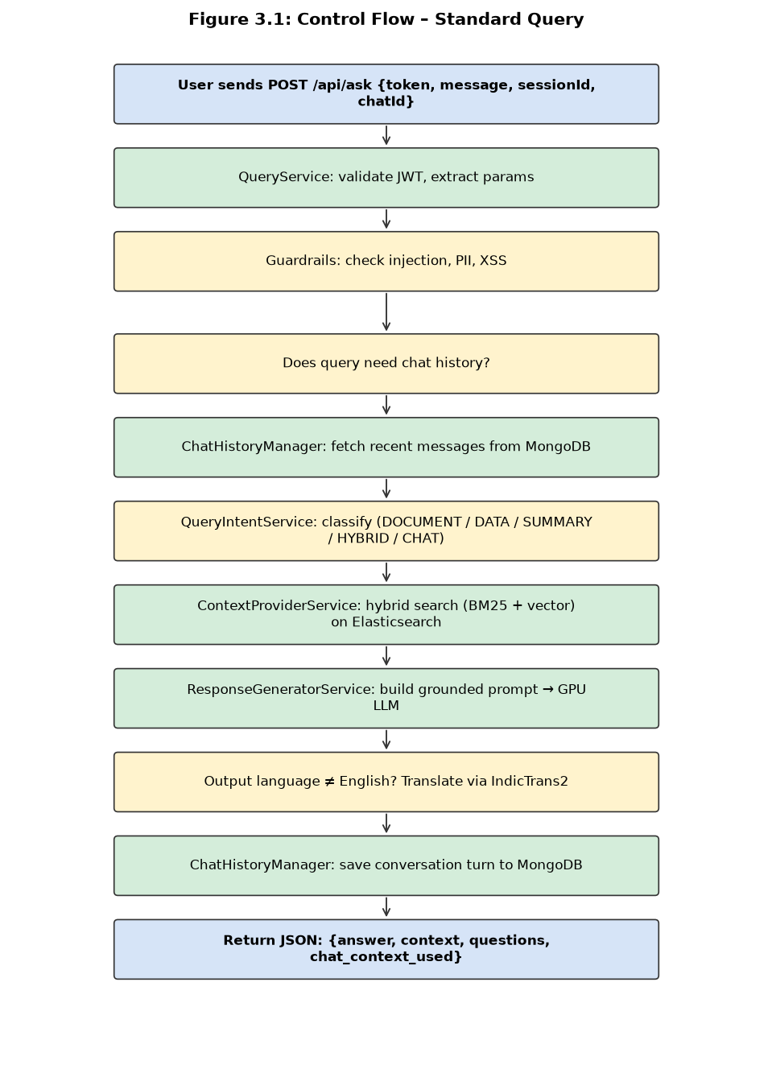
Figure 4-1: Standard Query Flow

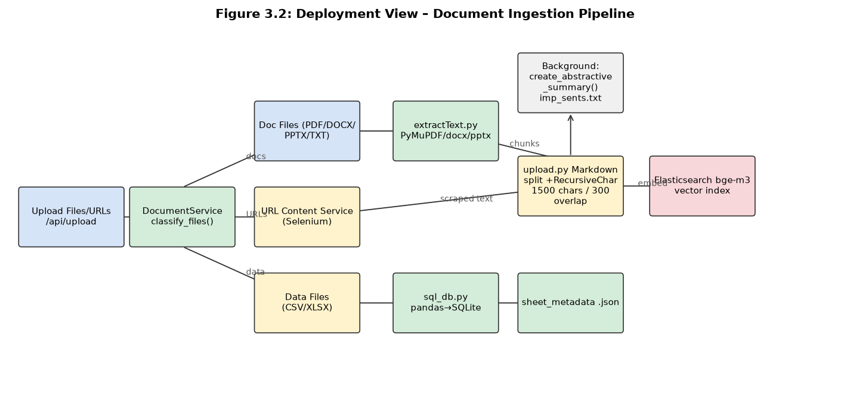
Figure 4-2: Document Ingestion Pipeline

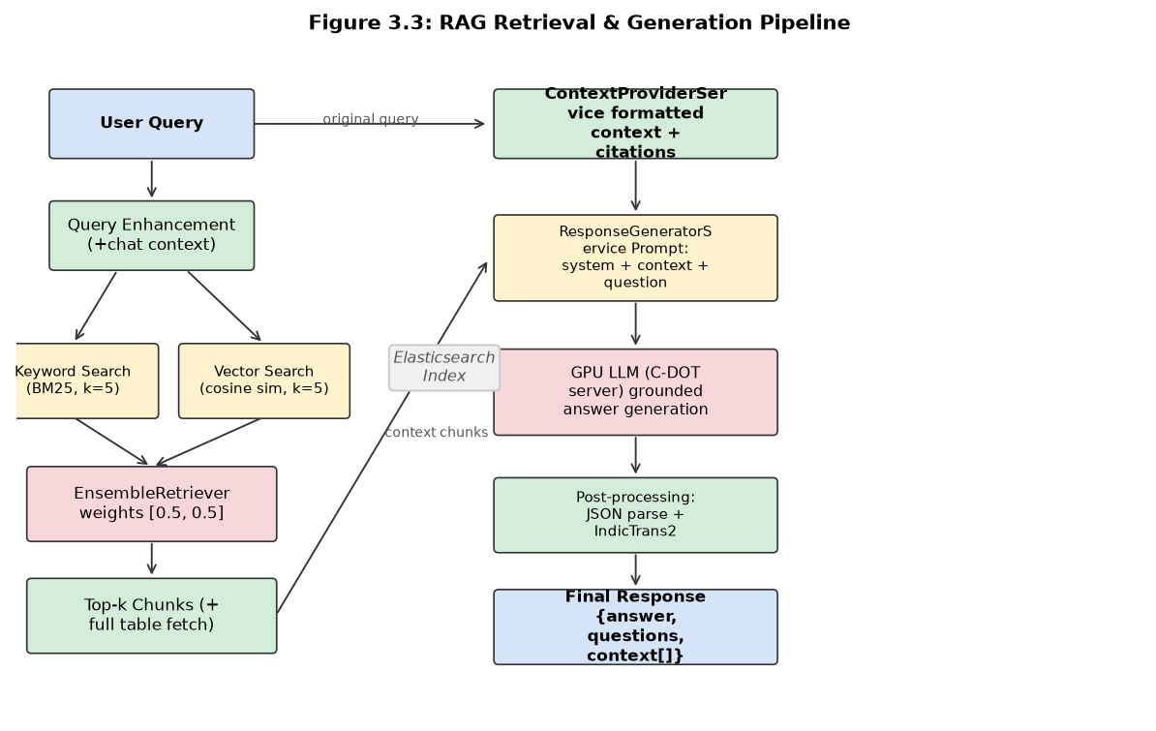
Figure 4-3: RAG Retrieval & Generation Pipeline

Data organisation

Store | Collection / Index | Contents | Persistence
Elasticsearch | <user_email><session_id> | Document chunks with text + bge-m3 vector embeddings. Metadata: source, filename, page, content_type, table_id. | Persistent
MongoDB — chat_sessions | Per user_session + chat_id | Chat messages: role, content, timestamp, message_id, query_type, save_to_note. | Persistent
MongoDB — chat_names | Per user_session + chat_id | Chat display names and creation timestamps. | Persistent
MongoDB — sessions | Per user email | Knowledge container metadata: session_id, files, name, timestamps. | Persistent
SQLite (in-memory) | Per CSV/XLSX upload | Tabular data via pandas. Schema in sheet_metadata.json. | Ephemeral — lost on restart
Filesystem — users/<session>/ | Per session | Raw uploaded files, extracted content.txt, imp_sents.txt (summary), metadata.json. | Persistent

Subsystem interface and dependencies

External interfaces and messages

Table 5-1: External interfaces

# | External Interface | Format / Protocol | Remarks
1 | Client Applications  (Frontend / WhatsApp / Mobile) | HTTP/HTTPS REST  JSON; multipart/form-data for uploads | JWT required for authenticated endpoints. Trial uses browser fingerprint.
2 | C-DOT GPU Server (LLM) | HTTPS POST to /cdot/ollama2/api/chat  (OpenAI-compatible chat format) | API key in Authorization header. SSL verification configurable. Timeout 120 s.
3 | Ollama Server (Embeddings) | HTTP — OllamaEmbeddings (LangChain) | Used at ingestion only. Model: bge-m3:latest. Must be accessible from backend host.
4 | vexyl-tts  (indic-parler-tts) | WebSocket — streams WAV audio chunks | On-premise. URL: VEXYL_TTS_URL. 23 Indian languages. Used by /api/ask-tts.
5 | vexyl-stt  (indic-conformer + distil-whisper) | WebSocket — streams partial + final transcripts | On-premise. URL: VEXYL_STT_URL. Auto language detection via Vakgyata LID.
6 | IndicTrans2 Server  (Translation) | HTTP POST {text, target_language} | Falls back to English on failure. 22 Indian languages supported.
7 | Gemma 4 Server  (Image Captioning) | HTTP POST with base64 image | Caption injected into document context when image attached to query.

Internal interfaces

All internal communication is in-process Python method calls via get_*_service() singleton factory functions. Key call chains:
- queries_bp (FastAPI router) → QueryService.process_authenticated_query() → QueryAgentService.process_query()
- QueryAgentService → QueryIntentService.classify_intent() → ContextProviderService.get_document_context() → ResponseGeneratorService.generate_document_response()
- QueryAgentService → CreativeReasoningService.process_creative_query_stream() → AdaptiveSearchService → ResultEvaluationService
- documents_bp → DocumentService.process_files_and_urls() → upload.py.store_vector() → ElasticDocumentManager.add_documents()
- ChatHistoryManager ↔ MongoDB (chat_sessions, chat_names) via Beanie ODM

Hardware interfaces

Component | Hardware Interface | Notes
C-DOT GPU Server | NVIDIA GPU cluster (HTTPS) | 70B LLM inference. Recommended: 2× A100 80 GB.
Elasticsearch | Cloud or bare-metal cluster | HTTP/HTTPS on port 9200.
MongoDB | Cloud or bare-metal | Default port 27017.
Ollama | Local GPU or CPU host | Port configurable via OLLAMA_BASE_URL.
vexyl-tts / vexyl-stt | Local GPU host (WebSocket) | WebSocket servers on-premise. GPU accelerates inference.
ChromeDriver | Local CPU — headless Chrome | Required for dynamic web page scraping via Selenium.

User interfaces

This subsystem does not expose a direct graphical user interface. All user interaction is mediated through client applications (web app, WhatsApp bot, mobile) consuming the REST API. The API exposes auto-generated documentation at /docs (Swagger UI) and /redoc (ReDoc). Refer to the Sachet Frontend and API Documentation for UI-level details.

Annexure A: Chunking Strategy Details

Text chunking is performed in controllers/upload.py via a two-stage pipeline.

Stage 1 — Markdown Header Splitting

MarkdownHeaderTextSplitter (LangChain) splits extracted text on heading markers (#, ##, ###). This preserves logical document structure so chunks respect section boundaries. Header text is propagated into chunk metadata for context attribution.

Stage 2 — Recursive Character Splitting

Parameter | Value | Rationale
chunk_size | 1500 characters | Fits within LLM context while carrying sufficient information per chunk.
chunk_overlap | 300 characters (20%) | Prevents loss of context at boundaries; 20% overlap is standard RAG practice.
Separators | ['\n\n', '\n', '. ', ' ', ''] | Hierarchical: paragraph → sentence → word → character split.

Each chunk carries metadata: source, filename, page, content_type (text/table), table_id. Table chunks receive special handling — when a table chunk appears in top-k, all chunks for that table_id are fetched to avoid partial table answers.

NuMarkdown Enhancement (numarkdown branch — pending merge)

The numarkdown branch improves chunking with NuExtract3-based extraction and hierarchical header breadcrumbs. Each chunk will carry a full header path (e.g., 'Chapter 2 > Section 3 > Sub-section 1') enabling better context attribution.

Annexure B: Scalability Considerations

Layer | Scalability Mechanism | Current Limit / Notes
FastAPI / Uvicorn Workers | Async stateless design — horizontally scalable behind Nginx + Uvicorn. Each worker holds its own singleton service instances. | Tested 100+ concurrent users. Workers = CPU cores × 2 + 1 recommended.
Elasticsearch | Horizontal scaling via shard replication. Separate index per knowledge container enables per-tenant isolation. | Scales to TB-level. Vector dimension fixed at 1024 (bge-m3).
MongoDB | Replica sets for HA; sharding for large deployments. Chat history can be time-partitioned per user_session. | Current: single instance. Production: 3-node replica set minimum.
LLM GPU Server | Centralised C-DOT GPU server. Multiple GPU nodes behind load balancer for high-concurrency production deployments. | Single GPU node = single point of failure. HA requires secondary node.
Embedding (Ollama) | Ollama scalable to multiple instances; OLLAMA_BASE_URL can point to a load-balanced cluster. | Embedding is ingestion-time only — not on query critical path.
Rate Limiting | Slowapi with Redis backend (recommended for multi-worker). Per-endpoint and per-user limits enforced. | Default: in-memory per worker. Multi-worker: Redis backend required.
File Storage | Local filesystem (users/). Multi-host: NFS or S3/MinIO object storage. | Current: local disk. Multi-node production: shared storage required.

Recommended production topology: 2× FastAPI/Uvicorn workers behind Nginx → 3-node Elasticsearch cluster → MongoDB replica set → Redis (rate limit state) → C-DOT GPU server cluster (2+ nodes) → Ollama on dedicated GPU host.

Annexure C: Branch Roadmap — Features Pending Merge

The following features are under active development in separate git branches and are planned for merging into the main codebase.

C.1 FastAPI Migration (release/fastapi-migration — merged into main)

Aspect | Flask (legacy) | FastAPI (current)
Framework | Flask 2.3 | FastAPI + Starlette
Rate Limiting | Flask-Limiter | Slowapi
Request Schemas | Manual dict parsing | Pydantic v2 (app/schemas/)
Auth | Manual JWT in route | Dependency injection (deps.py get_current_user)
MongoDB ODM | PyMongo direct | Beanie ODM + AsyncIOMotorClient (async)
API Docs | None | Swagger UI at /docs; ReDoc at /redoc
Streaming | flask.Response + generator | FastAPI StreamingResponse
App Entry | run.py (Flask app.run) | main.py (uvicorn / lifespan context)

C.2 Docling Ingestion Pipeline + Gemma 4 Vision (gemma4)

- Docling Pipeline (app/services/docling_pipeline.py): Layout-aware PDF parsing preserving table structure, headings, and page layout. Replaces PyMuPDF text extraction.
- Gemma 4 Vision Captioning: Images/charts extracted from PDFs sent to C-DOT GPU server running Gemma 4. Caption stored with chunk, enabling image-aware retrieval.
- Image Chat History: Images uploaded with queries stored in chat_images/ and served via /chat_images/<path>. Image URLs persisted in chat history metadata.
- Architectural impact: Standalone ingestion package for batch processing; MySQL schema for enterprise RAG (document_chunks, image_chunks, table_data).

C.3 NuMarkdown Chunking (numarkdown)

- NuExtract3 Integration: Structured extraction before chunking — improves handling of tables, lists, and formatted content.
- Hierarchical Chunks: Each chunk carries full header breadcrumb (e.g., 'Chapter 2 > Section 3'), enabling precise context attribution in LLM responses.
- Architectural impact: Backwards-compatible change to upload.py; chunk metadata schema extended with 'header' field.

C.4 STT / TTS via Vexyl (stt-tts — current development branch)

Service | Model | Server | Protocol | Languages
TTS | ai4bharat/indic-parler-tts | vexyl-tts | WebSocket — WAV chunks | 23 Indian languages
STT (Indic) | ai4bharat/indic-conformer-600m-multilingual | vexyl-stt | WebSocket — partial + final | 22 Indian languages
STT (English) | distil-whisper/distil-medium.en | vexyl-stt | WebSocket | English
Lang ID | onecxi/vakgyata-base | vexyl-stt | Auto detection | All supported

C.5 MongoDB Knowledge Base (feature/mongodb-kb-integration)

- NL→MongoDB Query Translation (controllers/mongodb_db.py): LLM translates natural language into PyMongo query JSON against the disaster_alerts.alerts collection.
- Alerts Schema: StateList, DistrictList, disaster_type, severity (ALERT/WARNING/WATCH), certainty, effective_start_time, effective_end_time, warning_message, centroidPoint (GeoJSON).
- Intent Routing: New intent type for MongoDB KB queries — disaster alert queries routed to MongoDB context provider instead of Elasticsearch.
- Architectural impact: New context provider path alongside existing Elasticsearch + SQLite paths.

Branch | Feature | Merge Status | Architectural Impact
release/fastapi-migration | Flask → FastAPI, Pydantic, Beanie ODM | Merged into main | High — framework change
gemma4 | Docling pipeline, Gemma 4 vision captioning | Pending merge | Medium — new ingestion path
numarkdown | NuExtract3, hierarchical header chunking | Pending merge | Low — backwards-compatible
stt-tts | vexyl-tts (indic-parler-tts), vexyl-stt (indic-conformer) | Pending merge | Medium — replaces cloud TTS/STT
feature/mongodb-kb-integration | NL→MongoDB for disaster alerts KB | Pending merge | Medium — new context provider

[ END OF DOCUMENT ]

