**To:** Prof. Bahram Shafai

**From:** S. Nazari

**Date:** 30 April 2014

**Subject:** ARARX Model Identification

**Summary**

The purpose of this memorandum is to report the calculations and simulation results for an ARARX model. First we setup the problem. Then all the necessary hand calculations are presented. After the hand calculations, we present the MATLAB code for the GLS and the PEM algorithm along with the simulation setup. Finally we show the simulation results and discuss them briefly.

**Problem Setup: ARARX Model Identification**

We consider identification of a second order system with the following polynomial representation

Model:







Input:



Noise:



Where

This type of model is sometimes referred to as an ARARX model.

Objective: Use the input and output sequence



to identify the coefficients of the mode (A,B,C above). Do this using the GLS algorithm and the PEM with a record of N=300.

**Calculations**

For part a, there are no hand calculations that are needed. For part b, the optimal prediction error equations are

**

For our specific problem, all that is required is to substitute the given expressions for C and A into the above equations. We leave these messy calculations out of the ensuing work.

The sample covariance function



will be needed in order to define a suitable criteria function. Once a suitable criteria function is defined, then it is possible to determine the parameter estimate :



**MATLAB Code & Simulation Setup**

The identification procedure initialization was coded in MATLAB. Then, the ARARX model was implemented simulated in Simulink according to the diagram in Figure 1. The GLS algorithm was implemented in MATLAB. No System Identification Toolbox was used for the GLS algorithm implementation. The GLS algorithm MATLAB listing is shown below. Also, the PEM algorithm was implemented (using the System Identification Toolbox). This is also shown in the MATLAB listing below. The results of the two approaches were studied. The MATLAB file SysIDP3.m contains all the MATLAB code to run the simulations and reproduce our results.

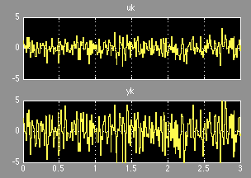

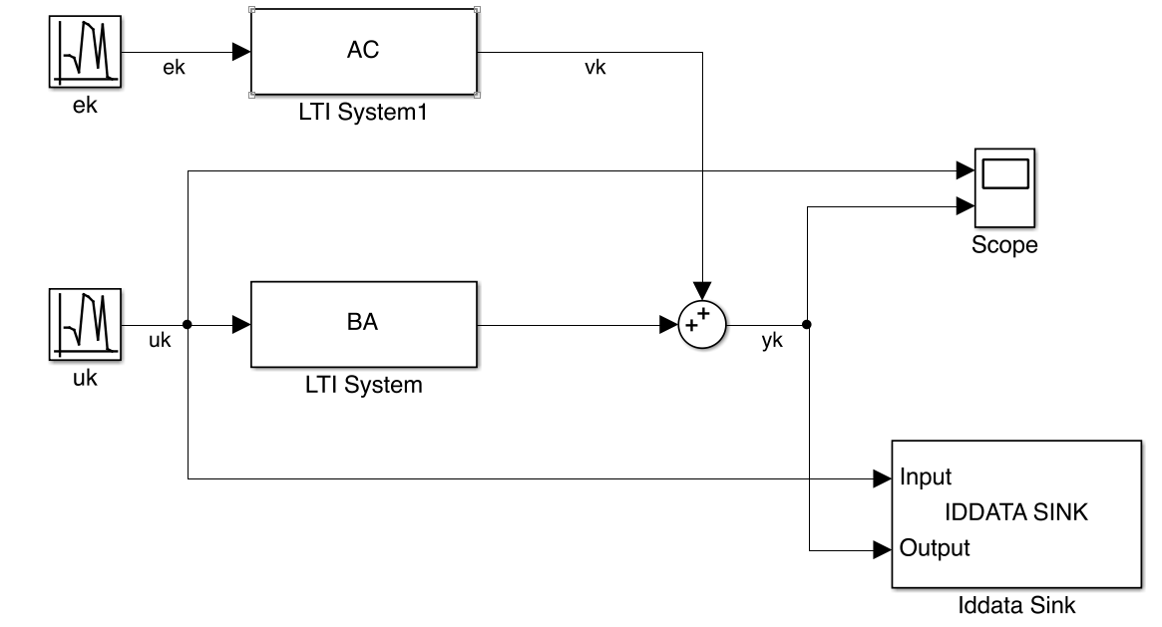

Figure 1- Model Structure for P3 & the Input and Outputs

Listing 1: GLS & PEM algorithm

%% System Identificaiton of an ARARX Model

% By: Sam Nazari

% Last Modified: Today

clear all

clc

%% init

% initialization

M = 350

N = 300;

Ts = 1/100;

A = tf([1 0 0],[1 -0.5 0.5],Ts);

BA = tf([1 0 0],[1 -0.5 0.5],Ts);

AC = tf([1 0 0 0],[1 0.35 0.075 0.425],Ts);

TStop = N*Ts;

sim('P3SysID','StopTime','TStop')

y = P3Data.OutputData;

u = P3Data.InputData;

e = 0;

mse = zeros(M,1);

%%

yn=awgn(y(1:N),0); % add white gaussian noise

Y1=[0;yn(1:N-1)];

Y2=[0;0;yn(1:N-2)];

X1=[0;u(1:N-1)];

% X2=[0;0;u(1:N-2)];

% U=[Y1 Y2 X1 X2];

U = [Y1 Y2 X1];

theta=(U'*U)\(U'*yn);

a1=-theta(1);

a2=-theta(2);

b1=theta(3);

%b2=theta(4);

n=0;

%% eHat

for n=1:M

ehat=zeros(N,1);

for k=1:1

ehat(k)=yn(k);

end

for k=2:2

ehat(k)=yn(k)+a1*yn(k-1)-b1*u(k-1);

end

for k=3:N

ehat(k)=yn(k)+a1*yn(k-1)+a2*yn(k-2)-b1*u(k-1);

end

Ue1=[0;-ehat(1:N-1)];

Ue2=[0;0;-ehat(1:N-2)];

Ue3=[0;0;0;-ehat(1:N-3)];

Ue=[Ue1 Ue2 Ue3];

d=(Ue'*Ue)\(Ue'*ehat);

%% x_t

unew=zeros(N,1);

for k=1:1

unew(k)=u(k);

end

for k=2:2

unew(k)=u(k)+d(1)*u(k-1);

end

for k=3:N

unew(k)=u(k)+d(1)*u(k-1)+d(2)*u(k-2);

end

%% y_t

ynew=zeros(N,1);

for k=1:1

ynew(k)=yn(k);

end

for k=2:2

ynew(k)=yn(k)+d(1)*yn(k-1);

end

for k=3:N

ynew(k)=yn(k)+d(1)*yn(k-1)+d(2)*yn(k-2);

end

Ynew1=[0;-ynew(1:N-1)];

Ynew2=[0;0;-ynew(1:N-2)];

Xnew1=[0;unew(1:N-1)];

Unew=[Ynew1 Ynew2 Xnew1];

theta=(Unew'*Unew)\(Unew'*ynew);

a1=theta(1);

a2=theta(2);

b1=theta(3);

sys = idpoly([1 theta(1:2)'],[theta(3)],[1],[1 d'],[1],0.64,Ts);

yhat = sim(sys,P3Data.InputData);

e = P3Data.OutputData-yhat;

mse(n) = (e'*e)/N;

end % while

theta

d

%% Using SystemID Toolbox

% ARARX Model Estimation

na = 2;

nb = 1;

nc = 0;

nd = 3;

nf = 0;

nk = 0;

opt = polyestOptions('SearchMethod','auto','Display','on')

opt.SearchOption.MaxIter = 100

opt.SearchOption.Tolerance= 1e-6

sys = polyest(P3Data,[na nb nc nd nf nk],opt)

%% Set up for P3 b

init_sys = init(sys);

sysPEM = pem(P3Data,init_sys,opt)

%% Plot GLS MSE

plot(1:M,mse),xlim([1 50]),title('MSE vs Iteration'),xlabel('Nth Step'),ylabel('MSE')

**Simulation Results & Discussion**

This memo summarizes the results of GLS and PEM identification of an ARARX model. The GLS algorithm MSE is shown in Figure 2. It is seen that the MSE converges quickly, but does not decrease to zero. The results model parameters for both the GLS and PEM are shown in Table 1. The GLS algorithm and the LS algorithm are particular instances of PE Methods. Therefore, this was a good problem to study the similarities between the two approaches.

|  |  |  |  |
| --- | --- | --- | --- |
| **Parameter** | **True** | **GLS** | **PEM** |
|  | -0.5 | -0.3690 | - 0.3923 |
|  | 0.5 | 0.5069 | 0.4895 |
|  | 1 | 0.1683 | 1.586 |
|  | 0.35 | 0.3061 | 1.756 |
|  | 0.075 | -0.2931 | 1.176 |
|  | 0.425 | 0.0542 | 0.358 |

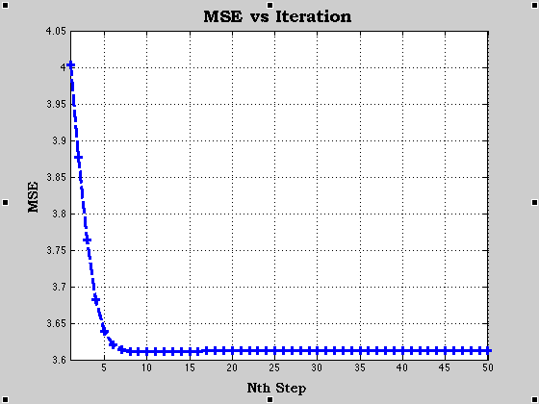

Figure 2-GLS Algorithm Convergence