**Deliverable 4: Data Modeling and Starting Design**

Group Name: WebIt

Group Members: Theresa Tomilson, Krishna Viradia, Mehak Uddin, Sara Nazir, Courtney Burns, Nuri Surur, Wubnyonga Tete

Class Name: IS 436 - Structured Systems Analysis and Design

Due Date: 5/09/2019

**ER DIAGRAM**

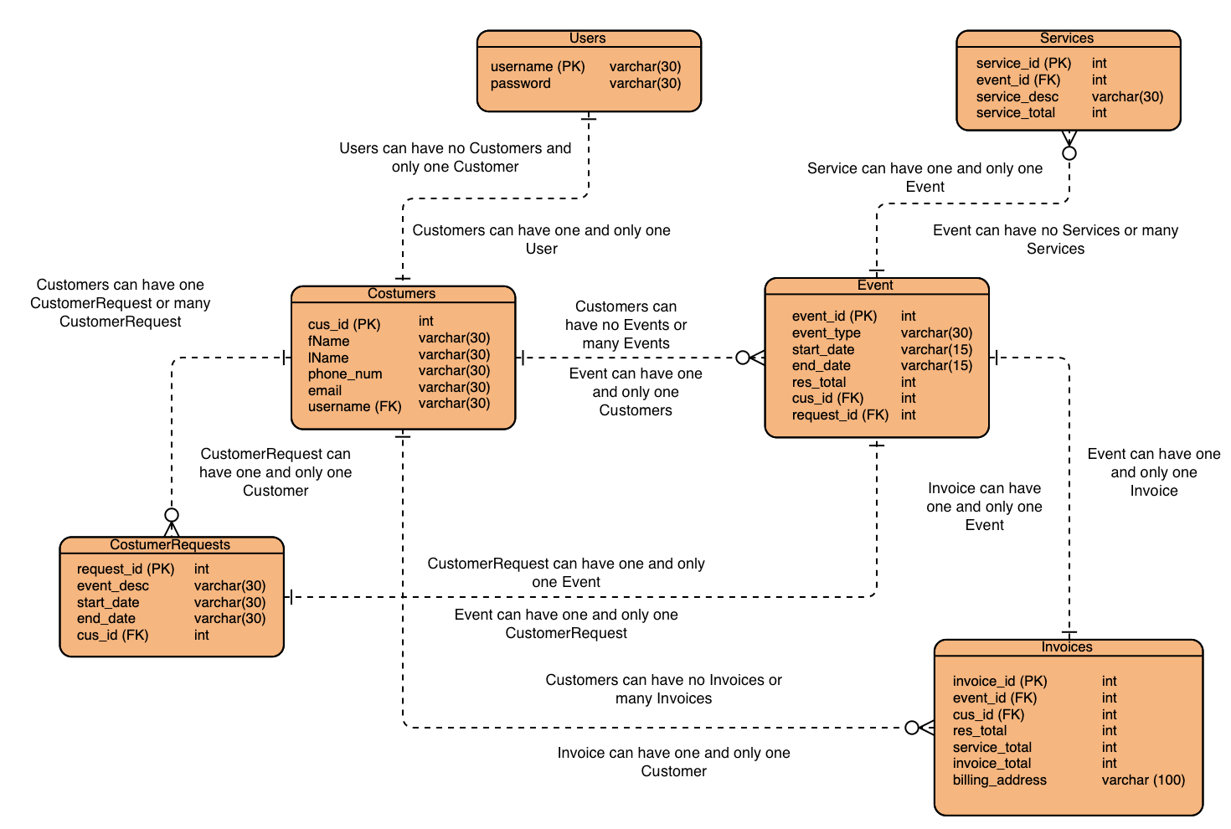

Note: Visual Paradigm (used to make the E-R diagram) did not have *optional on*e relationship and *mandatory one or many* relationship symbols

**Entities and Attributes**

**Employee**

* Emp_id, emp_name, emp_phone, emp_email, emp_address, emp_salary, emp_hours
* An employee can create zero, one or many events for customers.
* An employee can create an invoice once an event is created.

**Customer**

* Cus_id, cus_name, cus_email, cus_phone, cus_address
* A customer can create one or many events and a customer must have at least one event to be considered a customer.

**Event (create event)**

* Event_id, emp_id, manager_id, cus_id, event_type,event_date, event_location,event_time
* An event can be created by a customer, manager or employee
* An event belongs to one and only one customer
* An even can have one or many invoices, but an event must have at least one invoice

**Invoice (create invoice)**

* Invoice_id, event_id, cus_id, invoice_date, invoice_amount
* An invoice can belong to one and only one event.

**Add user**

* User_id, manager_id, user_name, user_password
* Only the manager can add a user

**Manager / Owner**

* Manager_id, manager_name, manager_phone, manager_email
* A manager can create zero, one or no employee. If there is no customer request, then there is no event creation.
* Only the manager/owner can add a new user to the system.

**Alternatives Description**

**MySQL**

The MySQL Database Server is the most popular open-source database. Whether you’re an aspiring web application developer or a person working on an existing database-driven web application like a content management system, e-commerce platform, or blogging platform.

It is very fast, reliable, scalable, and easy to use.

MySQL Server can run comfortably on a desktop or laptop, alongside your other applications, web servers.

The MySQL Database Software is a client/server system that consists of a multi-threaded SQL server that supports different back ends, several different client programs and libraries, administrative tools, and a wide range of application programming interfaces (APIs).

**Oracle**

Oracle database (Oracle DB) is a relational database management system (RDBMS) from the Oracle Corporation.

Oracle DB runs on most major platforms, including Windows, UNIX, Linux, and Mac OS. Different software versions are available, based on requirements and budget.

It is self-driving, self-securing, self-repairing, and designed to eliminate error-prone manual data management.

Oracle is the best choice as a portable DBMS solution. It supports more than 100 hardware platforms and 20 networking protocols.

**MangoDB**

MongoDB is a document-oriented NoSQL database written in the C ++ programming language. Instead of storing information in tables, as with traditional relational databases, MongoDB stores structured information in JSON format with dynamic schemas. This makes integrating information in certain applications much easier and faster.

MongoDB is freely available under the GNU (General Public License) . The language drivers are available under an Apache license.

MongoDB comes with links for the main programming languages, like C, C + +, Dart, Erlang, Haskell, Java, JavaScript , etc. These drivers allow you to manipulate the database and its data directly from these languages.

**ALTERNATIVE MATRIX**

**Individual Alternative Matrix**

**Courtney**

|  |  |  |  |  |  |  |  |
| --- | --- | --- | --- | --- | --- | --- | --- |
|  | | **Alternative 1:**  **MySQL** | | **Alternative 2:**  **Oracle** | | **Alternative 3:**  **MongoDB** | |
| **Evaluation Criteria** | **Relative Importance** | **Score** | **Weighted Score** | **Score** | **Weighted Score** | **Score** | **Weighed Score** |
| User Friendly | 5 | 4 | 20 | 3 | 15 | 2 | 10 |
| Cost | 4 | 3 | 12 | 3 | 12 | 2 | 8 |
| Technical Support | 4 | 3 | 12 | 4 | 16 | 3 | 12 |
| Maintenance | 3 | 4 | 12 | 2 | 6 | 2 | 6 |
| Total Score |  | Total Score | 56 | Total Score | 49 | Total Score | 36 |

**Theresa**

|  |  |  |  |  |  |  |  |
| --- | --- | --- | --- | --- | --- | --- | --- |
|  | | **Alternative 1:**  **MySQL** | | **Alternative 2:**  **Oracle** | | **Alternative 3:**  **MongoDB** | |
| **Evaluation Criteria** | **Relative Importance** | **Score** | **Weighted Score** | **Score** | **Weighted Score** | **Score** | **Weighed Score** |
| User Friendly | 5 | 4 | 20 | 3 | 15 | 2 | 10 |
| Cost | 4 | 3 | 12 | 4 | 16 | 2 | 8 |
| Technical Support | 4 | 3 | 12 | 3 | 12 | 2 | 8 |
| Maintenance | 3 | 4 | 12 | 3 | 9 | 2 | 6 |
| Total Score |  | Total Score | 56 | Total Score | 52 | Total Score | 32 |

**Sara**

|  |  |  |  |  |  |  |  |
| --- | --- | --- | --- | --- | --- | --- | --- |
|  | | **Alternative 1:**  **MySQL** | | **Alternative 2:**  **Oracle** | | **Alternative 3:**  **MongoDB** | |
| **Evaluation Criteria** | **Relative Importance** | **Score** | **Weighted Score** | **Score** | **Weighted Score** | **Score** | **Weighed Score** |
| User Friendly | 5 | 4 | 20 | 3 | 15 | 2 | 10 |
| Cost | 4 | 3 | 12 | 4 | 16 | 2 | 8 |
| Technical Support | 4 | 3 | 12 | 4 | 16 | 2 | 8 |
| Maintenance | 3 | 3 | 9 | 4 | 16 | 2 | 6 |
| Total Score |  | Total Score | 53 | Total Score | 63 | Total Score | 32 |

**Krishna**

|  |  |  |  |  |  |  |  |
| --- | --- | --- | --- | --- | --- | --- | --- |
|  | | **Alternative 1:**  **MySQL** | | **Alternative 2:**  **Oracle** | | **Alternative 3:**  **MongoDB** | |
| **Evaluation Criteria** | **Relative Importance** | **Score** | **Weighted Score** | **Score** | **Weighted Score** | **Score** | **Weighed Score** |
| User Friendly | 5 | 4 | 20 | 3 | 15 | 3 | 15 |
| Cost | 4 | 3 | 12 | 3 | 12 | 2 | 8 |
| Technical Support | 4 | 4 | 16 | 3 | 12 | 3 | 12 |
| Maintenance | 4 | 3 | 12 | 3 | 12 | 2 | 8 |
| Total Score |  | Total Score | 60 | Total Score | 51 | Total Score | 43 |

**Mehak**

|  |  |  |  |  |  |  |  |
| --- | --- | --- | --- | --- | --- | --- | --- |
|  | | **Alternative 1:**  **MySQL** | | **Alternative 2:**  **Oracle** | | **Alternative 3:**  **MongoDB** | |
| **Evaluation Criteria** | **Relative Importance** | **Score** | **Weighted Score** | **Score** | **Weighted Score** | **Score** | **Weighed Score** |
| User Friendly | 5 | 4 | 20 | 2 | 10 | 3 | 15 |
| Cost | 4 | 3 | 12 | 3 | 12 | 2 | 8 |
| Technical Support | 4 | 3 | 12 | 3 | 12 | 3 | 12 |
| Maintenance | 3 | 2 | 6 | 3 | 9 | 2 | 6 |
| Total Score |  | Total Score | 50 | Total Score | 43 | Total Score | 41 |

**Tete**

|  |  |  |  |  |  |  |  |
| --- | --- | --- | --- | --- | --- | --- | --- |
|  | | **Alternative 1:**  **MySQL** | | **Alternative 2:**  **Oracle** | | **Alternative 3:**  **MongoDB** | |
| **Evaluation Criteria** | **Relative Importance** | **Score** | **Weighted Score** | **Score** | **Weighted Score** | **Score** | **Weighed Score** |
| User Friendly | 5 | 4 | 20 | 4 | 20 | 3 | 15 |
| Cost | 4 | 4 | 16 | 3 | 12 | 4 | 16 |
| Technical Support | 4 | 3 | 12 | 3 | 12 | 3 | 12 |
| Maintenance | 3 | 4 | 12 | 3 | 9 | 2 | 6 |
| Total Score |  | Total Score | 60 | Total Score | 53 | Total Score | 49 |

**Nuri**

|  |  |  |  |  |  |  |  |
| --- | --- | --- | --- | --- | --- | --- | --- |
|  | | **Alternative 1:**  **MySQL** | | **Alternative 2:**  **Oracle** | | **Alternative 3:**  **MongoDB** | |
| **Evaluation Criteria** | **Relative Importance** | **Score** | **Weighted Score** | **Score** | **Weighted Score** | **Score** | **Weighed Score** |
| User Friendly | 5 | 4 | 20 | 4 | 20 | 3 | 15 |
| Cost | 4 | 4 | 16 | 4 | 16 | 2 | 8 |
| Technical Support | 4 | 3 | 12 | 3 | 12 | 2 | 8 |
| Maintenance | 3 | 3 | 9 | 4 | 12 | 2 | 8 |
| Total Score |  | Total Score | 57 | Total Score | 60 | Total Score | 39 |

**Team Matrix**

|  |  |  |  |  |  |  |  |
| --- | --- | --- | --- | --- | --- | --- | --- |
|  | | **Alternative 1:**  **MySQL** | | **Alternative 2:**  **Oracle** | | **Alternative 3:**  **MongoDB** | |
| Evaluation Criteria | Relative Importance | Score | Weighted Score | Score | Weighted Score | Score | Weighed Score |
| User Friendly | 5 | 4 | 20 | 3 | 15 | 3 | 15 |
| Cost | 4 | 3 | 12 | 4 | 16 | 2 | 8 |
| Technical Support | 4 | 3 | 12 | 3 | 12 | 3 | 12 |
| Maintenance | 3 | 3 | 9 | 3 | 9 | 2 | 6 |
| **Highest Possible Score** | **80** | Total Score | 58 | Total Score | 52 | Total Score | 41 |

**Justification of Team Matrix**

Our team picked MySQL in our final decision matrix. After evaluating each of our main criteria, it was established that MySQL best fit our needs with its flexibility and ease of use. Our client is not as tech savvy so it is very beneficial to have a system that is user friendly and does not require too much maintenance. The way that we scored technical support was based on how much it required and how reliable it was. MySQL would require the least out of our three options which made it a reliable option for our client.

**ARCHITECTURAL DESIGN**

**Operational Requirements**

|  |  |  |
| --- | --- | --- |
| **Requirement** | **Description** | **Example** |
| Technical | * Specific hardware, Software, and Network requirements needed by a business. | The client location will have network connection with real-time updates to the database system |
| System integration | * The system will have to obtain information from and interact with client site and admin site which is connected to the database.   . | Different systems will have to interact to stay up to date with the data within the system. |
| Portability | System will have to operate on mobile platforms | That is, Mobile phones, Tablet, Desktop  Browser 1E11, Chrome  OS supported: windows 7, 8,10, android |
| Maintainability | System will have to withstand the changes in the business and be able to adapt according to business needs. | Changes to documents and other files must be kept in check and up to date. |

**Performance Requirements**

|  |  |  |
| --- | --- | --- |
| Requirement | Description | Example |
| Speed | The amount of time needed for system to perform its functions. | Home page: 3 seconds  Operational pages: 5 seconds |
| Capacity | That is the number of users and request the system can handle | Database size per day: 200GB  Database size per year: 4000GB |
| Reliability/Availability | Amount of uptime/downtime of system | Minimum of 90% uptime, 99% at business/peak hour |

**Cultural/Political Requirements**

|  |  |  |
| --- | --- | --- |
| Requirement | Definition | Example |
| Language | The language the user will need | The system will , operate in English |
| Making Unstated Norms Explicit | Explicitly stating assumptions that differ from country to country | - All payments are in US currencies |

**Security Requirements**

|  |  |  |
| --- | --- | --- |
| Requirement | Definition | Example |
| Access Control | Limitation of accessibility of data | - Only Admin/Owner can create invoices  - Employees can’t update salary or schedule information. |
| Virus control | Controls to protect from viruses | - All files will be checked for viruses |
| Encryption/Authentication | Defines where Authorization is needed for the user | - To protect Customer/User information |

**Decision matrix**

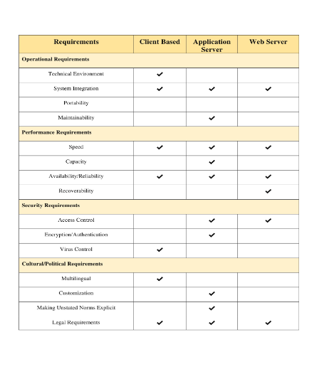

**Hardware and Software Specification**

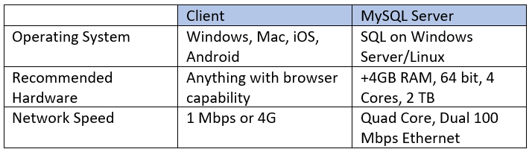

**Updated Project Plan**

