**Deliverable 5: Closing: User Interface Design, Program design and System Implementation**

Group Name: WebIt

Group Members: Theresa Tomilson, Krishna Viradia, Mehak Uddin, Sara Nazir, Courtney Burns, Nuri Surur, Wubnyonga Tete

Class Name: IS 436 - Structured Systems Analysis and Design

Due Date: 5/09/2019

**User Interface Design**

Prototypes:

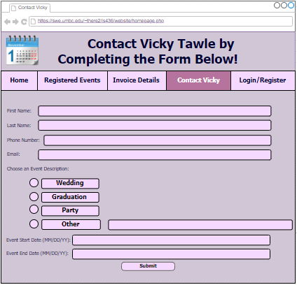

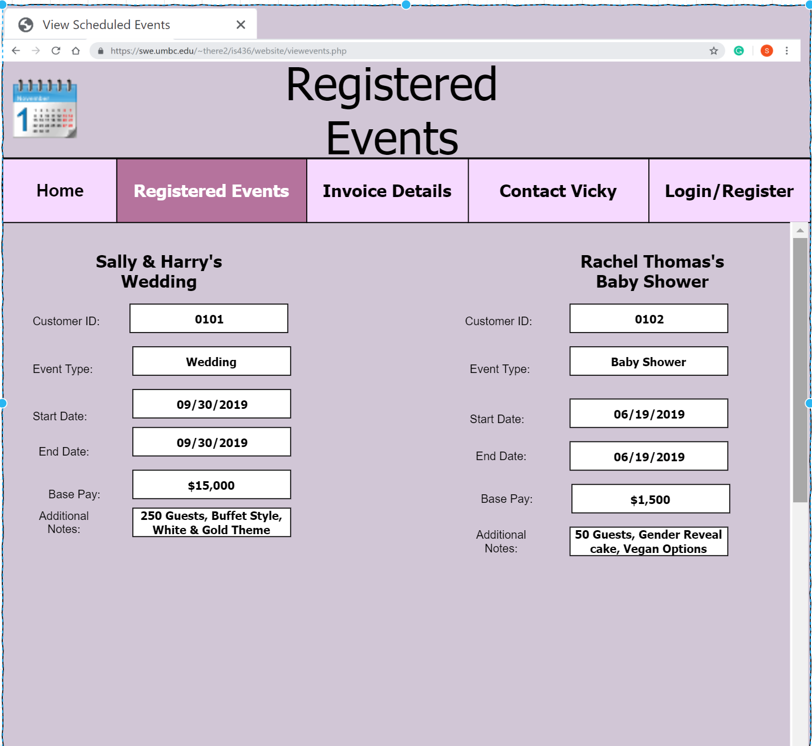

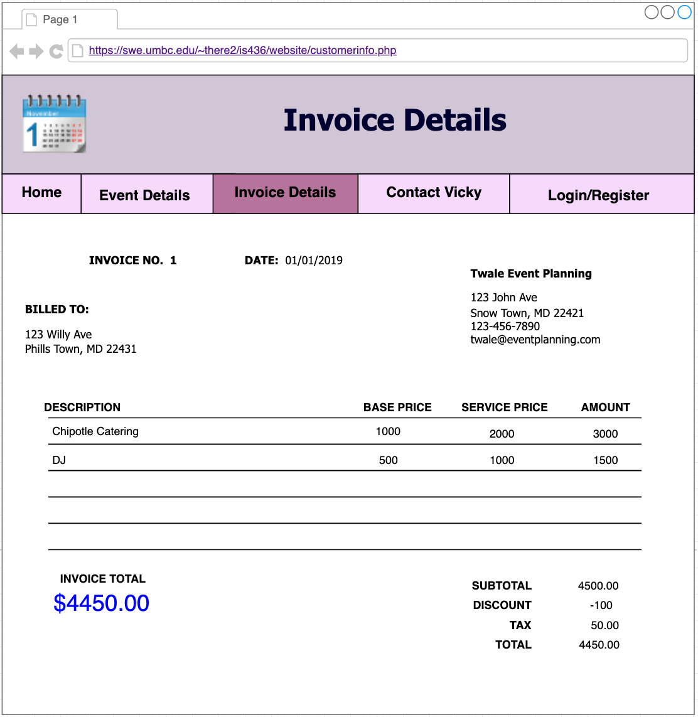

**Interface Standards:**

The interface standards that we would like to follow and make decisions are based upon common elements across individual screens, forms, and reports, interface metaphors, interface objects, interface actions, and interface templates. As a team we have decided to make the html templates have a consistent color theme and similar formats. Having the templates and themes be consistent, allows the user to navigate his/her way through the website with ease. The interface metaphor that we want to follow is having a calendar. The calendar will be used to allow admins and clients to view when they could schedule an event. This is essential to our website since we are designing it for a business that requires a specific date to be booked to plan the event. The interface objects that we would like to follow is having an admin/owner and employees. The users that will be able to access this website are employees and admins/owners. These objects will also have certain access limitations. There are multiple interface actions we would use to follow and make decisions. Some of these include login, register, view customer requests, schedule events, view and edit scheduled events, view and edit current customer information, and view and edit invoice details. The interface template that we would like to follow and make decisions upon involves having a consistent layout for all screens. A consistent layout for all screens makes it easier for the user to learn how to use the website and navigate through it.

**System Requirements**

Software: Web browser, DBMS

Hardware: Anything with browser capability

Platform: HTML, PHP, CSS, OS

**Team Experience with SDLC:**

Throughout the semester, our team had a strong grasp on SDLC and how to implement the different phases in our project. We started off in the planning stage which we thought was very simple since as a team we agreed to create a web application for an event planning business. After that the analysis, design, and implementation phases were easily completed because our group had a concrete project plan from the beginning. Creating a functional web application using relational databases was the most challenging since we only had one developer, Theresa coding the entire site. She made most of the site interactive with login credentials for different users to view certain workflows such as completing a customer survey to viewing/editing event details. The most rewarding part of this project was following through on our team’s vision and seeing the final web application after all the work our team put in. For most of us, we enjoyed creating the system requirements and use case analysis documents because they are very relevant in the IT industry and beneficial to those going into business/technical analyst or project manager careers.

**Updated Project Plan**

