EER6689 Final Project – Software Engineering
Department of Electrical and Computer Engineering
Faculty of Engineering Technology
Bachelor of Software Engineering Honours
The Open University of Sri Lanka
PROGRESS REPORT I
Physics-Informed AI for 3D Dent Assessment and Repair Decision Support in Paintless Dent Repair Workshops
Group 03 · Track No: [Track number]
Supervisor: [Supervisor name]
Name | Registration No. | Role
D.M.S.N. Bandara | 521436539 | Leader · C1 3D measurement
K.S. Dissanayaka | 521428593 | C3 Mechanics & PDR suitability
S.D.K.S. David | 721436620 | C2 AI outline & depth
U.S.N. Senevirathne | 621431330 | C4 Repair method, plan & cost
K.L.N.C. Liyanage | 621647715 | C5 App, confidence & integration

Submitted: 08 November 2026

Table of Contents
Executive Summary | 4
1. Introduction | 5
1.1 Background and Problem | 5
1.2 Aim and Objectives | 5
1.3 Project Scope | 6
1.4 Progress Summary | 6
2. Literature Survey | 7
2.1 Vision-Based Damage Detection | 7
2.2 Repair-Cost Estimation | 7
2.3 Sri Lankan Systems and Studies | 7
2.4 Measurement of Specular Surfaces and Depth Estimation | 8
2.5 Panel Mechanics, Repair Practice and Uncertainty | 8
2.6 Comparative Summary | 8
2.7 Research Gap and Novelty | 9
3. Software Requirements Specification | 10
3.1 Introduction | 10
3.2 Overall Description | 11
3.3 External Interface Requirements | 12
3.4 Functional Requirements | 12
3.5 Use Cases | 14
3.6 Non-Functional Requirements | 16
3.7 Data Requirements | 17
3.8 Requirements Traceability | 17
4. System Design | 18
4.1 System Overview | 18
4.2 Context and Data Flow | 18
4.3 Activity Diagrams | 20
4.4 Sequence Diagram | 21
4.5 Class Diagram | 22
4.6 Database Design | 23
4.7 State Machine | 24
4.8 Deployment Architecture | 24
4.9 Algorithm Design | 25
4.10 Repair Check After PDR | 27
5. Implementation Progress | 28
5.1 Prototype Overview | 28
5.2 3D Measurement by Deflectometry | 28
5.3 Plate Solver Verification | 29
5.4 PDR Suitability and Repair Method | 30
5.5 Prototype API and Tests | 31
5.6 Limitations of the Current Prototype | 32
6. Project Plan | 33
6.1 Work Breakdown Structure | 33
6.2 Schedule and Milestones | 33
6.3 Work Distribution | 34
6.4 Risk Register | 34
7. CMMI Meeting Minutes | 36
7.1 Process Approach | 36
7.2 Meeting Log | 36
7.3 Minutes of Meetings | 36
8. Conclusion and Next Steps | 40
References | 41

Executive Summary
This report presents the first progress of Group 03’s final-year project, a physics-informed decision-support system for Paintless Dent Repair (PDR) workshops. The system measures a vehicle dent in 3D with a smartphone and a laptop screen, decides whether PDR is suitable from the strain that the repair would impose on the metal and paint, selects between push repair, dent pulling (glue-pull or stud-pull) and replacement, plans the repair, and gives the workshop technician an explained recommendation with a success probability and a cost range.
Since the proposal, the team has completed the literature survey, agreed the novelty and scope with the supervisor, written the Software Requirements Specification (SRS), produced the full set of design diagrams and built an early working prototype of the core algorithms. On simulated dents of 1–10 mm depth, including camera noise and a ±2% calibration error, the prototype reconstructs dent depth with a mean absolute error of 0.061 mm (maximum 0.138 mm, R² = 0.9993). The in-house thin-plate solver agrees with the exact solution of a clamped circular plate within 0.8–2.8% for a point load. All eight automated tests pass. Real-world validation on test panels and workshop cases is the next phase.
Table 1: Status of the items required for Progress Report I
Required item | Status | Section
Completed SRS document | Completed (IEEE 830 structure, 32 functional and 18 non-functional requirements, use cases, traceability) | 3
Literature survey | Completed (international and Sri Lankan systems, measurement, mechanics, gap analysis) | 2
All diagrams (overview, use case, activity, etc.) | Completed: overview, context, DFD level 1, use case, 2 activity, sequence, class, ER, state, deployment, algorithm pipeline, repair check, WBS, Gantt | 4, 6
CMMI meeting minutes | Completed for six meetings; dates and attendance to be confirmed (highlighted) | 7
Project plan | Completed (WBS, schedule, milestones, work distribution, risk register) | 6
Implementation (encouraged) | Core algorithms, prototype REST API and 8 passing tests (simulated data) | 5

1. Introduction

1.1 Background and Problem
Dents caused by door contact, minor collisions, falling objects and hail are common in Sri Lanka, and most are repaired in small independent workshops. Many can be repaired with Paintless Dent Repair (PDR), which keeps the original factory paint and is faster and cheaper than conventional repair [1]. In push repair, the technician reaches behind the panel with rods and pushes the metal out; when the back of the panel cannot be reached, the technician uses dent pulling, bonding glue tabs to the paint and pulling with a slide hammer, or welding studs where the paint is already damaged.
Whether PDR will succeed depends on the depth and curvature of the dent and on how much the metal and paint must be strained to restore the surface. None of these quantities is visible in an ordinary photograph, and none is measured in current practice: the PDR technician standard accepts a repair when no sign of the dent remains visible [2]. Two technicians can therefore reach different decisions for the same dent; an over-optimistic decision cracks the paint and causes rework, and an over-cautious one sends a repairable dent to a more expensive repair. Existing AI tools, including those used by Sri Lankan insurers, detect damage in two-dimensional photographs and estimate cost, but they do not measure the dent or assess repair feasibility [3], [4], [5], [6].

1.2 Aim and Objectives
Aim. To develop and evaluate a physics-informed decision-support system that measures vehicle dents in 3D with a smartphone and recommends a repair method, repair plan and cost range with a stated confidence level for PDR workshop technicians.
Objectives.
- Measure dent depth and 3D shape with a smartphone using phase-measuring deflectometry, with a depth error of at most 0.5 mm against dial-gauge readings (C1, D.M.S.N. Bandara).
- Train a neural network that outlines a dent and estimates its height map from a single photograph, as a fallback when a stripe scan is not possible (C2, S.D.K.S. David).
- Assess PDR suitability from curvature and strain, replacing fixed threshold rules (C3, K.S. Dissanayaka).
- Select the repair method (push repair, glue-pull or stud-pull dent pulling, or replacement), calculate force, glue-tab size and number of pulls, plan the pushes or pulls and price the plan (C4, U.S.N. Senevirathne).
- Attach a calibrated success probability and cost interval to every recommendation (C5, K.L.N.C. Liyanage).
- Develop a technician report application with guided capture (C5, K.L.N.C. Liyanage).
- Validate the system on test panels and real workshop cases, including a repair check after PDR (all members).

1.3 Project Scope
The scope below was agreed with the supervisor. The system covers the dents that PDR workshops repair every day.
Table 2: Project scope
Included | Excluded
Painted metal outer body panels: doors, bonnet, roof, boot lid, wings/fenders, quarter panels  Steel and aluminium panels  Round dents, door dings, hail dents, creases and body-line dents  Dents up to about palm size (≈150 mm; adjustable)  With or without paint damage (damaged paint → a method including refinishing) | Plastic parts and bumpers  Structural or frame damage  Torn, punctured or rusted metal  Large collision damage (the system only recommends “replace”)  Scratches without a dent  Matte, wrapped or dull paint for deflectometry (single-photo estimate with lower confidence)

Users. The primary users are workshop technicians and PDR specialists. Workshop owners manage rates and staff. Customers and insurers receive the shared report as evidence; the system is not designed as an insurance claims tool.

1.4 Progress Summary
Table 3: Progress against the plan up to 08 November 2026
Work package | Planned output | Status
Literature survey | Review of detection, cost estimation, Sri Lankan systems, metrology, mechanics | Done
Novelty and scope | Approved focus: 3D measurement, PDR suitability, technician decision support | Done
Requirements | SRS with functional/non-functional requirements, use cases, traceability | Done
Design | Architecture, UML, DFD, ER, deployment, algorithm design | Done
C1 3D measurement | Phase shifting, temporal unwrapping, integration | Prototype on simulated data
C3 Mechanics | Curvature, strain, plate solver, suitability check | Prototype; solver verified
C4 Repair method | Method selection, force, tab size, pulls, push plan | Prototype on simulated data
C5 Confidence and API | Monte Carlo, conformal intervals, REST API | Prototype; app UI not started
C2 AI outline and depth | Synthetic renderer, U-Net | Design done; implementation next
Data collection | Test panels, dial gauge, workshop cases | Equipment being sourced

2. Literature Survey

2.1 Vision-Based Damage Detection
Early work applied convolutional neural networks to classify car damage types from photographs [7]. Later studies moved to object detection and instance segmentation. The CarDD dataset [3] provides about 4,000 high-resolution images with six damage classes, including dents, and benchmarks detection and segmentation models such as Mask R-CNN [8]. Enhanced YOLO models improve detection speed and accuracy for car damage [9], and the YOLO family is now the standard choice for real-time detection [10]. Dent-specific work [4] shows that small dents remain difficult to detect because they appear only as subtle changes in reflection and shading, and its authors identify 3D surface analysis as a necessary next step. The common limitation is that the output is a bounding box or a pixel mask: the dent is located, but its depth, shape and curvature, which decide whether PDR can be used, are not measured.

2.2 Repair-Cost Estimation
Cost-estimation studies combine detection with a pricing model. Zhang and Shin [11] and Ghita et al. [12] map detected damage to repair prices, and Ahaggach et al. [13] integrate ontology reasoning with regression models to improve prediction. Pérez-Zarate et al. [14] show that computer vision can support insurance claim handling in practice. These approaches learn the relationship between the appearance of damage and its historical price. They do not model the repair process, so they cannot explain why a dent costs what it does, and they cannot distinguish two dents that look alike in a photograph but need different repair methods.

2.3 Sri Lankan Systems and Studies
Sri Lankan insurers have digitised motor claims in several ways, summarised in the table below. These systems improve the speed of the claim process, but the assessment is performed by human engineers or inferred from 2D images, and all are designed for insurers rather than for the technician who performs the repair.
Table 4: Sri Lankan systems and studies
System / study | What it does | What it does not do
Allianz Lanka 3D motor accident assessment app (2018) [15] | Customer marks damage on a 3D car model and submits photos | No measurement; engineers assess
Asian Alliance Click2Claim (2015) [16] | Accident photos uploaded from a phone | Staff call back and assess
LOLC General Insurance V Claim [17] | Live video inspection by motor engineers | Assessment by humans only
Sri Lanka Insurance Virtual Claim Assistance (2023) [18] | Remote video-based claim assistance | No automated measurement
Fairfirst Insurance with CamCom AI [5] | AI photo inspection and instant estimate; closest system | 2D only; no PDR suitability; insurer-focused
Jayagoda & Kasthurirathna, SLIIT, IEEE SCSE 2025 [6] | Hybrid damage and severity model; 73.3% severity accuracy | Images only; no 3D, method or cost

2.4 Measurement of Specular Surfaces and Depth Estimation
Painted panels are specular, so 3D scanning methods that rely on diffuse reflection perform poorly on them. Phase-measuring deflectometry observes how a known stripe pattern is distorted by reflection and recovers the surface slope [19]; reviews show high sensitivity to small shape changes on specular surfaces [20]. Phase-shifting algorithms [21] and Fourier fringe analysis [22] extract the phase, and gradient-field integration [23] converts slopes to a height map. Learning-based monocular depth estimation [24] and encoder–decoder networks such as U-Net [25] can predict dense depth from a single image, but they are trained on large-scale scenes, not millimetre-scale dents on reflective panels, so they need domain-specific training data and ground truth. In this project, deflectometry is the primary measurement and also supplies labels for training the single-photo model.

2.5 Panel Mechanics, Repair Practice and Uncertainty
Thin-plate theory [26] relates out-of-plane deflection to curvature, bending strain and load, and yield-line theory [27] gives the load at which a plate deforms plastically, which corresponds to the force needed to reshape a dent. These methods are standard in structural engineering but have not been applied to dent assessment from measured shapes. In PDR practice, training standards define acceptable repairs visually and do not require measurement or post-repair testing [2], and reviews highlight strong dependence on technician skill [1]. None of the reviewed systems reports calibrated uncertainty; Monte Carlo propagation [28] and conformal prediction [29] provide practical ways to attach probabilities and guaranteed-coverage intervals, and the Brier score [30] allows such probabilities to be checked.

2.6 Comparative Summary
Table 5: Comparison of the most relevant studies and solutions
Study | Approach | Key finding | Limitation
Wang et al. [3] | Detection and segmentation benchmarks | Public benchmark, 6 damage classes | 2D only; no depth or feasibility
Baig et al. [4] | Deep-learning dent detection | Small dents hard to detect | No 3D; names it as future work
Ahaggach et al. [13] | Ontology + regression cost model | Reasoning improves cost prediction | Repair process not modelled
Jayagoda & Kasthurirathna [6] | Hybrid image model | 73.3% severity accuracy | No 3D, method or cost
Fairfirst + CamCom [5] | Commercial AI photo inspection | Fast estimates for insurers | 2D; no PDR decision
Knauer et al. [19] | Phase-measuring deflectometry | High sensitivity on specular surfaces | Not used for dent decisions

2.7 Research Gap and Novelty
Existing research detects damage in photographs and estimates cost from appearance; optical metrology can measure specular surfaces; and plate mechanics models bending and plastic deformation. These fields have not been connected. No reviewed system measures a dent in 3D with low-cost equipment, evaluates repairability from the mechanics of the panel, chooses between pushing and pulling, or gives the technician an explained and confidence-rated decision. The novelty approved for this project is therefore:
- 3D dent measurement from a phone using deflectometry, with a single-photo AI fallback.
- PDR suitability and repair-method decision from metal and paint strain, including push repair, glue-pull and stud-pull dent pulling, and replacement.
- Evidence-based decision support for workshop technicians: measurements, reasons, confidence and a cost range for every dent.
Damage detection and cost estimation are included as supporting functions; they are not claimed as novel.

3. Software Requirements Specification
This chapter follows the structure of IEEE Std 830 [31]. Requirement priorities use the MoSCoW scale: M must, S should, C could.

3.1 Introduction

3.1.1 Purpose
This SRS defines the functional and non-functional requirements of the Dent Assessment System (DAS). It is intended for the project team, the supervisor and the evaluation panel, and it is the baseline for design, implementation and testing. Changes are recorded through the requirements management practice described in Section 7.

3.1.2 Product Scope
DAS is a web-based decision-support system for PDR workshops. It captures stripe-pattern images and photographs of a dented panel, reconstructs the dent in 3D, assesses PDR suitability, recommends and plans a repair method, estimates a cost range with a confidence level, and produces a shareable report. DAS supports the technician’s decision; it does not perform repairs, make insurance decisions or process payments.

3.1.3 Definitions, Acronyms and Abbreviations
Table 6: Definitions and acronyms
Term | Definition
PDR | Paintless Dent Repair: restoring a dented panel without refinishing
Push repair | PDR using rods from behind the panel
Dent pulling | Pulling the dent from the outside: glue-pull (bonded tabs, slide hammer) or stud-pull (welded studs, requires refinishing)
Deflectometry | Measuring a shiny surface from the distortion of a reflected stripe pattern
Height map | Grid of surface heights z(x, y) in millimetres
Stripe set | Sequence of phase-shifted stripe images (coarse and fine, x and y)
Peak strain | Largest combined bending and membrane strain over the dent
Conformal interval | Prediction interval with a guaranteed coverage level
C1–C5 | The five system components defined in Section 4.1
SUS | System Usability Scale

3.1.4 References
IEEE Std 830-1998 [31]; the project proposal and concept paper of Group 03; Sri Lanka’s Personal Data Protection Act No. 9 of 2022 [32]; and the literature in Section 2.

3.1.5 Overview
Section 3.2 describes the product context, users and constraints. Sections 3.3 to 3.7 specify interfaces, functional requirements, use cases, non-functional requirements and data. Section 3.8 traces requirements to objectives, components and tests.

3.2 Overall Description

3.2.1 Product Perspective
DAS is a new, self-contained system. It runs in the browser of the technician’s smartphone and of a laptop or tablet used as the stripe display, communicates over HTTPS with a cloud server, and stores data in a PostgreSQL database and object storage. The overview diagram is given in Section 4.1.

3.2.2 Product Functions
- Manage users, workshops, vehicles, panels and assessment cases.
- Pair the phone with the stripe display and capture stripe sets and photographs with quality checks.
- Reconstruct a 3D height map by deflectometry, or estimate it from a single photo.
- Compute curvature and strain and assess PDR suitability with a stated reason.
- Select the repair method and calculate force, glue-tab size, number of pulls and push or pull plan.
- Estimate cost range and success probability; flag low-confidence cases for manual inspection.
- Generate, store and share reports; record the repair outcome and re-scan after repair.

3.2.3 User Classes and Characteristics
Table 7: User classes
User class | Description | Main tasks
Technician (primary) | PDR or panel technician; uses a phone daily; limited technical training | Capture, review results, decide, share reports, re-scan
Workshop owner | Manages the workshop and pricing | Manage technicians, labour rates, materials; view history
Customer / insurer | Receives a report link; no account | View the shared report
System administrator | Project team member | Manage models, material data, system settings

3.2.4 Operating Environment
- Phone: Android 10 or later with a camera of at least 12 MP and a current Chrome browser; tripod.
- Display: laptop or tablet screen of at least 13 inches with a current browser.
- Server: Linux virtual machine with Docker; Python 3.11, FastAPI, Celery, Redis, PostgreSQL 15, S3-compatible storage.
- Network: mobile data or workshop Wi-Fi.

3.2.5 Design and Implementation Constraints
- No 3D scanner or commercial FEA software may be required.
- Inference must run on CPU in production.
- Open-source licences must be respected (e.g. AGPL-3.0 for Ultralytics YOLO).
- Personal data must be handled according to the Personal Data Protection Act [32].
- The project must be completed within the academic calendar by a team of five.

3.2.6 Assumptions and Dependencies
- Panels have a glossy painted finish suitable for deflectometry, otherwise the fallback applies.
- Published material properties and paint cracking strains are adequate as starting values and will be calibrated on test panels.
- Partner workshops agree to provide cases and technician opinions.
- The technician can place a tripod and screen near the panel.

3.3 External Interface Requirements
Table 8: External interfaces
Interface | Requirement
User interface | Mobile-first web pages: case list, new case form, capture screen with live guidance, result screen (3D view, verdict, method, plan, cost range, confidence), report page. Large touch targets; English with Sinhala labels planned.
Stripe display | Full-screen page showing coarse and fine phase-shifted stripes in x and y, controlled by the phone through the server; brightness and pattern pitch configurable.
Hardware | Phone camera through the browser camera API; laptop/tablet screen; tripod; printed reference card; digital dial indicator and force gauge for validation (not connected to the system).
Software | REST/JSON API (FastAPI) documented with OpenAPI; PostgreSQL; S3-compatible object storage; Redis job queue; PyTorch, OpenCV, NumPy/SciPy in the analysis workers.
Communication | HTTPS (TLS 1.2+) for all traffic; WebSocket or polling for pairing and job status; time-limited signed links for shared reports.

3.4 Functional Requirements
Table 9: Functional requirements
ID | Requirement | Priority | Comp.
FR-01 | Users shall register and log in with email and password; roles: technician, owner, admin. | M | C5
FR-02 | The owner shall manage technician accounts, labour rate and material prices. | S | C5
FR-03 | The technician shall create a case with vehicle, panel type, material, thickness, rear access and paint state. | M | C5
FR-04 | The system shall pair the phone with the stripe display using a short code or QR code. | M | C5
FR-05 | The system shall display coarse and fine phase-shifted stripe sequences in x and y and trigger the phone capture for each pattern. | M | C1/C5
FR-06 | The system shall reject a stripe set with blur, movement, over-exposure or low fringe modulation and ask for a retake. | M | C1
FR-07 | The technician shall capture one ordinary photo with a reference card for scale and detection. | M | C5
FR-08 | The system shall detect and localise the dent in the photo (supporting function). | S | C2
FR-09 | The system shall compute the wrapped phase with the N-step phase-shifting algorithm. | M | C1
FR-10 | The system shall unwrap the fine phase using the coarse phase (temporal unwrapping). | M | C1
FR-11 | The system shall convert phase to slope and integrate slopes into a height map in millimetres. | M | C1
FR-12 | The system shall report dent depth, equivalent diameter and outline. | M | C1
FR-13 | When a stripe scan is not possible, the system shall estimate the dent mask and height map from the single photo. | S | C2
FR-14 | The system shall mark single-photo results with a lower confidence level. | M | C2/C5
FR-15 | The system shall compute principal curvatures, bending strain and membrane strain from the height map. | M | C3
FR-16 | The system shall detect creases from the curvature distribution. | S | C3
FR-17 | The system shall decide PDR suitability by comparing peak strain with the paint cracking limit and state the reason. | M | C3
FR-18 | The system shall solve the thin-plate equation for unit pushes to obtain the panel influence matrix. | S | C3
FR-19 | The system shall recommend push repair, glue-pull, stud-pull with refinishing, or replacement, with reasons. | M | C4
FR-20 | The system shall calculate the yield-line pull force for the panel material and thickness. | M | C4
FR-21 | For glue-pull, the system shall calculate the minimum glue-tab area and reject glue-pull if the tab does not fit the dent. | M | C4
FR-22 | For dent pulling, the system shall estimate the number of slide-hammer pulls. | M | C4
FR-23 | For push repair, the system shall plan push points and order them. | S | C4
FR-24 | The system shall price the plan from set-up time, time per push or pull, labour rate and materials. | M | C4
FR-25 | The system shall compute a success probability by Monte Carlo propagation of input uncertainties. | M | C5
FR-26 | The system shall give a cost interval with stated coverage using conformal prediction. | M | C5
FR-27 | The system shall flag low-confidence results for manual inspection. | M | C5
FR-28 | The system shall generate a report with 3D view, measurements, verdict, reasons, method, plan, probability and cost range. | M | C5
FR-29 | The technician shall share a report through a time-limited link or PDF. | S | C5
FR-30 | The technician shall re-scan after repair and the system shall report residual depth. | S | C1/C5
FR-31 | The technician shall record the repair outcome (method used, pulls, time, cost). | M | C5
FR-32 | The admin shall upload model versions and edit material properties. | C | C5

3.5 Use Cases
The use case diagram below shows the actors and use cases; the main use cases are then specified in detail.
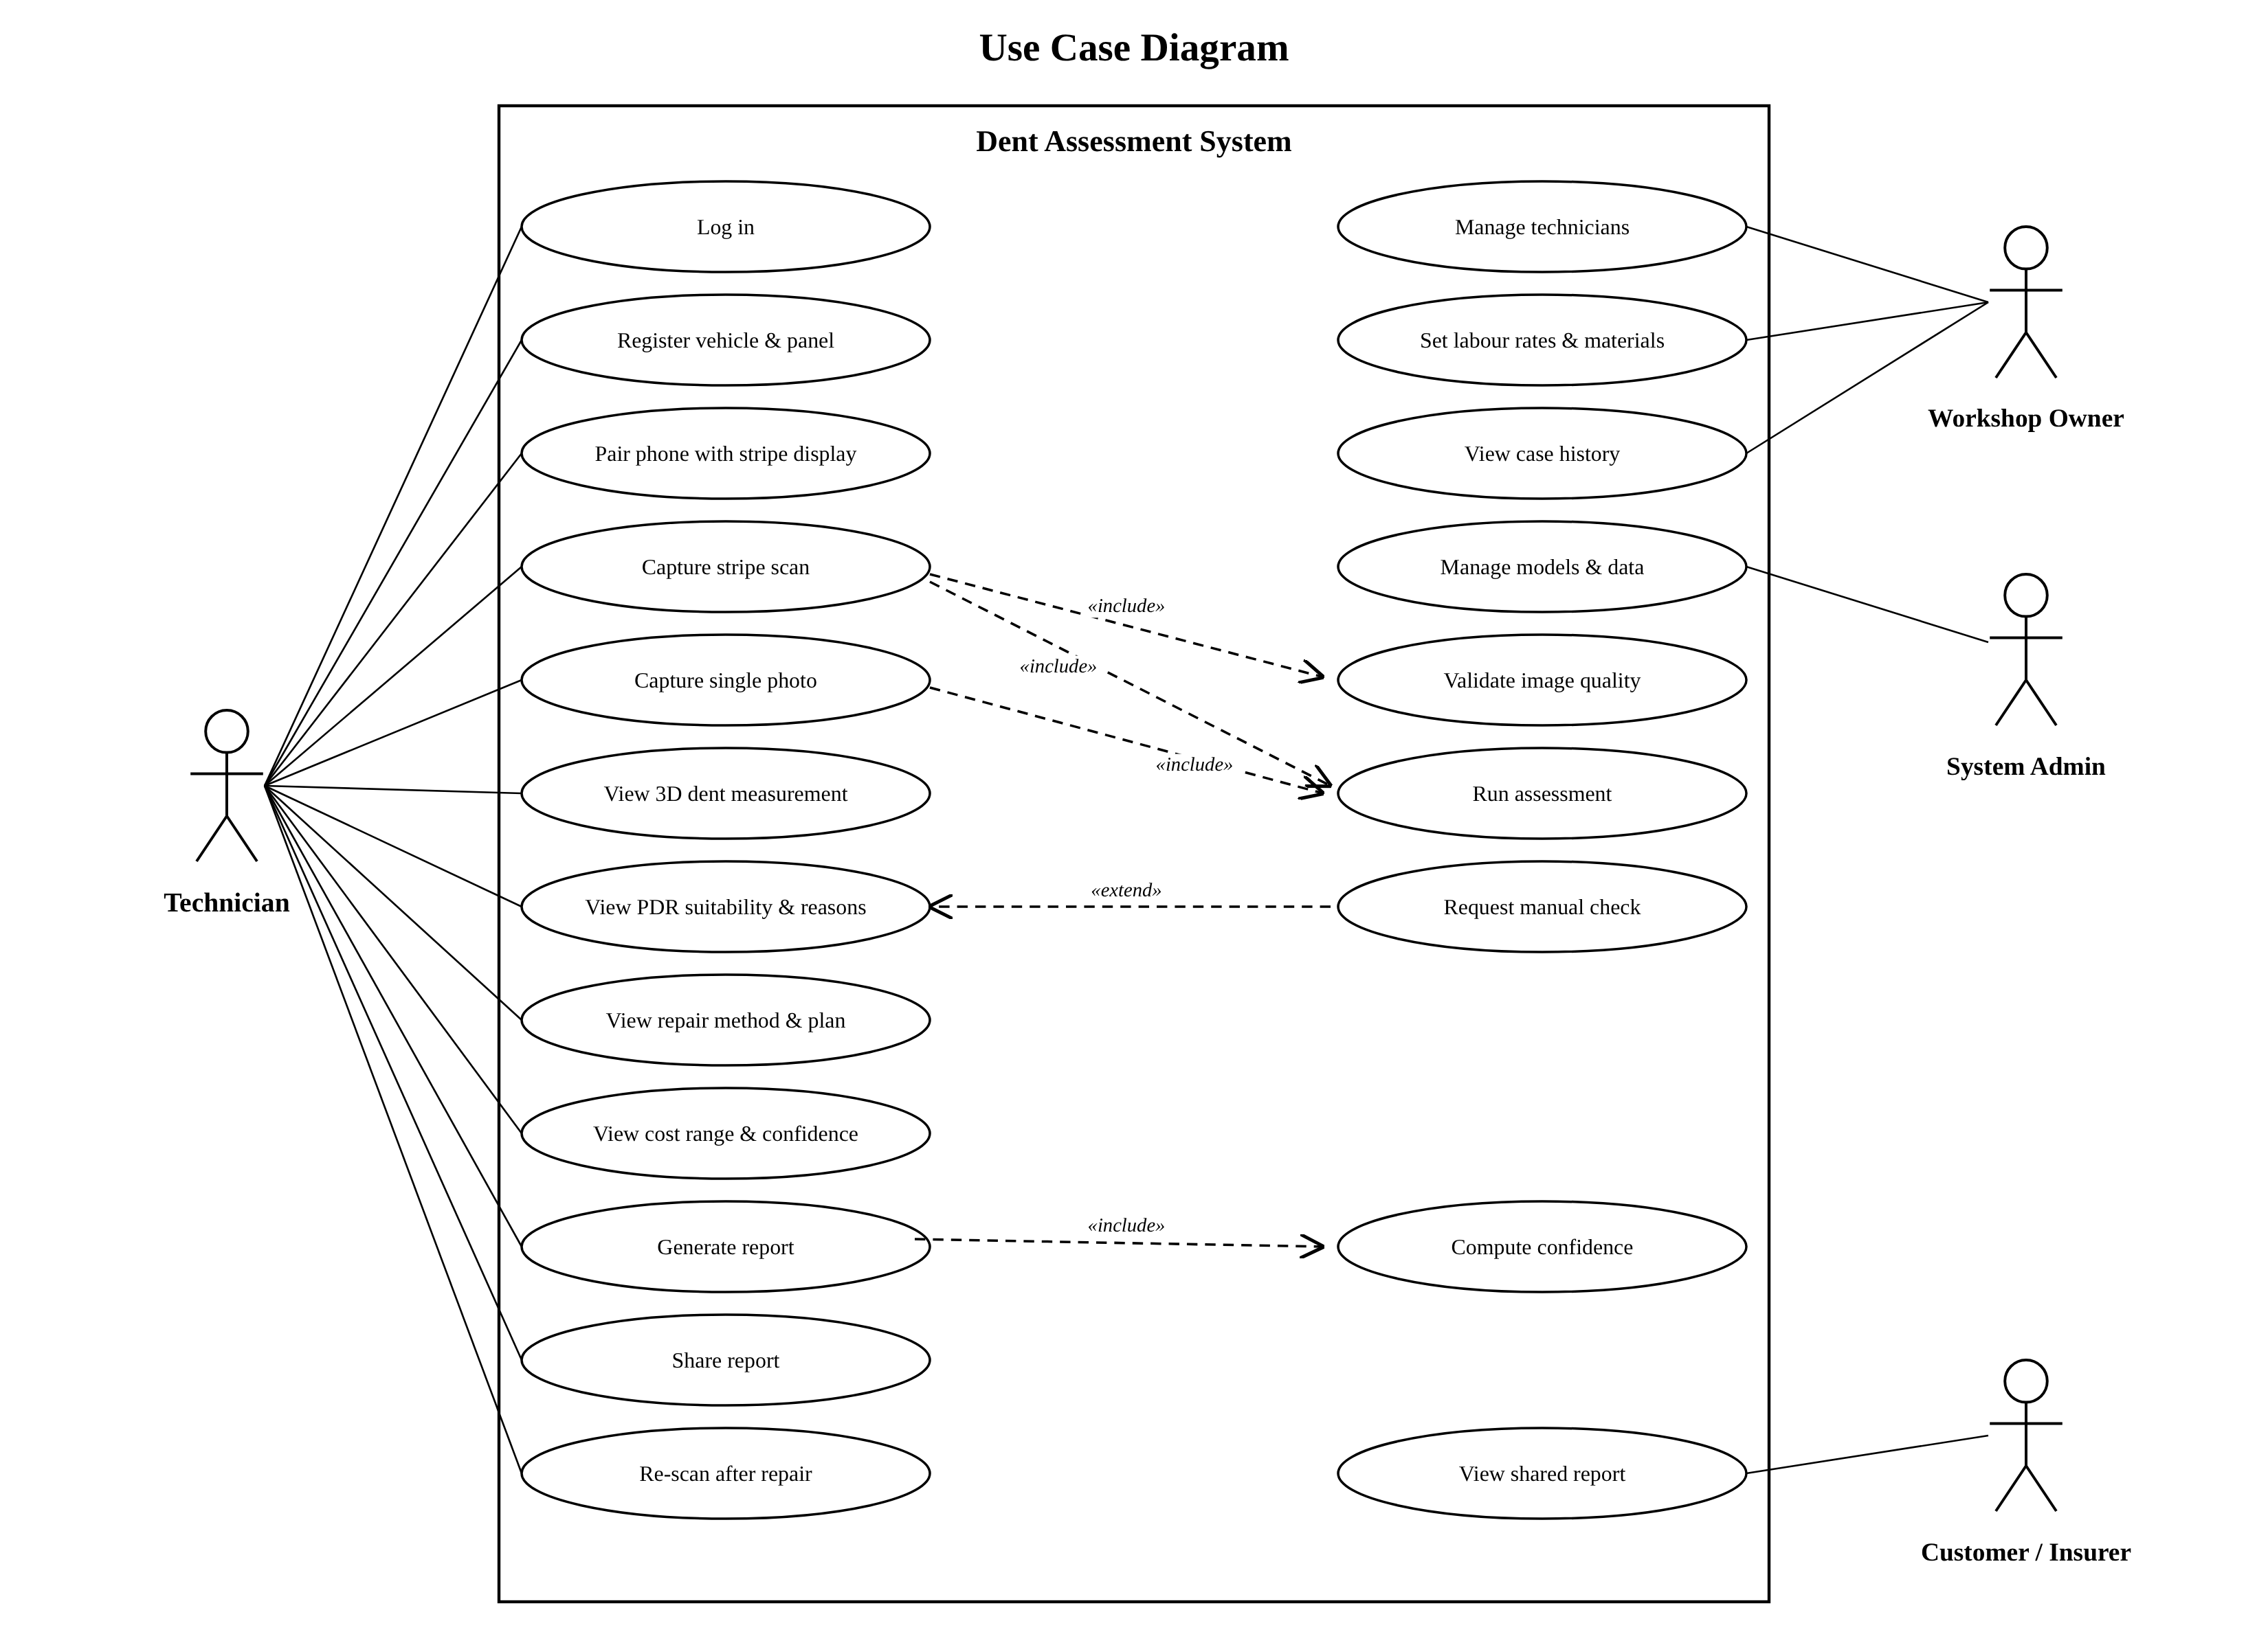
Figure 1: Use case diagram
Table 10: Use case UC-01: Capture stripe scan
Actor | Technician
Precondition | Logged in; case created; phone paired with the stripe display; tripod placed
Main flow | 1. Technician starts capture. 2. Display shows each stripe pattern. 3. Phone captures each image automatically. 4. System checks blur, movement, exposure and fringe modulation. 5. System confirms the set.
Alternative flow | 4a. Quality check fails → system explains the cause and asks for a retake. 4b. Low modulation (matte/wrapped paint) → system proposes single-photo capture (UC-02 fallback).
Postcondition | Valid stripe set stored for the case
Requirements | FR-04, FR-05, FR-06

Table 11: Use case UC-02: Run assessment
Actor | Technician (initiates); analysis server
Precondition | Valid stripe set or single photo stored
Main flow | 1. Technician submits. 2. Server queues a job. 3. C1 (or C2) produces a height map. 4. C3 computes strain and suitability. 5. C4 selects the method and plan. 6. C5 adds probability and cost range. 7. Report is stored and shown.
Alternative flow | 3a. Height map invalid → job fails with reason; case returns to capture. 6a. Probability between 0.2 and 0.8 → manual check flag.
Postcondition | Recommendation and report stored
Requirements | FR-09 to FR-28

Table 12: Use case UC-03: View repair recommendation
Actor | Technician
Precondition | Assessment completed
Main flow | 1. Technician opens the result. 2. System shows 3D view, depth, size and peak strain. 3. System shows verdict and reasons. 4. System shows method, force, tab size, pulls or push plan. 5. System shows success probability and cost range.
Alternative flow | 2a. Single-photo source → lower-confidence banner. 5a. Manual-check flag → system recommends inspection before quoting.
Postcondition | Technician decides the repair
Requirements | FR-12, FR-17, FR-19 to FR-28

Table 13: Use case UC-04: Share report
Actor | Technician; customer or insurer (receiver)
Precondition | Report generated
Main flow | 1. Technician chooses share. 2. System creates a signed link valid for a set time, or a PDF. 3. Receiver opens the report without an account.
Alternative flow | 3a. Link expired → receiver sees an expiry message.
Postcondition | Share recorded
Requirements | FR-29, NFR-09

Table 14: Use case UC-05: Re-scan after repair
Actor | Technician
Precondition | Repair carried out; case in “Repaired” state
Main flow | 1. Technician captures a new stripe set. 2. System reconstructs the height map. 3. System reports residual depth and compares it with the original. 4. Technician records the outcome.
Alternative flow | 3a. Residual depth above target → system suggests further work.
Postcondition | Outcome stored; case closed
Requirements | FR-30, FR-31

3.6 Non-Functional Requirements
Table 15: Non-functional requirements
ID | Category | Requirement and measure
NFR-01 | Accuracy | Dent depth error ≤ 0.5 mm against dial-gauge profiles on test panels
NFR-02 | Accuracy | Strain-based suitability agrees with technicians better than fixed rules (Cohen’s kappa [33])
NFR-03 | Calibration | 90% cost intervals cover ≥ 90% of actual costs; Brier score reported
NFR-04 | Performance | Capture to report in ≤ 60 s on a 4-vCPU server; stripe capture ≤ 20 s
NFR-05 | Performance | API responses (non-analysis) ≤ 500 ms at the 95th percentile
NFR-06 | Usability | SUS score ≥ 68 with at least eight technicians [34]; assessment completed without help
NFR-07 | Usability | Every verdict shows a plain-language reason
NFR-08 | Reliability | Failed jobs are reported with a cause; no silent failure; low confidence flagged
NFR-09 | Security | HTTPS only; JWT authentication; role-based access; shared links expire
NFR-10 | Security | Passwords hashed (bcrypt/argon2); secrets outside source code
NFR-11 | Privacy | Number plates and faces blurred before storage; plate stored only as a hash; consent recorded [32]
NFR-12 | Availability | ≥ 99% during the evaluation period
NFR-13 | Maintainability | Components behind typed interfaces; unit test coverage ≥ 70% for analysis modules
NFR-14 | Portability | Runs in Chrome on Android 10+; server deployable with Docker Compose
NFR-15 | Scalability | Analysis workers scale horizontally through the job queue
NFR-16 | Fairness | Accuracy reported separately for paint colours, lighting and panel types
NFR-17 | Auditability | Each result stores model version, parameters and inputs
NFR-18 | Legal | Open-source licences respected; no proprietary insurer data used

3.7 Data Requirements
The logical data model is shown in the ER diagram (Section 4.6). Images, stripe sets and height maps are stored in object storage and referenced by key; structured results are stored in PostgreSQL. Each measurement records its source (deflectometry or single photo), grid spacing and quality flags. Each recommendation stores method, force, tab size, pulls, plan, reasons, success probability and cost interval. Repair outcomes are stored to evaluate and improve the models. Personal data is minimised: only a hash of the number plate is kept, and data is retained only for the project and research analysis.

3.8 Requirements Traceability
Table 16: Traceability: objectives, requirements, components and tests
Objective | Requirements | Component / owner | Verification
O1 3D measurement | FR-05, 06, 09–12, 30; NFR-01, 04 | C1 · Bandara | Dial-gauge comparison; unit tests T1, T2
O2 Single-photo depth | FR-08, 13, 14; NFR-16 | C2 · David | IoU, height-map MAE on real photos
O3 PDR suitability | FR-15–18; NFR-02, 07 | C3 · Dissanayaka | Solver verification T3; agreement with technicians T4
O4 Method and plan | FR-19–24 | C4 · Senevirathne | Rule tests T5, T6; actual repairs
O5 Confidence | FR-25–27; NFR-03 | C5 · Liyanage | Coverage test T7; Brier score
O6 Technician app | FR-01–04, 07, 28, 29, 31; NFR-05, 06, 09–11 | C5 · Liyanage | API test T8; SUS study
O7 Validation | FR-30, 31; NFR-01–03, 06 | All members | Test panels, workshop cases, repair check

4. System Design

4.1 System Overview
The figure below gives the overview of the entire system. The technician’s phone and a laptop screen capture the dent; the analysis server reconstructs it in 3D (C1, or C2 as fallback), checks PDR suitability (C3), selects and plans the repair (C4), and attaches confidence (C5). The report goes to the technician, who makes the final decision and may share it with the customer or insurer.
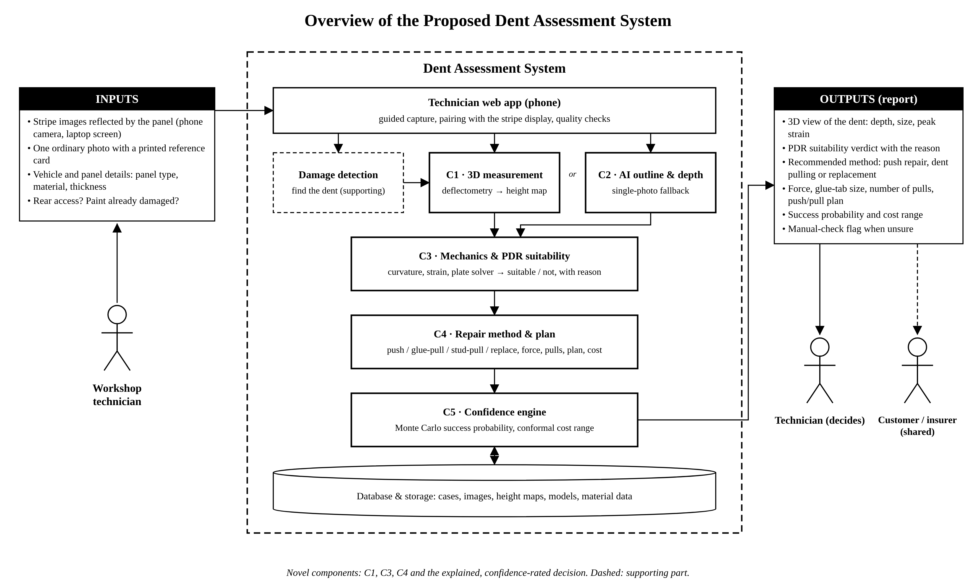
Figure 2: Overview diagram of the proposed system

4.2 Context and Data Flow
The context diagram shows the four external entities, and the level-1 DFD decomposes the system into eight processes and five data stores; note that the single-photo route (process 3.0) and the deflectometry route (2.0) both deliver a height map to the strain analysis (4.0).
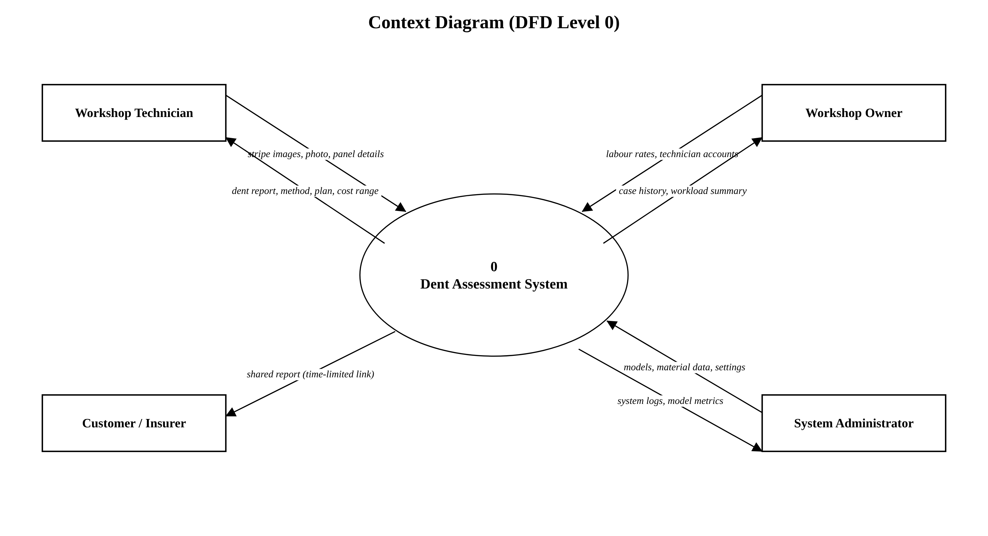
Figure 3: Context diagram (DFD level 0)
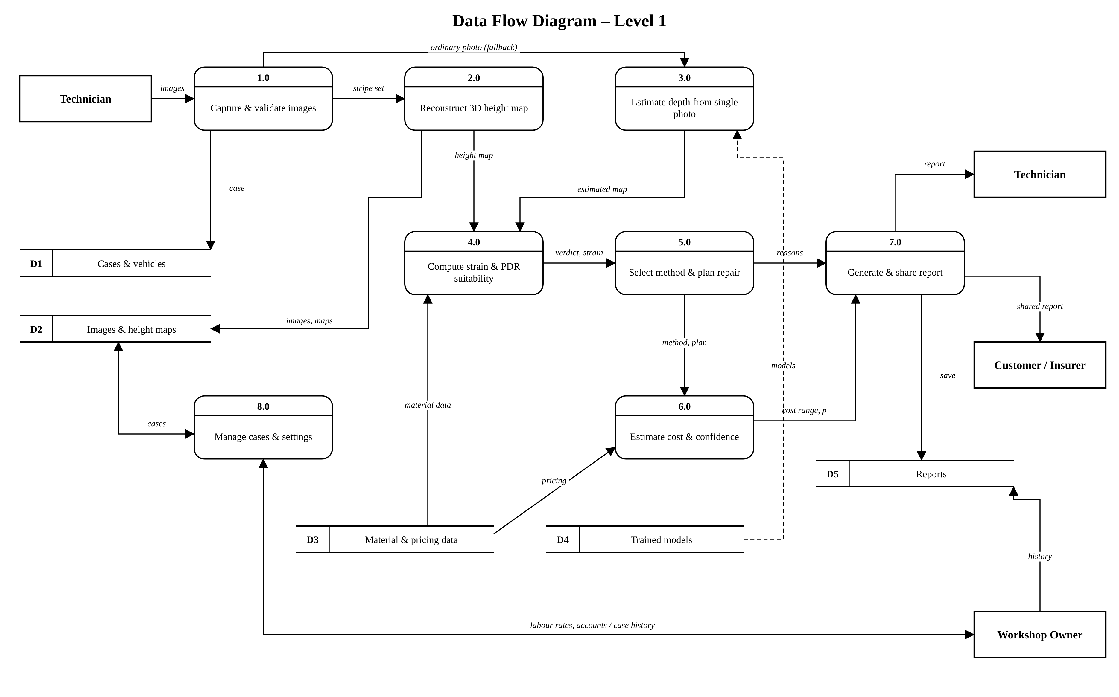
Figure 4: Data flow diagram, level 1

4.3 Activity Diagrams
The first activity diagram shows the end-to-end assessment workflow across the technician, the app and the server, including the image quality loop and the manual-check decision. The second details the repair-method selection logic of Component 4.
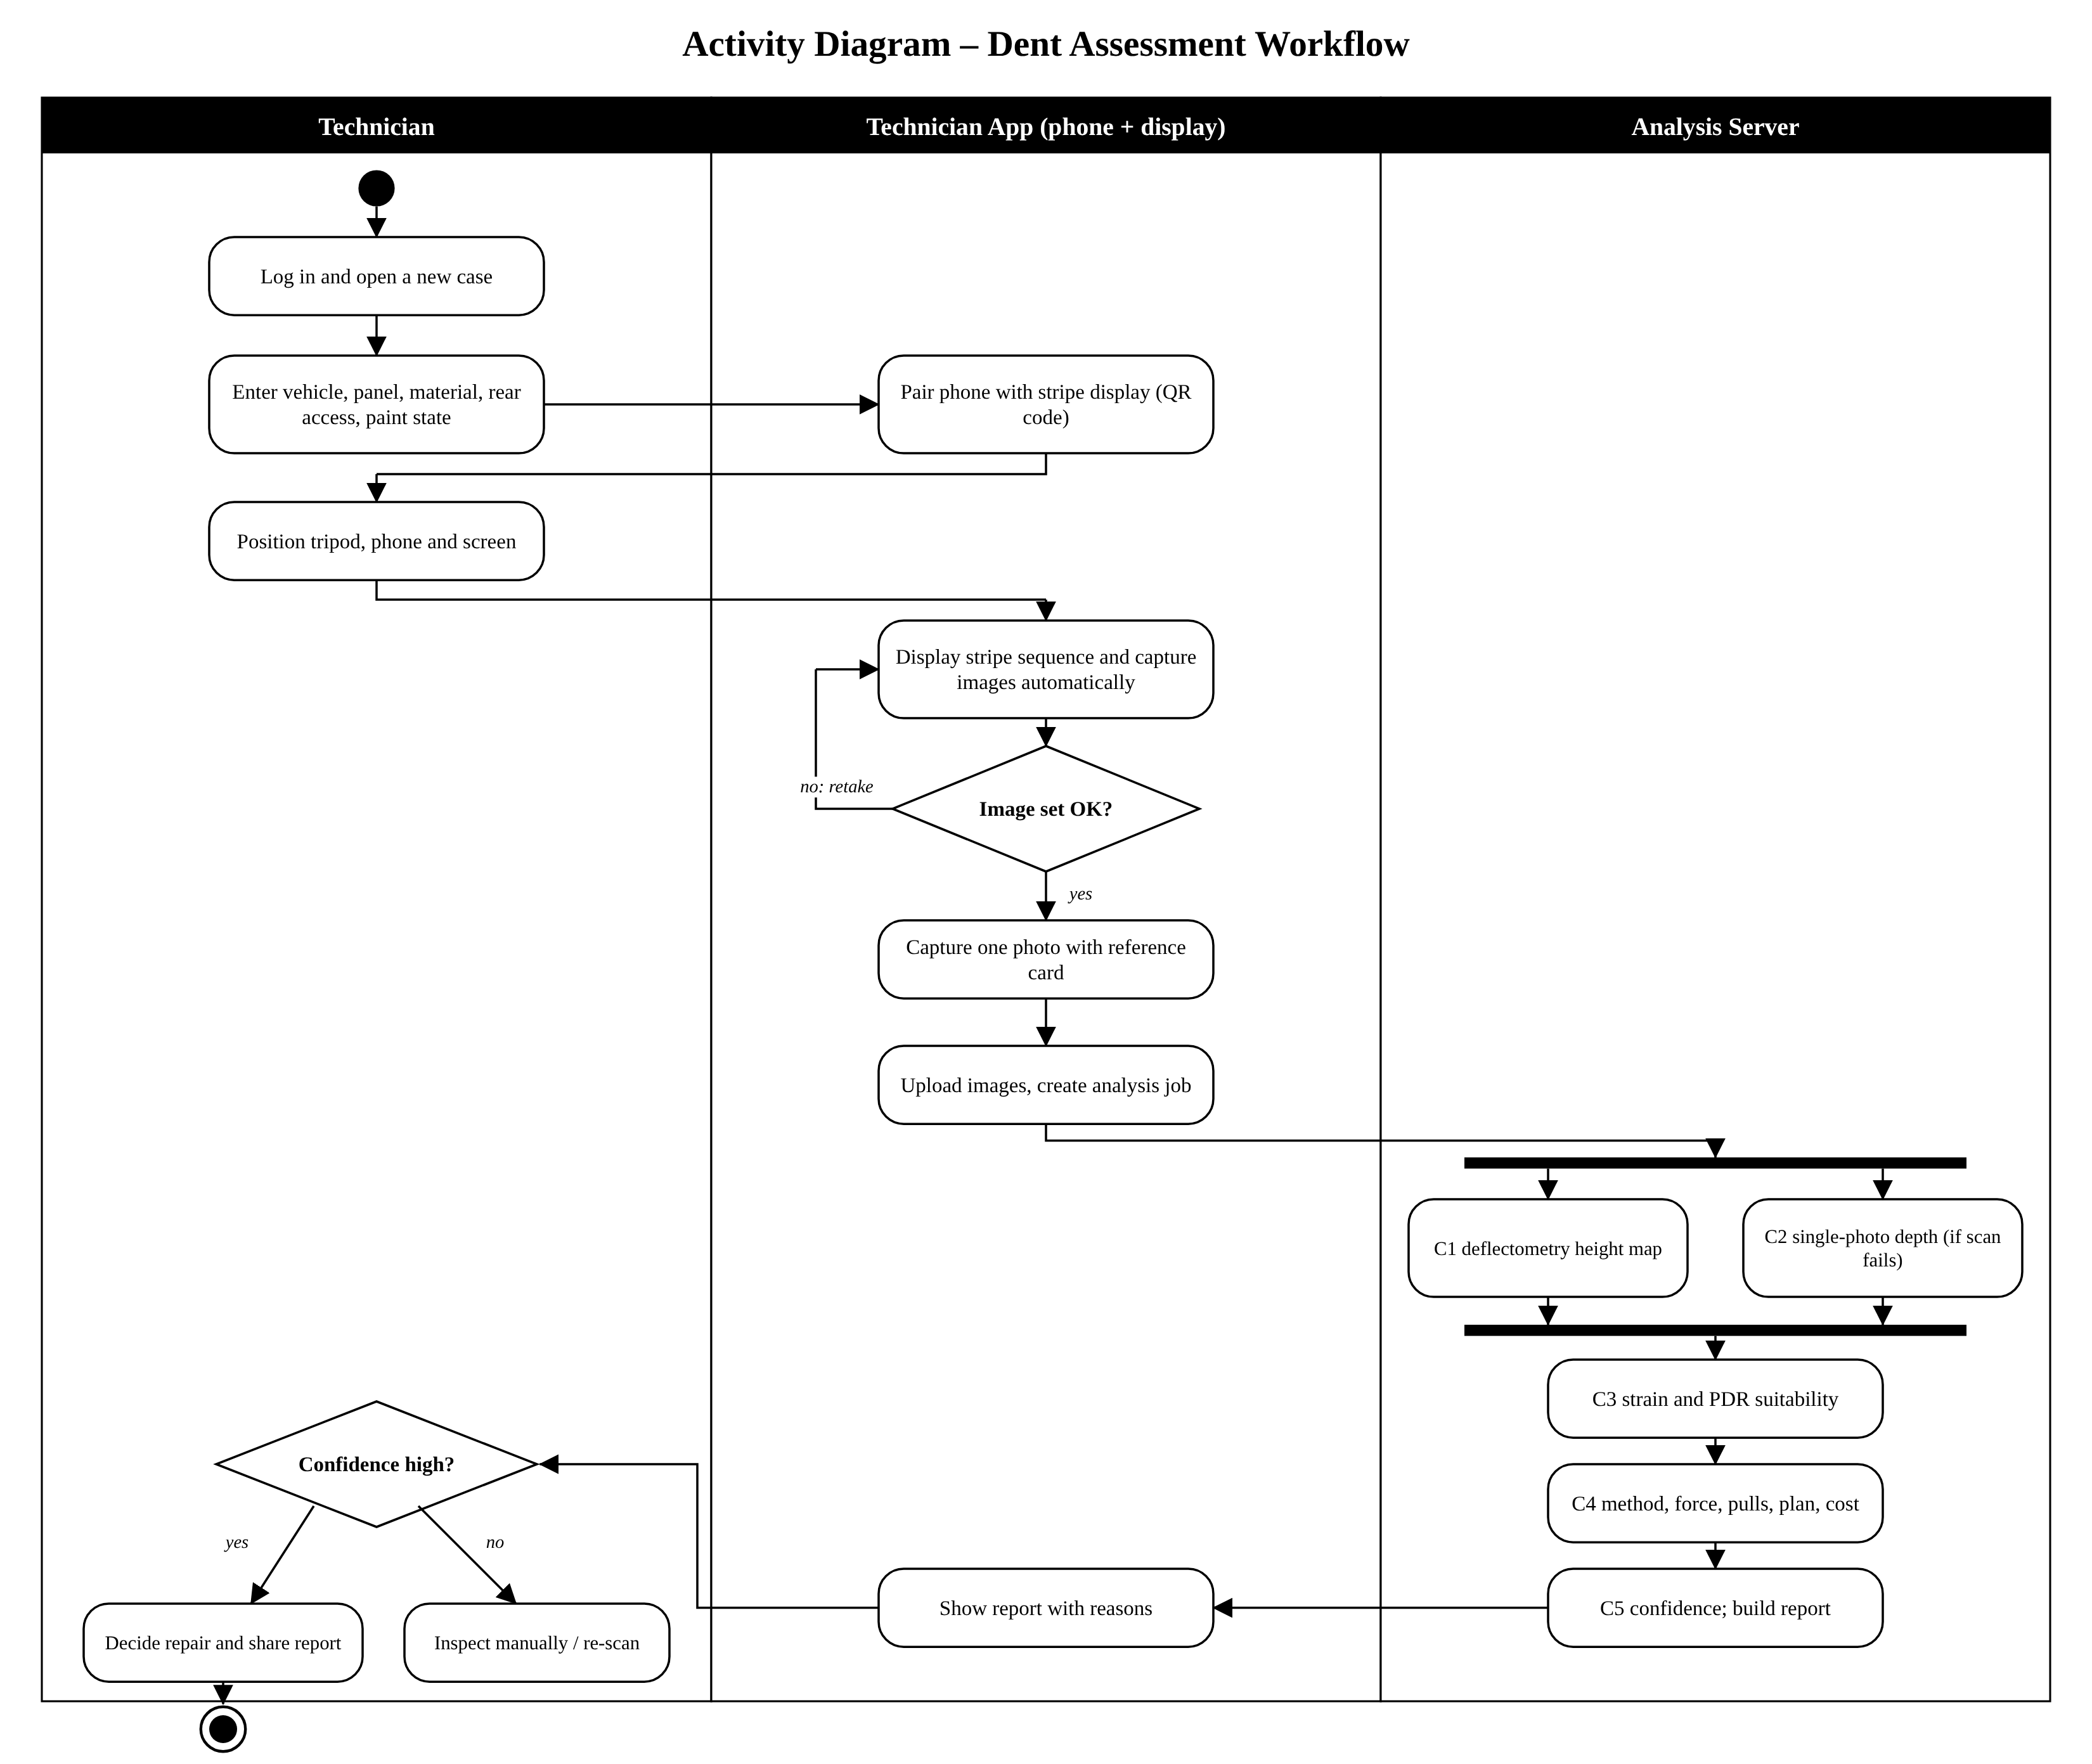
Figure 5: Activity diagram: dent assessment workflow
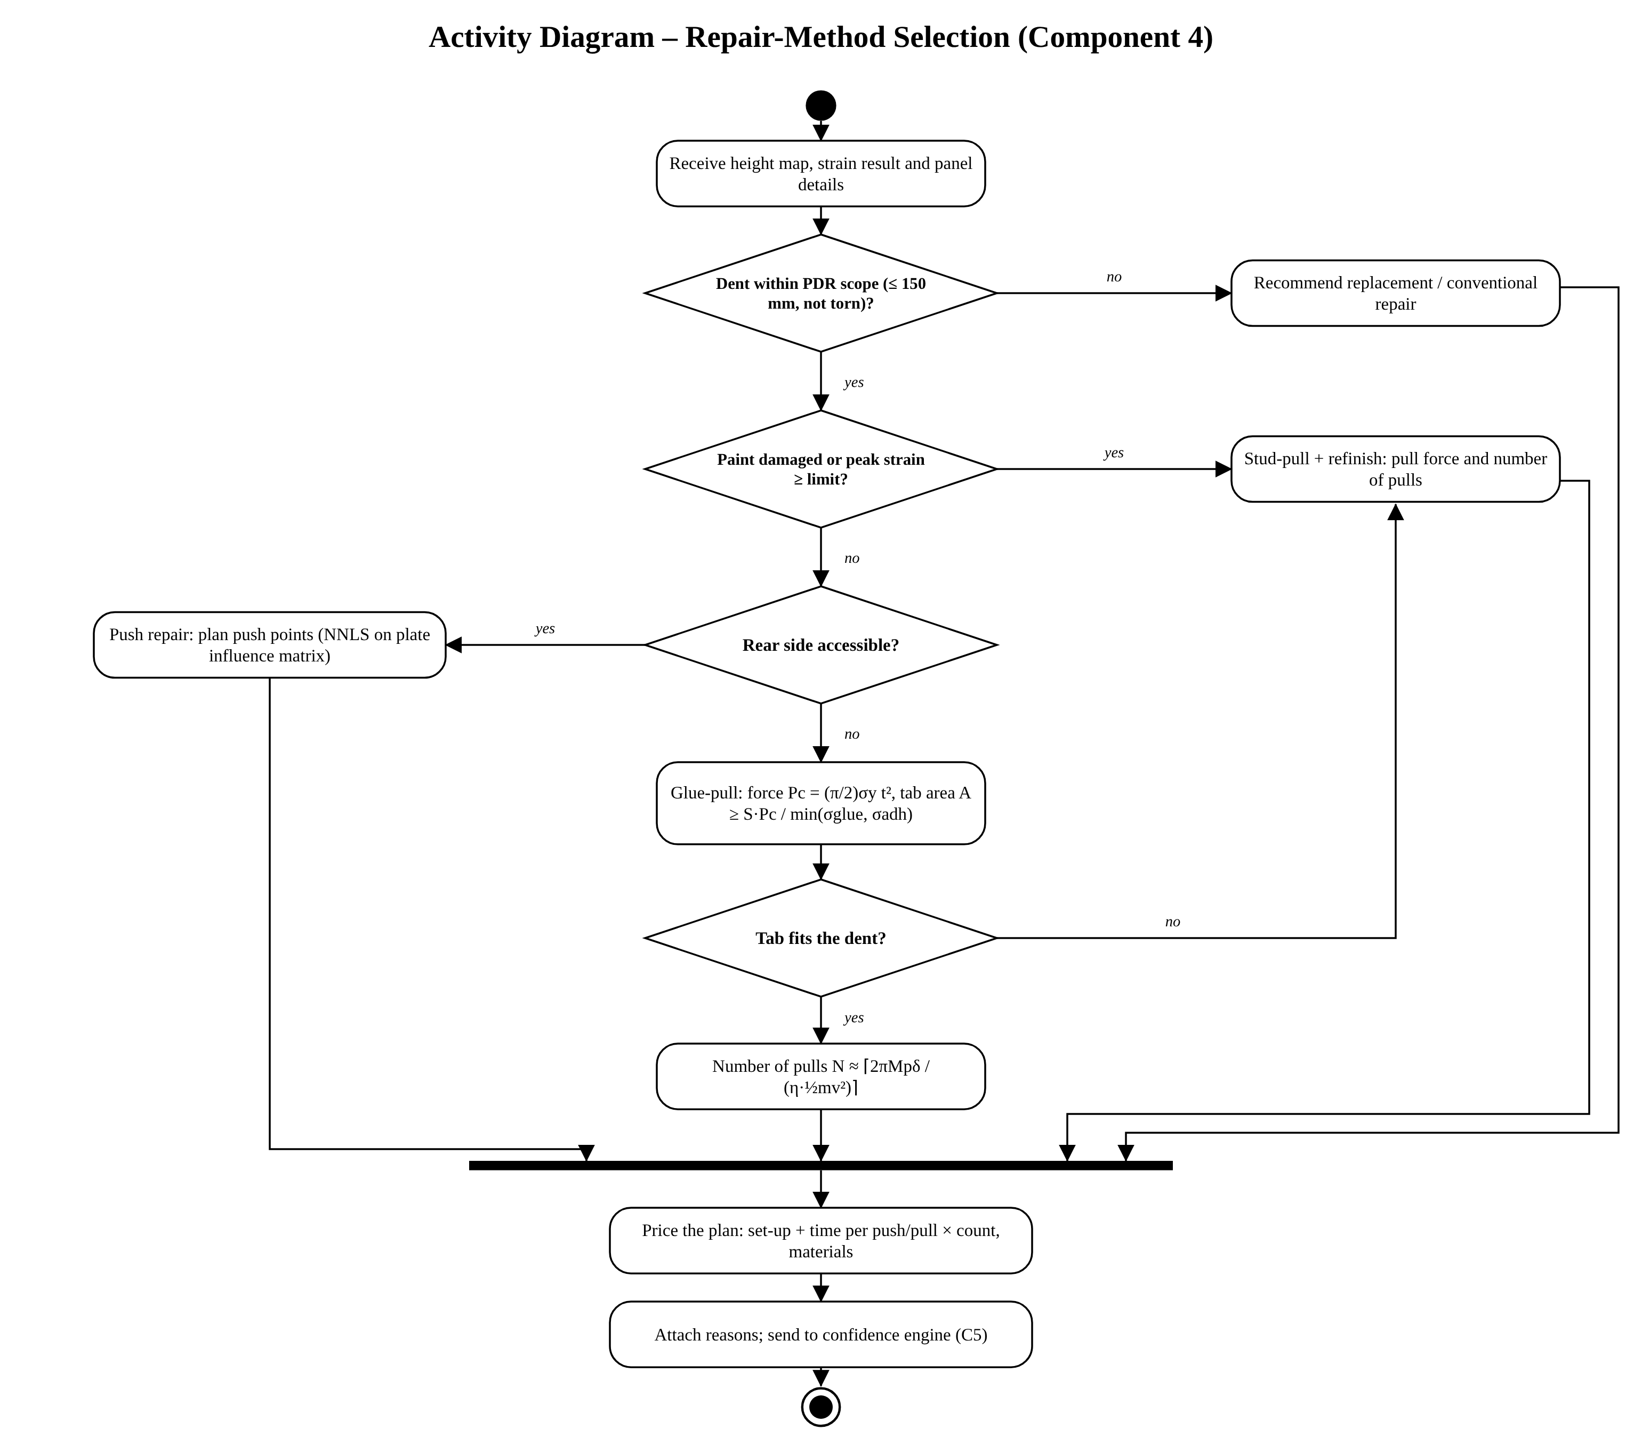
Figure 6: Activity diagram: repair-method selection

4.4 Sequence Diagram
The sequence diagram shows the interactions for one assessment. Analysis runs asynchronously: the API returns a job identifier immediately (HTTP 202) and the app polls until the report is ready, so long computations do not block the user interface.
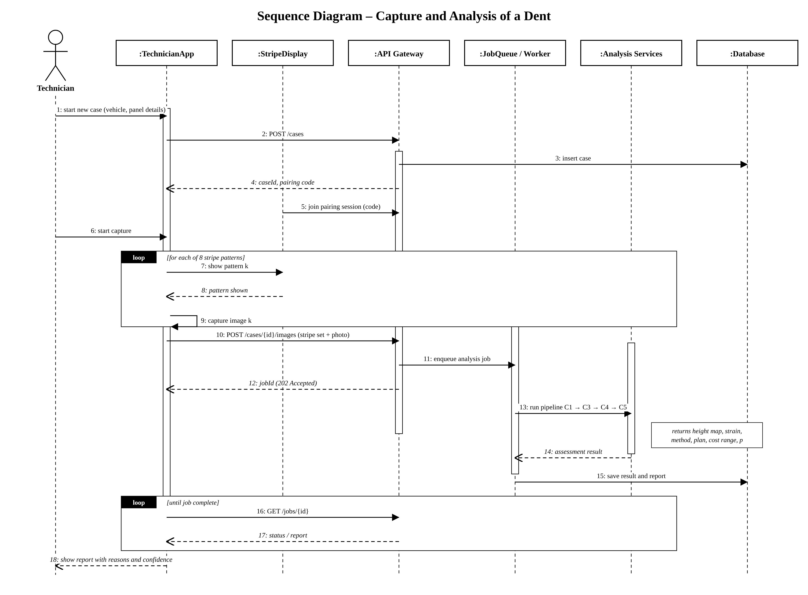
Figure 7: Sequence diagram: capture and analysis of a dent

4.5 Class Diagram
The class diagram shows the domain and analysis classes. The HeightSource interface is implemented by Deflectometry and SinglePhotoUNet, so the mechanics and planning code is independent of how the height map was obtained.
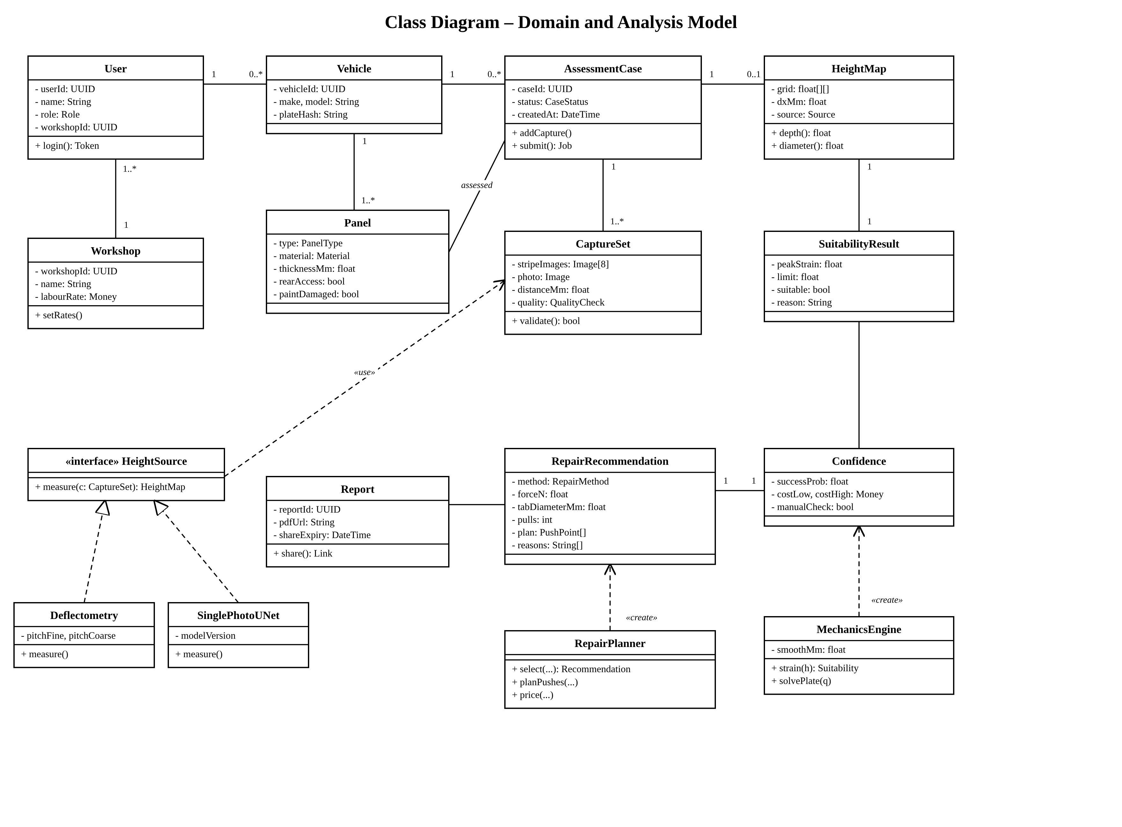
Figure 8: Class diagram

4.6 Database Design
The ER diagram shows the database design. The MEASUREMENT table separates the measured shape from the case so that a case can have both an initial scan and a re-scan after repair; REPAIR_OUTCOME stores what was actually done, which is needed to evaluate and calibrate the system.
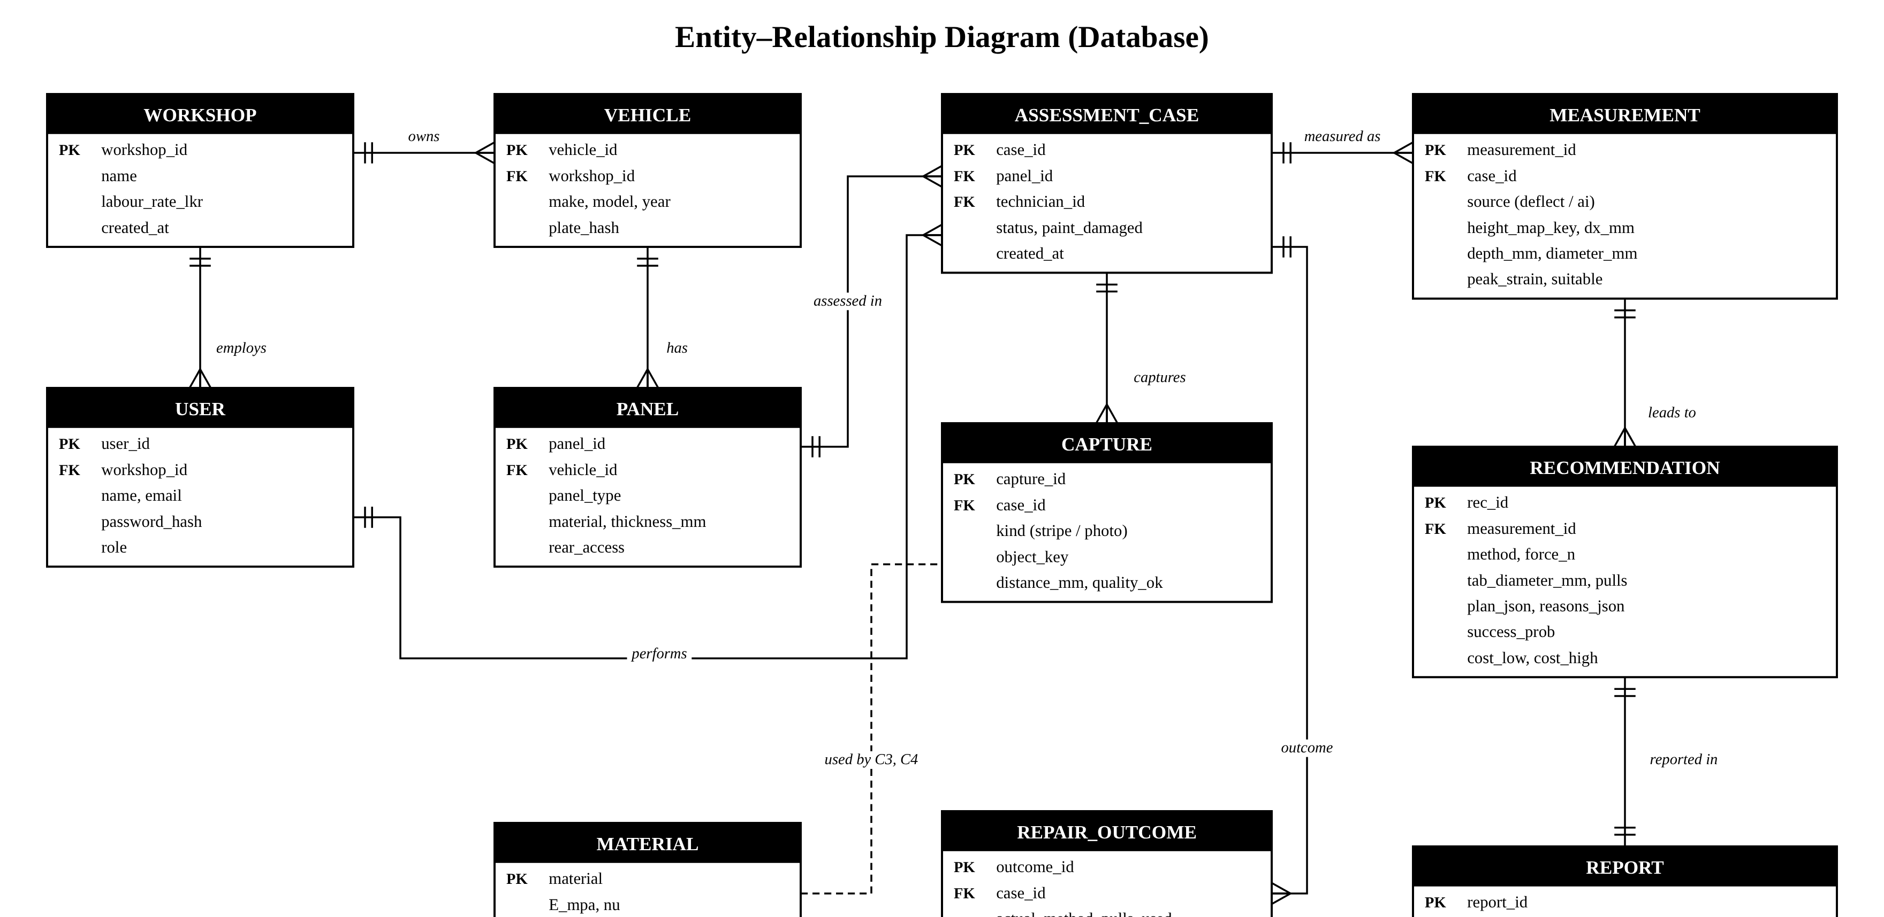
Figure 9: Entity–relationship diagram

4.7 State Machine
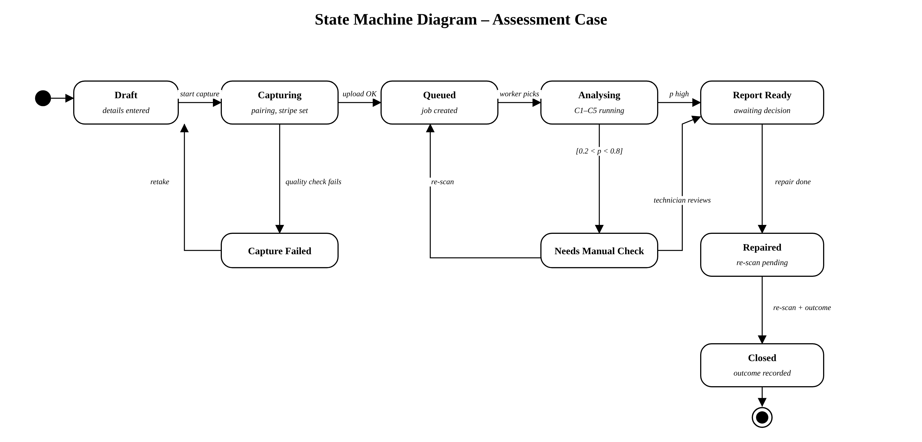
Figure 10: State machine diagram of an assessment case

4.8 Deployment Architecture
The server runs as Docker containers on one cloud virtual machine: an Nginx proxy for HTTPS and static files, the FastAPI gateway, Celery workers that run the analysis components, Redis as the job queue, PostgreSQL and MinIO object storage. Clients are browsers only, so no app-store installation is needed.
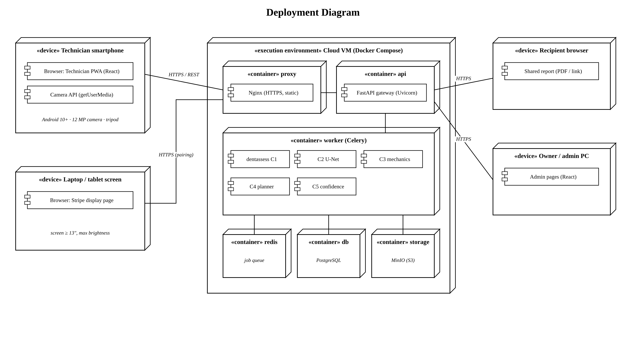
Figure 11: Deployment diagram

4.9 Algorithm Design

Component 1: 3D measurement
The pipeline is shown below. The phase at each pixel follows from the four phase-shifted intensities [21]; the fine phase is unwrapped using the coarse phase; the phase change gives the slope, where p is the stripe period and d the screen-to-panel distance; and the height map is obtained by solving a Poisson equation with the FFT [23].
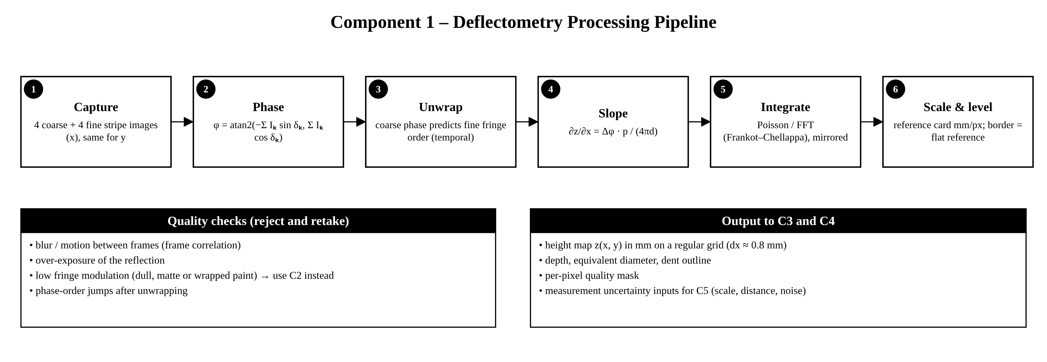
Figure 12: Component 1 deflectometry processing pipeline
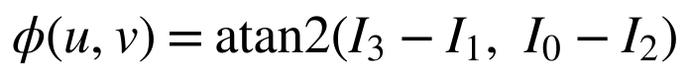
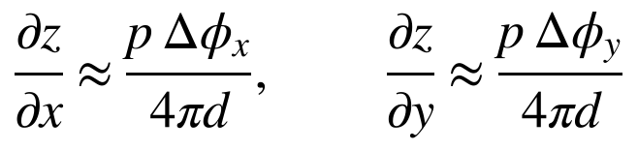
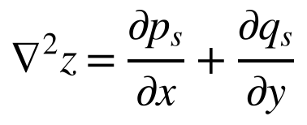

Component 2: single-photo depth
A U-Net [25] with two heads predicts a dent mask and a height map, trained on synthetic dents and fine-tuned on real photos labelled by deflectometry, with the combined loss:

Component 3: strain and PDR suitability
After light smoothing, bending strain is estimated from the maximum principal curvature and membrane strain from the slope; PDR is suitable when the total stays below the paint cracking strain with a safety margin. The thin-plate equation is solved by finite differences with a 13-point stencil and clamped edges [26].
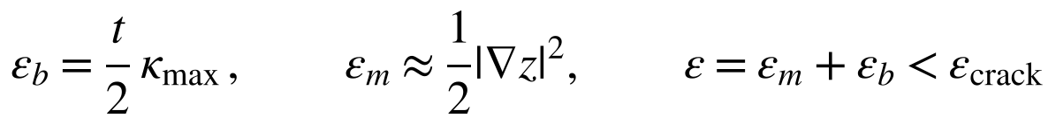
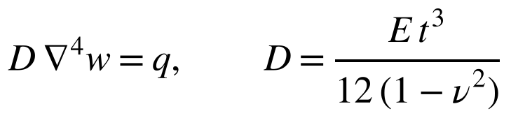

Component 4: repair method, force and pulls
The collapse force follows from yield-line theory [27]; the glue tab must keep the pull stress below the glue strength and the paint adhesion; and the number of slide-hammer pulls follows from the plastic work needed to restore a dent of depth δ. Push points are planned with non-negative least squares on the plate influence matrix.
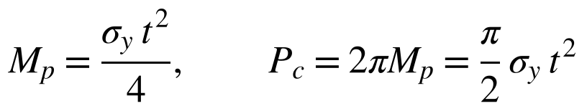
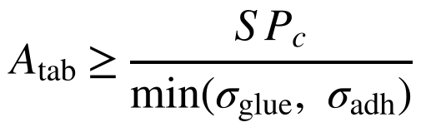
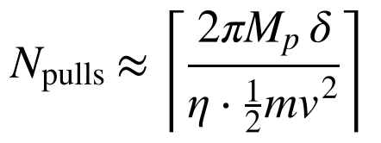

Component 5: confidence
The success probability is the share of Monte Carlo runs [28] in which the peak strain stays below the sampled cracking strain, and the cost interval uses split conformal prediction [29]:


4.10 Repair Check After PDR
Workshops do not test strength after PDR [2]. The system therefore uses a non-destructive field check on customers’ vehicles and proves strength with laboratory tests on scrap test panels only.
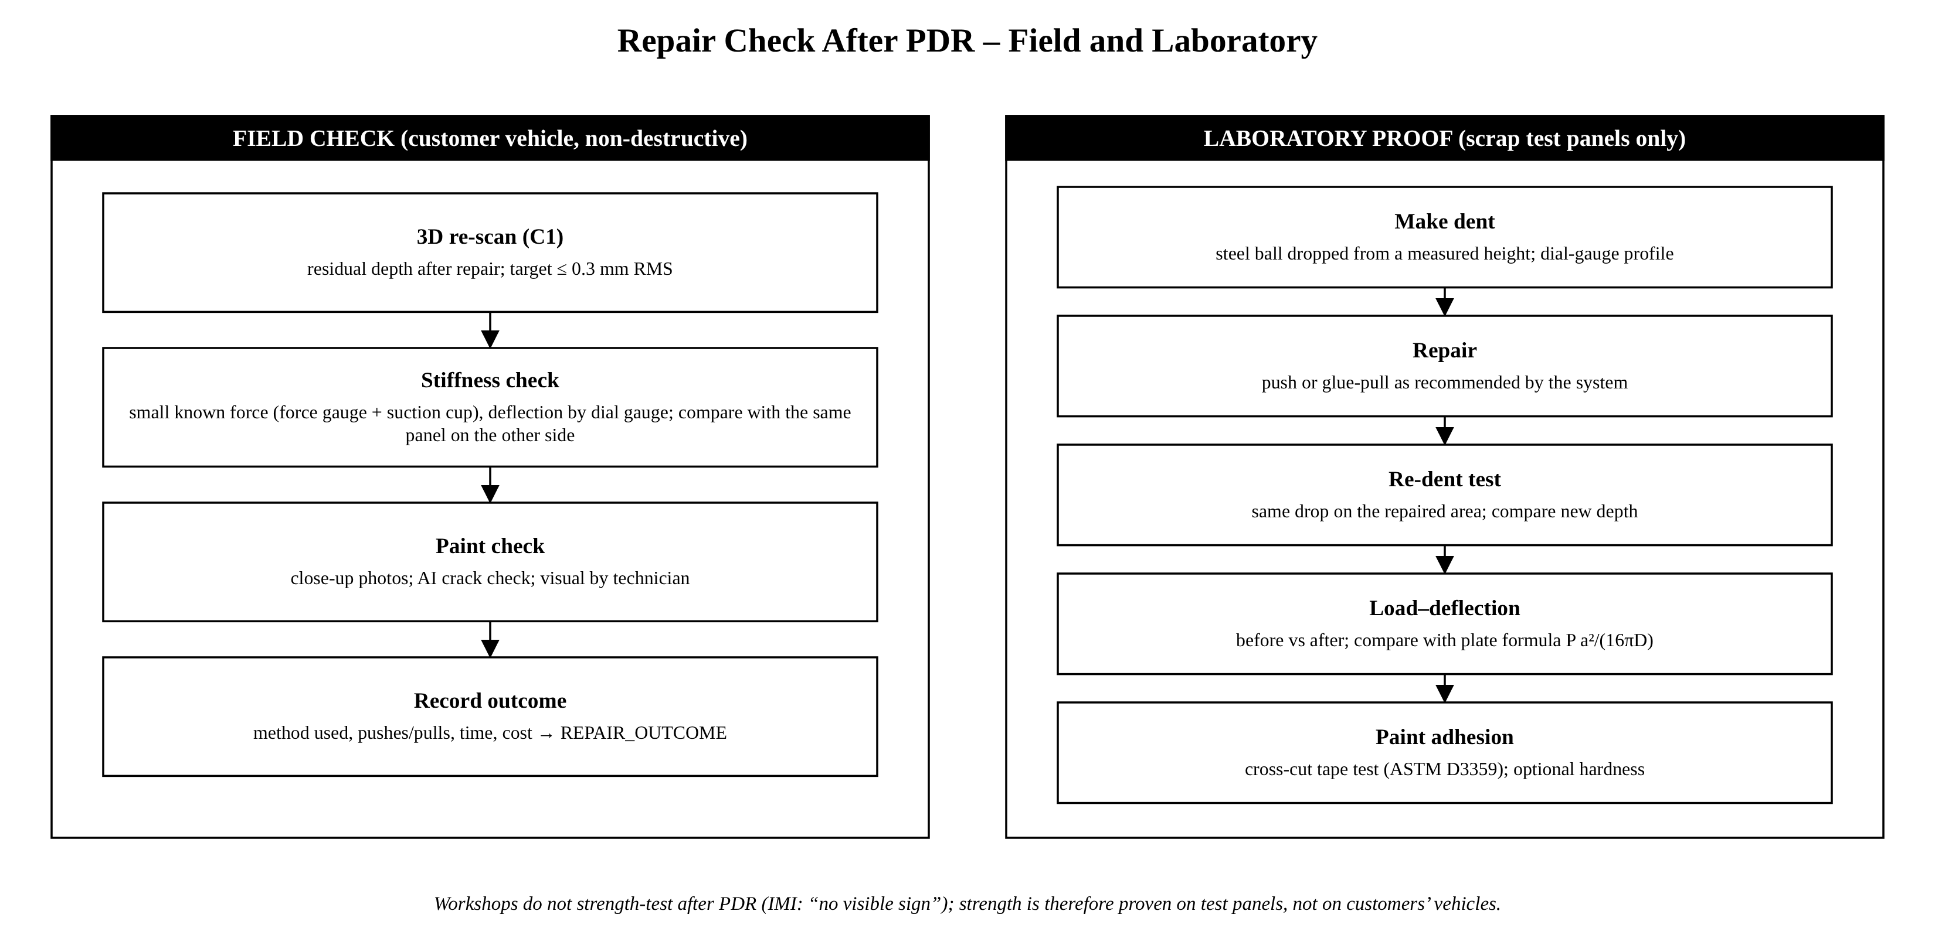
Figure 13: Repair check after PDR: field and laboratory

5. Implementation Progress

5.1 Prototype Overview
An early prototype of the core algorithms has been implemented in Python as the package dentassess, with a FastAPI service and automated tests. All results in this chapter use simulated dents with exact height maps; they verify the algorithms and the code, not yet the real-world accuracy, which will be measured on test panels in the next phase.
Table 17: Implemented modules
Module | Implemented functions | Status
synthetic.py | Synthetic dents (depth, size, sharpness, elongation) and panel waviness | Done
deflectometry.py | Stripe simulation, N-step phase, two-period temporal unwrapping, slope, Frankot–Chellappa integration, levelling | Done (simulated)
mechanics.py | Principal curvatures, bending and membrane strain, crease score, suitability check, clamped-plate FD solver, verification | Done
repair.py | Yield-line force, glue-tab area, number of pulls, method selection with reasons, NNLS push planning | Done (rules to be calibrated)
confidence.py | Monte Carlo success probability, split-conformal half-width, Brier score | Done
pipeline.py | End-to-end assessment returning an explained report | Done
app/main.py | FastAPI: /api/health, /api/assess/synthetic, /api/solver/verify | Prototype
tests/test_core.py | 8 automated tests (pytest) | All passing

5.2 3D Measurement by Deflectometry
The deflectometry module was tested on ten simulated dents from 1 to 10 mm deep. Each measurement used a fine stripe period of 40 mm and a coarse period of 400 mm at a 150 mm screen distance, camera noise of 5% of the fringe amplitude, and a random calibration error of up to ±2% in the assumed screen distance. The figures below show the processing stages and the accuracy.
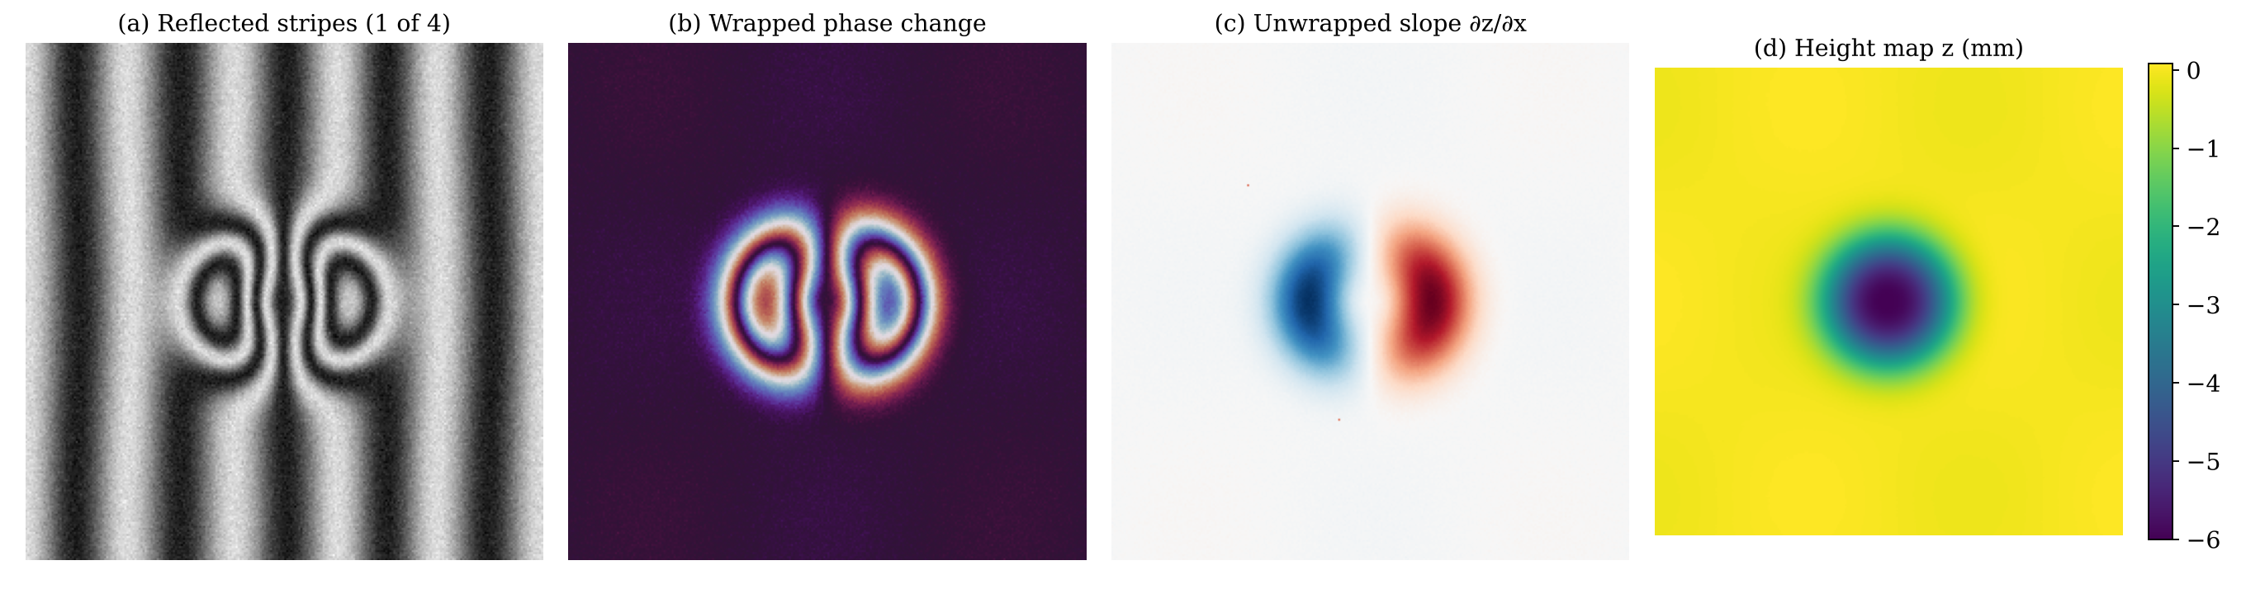
Figure 14: Prototype deflectometry stages on a simulated 6 mm dent
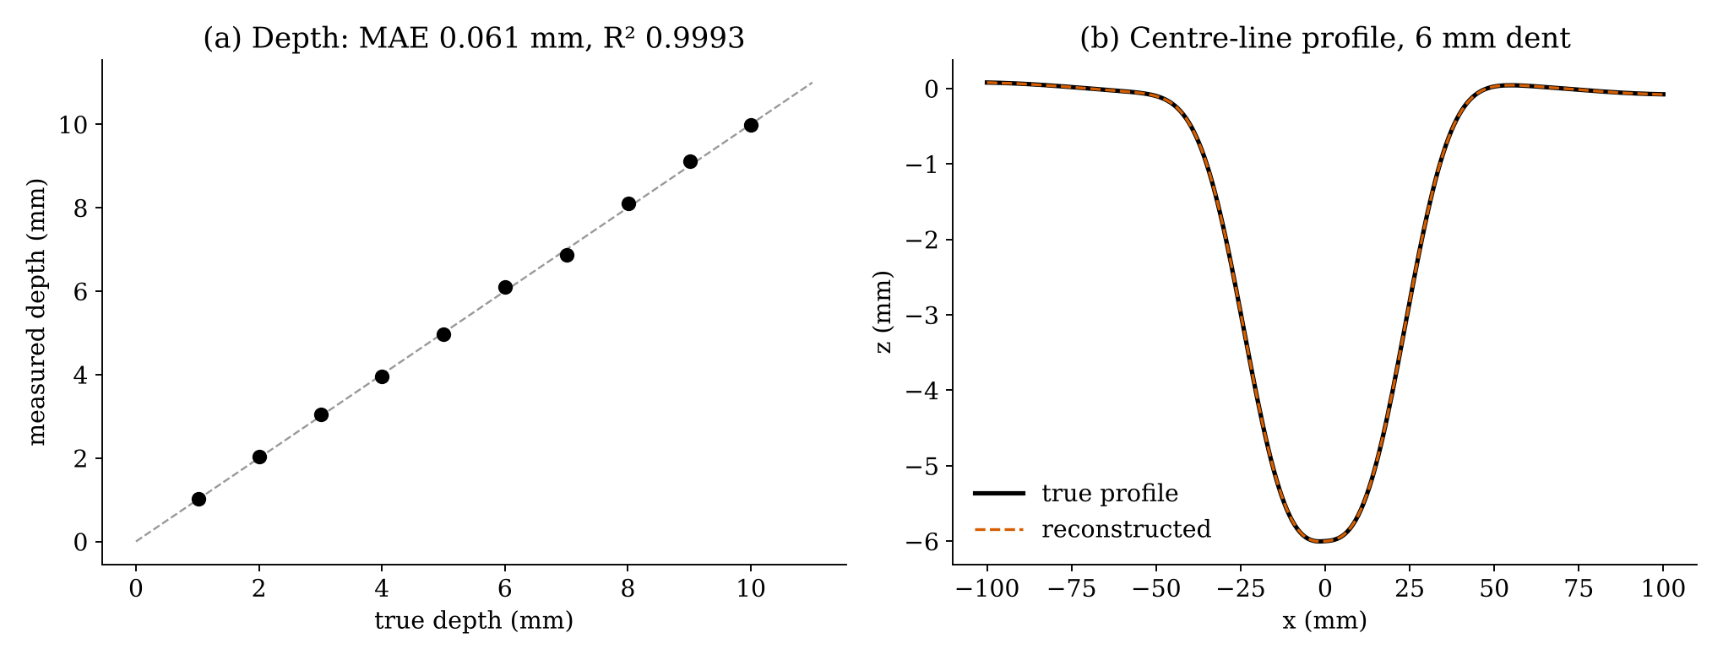
Figure 15: Measured versus true depth (10 simulated dents) and a centre-line profile
Table 18: Depth reconstruction results (simulated, noise 5%, distance error up to ±2%)
True depth (mm) | Measured (mm) | Error (mm) | Map MAE (mm) | Distance error
1.014 | 1.020 | 0.006 | 0.002 | +0.50%
2.008 | 2.039 | 0.031 | 0.003 | +1.59%
3.014 | 3.050 | 0.035 | 0.006 | +1.10%
4.003 | 3.958 | 0.045 | 0.003 | −1.10%
5.006 | 4.965 | 0.041 | 0.004 | −0.80%
6.005 | 6.095 | 0.090 | 0.006 | +1.49%
7.004 | 6.866 | 0.138 | 0.017 | −1.98%
8.002 | 8.105 | 0.103 | 0.005 | +1.28%
9.005 | 9.110 | 0.105 | 0.009 | +1.19%
10.003 | 9.992 | 0.011 | 0.002 | −0.13%
Mean |  | 0.061 |  | R² = 0.9993

The errors are dominated by the calibration error, which scales the slope and therefore the depth, rather than by camera noise. This confirms that accurate measurement of the screen distance and of the reference-card scale is the key calibration task for the real system.

5.3 Plate Solver Verification
The finite-difference solver was verified against the exact centre deflection of a clamped circular plate (radius 50 mm, 0.7 mm steel). The error decreases as the grid is refined, as expected for a consistent scheme.
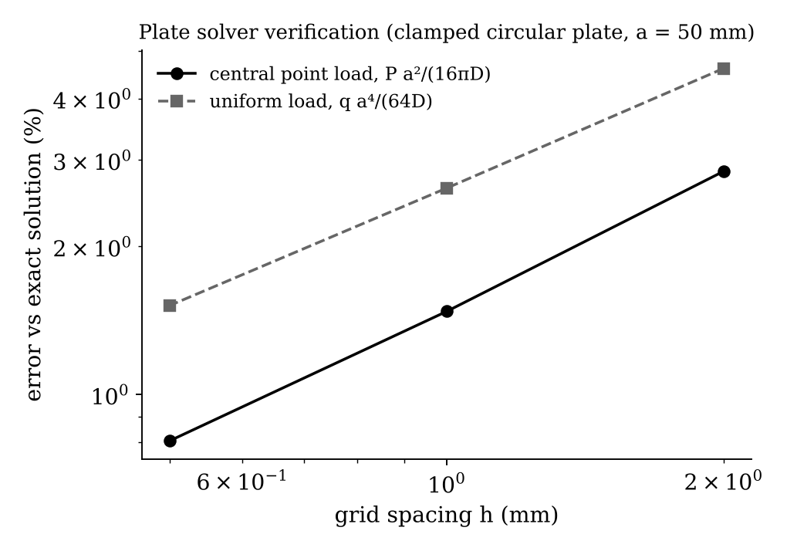
Figure 16: Plate solver error versus grid spacing
Table 19: Plate solver verification
Grid spacing h | Point load: error vs P a²/(16πD) | Uniform load: error vs q a⁴/(64D)
2.0 mm | 2.84% | 4.60%
1.0 mm | 1.47% | 2.63%
0.5 mm | 0.80% | 1.52%

5.4 PDR Suitability and Repair Method
The figure below shows how the peak strain varies with dent depth and size for 0.7 mm steel. Shallow, wide dents fall below the strain limit (suitable), while deep, narrow dents exceed it. The 0.8% limit used here (80% of an assumed 1% cracking strain) is a placeholder; the real limit will be calibrated on painted test panels.
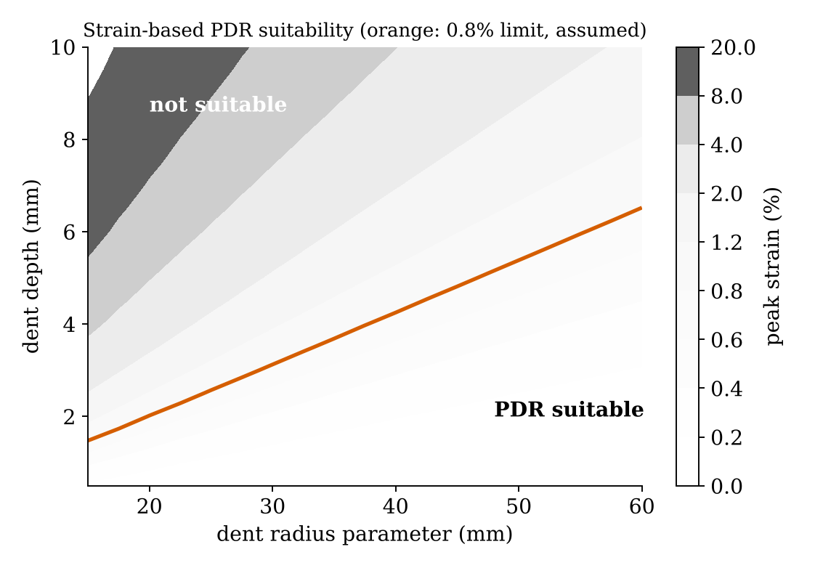
Figure 17: Peak strain map and the assumed PDR suitability limit
Table 20: End-to-end assessments produced by the prototype (simulated dents)
Case | Depth / size | Peak strain | P(success) | Recommendation and reason
Shallow door dent, rear access | 1.5 mm / 110 mm | 0.12% | 1.00 | Push repair: strain below limit; rear side accessible
Shallow roof dent, no rear access | 1.8 mm / 124 mm | 0.14% | 1.00 | Glue-pull: 20 mm tab, about 2 pulls, force 154 N
Sharp crease | 6.0 mm / 43 mm | 16.1% | 0.00 | Stud-pull + refinish: paint likely to crack
Dent with damaged paint | 3.0 mm / 94 mm | 0.56% | 0.96 | Stud-pull + refinish: paint already damaged

For 0.7 mm mild steel with a yield strength of 200 MPa the prototype gives a collapse force of 153.9 N and, with a safety factor of 2 and an adhesion strength of 1 MPa, a minimum glue-tab area of 308 mm² (about 20 mm diameter), consistent with common PDR tab sizes.

5.5 Prototype API and Tests
The FastAPI prototype exposes the full pipeline. A request to POST /api/assess/synthetic with a dent depth, size and panel description returns a JSON report containing depth, diameter, peak strain, suitability, success probability, method, reasons, force, tab size, number of pulls and a manual-check flag. The table below lists the automated tests.
Table 21: Automated tests (pytest 9.0, all passing)
ID | Test | What it verifies | Result
T1 | test_phase_shift_recovers_phase | 4-step algorithm returns the exact phase | Pass
T2 | test_reconstruction_depth_within_half_mm | Depth error ≤ 0.5 mm with noise and 2% calibration error | Pass
T3 | test_plate_solver_matches_exact_solution | Solver within 3–4% of exact plate solutions | Pass
T4 | test_flat_panel_is_suitable_and_deep_crease_is_not | Suitability check behaves correctly at both extremes | Pass
T5 | test_yield_line_force_example | Pc = 153.9 N for 0.7 mm, 200 MPa | Pass
T6 | test_method_selection_rules | Push, glue-pull, stud-pull and replacement chosen correctly | Pass
T7 | test_conformal_coverage | Average interval coverage ≥ 0.895 for α = 0.1 | Pass
T8 | test_api_end_to_end | API health and full assessment request | Pass

5.6 Limitations of the Current Prototype
- All results are on simulated dents; real stripe capture on car paint has not yet been tested.
- The suitability limit and the glue and adhesion strengths are literature-based placeholders awaiting calibration.
- The plate model is linear-elastic; plastic behaviour is approximated through yield-line theory only.
- The single-photo network (C2) and the technician user interface are not yet implemented.

6. Project Plan

6.1 Work Breakdown Structure
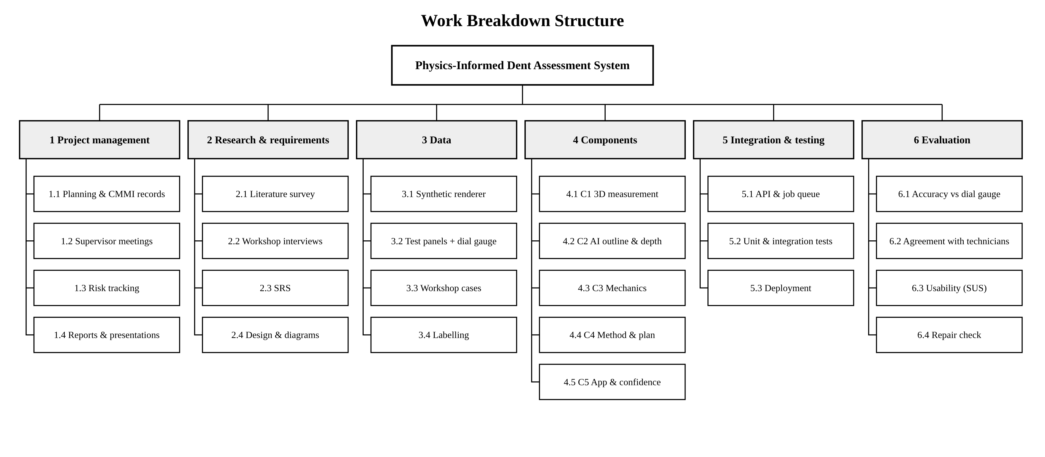
Figure 18: Work breakdown structure

6.2 Schedule and Milestones
The Gantt chart shows the schedule with progress as of 8 November 2026. Test panels are scheduled first because Components 1 and 3 need dial-gauge ground truth before they can be validated.
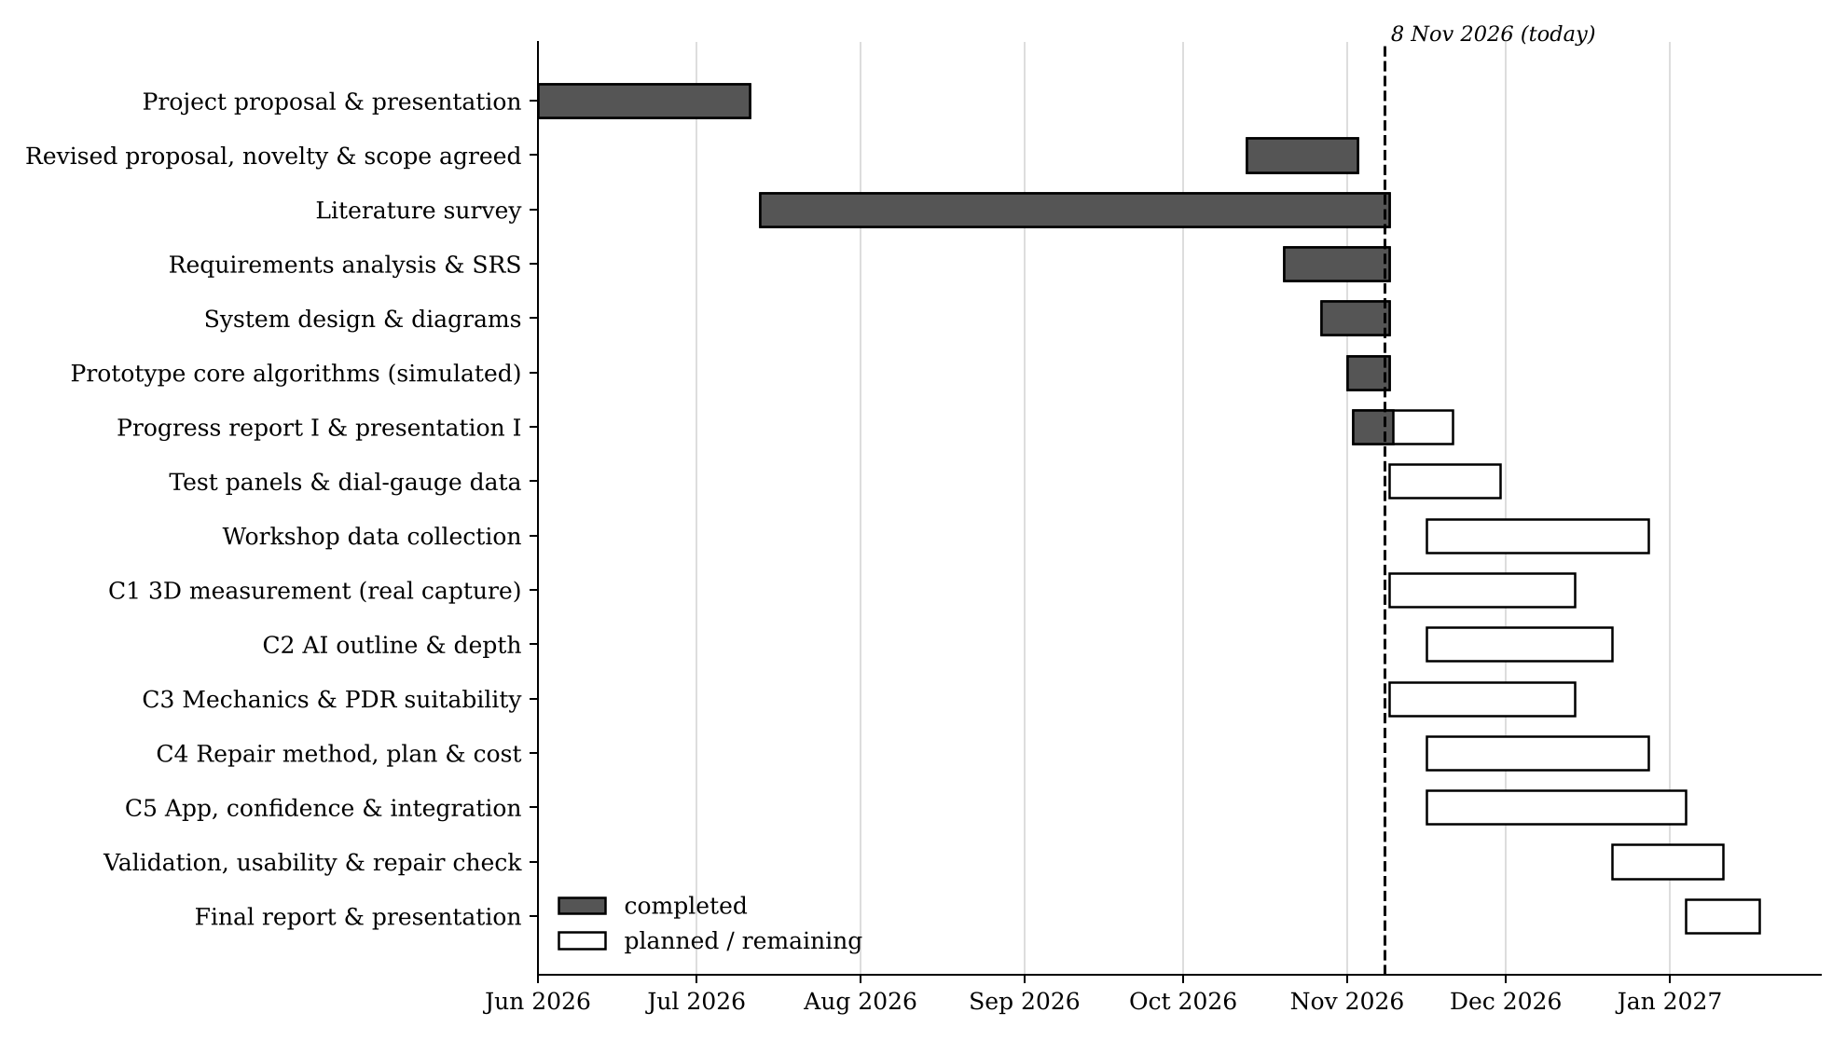
Figure 19: Project schedule (shaded: completed)
Table 22: Milestones
Milestone | Target date | Status
M1 Project proposal and presentation | Jul 2026 | Achieved
M2 Revised proposal; novelty and scope agreed | 02 Nov 2026 | Achieved
M3 Progress report I (SRS, literature, design, plan) | 08 Nov 2026 | Achieved (this report)
M4 Progress presentation I | [date] | Planned
M5 Test-panel dataset and first real 3D scans | 29 Nov 2026 | Planned
M6 All components integrated | 03 Jan 2027 | Planned
M7 Evaluation complete (accuracy, usability, repair check) | 10 Jan 2027 | Planned
M8 Final report and presentation | 17 Jan 2027 | Planned

6.3 Work Distribution
Table 23: Work distribution
Member | Component / objective | Main algorithms and tasks
D.M.S.N. Bandara (Leader) | C1 3D measurement (O1); project management | Phase shifting, temporal unwrapping, slope calibration, Poisson integration; planning, CMMI records
S.D.K.S. David | C2 AI outline and depth (O2) | Synthetic renderer, U-Net mask and height network, synthetic-to-real fine-tuning
K.S. Dissanayaka | C3 Mechanics and PDR suitability (O3) | Curvature, strain maps, finite-difference plate solver, suitability check
U.S.N. Senevirathne | C4 Repair method, plan and cost (O4) | Yield-line force, glue-tab and pull calculations, push planning, plan-based costing
K.L.N.C. Liyanage | C5 App, confidence and integration (O5, O6) | Paired capture app, Monte Carlo, conformal intervals, API, deployment
All members | Validation (O7) | Test panels, dial-gauge measurement, workshop data, repair check, usability study, reports

6.4 Risk Register
Table 24: Risk register
Risk | Likelihood / impact | Mitigation | Owner
Poor stripe reflections (dirty, dull paint, sunlight) | Medium / High | Capture in shade, clean panel, quality checks, C2 fallback | Bandara
Phone movement between patterns | Medium / Medium | Tripod, frame alignment, automatic rejection | Bandara
Elastic model misses plastic behaviour | High / Medium | Yield-line corrections calibrated on test panels | Dissanayaka
Paint cracking strain uncertain | High / Medium | Use published range; Monte Carlo reports it as probability | Dissanayaka
Large synthetic-to-real gap | Medium / Medium | Deflectometry labels real photos for fine-tuning | David
Too few workshop cases | Medium / High | Early workshop contact; test panels answer RQ1–RQ3 | All
Equipment delay (dial gauge, panels) | Low / High | Order now; borrow from university lab | Senevirathne
Integration delays | Medium / Medium | Typed interfaces, continuous integration, weekly merges | Liyanage

7. CMMI Meeting Minutes

7.1 Process Approach
The team records its meetings following practices from CMMI for Development [35]. Each meeting is linked to the process areas it supports: PP Project Planning, PMC Project Monitoring and Control, REQM Requirements Management, DAR Decision Analysis and Resolution, and RSKM Risk Management. Every meeting records the agenda, discussion, decisions with their rationale, and action items with an owner and due date; open actions are reviewed at the start of the next meeting. Fields highlighted in yellow must be confirmed by the team before submission.

7.2 Meeting Log
Table 25: Meeting log
No. | Date | Type | Main outcome | CMMI areas
MM-01 | [date] | Panel feedback review | Proposal to be revised: more depth and mathematical content | PMC, REQM
MM-02 | [date] | Team meeting | New features defined; one component per member | PP, DAR
MM-03 | [date] | Supervisor meeting | Repair (strength) check added: field + laboratory | REQM, DAR
MM-04 | [date] | Supervisor meeting | Application justified; local prior art reviewed; novelty narrowed | REQM, DAR, RSKM
MM-05 | [date] | Supervisor meeting | Novelty approved; workshops as users; dent scope agreed | REQM, PP
MM-06 | [date] | Team meeting | Work distribution revised; Progress Report I tasks allocated | PP, PMC

7.3 Minutes of Meetings
Table 26: MM-01: Review of panel feedback on the initial proposal
Date / time | [date and time]
Type / venue | Panel / lecturer feedback session
Attendees | Group 03 members; [confirm attendance]
Agenda | 1. Feedback received on the initial proposal. 2. Response strategy.
Discussion | The panel considered the initial scope (dent detection and cost estimation) too simple for five members and noted that it did not require significant AI or mathematical work. The team discussed adding measurement, mechanics and planning features that each member could own.
Decisions | Revise the proposal to increase depth and breadth with mathematically grounded components; prepare a revised proposal and presentation.
Action items | Draft revised feature list – all – [due]; Collect literature on 3D measurement and panel mechanics – all – [due]
CMMI process areas | PMC, REQM
Recorded by | [name]

Table 27: MM-02: Revised feature set and component allocation
Date / time | [date and time]
Type / venue | Team meeting
Attendees | All five members; [confirm]
Agenda | 1. Candidate features. 2. Allocation to members. 3. Revised proposal documents.
Discussion | Features considered: 3D measurement by deflectometry, single-photo depth with AI, strain-based PDR suitability, repair-method selection and planning, confidence levels. Each was assessed for novelty, feasibility with low-cost equipment and testability with a dial gauge.
Decisions | Adopt five components (C1–C5), one per member, each with an algorithmic core; keep detection and cost estimation as supporting parts.
Action items | Revised proposal document – Bandara – [due]; Revised presentation – all – [due]
CMMI process areas | PP, DAR
Recorded by | [name]

Table 28: MM-03: Strength checking after repair; literature reading
Date / time | [date and time]
Type / venue | Supervisor meeting (online) [confirm mode]
Attendees | Supervisor; Group 03 members; [confirm]
Agenda | 1. Supervisor question: where is the strength check after repair? 2. Papers read by the team.
Discussion | The team reported that workshops do not strength-test after PDR and that the IMI standard accepts a repair when no sign of the dent is visible. The supervisor asked why the project could not include such a check and whether it would add value. The team agreed that a check is useful if it does not damage customer vehicles.
Decisions | Add a repair check: non-destructive field check (3D re-scan, stiffness comparison with the opposite panel, AI paint-crack check) and laboratory strength tests on scrap test panels (re-dent, load–deflection, cross-cut adhesion).
Action items | Design repair-check procedure – Dissanayaka & Bandara – [due]; Each member to summarise key papers – all – [due]
CMMI process areas | REQM, DAR
Recorded by | [name]

Table 29: MM-04: Justification of the application and local prior art
Date / time | [date and time]
Type / venue | Supervisor meeting (online) [confirm mode]
Attendees | Supervisor; Group 03 members; [confirm]
Agenda | 1. Issues caused by wrong dent assessment. 2. Existing Sri Lankan systems. 3. Novelty.
Discussion | The team explained the consequences of wrong assessment: cracked paint and rework, unnecessary repainting, inconsistent quotes and lack of evidence. A lecturer identified local prior art (Allianz Lanka 3D app, Click2Claim, LOLC V Claim, SLIC virtual claims, Fairfirst/CamCom AI, and a SLIIT 2025 paper). These detect damage or digitise claims but do not measure dents or decide PDR suitability.
Decisions | Narrow the novelty to 3D dent measurement, PDR suitability/repair-method decision and evidence-based decision support; add local prior art to the literature review. Risk noted: overlap with insurer AI tools.
Action items | Update literature review with local systems – David – [due]; Send novelty proposal to supervisor – Bandara – [due]
CMMI process areas | REQM, DAR, RSKM
Recorded by | [name]

Table 30: MM-05: Approval of novelty, users and scope
Date / time | [date and time]
Type / venue | Supervisor meeting (online) [confirm mode]
Attendees | Supervisor; Group 03 members; [confirm]
Agenda | 1. Novelty focus. 2. Target users. 3. Meaning of “dent”.
Discussion | The supervisor agreed to focus on the proposed novelty. The team clarified that the system is designed for workshop technicians rather than insurers. The supervisor asked whether “dent” means all damage; the team proposed a scope limited to painted metal outer panels, up to about palm size, with or without paint damage.
Decisions | Novelty approved. Primary users: workshop technicians; reports shareable with insurers. Scope as in Section 1.3. Dent pulling (glue-pull, stud-pull) explicitly included.
Action items | Update proposal and presentation – Bandara – [due]; Concept paper – all – [due]
CMMI process areas | REQM, PP
Recorded by | [name]

Table 31: MM-06: Work distribution and Progress Report I
Date / time | [date and time]
Type / venue | Team meeting
Attendees | All five members; [confirm]
Agenda | 1. Final component ownership. 2. Progress report requirements. 3. Implementation start.
Discussion | Ownership was rebalanced to match skills: 3D measurement to Bandara, AI depth to David, app and confidence to Liyanage. The progress report requirements (SRS, literature survey, diagrams, CMMI minutes, project plan, early implementation) were allocated.
Decisions | Adopt the work distribution in Section 6.3. Start implementation of core algorithms in Python with automated tests.
Action items | SRS – Liyanage & Senevirathne – [due]; Diagrams – all – [due]; Prototype algorithms – component owners – [due]; Order dial gauge and scrap panels – Senevirathne – [due]
CMMI process areas | PP, PMC
Recorded by | [name]

8. Conclusion and Next Steps
The project has moved from proposal to a specified, designed and partly implemented system. The literature survey confirms the gap: existing solutions, including those in Sri Lanka, detect damage in 2D and estimate cost, but none measure the dent, check repairability from mechanics or support the technician’s choice between pushing and pulling. The SRS defines 32 functional and 18 non-functional requirements traced to the seven objectives, and the design is documented with the full set of UML, DFD, ER and deployment diagrams. The prototype shows that the core algorithms work on simulated data and that the plate solver is correctly implemented.
Next steps before Progress Presentation II:
- Build the test-panel rig and measure at least 30 steel-ball dents with the dial gauge (all).
- Capture real stripe sets on painted panels and compare with dial-gauge profiles (Bandara).
- Implement the synthetic renderer and train the first U-Net (David).
- Calibrate the strain limit on painted test panels (Dissanayaka).
- Calibrate pull counts and tab sizes with real glue-pull trials (Senevirathne).
- Build the technician capture interface and connect it to the API (Liyanage).
- Begin workshop data collection with signed consent (all).

References
[1] Davydenko, “Paintless dent repair (PDR) technology: Operational, economic, and environmental aspects of implementation in the auto body repair system,” Amer. J. Eng. Technol., 2026.
[2] Institute of the Motor Industry (IMI), “Paintless Dent Removal (PDR) Technician” accreditation and standards, U.K.
[3] X. Wang, W. Li and Z. Wu, “CarDD: A new dataset for vision-based car damage detection,” IEEE Trans. Intell. Transp. Syst., vol. 24, no. 7, 2023.
[4] S. Baig, M. Kamal and A. Ullah, “Small dents, big impact: A dataset and deep learning approach for vehicle dent detection,” arXiv:2508.15431, 2025.
[5] CamCom, “Fairfirst Insurance brings CamCom AI inspection to Sri Lanka,” press release. [Online]. Available: https://camcom.ai/press-release/fairfirst-insurance-brings-camcom-ai-inspection-to-sri-lanka
[6] N. M. Jayagoda and D. Kasthurirathna, “Hybrid model-based automated exterior vehicle damage assessment and severity estimation for insurance operations,” in Proc. Int. Res. Conf. Smart Comput. Syst. Eng. (SCSE), 2025, doi: 10.1109/SCSE65633.2025.11031047.
[7] K. Patil, M. Kulkarni, A. Sriraman and S. Karande, “Deep learning based car damage classification,” in Proc. 16th IEEE Int. Conf. Mach. Learn. Appl. (ICMLA), 2017, pp. 50–54.
[8] K. He, G. Gkioxari, P. Dollár and R. Girshick, “Mask R-CNN,” in Proc. IEEE Int. Conf. Comput. Vis. (ICCV), 2017, pp. 2961–2969.
[9] Ramazhan, Bustamam and Buyung, “Smart car damage assessment using enhanced YOLO algorithm and image processing techniques,” Information, vol. 16, no. 3, art. 211, 2025.
[10] Kotthapalli, Ravipati and Bhatia, “YOLOv1 to YOLOv11: A comprehensive survey,” arXiv:2508.02067, 2025.
[11] Zhang and S.-S. Shin, “AI-based vehicle damage repair price estimation system,” J. Digit. Contents Soc., vol. 24, no. 12, pp. 3143–3152, 2023.
[12] Ghita et al., “AI for car damage detection and repair price estimation in insurance: Market research and novel solution,” Springer, 2024, pp. 167–179.
[13] H. Ahaggach et al., “Enhancing car damage repair cost prediction: Integrating ontology reasoning with regression models,” Intell. Syst. Appl., vol. 23, art. 200411, 2024.
[14] S. A. Pérez-Zarate et al., “Automated car damage assessment using computer vision: Insurance company use case,” Appl. Sci., vol. 14, no. 20, art. 9560, 2024.
[15] “Allianz introduces Sri Lanka’s 1st 3D motor accident assessment app,” Daily Mirror, Mar. 13, 2018. [Online]. Available: https://www.dailymirror.lk/press_releases/Allianz-Introduces-Sri-Lanka-s-st-D-Motor-Accident-Assessment-App/335-147195
[16] “Asian Alliance Insurance introduces new product Click2Claim,” The Sunday Times (Sri Lanka), Feb. 22, 2015. [Online]. Available: https://www.sundaytimes.lk/150222/business-times/asian-alliance-insurance-introduces-new-product-click2claim-136543.html
[17] “LOLC Insurance offers faster, smarter motor claims,” The Sunday Times (Sri Lanka), May 10, 2026. [Online]. Available: https://www.sundaytimes.lk/260510/business-times/lolc-insurance-offers-faster-smarter-motor-claims-641027.html
[18] “Sri Lanka Insurance introduces Virtual Claim Assistance for Motor Plus customers,” Daily Mirror, 2023. [Online]. Available: https://www.dailymirror.lk/press_releases/Sri-Lanka-Insurance-introduces-Virtual-Claim-Assistance-for-Motor-Plus-Customers/335-258166
[19] M. C. Knauer, J. Kaminski and G. Häusler, “Phase measuring deflectometry: A new approach to measure specular free-form surfaces,” in Proc. SPIE 5457, Optical Metrology in Production Engineering, 2004, pp. 366–376.
[20] L. Huang, M. Idir, C. Zuo and A. Asundi, “Review of phase measuring deflectometry,” Opt. Lasers Eng., vol. 107, pp. 247–257, 2018.
[21] C. Zuo, S. Feng, L. Huang, T. Tao, W. Yin and Q. Chen, “Phase shifting algorithms for fringe projection profilometry: A review,” Opt. Lasers Eng., vol. 109, pp. 23–59, 2018.
[22] M. Takeda, H. Ina and S. Kobayashi, “Fourier-transform method of fringe-pattern analysis for computer-based topography and interferometry,” J. Opt. Soc. Amer., vol. 72, no. 1, pp. 156–160, 1982.
[23] R. T. Frankot and R. Chellappa, “A method for enforcing integrability in shape from shading algorithms,” IEEE Trans. Pattern Anal. Mach. Intell., vol. 10, no. 4, pp. 439–451, 1988.
[24] D. Eigen, C. Puhrsch and R. Fergus, “Depth map prediction from a single image using a multi-scale deep network,” in Adv. Neural Inf. Process. Syst. (NeurIPS), 2014, pp. 2366–2374.
[25] O. Ronneberger, P. Fischer and T. Brox, “U-Net: Convolutional networks for biomedical image segmentation,” in Proc. MICCAI, 2015, pp. 234–241.
[26] S. Timoshenko and S. Woinowsky-Krieger, Theory of Plates and Shells, 2nd ed. New York, NY, USA: McGraw-Hill, 1959.
[27] K. W. Johansen, Yield-Line Theory. London, U.K.: Cement and Concrete Association, 1962.
[28] N. Metropolis and S. Ulam, “The Monte Carlo method,” J. Amer. Statist. Assoc., vol. 44, no. 247, pp. 335–341, 1949.
[29] A. N. Angelopoulos and S. Bates, “Conformal prediction: A gentle introduction,” Found. Trends Mach. Learn., vol. 16, no. 4, pp. 494–591, 2023.
[30] G. W. Brier, “Verification of forecasts expressed in terms of probability,” Monthly Weather Rev., vol. 78, no. 1, pp. 1–3, 1950.
[31] IEEE Recommended Practice for Software Requirements Specifications, IEEE Std 830-1998, 1998.
[32] Personal Data Protection Act, No. 9 of 2022, Parliament of the Democratic Socialist Republic of Sri Lanka, 2022.
[33] J. Cohen, “A coefficient of agreement for nominal scales,” Educ. Psychol. Meas., vol. 20, no. 1, pp. 37–46, 1960.
[34] J. Brooke, “SUS: A ‘quick and dirty’ usability scale,” in Usability Evaluation in Industry, P. W. Jordan, B. Thomas, B. A. Weerdmeester and I. L. McClelland, Eds. London, U.K.: Taylor & Francis, 1996, pp. 189–194.
[35] CMMI Product Team, CMMI for Development, Version 1.3, CMU/SEI-2010-TR-033, Software Engineering Institute, Carnegie Mellon University, 2010.

