   |  | Quantum Open Innovations | ASSEMBLY INSTRUCTIONS  NV-Diamond Quantum Sensor · Rev 1.0

NV-Diamond Quantum Sensor
Fluorescence Quenching Readout Prototype
⏱ ~15 min assembly 8 steps No soldering
PARTS INCLUDED
A  1×  Main PCB | B  1×  16-bit I²C  ADC Module | C  1×  STAMP M5  ESP32 | D  1×  Bottom Enclosure | E  1×  Top Lid | F  1×  Optical Module | G  1×  Sensor Module | H  1×  USB-C Cable  & Power bank | I  4×  M3 Screws

ASSEMBLY STEPS
1 Mount PCB modules  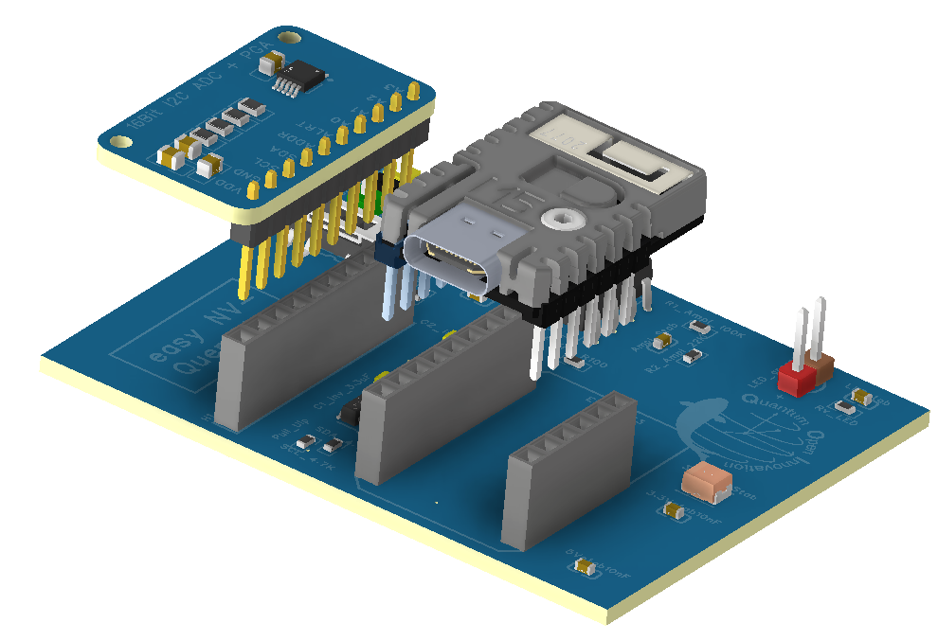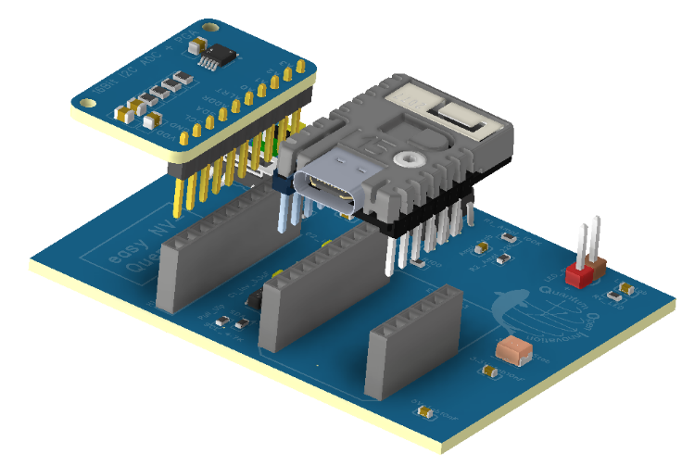  B  C  A  Mount the 16-bit ADC Module (B) onto the Main PCB (A). Then place the STAMP-M5 ESP32 (C) into its socket. Press each firmly until pins are fully engaged and boards sit flush.  Align pin markers before pressing. No gap should be visible. | 2 Place PCB into enclosure  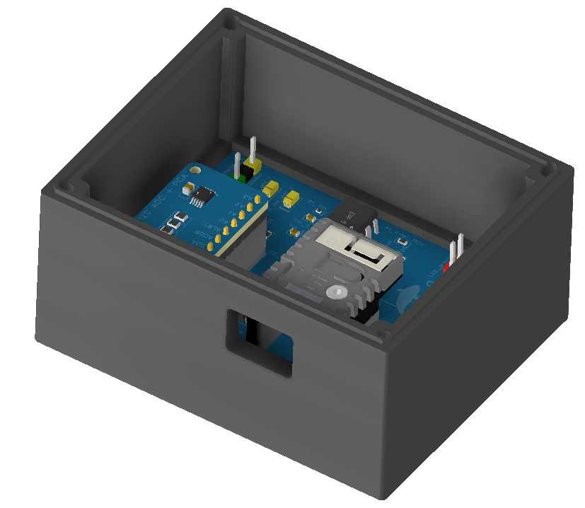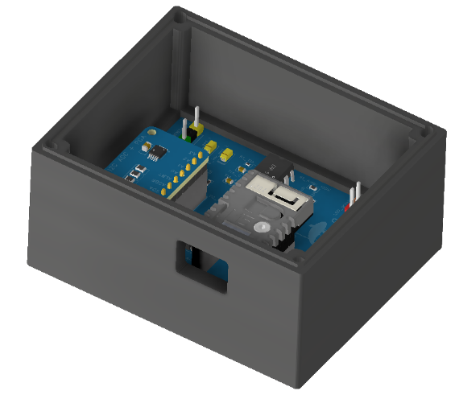  D  Lower the assembled PCB into the Bottom Enclosure (D). The USB-C port must face the front cutout. Press down until the board sits flat on mounting posts.  USB-C port alignment is critical. Verify from the front opening before continuing.

3 Prepare the top lid  F  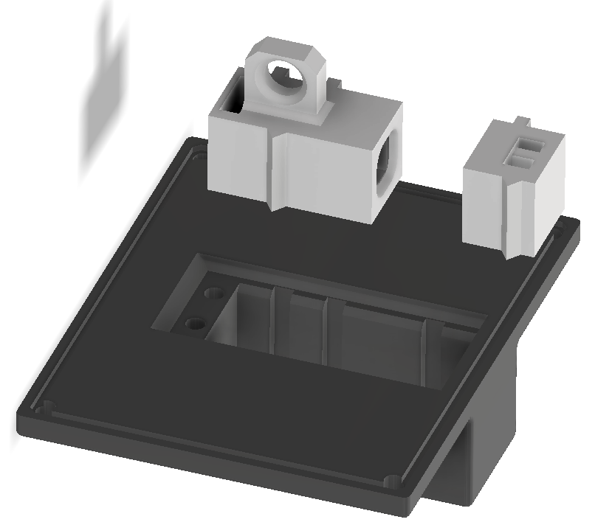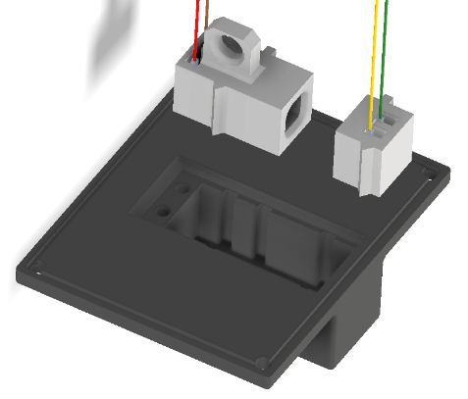  E  G  Insert the Optical Module (F) into the left opening of the Top Lid (E). Insert the Sensor Module (G) into the right slot. Both mount from the inner face.  The connector is keyed — one way only. If it resists, rotate 180° and try again. Never force. | 4 Seat lid components  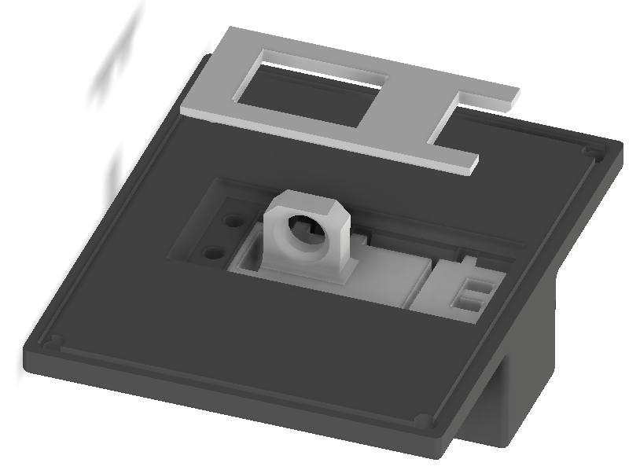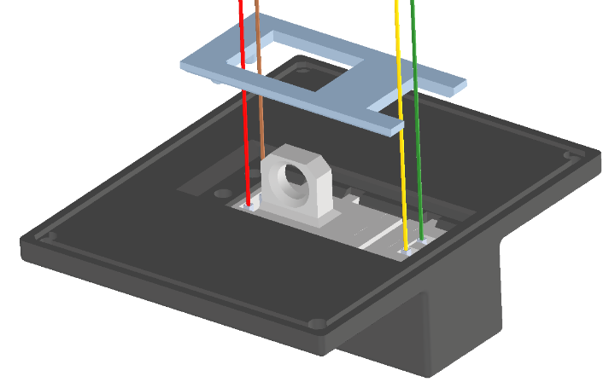  Press both modules fully into their slots until they sit flush with the interior surface. No part should protrude inward.
6 Verify before closing  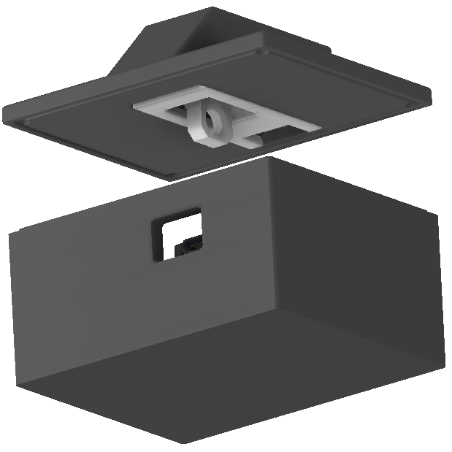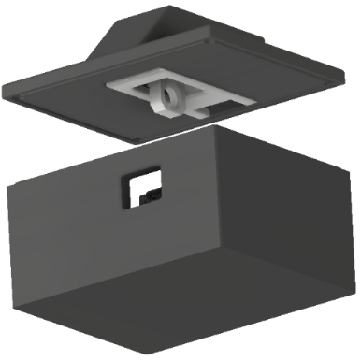  Verify both sub-assemblies match the image. The enclosure holds the PCB stack flat; the lid has both modules flush mounted. Nothing should move from either half.  ✅ Checklist: ADC board seated · ESP32 seated · USB-C port visible at front · lid modules flush · Wires connected | 7 Align the lid  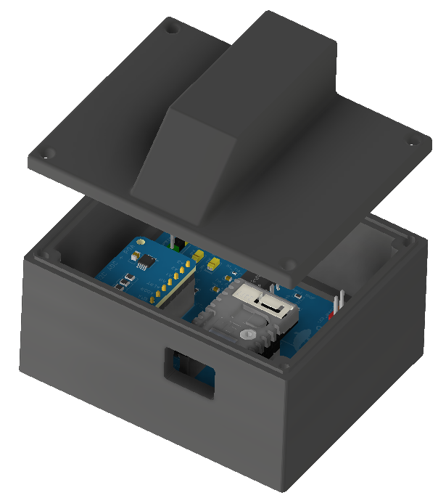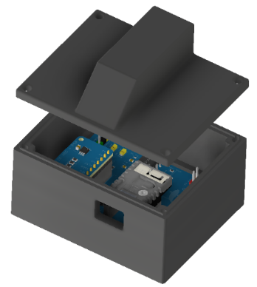  Hold the Top Lid (E) directly above the enclosure. Align corner screw holes with the enclosure posts. Lid connector pins must line up with the PCB headers before lowering. Use the 4x M3 Screws (I) to seal the box.  Lower straight down as shown in the image. Hand tight the screws, do not apply too much force.
5 Connect color-coded wires to PCB  With the lid partially lowered, connect the four wires from the lid connector to the matching PCB header pins. Match by color before fully seating the lid.  ⚠️ Reversing Red and Brown wires can damage the LED. Always verify wire colors against PCB silkscreen labels before fully lowering the lid. | 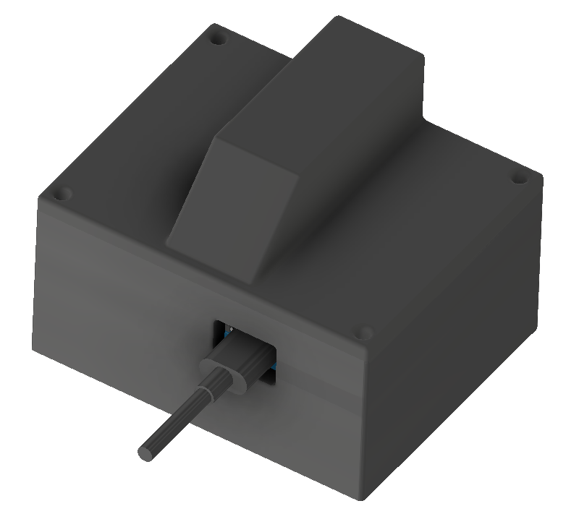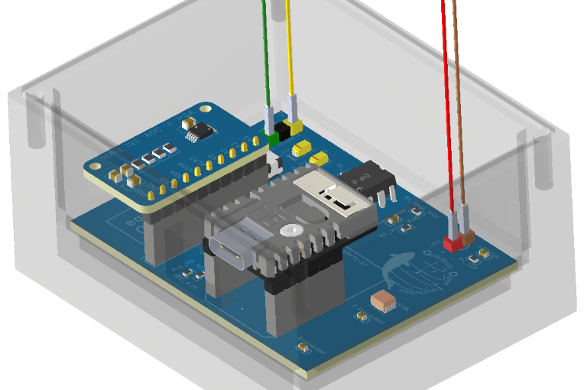

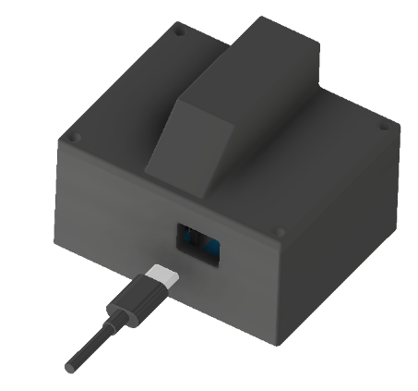  H | 8 Connect USB-C & power on  Connect the USB-C cable (H) between the front port and Power bank. The device powers on immediately. The LED glows green within seconds as the NV-Plotter Wi-Fi hotspot initializes.  🎉 Assembly complete! If LED does not light, unplug, reopen and verify all header pins are fully seated (step 5).  Next step → Connect to the sensor's Wi-Fi hotspot and open the browser dashboard for live fluorescence data.

FIRST CONNECTION  Connect to the sensor's Wi-Fi hotspot  Once powered, the NV sensor broadcasts its own access point. Connect any phone or laptop - no app, no driver, no cloud needed. Open a browser to see the live fluorescence waveform, dip event log, and one-click CSV export. Sensitivity is tunable in real time from the browser. | 📶NV-Plotter-(N)  Password: 12345678  Browser → 192.168.10.1  iOS · Android · Windows · macOS

Fraunhofer IAO  Quantum Open Innovations · Stuttgart · 2026 | NV-Diamond Quantum Sensor ·Assembly Instructions · Rev 1.0

