NV Quenching Readout System
Quick Reference — Firmware & Software

Samuel Sanchez | Fraunhofer IAO, Quantum Open Innovations | 2025

At a Glance
16-bit  ADC resolution | 7.8 µV/LSB  At GAIN_SIXTEEN | 0.34 mV RMS  System noise | 2–3 %  Quench amplitude

~86 Hz  Step rate | ~22 Hz  WebSocket rate | ~91 s  CSV buffer | < 20 €  Total BOM cost

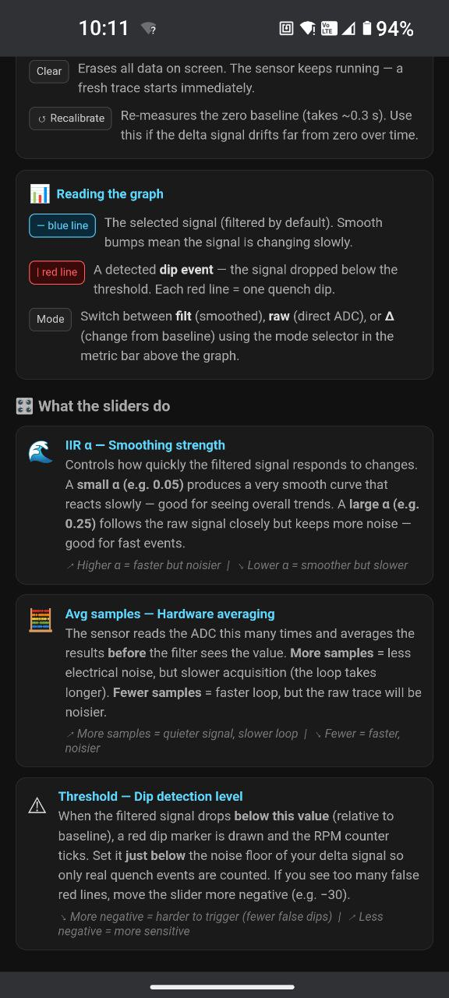
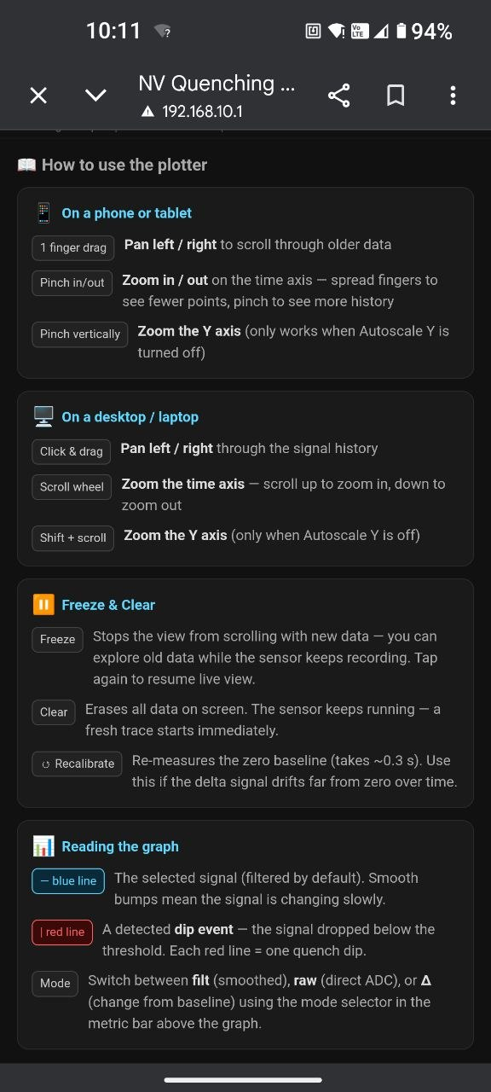
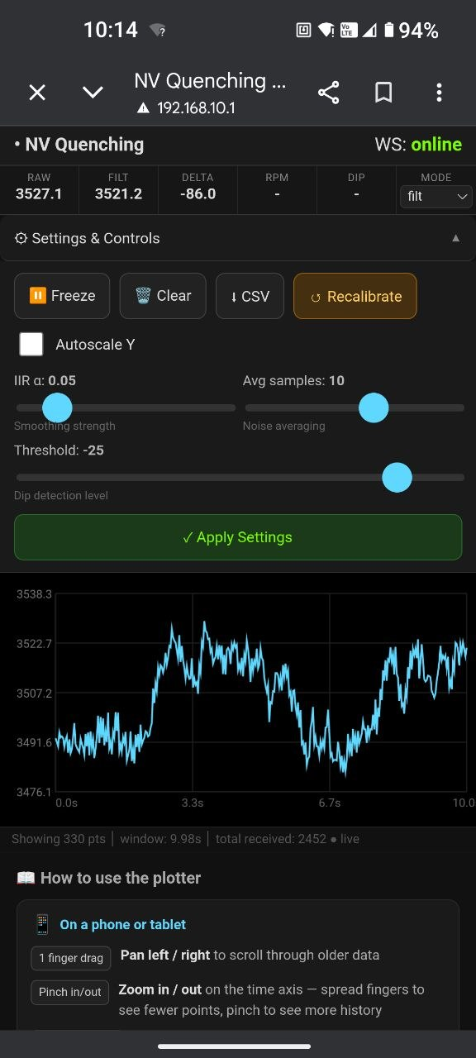

Figure 1 Live interface with built in settings panel and usage guide

System Overview
Hardware chain  - BPW34 photodiode — light-to-current  - MCP607 TIA — Rf = 1 MΩ, 0–1 V output  - RC filter — 2-stage, fc ≈ 160 kHz  - ADS1115 — 16-bit I²C ADC, 860 SPS  - ESP32-S3 — M5 Stamp S3, Wi-Fi AP  Connectivity  - Wi-Fi AP — SSID: NV-Plotter-N  - IP — 192.168.10.1  - mDNS — http://nv-plotter.local  - HTTP :80 — browser app + CSV export  - WebSocket :81 — live data + config | Signal path  - Average N fresh ADC reads  - Display IIR filter — slow (α configurable)  - Detection IIR filter — fast (α = 0.50, fixed)  - Baseline subtraction — delta = filtered − baseline  - Hysteresis comparator — entry + 50 ms guard  - Dip latch — accumulates over 4-step window  - Publish JSON — ~22 Hz to all WS clients  - CSV ring buffer — 2000 entries, ~91 s  Firmware modules  - nv_signal — ADC, filters, dip, RPM  - csv_logger — buffer + HTTP export  - web_ui — AP, HTTP, WebSocket  - web_page — full browser app (PROGMEM)  - main — loop, decimation, latch

System Performance
Parameter | Value | Notes
ADC resolution | 16-bit (7.8 µV/LSB) | GAIN_SIXTEEN, ±0.256 V FS
Noise single read | ~2 LSB RMS ≈ 15.6 µV | ADS1115 datasheet at 860 SPS
Noise avg = 10 | ~0.6 LSB RMS ≈ 4.7 µV | √10 improvement
System noise (measured) | 0.34 mV RMS | At TIA output
Baseline signal level | 0.80–1.00 V | 525-532 nm LED, BPW34, Rf = 1 MΩ
Quench dip amplitude | 15–30 mV (2–3%) | 1920-3840 ADC counts
Display filter −3 dB | ~0.69 Hz | α = 0.05, ~86 steps/s
Detection filter −3 dB | ~21 Hz | α = 0.50, ~86 steps/s
Step rate | ~86 steps/s | 860 SPS / avg = 10
WebSocket rate | ~22 Hz | Step rate / SEND_EVERY_N = 4
CSV buffer | 2000 samples (~91 s) | Static allocation, ~56 KB RAM
Max dip rate | 1200 dips/min | MIN_DIP_INTERVAL_MS = 50 ms
Encoder — mean RPM | 61.5 rpm (±3.9 rpm, 6.3%) | 6 dips; theoretical 58.6 rpm
Encoder — deviation | +4.9 % | SG90 servo dynamics, not ADC error
Total BOM cost | ~20 € | Including ADS1115 and Fabricated PCB

Configuration Parameters

Run-time (adjustable from browser, no reflash)
Parameter | Default | Range | Unit | Effect
IIR α — display filter | 0.05 | 0.01–0.50 | — | Displayed trace smoothness. No effect on dip detection.
Averaging depth | 10 | 1–32 | samples | Noise reduction (√N). Adds N × 1.16 ms latency per step.
Detection threshold | −15 | −5000–0 | ADC cts | Dip trigger level. 1 ct ≈ 7.8 µV. Set to ~50% of dip depth.

Compile-time (edit source, reflash)
Constant | File | Default | Description
SEND_EVERY_N | main.cpp | 4 | Decimation ratio. 1 of N steps forwarded to WS and CSV.
RPM_HIST | nv_signal.cpp | 8 | Inter-dip interval ring buffer depth. Larger = smoother RPM.
MIN_DIP_INTERVAL_MS | nv_signal.cpp | 50 ms | Dead time between dip entries. 50 ms ↔ max 1200 dips/min.
DETECT_ALPHA | nv_signal.cpp | 0.50 | Detection filter α. Fixed — do not reduce below 0.30.
CSV_BUF_N | csv_logger.cpp | 2000 | Ring buffer capacity. Each entry ≈ 28 bytes.

Threshold calibration
1. Set Mode to Δ.
2. Approach the magnet and read the minimum delta in the metric strip.
3. Set threshold to ~50% of that minimum.
Example: delta reaches −80 → set threshold to −40.
4. Press Apply Settings. Confirm red dip markers appear on approach.

Main Features
Signal Processing  - Dual IIR filters — independent display and detection paths  - Paced averaging — N distinct conversions per step  - Static baseline — 60-sample average at startup  - Live recalibration — /recal HTTP or browser button  - Hysteresis comparator — 50% exit threshold  - Dip guard timer — prevents burst false triggers  - RPM averaging — 8-interval ring buffer  - Angular velocity & accel. — ω and α computed per dip  Data Export  - CSV download — /export.csv, chunked HTTP  - Relative timestamps — seconds from oldest sample  - Columns — t_s, raw, filtered, delta, dip, rpm  - Auto filename — nv_export.csv via Content-Disposition | Browser Interface  - Zero dependencies — served from ESP32 flash (PROGMEM)  - Live metric strip — raw, filt, Δ, RPM, dip, mode  - 5000-point ring buffer — typed arrays, no GC pressure  - 60 fps canvas render — signal trace + dip markers  - HiDPI aware — crisp on Retina / AMOLED  - Mobile responsive — adaptive layout below 420 px  - Freeze / Clear — view control without data loss  - Autoscale Y — or manual zoom via pinch / Shift+scroll  Interaction Gestures  - 1-finger drag — pan time axis  - 2-finger pinch (H) — zoom time axis  - 2-finger pinch (V) — zoom Y axis  - Mouse drag — pan  - Scroll wheel — zoom time axis  - Shift + scroll — zoom Y axis

HTTP & WebSocket Quick Reference
Endpoint | Method | Description
192.168.10.1 or nv-plotter.local | GET | Browser application (HTML/CSS/JS, ~12 KB, no CDN)
/export.csv | GET | Download full ring buffer as CSV (chunked, nv_export.csv)
/recal | GET | Re-run 60-sample baseline capture; broadcasts recal_done to all WS clients
ws://192.168.10.1:81/ | WebSocket | Live data stream at ~22 Hz; accepts cfg messages; replies cfg_ack

WebSocket messages
Server → Client (sample, ~22 Hz)  { "t": 45231, // ms from boot  "raw": 18432.5, // avg ADC counts  "filtered": 18431.1, // display IIR  "delta": -42.3, // counts vs baseline  "dip": 1, // 1 on entry only  "rpm": 61.5 } | Client → Server (config update)  { "type": "cfg",  "alpha": 0.05,  "avg": 10,  "thr": -45.0 }  Server → Client (ack / recal)  { "type": "cfg_ack", "alpha": 0.050,  "avg": 10, "thr": -45.00 }  { "type": "recal_done" }

Build & Connect
platformio.ini  [env:m5stack-stamps3]  platform = espressif32@>=6  board = m5stack-stamps3  framework = arduino  lib_deps = adafruit/Adafruit ADS1X15@^2.6.0  Flash command  pio run --target upload | First-use steps  - Connect to Wi-Fi: NV-Plotter-2 / 12345678  - Open: http://nv-plotter.local  - Observe live delta in the metric strip  - Approach magnet → note minimum delta  - Set threshold to ~50% of that value → Apply  - Confirm red dip markers on approach  - Recalibrate if delta drifts from zero

