Proiect API

In proiectul meu am ales sa citesc numere de pe placutele de inmatriculare ale masinilor si sa le introduce intr-o baza de date.

Folosind Vision Assistant incarcam imaginea cu placuta de inmatriculare:

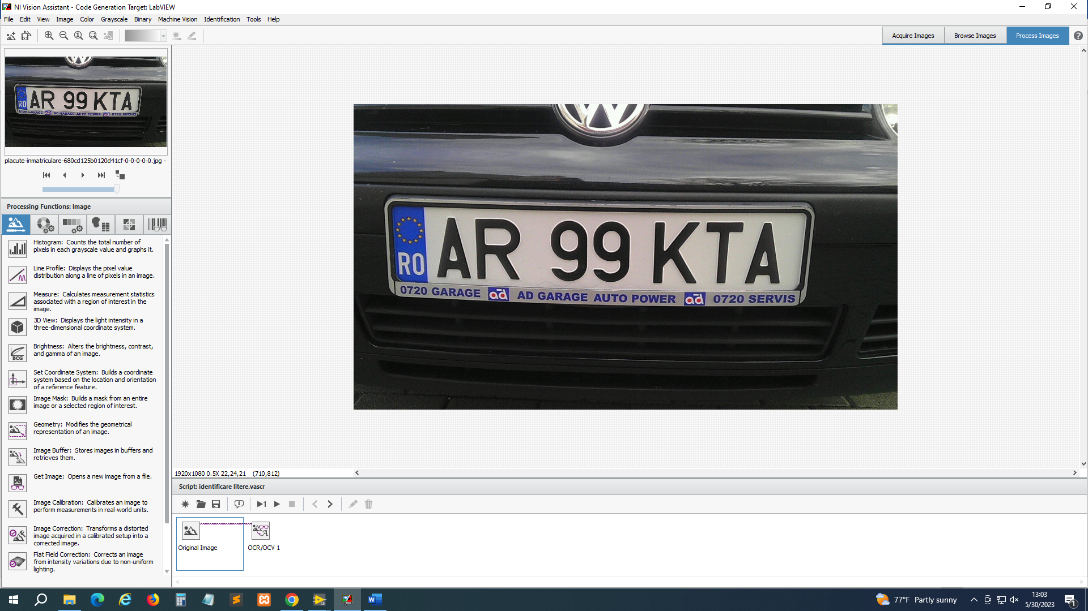

Cu functia OCR/OCV 1 identificam literele de pe placuta, dupa ce am antrenat setul de caractere:

Dupa aceea am exportat in LabView, creand urmatorul VI:

In final, in Frontpanel, am creat un buton de citire numit “Citeste” pe care, dupa ce il apasam, va scrie in baza de date textul selectat:

