June 2007

The pPOD Core Data Model, Draft 1

the pPOD team

The Core Data Model (CDM) under development in the pPOD project will serve the following purposes:

- It will allow experimentation with the modeling of provenance in phylogenetic pipelines, hopefully tracking data from its raw form (specimen, images, tissue samples, raw molecular sequences) through its processing, homological assumptions, alignment, matrix and tree form.
- It will serve as a schema for a persistence tool to be included in our lab notebook suite and that we would also very much like to integrate as a Mesquite module (pending Wayne and David’s agreement)
- It will serve as a target for schema mappings used to connect other AtoL databases as well as resources like TreeBASE, etc., through our data integration system (based on the Orchestra engine developed at Penn).

In what follows we sketch several simple views of the CDM and we illustrate their meaning with some queries. Being able to support such queries is an essential property of the CDM and its future implementations.

As far as the presentation of the model, we wish to avoid having people looking for Waldo inside large UML-style diagrams. One should be able to explore the CDM using simple partial views, that hopefully bring together the classes relevant to some category of queries. Such a view will have «hyperhooks» with which the user would interact to show more of the model, as well as ways to «turn off» unnecessary parts of the model.

The modeling so far was inspired by our work with TreeBASE, by what we learned from Mesquite (especially the Silk module), by the data modeling in Tolkin, and by interviews with phylogeneticists, eg., Brent Mishler.

The work is very preliminary and in a state that allows only limited distribution.

View 1 and some illustrative queries:
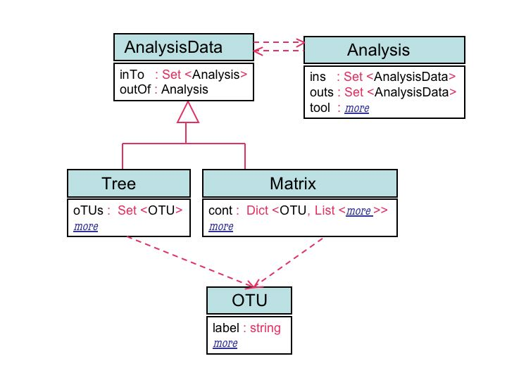

«Find all matrices used in some analysis that produced
a tree containing the OTU "Habronattus pugillis".»

SELECT m
FROM m in Matrix.allInstances(),
a in m.inTo,
t in a.outs,
x in t.oTUs
WHERE AnalyzedData.isTree(t)
AND x.label = "Habronattus pugillis"

«Find all the other OTUs that appear together with the
OTU "Bembidion poculare" in some matrix.»

SELECT y.label
FROM m in Matrix.allInstances(),
x in m.cont.allKeys(),
y in m.cont.allKeys()
WHERE x.label = "Bembidion poculare"
AND y.label != "Bembidion poculare"

«Find all trees T that are outputs of analyses A
such that the OTUs of any matrix that is input to A
are among the OTUs of T.»

SELECT t
FROM t in Tree.allInstances(),
WHERE (SELECT x
FROM m in t.outOf.ins,
x in m.cont.allKeys()
WHERE AnalyzedData.isMatrix(m)
)
SUBSET t.oTUs

View 2 and one related query:

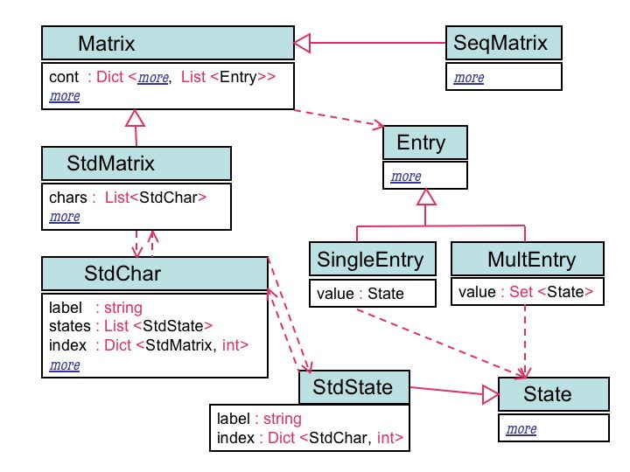

«Find all standard matrices with some character C whose label
contains the substring "elytra" and some OTU whose state for
character C contains the substring "transverse"; return all such
character-, OTU- and state-labels also.»

SELECT m, c.label, x.label, e.label
FROM m in Matrix.allInstances(),
c in m.chars,
x in m.cont.allKeys()
WHERE Matrix.isStdMatrix(m)
AND c.label LIKE "*elytra*"
AND (LET e = m.cont[x][c.index[m]]
IN Entry.isSingleEntry(e)
AND State.isStdState(e.value)
AND e.label LIKE "*transverse*")
View 3 and one related query:
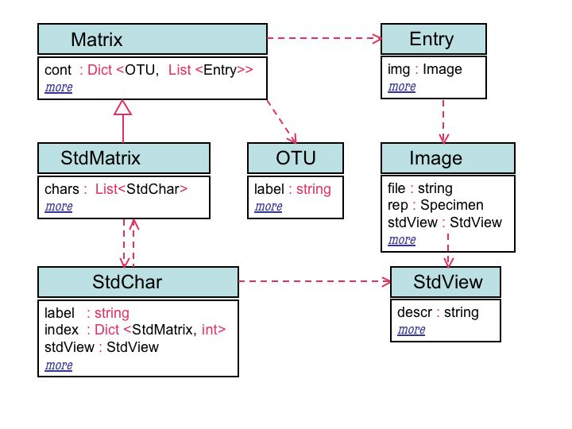
«Find all standard matrices and entries in them where there are discrepancies between the standard view associated with the corresponding character and the standard view used in images that document the entry for the same characters; return the matrix, the OTU label, the character index and the entry where discrepancies occur.»

SELECT m,
x.label,
c.index[m],
m.cont[x][c.index[m]]
FROM m in Matrix.allInstances(),
c in m.chars,
x in m.cont.allKeys()
WHERE Matrix.isStdMatrix(m)
AND m.cont[x][c.index[m]].img.stdView
!= c.stdView

