150-inch Home Theater System
A 150-inch 16:9 laser DLP home theater built around a 4K/120 Hz video pipeline, DMD PWM modulation, constant-current laser drive, and photodiode feedback. The simulation closes the loop from digital drive to screen luminance and checks bandwidth, timing, and thermal limits.

1 System target and architecture
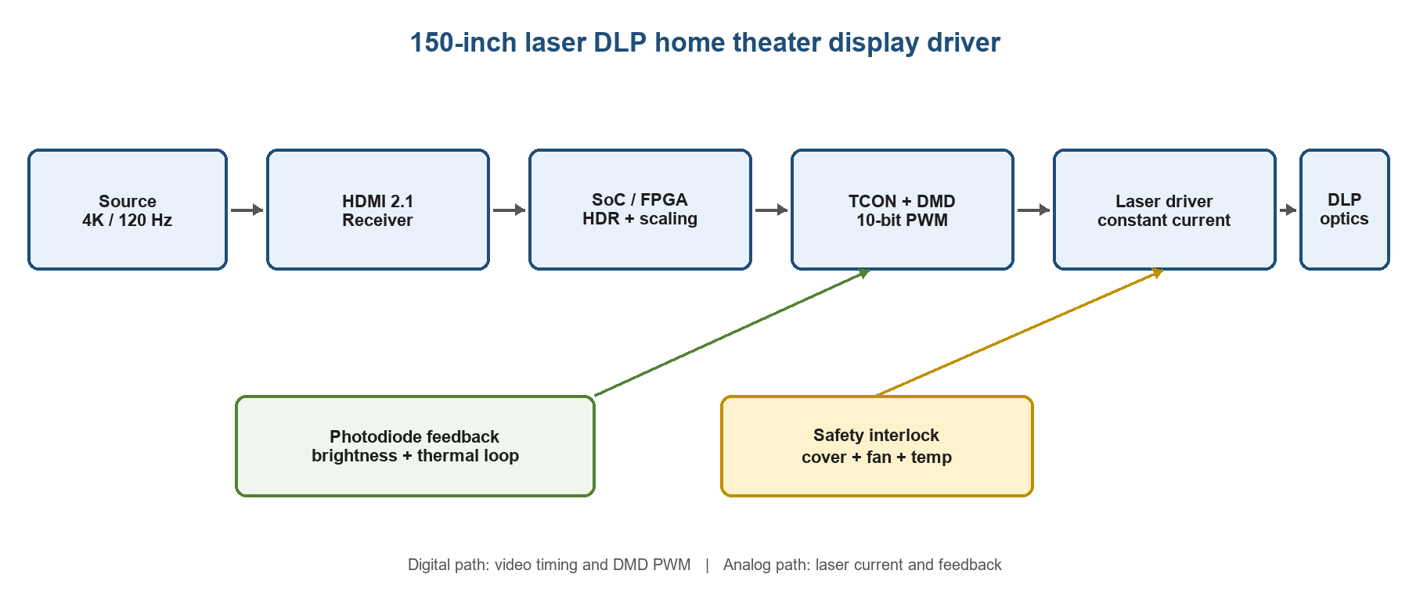
Figure 1. driver architecture
Item | Design value | Purpose
Screen | 150 in, 16:9 (3.32 m × 1.87 m) | Large-format cinematic image
Video | 3840×2160, 120 Hz, 10 bit, HDR10 | Low latency and high motion clarity
Optical engine | Laser DLP, 3600 lm peak | Efficient, dimmable light source
Installation | Throw ratio 1.35, 4.48 m throw | Front projection without keystone
Feedback | Photodiode + PI loop | Compensate drift and aging

2 Room layout and optical calculation
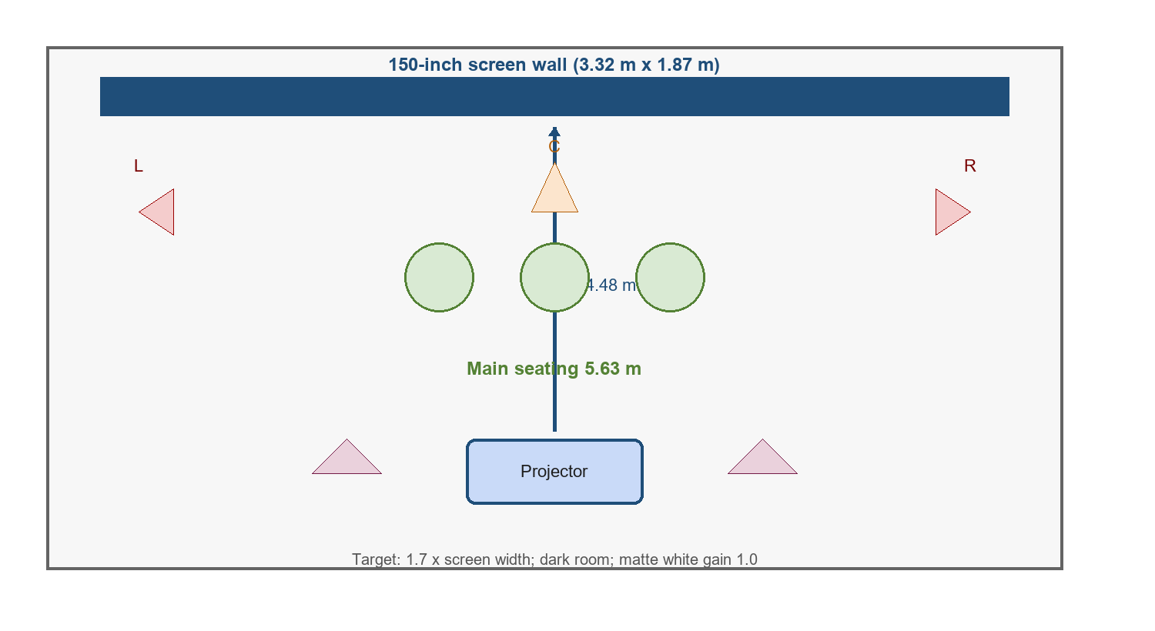
Figure 2. Room geometry and speaker/projector positions
The screen area is 6.20 m². A 1.35 throw ratio gives a nominal throw distance of 4.48 m. The main seat is placed at 5.65 m (1.70 screen widths), which provides a practical field of view for both movies and games.

3 Simulation run
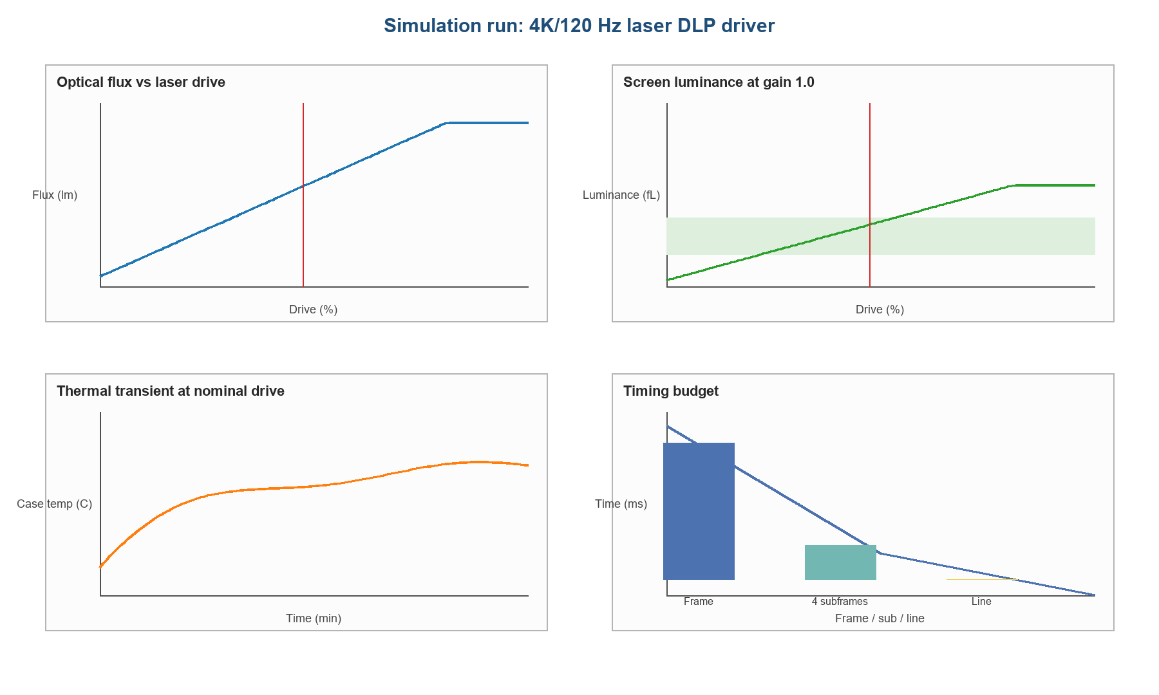
Figure 3. flux, luminance, temperature and timing
Check | Result | Evidence
Frame timing | PASS | 8.33 ms frame; 3.86 μs line
HDMI bandwidth | PASS | 9.95 Gbps < 48 Gbps
Cinema luminance | PASS | 26.8 fL at 50% drive
Thermal margin | PASS | 39.5 °C peak < 45 °C

The luminance model is Φ=Φmax·min(d/0.82,1)·ηopt, followed by E=Φ/A and L=E/π. At the 50% working point, the screen is within the 14–30 fL cinema target. The computed raw data rate is below the HDMI 2.1 limit, and the 30-minute thermal transient remains below the protection threshold.

