Laser Beam Expander System
Abstract. This paper presents the design, numerical simulation, experimental setup, and perturbation testing of a Galilean laser beam expander. A 632.8 nm Gaussian beam is used as the input. A propagation model combining the complex beam parameter q with ABCD matrices is implemented in Mworks to calculate beam radius, beam expansion ratio, and far-field divergence. The model is validated with white-screen measurements and CCD images. The measured expansion ratios of the basic and optimized configurations are 7.38 and 3.92, compared with theoretical values of 7.5 and 4.0. The far-field divergence is approximately 0.022 mrad, and the overall difference between simulation and experiment remains below 5%. Single-variable tests further identify the sensitive ranges of beam-waist position and lens spacing, providing quantitative limits for system alignment and adjustment.
1 Research Objective and System Design
The objective is to build a Galilean laser beam expander that is adjustable, measurable, and suitable for quantitative validation. The study addresses three practical questions: how the focal lengths determine the expansion ratio, how performance changes when the beam waist or lens spacing is displaced, and whether the simulation can guide real alignment. The system uses a negative lens followed by a positive lens. This arrangement expands and then collimates the beam without a real internal focus, reducing the risk of local intensity damage to optical elements.
The input wavelength is 632.8 nm and the incident beam-waist radius is 1 mm. The basic configuration uses f1 = -30 cm and f2 = 225 cm, giving a theoretical expansion ratio of 7.5. The optimized configuration uses f1 = -25 mm and f2 = 100 mm, giving a theoretical ratio of 4. The simulations scan the nominal lens spacing and ±10% perturbations. Observation planes are placed 25, 50, 75, 100, and 125 cm after the positive lens.

Item | Basic configuration | Optimized configuration
Negative-lens focal length f1 | -30 cm | -25 mm
Positive-lens focal length f2 | 225 cm | 100 mm
Theoretical expansion ratio |f2/f1| | 7.5 | 4.0
Nominal lens spacing | 75 cm | 75 mm
Wavelength / incident waist radius | 632.8 nm / 1 mm | 632.8 nm / 1 mm
Table 1. Main system parameters and the two design configurations
2 Propagation Model and Algorithm
The model is organized into parameter initialization, beam propagation, and result analysis. A Gaussian beam is represented by the complex parameter q: 1/q = 1/R - jλ/(πw²), where R is the wavefront radius of curvature and w is the beam-waist radius at the current position. At the waist, R approaches infinity and the input state can be written as q0 = jπw0²/λ.
The negative lens, free-space section, and positive lens are represented by their respective ABCD matrices. The total matrix is M = M2 · Md · M1, and the output parameter is updated by q2 = (Aq1 + B)/(Cq1 + D). The beam radius is then recovered from q. This formulation preserves the physical meaning of each optical section while producing a continuous beam-radius curve for lens-position scans.
The numerical solver samples the z axis and extracts the sections before the negative lens, before the positive lens, after the positive lens, and in the far field. Horizontal and vertical centerline data are fitted with a Gaussian function to obtain radius error, symmetry deviation, and divergence angle. Experimental images undergo background subtraction and 3 × 3 Gaussian filtering before the same fitting procedure is applied, which keeps simulation and measurement comparable.
3 Simulation Results and Experimental Validation
Figure 1 shows the simulated two-dimensional spots at four key sections of the basic configuration. The beam first diverges after the negative lens, then expands rapidly after the positive lens while remaining approximately circular. The result confirms the intended expansion and collimation behavior of the two-lens system.
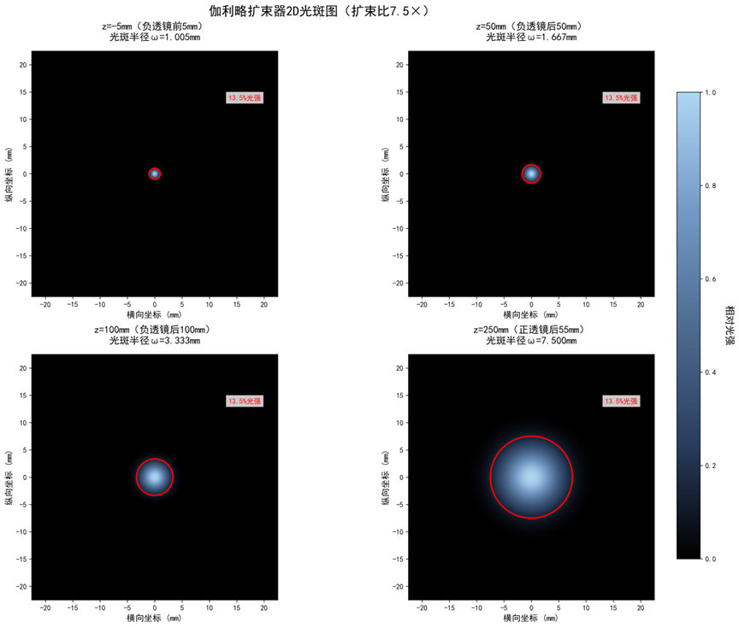
Figure 1. Two-dimensional spots and fitted radii at key sections of the basic configuration
Figure 2 compares the beam-radius evolution for different lens spacings. The curve around the nominal spacing of 195 mm is the most stable. Moving the spacing in either direction changes the slope after the positive lens and produces different far-field divergence or convergence trends. The simulation therefore predicts the effect of lens placement continuously rather than at isolated points.
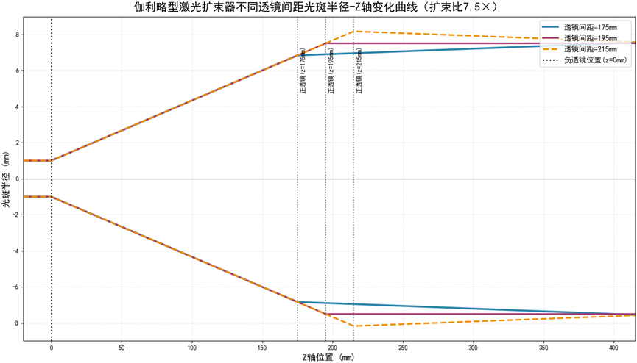
Figure 2. Beam-radius evolution along z for different lens spacings
For the experiment, a red collimated laser is used for coaxial alignment. White screens are placed 50 cm and 100 cm after the positive lens, and a CCD records the spots. Figure 3 shows spot images, radial intensity data, and Gaussian fits under several perturbation conditions. The measured and fitted curves largely overlap, demonstrating that the image-processing and fitting pipeline can extract beam radius reliably.
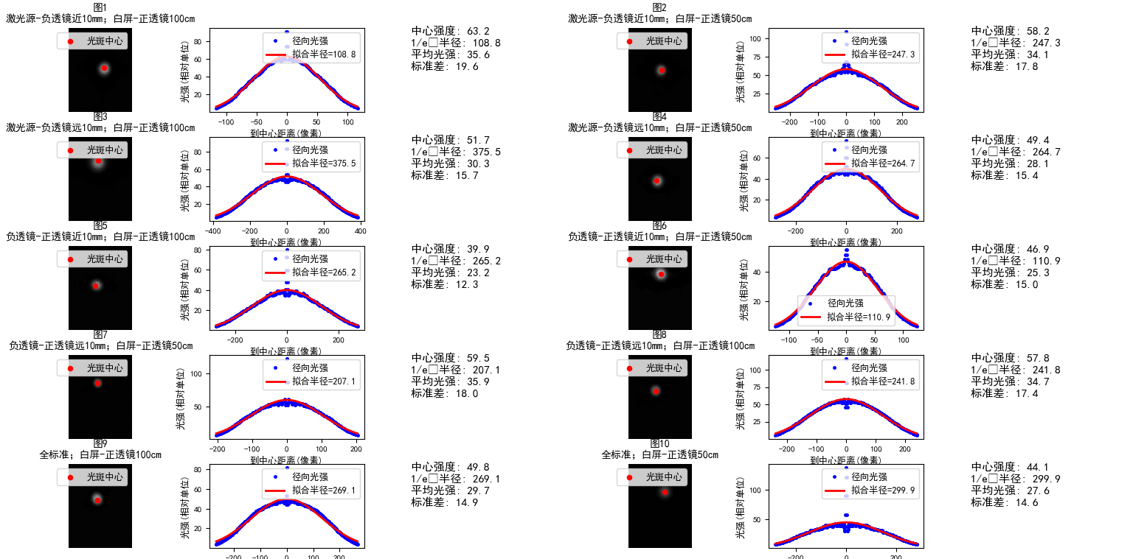
Figure 3. Experimental spots, radial intensity profiles, and Gaussian fits
4 Perturbation Laws and Parameter Optimization
The beam-waist displacement test shows that the spot remains approximately circular when the displacement is within ±5 mm and the expansion-ratio error stays below 3%. At ±10 mm, the spot becomes elliptical, the symmetry deviation rises to 8.6%, and the far-field divergence increases by about 15%. The beam-waist position is therefore the most sensitive alignment parameter, and the residual coaxial error should be kept below 0.08 mm.
The lens-spacing test confirms the importance of focal-length matching. A 10% spacing deviation increases the expansion-ratio error by approximately 4.2% and increases the far-field divergence by about 8% to 12%. At screen distances of 25 to 75 cm, the spot radius grows almost linearly. At 100 cm, it becomes stable with a radius fluctuation below 0.1 mm. At 125 cm, weak attenuation caused by air scattering becomes visible. A 100 cm observation distance is therefore recommended for a balance between stability and measurement accuracy.
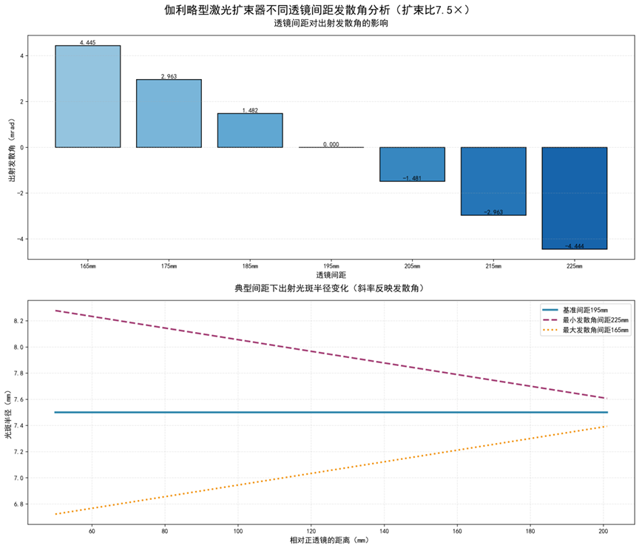
Figure 4. Effect of lens spacing on output divergence and spot evolution
5 Key Performance Indicators
The main contribution of this work is a reproducible chain from physical modeling to engineering judgment. The system design, matrix-based calculation, experimental alignment, image fitting, and error analysis are connected by the same measurable indicators. Table 2 summarizes the results that best demonstrate completion of the design and validation work.

Indicator | Theory | Simulation | Experiment | Relative difference
Basic expansion ratio | 7.50 | 7.42 | 7.38 | 1.07%
Optimized expansion ratio | 4.00 | 3.95 | 3.92 | 2.00%
Far-field divergence | 0.021 mrad | 0.0215 mrad | 0.022 mrad | ≤4.76%
Key-section spot-radius error | — | ≤0.99% | ≤1.20% | within 2%
Gaussian-fit error | — | ≤0.5% | ≤8% in normal conditions | within engineering limit
Table 2. Comparison of key simulation and experimental indicators
The project therefore establishes a complete workflow from focal-length-based estimation to ABCD-matrix propagation, image-based extraction of experimental indicators, and single-variable identification of error sources. The simulated and measured trends agree, and the overall relative difference remains below 5%, showing that the model can support preliminary design and parameter optimization of similar systems.
6 Conclusions
A Galilean laser beam expander was designed, simulated, assembled, and tested under controlled perturbations. The model based on Gaussian-beam q parameters and ABCD matrices describes the beam-radius and far-field divergence trends accurately. The basic configuration achieves approximately 7.5× expansion, the optimized configuration achieves approximately 4× expansion, and the far-field divergence is controlled near 0.022 mrad.
The experiments define practical operating limits: the beam-waist displacement should remain within ±5 mm, the lens spacing should stay close to its nominal value, and the observation screen should preferably be placed 100 cm after the positive lens. These results validate the design and provide a direct basis for future improvements such as offset correction, higher-precision beam shaping, and migration to laser communication or optical measurement systems.

