Optical Power Meter
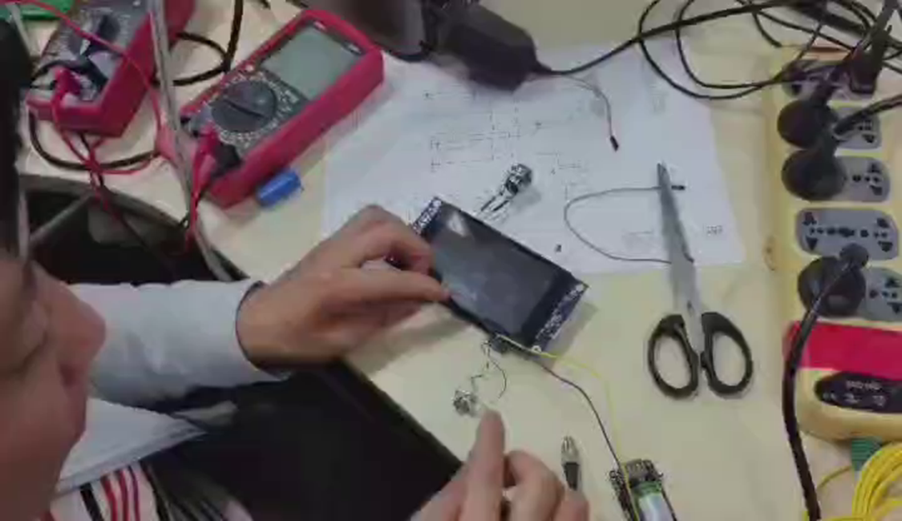
Figure 1 Optical power meter prototype and test setup

1 Project Overview
This project produced a prototype optical power meter for measuring optical signal power. The system converts the output of a photodetector into an electrical signal, performs analog processing and ADC sampling, and uses a microcontroller to process and display the data. The display supports dBm unit switching.
The project covers schematic design, PCB layout, embedded parameter configuration, touch-interface design, hand soldering, troubleshooting, and system testing, forming a complete implementation path from circuit design to a working prototype.
Measurement Function | Hardware and Software Implementation | Engineering Skills
Optical power acquisition, display, and dBm unit switching | ADC sampling, STM32CubeMX configuration, and TouchGFX interface | Schematic, PCB, soldering, debugging, and verification

2 System Design and Implementation

2.1 Functional Definition
An optical power meter is used to measure source output power, optical-fiber link loss, and optoelectronic-device response. The design goal is to convert optical signals into stable, readable power data and provide intuitive display and operation.
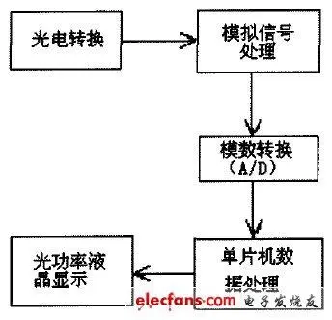
Figure 2 System signal chain: Photoelectric conversion → Analog processing → ADC → Microcontroller → Display

2.2 Key Modules
Module | Implementation Details
Signal Acquisition | The photodetector converts the optical signal into an electrical signal, which enters the ADC after analog processing.
Embedded Control | Configured the ADC channel, TIM2 priority, and main-clock parameters to keep sampling and display stable.
Human-Machine Interface | Designed the display page in TouchGFX with power readout and dBm unit switching.

2.3 Circuit and PCB
The schematic and PCB layout were completed according to the signal chain. Particular attention was given to component clearance, cross-layer connections, and signal integrity, providing a reliable basis for soldering and debugging.
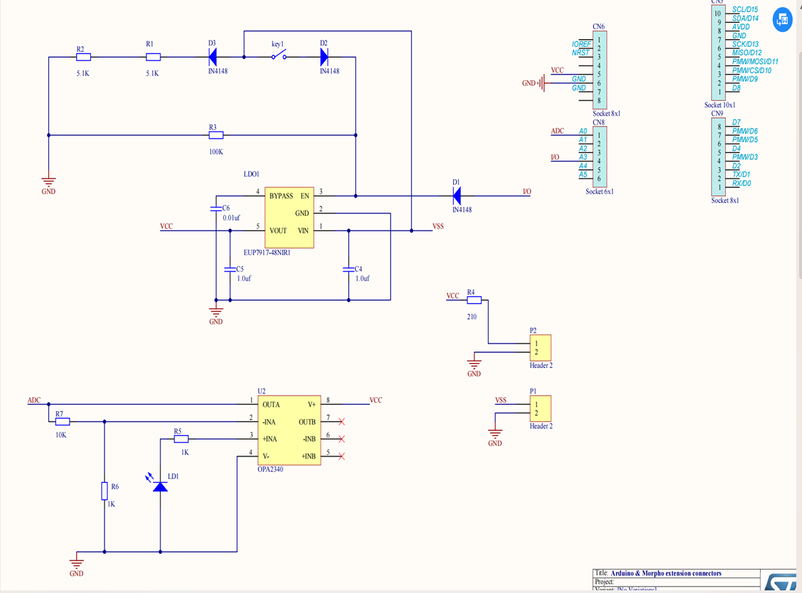
Figure 3 Optical power meter schematic
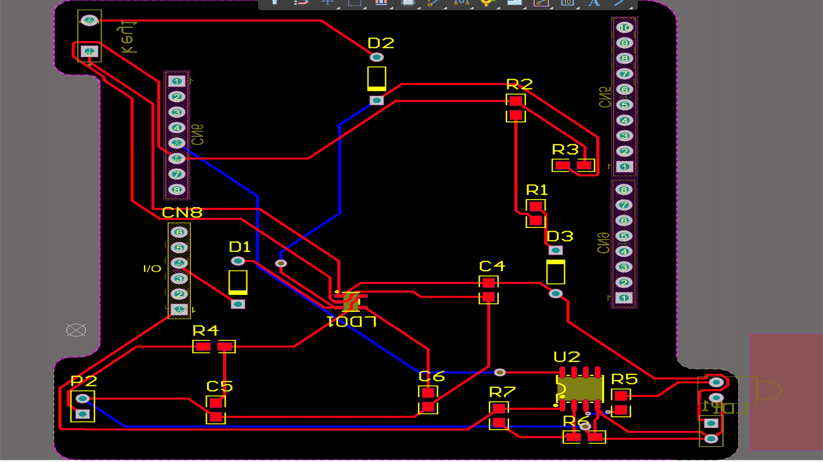
Figure 4 PCB routing and component layout

3 Engineering Implementation and Problem Resolution

3.1 Key Problems in the Design Process
Stage | Problem Observed | Resolution
Schematic | Inconsistent net connections and label placement caused unintended parallel connections or labeling errors. | Inspected connections one by one, repositioned net labels, and checked the wiring.
PCB Layout | Insufficient clearance, missing vias across layers, and locally congested routing. | Rechecked clearance rules, added vias where possible, and rerouted congested areas.
Interface Design | Asset handling affected touch interaction, and Chinese paths caused save errors. | Adjusted interface assets and interaction elements, and used compatible project paths.
Soldering and Debugging | Small components led to solder bridges, cold joints, and misplaced headers. | Checked each joint with a multimeter during soldering, repaired faults immediately, and verified the measurement range.

3.2 Soldering and Hardware Debugging
During soldering, each component was checked immediately after placement. Point-by-point multimeter checks were used to reduce the risk of short circuits, open circuits, and cold solder joints.
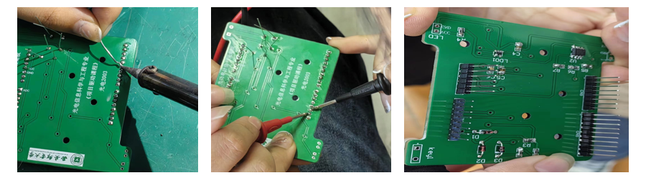
Figure 5 Soldering, measurement, and board-level inspection

3.3 Embedded Configuration
The STM32CubeMX clock, ADC, and timer parameters were configured, followed by integrated debugging of sampling, display, and button response.

4 Testing and Results

4.1 Test Procedure
- Confirm the optical module, fiber type, interface type, center wavelength, and optical-power-meter interface.
- Test each soldered component with a multimeter, compare the readings with the standard circuit values, and calibrate as needed.
- Connect the optical module to the switch and connect the optical power meter with a patch cord; set the measurement wavelength to match the optical module center wavelength.
- Read the optical power value on the screen and use the dBm button to switch the displayed unit.

4.2 Results and Conclusion
The prototype can read and display optical power values normally, and the screen buttons respond reliably. It is ready for basic test use. The test process covered connection checks, parameter matching, data reading, and result confirmation, verifying coordinated operation from hardware to software.

