Smart Parcel Pickup Navigation System
This project addresses congestion, difficult-to-locate pickup points, and uneven resource utilization at campus parcel stations during peak hours. It presents the system problem, architecture, algorithmic logic, and implementation effects. The system transforms pickup records, current order volume, time periods, and station locations into waiting-time estimates, off-peak recommendations, and route planning, forming a complete processing chain from data input to actionable advice.
1. Research Problem and Objective
Campus parcel pickup is constrained by simultaneous increases in waiting costs across several stations during peak periods. The system combines the parcel station, the user’s current location, and the estimated waiting time to produce an arrival route and an off-peak recommendation. When a user has multiple parcels or genuinely selectable stations, it also compares the overall cost of different stations.
Existing questionnaire records contain 200 valid responses. Among the respondents, 85% rated the current pickup experience as “dissatisfied” or “average,” and 72% reported an average waiting time longer than 10 minutes. The most problematic periods were 12:30–14:00 and 18:00–19:00. These statistics define the design priorities for the system.
2. System Architecture and Method
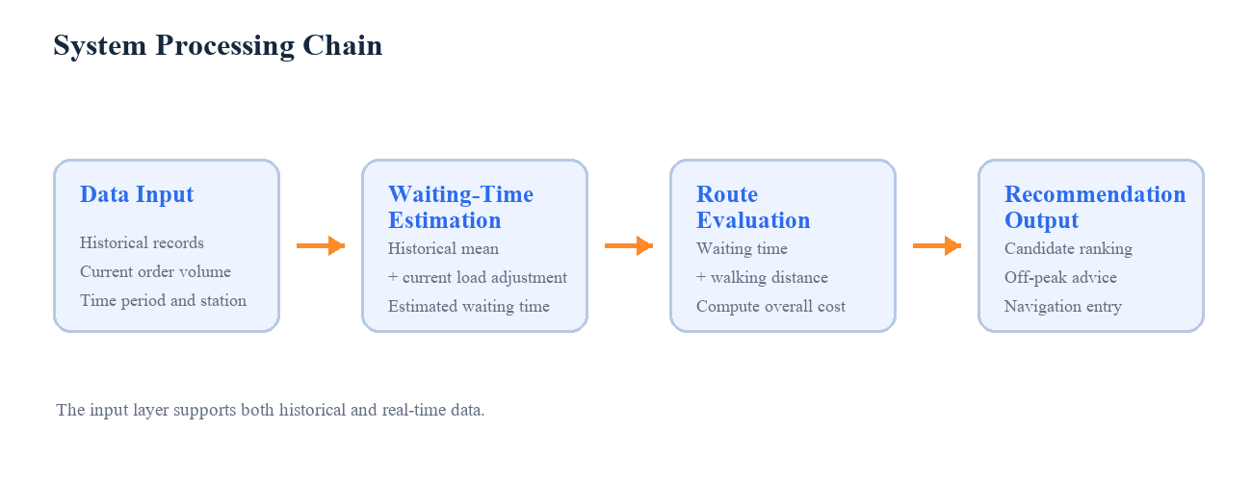
Figure 1. System processing chain from data input to actionable advice.
The system is organized into three layers. The data layer receives historical pickup records, current order volume, time periods, station locations, and user locations. The model layer estimates waiting time and normalizes waiting time and walking distance. The service layer returns station status, off-peak advice, and navigation entry points to the front end. The planned front end is a lightweight WeChat Mini Program or H5 page, while Python or Java is used for data processing and algorithm computation.
Table 1
Layer | Inputs or Modules | Outputs and Functions
Data Layer | Historical orders, current orders, time period, station and user locations | Build computable station states
Model Layer | Waiting-time estimate; walking distance; overall cost ranking | Estimated waiting, overall score, and recommended station
Service Layer | Status cards, peak-avoidance prompts, station navigation | Convert results into actionable pickup advice
The system uses an adjustable overall-cost function: Cᵢ = αTᵢ + βDᵢ, where Tᵢ is normalized waiting time, Dᵢ is normalized walking distance, and α and β are weights. In this report, α = 0.6 and β = 0.4, giving waiting time priority in the pickup decision.
3. Algorithm and Implementation Effects
Python scripts implement waiting-time calculation, overall-cost ranking, and interface output. The inputs contain the waiting time and walking distance for three candidate stations. The system calculates the overall cost, ranks the stations, and returns the corresponding recommendation. The figures use a reproducible set of example inputs.
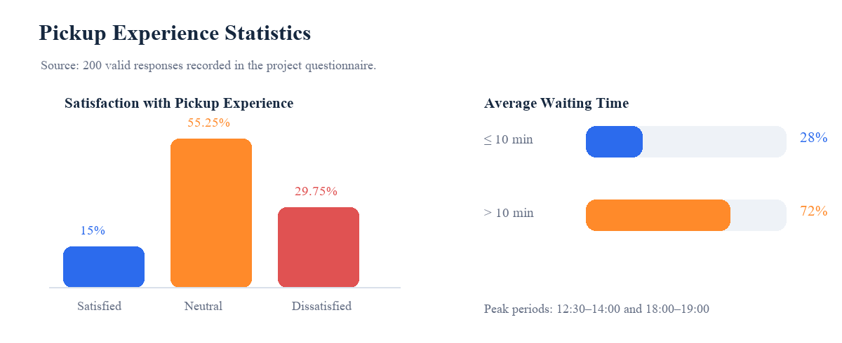
Figure 2. Distribution of campus pickup experience based on the project questionnaire records.
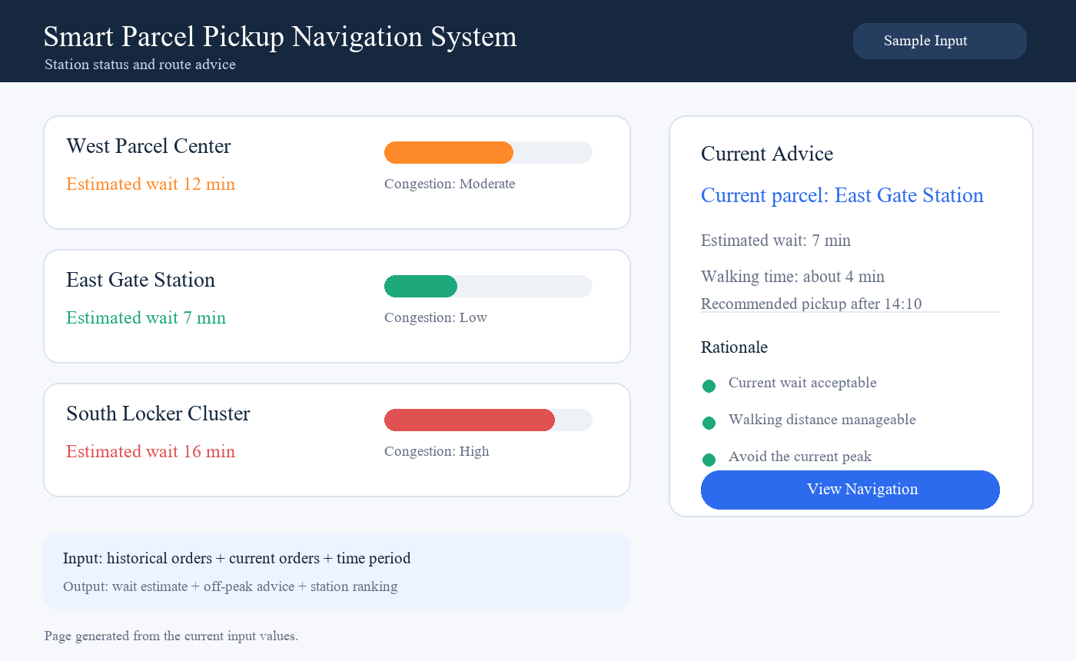
Figure 3. Station status and recommendation output of the system interface.
With the example inputs, the system treats East Gate Station as the fixed destination for the current parcel, estimates a 7-minute wait and approximately 4 minutes of walking, and provides an off-peak recommendation. The other stations remain visible for comparison in multi-parcel or selectable-station scenarios. The interface presents station status, pickup timing advice, and a navigation entry in one view.
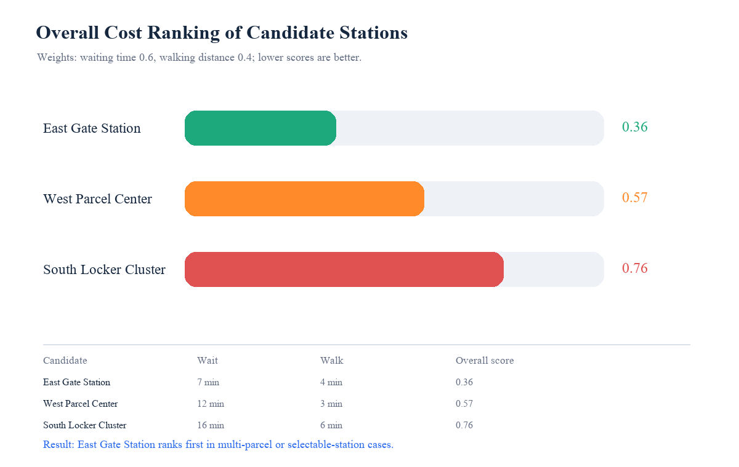
Figure 4. Overall-cost ranking in a multi-parcel or selectable-station scenario.

