Design and Verification of a 16-Point FNT Hardware Core Based on Fast Number Theoretic Transform over Finite Fields
Abstract This project targets an entry-level FPGA digital signal processing hardware implementation, completing a 16-point Fast Number Theoretic Transform (FNT) hardware core based on a finite field. The design operates modulo Q=12289, constructs a 16th-order root of unity, and adopts a radix-2 DIT decomposition, splitting the transform into 4 stages of butterfly operations. Each stage is configured with 8 butterfly units, and registers are inserted between stages to achieve a verifiable block-level pipeline structure. The project also implements the inverse transform, input bit-reverse reordering, inverse-transform normalization, as well as a Python reference model and an automated RTL comparison flow. Simulation results show that all 16 data points of both the forward and inverse transforms match the reference model, with a maximum error of 0. This design provides a foundation for subsequent frequency-domain dispersion compensation, configurable coefficient loading, and integration of a complete FNT accelerator.
Keywords Fast Number Theoretic Transform; Finite Field; Butterfly Operation; Radix-2; FPGA; Pipeline; RTL Verification

1 Research Objectives and Overall Scheme
The objective of this project is to build a well-structured 16-point FNT/IFNT hardware core. The implementation follows the sequence of “mathematical definition — unit RTL — cascaded structure — simulation verification,” ensuring that each computational stage can be independently inspected. Input data are represented as 14-bit unsigned integers, and all operations are performed modulo Q=12289.
A 16-point radix-2 DIT structure requires log₂(16)=4 butterfly stages. Each stage contains 8 butterflies, so the entire transform core logically comprises 32 butterfly computation units. Inter-stage registers hold intermediate results and partition the data path into multiple timing stages. Figure 1 shows the overall structure of this four-stage pipeline.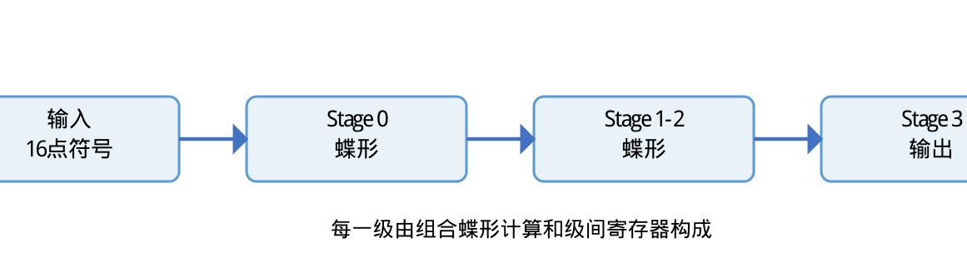
Figure 1 Four-stage pipeline structure of the 16-point FNT

2 Mathematical Foundations of Finite-Field FNT

2.1 Modular Arithmetic Parameters
A prime Q=12289 is chosen. Since Q−1=12288 is divisible by 16, a 16th-order root of unity exists in the finite field F_Q. Using the primitive root 11 as the basis, the forward-transform root of unity ω=4134, the inverse root ω⁻¹=10984, and the modular inverse of 16 under Q, i.e., N⁻¹=11521, are obtained. These key parameters are summarized in Table 1.
Parameter | Value | Usage
Q | 12289 | Finite-field modulus
N | 16 | Transform size
ω | 4134 | Forward-transform root of unity
ω⁻¹ | 10984 | Inverse-transform root of unity
N⁻¹ mod Q | 11521 | Inverse-transform normalization coefficient
Table 1 Key parameters of the FNT core

2.2 Butterfly Operation
The basic computational unit of FNT is the butterfly. Given inputs a, b and twiddle factor w, the butterfly outputs are computed as follows:
t = b × w (mod Q)
y₀ = (a + t) (mod Q)
y₁ = (a − t) (mod Q)
In RTL, the modular multiplication result is first stored as a signed temporary integer, followed by modular addition and subtraction. This avoids wrap-around errors that would occur when negative values are written directly to unsigned output ports. The standalone butterfly unit is implemented in fnt_butterfly.v, and tb_fnt_butterfly.v is used to perform basic numerical checks.

2.3 Forward and Inverse Transforms
The forward transform is defined as:
X[k] = Σ x[n]·ω⁽k·n⁾ (mod Q)
The inverse transform replaces ω with ω⁻¹ and multiplies the final result by N⁻¹ (mod Q). Through this normalization step, the forward and inverse transforms recover the original input sequence.

3 RTL Hardware Architecture Design

3.1 Data Organization and Input Reordering
All 16 input samples are 14 bits wide, giving a total input bus width of 16×14=224 bits. fnt16_pipeline.v uses a packed bus to transmit a complete data block and performs the 4-bit bit-reverse input reordering required by the DIT structure through the bitrev4 function:
for(i=0;i<16;i=i+1)
s0[i] <= din[bitrev4(i)*14 +: 14];
The above statement means: the bitrev4(i)-th 14-bit sample is taken from the 224-bit input bus and written into the stage-0 register array s0.

3.2 Four-Stage Butterfly Pipeline
fnt16_pipeline.v uses s0, s1, s2, s3, and s4 to hold data at each stage. Within each stage, butterflies are computed in combinational logic, while inter-stage results are stored in clocked registers. The valid signals v0, v1, v2, v3 move in sync with the data, ensuring that the output-valid flag aligns with the corresponding data block:
v0 <= start;
v1 <= v0;
v2 <= v1;
v3 <= v2;
valid_out <= v3;
Forward-transform mode uses ω to generate twiddle factors, while inverse-transform mode uses ω⁻¹. Twiddle factors are computed through a modular exponentiation function; modular multiplication, addition, and subtraction are each encapsulated as functions to ensure uniform arithmetic rules.

3.3 Relationship Between the Standalone Butterfly Module and the Pipeline Core
fnt_butterfly.v provides a standalone, intuitive butterfly module interface suitable for unit testing and understanding the basic operation; fnt16_pipeline.v, to simplify array-level data organization, directly unfolds the same butterfly equations in an always @* block. Both use the same mathematical definitions and respectively serve unit verification and multi-stage pipeline implementation.

4 Verification Scheme and Experimental Results

4.1 Reference Model
The Python script reads grayscale data from aaa.png and takes the first 16 grayscale samples as the input sequence. The reference model computes forward and inverse transform results using the same Q, ω, ω⁻¹, and N⁻¹ parameters as the RTL, and writes the input vector to small1_input.mem.

4.2 RTL Simulation Flow
tb_fnt16_pipeline.v reads inputs from small1_input.mem, packs the 16 14-bit samples onto the din bus, launches forward and inverse transforms respectively, and writes the results to small1_results.csv. run_small_project1.py invokes the Icarus Verilog compiler, runs the simulation, and compares RTL output with the Python reference results point by point. The verification results are summarized in Table 2.
Verification Item | Result | Conclusion
Butterfly Unit | PASS | Modular add, subtract, and multiply results are correct
16-point Forward Transform | 16/16 points match | Matches the Python reference model
16-point Inverse Transform | 16/16 points recovered | Original input fully recovered
Maximum Error | 0 | Finite-field integer results match point by point
Table 2 Verification results of the 16-point FNT core

Figure 2 aaa.png image used to generate the test sequence

5 Results Analysis
Simulation results show that the butterfly unit, forward transform, and inverse transform all satisfy the finite-field mathematical definitions. The forward-transform output matches the 16 frequency-domain samples of the Python reference model point by point; after feeding this result into the inverse transform, all 16 time-domain samples are fully recovered, with a maximum error of 0. This confirms that the modular arithmetic functions, twiddle factor generation, bit-reverse input reordering, inter-stage registers, and inverse-transform normalization are all correctly connected.
From a hardware architecture perspective, the 16-point FNT core contains 4 computation stages with 8 butterflies per stage, logically totaling 32 butterfly units. Combinational butterflies perform the current-stage computation, while registers handle inter-stage isolation and timing advancement. This structure provides a clean data interface for subsequent insertion of frequency-domain dispersion-compensation multiplication, configurable LUTs, and extension to larger transform sizes.

