Design and Verification of a Streaming Symbol Synchronization and Serial-to-Parallel Conversion Interface
Abstract This project targets an FPGA streaming symbol processing chain and designs and verifies a serial-to-parallel conversion interface between a 14-bit symbol stream and a 16-point parallel data block. The input module identifies frame boundaries based on in_valid and in_sof; after consecutively receiving 16 valid symbols, it writes data into a 224-bit block buffer and asserts block_start for one cycle. The output module latches the complete data block, outputs 14-bit symbols cycle by cycle in ascending index order, and simultaneously asserts out_valid. The design uses sequential registers to hold the counter, data block, and output state, keeping the data interface and control interface cycle-aligned. RTL simulation covers basic block reception and a full serial-parallel roundtrip test, with all 16 test symbols recovered point by point and a maximum error of 0.
Keywords Streaming Interface; Frame Synchronization; Serial-to-Parallel Conversion; Parallel-to-Serial Conversion; Block Buffer; FPGA; RTL Verification

1 Research Objectives and Interface Definition
The objective of this project is to establish a block-level data interface that an FNT or frequency-domain compensation core can directly consume. The upstream provides data as a symbol stream, while the downstream transform core requires the complete N-point parallel vector at once. The interface must therefore simultaneously solve three problems: identifying the start of a data block, continuously buffering samples during valid cycles, and re-serializing the output in a fixed order after computation completes.
The input interface consists of clk, rst, in_valid, in_sof, and the 14-bit din. in_sof marks the first sample of a frame or data block, and in_valid indicates whether the current din is valid. The output interface consists of block_start and the 224-bit block_data; block_start is asserted when the 16th sample has been written. The parallel-to-serial module receives start and block_data, and outputs out_valid, index, and the 14-bit dout in subsequent clock cycles. Figure 1 shows the overall structure of this streaming interface. Figure 1 Streaming symbol and 16-point parallel block interface structure 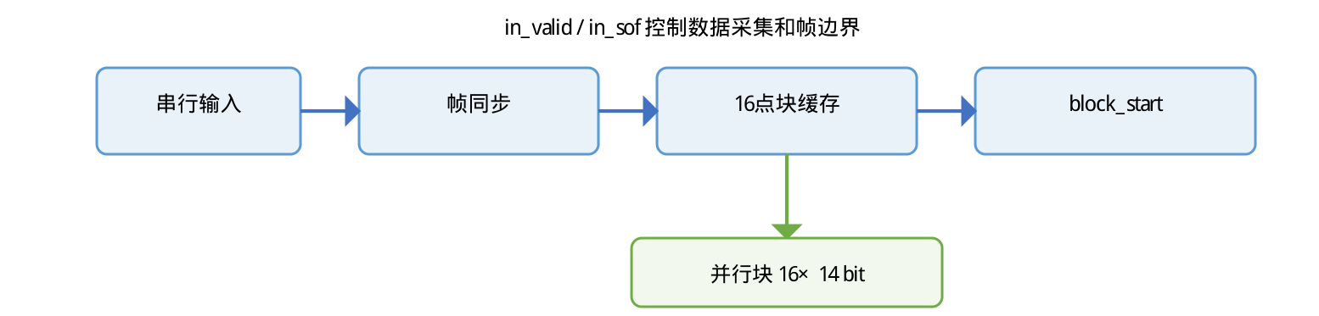

2 Serial-to-Parallel Conversion Module Design

2.1 Frame Boundary and Counter
stream_to_block16.v uses a 4-bit count to track the current write position. After reset, count is cleared to 0; when in_sof is asserted, the counter returns to the start of the block; on each in_valid cycle, din is written into the count-th 14-bit slice of block_data. count increments from 0 to 15; upon completing the 16th sample, block_start is asserted and count returns to 0.
if (in_sof) count <= 0;
block_data[count*14 +: 14] <= din;
if (count == 15) begin
block_start <= 1; count <= 0;
end
This structure consolidates frame synchronization, data buffering, and block-completion indication within a single sequential process. block_start is a register output and is therefore valid for only one clock cycle, making it suitable for directly connecting to the start signal of an FNT core.

2.2 Data Layout
block_data is a 224-bit bus; sample i occupies bits [14i+13 : 14i]. Sample 0 is placed in the lowest 14 bits and sample 15 in the highest 14 bits. This layout matches the packing format of the downstream parallel FNT core, avoiding additional reordering between interfaces.

3 Parallel-to-Serial Conversion Module Design

3.1 Block Latch and Output State
block_to_stream16.v copies the input block into the hold register when start is asserted, sets busy=1, and clears index to 0. Thereafter, on each clock cycle it reads data from the hold slice corresponding to index, updates dout, and raises out_valid; when index=15, the final symbol is output and the module exits the busy state.
if (start) begin
hold <= block_data; busy <= 1; index <= 0;
end else if (busy) begin
dout <= hold[index*14 +: 14];
out_valid <= 1;
end
Output data uses sequential indices, transmitted from 0 to 15 in order. Separating start from out_valid provides a clear timing boundary between input block latching and the first valid output, and also makes it easy to insert the processing latency of FNT, LUT, and IFNT in the project. Figure 2 shows the timing diagram of input acquisition and output serialization.
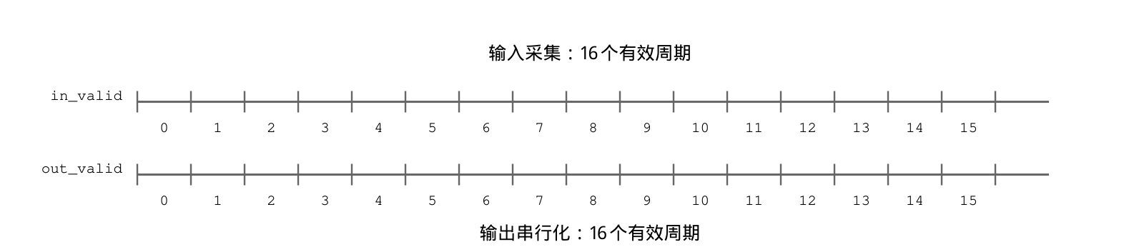
Figure 2 Timing diagram of input acquisition and output serialization

3.2 Pipeline Connection
The serial-to-parallel module is a block-boundary interface that relies mainly on sequential logic to accumulate data; there are no multiply-accumulate or modular operations inside the block, so no combinational computation stages need to be unfolded. The parallel-to-serial module likewise uses register holding and index counting. When an FNT or dispersion-compensation core is connected between the two modules, block_start can be used as the processing start signal, and a processing-complete signal can then drive the output start. The data block is held by registers or RAM during processing, and the input and output valid flags are generated by their respective modules.

4 Verification Scheme and Experimental Results

4.1 Basic Serial-to-Parallel Test
tb_stream_blocks.v generates 16 consecutive valid input samples, with the first sample carrying in_sof. The test checks whether block_start is asserted and whether samples 0 and 15 of block_data are 0 and 15, respectively. The simulation log shows that the basic serial-to-parallel test passes.

4.2 Serial-Parallel Roundtrip Test
tb_stream_blocks_roundtrip.v writes values 100 to 115 into the input stream, launches the parallel-to-serial module after block_start, samples dout corresponding to out_valid cycle by cycle, and writes them to stream_roundtrip.csv. run_small_project3.py automatically handles compilation, execution, log saving, and point-by-point CSV comparison for both testbenches.

4.3 Verification Results
Table 1 RTL verification results of the streaming interface
Test Item | Valid Samples | Result | Max Error
Basic serial-to-parallel buffering | 16 | PASS | 0
Serial-parallel / parallel-serial roundtrip | 16 | PASS | 0
Input block boundary | 1 block_start | PASS | No anomaly
Output order | index 0 to 15 | PASS | 0

5 Timing, Resource, and Scaling Analysis
Under continuous bubble-free input, the serial-to-parallel module receives one 14-bit sample per clock, and 16 valid cycles form one data block; the parallel-to-serial module outputs one 14-bit sample per clock, and 16 valid cycles complete one data block. The input side uses a 4-bit counter and a 224-bit block register, while the output side uses a 224-bit hold register, a 4-bit index, and a busy status bit, yielding a simple structure that is easy to synthesize.
When the system is scaled to 64-point or 256-point operation, count, index, and the data bus width can be parameterized, replacing the fixed 16 with N. If bubbles exist on the input, in_valid pauses counting and writing; if frame-loss risk exists, frame sequence numbers, timeout counters, and error flags can be added. For continuous high-throughput links, block_data can be replaced by a dual-port RAM, and ping-pong buffering can be used to overlap input acquisition with FNT computation.

