**Contents**

1. Clock
2. GPIO

CLOCK

GPIO_ General Purpose IO

1. **Input**:Every GPIO pin in modern MCU is provided with Internal Pull-up and Pull-down register ckt if not then.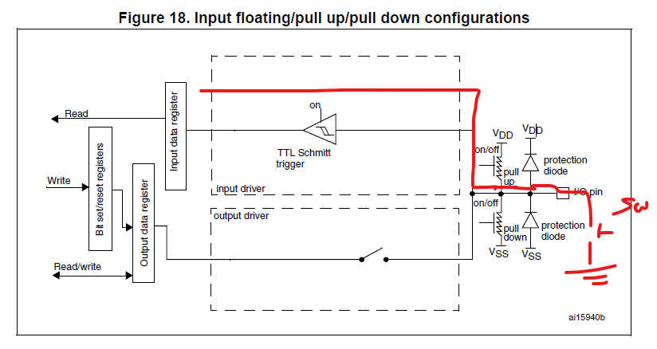Assume if switch is pressed then Input is 0 but if not pressed the the state of input is floating , i.e, because of noise in internal circuit the input may be 0 or 1 so using internal/external Pull-up or Pull down ckt is essential to avoid uncertainity. The pull-up and pull-down resistors are activated depending on the value in the GPIOx_PUPDR register.
2. **Output:** For 0 input Output is driven to GND(Vss) but for 1 it becomes Floating state so because Vdd at P-mops is also offstate it’s floating state so we need to activate internal/external Pull-up resitor ckt.In real time External Pull-up ckt with low resistor is used so that High voltage is passed as Output whereas internal pull-up ckt has higher resistance causing lower voltage to appear as output which is not sufficient to turn On LED.

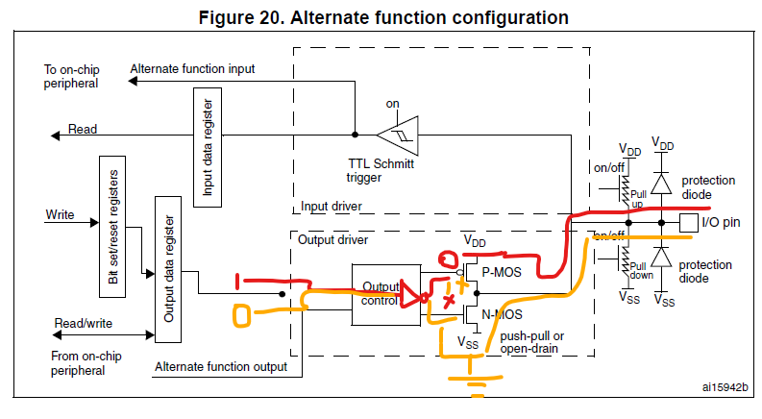

1. **Alternate function configuration:**

The output buffer can be configured as open-drain or push-pull.The output buffer is driven by the signal coming from the peripheral (transmitter enable and data).The Schmitt trigger input is activated.The weak pull-up and pull-down resistors are activated or not depending on the value

in the GPIOx_PUPDR register.The data present on the I/O pin are sampled into the input data register every AHB clock cycle

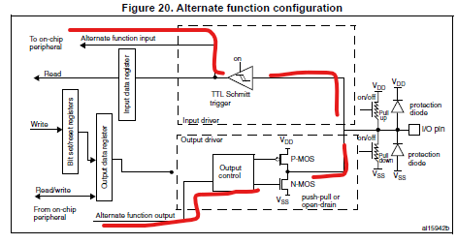

GPIO Registers:



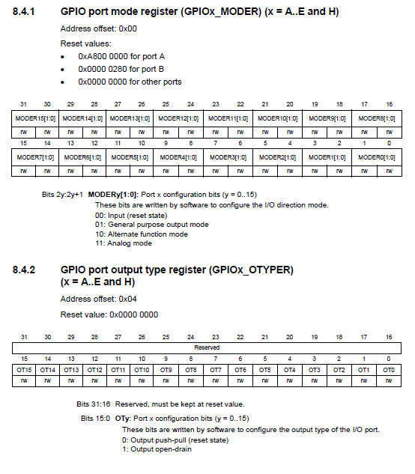

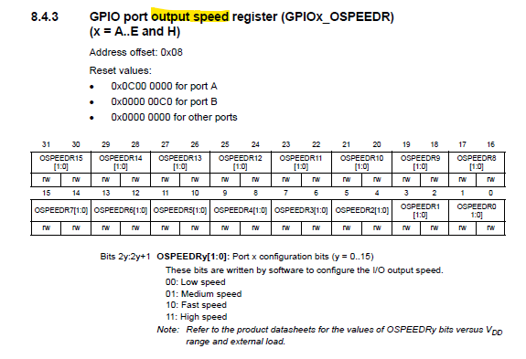

**From STM32F411Re datasheet  
OSPEED can be configured to below speed to specific freq**

