**Project proposal on Blogging Web Application**



**Tribhuvan University**

**Faculty of Humanities and Social Sciences**

**A Project Proposal**

**ON**

**“Blogging Web Application”**

**Submitted To**

**Department of Computer Application**

**Damak Multiple Campus**

**In partial fulfillment of the requirements for the Bachelors in Computer Application**

**Submitted By**

**Sandip Chapagain**

**TU-Reg-no: 6-2-0202-0885-2019**

**April,2023**



**Tribhuvan University**

**Faculty of Humanities and Social Sciences**

**Damak Multiple College**

**Supervisor’s Recommendation**

I hereby recommend that this project prepared under my supervision by Entitled **“Blogging Web App”** in partial fulfillment of the requirements for the degree of Bachelor of Computer Application is recommended for the final evaluation.

**SUPERVISOR**

Damak Multiple college

Department of BCA



**Tribhuvan University**

**Faculty of Humanities and Social Science**

**Damak Multiple college**

**LETTER OF APPROVAL**

This is to certify that this project prepare by sandip chapagain entitled **“Blogging Web App”** in partial fulfillment of the requirement for that degree of Bachelor in computer Application has been evaluated. In our opinion it is satisfactory in the scope and quality as project for the required degree.

|  |  |
| --- | --- |
| Signature  Supervisor  BCA Department  Damak Multiple Campus | Signature  Abhinash jha  Project Coordinator  BCA Department  Damak Multiple Campus |
| **Signature of Internal Examiner** | **Signature of External Examiner** |

**Damak Multiple College**

Ref No:

Date:

**Subject: Approval of Project Proposal**

The project entitled **“Blogging Web App”** by **Mr.Sandip Chapagain** for the partial fulfillment of the requirement for Bachelor in computer Application (BCA), Sixth Semester has been Approved for further development.

**Proposal Evaluation Committee**

**1 .**

**2 .**

**3 .**

**4 .**

**Mr.Netra Budhathok**

Table of Contents

Chapter 1 .Introduction 1

1.1 Introduction of Proposed project 1

1.2 Problem Statement 1

1.3 Objective 2

1.4 Scope and Limitation 3

1.4.1 Scope 3

1.4.2 Limitations 3

Chapter 2 Literature Review 4

2.2 Literature Review 4

Chapter 3 Methodology 6

3.1 System Analysis 6

Feasibility Study: 8

3.2 System Design 9

3.3 Project Schedule 10

Chapter-4 Conclusion 11

4.1 Expected Outcome 11

Bibliography 12

Chapter 1 .Introduction

* 1. Introduction of Proposed project

Blogging has become a popular form of online self-expression, allowing individuals like me to share my thoughts, experiences, and expertise with a wider audience. To make it easier for bloggers and readers alike, I have developed a Blogging WebApp using Spring Boot and React JS that provides a streamlined and user-friendly experience.

My platform allows bloggers to easily create and publish content, customize their blog's appearance, and interact with their audience through comments and social sharing. Readers can discover new and interesting blogs, search for specific topics, and leave feedback for the bloggers they enjoy. To help bloggers grow their audience and improve their content, my WebApp includes features such as email subscriptions, RSS feeds, and analytics. In addition to providing a great user experience, I prioritize security and privacy. My WebApp includes robust security features such as JSON Web Token (JWT) authentication, encryption, and access control to ensure that user data is protected. With JWT authentication, users can securely log in and access their account information without worrying about unauthorized access. With its intuitive interface, advanced features, and strong security measures, I aim to make blogging more enjoyable and rewarding for everyone involved

* 1. Problem Statement

In today's digital age, there is a lot of information available online. However, with this comes the challenge of identifying credible sources and content. Many bloggers are facing difficulties in establishing trust and reliability with their audience due to the saturation of low-quality content. As a result, readers often struggle to find valuable and informative content that is worth their time.

To address this problem, a Blogging Web Application is going to be developed that aims to provide a platform for bloggers to publish high-quality content, connect with their audience and build a reputation based on their expertise. The application will focus on promoting credible and informative content, and provide tools to help bloggers create engaging and valuable posts. This will help readers to easily find valuable content and build trust in the bloggers they follow. With this application, bloggers can grow their audience, establish their credibility and make a positive impact on the online community.

1.3 Objective

The main objectives of Blogging Web App are as below:

* To provide bloggers with a user-friendly and customizable platform to publish and showcase their content.
* To create a community of bloggers who can connect, collaborate, and support each other in their creative pursuits.
* To offer a variety of blog templates and design options to help bloggers express their individuality and creativity.
* To ensure the security and privacy of bloggers' content and personal information.
* To provide analytics tools to help bloggers track their blog's performance and engagement.
* To allow bloggers to monetize their content and earn income through advertising or other means.
* To encourage bloggers to engage with their audience and build a following through social media sharing and email subscriptions.
* To continuously improve and update the platform based on user feedback and emerging trends in blogging.

**Main modules of the project:**   
This project has the following modules, to manage all the requirements of the User

* User registration and Login system
* Blog post creation and publishing system.
* Blog post categorization system.
* Commenting functionality for readers.
* User Profile Management System

1.4 Scope and Limitation

1.4.1 Scope

* The Blogging WebApp will be developed using SpringBoot and React JS to provide a streamlined and user-friendly experience for bloggers and readers.
* The platform will allow bloggers to easily create and publish content, customize their blog's appearance, and interact with their audience through comments.
* Readers can discover new and interesting blogs, search for specific topics, and leave feedback for the bloggers they enjoy.
* The WebApp will include security features such as encryption, authentication, and access control to ensure that user data is protected.
* The platform will comply with relevant regulations to ensure that it is safe and trustworthy.

1.4.2 Limitations

* The Blogging WebApp will not include features such as email subscriptions or social media sharing.
* The platform will not offer any monetization or subscription functionality.
* The WebApp will not include analytics or reporting features.
* The WebApp may face security risks, such as hacking or data breaches, that could compromise bloggers' content and personal information.
* Lack of Draft Feature
* Limited Tagging Functionality
* Lack of Two-Factor Authentication (2FA)

Chapter 2 Literature Review

2.2 Literature Review

Blogging has become an increasingly popular means of communication in the digital age. With the rise of social media and the internet, people have more ways to express themselves and share their thoughts and ideas with others than ever before. As such, blogging has become a valuable tool for individuals, organizations, and businesses to reach a wider audience and engage with their customers.

In addition, the study by D. Kim et al. (2018) [1] found that the use of a blogging platform allowed students to express their thoughts and ideas more freely, which improved their language proficiency and writing skills. The platform also provided opportunities for students to give and receive feedback on their work, leading to improved learning outcomes. Overall, the study suggests that blogging web apps can be an effective tool for supporting language learning and promoting communication and collaboration among students.

[1]The study by S. Li et al. (2020) also revealed that blogging can facilitate informal learning and create a culture of knowledge sharing within an organization. Furthermore, the study found that the use of blogging in knowledge management can help capture tacit knowledge, which is often difficult to document and share using traditional methods.

Moreover, the study found that blogging can encourage employees to express their opinions and ideas more freely, leading to greater creativity and innovation within the organization. By providing a platform for employees to share their insights, experiences, and ideas, blogging can help foster a more collaborative and inclusive work environment.

Similarly, a study by [1] H. Wang et al. (2016) investigated the use of blogging as a tool for promoting critical thinking skills in college students. The study found that blogging can be an effective way to encourage students to think critically about a variety of topics and to engage in meaningful discussion with their peers. In addition, the study also found that blogging allowed students to practice their writing skills and to receive feedback from their peers, which can further enhance their critical thinking abilities. Furthermore, the study highlighted the importance of providing clear guidelines and expectations for blog assignments to ensure students understand the purpose and goals of the activity.

The study by [2] W. Chen et al. (2018) further emphasized that an effective educational blogging platform should also provide features for customization and personalization, such as the ability to customize the layout and design of the blog. In addition, the study suggested that the platform should allow for easy integration with other digital tools and platforms, such as social media and learning management systems. Finally, the study found that the ability to provide feedback and assessment on blog content is crucial for creating a successful educational blogging platform.

[3]The study by J. Lee et al. (2020) identified several gamification techniques that were effective in promoting student engagement and motivation, including badges, points, and leader boards. The study also found that the use of gamification increased student enjoyment and satisfaction with the blogging activity. Additionally, the study suggested that careful consideration should be given to the type and level of gamification used in a blogging web app, as excessive gamification can have a negative impact on intrinsic motivation. Finally, the study recommended that future research should explore the long-term effects of gamification on student learning and motivation.

In conclusion, blogging web apps have been found to be effective in a variety of contexts, including language learning, knowledge management, critical thinking skills, and student engagement. The design and features of these web apps play an important role in their success, and should be carefully considered when developing a blogging platform.

Chapter 3 Methodology

I am going to use the waterfall methodology while building the website This project have specific documentation, ample time, fixed requirement, well-understood technology so in order to build this system, waterfall methodology can be used.

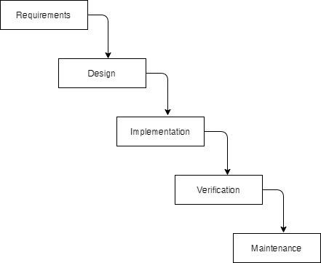

Fig: Waterfall Model

The |Waterfall Model was the first Process Model to be introduced. It is also refereed to as a Liner-sequential life cycle model. It is very simple to understand an dues. In a Waterfall model, each phase must be completed before the next phase can began and there is no overlapping in the phases. It is easy to arrange tasks and defined stages

3.1 System Analysis

It is a process of collecting and interpreting facts, identifying the problems, and decomposition of a system into its components.

System analysis is conducted for the propose of studying a system or its parts in order to identify its objectives. It is a problem solving technique that involves the system and ensures that all components of the system work efficiently to accomplish their purpose.

Requirements identification:

This system need to fulfill following functional and non-functional requirements

Functional Requirements:

**Functional Requirement**

Different functional requirement of the system have been identified and are listed as below:

**For Admin:**

* The system should allow the admin to register and login to the system.
* The system should allow the admin to manage and edit the content and posts on the website.
* The system should allow the admin to view and manage user profiles, comments, and feedback.
* The system should allow the admin to monitor website traffic and analytics.
* The system should allow the admin to create and manage user roles and permissions.

**For User:**

* The system should allow users to register and create a profile.
* The system should allow users to create, edit, and publish blog posts.
* The system should allow users to upload images and other multimedia content to their blog posts.
* The system should allow users to comment on other users' posts and interact with other users on the platform.
* The system should allow users to search for and discover new content and blogs on the platform.

**Non-Functional Requirements**

Different non-functional requirement are as below:-

* The webapp should be designed to have a clean and user-friendly interface, allowing for easy navigation and intuitive use.
* The system should be designed to be scalable, allowing for potential growth in the number of users and content on the platform.
* The webapp should be secure, with appropriate measures in place to protect user data and prevent hacking or other malicious activity.
* The system should have a reliable and fast hosting infrastructure to ensure quick and seamless access to the platform.
* The web app should be accessible to users with disabilities, following relevant accessibility guidelines and standards.

Feasibility Study:

The feasibility study concluded that the project is able to be implemented successful as it was carefully planned.

1. **Technical Feasibility Study**

The system is technically feasible as the necessary hardware and software required for the development and implementation of the system is available. The project is built using Spring Boot framework for the backend and ReactJS for the frontend. The use of Spring Boot allows for efficient and easy development, while ReactJS provides a modern and responsive user interface. The required libraries and dependencies for both technologies are readily available and easily accessible. Additionally, the use of JWT Security ensures secure authentication and authorization of users.

1. **Operational Feasibility Study**

The system is easy to operate with basic knowledge of computer and internet. Users can easily access the system as it is user-friendly with a well-designed user interface. The system allows for easy creation and management of blog posts, as well as interaction between users through comments. Additionally, the system allows for searching and viewing of other users' blog posts. The administrative tasks of managing user information, blog posts, and comments can also be easily performed.

1. **Economic Feasibility**

The system is economically feasible and cost-effective. As all the necessary tools and resources required are either open source or free. After the completion of the system, the organization does not need to deploy any new hardware and software as the required software and hardware are already in place. The use of open-source technologies also reduces the cost of licensing fees.

**Tools**

* **Front end**
* React Js

ReactJS is a popular JavaScript library for building user interfaces. We used ReactJS to create the front-end of our blogging web app project. ReactJS allowed us to create reusable UI components and efficiently render updates to the user interface

* Bootstrap

Bootstrap is a widely used front-end development framework that provides a set of pre-designed HTML, CSS, and JavaScript components to build responsive web pages and applications.

* **Back end**
* Spring boot

Spring Tool Suite 4 is an IDE based on the Eclipse platform, designed specifically for developing Spring-based enterprise applications. We used STS to develop the back-end of our project using Spring Boot.

3.2 System Design

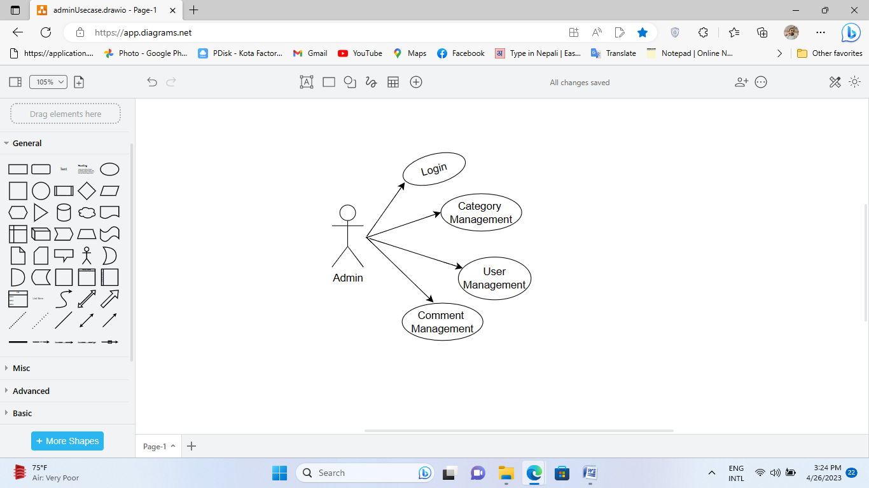Administrator(Use Case)

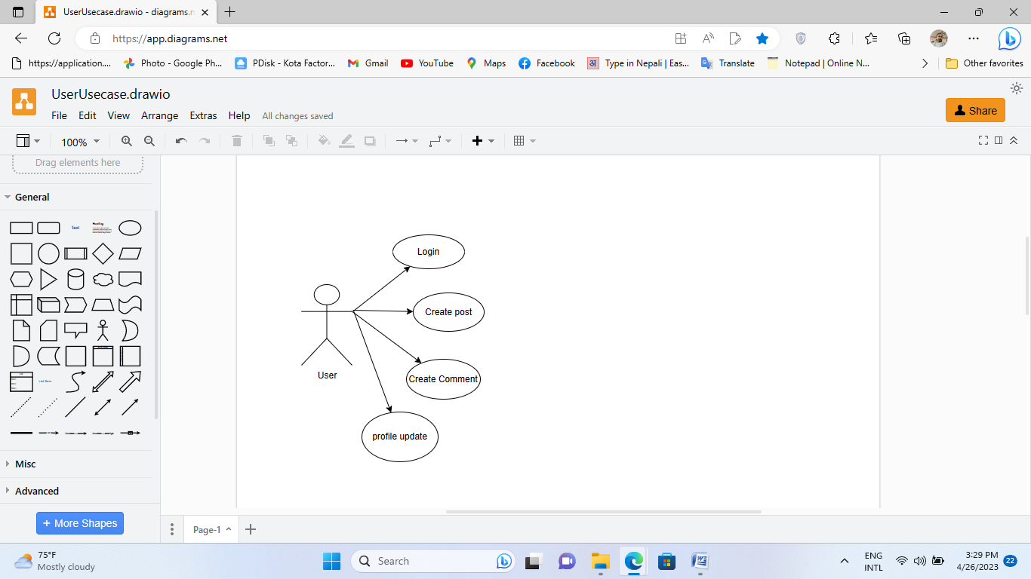User(Use Case)

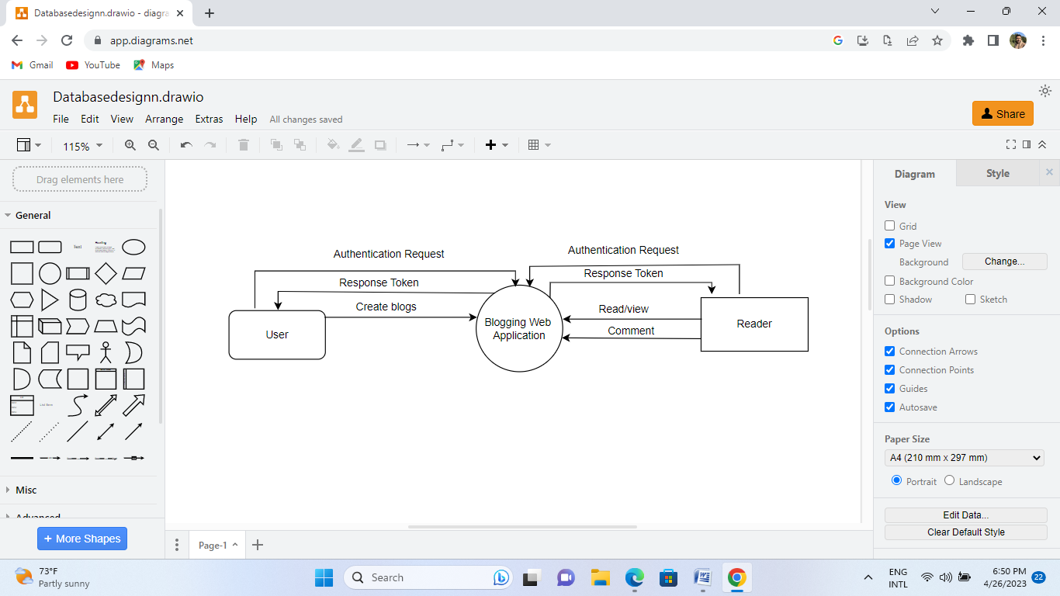Database Diagram

**\\\**

3.3 Project Schedule

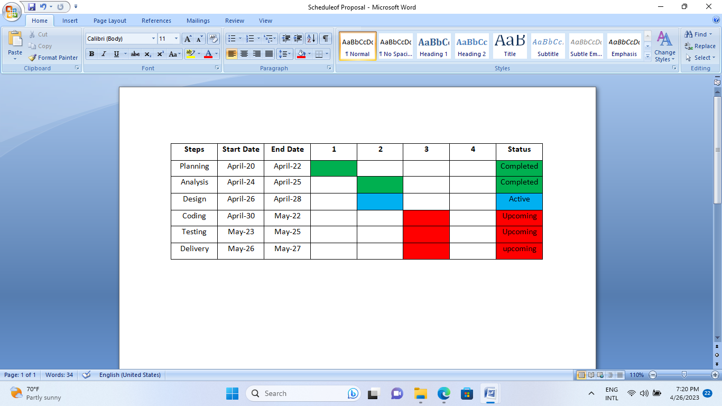

**Fig: Gantt Chart**

Chapter-4 Conclusion

This project mainly focuses on providing a platform for bloggers to share their ideas and insights with others. The app's features include categories, comments, and user authentication, among others. As the sole developer, I aimed to create an intuitive and user-friendly platform that would enable bloggers to engage with their readers and grow their audience The development of the Blogging Web Application Will involves Various Methodologies. Initially, the requirements and objective for the project will be identified by analyzing the existing the blogging websites and identifying the necessary features for our application

4.1 Expected Outcome

The expected outcome of My blogging web app would be a functional platform that allows users to create and publish blog posts, as well as search for content within the app. Users should also be able to register and login to the app. The web app should have a user-friendly interface that is easy to navigate, with clear instructions for creating, editing, and publishing posts. Additionally, the app should be secure, with measures in place to prevent unauthorized access or data breaches. Overall, the successful completion of your blogging web app would provide users with a valuable tool for sharing their ideas and perspectives online, while also demonstrating your skills as a developer

Bibliography

|  |  |
| --- | --- |
| [1] | W. T. C. &. H. Chen, 2018. [Online]. Available: https://www.tandfonline.com/. [Accessed 20 march 2023]. |
| [2] | D. L. H. &. L. Kim, 2018. [Online]. Available: https://www.researchgate.net/. [Accessed 15 march 2023]. |
| [3] | J. P. S. &. P. Lee, 2020. [Online]. Available: https://www.sciencedirect.com. [Accessed 23 march 2023]. |
| [4] | S. L. Y. &. C. Li, 2020. [Online]. Available: https://www.emerald.com. [Accessed 3 march 2023]. |
| [5] | H. C. Y. &. H. Wang, 2016. [Online]. Available: https://www.sciencedirect.com/. [Accessed 10 march 2023]. |