# 

# Tribhuvan University

**Faculty of Humanities and Social Sciences**

**LiveJournal Blogging Web Application**

**A PROJECT REPORT**

**Submitted to:**

**Department of Computer Application**

**Damak Multiple Campus**

***In partial fulfillment of the requirements for the Bachelors in Computer Application***

Submitted by

Sandip Chapagain (TU symbol No: 6-2-202-885-2019

July,2023

Under the Supervision of

Ghanashyam Adhikari

# 

# 

# Tribhuvan University

**Faculty of Humanities and Social Sciences**

**Damak Multiple College**

# Supervisor’s Recommendation

I hereby recommend that this project prepared under my supervision by Sandip Chapagain entitled “**LiveJournal Blogging Web Application”** in partial fulfillment of the requirements for the degree of Bachelor of Computer Application is recommended for the final evaluation

**Mr.Ghanashyam Adhikari**

**SUPERVISOR**

Damak Multiple College

Department of BCA



# Tribhuvan University

**Faculty of Humanities and Social Sciences**

**Damak Multiple College**

# LETTER OF APPROVAL

|  |  |
| --- | --- |
| Signature  Supervisor  BCA Department  Damak Multiple Campus | Signature  Abhinash jha  Project Coordinator  BCA Department  Damak Multiple Campus |
| **Signature of Internal Examiner** | **Signature of External Examiner** |

This is to certify that this project prepared by **Sandip Chapagain** entitled **“LiveJournal Blogging Web Application**” in partial fulfillment of the requirements for the degree of Bachelor in computer Application has been evaluated. In our opinion, it is satisfactory in the scope and quality as a project for the required degree**.**

# Acknowledgement

This project is prepared in the partial fulfillment of the requirement for the degree of Bachelor in Computer Application (BCA). The satisfaction and success of completion of this task would be incomplete without heartfelt thanks to people whose constant guidance, support and encouragement made this work successful. On doing this undergraduate project I have been fortunate to have help, support and encouragement from many people I would like to acknowledge them for their cooperation.

My first thanks go to Tribhuvan University for designing such a worthy syllabus and making us do this project. My next batch of thanks goes to the faculty of Management of DMC without whose help our project would have been impossible. This list includes chief of DMC, Mr.Yagyaraj Giri My very sincere and heartfelt thanks go to Mr.Ghanashyam Adhikari our project supervisors who constantly guided us through the project time period. Without his guidance, my project would have been impossible. Last but not the least I want to thank every direct and indirect hands that were involved in completion of this project. This project has been a wonderful experience where I have learnt and experienced many beneficial things.

# Abstract

The "LIVEJOURNAL BLOGGING WEB APPLICATION" is a web-based application that allows users to create and publish their blog posts. It is developed using the Spring Boot framework, MySQL, and ReactJS. The application offers a user-friendly dashboard where users can create, edit, and manage their blog posts. The platform is designed to simplify the process of creating and sharing blog content with a wider audience.

The main objective of this project is to provide a simple and efficient platform for users to publish their blog posts. The proposed system allows users to create and publish their blog posts on a single platform. The system is designed to provide an easy-to-use interface with the necessary tools required to create, edit, and manage blog content. The platform also allows users to interact with other bloggers and readers, share feedback, and engage in discussions.

The proposed system is implemented using the Spring Boot framework, which provides a stable, scalable, and reliable platform for web application development. MySQL is used as a database management system, which provides efficient data storage and retrieval capabilities. ReactJS is used for front-end development, which offers a fast and dynamic user interface.

In conclusion, the "Blogging Web Application" project offers a simple and efficient platform for users to create, publish, and manage their blog posts. The system is designed to provide a user-friendly interface with the necessary tools and features required for creating and sharing blog content

Table of Contents

Tribhuvan University 1

Tribhuvan University 2

Supervisor’s Recommendation 2

Tribhuvan University 3

LETTER OF APPROVAL 3

Acknowledgement i

Abstract ii

**CHAPTER: 1 INTRODUCTION** 1

1.1 Introduction 1

1.2 Problem Statement 1

1.3 Objectives 2

1.4 Scope and Limitation 2

1.4.1 Scope 2

1.4.2 Limitations 2

1.5 Development Methodology 2

1.6 Report Organization 3

**CHAPTER: 2 BACKGROUND STUDY AND LITERATURE REVIEW** 4

2.1 Background Study 4

2.2 Literature Review 4

**CHAPTER: 3 SYSTEM ANALYSIS AND DESIGN** 7

3.1 System Analysis 7

3.1.1 Requirement Analysis 7

3.1.2 Feasibility Analysis 9

3.1.3 Object Modeling: Class Diagram 11

3.1.4 Dynamic Modeling: State and Sequence Diagram 12

3.1.5 Process Modeling: Activity Diagram 14

3.2 System Design 15

3.2.1 Refinement of class and object 15

3.2.2 Component Diagram 16

3.2.3 Deployment Diagram 17

3.3. Algorithm Details 18

**CHAPTER: 4 IMPLEMENTATION AND TESTING** 19

4.1 Implementation 19

4.1.1 Tools Used (CASE tools, programming language, Database platforms) 19

4.1.2 Implementation Details of Modules 19

4.2. Testing 21

4.2.1 Test Cases for Unit Testing 21

4.2.2 Test case For System Testing 22

**CHAPTER: 5 CONCLUSION AND FUTURE RECOMMENDATIONS** 24

5.1 Lesson Learnt/ Outcome 24

5.2 Conclusion 24

5.3. Future Recommendations 24

REFERENCES 25

APPENDICES 26

**LIST OF APPREVIATIONS**

|  |  |
| --- | --- |
| STS | Spring Tools Suits |
| SQL | Structure Query Language |
| JWT | JSON Web Token |
| JS | Java Script |
| ISO | Iphone Operating System |
| API | Application Programming Interface |
| OTP | One Time Password |
| UI | User Interface |
| DMC | Damak Multiple College |
| SMS | Short Message Service. |
| SOS | Save Our Souls |
| UI | User Interface |
| URL | Uniform Resource Locator |

**LIST OF FIGURES**

Figure 3.1: Waterfall Methodology for Blogging Web Application 7

Figure 3.2 Use Case Diagram of Blogging Web App 9

Figure 3.3: Gantt chart for Blogging Web App 11

Figure 3.4: Class Diagram of Blogging Web App 11

Figure 3.5: Sequence Diagram for User of Blogging Web App 12

Figure 3.6: Sequence Diagram for Admin of Blogging Web App 13

Figure 3.8: Refinement of Class and Object Diagram for Blogging Web App 15

Figure 3.9: Component Diagram for Blogging Web App 17

Figure 3.10: Deployment Diagram for Blogging Web App 17

# CHAPTER: 1 INTRODUCTION

* 1. Introduction

Blogging has become a popular form of online self-expression, allowing individuals like me to share my thoughts, experiences, and expertise with a wider audience. To make it easier for bloggers and readers alike, I have developed a Blogging Web Application using Spring Boot and React JS that provides a streamlined and user-friendly experience.

My platform allows bloggers to easily create and publish content, customize their blog's appearance, and interact with their audience through comments and social sharing. Readers can discover new and interesting blogs, search for specific topics, and leave feedback for the bloggers they enjoy. To help bloggers grow their audience and improve their content, my Web Application includes features such as email subscriptions, RSS feeds, and analytics.

In addition to providing a great user experience, I prioritize security and privacy. My Web Application includes robust security features such as JSON Web Token (JWT) authentication, encryption, and access control to ensure that user data is protected. With JWT authentication, users can securely log in and access their account information without worrying about unauthorized access. I also follow best practices for data handling and comply with relevant regulations to ensure my platform is safe and trust worth

Overall, my Blogging Web Application is a powerful and accessible tool for anyone looking to share their ideas and connect with others online. With its intuitive interface, advanced features, and strong security measures, I aim to make blogging more enjoyable and rewarding for everyone involved

* 1. Problem Statement
* Traditional information conveyance hampers quick access due to disorganized content in printed media or face-to-face discussions. Embrace more efficient methods for better information sharing.
* Traditional information retrieval and searching might encounter delays, particularly when dealing with large datasets
* Language barriers limit effective communication with diverse audiences, hindering content reach. Improved translation solutions can expand global accessibility to ideas and information.
  1. Objectives

The main objectives of Blogging Web Application are as below:

* Allowing users to translate any blog post into their preferred language. It will explain the underlying technology and demonstrate how users can utilize this feature effectively to break language barriers and reach a wider audience.
* Display blog posts in a categorized manner. It will demonstrate how users can easily navigate through different categories, making it simpler for them to find specific
* The search feature effectively to save time and locate relevant information quickly ,designed to provide users with a faster and more efficient way to find the content they need
  1. Scope and Limitation
     1. Scope
* The Blogging Web Application will be developed using SpringBoot and React JS to provide a streamlined and user-friendly experience for bloggers and readers.
* The platform will allow bloggers to easily create and publish content, customize their blog's appearance, and interact with their audience through comments.
* Readers can discover new and interesting blogs, search for specific topics, and leave feedback for the bloggers they enjoy.
* The Web Application will include security features such as encryption, authentication, and access control to ensure that user data is protected.
* The platform will comply with relevant regulations to ensure that it is safe and trustworthy.
  + 1. Limitations
* The Blogging Web Application will not include features such as email subscriptions or social media sharing.
* The platform will not offer any monetization or subscription functionality.
* The Web Application will not include analytics or reporting features.
* The Web Application may face security risks, such as hacking or data breaches, that could compromise bloggers' content and personal information.
  1. Development Methodology

For the development of my Blogging Web Application, I have used an object-oriented approach that includes various design diagrams such as object and class diagram, sequence diagram, and activity diagram. I have also used the Spring Boot framework to streamline the development process and React JS for building the user interface.

* 1. Report Organization

Chapter 1:- deals with the introduction of the system with its objectives and limitations along with the reason why the system is made.

Chapter 2:- summarizes the work that has been carried out in the field of data mining and also describes the features about some existing applications related to the Women Safety Alert system.

Chapter 3:- focuses on the different requirement of the system, which describes about the functional, non-functional, feasibility analysis, Object Modeling: Object and Class Diagram, Dynamic Modeling: State and Sequential Diagram, Process Modeling: Activity Diagram design of the system with Component Diagram, and Deployment Diagram, Refinement of Classes and Object, and the implementations of Algorithm with its details.

Chapter 4:- emphasizes tools used in system development, implementing details and result of test performed.

Chapter 5 :- highlights brief summary of lesson learnt, outcome and conclusion of the whole project and explain what have been done and what further improvements could be done.

# CHAPTER: 2 BACKGROUND STUDY AND LITERATURE REVIEW

2.1 Background Study

Blogging has become an increasingly popular form of self-expression in recent years, with individuals and businesses using blogs to share their thoughts, experiences, and expertise with a wider audience. With the rise of social media and online content consumption, blogs have become a valuable tool for building brand awareness, driving website traffic, and establishing thought leadership.

However, many blogging platforms can be difficult to use and lack advanced features that bloggers need to succeed. Some platforms are also expensive or require technical expertise to set up and maintain. These challenges can discourage individuals from starting a blog or limit their ability to grow and succeed in the competitive online environment.

To address these issues, I have developed a Blogging Web Application using SpringBoot and React JS that provides an easy-to-use, streamlined, and powerful platform for bloggers of all skill levels. My platform offers advanced features such as customizable design, search engine optimization, and analytics that help bloggers increase their visibility and engagement.

In addition, my platform prioritizes security and privacy, providing robust features such as encryption, authentication, and access control to ensure that user data is protected. I also follow best practices for data handling and comply with relevant regulations to ensure that my platform is safe and trustworthy.

Through my Blogging Web Application, I aim to empower bloggers to create and share high-quality content, build their audience, and achieve their goals in the online space.

2.2 Literature Review

There are many similar applications that has been developed or in developing process available in web where some are free and many need to be procured. Similar applications are found in Google play store, app store, Microsoft store and some are third parties application or system also.

In This today world, Blogging has become an increasingly popular means of communication in the digital age. With the rise of social media and the internet, people have more ways to express themselves and share their thoughts and ideas with others than ever before. As such, blogging has become a valuable tool for individuals, organizations, and businesses to reach a wider audience and engage with their customers.

Geeksforgeeks [1] is a popular computer science portal that allows individuals and organizations to learn and share information on a variety of topics, including data structures, algorithms, programming languages, and interview questions. It is known for its clean and minimalist design, user-friendly interface, and a wide range of topics covered by its diverse community of contributors. Geeksforgeeks offers a seamless learning experience with its built-in text editor, formatting options, and easy publishing process. It also provides social features such as following other users, highlighting and commenting on articles, and recommending content to learners based on their interests.

By studying Geeksforgeeks, you can learn about the best practices for developing a blogging web application. You can also learn about innovative features that can be added to your application to make it more engaging and useful for users.

Quora [2] is a question-and-answer website where users can ask questions, share answers, and learn from each other. It is known for its vast library of questions and answers, as well as its active and engaged community of users. Quora offers a seamless learning experience with its built-in text editor, formatting options, and easy publishing process. It also provides social features such as following other users, highlighting and commenting on answers, and recommending content to learners based on their interests.

By studying Quora, you can learn about the best practices for developing a blogging web application that is interactive, engaging, and informative. You can also learn about innovative features that can be added to your application to make it more user-friendly and useful.

Javatpoint [3] is a popular website that provides tutorials, articles, and code snippets on a variety of Java topics. It is known for its clear and concise explanations, as well as its large library of content. Javatpoint also offers a number of interactive features, such as coding challenges and practice problems.

By studying Javatpoint, you can learn about the best practices for developing a blogging web application that is informative and helpful. You can also learn about innovative features that can be added to your application to make it more user-friendly and useful.

TutorialsPoint is a popular website that provides tutorials, articles, and code snippets on a variety of programming topics. It is known for its clear and concise explanations, as well as its large library of content. TutorialsPoint also offers a number of interactive features, such as coding challenges and practice problems.

By studying TutorialsPoint, you can learn about the best practices for developing a blogging web application that is informative and helpful. You can also learn about innovative features that can be added to your application to make it more user-friendly and useful satisfaction with the blogging activity. Additionally, the study suggested that careful consideration should be given to the type and level of gasification used in a blogging Web Application, as excessive gasification can have a negative impact on intrinsic motivation.

Stack Overflow [4] is a question-and-answer website for programmers. It is a great resource for getting help with programming problems. Stack Overflow is known for its large and active community of users, as well as its high-quality content. anyone who is interested in programming. The site's content is high-quality and well-written, and the active community makes it a great place to get help with problems and learn new concepts.

By studying Stack Overflow, you can learn about the best practices for developing a blogging web application that is informative, helpful, and interactive. You can also learn about innovative features that can be added to your application to make it more user-friendly and useful.

Finally, the study recommended that future research should explore the long-term effects of gasification on student learning and motivation.

In conclusion, blogging Web Applications have been found to be effective in a variety of contexts, including language learning, knowledge management, critical thinking skills, and student engagement. The design and features of these Web Applications play an important role in their success, and should be carefully considered when developing a blogging platform.

# CHAPTER: 3 SYSTEM ANALYSIS AND DESIGN

3.1 System Analysis

This system is designed with the series of processes starting with requirement analysis, design, implementation, testing and maintenance. During requirement analysis, all the functional and non-functional requirement are analyzed and system is developed according to the requirement then designing of the system is carried out. After the design process, coding and development part is started then after integrating the system there is testing of the system. If the testing is positive then system is implemented otherwise some maintenance is done and system come in operation.

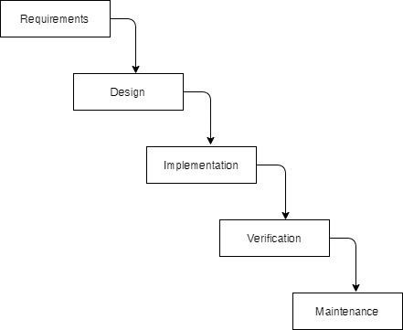

Figure 3.1: Waterfall Methodology for Blogging Web Application

3.1.1 Requirement Analysis

The requirement are to be collected before starting project’s development life cycle. To design and develop system, functional as well as non-functional requirement of the system has been studied.

1. Functional Requirement

Different functional requirement of the system have been identified and are listed as below:

**For Admin:**

* The system should allow the admin to register and login to the system.
* The system should allow the admin to manage and edit the content and posts on the website.
* The system should allow the admin to view and manage user profiles, comments, and feedback.
* The system should allow the admin to monitor website traffic and analytics.
* The system should allow the admin to create and manage user roles and permissions.

**For User:**

* The system should allow users to register and create a profile.
* The system should allow users to create, edit, and publish blog posts.
* The system should allow users to upload images and other multimedia content to their blog posts.
* The system should allow users to comment on other users' posts and interact with other users on the platform.
* The system should allow users to search for and discover new content and blogs on the platform.

USECASEDIAGRAM

In the Blogging Web application, the use case diagram consists of a user and admin where user is allowed to create an account. Users are allowed to create blog posts and interact with other users through comments. They can also view and search for other users' blog posts.

Likewise, admin is allowed to register and login to the system. Admin is allowed to manage information of the users and their blog posts. They can also monitor comments and take action if needed, such as deleting inappropriate comments or banning users. Additionally, admin can view usage analytics, such as the number of posts and users on the platform.

Furthermore, users can customize their profiles and receive notifications about new blog posts or comments. The web application should also have a search feature to allow users to search for specific blog posts or users. Finally, the system should ensure the security of user data and prevent unauthorized access to the platform.

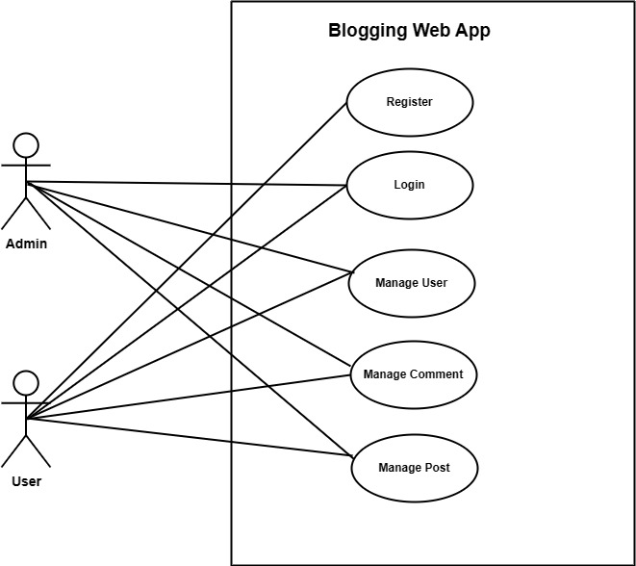

Figure 3.2 Use Case Diagram of Blogging Web App

1. Non-Functional Requirement

Different non-functional requirement are as below:-

* The web application should be designed to have a clean and user-friendly interface, allowing for easy navigation and intuitive use.
* The system should be designed to be scalable, allowing for potential growth in the number of users and content on the platform.
* The web application should be secure, with appropriate measures in place to protect user data and prevent hacking or other malicious activity.
* The system should have a reliable and fast hosting infrastructure to ensure quick and seamless access to the platform.
* The Web application should be accessible to users with disabilities, following relevant accessibility guidelines and standards.

3.1.2 Feasibility Analysis

The feasibility study concluded that the project is able to be implemented successful as it was carefully planned.

1. **Technical Feasibility Study**

The system is technically feasible as the necessary hardware and software required for the development and implementation of the system is available. The project is built using Spring Boot framework for the backend and ReactJS for the frontend. The use of Spring Boot allows for efficient and easy development, while ReactJS provides a modern and responsive user interface. The required libraries and dependencies for both technologies are readily available and easily accessible. Additionally, the use of JWT Security ensures secure authentication and authorization of users.

1. **Operational Feasibility Study**

The system is easy to operate with basic knowledge of computer and internet. Users can easily access the system as it is user-friendly with a well-designed user interface. The system allows for easy creation and management of blog posts, as well as interaction between users through comments. Additionally, the system allows for searching and viewing of other users' blog posts. The administrative tasks of managing user information, blog posts, and comments can also be easily performed.

1. **Economic Feasibility Study**

In the context of my blogging web application project, I have evaluated the economic feasibility by considering the various tools and resources utilized throughout the development lifecycle. The following table outlines the key aspects, tools/resources, and their associated costs:

|  |  |  |
| --- | --- | --- |
| **Aspect** | **Tools/Resources** | **Cost** |
| Development | Spring boot ,ReactJs , STS, Database, JWT Security, VSCode, | Free |
| APIs | Google ApIs , Postman |  |
| Deployment | Railway.app(Backend), Netlify(Frontend) | Free |
| Hardware, Software | Existing infrastructure | N/A |
| Licensing | Open-source technologies | Reduced |
| Deployment | No new hardware/software | Savings |

1. **Schedule Feasibility Study**

The system can be completed within the scheduled time as it was carefully planned and development is being carried out using Waterfall methodologies. Regular testing and quality assurance practices are also being implemented to ensure timely delivery and high-quality output.

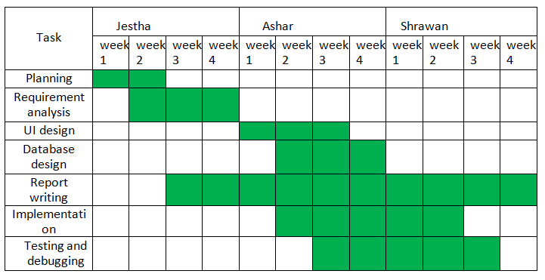

Figure 3.3: Gantt chart for Blogging Web App

3.1.3 Object Modeling: Class Diagram

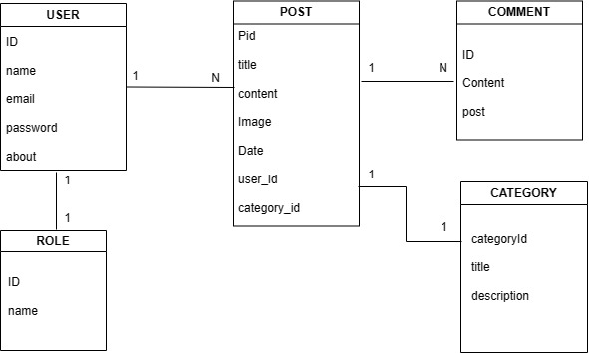The class diagram for the blogging web app is displayed below. It comprises multiple tables with unique fields. For instance, the User table includes Id, name, email, and password; the Comment table has id, content, and post attributes; the Post table contains id, title, content, image, date, user_id, and category_id; and the Category table consists of id, title, and description fields. Each table is linked by unique identifiers and foreign keys.

Figure 3.4: Class Diagram of Blogging Web App

3.1.4 Dynamic Modeling: State and Sequence Diagram

The sequence diagram used in this system helps to understand the existing and the requirements of the new features and application

**Sequence Diagram**

**For User**

The sequence diagram for the Blogging Web Application project starts with the User registering with the system by providing their details. After successful registration, the User logs in to the system and is redirected to their dashboard page.

The Dashboard page allows the User to manage their profile information, view their published blog posts, and create new blog posts.

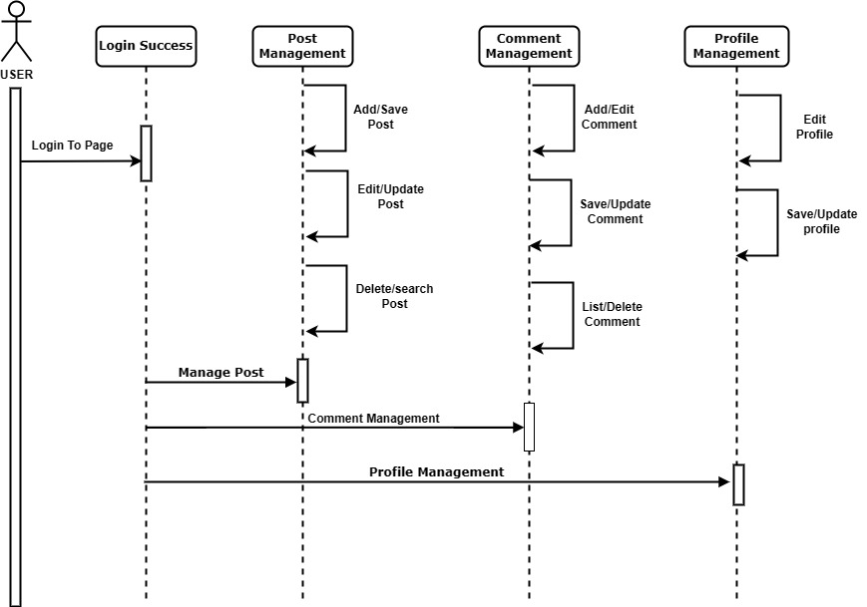

Figure 3.5: Sequence Diagram for User of Blogging Web App

**For Admin**

The sequence diagram for the Blogging Web Application project starts with the User registering with the system by providing their details. After successful registration, To assign the Admin role to another user, the Admin user with database access can assign the role ID 502 to that user. Once the Admin assigns the Admin role to another user, the user will have access to the same functionalities as the Admin user.

This sequence diagram will illustrate the interactions between the User and the system components involved in managing their profile information and blog posts.

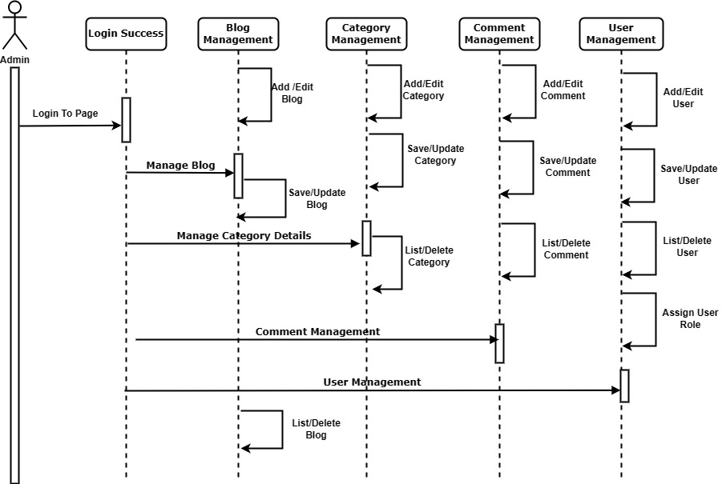

Figure 3.6: Sequence Diagram for Admin of Blogging Web App

3.1.5 Process Modeling: Activity Diagram

The activity of the system begins with the user registration process, where new users can sign up by providing their basic details. The system verifies the user's credentials, and once verified, the user gains access to the system. The application allows registered users to create and manage their blog posts, which can be published and shared with others.

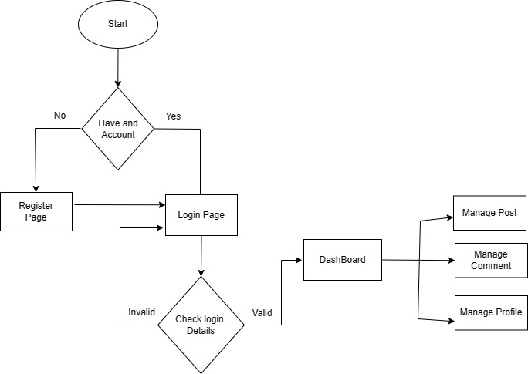The Blogging Web application also provides features for enhanced security, such as password encryption, user authentication, and authorization. The system uses JWT tokens to ensure that only authorized users can access the application's resources.

Figure 3.7: Activity Diagram for Blogging Web App

3.2 System Design

To realize the different functional requirement of the system in graphical form, different design diagram of the system has been prepared with are following:

3.2.1 Refinement of class and object

The figure below is the refinement of class diagram for Blogging Web Application. In Blogging Web Application, there are five tables each of them has their own field as user has name,email,password,about likewise post has pid,title,image,date, comment has id,content,post, category has id,title,description. In this system user register,login and manage post.

This refined class diagram provides a clear understanding of the entities and their attributes in the Blogging Web Application.

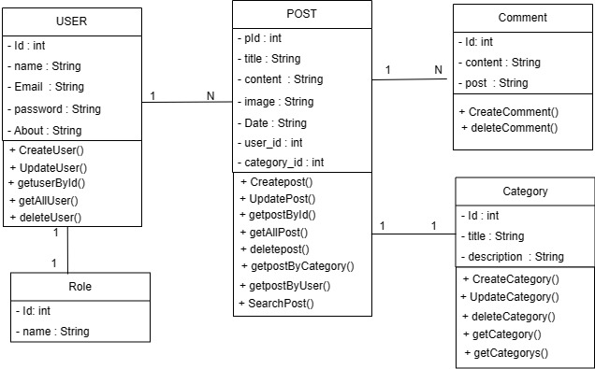

Figure 3.8: Refinement of Class and Object Diagram for Blogging Web App

3.2.2 Component Diagram

To visualize the physical components of the system and their dependency relationship component diagram has been prepared.

The Blogging Web Application allows users to create and manage their own blog posts, which can be published and shared with others. The system has a feature for the admin to add categories for the blog posts, giving users the ability to categorize their posts. Users can view blog posts created by other users and interact with them through commenting. The commenting feature allows users to engage in discussions and provide feedback to the authors. The system also provides important security features, such as user authentication using JWT tokens. This ensures that only authorized users can access the system and create, edit or delete their blog posts.

**For Admin**

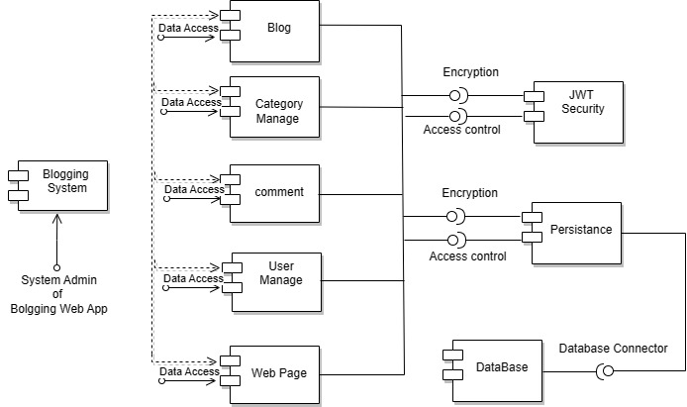

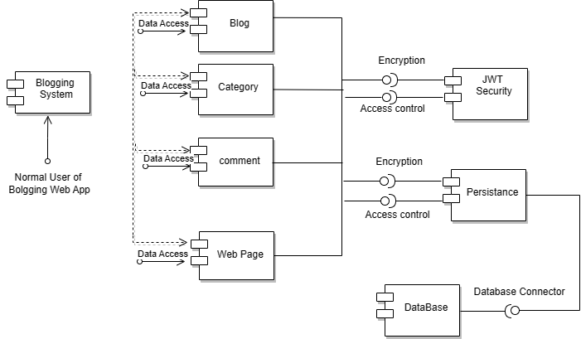**For User**

Figure 3.9: Component Diagram for Blogging Web App

3.2.3 Deployment Diagram

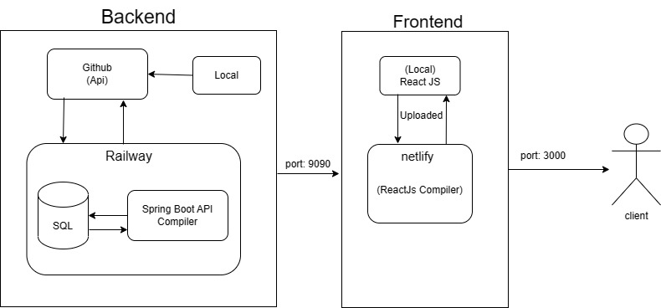The deployment diagram has been made to show the execution architecture of the system which includes nodes such as hardware and software components, and the middleware for the system execution.

Figure 3.10: Deployment Diagram for Blogging Web App

3.3. Algorithm Details

**Algorithm Name:** Natural Language Processing

**Description:** This algorithm is used to convert text from one language to another. It uses Google's API key to access the Google Translate service.

**Input:** The input to the algorithm is a piece of text in a specific language.

**Output:** The output of the algorithm is the same piece of text in a different language.

**Steps:**

* The algorithm retrieves the Google Translate service using the Google API key.
* The algorithm sends the piece of text to the Google Translate service.
* The Google Translate service translates the text to the desired language.
* The algorithm returns the translated text.

**Weaknesses:**

The algorithm is not perfect and can sometimes produce inaccurate translations.

The algorithm is not able to translate all languages.

**Strengths:**

The algorithm is relatively simple to implement.

The algorithm is able to translate text from a wide variety of languages.

# CHAPTER: 4 IMPLEMENTATION AND TESTING

* 1. Implementation
     1. Tools Used (CASE tools, programming language, Database platforms)

Following are the tools and framework used for the accomplishment of this project:

1. **Spring Tool Suite 4 (STS) (IDE)**

Spring Tool Suite 4 is an IDE based on the Eclipse platform, designed specifically for developing Spring-based enterprise applications. We used STS to develop the back-end of our project using Spring Boot.

1. **Java**

In Blogging Web App, java programming language is used for backend development of the project.

1. **ReactJS**

ReactJS is a popular JavaScript library for building user interfaces. We used ReactJS to create the front-end of our blogging web app project. ReactJS allowed us to create reusable UI components and efficiently render updates to the user interface.

1. **VS Code**

Visual Studio Code is a popular code editor used for the development of ReactJS and other JavaScript-based applications.

1. **MySQL (Database)**

MySQL is a widely-used open source relational database management system. We used MySQL to store all the data required for our blogging web app project. It allowed us to perform CRUD operations such as creating, reading, updating, and deleting data from the database as requested by the user.

1. **Draw.io (Diagramming Tool)**

Draw.io is an online diagramming tool that we used to create system analysis and design diagrams for our blogging web app project. It allowed us to quickly and easily create diagrams using drag-and-drop functions.

1. **MS Office**

This is used for writing and editing the documentation of Blogging Web Application

* + 1. Implementation Details of Modules

Modules of this system are described as below:

**User Module:**

**User add/edit/delete comment**

In this module, User can add, edit, and delete comments on blog posts. The User starts the action by clicking on a blog post and then adding their comment in the comment section. The user can perform edit and delete actions on their own comments.

**User post view of all user according to the category**

User can view all the blog posts in the system sorted by category. The page displays all the list of blog posts in the selected category from the database.

**User add/edit/delete post**

Users can create their own posts within the categories created by the admin. They can add text, images, and other media to their posts, and edit or delete them as needed.

**User post view of all user according to the category**

In this module, users can view all the posts created by other users within a particular category. Users can browse through these posts and interact with them by commenting on them . Additionally, users can add, edit, and delete their own posts within the same category. This module allows users to engage with the content on the platform and contribute to the community.

**Admin Module**

**Admin Login and Dashboard**

Admin can log in to the system using their username and password. Once logged in, they can access the admin dashboard which displays an overview of the system's activity and important metrics

**Category Management**

Admin can manage the categories available in the system. This includes adding, editing, and deleting categories. Admin can also view a list of all categories in the system.

**Post Management**

Admin can manage the posts available in the system. This includes adding, editing, and deleting posts. Admin can also view a list of all posts in the system and search for specific posts by category, author, or title.

**User Management**

Admin can manage the users registered in the system. This includes viewing a list of all users, searching for specific users by username or email, and deleting users if necessary.

**Comment Management**

Admin can manage the comments made by users on the posts. This includes viewing a list of all comments, searching for specific comments by post, author, or content, and deleting comments if necessary

4.2. Testing

To ensure the quality and reliability of the Blogging web app, a series of testing is conducted throughout the development process. The testing aims to evaluate the functionality of each module and verify that the system is providing accurate results. The following are the testing phases

4.2.1 Test Cases for Unit Testing

During unit testing, the system is modularized, and each module is independently tested. This includes validating input forms, ensuring accurate outputs for each module before progressing to the next, thus confirming the app's comprehensive functionality.

**User Registration**

**Table 4. 2: Test case for User Registration of Blogging Web Application**

|  |  |  |  |  |  |
| --- | --- | --- | --- | --- | --- |
| S.  No | Test Name | Input | Expected  Output | Actual  Output | Test  Result |
| 1. | Enter Invalid name, Email, About, password and click register  button | Name = Sandip Chapagain Email = sandip  Password =sandip  About =this is programmer | Enter Valid email address | Registration Failed | Pass |
| 2. | Enter valid name, Email, About, password and click register  button | Name = Sandip Chapagain Email = sandip@gmail.com  Password =sandip  About =this is programmer | Registration successful | Registration Success | Pass |

**User Login**

**Table 4.3: Test case for User Login of Blogging Web Application**

|  |  |  |  |  |  |
| --- | --- | --- | --- | --- | --- |
| S.No | Test Name | Input | Expected  Output | Actual  Output | Test  Result |
| 1 | Enter Invalid  Username , pass  And click login button | Username:sandip@gmail.com  Password: blank | Login  Failed and  Login Failed!!  Message is shown | Login  Failed | Pass |
| 2 | Enter valid  Username , pass  And click login button | Username:sandip@gmail.com  Password: 12345 | Login  Successful  And  Redirect to  dashboard | Redirect  To  Dashboard | Pass |

4.2.2 Test case For System Testing

In System testing whole system is tested as below:

**Test Plan**

**Table 4.4: Test case for Test Plan of Blogging Web Application**

|  |  |
| --- | --- |
| S.N | Test Plan |
| 1 | To check if registration Module Works properly |
| 2 | To check if login module works properly |
| 3 | To Check if add Post module works properly |
| 4 | TO check if category works properly or not |

**Post**

**Table 4.5: Test case for Post of Blogging Web Application**

|  |  |  |  |  |  |
| --- | --- | --- | --- | --- | --- |
| S.No | Test Name | Input | Expected  Output | Actual  Output | Test  Result |
| 1. | Enter valid  Title, content,  image,category | Title: java  Content:java_is pro.. lang..  Image:IMG123.jpg  Category: language | Post added  success | Post added  Success | Pass |
| 2. | Enter invalid  category | Title:Salman khan  Content: salman..  Image:123.jpg  Category:blank | Category must_be selected | Post added failed | Pass |
| 3 | Deleting the  selected  Post | Select the post to be deleted | Title: java  Content:java_is pro.. lang..  Image:IMG123.jpg  Category: language | Post Deleted success | Pass |
| 4 | Updating the  Selected Post | Select the post to be edit | Title: salman Khan  Content: sallu  Is a hero.  Image:IMG123.jpg  Category: Actor | Update record should be  Display | Pass |

**Table 4.6: Test case for validation of Blogging Web App**

|  |  |  |  |  |  |  |
| --- | --- | --- | --- | --- | --- | --- |
| Test ID | Test Scenario | Test Steps | Test Data | Expected result | Actual Result | Pass/ Fail |
| ST01 | * valid login credentials * loading dashboard * loading different windows on clicking button on dashboard * Load Category From backend | Enter valid login Credentials  Check dashboard  Check  Different windows  Check  Category | Valid details  click  click  click  selected | Login successful  load dashboard  load different windows  display accurate data | As excepted | Pass |

# CHAPTER: 5 CONCLUSION AND FUTURE RECOMMENDATIONS

5.1 Lesson Learnt/ Outcome

Building this blogging app has provided me with a wealth of knowledge and skills in various areas of software development. As the sole developer of this application, I have gained valuable experience in problem-solving, effective communication, and project management.

* **Problem-Solving Skills:**

Throughout the development process, I faced various challenges that helped me improve my problem-solving skills.

* **Effective Communication:**

I learned the importance of clear and concise communication in ensuring that the application met my requirements and goals.

* **Project Management:**

I developed excellent time management skills, which allowed me to prioritize critical features and deliver the project within the deadline.

5.2 Conclusion

This project mainly focuses on providing a platform for bloggers to share their ideas and insights with others. The app's features include categories, comments, and user authentication, among others. As the sole developer, I aimed to create an intuitive and user-friendly platform that would enable bloggers to engage with their readers and grow their audience.

5.3. Future Recommendations

In the future, the Blogging web app can be enhanced with the following features:

* Mobile apps for both iOS and Android platforms to make it more accessible to users.
* Integration with social media platforms to enable users to share their posts on their social media accounts.
* The ability for users to schedule their posts to be published at a later time or date..
* Support for multiple languages to make the app more inclusive.
* Implementation of an in-app messaging system to allow users to communicate with each other.
* The ability for users to monetize their content through advertising or by offering paid subscriptions to their readers.

# REFERENCES

|  |  |
| --- | --- |
| [1] | G. A. a. R. Agarwal, "GeeksforGeeks," 3 oct 2009. [Online]. Available: https://www.geeksforgeeks.org/. [Accessed 2019]. |
| [2] | A. D. a. C. Cheever, "Quora," 21 june 2009. [Online]. Available: https://www.quora.com/. [Accessed 2018]. |
| [3] | N. Yadav, "Tutorials points," 2003. [Online]. Available: https://www.tutorialspoint.com/. [Accessed jan 2023]. |
| [4] | J. A. a. j. Spolsky, "stackoverflow," 15 june 2008. [Online]. Available: https://stackoverflow.com/. [Accessed march 2023]. |
| [5] | "Draw.io," [Online]. Available: https://app.diagrams.net/. |
| [6] | D. Tiwari, "youtube," [Online]. Available: https://youtu.be/I7BTYi5augU. [Accessed 2019]. |
| [7] | N. Yadav, "javapoint," 2003. [Online]. Available: https://www.javatpoint.com/. [Accessed jan 2019]. |
| [8] | "Google Translate API," 2006. [Online]. Available: https://cloud.google.com/translate/docs/reference/rest/v2/languages. |
| [9] | "Natural Language processing," [Online]. Available: https://en.wikipedia.org/wiki/Natural_language_processing. [Accessed 2023]. |

APPENDICES**: SYSTEM SCREENSHOOTS**



