

**Tribhuvan University**

**Faculty of Humanities and Social Sciences**

**Java Development**

**AN INTERNSHIP REPORT**

**Submitted to**

**Department of Computer Application**

**Damak Multiple Campus**

**Damak, Jhapa**

***In partial fulfillment of the requirements for the Bachelors in Computer Application***

**Submitted by**

Sandip Chapagain(TU Regd: 6-2-0202-0885-2019)

Jan 2024

Under the Supervision of

**Ghanashyam Adhikari**

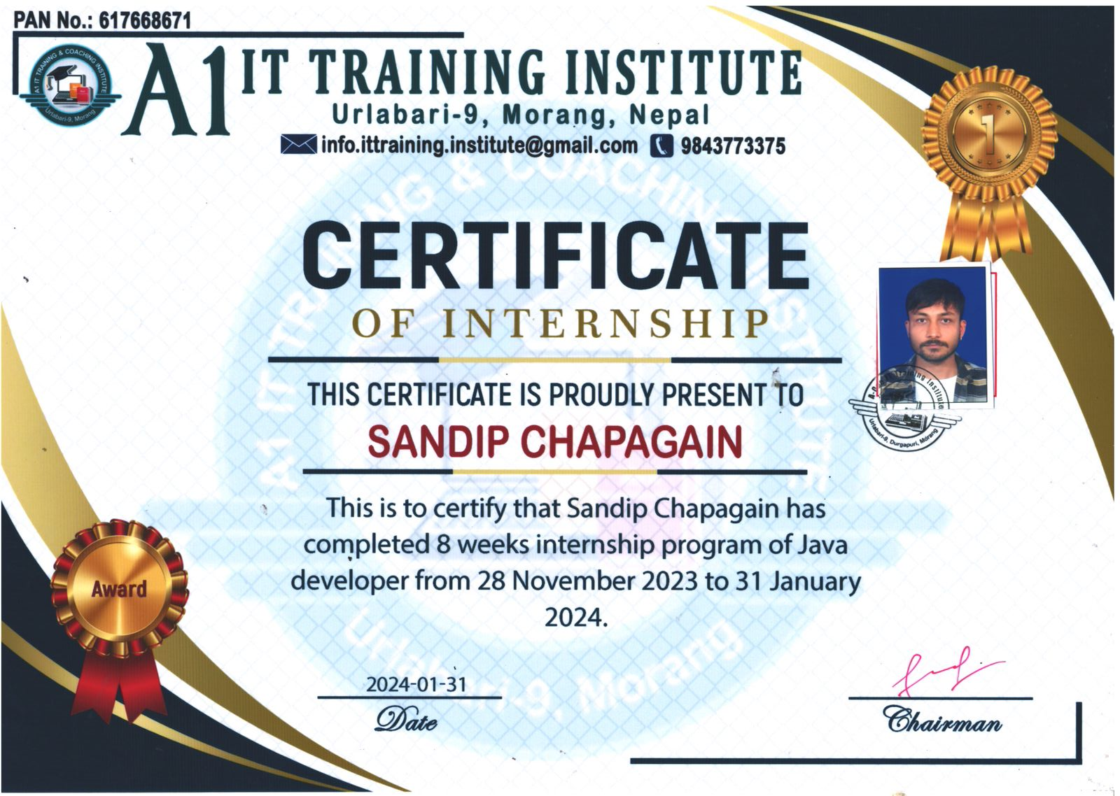

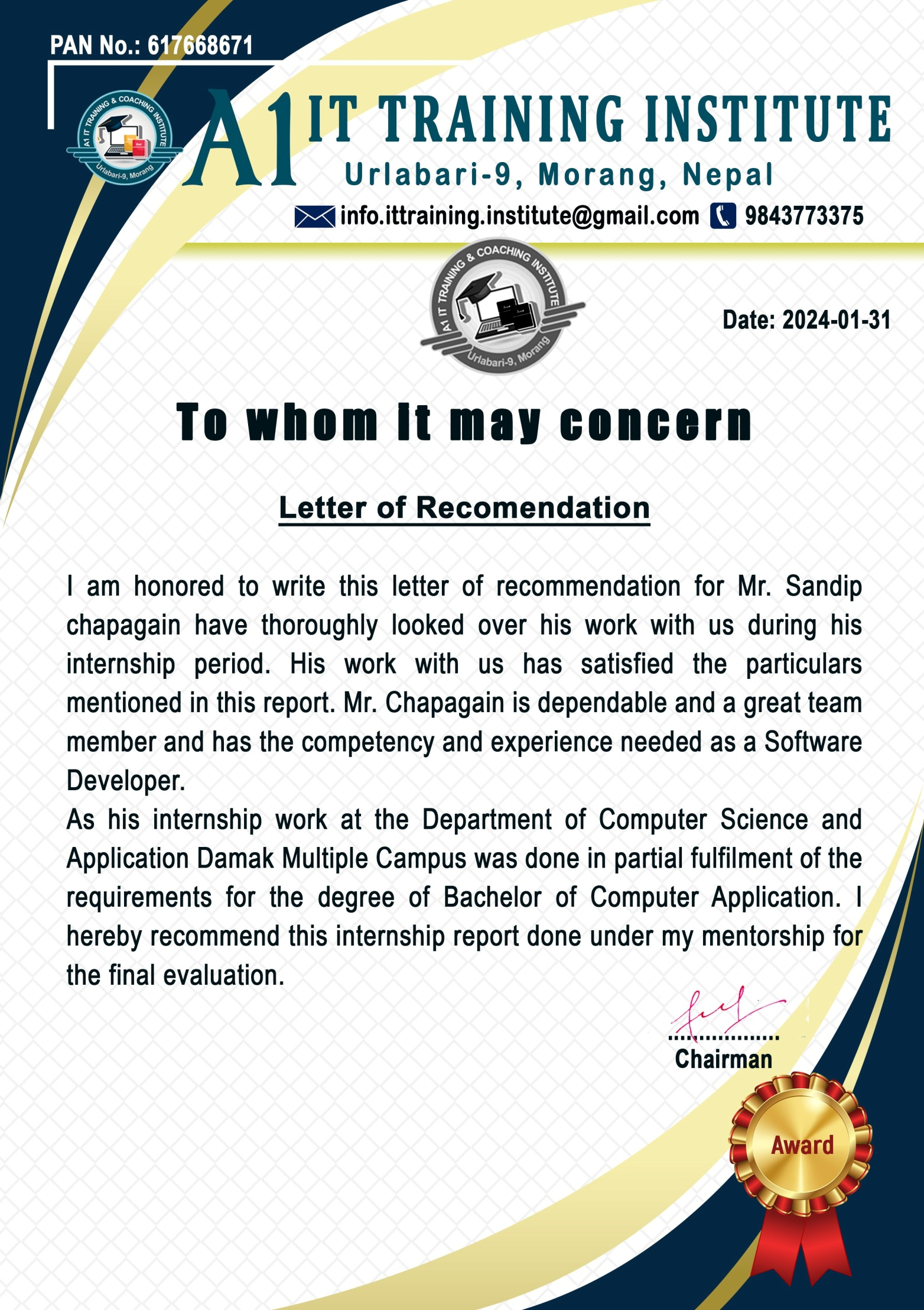



**Tribhuvan University**

**Faculty of Humanities and Social Sciences**

**Damak Multiple Campus**

Damak, Jhapa

Bachelor in Computer Applications (BCA)

# Supervisor’s Recommendation

I hereby recommend that this internship report prepared under my supervision by S**andip Chapagain** in the Partial Fulfillment of requirement for the degree of Bachelor in Computer Application is recommended for that final evaluation. I have thorougly looked over the works he has done during his internship period. His work as Java developer has satisfied the particulars mentioned in the report.

______________________

**Supervisor**

**Damak Multiple Campus**

**Department of BCA**



**Tribhuvan University**

**Faculty of Humanities and Social Sciences**

**Damak Multiple Campus**

Damak, Jhapa

Bachelor in Computer Applications (BCA)

# Letter Of Approval

This is certify that this internship report prepared by **Sandip Chapagain** in the Partial Fulfillment of requirement for the degree of Bachelor in Computer Application has been evaluated. In our opinion it is satisfactory in the scope and quality as a project for the required degree.

|  |  |
| --- | --- |
| ……………………..  **Mr. Ghanashyam Adhikari**  **Supervisor**  **Address** | …………………..  **Mr. Abhinash Jha**  **Coordinator**  **Address** |
| ……………………  **Mentor** | ……………………  **External Examiner** |

# Abstract

The purpose of this internship report is to provide an account of my time spent interning at A1 IT Training Institute, Urlabari. This report will provide a summary of the eight-week service industry internship I undertook between 2023 November 28 and 2024 January 31.

Before graduating from the Computer Application Department at Tribhuvan University, all students must undergo an industrial training program lasting at least 8 weeks at reputable company or organization. If the organization has an IT infrastructure to work on, students are free to choose where they want to do their internship. The objectives of this internship are to expose students to the working world, help them comprehend the material they are learning more thoroughly, and give them the crucial work-related to training in the fields of software development and computer application.

Students have a great opportunity to obtain work experience and choose a career through work-related learning. It establishes the foundation for an extraordinary learning experience by using the student’s institutional skills with current job requirements. The project’s main objective is to get useful work experience and career chances. The improvement and expansion of learning opportunities as well as the promotion of both personal and professional growth were also objectives. The duties conducted during the period of internship to develop a variety of abilities are described in this report.

My main duty in this project was to construct the application's Back-end design in an efficient and effective manner.As an intern, I was tasked with implementing the backend logic and infrastructure using java with Spring Boot. I focused on developing RESTful APIs to handle data retrieval, manipulation, and authentication.

Additionally, I played a crucial role in writing unit tests and integration tests to ensure the reliability and functionality of the backend components. This allowed me to gain practical experience in testing methodologies and ensure the stability of the application.

# Acknowledgement

Foremost, I would like to express my sincere thanks of gratitude to my internship supervisor, Sir. Ghanashyam Adhikari for his continuous support and help in the internship work. I cannot thank him enough for all his patience, motivation, and immense knowledge. His guidance helped me all the time with the project.

Secondly, I would like to express my sincere gratitude to Mr. Sandeep Neupane for their invaluable guidance, support, and encouragement throughout my internship. I am deeply grateful for the opportunity to work under their mentorship and for their unwavering support in helping me to complete this project. I would also like to thank A1 IT Training Institute for providing me with the opportunity to work on this project and for their support in my professional development. I am grateful to the entire team at A1 IT Training Institute for their guidance and support throughout my internship.

I would like to express my gratitude to Tribhuvan University for providing me with a great opportunity of collecting experience by working as an intern and preparing this project report in according to its syllabus. I highly appreciate and honor the effort of Tribhuvan University to develop required attitude, abilities, and practical skills in students which constitute a foundation for their future development. Lastly, I want to thank my parents and friends and all known unknown individuals who helped me in various way during my internship period. With this internship, got a chance to collect real world work experience as a software developer. I am thankful to them for all their support, helps guidance, motivation, and corrections.

I have tried to mention and give credit to everyone who helped me in this project, along with the sources from where I collected the required data and information which supported this project. Yet, there may be some unintended errors and some sources or individuals may have been missed to mention. I shall feel obligated if they are brought to my notice.

Yours Sincerely,

Sandip Chapagain

Table of Contents

Supervisor’s Recommendation I

Letter Of Approval II

Abstract III

Acknowledgement IV

Chapter 1: Introduction 1

1.1 Introduction 1

1.2 Problem Statement 2

1.3 Objectives 2

1.4 Scope and Limitation 2

1.4.1 Scope and Limitations 2

1.6 Report Organization 3

Chapter 2: Introduction of Organization 4

2.1 Organization Details 4

2.2 Organizational Hierarchy 4

2.3 Working Domains of Organization 5

Chapter 3: Background Study And Literature Review 7

3.1 Background Study 7

3.2 Literature Review 8

Chapter 4: Internship Activities 10

4.1 Roles and Responsibilities 10

4.2 Weekly Log 10

4.3 Description of the Project during Internship 19

4.4 Task/Activities Performed 19

Chapter 5: Conclusion And Future Recommendations 20

5.1 Lesson Learnt / Outcome 20

5.2 Conclusion 20

References 21

**List of Tables**

Table 1 : Internship Duration Table 6

# Chapter 1: Introduction

## 1.1 Introduction

Spring Boot is a powerful backend development framework created by the Spring team at Pivotal. It utilizes the Java programming language and enables developers to build robust, production-ready applications with minimal configuration.

One of the key features of Spring Boot is its opinionated approach to configuration and convention-over-configuration paradigm, which reduces boilerplate code and simplifies application setup. The framework also offers a wide range of built-in features and extensions, allowing developers to focus on business logic rather than infrastructure concerns.

In addition to the core Spring Boot framework, there is a vast ecosystem of third-party libraries and plugging available that extend its functionality, such as support for database access, security, and cloud integration. Overall, Spring Boot provides a comprehensive solution for building backend services that are scalable, maintainable, and easy to deploy.

Spring Tool Suite (STS) is a popular integrated development environment (IDE) based on Eclipse that provides excellent support for Spring Boot development. The Spring Tool Suite enhances the IDE with features such as project setup assistance, code generation, and seamless integration with Spring Boot's configuration options. Additionally, Spring Boot applications can be easily tested and debugged using STS's built-in tools**.**

Spring Boot's popularity among developers stems from its productivity-enhancing features, robust ecosystem, and strong community support. The framework's convention-over-configuration approach simplifies development tasks, while its extensive documentation and vibrant community forums provide valuable resources for developers at all skill levels. Overall, Spring Boot empowers developers to build high-quality backend services efficiently, making it a preferred choice for a wide range of applications and industries.

## 1.2 Problem Statement

Some problem statements of Java are as follows:

•

1. To create a store application where store owners can manage entire sales details
2. To segregate the admin and counter such that specific tasks can be performed
3. To automate the record keeping and sales history
4. To optimize and boost the selling process by enhancing the current business.

These are just a few examples of problem statements that could be addressed by this project. The possibilities are endless, and Java's powerful features and capabilities make it a versatile tool for building a wide range of applications.

## 1.3 Objectives

The main objectives of this project are as follows.

1. Automate the record keeping, sales history, etc
2. Provide a framework where sustainable business can run

## 1.4 Scope and Limitation

### 1.4.1 Scope and Limitations

Some scopes of java are as follows:

1. Reduce or minimize the unnecessary costs
2. Real time visibility and transparency
3. Increase employee’s satisfaction and morale

Some potential limitations include:

1. Limited support for older platforms: The backend API developed using Spring Boot may encounter compatibility issues with older platform, particularly legacy versions of operating system.
2. Increased File Size: Spring Boot applications tend to have larger files size compared to native backend solutions.
3. Framework Dependency: Developing and maintaining a backend API using Spring Boot requires a strong reliance on the Spring Framework ecosystem.

## 1.6 Report Organization

**Chapter 1:** deals about general introduction of the Spring. It answers “What is spring?”, “What this spring does?”, "Why do we need spring?" It also states problem of statement what existing problem lags. Objective of the spring, scope and limitation in detail.

**Chapter 2:** describe the details of the organization and its hierarchy. It includes working domains of the organization and talks about the intern department or unit.

**Chapter 3:** is all about literature review and background study.

**Chapter 4:** is about what roles and responsibilities participants played and their weekly log. It deals about the description of job which is involved during internship and the tasks or activities performed while doing this job.

**Chapter 5:** describe about Conclusion and Learning outcome.

# Chapter 2: Introduction of Organization

## 2.1 Organization Details

A1 IT Training Institute stands at the forefront of technology education and solutions, playing a pivotal role in empowering individuals and businesses. The institute's technical department is instrumental in ensuring the overall efficiency and productivity of the organization by providing essential technical assistance and support across various departments.

A1 IT Training Institute is the of the best it company in eastern part of the Nepal. It is located in Urlabari of Morang district. A1 IT Training Institute was established on 07 Aashadha 2076 BS (i.e. 22 June, 2019 AD) The CEO of this company is Sandeep Neupane and he is a full stack developer. More than 5 people are working in different programming field according to their skills. There are two full stack developer , All of them are Sandeep Neupane (C.E.O and full stack developer), Rupak Shrestha (full stack developer), Ujwal Ghimire (content creater), Ramesh Katuwal (MERN developer), and Dipak Karki (frontend Developer). This company is focus on different area of IT field like digital marketing , graphics designing, mobile application, website etc. Digital marketing focuses different services which are content writing, video advertisement , social media management and S.E.O like wise graphics designing have different services i.e advertisement, UI/UX and brand identity. A1 IT Training Institute mainly provide IT Training in different sectors like web development, graphics designing, app development, digital marketing, etc



Figure 1: Logo of organization

## .2.2 Organizational Hierarchy

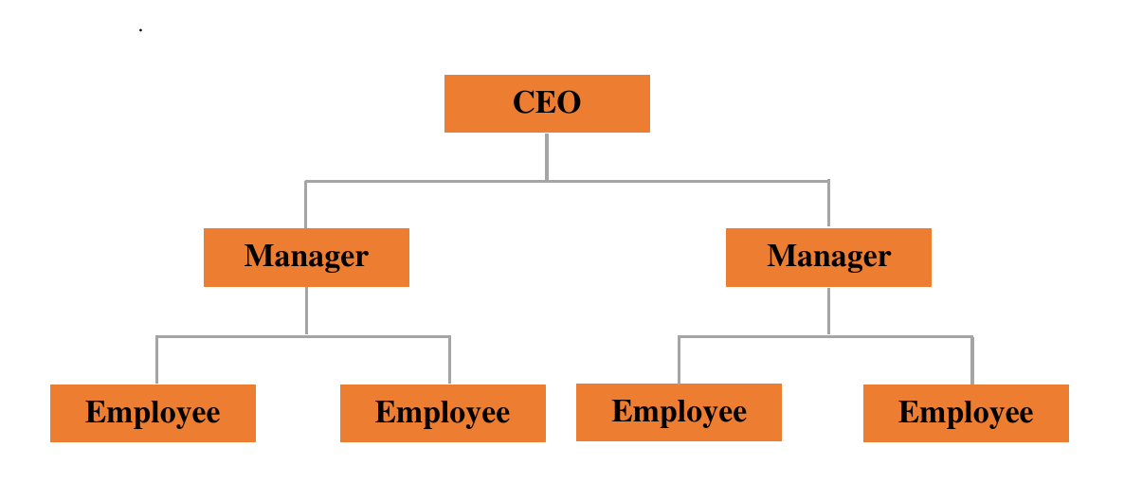

Figure 2: Organization Hierarchy

## 2.3 Working Domains of Organization

A1 IT Training Institute excels in technology education and solutions, specializing in customized and responsive websites. Our web development team creates expert web applications and designs, tailoring solutions for our clients.

The institute's website is a vital digital platform, offering comprehensive information about courses, faculty, and the learning experience. It enhances credibility, showcases educational offerings, and ensures visibility on search engines, contributing to a strong online presence.

Key Importance:

1. A professionally designed website enhances the institute's credibility, instilling confidence in prospective students.
2. The website serves as a central hub for students, facilitating their learning journey by providing access to courses, resources, and event information.

**2.4 Description of Intern Unit**

An intern department or unit is a department or unit within an organization that is responsible for managing the internship program and overseeing the work of interns within the organization. This department or unit typically works closely with other departments to identify opportunities for interns, recruit and select candidates, and coordinate the internship experience.

The intern department or unit may also be responsible for providing support and guidance to interns as they learn and gain experience within the organization. This may include providing training, supervision, and mentorship to interns, as well as helping them to set goals and track their progress.

Overall, the intern department or unit plays a key role in helping interns to succeed in their roles and gain valuable experience within the organization.

|  |  |
| --- | --- |
| Start Date | 28 November, 2023 |
| End Date | 31 January, 2024 |
| Position | Intern |
| Intern Superisor | Sandeep Neupane |
| Sector | Java Developer |
| Working Hours | 6 hours per day |
| Average Working | 36 hours in a week |
| Working days | 6 days in a week |

Table 1: Internship Duration Table

# Chapter 3: Background Study And Literature Review

## 3.1 Background Study

Every institution or business must create its own application to advertise its products and services online. The application assists in promoting the company's offerings to customers. The organization must be digitalized in order for it to expand and develop successfully and efficiently because in the modern world everything is computerized and digitalized. This internship report is a background study of Java, a free and open-source mobile application development framework created by Google. The goal of this study is to evaluate the feasibility of using Java for the development of a new mobile application.

Spring Boot is a Web API development framework that uses the Java programming language. It was first released in 2014 and has since grown in popularity among developers.Spring allows for the creation of high-performance, visually attractive, and responsive APIs.Some of its key features include a reactive programming model, a customizable and extensible widget set, and a fast development cycle with hot reload. In order to gather information for this report, I can research different method, A review of existing Java applications to understand the capabilities and limitations of the framework, also Interviews with developers who have experience working with Java to gather their insights and feedback as well as analysis of industry trends related to Java and other mobile application development frameworks.

The results of the research show that Spring is a powerful and versatile framework that can be used to create high-quality mobile applications. It offers a reactive programming model, which makes it easy to handle user interactions and animations. Its customizable and extensible widget set allows for the creation of visually attractive and responsive user interfaces. Additionally, the fast API development cycle with hot reload allows for faster iterations and shorter development time. The framework has many advantages that make it well-suited for creating high-performance and visually attractive applications. However, it is important to keep in mind that there is a learning curve for developers and a smaller community compared to more established frameworks.

## 3.2 Literature Review

As technology has evolved over the last few years, every human being has developed accordingly. Nowadays, having smartphones in their pocket is like a trend for every person. Moreover, to continue this trend many mobile applications also prevail so that people can spend their leisure time scrolling over the applications. Due to the desire of people to search for something new, a large number of applications are present in the market in all categories which can be Health Care, Games, Music, Shopping, and many more. In the current scenario, people can now watch live matches, consult a doctor, learn new things through distance learning by just sitting at their homes through applications. This has caused a massive increase in application development.

A literature review in Java would involve researching and analyzing existing literature and resources on the topic of using the Spring Boot framework for Web app development. This could include articles, tutorials, case studies, and documentation from both official and unofficial sources. The goal of a literature review would be to gain a comprehensive understanding of the current state of knowledge on the topic, including its strengths and limitations, as well as to identify potential areas for further research or development. The literature review would be a crucial step in the overall research and development process for an internship project using Java.

Blue Fox Pvt Ltd (Ltd B. F., 2019) is one of the software company of Nepal who has developed the websites and application for the organization to make the organization digital through online medium and promote the business. This company is creative digital agency based in Itahari, Province No.1 Nepal. Their core skills focus on Graphic Design, UX/UI Design, Web Development, Software Development, Mobile App Development, Digital Marketing, SEO and in particular where we all meet. They have been committed to delivering excellent, innovative digital projects completed to the highest possible standards by their fully qualified and experienced staff at their in-house studio.

Kyanite Software Company (Company, 2017) is another software company of Nepal who has also developed the websites and application for the company. This company is special for develop cutting-edge software and services for every kind of organizational need. In addition to that, they also offer a variety of services, including web design and development, e-commerce solutions, and android/ios app development. Many delighted clients all over the world attest to the high quality of our work.

Delta Tech Nepal (Nepal, 2018) is another software company which is located in Nepal as well as it’s headquarter is on Kathmandu. They have served 100+ clients with Their services in a just few years and They believe that client satisfaction is something, They never compromise on. With the commitment of providing IT services in Nepal, They have expanded their services to software development (Delta Tech Products), search engine optimization (SEO), web application & portals, graphic designing, and many more. They have developers in-house, who works on client requirement, design and develop as per client need to complete the project in time. They not only serve local peoples, but They have also taken care of international.

Pracas Infosys (Infosys, 2007) is another software company in Nepal who has been providing the different services for the clients and different organization. Pracas Infosys (PFS), an innovative IT company located at Hanumandas Road, Jaljala Chowk above Standard Chartered Bank Ltd. It has started rendering its technological service since 21 September 2007 and stood as a pioneer Information Technology Consulting Company providing Website Development, Software Development, Multimedia Solutions, IT Consultancy, Internet Marketing, Social Media Promotion & Technology Offshoring services in Eastern Region of Nepal. Pracas Infosys is the registered Company & certified by the Government of Nepal and also registered Tax Payer of Inland Revenue Department, Government of Nepal which promises to provide one single yet simple thing: satisfaction & reliability in order to promote IT sector to the local community and round the globe.

Vertex Web Surf Pvt Ltd (Ltd V. W., 2016) is a leading web designing, hosting and SEO Company based on Biratnagar, Nepal. This are a client-centrist organization. They make it our business to understand and help their clients achieve our business goals.They have successfully completed hundreds of projects of different sizes and complexity in various business and technological domains. Capitalizing on the accumulated experience Vertex Web Surf provides full-cycle services ranging from web design, graphic design, web hosting, search engine optimization and so on.

# Chapter 4: Internship Activities

## 4.1 Roles and Responsibilities

As a backend developer, my primary role in this project involved architecting, developing, and maintaining the server-side logic of the application using java and Spring Boot framework. I was responsible for designing and implementing robust APIs to facilitate communication between the frontend and backend components of the application. This included defining endpoints, request and response structures, and data models to ensure seamless data exchange.

Additionally, I collaborate closely with the UI/UX designers to understand the requirements and specifications for integrating the frontend with the backend services. I provided support in integrating the frontend with the backend APIs, ensuring proper handling of data transmission and processing on the server side.

## 4.2 Weekly Log

A weekly log in an internship is a record of the tasks and activities that were completed over the course of a week as part of the internship. A weekly log can be used to track progress, identify any issues or challenges that arose, and highlight any notable accomplishments .In an internship context, a weekly log might include information such as the specific tasks that were completed, the amount of time spent on each task, any skills or knowledge that were gained, and any feedback or guidance received from mentors or supervisors. The weekly log during internship project are as follows:

**Weekly Internship Log**

**Name of the Student: Sandip Chapagain Date: 2023**

**Project/Job Title: HamroDokan**

**Week Number: 01**

**Responsibilities:**

|  |
| --- |
| 1. Brainstorm ideas for the project 2. Initialize the project |

**Activities:**

|  |
| --- |
| 1. Discuss about the idea and find the optimal and most suitable project 2. Initialize the git repository and add required team members for the development of the project 3. Create starter for the application using STS tool |

**Observation:**

|  |
| --- |
| 1. Before starting, requirement analysis is required for the smooth succession |

**Plan for Next Week:**

|  |
| --- |
| 1. Created a new starter project |

**Performance Appraisal by Mentor:**

|  |
| --- |
| Good Analyze frontend and determine backend data and logic needs. |

|  |
| --- |
| **Supervisor’s Verification**  **Signature Name:**  **Date:** |

|  |
| --- |
| **Mentor’s Approval**  **Signature:……………………..**  **Name:Sandeep Neupane**  **Date: 2023/12/05** |

**Weekly Internship Log**

**Name of the Student: Sandip Chapagain Date: 2023**

**Project/Job Title: HamroDokan**

**Week Number: 02**

**Responsibilities:**

|  |
| --- |
| 1. Setup the initial app structure 2. Complete the RESTAPIs and auth gates |

**Activities:**

|  |
| --- |
| 1. Installed STS tools and set up Lombok. 2. Created a new Spring Boot starter project, providing name and package structure. 3. Adding dependencies such as SQL,JPA, Hibernate, etc.. |

**Observation:**

|  |
| --- |
| 1. Created package and sub-packages including entity, controller, exception, services, and serviceImpl. 2. Initialized basic configurations for Spring Boot applicat |

**Plan for Next Week:**

|  |
| --- |
| 1. Write code for entity classes, defining database tables and relationships. |

**Performance Appraisal by Mentor:**

|  |
| --- |
| Good Implement backend logic to support dynamic data |

|  |
| --- |
| **Supervisor’s Verification**  **Signature Name:**  **Date:** |

|  |
| --- |
| **Mentor’s Approval**  **Signature:…………….**  **Name:Sandeep Neupane**  **Date:2023/12/13** |

**Weekly Internship Log**

**Name of the Student: Sandip Chapagain Date: 2023**

**Project/Job Title: HamroDokan**

**Week Number: 03**

**Responsibilities:**

|  |
| --- |
| 1. Complete the entity class 2. Implement all entities and DTO |

**Activities:**

|  |
| --- |
| 1. Developed entities class Categories,product,Role,Sale,User, 2. Developed Corresponding DTO classes |

**Observation:**

|  |
| --- |
| 1. Utilized annotation such as @Entity, @Table, @Column, etc.. to map entities to databases tables. 2. Utilized Lombok annotation for reducing boilerplate code in entity classes. 3. Implemented DTO classes to transfer data between layers of the application |

**Plan for Next Week:**

|  |
| --- |
| 1. Develop repositories for corresponding classes to implement CRUD operations. |

**Performance Appraisal by Mentor:**

|  |
| --- |
| Excellent making entities classes |

|  |
| --- |
| **Supervisor’s Verification**  **Signature Name:**  **Date:** |

|  |
| --- |
| **Mentor’s Approval**  **Signature:…………….**  **Name:Sandeep Neupane**  **Date:2023/12/21** |

**Weekly Internship Log**

**Name of the Student: Sandip Chapagain Date: 2023**

**Project/Job Title: HamroDokan**

**Week Number: 04**

**Responsibilities:**

|  |
| --- |
| 1. Define repository interface for Categories,product, Role, Sale, and user Entities 2. Define Service and serviceImpl classes for corresponding entities to encapsulate business logic |

**Activities:**

|  |
| --- |
| 1. Implement custom queries and methods in repository interfaces as needed 2. Implement Service layer methods to orchestrate repository operations and perform business logic |

**Observation:**

|  |
| --- |
| 1. Test service layer methods using unit testing to ensure proper functionality and logic execution |

**Plan for Next Week:**

|  |
| --- |
| 1. Creating Controllers for corresponding entities to handle HTTP requests and responses |

**Performance Appraisal by Mentor:**

|  |
| --- |
| Excellent |

|  |
| --- |
| **Supervisor’s Verification**  **Signature Name:**  **Date:** |

|  |
| --- |
| **Mentor’s Approval**  **Signature: ……………………**  **Name:Sandeep Neupane**  **Date:2023/12/29** |

**Weekly Internship Log**

**Name of the Student: Sandip Chapagain Date: 2023**

**Project/Job Title: HamroDokan**

**Week Number: 05**

**Responsibilities:**

|  |
| --- |
| 1. Creating Controller classes to interact with service layer 2. Define request mapping method. 3. Test controller method using integration test |

**Activities:**

|  |
| --- |
| 1. Implement CRUD operations in controller classes to interact with service layer 2. Implement request mapping methods to handle various HTTP methods (GET,POST,PUT,DELETE) 3. Testing APIS in POSTMAN |

**Observation:**

|  |
| --- |
| 1. Utilize Spring MVC annotations such as @RestController, @RequestMapping, and @RequestBody/ @ResponseBody |

**Plan for Next Week:**

|  |
| --- |
| 1. Implementing exception handler |

**Performance Appraisal by Mentor:**

|  |
| --- |
| Better performing in creating HTTP GET,POST,PUT request. |

|  |
| --- |
| **Supervisor’s Verification**  **Signature Name:**  **Date:** |

|  |
| --- |
| **Mentor’s Approval**  **Signature:……………..**  **Name:Sandeep Neupane**  **Date:2023/12/07** |

**Weekly Internship Log**

**Name of the Student: Sandip Chapagain Date: 2023**

**Project/Job Title: HamroDokan**

**Week Number: 06**

**Responsibilities:**

|  |
| --- |
| 1. Exception handling in controller classes to gracefully handle errors and exception 2. Persist the user data and handle the api responses accordingly |

**Activities:**

|  |
| --- |
| 1. Implementing global exception handler 2. Implementing custom exception classes to represent different types of errors and exception 3. Testing exception handling mechanisms. |

**Observation:**

|  |
| --- |
| 1. Exception handler is most important while handling every request |

**Plan for Next Week:**

|  |
| --- |
| Implement Security to all the APIs |

**Performance Appraisal by Mentor:**

|  |
| --- |
| Good Develop custom error response mechanisms. |

|  |
| --- |
| **Supervisor’s Verification**  **Signature Name:**  **Date:** |

|  |
| --- |
| **Mentor’s Approval**  **Signature:……………………**  **Name:Sandeep Neupane**  **Date:2024/01/15** |

**Weekly Internship Log**

**Name of the Student: Sandip Chapagain Date: 2023**

**Project/Job Title: HamroDokan**

**Week Number: 07**

**Responsibilities:**

|  |
| --- |
| 1. Implement JWT (JSON Web Token) security to secure API endpoints. |

**Activities:**

|  |
| --- |
| 1. Configure Spring Security to authenticate and authorize requests using JWT tokens 2. Implement authentication filter to validate JWT tokens in incoming requests 3. Implement authorization filter to authorize access to protected resources based on JWT claims 4. Test JWT Security |

**Observation:**

|  |
| --- |
| 1. Ensure proper authentication and authorization |

**Plan for Next Week:**

|  |
| --- |
| Provide API documentation to UI developers for integration. |

**Performance Appraisal by Mentor:**

|  |
| --- |
| Good Handle token expiration technique |

|  |
| --- |
| **Supervisor’s Verification**  **Signature Name:**  **Date:** |

|  |
| --- |
| **Mentor’s Approval**  **Signature: ……………….**  **Name:Sandeep Neupane**  **Date:2024/01/23** |

**Weekly Internship Log**

**Name of the Student: Sandip Chapagain Date: 2024**

**Project/Job Title: HamroDokan**

**Week Number: 08**

**Responsibilities:**

|  |
| --- |
| 1. Make APIs Available to UI developer. |

**Activities:**

|  |
| --- |
| 1. Deploy APIs on railway platform 2. Testing all APIs using Postman to ensure functionality and proper responses. 3. Document all APIs and their endpoints, along with request methods, for UI developers. |

**Observation:**

|  |
| --- |
| 1. Testing every APIs is Required |

**Plan for Next Week:**

|  |
| --- |
| ------------------------------------------------------------------------------------ |

**Performance Appraisal by Mentor:**

|  |
| --- |
| **Perfect**  (On time) |

|  |
| --- |
| **Supervisor’s Verification**  **Signature Name:**  **Date:** |

|  |
| --- |
| **Mentor’s Approval**  **Signature:………………….**  **Name: Sandeep Neupane**  **Date:2024/01/31** |

## 4.3 Description of the Project during Internship

During my internship, the project I worked on involved building a backend API for a mobile application using the Spring Boot framework. The API was designed to serve as the backend infrastructure for a retail management system, providing functionalities for managing sales procedures and product information. It included futures such as authentication, product management, sales tracking, and user-friendly endpoints for seamless integration with the frontend.

The project presented various challenges, including learning and implementing new technologies such as Spring Boot and java, as well as designing efficient API endpoints to cater to the requirements of the mobile application. However, it was a rewarding experience as I successfully contributed to the development of a robust backend system that supported the functionality and performance requirements of application.

Overall the project provided valuable experience in backend development using Spring Boot ,API design and collaboration with frontend teams, enhancing my skills in software engineering and contributing to the successful delivery of the project

## 4.4 Task/Activities Performed

1. Requirements Analysis
2. Design of the Project
3. Backend Development
4. Frontend Integration
5. Unit and System Testing

# Chapter 5: Conclusion And Future Recommendations

## 5.1 Lesson Learnt / Outcome

In conclusion, an internship focusing on backend development with A1 IT Training Institute offers a valuable learning opportunity for individuals aspiring to pursue a career in information technology. Throughout the internship, I gained practical experience in various aspects of backend development, including implementing API endpoints, database interactions, and system testing. I got the opportunity to learn about Spring Backend side . Throughout the internship, I'm able to develop coding skills and gain knowledge of Backend and will have the opportunity to work with experienced programming in the field. I also got chance to coding in the JAVA. Additionally, the internship helped me identify my strengths and flaws. I'm happy that my programming expertise allowed me to actively participate in the task at hand. Finally, this internship has inspired me to pursue a career in JAVA Programming and provided me with fresh perspectives.

## 5.2 Conclusion

I have determined that after completing this internship, I have gained the following crucial lessons.

1. The capacity to recognize the technologies needed for development.
2. The capacity to use both new and current technical knowledge in industrial settings.
3. Experience of working in a team
4. Created APIs to serve as the backend.

# References

1. Blue Fox (P) Ltd., bluefox.com.np/. Accessed 06 Feb. 2024.
2. Delta Tech - software company based in Nepal. “Software Company, Offering the Best Digital Product & Services.” Delta Tech, www.deltatechnepal.com/. Accessed 06 Feb. 2024.
3. Surf, Vertex Web. “Webdesign Nepal - Affordable, Fast, Impressive and Professional.” Vertex Web Surf Pvt. Ltd., www.vertexwebsurf.com.np/. Accessed 06 Feb. 2024.