

**Tribhuvan University**

**Faculty of Humanities and Social Sciences**

**An Internship Report On**

**Java(Backend)**

**Submitted to Department of Computer Application Damak Multiple Campus**

##### In partial fulfillment of the requirements for the Bachelors in Computer Application

Submitted by

Sandip Chapagain

TU-Reg-No: 6-2-0202-0885-2019

January,2024

Under the Supervision of

#### Ghanashyam Adhikari

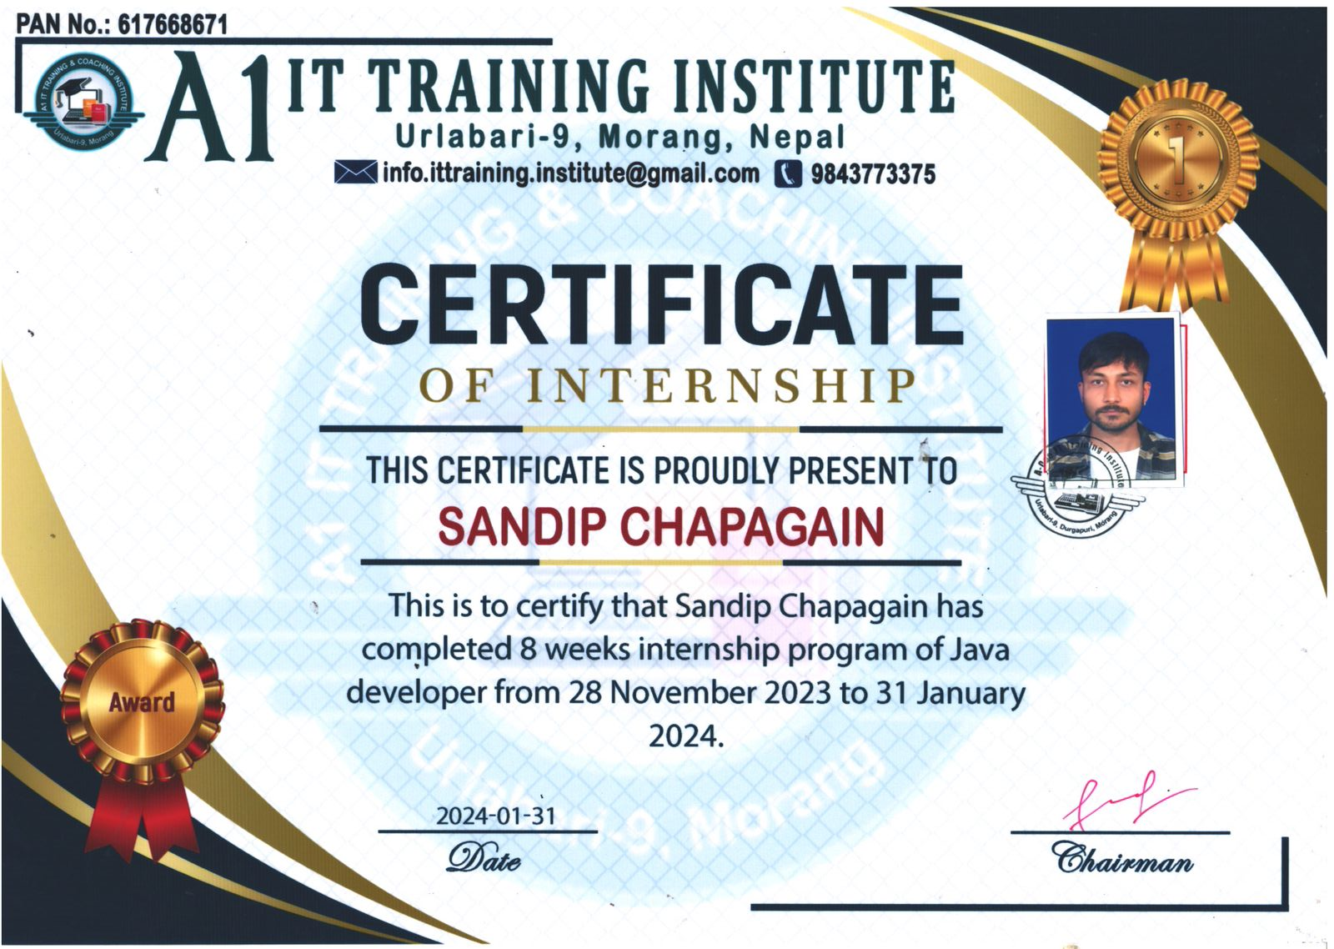

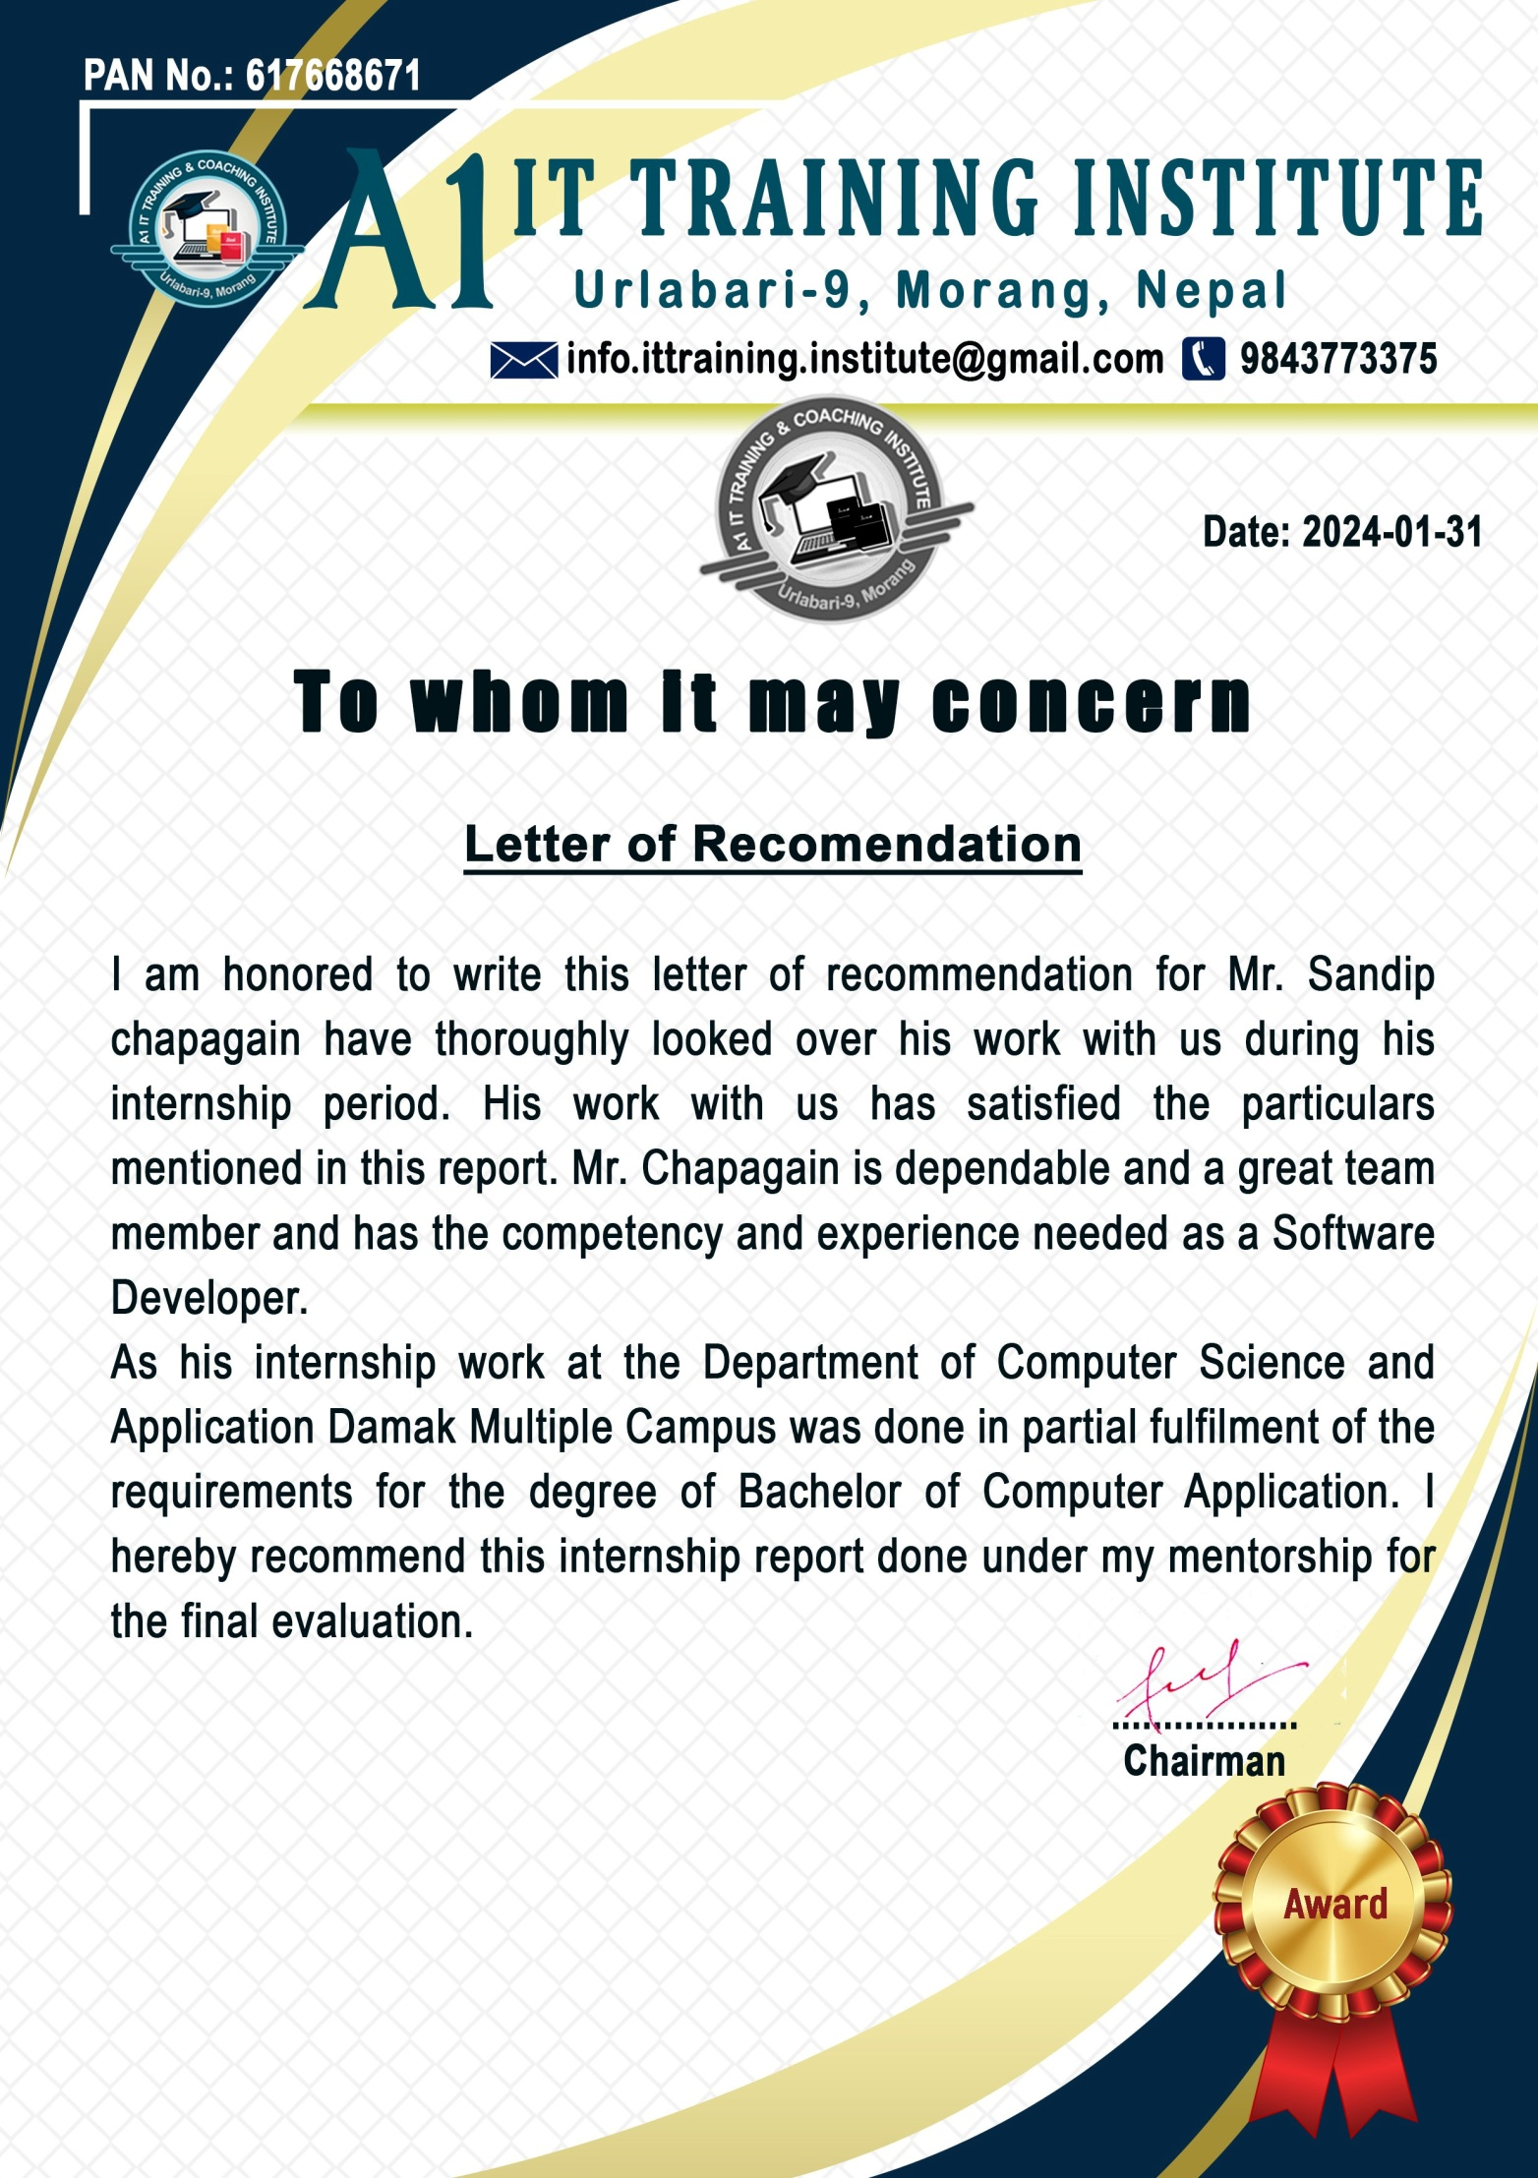



**Tribhuvan University**

**Faculty of Humanities and Social Sciences Damak Multiple Campus**

**Supervisor’s Recommendation**

I hereby recommend this internship report prepared under my supervision by Mr. Sandip Chapagain in partial fulfillment of the requirements for the degree of Bachelor of Computer Application is recommended for the final evaluation. I have thoroughly looked over the works he has done during his internship period. His work is Java developer**, A1IT Training Institute** has satisfied the particulars mentioned in this report.

#### SIGNATURE

Ghanashyam Adhikari **SUPERVISOR** BCA 6th SEM

Damak Multiple Campus Damak-09, Jhapa



**Tribhuvan University**

**Faculty of Humanities and Social Sciences Damak Multiple Campus**

#### LETTER OF APPROVAL

This is certified that this internship report prepared by **Mr. Sandip chapagain** in partial fulfillment of the requirements for the degree of Bachelor of Computer Application has been evaluated. In our opinion it is satisfactory in the scope and quality as a project for the required degree.

|  |  |
| --- | --- |
| **Signature of Supervisor**  Signature Ghanashyam Adhikari BCA Department  Damak Multiple Campus Damak-09, Jhapa | **Signature of HOD/Coordinator**  Signature Abhinash Kumar Jha  BCA Coordinator BCA Department  Damak Multiple Campus Damak-09, Jhapa |
| **Signature of Mentor**  Signature | **Signature of External Examiner**  Signature |

**Acknowledgement**

Foremost, I would like to express my sincere thanks of gratitude to my internship supervisor, Sir. Ghanashyam Adhikari for his continuous support and help in the internship work. I cannot thank him enough for all his patience, motivation, and immense knowledge. His guidance helped me all the time with the project.

Secondly, I would like to express my sincere gratitude to Mr. Sandeep Neupane for their invaluable guidance, support, and encouragement throughout my internship. I am deeply grateful for the opportunity to work under their mentorship and for their unwavering support in helping me to complete this project. I would also like to thank A1IT Training Institute for providing me with the opportunity to work on this project and for their support in my professional development. I am grateful to the entire team at A1IT Training Institute for their guidance and support throughout my internship.

I would like to express my gratitude to Tribhuvan University for providing me with a great opportunity of collecting experience by working as an intern and preparing this project report in according to its syllabus. I highly appreciate and honor the effort of Tribhuvan University to develop required attitude, abilities, and practical skills in students which constitute a foundation for their future development.

Lastly, I want to thank my parents and friends and all known unknown individuals who helped me in various way during my internship period. With this internship, got a chance to collect real world work experience as a software developer. I am thankful to them for all their support, helps guidance, motivation, and corrections.

I have tried to mention and give credit to everyone who helped me in this project, along with the sources from where I collected the required data and information which supported this project. Yet, there may be some unintended errors and some sources or individuals may have been missed to mention. I shall feel obligated if they are brought to my notice.

28 February, 2024 Sandip Chapagain

**Abstract**

The purpose of this internship report is to provide an account of my time spent interning at A1IT Training Institute, Ulabari, Nepal. This report will provide a summary of the eight-week service industry internship I undertook between November 2023 and January 2024.

Before graduating from the Computer Application department at Tribhuvan University, all students must undergo an industrial training program lasting at least 8 weeks at a reputable company or organization. The objectives of this internship are to expose students to the working world, help them comprehend the material they are learning more thoroughly, and give them the crucial work-related training in the fields of software development and computer application.

Students have a great opportunity to obtain work experience and choose a career through work-related learning. It establishes the foundation for an extraordinary learning experience by fusing the student's institutional skills with current job requirements. This project's main objective is to get useful work experience and career chances. The improvement and expansion of learning opportunities as well as the promotion of both personal and professional growth were also objectives. The duties conducted by A1IT Training Institute to develop a variety of abilities are described in this paper.

My main duty in this project was to construct the application's back-end in an efficient and effective manner. As an intern, I was tasked with implementing the backend logic and infrastructure using java with Spring Boot. I focused on developing RESTful APIs to handle data retrieval, manipulation, and authentication.

Additionally, I played a crucial role in writing unit tests and integration tests to ensure the reliability and functionality of the backend components. This allowed me to gain practical experience in testing methodologies and ensure the stability of the application.

**Table of Content**

Chapter 1:Introduction 1

* 1. Introduction 1
  2. Problem Statement 2
  3. Objective 2
  4. Scope and Limitation 3
  5. Report Organization 3

Chapter 2:Introduction of Organization 5

* 1. Organization Details 5
  2. Organizational Hierarchy 6
  3. Working Domains of Organization 7
  4. Description of Intern Department/Unit 8

Chapter 3:Background Study and Literature Review 10

* 1. Background Study 10
  2. Literature Review 11

Chapter 4: Internship Activities 13

* 1. Roles and Responsibilities 13
  2. Weekly Log 13
  3. Description of the Project Involved During Internship 22
  4. Task /Activities Performed 22

Chapter 5: Conclusion and Learning Outcomes 23

* 1. Conclusion 23
  2. Learning Outcomes 23

References 24

**List of Abbreviations**

IT – Information Technology TU – Tribhuvan University

BCA – Bachelor of Computer Application UI – User Interface

COO – Chief Operation Officer BOD – Board of Director

MD – Managing Director CFO – Chief financial officer CEO – Chief Executive Officer

**List of Tables**

Table 1: Internship Duration Table 9

**List of Figures**

Figure 1 : Logo of Company i.e Hunchha Digital Agency 6

Figure 2: Hunchha Digital Agency Organization Hierarchy 7

Figure 3: Working Domains of Hunchha Digital Agency 8

# Chapter 1:Introduction

## Introduction

Spring Boot is a powerful backend development framework created by the Spring team at Pivotal. It utilizes the Java programming language and enables developers to build robust, production-ready applications with minimal configuration.

One of the key features of Spring Boot is its opinionated approach to configuration and convention-over-configuration paradigm, which reduces boilerplate code and simplifies application setup. The framework also offers a wide range of built-in features and extensions, allowing developers to focus on business logic rather than infrastructure concerns.

In addition to the core Spring Boot framework, there is a vast ecosystem of third-party libraries and plugging available that extend its functionality, such as support for database access, security, and cloud integration. Overall, Spring Boot provides a comprehensive solution for building backend services that are scalable, maintainable, and easy to deploy.

Spring Tool Suite (STS) is a popular integrated development environment (IDE) based on Eclipse that provides excellent support for Spring Boot development. The Spring Tool Suite enhances the IDE with features such as project setup assistance, code generation, and seamless integration with Spring Boot's configuration options. Additionally, Spring Boot applications can be easily tested and debugged using STS's built-in t**ools.**

Spring Boot's popularity among developers stems from its productivity-enhancing features, robust ecosystem, and strong community support. The framework's convention-over-configuration approach simplifies development tasks, while its extensive documentation and vibrant community forums provide valuable resources for developers at all skill levels. Overall, Spring Boot empowers developers to build high-quality backend services efficiently, making it a preferred choice for a wide range of applications and industries. Some of the key reasons for Spring Boot's popularity include:

* + 1. Rapid development: Spring Boot's auto-configuration and starter dependencies enable developers to quickly bootstrap new projects and focus on implementing business logic.
    2. Opinionated defaults: Spring Boot provides sensible defaults and conventions that minimize configuration overhead and promote best practices.
    3. Scalability Spring Boot applications can easily scale to handle increased traffic and workload, thanks to its support for distributed computing and microservices architecture.
    4. Testing support: Spring Boot's comprehensive testing framework simplifies the process of writing and executing tests, ensuring the reliability and robustness of applications.
    5. Active community: Spring Boot boasts a large and active community of developers who contribute to the framework's ongoing development, share knowledge, and provide support to fellow users.

## Problem Statement

Some problem statements related to backend development Spring Boot include:

* To create a store application where store owners can manage entire sales details
* To segregate the admin and counter such that specific task can be performed
* To automate the record keeping and sales history
* To optimize and boost the selling process by enhancing the current business.

These are just a few examples of problem statements that could be addressed using this project. The possibilities are endless, and Spring Boot's powerful features and capabilities make it a versatile tool for building a wide range of applications.

## Objective

The main objectives of this project are as follows:

* Automate the record keeping, sales history, etc
* Provide a framework where sustainable business can run

## Scope and Limitation

Some scopes of spring Boot are as follows:

* Reduce or minimize the unnecessary costs
* Real time visibility and transparency
* Increase employee’s satisfaction and morale

Some potential limitations include:

* Limited support for older platforms: Flutter may not work on older versions of Android or iOS, which could limit its usability on certain devices.
* Larger app size: Flutter applications may have a larger file size compared to natively developed apps, which could impact their performance on some devices.
* Dependence on Flutter framework: Flutter applications rely on the Flutter framework, which means that developers must be familiar with it in order to build and maintain their applications.

Overall, while Flutter has many benefits and capabilities, it is important for developers to carefully consider its limitations when deciding whether it is the right choice for a particular project.

## Report Organization

**Chapter 1:** deals about general introduction of the flutter. It answers “What is flutter?”, “What this flutter does?”, "Why do we need flutter?" It also states problem of statement what existing problem lags. Objective of the flutter, scope and limitation in detail.

**Chapter 2:** describe the details of the organization and its hierarchy. It includes working domains of the organization and talks about the intern department or unit.

**Chapter 3:** is all about literature review and background study.

**Chapter 4:** is about what roles and responsibilities participants played and their weekly log. It deals about the description of job which is involved during internship and the tasks or activities performed while doing this job.

**Chapter 5:** describe about Conclusion and Learning outcome.

# Chapter 2:Introduction of Organization

## Organization Details

A1 IT Training Institute stands at the forefront of technology education and solutions, playing a pivotal role in empowering individuals and businesses. The institute's technical department is instrumental in ensuring the overall efficiency and productivity of the organization by providing essential technical assistance and support across various departments. A1 IT Training Institute is recognized as one of the best IT companies in the eastern part of Nepal, setting its headquarters in Urlabari of Morang district. Established on 07 Aashadha 2076 BS (June 22, 2019 AD), it has since thrived under the leadership of CEO Sandeep Neupane, a seasoned full-stack developer. With a dedicated team of over 5 professionals specializing in diverse programming fields, including full-stack development led by Sandeep Neupane and Rupak Shrestha, content creation by Ujwal Ghimire, MERN development by Ramesh Katuwal, and frontend development by Dipak Karki, A1 IT Training Institute is committed to excellence. The company's focus spans various areas of the IT field, encompassing digital marketing, graphics designing, mobile applications, and website development. Digital marketing services offered include content writing, video advertisement, social media management, and SEO optimization, while graphics designing expertise extends to advertisement, UI/UX design, and brand identity creation. A1 IT Training Institute primarily specializes in IT training across sectors such as web development, graphics designing, app development, and digital marketing, among others.



#### Figure 1 : Logo of Company i.e A1 IT Training Institute

## Organizational Hierarchy

An organizational hierarchy refers to the structure of an organization, including the different levels of management and the reporting relationships between them. The hierarchy typically consists of a top level of management (such as a CEO or president), followed by middle management (such as directors or department heads), and lower-level management (such as supervisors or team leaders).

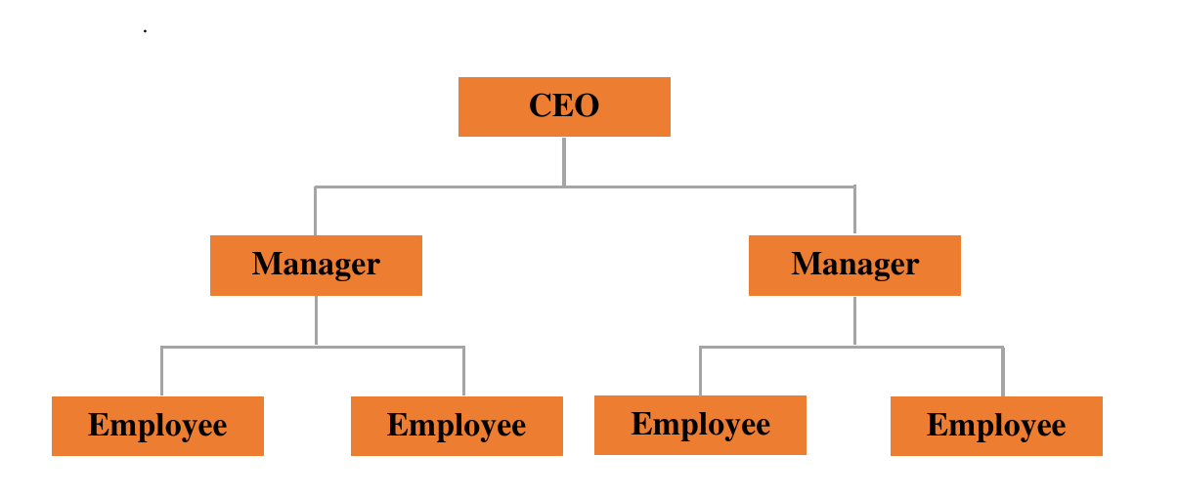

Figure 2: A1 IT Training Institute Organization Hierarchy

## Working Domains of Organization

In an IT software company, the working domains refer to the specific areas in which the company focuses its efforts in developing and selling software products or services. The working domains of an IT software company will depend on its target audience, the needs of that audience, and the company's own areas of expertise and focus.

**Hunccha Digital agency** company offers in different IT related platforms which are graphics designing, Digital marketing, advertisement , social media management. Mainly focus on making of web application and mobile application . These mobile application and web application include frontend and backend part.

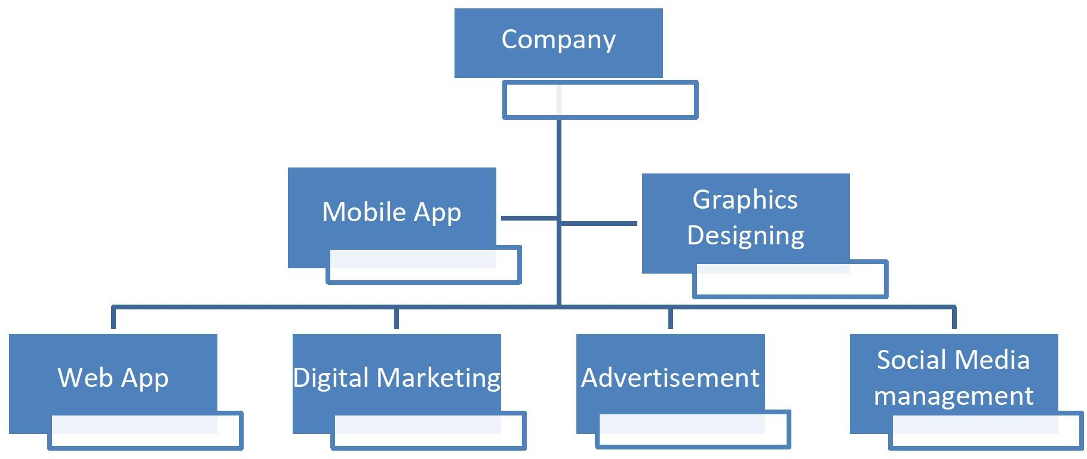

#### Figure 3: Working Domains of Hunchha Digital Agency

## Description of Intern Department/Unit

An intern department or unit is a department or unit within an organization that is responsible for managing the internship program and overseeing the work of interns within the organization. This department or unit typically works closely with other departments to identify opportunities for interns, recruit and select candidates, and coordinate the internship experience.

The intern department or unit may also be responsible for providing support and guidance to interns as they learn and gain experience within the organization. This may include providing training, supervision, and mentorship to interns, as well as helping them to set goals and track their progress.

Overall, the intern department or unit plays a key role in helping interns to succeed in their roles and gain valuable experience within the organization.

#### Table 1: Internship Duration Table

Start Date September 4th, 2022

End Date November 25th ,2022

Position Intern

Intern Supervisor Mr. Manish Regmi

Department Flutter fronted Developer

Working Hours 6 hours per day

Average Working 36 hours in a week

Working days 6 days in a week

# Chapter 3:Background Study and Literature Review

## Background Study

Every institution or business must create its own application to advertise its products and services online. The application assists in promoting the company's offerings to customers. The organization must be digitalized in order for it to expand and develop successfully and efficiently because in the modern world everything is computerized and digitalized. This internship report is a background study of Flutter, a free and open-source mobile application development framework created by Google. The goal of this study is to evaluate the feasibility of using Flutter for the development of a new mobile application for Hunchha Digital agency Company.

Flutter is a mobile application development framework that uses the Dart programming language. It was first released in 2017 and has since grown in popularity among developers. Flutter allows for the creation of high-performance, visually attractive, and responsive mobile applications for both iOS and Android platforms. Some of its key features include a reactive programming model, a customizable and extensible widget set, and a fast development cycle with hot reload. In order to gather information for this report, I can research different method, A review of existing Flutter applications to understand the capabilities and limitations of the framework, also Interviews with developers who have experience working with Flutter to gather their insights and feedback as well as Analysis of industry trends related to Flutter and other mobile application development frameworks.

The results of the research show that Flutter is a powerful and versatile framework that can be used to create high-quality mobile applications. It offers a reactive programming model, which makes it easy to handle user interactions and animations. Its customizable and extensible widget set allows for the creation of visually attractive and responsive user interfaces. Additionally, the fast development cycle with hot reload allows for faster iterations and shorter development time. Based on the results of this study, it is recommended that Hunchha Digital Agency Company consider using Flutter for the development of their new mobile application. The framework has many advantages that make it well-suited for creating high-performance and visually attractive applications. However, it is important to keep in mind that there is a learning curve for developers and a smaller community compared to more established frameworks.

## Literature Review

As technology has evolved over the last few years, every human being has developed accordingly. Nowadays, having smartphones in their pocket is like a trend for every person. Moreover, to continue this trend many mobile applications also prevail so that people can spend their leisure time scrolling over the applications. Due to the desire of people to search for something new, a large number of applications are present in the market in all categories which can be Health Care, Games, Music, Shopping, and many more. In the current scenario, people can now watch live matches, consult a doctor, learn new things through distance learning by just sitting at their homes through applications. This has caused a massive increase in application development.

A literature review in Flutter would involve researching and analyzing existing literature and resources on the topic of using the Flutter framework for mobile app development. This could include articles, tutorials, case studies, and documentation from both official and unofficial sources. The goal of a literature review would be to gain a comprehensive understanding of the current state of knowledge on the topic, including its strengths and limitations, as well as to identify potential areas for further research or development. The literature review would be a crucial step in the overall research and development process for an internship project using Flutter.

Blue Fox Pvt Ltd (Ltd B. F., 2019) is one of the software company of Nepal who has developed the websites and application for the organization to make the organization digital through online medium and promote the business. This company is creative digital agency based in Itahari, Province No.1 Nepal. Their core skills focus on Graphic Design, UX/UI Design, Web Development, Software Development, Mobile App Development, Digital Marketing, SEO and in particular where we all meet. They have been committed to delivering excellent, innovative digital projects completed to the highest possible standards by their fully qualified and experienced staff at their in-house studio.

Kyanite Software Company (Company, 2017) is another software company of Nepal who has also developed the websites and application for the company. This company is special for develop cutting-edge software and services for every kind of organizational need. In addition to that, they also offer a variety of services, including web design and development, e-commerce solutions, and android/ios app development. Many delighted clients all over the world attest to the high quality of our work.

Delta Tech Nepal (Nepal, 2018) is another software company which is located in Nepal as well as it’s headquarter is on Kathmandu. They have served 100+ clients with Their services in a just few years and They believe that client satisfaction is something, They never compromise on. With the commitment of providing IT services in Nepal, They have expanded their services to software development (Delta Tech Products), search engine optimization (SEO), web application & portals, graphic designing, and many more. They have developers in-house, who works on client requirement, design and develop as per client need to complete the project in time. They not only serve local peoples, but They have also taken care of international.

Pracas Infosys (Infosys, 2007) is another software company in Nepal who has been providing the different services for the clients and different organization. Pracas Infosys (PFS), an innovative IT company located at Hanumandas Road, Jaljala Chowk above Standard Chartered Bank Ltd. It has started rendering its technological service since 21 September 2007 and stood as a pioneer Information Technology Consulting Company providing Website Development, Software Development, Multimedia Solutions, IT Consultancy, Internet Marketing, Social Media Promotion & Technology Offshoring services in Eastern Region of Nepal. Pracas Infosys is the registered Company & certified by the Government of Nepal and also registered Tax Payer of Inland Revenue Department, Government of Nepal which promises to provide one single yet simple thing: satisfaction & reliability in order to promote IT sector to the local community and round the globe.

Vertex Web Surf Pvt Ltd (Ltd V. W., 2016) is a leading web designing, hosting and SEO Company based on Biratnagar, Nepal. This are a client-centrist organization. They make it our business to understand and help their clients achieve our business goals.They have successfully completed hundreds of projects of different sizes and complexity in various business and technological domains. Capitalizing on the accumulated experience Vertex Web Surf provides full-cycle services ranging from web design, graphic design, web hosting, search engine optimization and so on.

# Chapter 4: Internship Activities

## Roles and Responsibilities

My major responsibility in this project was to Designing and implementing the visual and interactive elements of a mobile application using Flutter's widget library and material design principles and also Collaborating with a team of developers to integrate the frontend with the backend of the application as well as Debugging and troubleshooting frontend issues. After Designing application and integrate the frontend with backed then this application Testing the application on multiple devices and platforms to ensure compatibility and usability. Maintaining and updating the frontend codebase as the application evolves.

## Weekly Log

A weekly log in an internship is a record of the tasks and activities that were completed over the course of a week as part of the internship. A weekly log can be used to track progress, identify any issues or challenges that arose, and highlight any notable accomplishments .In an internship context, a weekly log might include information such as the specific tasks that were completed, the amount of time spent on each task, any skills or knowledge that were gained, and any feedback or guidance received from mentors or supervisors. The weekly log during internship project are as follows:

**Weekly Internship Log**

**Name of the Students: Sandip Chapagain Date: 2022/09/4 Project/Job Title: Company-Application**

**Week Number: 01**

#### Responsibilities:

Initialize the Project.

* Initialize the GIT Repository.

#### Activities:

* Initialize the application project and the technology used are flutter in frontend,

Java in backend.

* Initialize the git project with master branch at initial and further the branch will

be added.

* + Implementing Backed part of the project by using Spring Boot.

#### Observations:

* Before Implement the project Requirement analysis is more important.

#### Plan for Next Week:

* Coding of admin panel screen and dashboard using the Flutter dart.

#### Performance Appraisal by Mentor:

**Satisfactory**

( Good thinking in the designing of project after analyzing the project )

**Mentors’ Approval**

**Signature: Name: Manish Regmi**

**Date:**

**Supervisor’s Verification**

**Signature:**

**Name: Ghanashyam Adhikari Date:**

**Weekly Internship Log**

**Name of the Students: Basanta Karki Date: 2022/09/11 Project/Job Title: Company-Application**

**Week Number: 02**

#### Responsibilities:

* Build Admin panel screen and Dashboard screen
* Setup project structure.

#### Activities:

* Coding of the admin panel screen like View details screen, admin’s home screen ,admin’s add permission to role screen etc and dashboard screen by using flutter dart.
* Making of Application for laptop screen as well as mobile screen.

#### Observations:

* The dart file is suitable to link the API which makes easier in development of application.

#### Plan for Next Week:

* Coding for user panel.
* Coding of Different module according to Demand of project.

#### Performance Appraisal by Mentor:

**Excellent**

(Your activities is increasing of creating scrollable dashboard.)

**Mentors’ Approval**

**Signature: Name: Manish Regmi**

**Date:**

**Supervisor’s Verification**

**Signature:**

**Name: Ghanashyam Adhikari Date:**

**Weekly Internship Log**

**Name of the Students: Basanta Karki Date: 2022/09/20 Project/Job Title: Company-Application**

**Week Number: 03**

#### Responsibilities:

* User panel screen coding according to project.
* Coding of Different module according to Demand of project.

#### Activities:

* The user panel Screen like User’ s home Screen and Drawer . User CURD screen, product CURD screen , add permission to role screen etc.
* The different screen like contact screen , appointment screen, application screen are also created.

#### Observations:

* Making the application responsive is important to make the application dynamic.

#### Plan for Next Week:

* Validation of admin panel screen of fronted part in flutter .

#### Performance Appraisal by Mentor:

**Satisfactory**

(Excellent Making of the application attractive and also mobile responsive)

**Mentors’ Approval**

**Signature: Name: Manish Regmi**

**Date:**

**Supervisor’s Verification**

**Signature:**

**Name: Ghanashyam Adhikari Date:**

**Weekly Internship Log**

**Name of the Students: Basanta Karki Date: 2022/09/25 Project/Job Title: Company-Application**

**Week Number: 04**

#### Responsibilities:

* Validation of Admin panel screen of fronted part using flutter part.

#### Activities:

* The validation of different type of admin panel screen
* The validation is done to prevent from the submission of invalid data.

#### Observations:

* The regex expression is suitable for the validation of form.
* Laravel framework is suitable to show the error message below the input field.

#### Plan for Next Week:

* Validation of user panel screen in a fronted part using flutter code.

#### Performance Appraisal by Mentor:

**Satisfactory**

(Good Focus on the validation of the application)

**Mentors’ Approval**

**Signature: Name: Manish Regmi**

**Date:**

**Supervisor’s Verification**

**Signature:**

**Name: Ghanashyam Adhikari Date:**

**Weekly Internship Log**

**Name of the Students: Basanta Karki Date: 2022/10/31 Project/Job Title: Company-Application**

**Week Number: 05**

#### Responsibilities:

* Validation of Admin panel screen of fronted part using flutter part.

#### Activities:

* Validation of user different type of user panel screen.
* The validation is done to prevent from the submission of invalid data.

#### Observations:

* The regex expression is suitable for the validation of form.
* Laravel framework is suitable to show the error message below the input field.

#### Plan for Next Week:

* Backend coding for using Laravel Framework.

#### Performance Appraisal by Mentor:

**Excellent**

(Good performing in frontend part of project using flutter regression.)

**Mentors’ Approval**

**Signature: Name: Manish Regmi**

**Date:**

**Supervisor’s Verification**

**Signature:**

**Name: Ghanashyam Adhikari Date:**

**Weekly Internship Log**

**Name of the Students: Basanta Karki Date: 2022/11/06 Project/Job Title: Company-Application**

**Week Number: 06**

#### Responsibilities:

* Backend coding(Laravel Framework ) for application.
* Validation of application

#### Activities:

* Coding in Laravel Framework in model, View ,Controller
* The validation is done to prevent from the submission of invalid data.

#### Observations:

* The regex expression is suitable for the validation of form.
* Laravel framework is suitable to show the error message below the input field.

#### Plan for Next Week:

* Integrating API with flutter

#### Performance Appraisal by Mentor:

**Satisfactory**

(Good Focus on the learning of flutter laravel )

**Mentors’ Approval**

**Signature: Name: Manish Regmi**

**Date:**

**Supervisor’s Verification**

**Signature:**

**Name: Ghanashyam Adhikari Date:**

**Weekly Internship Log**

**Name of the Students: Basanta Karki Date: 2022/11/13 Project/Job Title: Company-Application**

**Week Number: 07**

#### Responsibilities:

* Integrating API with flutter.

#### Activities:

* Integrating of flutter fronted URL in Laravel of backend.
* Creating flutter HTTP get request.
* .Creating flutter HTTP post request.

#### Observations:

* The HTTP request is main part in between frontend and backend part of the project

#### Plan for Next Week:

* System and unit testing

#### Performance Appraisal by Mentor:

**Satisfactory**

**(**Better Performing in creating of HTTP get and post request)

**Mentors’ Approval**

**Signature: Name: Manish Regmi**

**Date:**

**Supervisor’s Verification**

**Signature:**

**Name: Ghanashyam Adhikari Date:**

**Weekly Internship Log**

**Name of the Students: Basanta Karki Date: 2022/11/25 Project/Job Title: Company-Application**

**Week Number: 08**

#### Responsibilities:

* System and unit testing.

#### Activities:

* Each unit of the application is tested.
* System testing is done.

#### Observations:

* The testing should be done for the proper functionality of the application.

#### Plan for Next Week:

#### Performance Appraisal by Mentor:

**Perfect**

(On time)

**Mentors’ Approval**

**Signature: Name: Manish Regmi**

**Date:**

**Supervisor’s Verification**

**Signature:**

**Name: Ghanashyam Adhikari Date:**

## Description of the Project Involved During Internship

During my internship, the project I worked on involved the development of a mobile application using the Flutter framework. The app was designed to provide users with a platform to connect with other users, view profiles, and exchange messages. It also had features such as push notifications, location-based services, and a user-friendly interface. The project was challenging as it required me to learn and apply new technologies, but it was also very rewarding as I was able to contribute to the development of a functional and visually appealing app. Additionally, the project also required me to work closely with the design team to implement the app's visual design and user experience. I was responsible for implementing the app's UI and ensuring that it was responsive and user- friendly. I also worked on implementing backend integrations such as user authentication and database management using Laravel framework. Overall, the project was a great learning experience for me as I was able to improve my skills in Flutter development, user interface design, and backend integrations.

## Task /Activities Performed

* + - Requirement Analysis.
    - Design of the Project.
    - Frontend Development.
    - Backend development.
    - Integrating in API.
    - Unit Testing.
    - System Testing.

# Chapter 5: Conclusion and Learning Outcomes

## Conclusion

In conclusion, an internship in the flutter (frontend side) of a Hunchha Digital agency can provide a valuable learning experience for an individual interested in a career in the field of information technology. I got the opportunity to gain hands-on experience with a variety of projects and tasks, such as coding of admin screen, coding of dashboard screen, coding of user screen, validation in flutter frontend side , integrating API with flutter , unit and system testing of project. . I got the opportunity to learn about Flutter frontend side . Throughout the internship, I'm able to develop coding skills and gain knowledge of flutter and will have the opportunity to work with experienced programming in the field. I also got chance to coding in the flutter API.

Additionally, the internship helped me identify my strengths and flaws. I'm happy that my programming expertise allowed me to actively participate in the task at hand. Finally, this internship has inspired me to pursue a career in Flutter Programming and provided me with fresh perspectives.

## Learning Outcomes

I have determined that after completing this internship, I have gained the following crucial lessons.

* + - The capacity to recognize the technologies needed for development.
    - The capacity to use both new and current technical knowledge in industrial settings.
    - Experience of working in a team
    - API integration capabilities with flutter.

# References

Company, K. S. (2017). *Kyanite Software Company*. Retrieved from home: https://kyanitesoftware.com/

Infosys, P. (2007). *Pracas Infosys*. Retrieved from home: https://pfs.com.np/

Ltd, B. F. (2019). *Blue Fox Pvt Ltd*. Retrieved from home: https://codebluefox.com/

Ltd, V. W. (2016). *Vertex Web Surf Pvt Ltd*. Retrieved from home: https://[www.vertexwebsurf.com.np/](http://www.vertexwebsurf.com.np/)

Nepal, D. T. (2018). *Delta Tech Nepal*. Retrieved from home: https://deltatechnepal.com/