## 22532382_10214037906405775_2024227798_o.jpg

**Tribhuvan University**

**Faculty of Humanities and Social Sciences**

A Lab REPORT

Of

Software Project Management

**Submitted to:**

**Department of Computer Application**

**Damak Multiple Campus**

***In partial fulfillment of the requirements for the Bachelors in Computer Application***

Submitted by

Sandip Chapagain

(TU Symbol No: 6-2-202-885-2019)

March, 2024

Under the Supervision of

Santosh Bajgain

## Acknowledgement

The lab work report has been prepared in the partial fulfillment of course “**Software Project Management**” of Seven semester of Bachelor of art in computer application while preparing this report, I got a lot of co-operation and suggestion from different persons.

I am thankful to **Mr.Santosh Bajgain** (subject teacher) for properly guiding me. I also want to thank my friends who helps me a lot in the lab work.

I would like to express my hearty thanks to my family member who provided inspiration and motivation regularly for my success.

## Certificate

This is to certify that the lab report entitled Software Project Management is an academic work done by Sandip Chapagain submitted in the partial fulfillment of the requirements for the degree of Bachelor of Computer Application at Faculty of Humanities and Social Science ,Tribhuvan University under my guidance and supervision. To the best of my knowledge, the work performed by him in the lab report is his own creation.

# 

Signature

Table of Contents

[Acknowledgement i](#_Toc161315999)

[Certificate ii](#_Toc161316000)

[Introduction 1](#_Toc161316001)

[Best Use Cases 1](#_Toc161316002)

[Installation and Setup 3](#_Toc161316003)

[Features 4](#_Toc161316004)

# Introduction

ClickUp is a powerful project management and productivity tool that can help individuals and teams manage tasks, projects, and goals more effectively. It works great for individual users, team collaboration, and organizations with multiple business departments.

Here are some of the ways ClickUp can help you with your workflow and process:

1. **Flexible Task Management:** ClickUp offers a range of task management features, including customizable statuses, priorities, due dates, and more. You can create and organize tasks in a way that suits your workflow, and easily track progress.
2. **Collaboration:** ClickUp allows teams to collaborate more effectively by providing features like comments, mentions, and task assignments. You can communicate with team members directly within the app through chat or assigned comments and ensure that everyone is on the same page.
3. **Time Tracking:** ClickUp offers built-in time-tracking tools, making it easy to track time spent on tasks and projects. This can be useful for tracking hours, improving productivity, and optimizing workflow.
4. Integrations: ClickUp can be integrated with a range of other tools and services, including Google Drive, Trello, Slack, and more. This allows you to easily bring all of your tools and data together in one place so you don’t have to switch a lot between multiple tools and apps when working.
5. **Custom Dashboards:** ClickUp allows you to choose from 50+ widget variations and build a dashboard for any business scenario to get high-level reporting and an overview of your work. It can be configured to display a wide range of information, including task lists, project timelines, charts, graphs, and more.
6. **Customizable Views:** ClickUp offers a range of customizable views, including list, board, calendar, and timeline views. This allows you to visualize your tasks and projects in a way that suits your workflow and preferences.

## Best Use Cases

ClickUp is a versatile project management tool that can be used in a wide range of use cases. Here are some of the best use cases for ClickUp:

**Team Collaboration**

ClickUp is a great team collaboration tool as it allows teams to work together on projects, assign tasks, set deadlines, and communicate in real-time without the need to move from one app to another. The platform includes features like comments, mentions, and chat that makes it easy for teams to collaborate on projects.

**Project Management**

ClickUp's project management features are robust and flexible. It allows users to create tasks, set deadlines, assign tasks to team members, and track progress. Users can also use Gantt charts and custom workflows to manage projects. ClickUp's Project Management Template offers every tool and view necessary to provide project managers with the support that they need.

**Agile Development**

ClickUp has features that make it ideal for Agile development projects. It allows users to create sprints, set priorities, and use Kanban boards to manage tasks. ClickUp also offers a specific template for Agile Project Management for an interactive approach.

**Marketing Campaign Management**

ClickUp's features can help marketing teams manage their campaigns effectively. Users can set up tasks, timelines, and checklists to ensure that each campaign is executed smoothly.

**Product Development**

ClickUp's customizable features make it a great tool for product development teams. Users can set up tasks, deadlines, and priorities for each stage of the development process, from ideation to launch.

**Event Planning**

ClickUp's features can help event planners manage their tasks and timelines effectively. Users can create tasks for each aspect of the event, assign team members, and track progress. ClickUp offers a library of templates which includes an Event Planning folder level template to make your job as an event planner easier.

**Personal Productivity**

ClickUp can also be used for personal management, growth, and goals. Users can create a personal workspace and use it to manage their to-do lists, set reminders, and track their progress. They can also use features like goals and habits to stay motivated and focused.

These are just some of the many use cases for ClickUp. This versatile tool can be customized according to any project type as well as your team's workflow process, needs, and requirements.

# Installation and Setup

ClickUp is available for all kinds of devices such as mobile, desktop, chrome extension, apple watch in several forms like app, cloud platform, extensions and etc. In browser we can visit to <https://clickup.com> and signup with email to get started

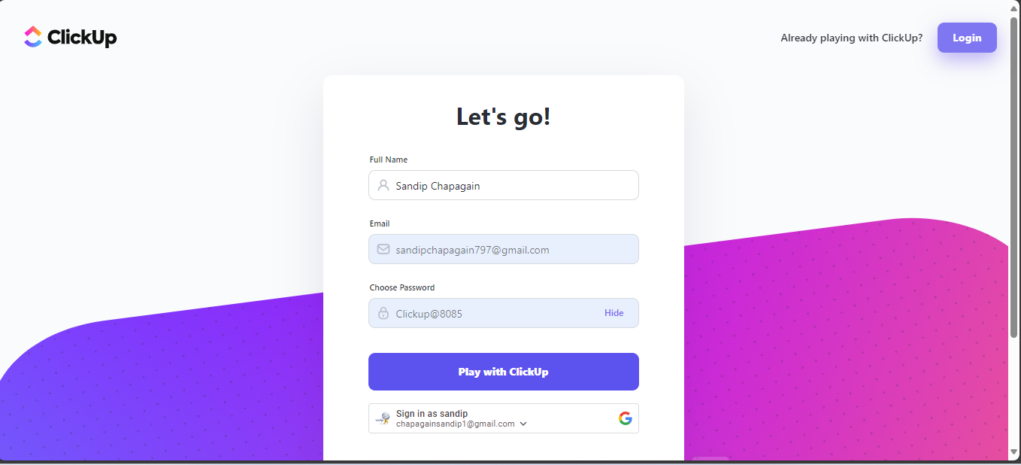

# Features

**Workspace**

Workspaces in ClickUp serve as the top-level organizational structure where you can group together teams, projects, and tasks. Each workspace provides a distinct environment for collaboration, allowing teams to work on multiple projects simultaneously without interference. Workspaces offer a centralized hub for managing all activities, facilitating efficient communication, task tracking, and project management across teams and departments.

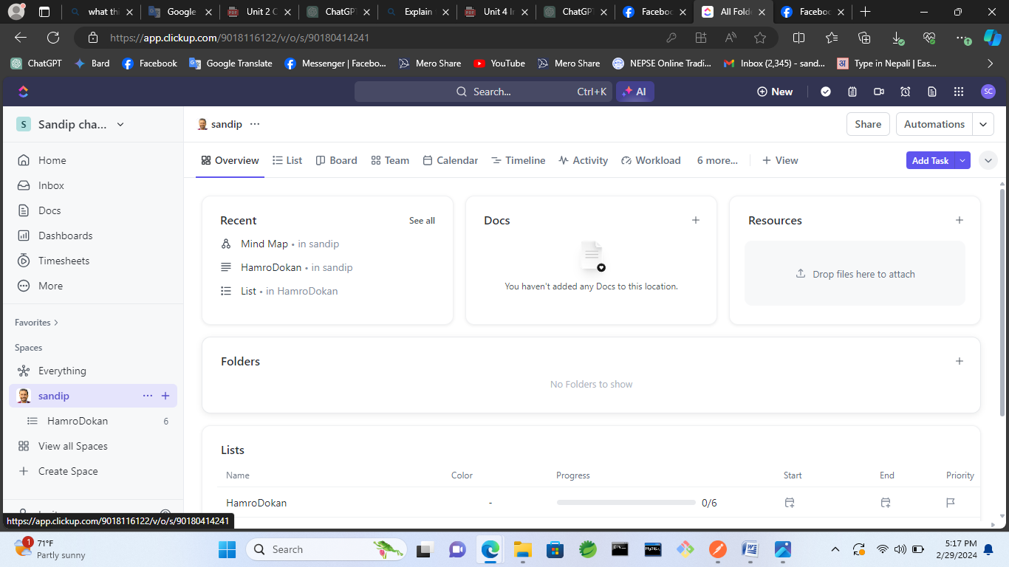

**Board for task list**

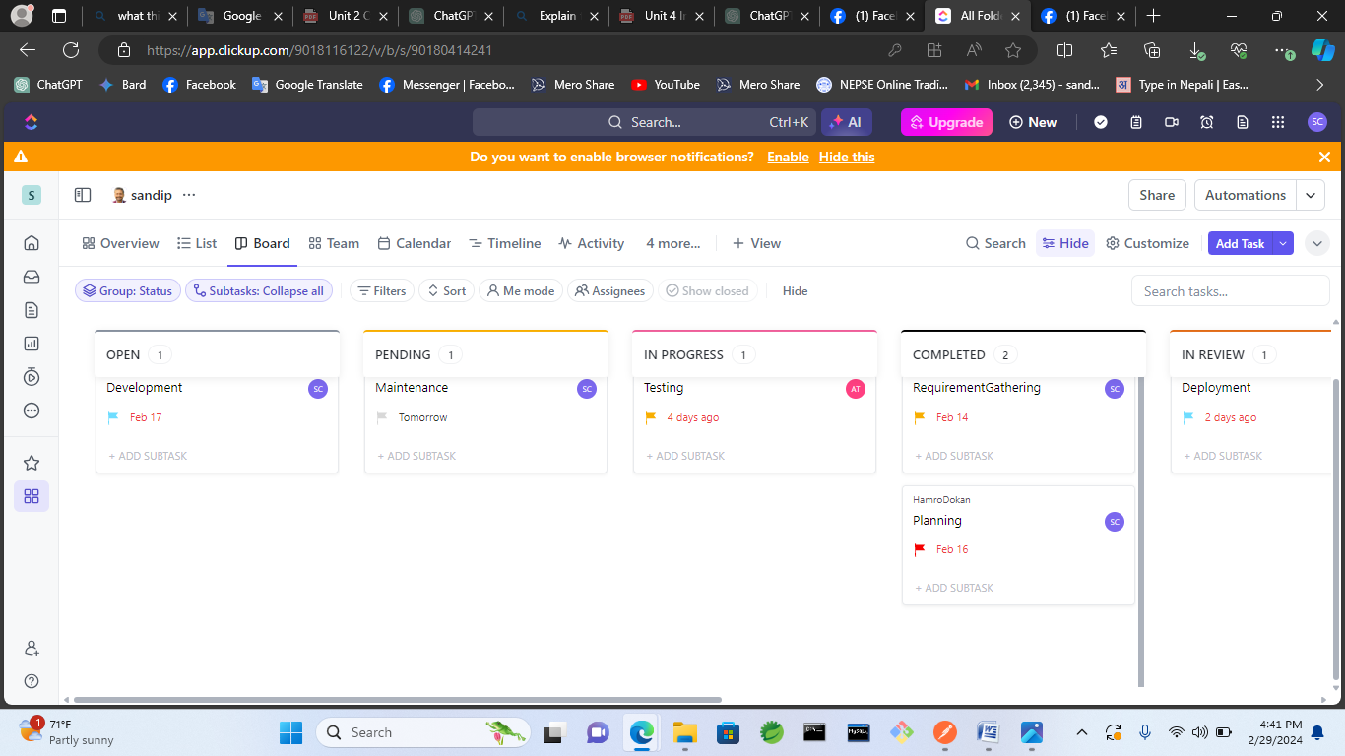Boards in ClickUp offer a visual way to organize tasks and workflows using a Kanban-style approach. With boards, you can create customizable columns representing different stages of your project or process. Tasks can be moved between columns to indicate progress, making it easy to track their status at a glance. Boards provide flexibility for teams to customize their workflow, collaborate effectively, and streamline task management in a visual, intuitive manner.

**Mindmap**

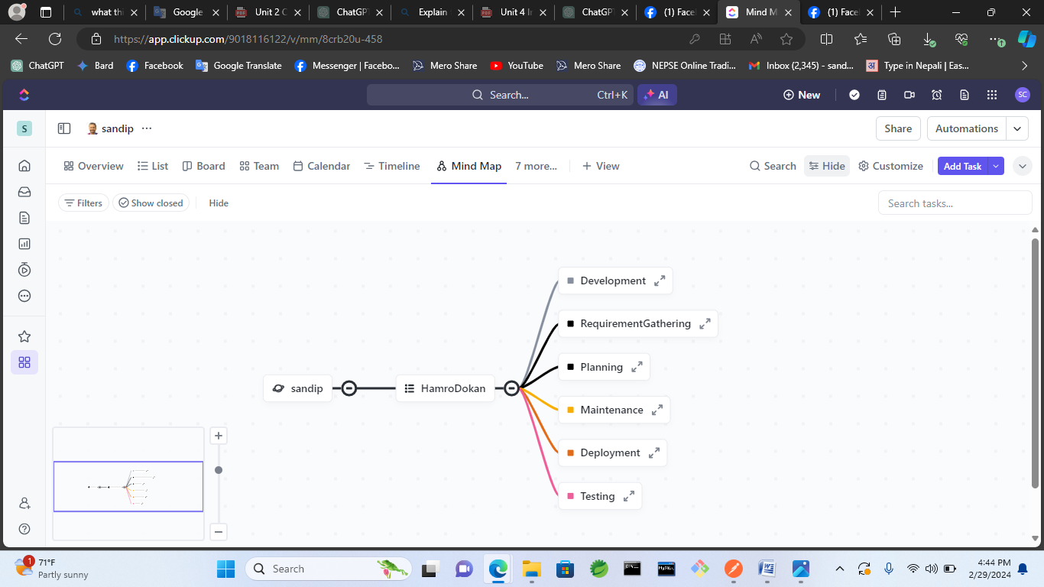Mindmap in ClickUp is a visual tool that allows users to brainstorm, organize ideas, and create hierarchical structures. With the Mindmap feature, you can easily capture thoughts, concepts, and relationships between them in a visually appealing format. It offers flexibility in arranging and connecting nodes, enabling users to create dynamic representations of their thoughts and plans. Mindmaps in ClickUp provide a collaborative platform for ideation, planning, and organizing information, helping teams to generate and visualize ideas more effectively.

**Task List**

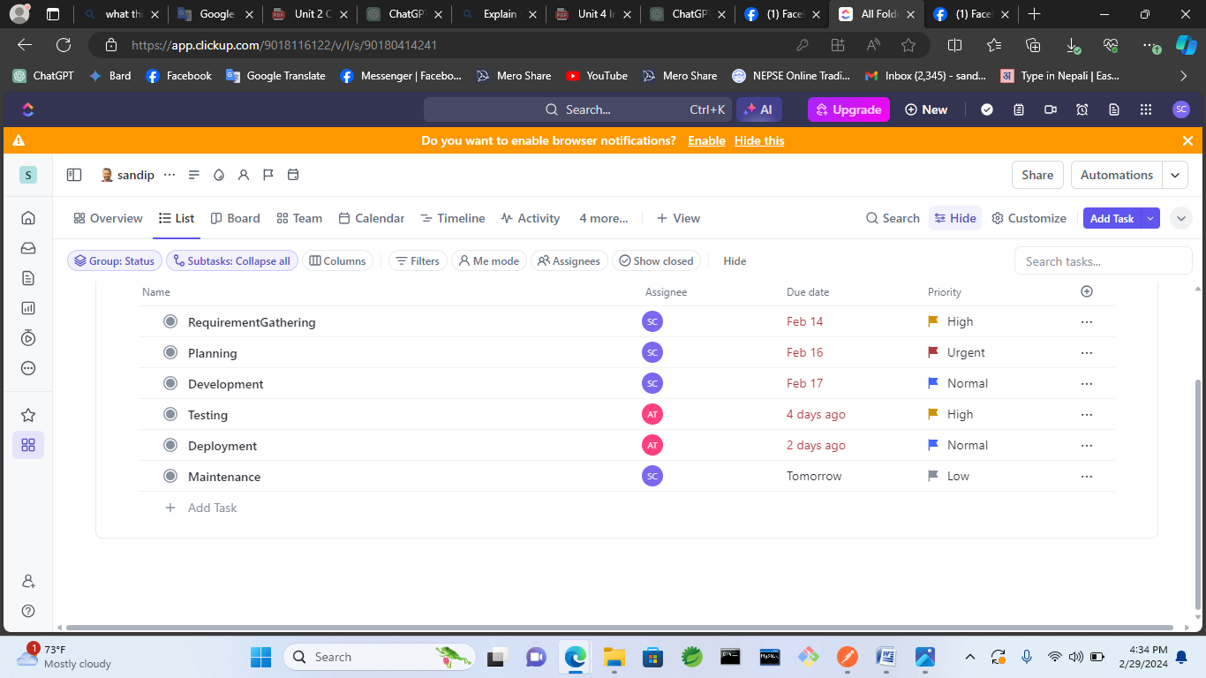The Task List feature in ClickUp provides a structured view of all tasks within a project or workspace. It displays tasks in a list format, allowing users to see essential details such as task names, due dates, assignees, statuses, and priorities at a glance. Task Lists offer flexibility in organizing and sorting tasks based on various criteria, such as priority, due date, or assignee. Users can easily navigate, update, and manage tasks directly from the Task List view, making it a central hub for task management and coordination within teams.

**GanttChart**

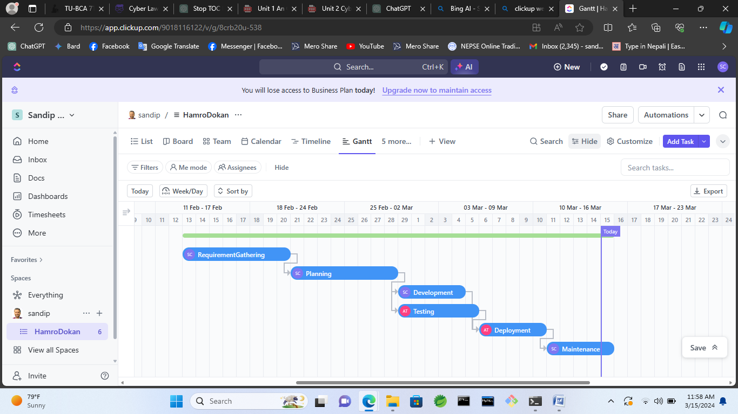The Gantt Chart feature in ClickUp provides a visual representation of project timelines, tasks, and dependencies. It displays tasks as horizontal bars along a timeline, showing their start dates, durations, and dependencies. Gantt Charts offer a comprehensive overview of project progress, allowing users to track task dependencies, identify critical paths, and adjust schedules accordingly. Users can easily create, edit, and rearrange tasks directly within the Gantt Chart view, facilitating efficient project planning and management. Additionally, Gantt Charts in ClickUp support collaborative editing, enabling teams to coordinate tasks and schedules in real-time.

**Task with Assignes, Due date and priority**

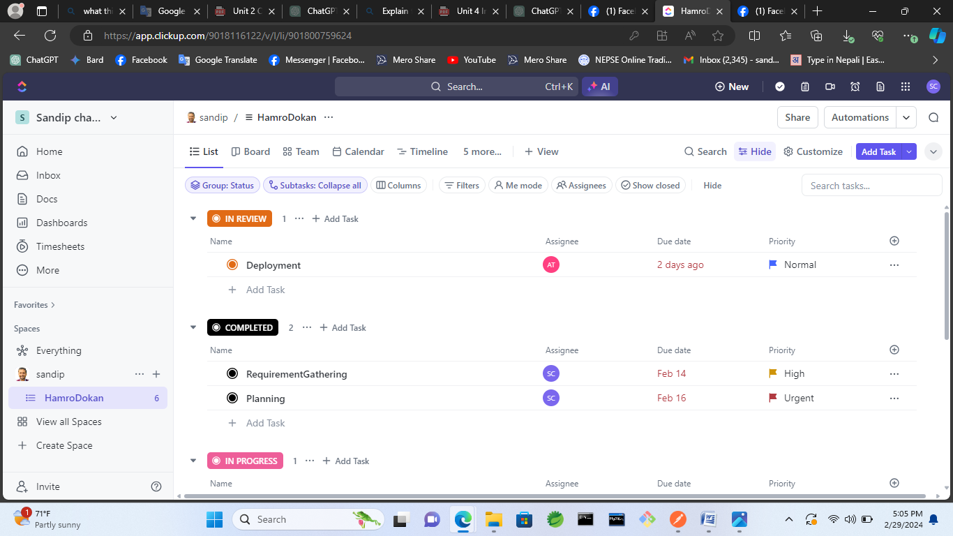

**Team Management**

Team Management in ClickUp encompasses various tools and features designed to streamline collaboration, communication, and coordination among team members.

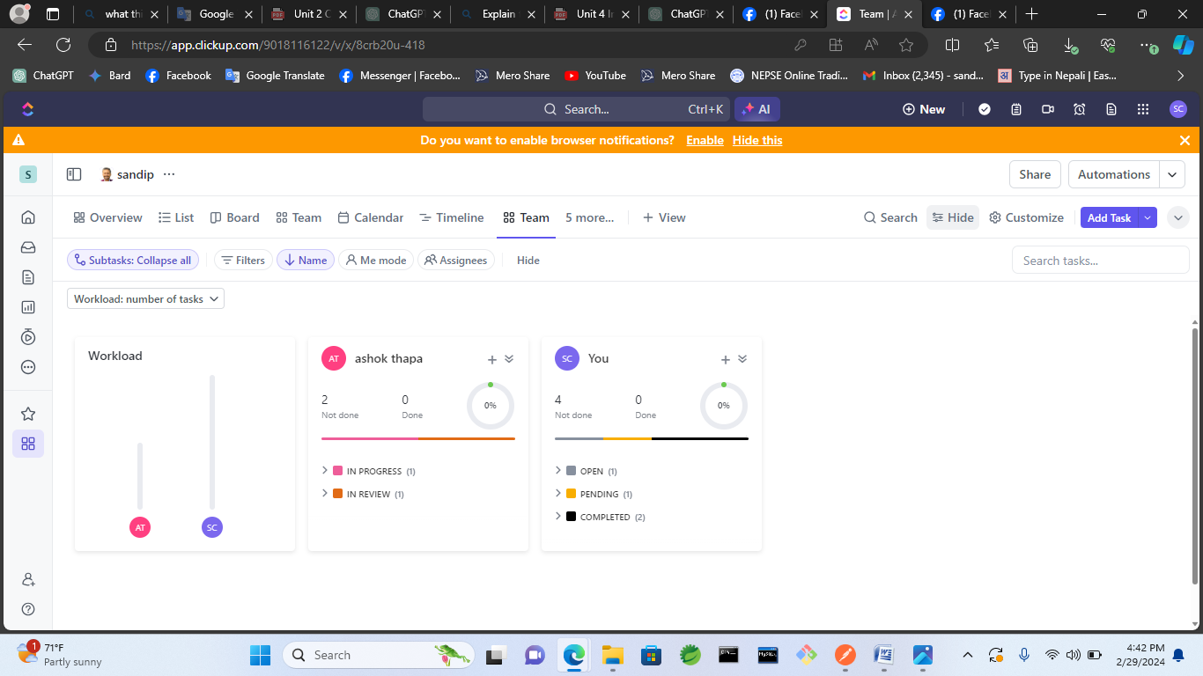

**Dashboard, Analytics for the project**

The Dashboard and Analytics feature in ClickUp provides users with a centralized hub for monitoring and analyzing various aspects of their projects, tasks, and team performance.

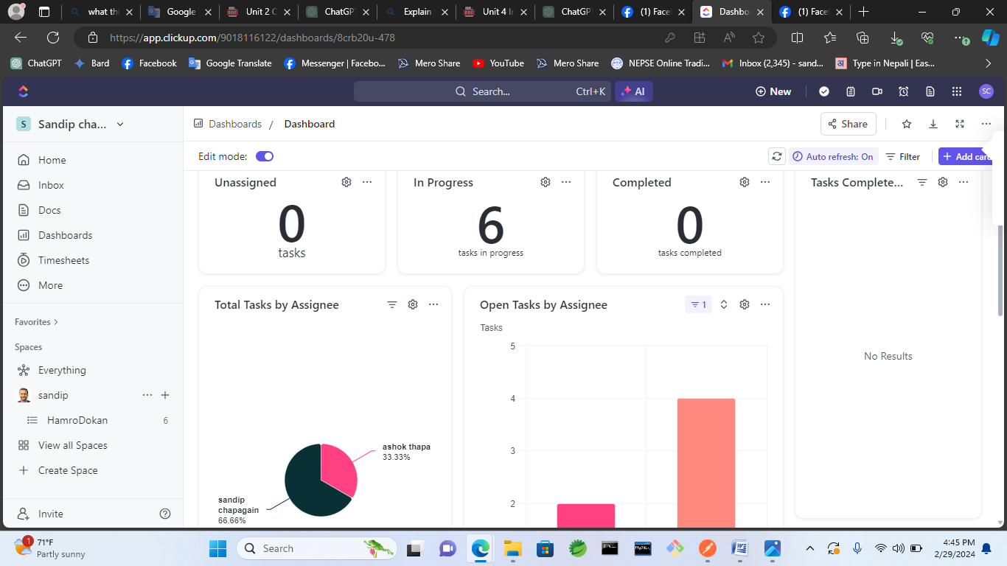

**Slack Time**

"Slack time" typically refers to the idle or unallocated time that occurs within a project schedule or among team members. It's the time available for tasks or activities that are not planned or scheduled, often used for unplanned work, breaks, or other non-project-related activities. In project management, "slack time" is also known as "float" and represents the amount of time a task can be delayed without affecting subsequent tasks or the overall project deadline. It provides flexibility in project schedules and allows for adjustments in case of unexpected delays or changes.

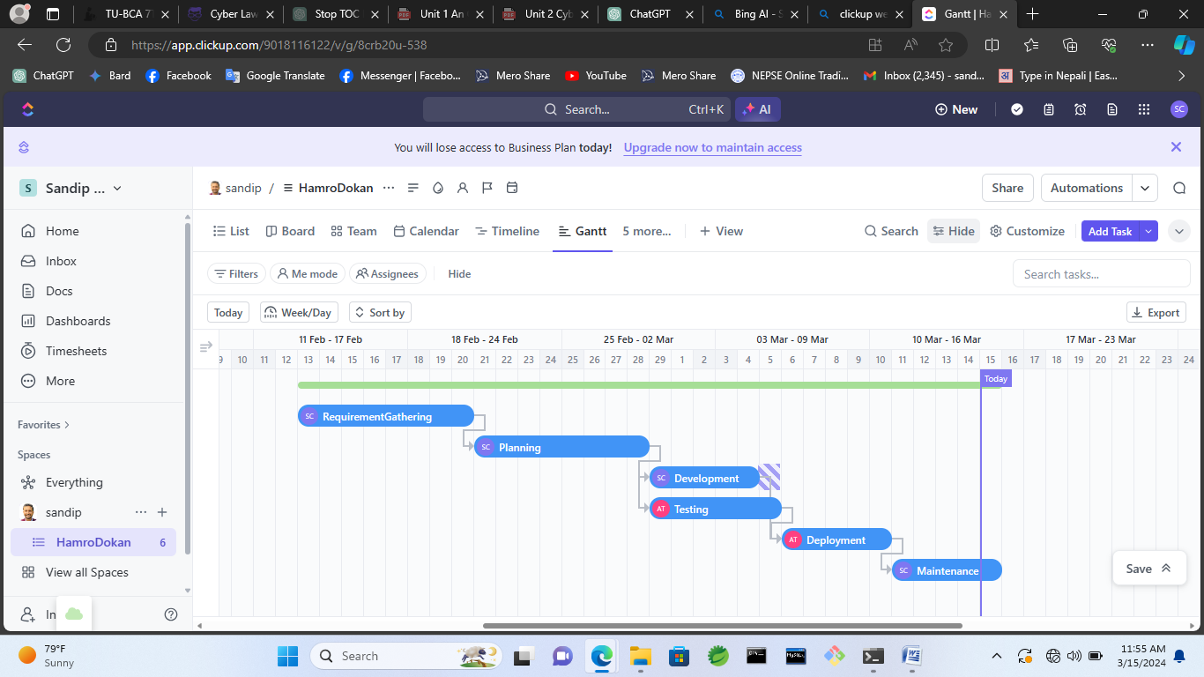

**Critical Path**

The critical path in project management refers to the sequence of tasks or activities that determine the shortest duration in which a project can be completed. These tasks are critical because any delay in their completion would directly impact the project's overall timeline. The critical path is derived from the network diagram of the project, which maps out the dependencies between tasks and their durations

**