ShadowFox
Data Science Internship
Internship Completion Report
Levels Completed: Beginner · Intermediate · Advanced
Submitted by: Sneha
Domain: Data Science

1. About This Internship
I took part in the ShadowFox Data Science Internship, working through three levels of tasks — Beginner, Intermediate, and Advanced — that were designed to build up practical data analysis skills step by step. Each level pushed me to work with a different kind of dataset and a different set of tools, starting from basic charting all the way to building a scoring system from scratch.
This report walks through what I did at each level, why I made the choices I made, and what I actually learned along the way. All the code, notebooks, and data files for every task are in my GitHub repository, linked at the end of this report.

2. Beginner Level — Visualization Library Documentation

What the task asked for
The brief was to pick two Python visualization libraries and document the different types of charts each one can create, with working code examples for each.

What I did
I picked Pandas and Matplotlib, mainly because pandas plotting is actually built on top of Matplotlib — so documenting both together let me show the quick way of making a chart and the fully-controlled way of making the same chart, side by side.
Instead of using made-up numbers for the examples, I used a real dataset of IPL matches played between 2008 and 2022 (950 matches in total). That way every single chart in the documentation was answering an actual cricket question instead of just being a demo.
- Covered 10 chart types in Pandas: line, bar, horizontal bar, histogram, KDE, box plot, pie, area, stacked bar, and scatter.
- Covered the same chart types again in Matplotlib, plus extras only Matplotlib can do well — a grouped bar chart, an annotated scatter plot, and a 2×2 dashboard combining four charts into one figure.
- Ended with a comparison table of both libraries — ease of use, customization, interactivity, and performance on large datasets.

What the data showed
Mumbai Indians and Chennai Super Kings have won clearly more matches than any other IPL team, and teams choose to field first after winning the toss about 63% of the time — a habit that's grown a lot since 2014.
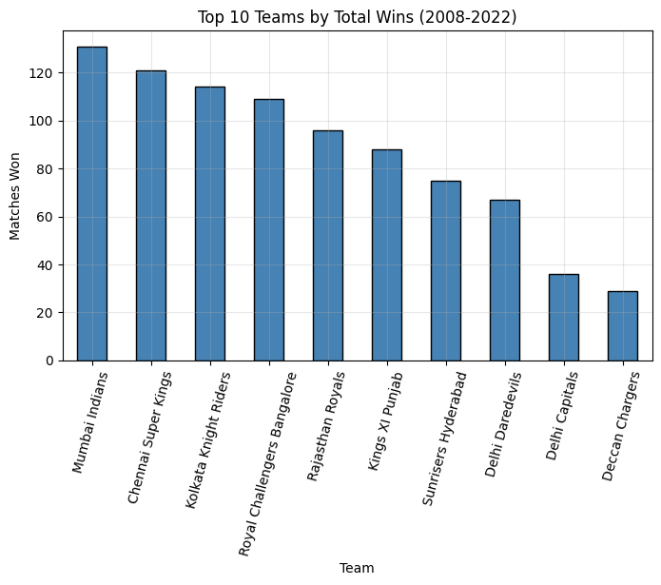
Figure 1 — Top 10 IPL teams by total wins, 2008–2022
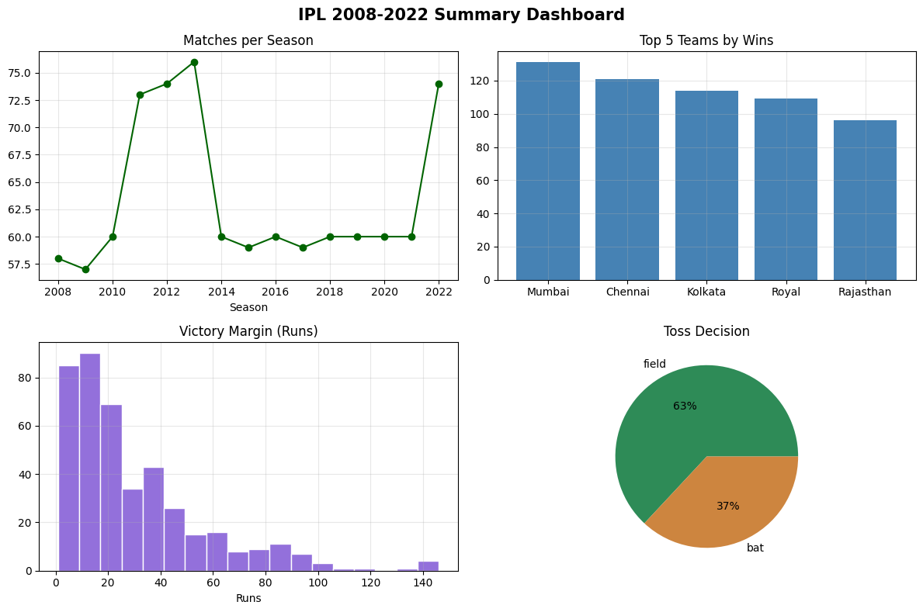
Figure 2 — A four-panel dashboard built entirely in Matplotlib, combining season trends, top teams, victory margins, and toss decisions

What I learned
The biggest thing I took away is that pandas is great for quickly looking at data while you're still exploring it, but the moment you need something specific — labeling a bar with its exact value, combining four charts into one dashboard, or drawing an arrow pointing at a spike — you need Matplotlib. They're not really competing tools; pandas plotting is Matplotlib underneath, so learning both together made a lot more sense than learning them separately.

3. Intermediate Level — Delhi Air Quality Index Analysis

What the task asked for
The brief asked for an in-depth look at Delhi's air quality, defining research questions around pollutants, patterns over time, and what the data says about air quality challenges in the city.

What I did
I worked with an hourly air quality dataset for Delhi covering 1–24 January 2023. Since this was only a 24-day window in one month, I couldn't really talk about full seasonal variation the way the brief originally asked — so I reshaped my research questions to what the data could actually support: how bad the air really was, whether pollution follows a pattern across the day, which pollutants move together, and how weekdays compare to weekends.
I converted the raw pollutant readings into the real Indian AQI scale using the official CPCB formula, rather than a shortcut, so the numbers would mean the same thing they do on a news headline.
- Found that 97% of all hours in the dataset fell into the two worst AQI categories — Severe or Very Poor.
- Found a clear pattern through the day: air quality is best around 8–9 AM and worst in the afternoon-to-evening stretch.
- Found that weekends were measurably cleaner than weekdays across every pollutant checked — a sign that traffic and daily activity are a real part of the problem, not just fixed weather.
- Found that PM2.5 and PM10 move almost perfectly together (correlation of 0.99), while nitrogen oxide (NO) was the most unpredictable pollutant of all.
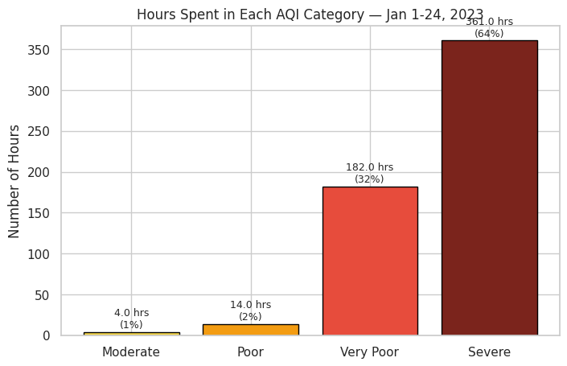
Figure 3 — Number of hours spent in each AQI category over the 24-day window
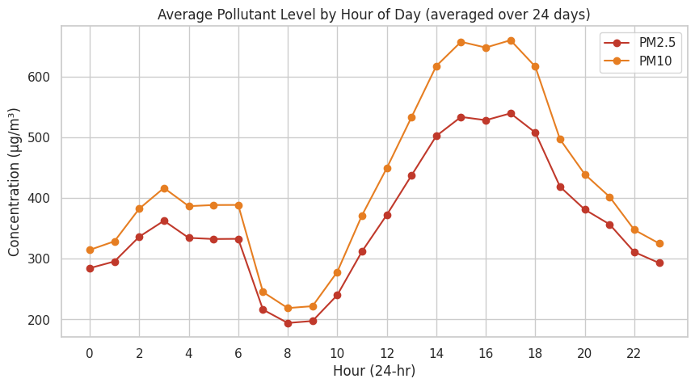
Figure 4 — Average PM2.5 and PM10 levels by hour of day, showing the daily pollution pattern
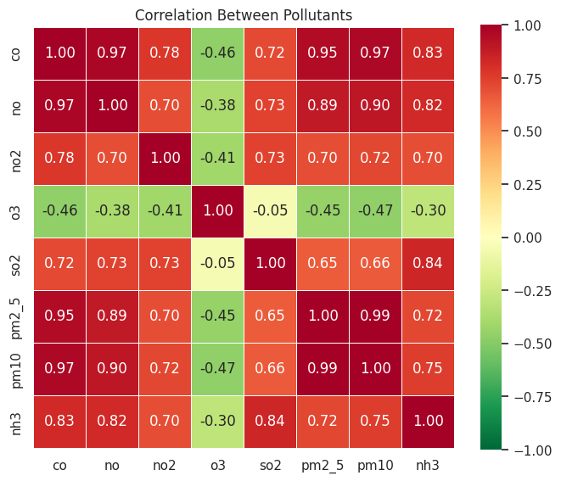
Figure 5 — Correlation between different pollutants, showing which ones rise and fall together

What I learned
This task taught me to be honest about what a dataset can and can't answer. The original brief wanted seasonal analysis, but 24 days of data just can't support that claim — so instead of forcing an answer, I reshaped the question to something the data could actually back up. I also learned how much a simple hour-of-day breakdown can reveal that a daily average completely hides.

4. Advanced Level — Indian Cinema Exploratory Data Analysis

What the task asked for
The brief for this level offered a choice. The option I went with was the open-ended final project: pick a dataset, explore it from scratch in a Jupyter notebook, define my own research questions based on what I found, and use visualizations to answer them.

What I did
I worked with a dataset of 1,629 Indian films released between 2001 and 2019, with IMDb ratings, vote counts, genres, cast, runtime, and awards data. After exploring the columns, I settled on seven research questions I thought the data could actually answer well: how the genre mix has shifted over time, whether popularity lines up with quality, which genres rate highest, whether runtime matters, whether a familiar cast means a better film, how award recognition relates to rating, and how average ratings have trended year to year.
Two of the columns needed real cleanup before they were usable — genres were stored as a single pipe-separated string per film, and the awards column was free text like "3 wins & 5 nominations" that I had to parse out into actual numbers using regular expressions.
- Drama dominates the dataset, appearing in 67% of all films, followed by Comedy, Romance, and Action.
- Vote count and rating correlate moderately (0.44) — popular films tend to rate a bit higher, but it's a loose relationship, not a rule.
- Runtime has almost no effect on rating at all (correlation of just 0.02).
- Biography is the highest-rated genre on average (6.58), Horror the lowest (4.70).
- The most surprising finding: films featuring the most frequently credited actors actually rated slightly lower on average (5.46) than films without them (5.59) — a familiar face didn't mean a better film.
Once the seven core questions were answered, I went looking for a few fun extras the data could clearly settle. 23 films rate 7.5 or higher on fewer than 1,000 votes — genuine hidden gems, topped by Family of Thakurganj (2019) at 9.4 on just 895 votes. On the flip side, Aag (2007) sits at a brutal 1.7 despite 6,421 votes, and Race 3 (2018) isn't far behind at 2.0 — on a massive 30,038 votes. Popularity got both of those films watched. It didn't get them liked.
I also mapped which genres actually pair up most often in the same film. Comedy and Romance show up together in 189 films — the rom-com formula, alive and well — while Action and Crime pair up 140 times, the cops-and-gangsters staple.
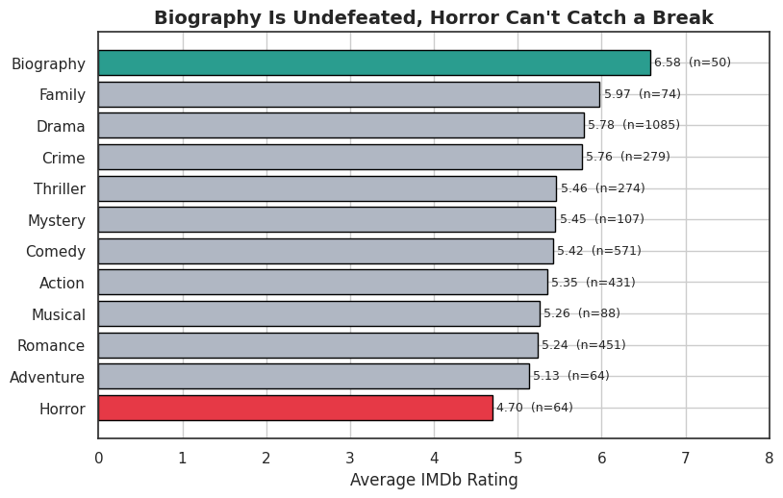
Figure 6 — Average IMDb rating by genre, for genres with 50 or more films
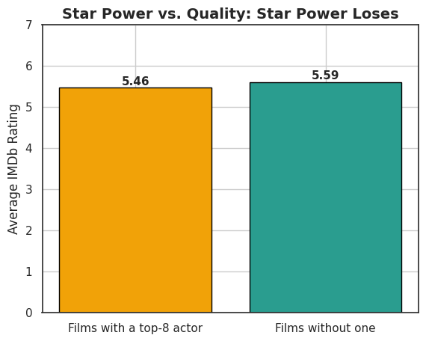
Figure 7 — Average rating: films with a top-8 prolific actor vs. films without
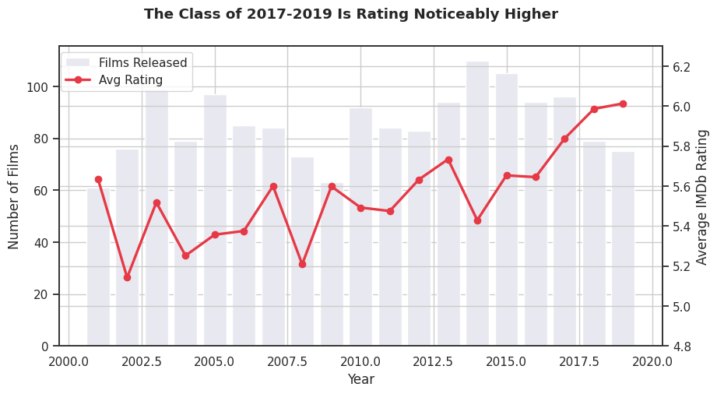
Figure 8 — Number of films released and average rating by year
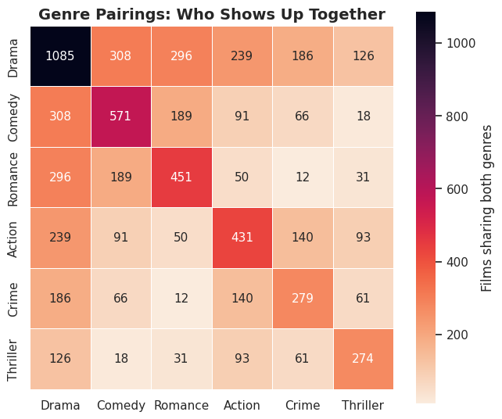
Figure 9 — Which genres actually show up together most often

What I learned
This was the first task where I had to come up with my own research questions instead of being handed a formula. The most useful skill here was resisting the obvious assumption — I expected a familiar, prolific cast to correlate with better films, and the data said the opposite. I also had to get comfortable parsing messy free text (the awards column) into real numbers before I could do anything with it, which was a genuinely new skill for me.

5. Overall Learnings
Across all three levels, a few things came up again and again:
- Pandas and Matplotlib work best together — one for speed, one for control.
- A dataset's limits should shape the questions you ask, not the other way around.
- Obvious assumptions are worth checking against the data before trusting them — the cast-and-rating result in the advanced task is a good example of an assumption the data didn't support.
- Messy free-text fields (like the awards column) usually need real parsing before they're usable — not just a glance.
Tools used throughout: Python, Jupyter Notebook, Pandas, Matplotlib, Seaborn, NumPy, and regular expressions for text parsing.

6. Conclusion
This internship gave me a real, hands-on run at the kind of work a data analyst actually does — cleaning messy data, asking the right questions, building visualizations that answer those questions, and being honest about a dataset's limits. I'm submitting all three levels — Beginner, Intermediate, and Advanced — with full code and notebooks, all available in the GitHub repository below.

7. Repository
GitHub Repository: ShadowFox-DataScience-Internship (https://github.com/sne-hue/ShadowFox-Data-Science-Internship)

