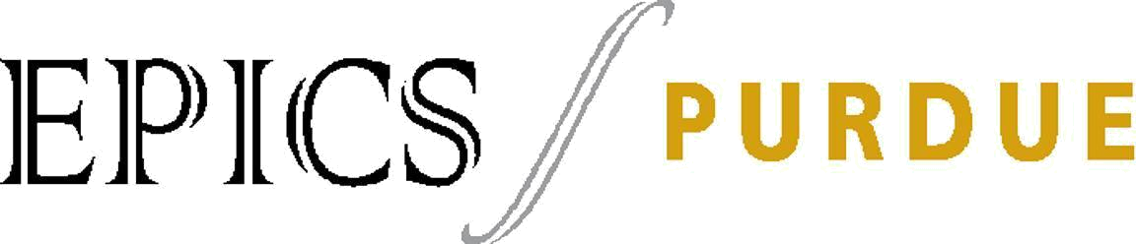

Design Document

Team: ISD

Project: DASL

Date: 4/12/2019

1 | Table of Contents
1 | Table of Contents | 2
2 | Revision History | 3
3 | Design Status | 4
4 | Project Charter | 5

4.1 | Description of the Community Partner | 5
4.2 | Stakeholders | 5
4.3 | Project Objectives | 5
4.4 | Outcomes/Deliverables | 7
4.5 | Expected Semester Timeline | 7

5 Semester Documentation (current semester) |  |  | 8
5.1 | Team Member |  | 8
5.2 | Current Status and Location on Overall Project Timeline |  | 8
5.3 | Goals for the Semester |  | 8
5.4 | Semester Timeline |  | 8
5.5 | Semester Budget |  | 8
5.6 | Transition Report |  | 8
5.6.1 |  | Summary of Semester Progress / Comparison of Actual Semester Timeline to Proposed
Semester Timeline |  |  | 8
5.6.2 |  | Draft Timeline for (next semester) and Relationship to Overall Project Timeline | 9
6. Current Design |  |  | 10
Appendix A: Past Semester Archive |  |  | 11
A.1 | Past Semester 1* |  | 11
A.1.1 |  | Past Team Members | 11
A.1.2 |  | Past Timeline | 11
Appendix B: Overall Project Design |  |  | 12
B.1 | Project Identification |  | 12
B.2 | Specification Development |  | 13
B.3 | Conceptual Design |  | 14
B.4 | Detailed design |  | 15
B.5 |  | Delivery | 16
B.6 | Service / Maintenance |  | 17

2 Revision History

Date | Author | Revisions Made
9/11/2017 | Pierce Woodling | Transferred Project Identification Phase onto document
11/26/2017 | Pierce Woodling | Transferred end of semester documentation information onto
 |  | document
2/10/2018 | Pierce Woodling | Adding final parts of Conceptual Design and beginning of
 |  | Detailed Design for midterm design documentation
9/24/2018 | Ashlie Sass | Adding Detailed Design information for midterm design
 |  | documentation
11/27/2018 | Ashlie Sass | Transferred end of semester documentation information onto
 |  | document
2/13/2019 | Katherine Brennan | Added Spring 2019 progress

3 Design Status

Phase 6: Service / Maintenance | Status: ​Completed/ In Process/ To be done*
 | ​Semester: ​name in which it was completed
Phase 5: Delivery | Status: ​Completed/ In Process/ To be done*
 | Semester: ​name in which it was completed
Phase 4: Detailed Design | Status: ​​In Process
 | Semester: ​Spring 2019
Phase 3: Conceptual Design | Status: ​Done
 | Semester: ​Spring 2018
Phase 2: Specification Development | Status:​​Done
 | Semester: ​Fall 2017
Phase 1: Project Identification | Status: ​Done
 | Semester: ​Fall 2017

*Note​: Identify which of the three (​Completed/ In Process/ To be done​)your project is in.
4 Project Charter

4.1 Description of the Community Partner

This section should address such questions as:

- Who is the project partner for this project?

- What is the overall mission of the project partner?

- Who will benefit from the project?

- Who will receive the project outcomes/deliverables?

The project partner for DASL is the Indiana school for the deaf(ISD). They are an education facility located in Indianapolis which offers K-12 education for the Deaf community. Our mission is to create an application which will serve as a dictionary in ASL. We were also tasked to generate a new way of organizing this dictionary which might feel more natural to those that are Deaf. This will help Deaf students learn how to write better in English as they will be able to more easily connect specific signs to written words and letters. Evidently, the students at ISD and other Deaf community member will be able to benefit from this app which will allow them to translate from ASL into written English more easily. As we are directly in contact with the community with the issue, we will be delivering the product directly to ISD.

4.2 Stakeholders

This section should address such questions as:

- Who will be affected by your project other than your customer?

- Who has vital interest in the project’s success?

Project: | ASL Dictionary Application
# | Stakeholder
1 | Deaf students (Children 4-12)
2 | Teachers of Deaf students
3 | ISD's IT Team/ Administration
4 | Parents of Deaf students
5 | Other App Users

4.3 Project Objectives

This section should address such questions as:

- Why are you doing the project (i.e. what is the motivation or need for the project?)

- How does your project fit within the mission of the project partner and your team?

The goal of this project is to create an app that will serve as an ASL dictionary. This dictionary will be organized in a non-standard way to better fit the needs of Deaf students. We will also have lots of videos of people signing words so that students can tell that they are at the right word (just like in normal bilingual dictionaries we give the word in one language and the word in the other).

We are doing this project to help Deaf students learn English words, and specifically how to spell them. We need to do this as a lot of these students have difficulty differentiating between letters that are phonetic equivalents as they we interchange them when spelling, and so they can make mistakes that we don't due to our more direct experience with the English language. The project will help Deaf students' spelling by showing them how to spell what they already know how to sign.

Social Context:

The DASL App will be used to assist in deaf education at the Indianapolis School for the Deaf (ISD). All students at ISD are assigned an iPad that they are able to bring home. The app would contain categories that the students could navigate to help them learn English. Teachers would be able to have lessons and specific vocabulary lists for what they are teaching in class.

This app will allow for easy access for an online database of ASL to English translation. The app will also permit downloading words for offline use as well.

For many kids in the deaf community, ASL is there first language. They may think in terms of sign language and do not immediately think of how a word is said or spelled. They need a dictionary where they can look up a word in a natural way. Hopefully, this app will help students in the deaf community feel more comfortable writing / reading in the English language.

The deaf community does not see deafness as a disability. Instead, they see it as having an attribute such red hair or blue eyes. In our app, we need to be respectful and make sure we are not trying to "cure deafness" or trying to change those in the deaf community. Hearing loss is not a disservice to those using the app. Instead, we are trying to empower them to easily learn written English by humanizing ASL and utilize real-time video detection and recognition of gestures.

Project: | ASL Dictionary App
Need # | User Need | Stakeholder | Importance
1 | Aid ASL students in spelling (they know how to | Student | Requirement
 | spell more or less but it gets hard when letters
 | are phonetic equivalents)
2 | Must be organized in a non-alphabetical order so | Student | Requirement
 | that it feels more natural for them
3 | Must be appropriate for students 4-12 years old | Student | Requirement
4 | Video/GIF signing each word so the students | Student | Requirement
 | know they have reached the correct word
5 | Should also include pictures of the word | Student | Requirement
6 | Have a large base of words (PP has said they | Student | Requirement
 | could provide a list along with videos)

7 | Capability to add, delete and edit words by | Administration | Requirement
 | Admin (requires new update of app)
8 | Be usable on an iPad | Administration/IT | Requirement
 |  | Team/Student
9 | Be usable on other platforms(Android, other iOS) | Student/other | Nice to have
 |  | users
10 | Use the word in a sentence | Student | Nice to have
11 | Search function to find words | Student | Nice to have
12 | Have different ways of organizing the words so | Student/other | Nice to have
 | the app becomes more versatile | users
13 | "Word of the Day" to make learning more fun | Student | If time
14 | Recently used or favorites category | Student | If time
15 | Can be used without wifi | Student | If possible

4.4 Outcomes/Deliverables

This section should address such questions as:

- What are going to be the project results?

- When the project is finished, what will be left behind by your team?

The result of this project should be an application that will act as a dictionary for ASL. We hope to make a tangible difference in ISD so that we may help the Deaf students learn English in a way which is easier and more natural for them. We also hope that the app that we develop may be used by others in the Deaf community so that they can help themselves or others. This way we can help improve the lives of those in the Deaf community and allow them to have the same level of written English as other people their age. In addition, we want the app to be customizable for the user. The student should be able to add or remove words that are not needed.

4.5 Expected Semester Timeline

This section should address such questions as:

- What is the timeline for completion of the project?

- What are the major milestones?

- When is the project intended to be completed?

The expected timeline for completion of the entire project will either be next semester, or more likely the following school year. This semester the goal is to complete the Project Identification section of the project. A well-developed layout of how the app will operate should be done by the end of the semester, and research on the coding needed should be done.

- Semester Documentation (current semester)

5.1 Team Member

Katherine Brennan, Michaela Griffey, Varun Mavilla, Zack Dolsen

5.2 Current Status and Location on Overall Project Timeline

This is the third semester for the DASL project. We are in the beginning stages of our overall project timeline as we are all new to the project.

5.3 Goals for the Semester

The goal for the semester is to improve upon the functioning app and add new features. Our goal is to film GIFS of the sign for the words in the app and incorporate those into the app. This includes either filming the GIFS ourselves, hiring someone who knows ASL to do so, or getting the release forms finalized so the kids at ISD can do it. The coding of the app will then need to be altered to include these videos. We hope to continue to increase the word list with part of speech and example sentences from 100 to 200 or more. We also want to improve the user interface to make it more user friendly and aesthetically pleasing. Since it is aimed at the age group K-6, the goal is to make sure the app has a lot of visuals and limited text to make it fun to look at for children. We also want to ensure the user can get to the definition of a word in 3 clicks so that it is not too complex for young kids to navigate. Our final goal is to get the app running on iOS and Android because currently it is only working in the Windows version.

5.4 Semester Timeline

Insert a detailed timeline for the current semester, making sure to identify important milestones, responsibilities and resources.
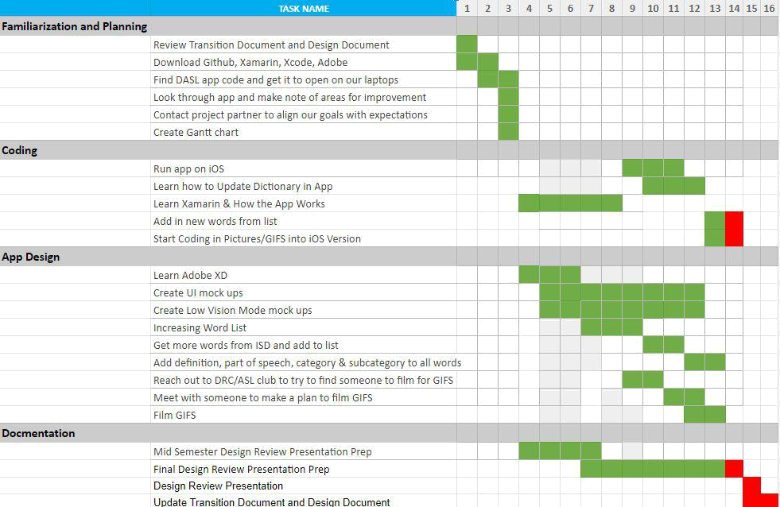

5.5 Semester Budget

No budget is currently needed.

5.6 Transition Report

Will be completed at the end of the semester

5.6.1 Summary of Semester Progress / Comparison of Actual Semester Timeline to Proposed Semester Timeline

Compare actual semester timeline to proposed semester timeline (if different). What aspects varied the most from proposed to actual?

Discuss the progress made during the current semester, including any pitfalls that you encountered that would be helpful for future teams to avoid as well as any best practices you found that helped you to advance the status of the project or work well as a team.

__________________________________________________________________________________

This semester we have been working on both the design of the app as well as the code. We have also expanded the word list, made the UI more appealing, and have created mock ups to reduced the amount of clicks to get to a word. We want there to be 3 clicks to get to a word.
On the coding side we have made a lot of progress. All fonts have been changed from Comic Sans to Helvetica. The app will now run on iOS devices, android and windows. About 70 videos of ASL sign language / fingerspelling were videotaped. These videos were then converted into GIFs. The previous semester’s team had lesson plans created where the high school students at the Indiana School of the Deaf performed ASL signs / fingerspelling for the first 100 words. Therefore we have all of those to code into the app also.

To make the videos that we filmed better - we should have done it with the background of a green screen. There was too much noise in the background of the ones that we filmed, making it hard for someone who needs low vision mode to see what signs are being done.

On the design side we have created more UIs. The new UIs have features such like a home button, sidebar menu - to reduce the amount of clicks, bigger font, more contrast between colors, and a grade level option. This new UI is optimized for younger kids viewing the app on iPads. The new user interface is laid out in a way that is easy to use and efficient. It is more aesthetically pleasing as it has even spacing between words and figures, different colors in the background vs the foreground to create a between contrast, there is also consistency with the font, alignment, colors and sizing. It is efficient to use and user friendly because the user is 3 clicks away from the word they are trying to get to - from the category to the subcategory to the word. We have also included more words in the current dictionary, we now have 257 words.
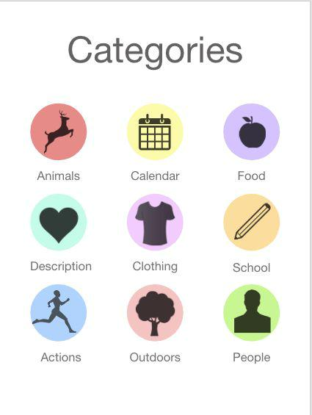
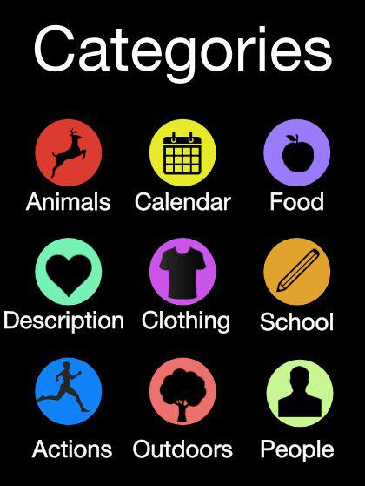

5.6.2 Draft Timeline for (next semester) and Relationship to Overall Project Timeline Based on the work completed this semester, the work left to be completed, and the overall project timeline, create a draft timeline for the following semester.

________________________________________________________________________________
Finish filing GIFs- We have filmed a few GIFs, and Stephanie has about 100 GIFs filmed. Next semester one of the goals should be to finish filming. The movie files will also need to be converted into GIFs

Code in new dictionary words. We have finished the dictionary pages for over 250 words. The next is going to be coding them into the app. We have figured out how to do this, and instructions will be inside the transition document.

Add support for images and GIFs in iOS. After getting the iOS app to open, we realized that there was no support for GIFs or images in it yet. This will be quite a difficult job on Xamarin, since GIFs are not natively supported for iOS through Xamarin.

Start updating the UI/UX- We have created a few different mockups of how we think the redesign of the app should look.

Alpha Version- The alpha version of the app should be delivered by the end of net semester. The alpha version is almost ready to go. The only thing that needs to be added still are pictures and GIFs on iOS.

Beta Version- The beta build will feature the updated user interface in the app, as well as a low vision mode. The add word feature also needs to work and be functional.

6. Current Design

Write a detailed design description of the phase the project currently is in and work done this semester by the project team.

Example:

- Rationale for design decisions.

- Design sketches/flow charts/ calculations etc.

- Include important information that your team has compiled.

- Conclusion and recommendations.

___________________________________________________________________________________________________________

2/13/19

- Rationale for design decisions :

  - One of our primary goals is to include GIFS of each word being signed within the app. This is to fulfill the needs of the kids, as the app is primarily targeted at the K-6 range. GIFS would serve as a valuable visual aid for students that are not completely familiar with ASL conventions for spelling and using phrases. Ideally, we could approach experts in ASL to build a collection of sign GIFS, minimizing errors.

  - We also want to revamp the user experience of the app, specifically through making the app’s front-end interface more aesthetically pleasing and minimalistic. Also, we

must add new pictures/icons to the app that further this design direction. Specifically, this is to serve the purpose of aiding navigation for users as well as to increase the effectiveness of the DASL as a reference guide.

  - Adding a low vision mode to the app is another objective we intend to complete. As we have learned, some students that attend ISD are hard of hearing and have problems with sight, necessitating this feature set. Low Vision Mode increases the contrast of elements in the app, removes unnecessary items on an app page, and increases the font size throughout. These changes come together to create a more readable app for those that require it.

  - Expanding the word list. Currently we have 100+ words in the app along with its definition and example sentences. We intend to add over 85 words to the app. This is to allow for greater learning opportunities for the students, as well as to potentially increase the target audience for our app from K-6.

- Design sketches​:

Improved user interface with a better aesthetic - fun colors with more descriptive pictures for the categories.

MOCK UP 1:
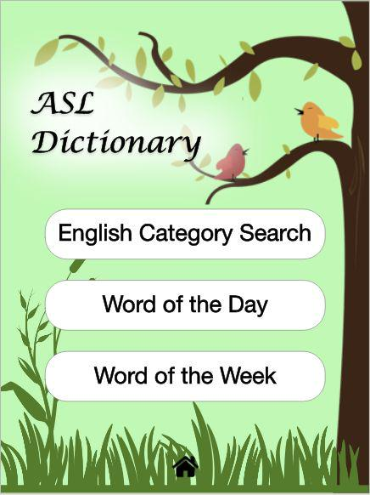

Home page based off the current design. If user clicks on categories they would navigate to page 2.

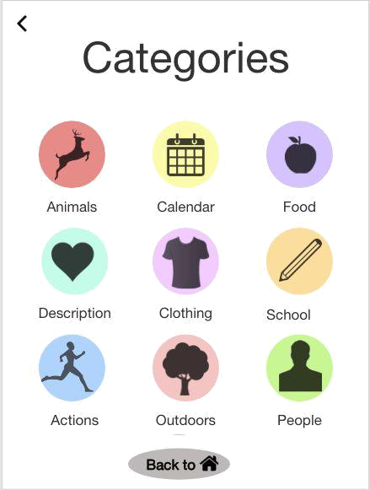

Page 2. From here the user can choose a category and navigate to page 3 sub categories, or go back to the home page using either the back to home button or the back arrow.
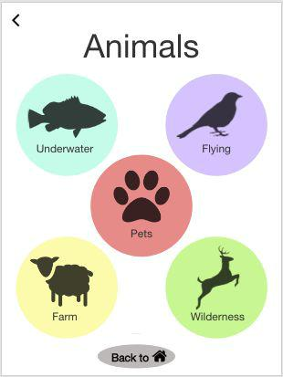

Page 3. From here the user can choose a subcategory and navigate to page 4 the list of words, go back to home using the back to home button, or go back to categories using the back arrow.

MOCK UP 2:
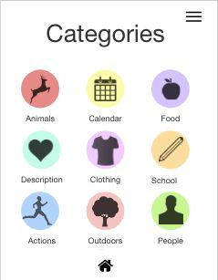

Home page. To reduce the number of clicks to definition, the category page can be the home page since this app will be most commonly used for getting to the word. From here the user can choose a category, or click the side bar menu which would bring them to page 2.
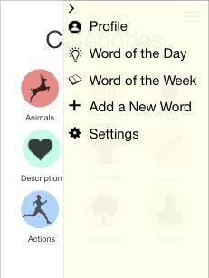

Page 2. With the side bar menu opened the user can navigate to any of these (less frequently used) pages if they do not want to navigate to a word definition. Choosing profile will bring them to page 3. Clicking the arrow will hide the side menu and show the category home page again.
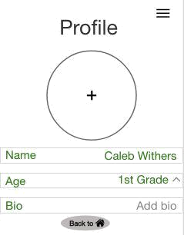

Page 3. From here the user can navigate back to category home page with the back to home button, open the side bar and navigate to any of those pages, or adjust their profile. If they click the arrow for age it will bring them to page 4.
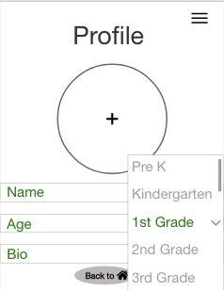

Page 4. The age menu opens and the user can see they currently have 1st grade selected but can choose a different option. Clicking an age option or the arrow again will close the menu.
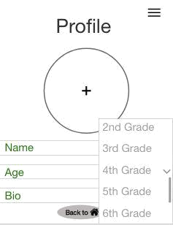

Page 5. The user can scroll through the various age options.
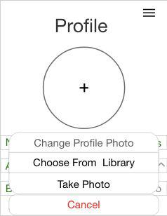

Page 6. By clicking the plus button in the circle, the user can upload a profile photo, or cancel to get rid of this menu and be back at page 3.
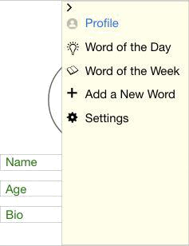

MOCK UP 3:

Low Vision Mode ​-there is a better contrast with the background and the categories. The category pictures are filled with brighter colors. The pictures are larger along with the fonts being larger.

Updated Low Vision Mode based on mid semester design review feedback - capital is easier to read
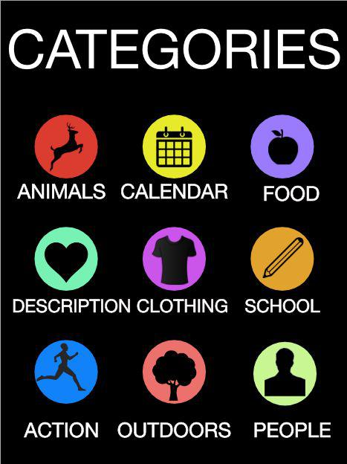

- Important and Relevant Knowledge Learned​:

People who are hard at hearing learn words differently and learn to spell differently. Therefore, adding the GIFs, the example sentences, and pictures will help them learn tremendously. They are being exposed to the word in three different ways. Also the low vision mode - some students at ISD are deaf and also have vision problems. So by adding this feature we increase the font size and the contrast between the colors.

- Conclusions:

Thus far, we have familiarized ourselves with what we expect to complete. We have seen which softwares we intend to use to complete our objectives, and begun to learn the softwares and experiment with modifying components. The largest hurdles we currently face are programming in the new user interface, and getting the app as it is currently programmed to run on simulators of mobile devices. Our immediate next steps will be to solve these two issues, continue to expand out word list, and reaching out to relevant individuals to create the signing GIFS.

At the end of the semester, one of the conclusions we reached is in regards to the programming aspect. The previous teams employed the use of the Xamarin language in an attempt to develop a cross-platform mobile solution. This solution ostensibly would run on

both the iOS and Android platforms natively, as well as a web app. What we came to learn however was that the teams focused on building out the web app before porting and testing on the mobile platforms, leading to compatibility issues and bugs that we had to combat throughout the semester. When we were given the code base, neither the Android nor the iOS versions of the app were running. By “putting too much on the plate,” we believe the previous teams may have lost sight of the original goal: a usable app for the ISD. Due to the 1:1 iPad to student ratio, we decided to refocus on iOS, and through our fixing of bugs, were able to successfully run the app on the iOS platform. This represents a milestone of progress and in the future we suggest teams to commit to staying the course on iOS development of the app in order to fully flesh out the feature set required of the ASL Dictionary App. Eventually we suggest returning to development for a cross-platform solution, as this is the ultimate goal, but only after sufficient progress is made on the iOS front.
Appendix A: Past Semester Archive

A.1 Fall 2017

Retitle this heading to reflect the appropriate semester (e.g. Spring 2011)

A.1.1 Past Team Members

Pol Francesch, Tory Ochs, Gabe Burke, Caleb Withers, Pierce Woodling

A.1.2 Past Timeline

Paste in previous semester timelines to indicate what was accomplished during this semester.
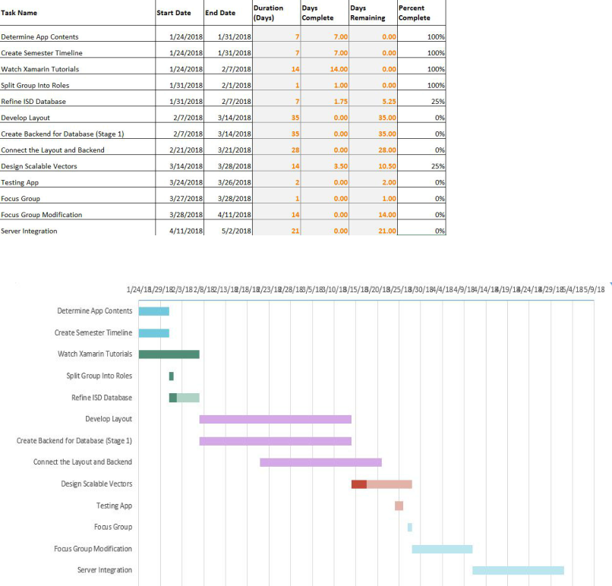

*Note:​Keep adding the information after every semester.

Appendix B: |  | Overall Project Design
B.1 | Project Identification
Phase 1: Project Identification |  |  | Status: | Evidence can be found:
Goal is to identify a specific, compelling need to be addressed
● Conduct needs assessment (if need |  |  | Completed | Section 4.2
not already defined)
● Identify stakeholders (customer, |  |  | Completed | Section 4.2
users, person maintaining project,
etc.)
● Understand the Social Context |  |  | Completed | Section 4.3 under the social context
 |  |  |  | subsection
● Define basic stakeholder |  |  | Completed | Section 4.3 in the User Needs table
requirements (objectives or goals of
projects and constraints)
● Determine time constraints of the |  |  | Completed | In Gantt Chart
project

Summary of Project Identification phase of design….

Fall 2017 marks the beginning of the DASL (Dictionary American Sign Language) project that is partnered with the Indianapolis School for the deaf. The mission of this project is to create a IOS application that functions as a dictionary for ASL and English translation. The purpose of this application is to assist the students of ISD in learning new vocabulary in English. This dictionary will also assist the school’s teachers in teaching lessons along with the immediate family members of students who can utilize the app to talk with students or help them with vocabulary. The project partner requires that the app be usable for students aged 4-12, have videos of words being signed, customizability, and be usable on iPads. Due to the needs of deaf students, the dictionary will be designed in non-standard way in order to accommodate these students. This project, when completed, will be directly delivered to ISD.
B.2 Specification Development

Phase 2: Specification Development | Status: | Evidence can be found:
Goal is to understand “what” is needed by understanding the context, stakeholders, requirements of the project, and why current solutions don’t meet need, and to develop measurable criteria in which design concepts can be evaluated.

● Understand and describe context (current | Completed | DASL Fall 2017 Sharepoint
situation and environment)
● Create stakeholder profiles
● Create mock-ups and simple prototypes: | Completed | DASL Fall 2017 Sharepoint
quick, low-cost, multiple cycles
incorporating feedback
● Develop a task analysis and define how | Completed | DASL Fall 2017 Sharepoint
users will interact with project (user
scenarios)
● Identify other solutions to similar needs | Completed | DASL Fall 2017 Sharepoint
and identify benchmark products (prior
art)
● Define customer requirements in more | Completed | DASL Fall 2017 Sharepoint
detail; get project partner approval
● Develop specifications document | Completed | DASL Fall 2017 Sharepoint
● Establish evaluation criteria | Completed | DASL Fall 2017 Sharepoint
Summary of Specification Development phase of design….

In the Specification Development phase, we searched the market for apps with a similar concept to our own. To our knowledge there is nothing on the market with a design similar to the one that we are planning on making. Along with this, patent research found that there is no patent for a app design that is similar to the one that we will be creating. Since we seem to be creating an original idea, we plan to patent our app design to ensure intellectual integrity. Along with this the specifications on the user needs have been identified and laid out so that we can begin to draw a path on how to implement these needs.
B.3 Conceptual Design

Phase 3: Conceptual Design | Status: | Evidence can be found:
Goal is to expand the design space to include as many solutions as possible. Evaluate different approaches and selecting “best” one to move forward. Exploring “how”.

● | Complete functional decomposition | Completed | Adobe Creative Design Mock up
● | Brainstorm several possible solutions | Completed | DASL Fall 2017 Sharepoint
● | Prior Artifacts Research | Completed | DASL Fall 2017 Sharepoint
● Create prototypes of multiple concepts, |  | Completed | DASL Fall 2017 Sharepoint
 | get feedback from users, refine
 | specifications
● Evaluate feasibility of potential |  | Completed | DASL Fall 2017 Sharepoint
 | solutions (proof-of-concept prototypes)
● | Choose "best" solution | Completed | DASL Fall 2017 Sharepoint

Summary of Conceptual Design phase of design….

In the Conceptual Design phase of design we created a mock-up, had a focus group, and adjusted our project from the feedback. We generated a comprehensive mock-up using Adobe Design Experience, which allowed us to walk through what the app would be able to do when it was fully functional. We also visited ISD to get a better idea of some of the differences in education between hearing based and non-hearing based schools. They were also kind of enough to provide a focus group for us, whom told us to make the app more lively so that we could attract kids of younger ages. They also specified that they liked both the hand-motions and english organizations that we provided, as they served their purpose in different situations. However, we also talked with an ASL professor at Purdue whom told us that organizing ASL by hand motions would be rather difficult, as she has been unsuccessful after ten years. With this in mind, we consulted the project partner and made the decision that at least for this semester, we would be focusing on english categories for the app.
B.4 | Detailed design
Phase 4: Detailed Design |  | Status: | Evidence can be found:
Goal is to design working prototype which meets functional specifications.
● Bottom-Up Development of component
designs
● Develop Design Specification for |  | Completed | Design Specifications document
components |  |  | (DASL Sharepoint)
● Design/analysis/evaluation of project, |  | Completed | DASL GitHub
sub-modules and/or components (freeze |  |  | ISD Focus Group Feedback
interfaces) |  |  | ISD Focus Group Feedback
 |  |  | (DASL Sharepoint)
● Design for Failure Mode Analysis
(DFMEA)
● Prototyping of project, sub-modules
and/or components
● Field test prototype/usability testing
Summary of Detailed Design phase of design….

B.5 | Delivery
Phase 5: Delivery |  | Status: | Evidence can be found:
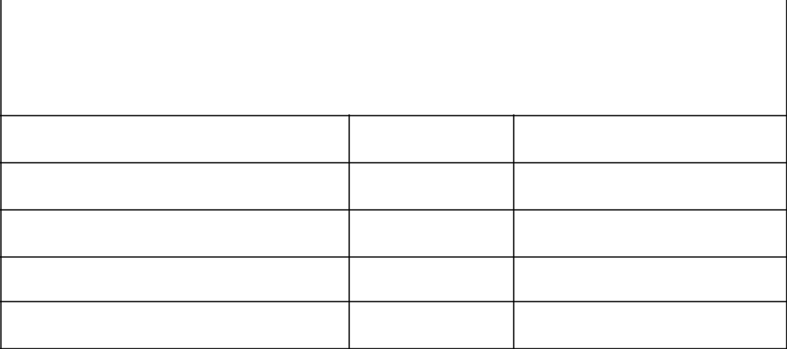
Goal is to refine detailed design so as to produce a product that is ready to be delivered! In addition, the goal is to develop user manuals and training materials.

- Complete deliverable version of project including Bill of Materials
- Complete usability and reliability testing

- Complete user manuals/training material

- Complete delivery review

- Project Partner, Advisor, and EPICS Admin Approval

Summary of Delivery phase of design….
B.6 Service / Maintenance
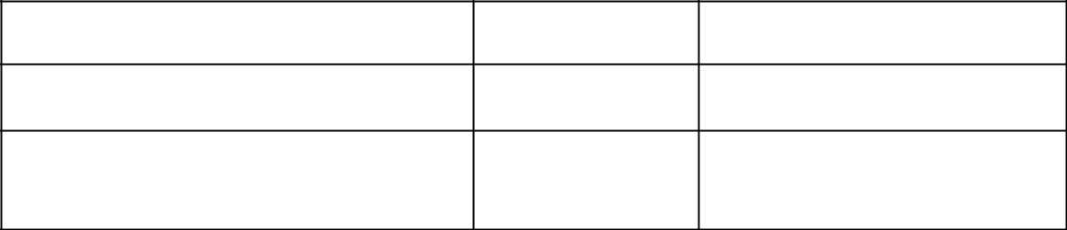

Phase 6: Service / Maintenance | Status: | Evidence can be found:

- Evaluate performance of fielded project
- Determine what resources are necessary to support and maintain the project

Summary of Service/Maintenance phase of design….

