1. 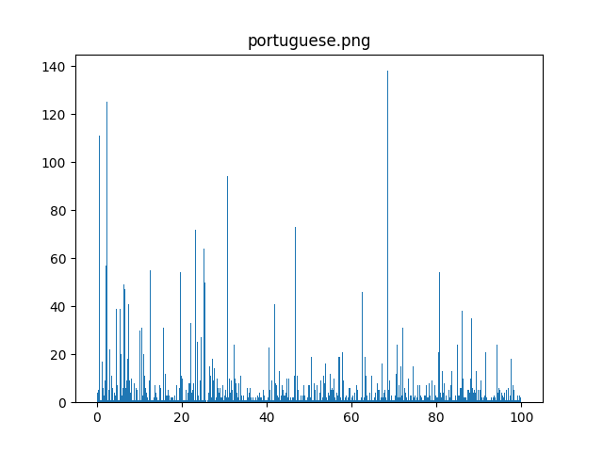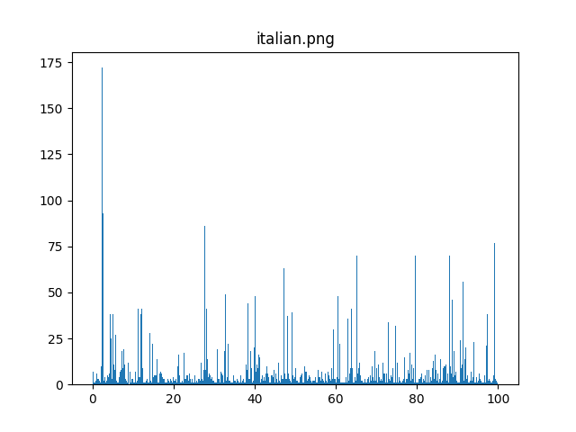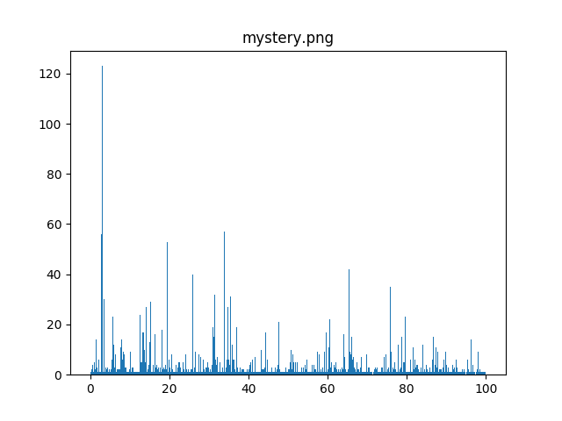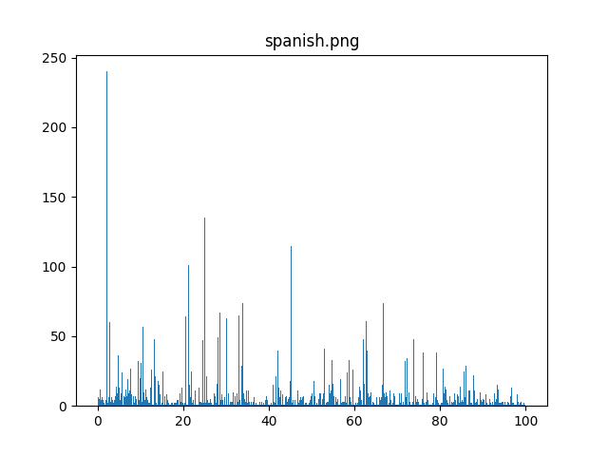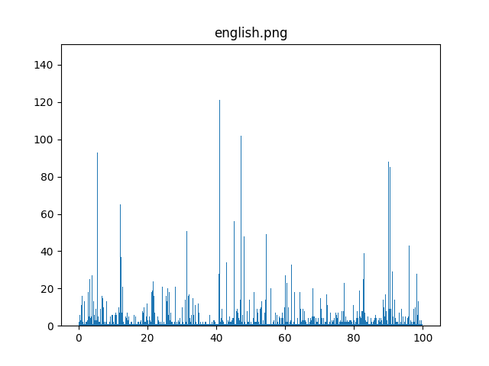Looking at these graphs the mystery text looks like it is Spanish. Some close languages to Spanish are Italian and Portuguese. However, the mystery text does not match Portuguese and while it is a little more similar to Italian the mystery bars that have more frequency match much closely to the most frequent bars in the Spanish text. 