Informal Project Description
Mediastopf

Name | Mediastopf
Contacts | Thomas Kallenberg <tkallenb@hsr.ch>  Martin Schwab <mschwab@hsr.ch>  David Tran <david.tran@hsr.ch>  Marco Birchler <m1birchl@hsr.ch>

Revisions

Version | Date | By | Comments
1.0 | 22nd Feb 2009 | Marco Birchler | First Draft

- Summary

Mediastopf is a client-server application that enables the operator to process media files in an automated way. Mediastopf will be specialised in a first step to process audio files which are imported from CD. But the program should basically have a generic structure that allows setting up handlers also for other formats.
The program makes use of an external order database which is part of a CRM system. This database contains the open orders which are ready to process with Mediastopf.

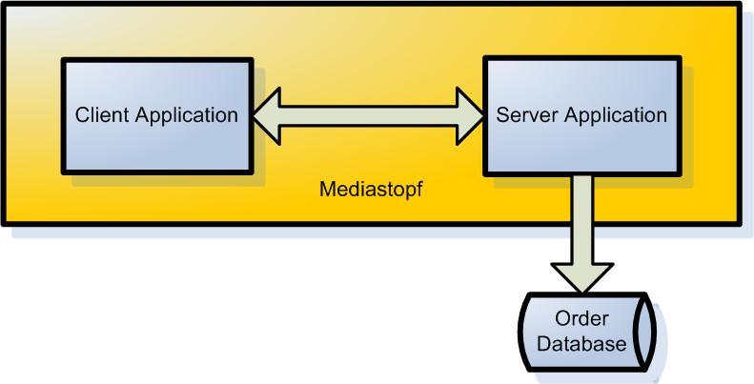
- Client Application (CD importer)

The client application does actually not very much. One thread is monitoring the local cd drives. If a new Audio CD is inserted in a drive a window like the following pops up:
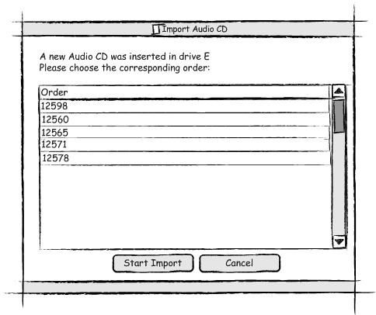
After the operator has chosen the order to which the Audio CD belongs. The client initialises the import of the audio files whit a 3rd party program. This program saves the ripped sound files on the file system. The client will then be responsible that the sound files from the imported CD are stored in a unique location and will save additional information from the imported CD. This information will later be used by the server to load more information about this CD from the internet.

- Server Application

The server application is collecting in the background all the generated media files from the clients. The operator can somehow supervise this process and should always be able to know the state of the import process: 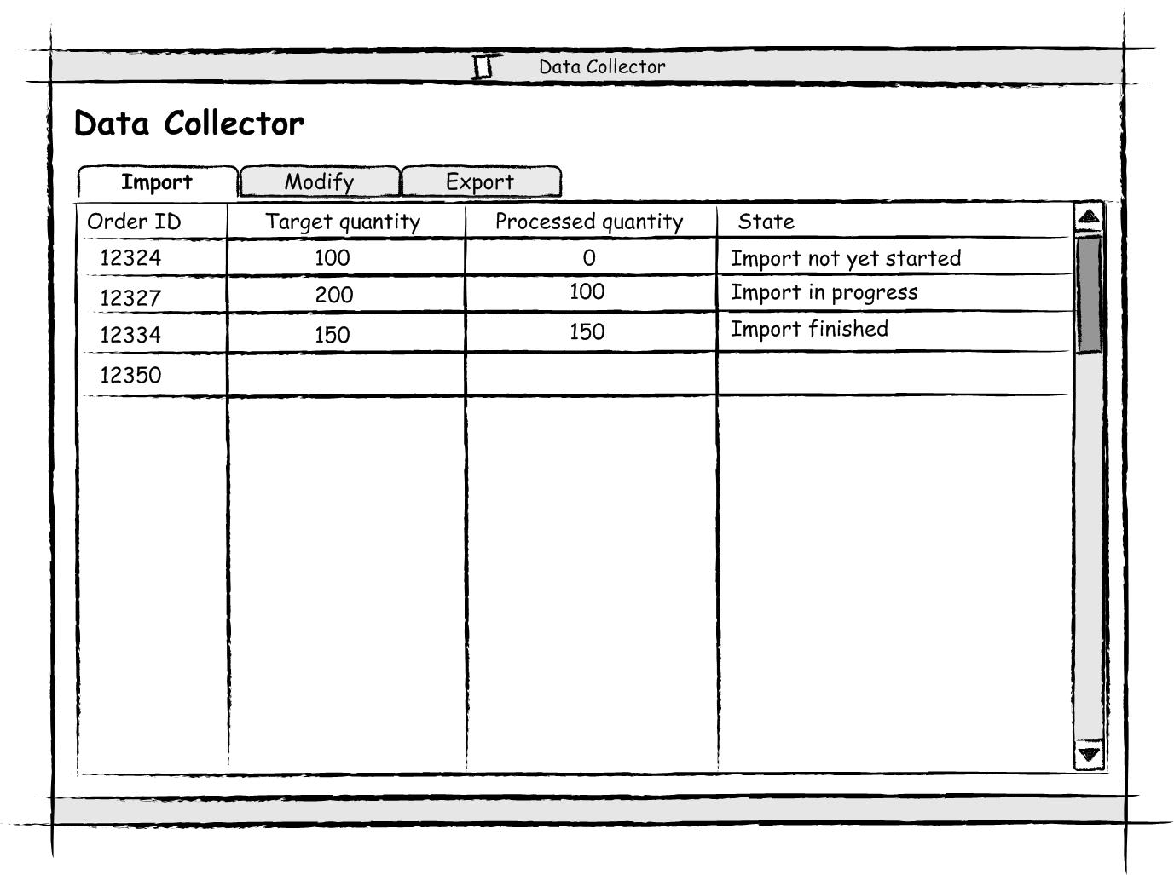

Once the server application realises that all the needed media is imported by the clients, it provides the operator with available modification steps for the media. This step is depending on the format of the media file. In our effective CD ripping tool this step will be needed to look up the CD information in an external database and find CD covers in the internet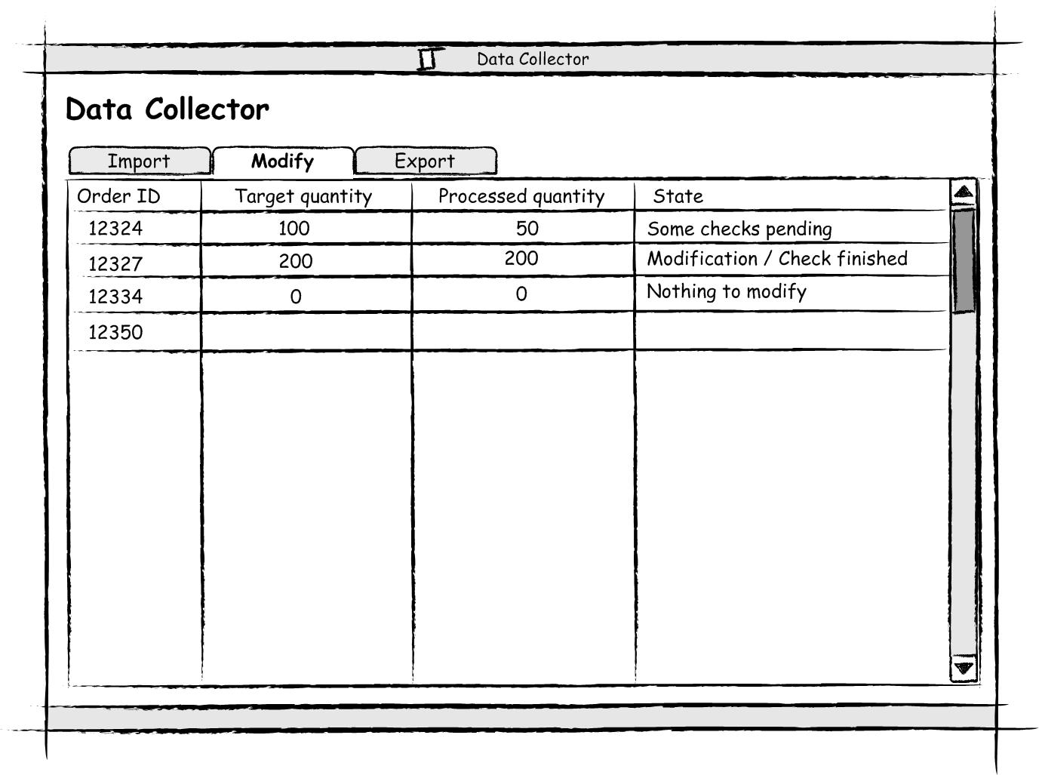
The last step which can be automated with our tool is the export function. Exporting in this context means to prepare the media files for the delivery to the customer. This will normally be done by copying the files to a connected USB hard drive or another storage device. 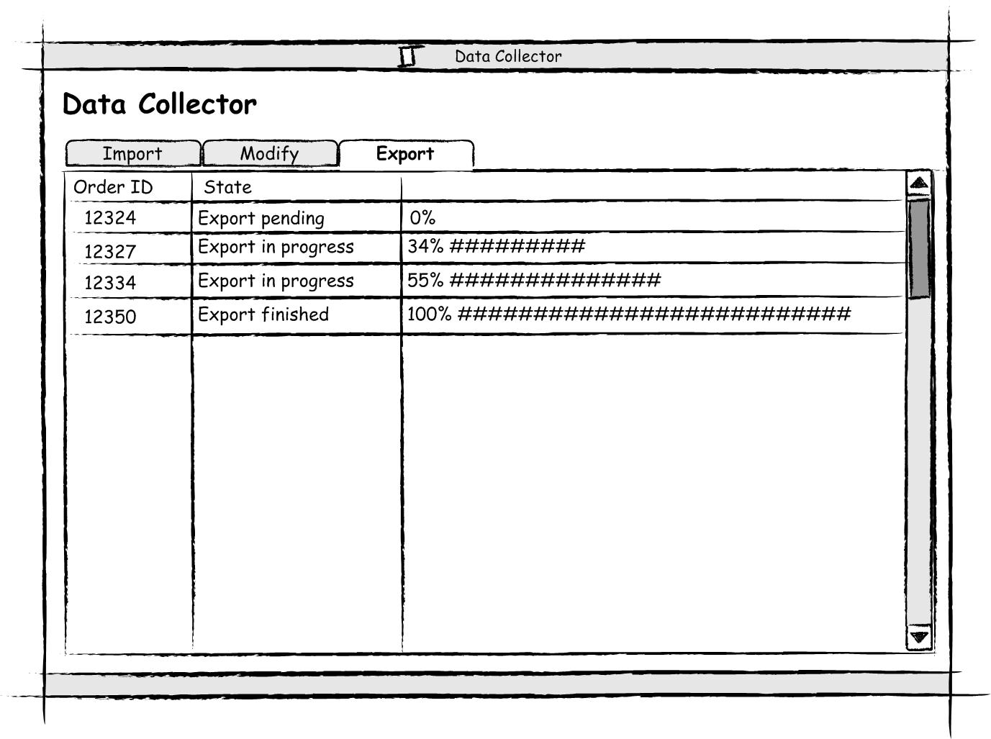
Once the export has finished the application confirm the export in the order database. Now the shipping and invoice process can be launched by the existing CRM system.

