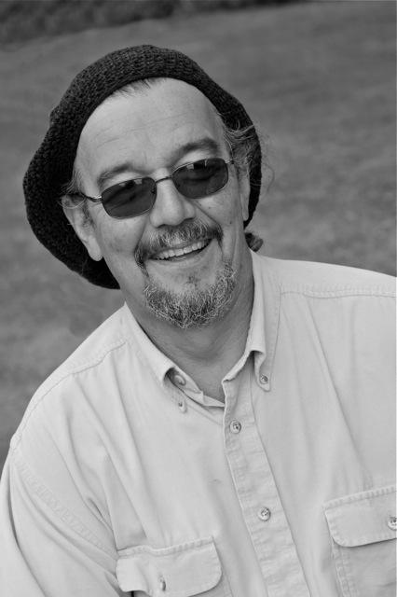
Biography: Donald B. Ivy

Donald (Don) Ivy recently retired as the Cultural Resources Program Coordinator and Tribal Historic Preservation Officer for the Coquille (pronounced “Ko-Kwel”) Tribe, headquartered in North Bend, OR, on the Southern Oregon Coast.

Mr. Ivy is a life-long Oregonian and enrolled member of the Coquille Indian Tribe. Besides his Coquille ancestry, Don’s Native heritage is Hanis and Miluk Coos on his Mother’s side; and Mississippi Choctaw-Chickasaw on his Father’s.

Mr. Ivy’s involvement with the Tribe began in 1989 as a volunteer ‘fish cooker’ at the first Restoration Celebration. Through multiple involvements in volunteer committees through the years, Mr. Ivy was appointed by the Tribal Council as the Economic Development Specialist and Self-Sufficiency Planner. From 1993-1997, he continued to live in Coos Bay and represented the Tribe in various committees, but also served other Indian groups in the Northwest, which included his role as a “Tribal Liaison” for the Portland Areas BIA Re-Organization process, and several short-term economic community development projects with Tribal Councils in Oregon and Washington.

From 1997 until 2013, Mr. Ivy served as the Cultural Resources Program Coordinator for the Coquille Tribe; work that involved extensive government to government consultation with federal and state agencies to represent Tribal heritage preservation interests. His Program also spearheaded several collaborative projects with Oregon universities and other agencies and Tribes to investigate, interpret, and protect archeological sites and cultural places in Western Oregon and elsewhere in the Pacific Northwest.

In addition to co-authoring and serving as contributor to several published reports about the archeology and historic landscapes of Oregon’s South coast, Mr. Ivy has been a consultant/teacher at many federal and state agency trainings; has made countless presentations to various public audiences about the cultural-natural history of southern Oregon; and has provided classroom teachings about traditional knowledge and technologies, ranging from Head Start children to University Graduate students. In the recent past, Mr. Ivy served as Vice-Chair of the Oregon Heritage Commission, and in spring 2013 received an Oregon Heritage Excellence Award.

Mr. Ivy lives in the Empire District of Coos Bay; in the neighborhood he grew up. He is married, likes to travel, is an avid reader; and a passionate recreational fisherman. Through his years of serving his community and extended Indian community, he learned that “cultural resources” can be any/all things held dear by humans that informs or influences their contemporary sense of social and political identity, their relationship with—and value for—the historical past, their systems of beliefs and the practices, and their relationships and interactions to the natural world. Between all this are two aspects of Indian Country: how things are perceived to be by those who are not of it; and how things are for those who are of it—or for some reason find themselves in it. The key role Mr. Ivy has played is finding ways to bring those two aspects of Indian Country to places of convergence, where each can be appreciated and respected, even if not completely understood, one to the other.

RSVP History Lecture Series, Coos bay Public Library History Lecture Series, Port of Bandon History Lecture Series, South Coast Striders Natural-Cultural History Hikes, Elder Hostel South Coast Cultural-Natural History Program, Port Orford Public Library History Lecture Series

