Budget Change Entry Instructions

- Budget change rule codes allow units to adjust their budgets on all unrestricted funds only (see attached “Funds at a Glance”). The budget change must balance by fund.
- Budget change entry uses the same Banner screen as a regular JV: FGAJVCD.
- One rule code is for permanent budget changes (1DP_) and one is for temporary budget changes (1DT_). Do NOT USE A MIX of Perm and Temp on any budget change!
- Use Journal Type “1DP_” for permanent budget changes, i.e., changes that will be included in beginning budget and in subsequent years. Use Journal Type “1DT_” for temporary budget changes, i.e., changes that will NOT be included in beginning budget and therefore will only affect the current fiscal year.
- Instead of using debits and credits, budget entries use pluses (+) and minuses (-). A plus (+) indicates that the budget will be increased and a minus (-) indicates that the budget will be decreased.
- The dollar value of pluses must equal the dollar value of minuses.
- NO revenue account codes (0xxxx) may be used
For example, you are setting up a new index and wish to create a budget of $5,000 revenue and $5,000 expense. You are, therefore, increasing (+) both your revenue and your expense budget which results in an unbalanced budget change. If you need to budget revenue, please send the budget change to your financial analyst.
- Only numeric operating ledger (OPAL) account codes may be used.
- NO PENNIES. Please use standard rounding convention to the nearest dollar.
- The Budget Period field is required and follows the normal FIS paradigm: Jul = 01, Aug = 02, etc.
- Budget changes for restricted funds, those that require a change to a revenue budget, and most fund transfers must still be sent to BRP for processing.
How to Process a Budget Change (BC)
You begin a budget change in the same way you do a JV: at FGAJVCD (or FGAJVCQ)
Use the Page down command to get an auto-fill Document Number
1. Enter the Transaction Date that matches the open period you want the BC to be in
2. Enter the Document Total
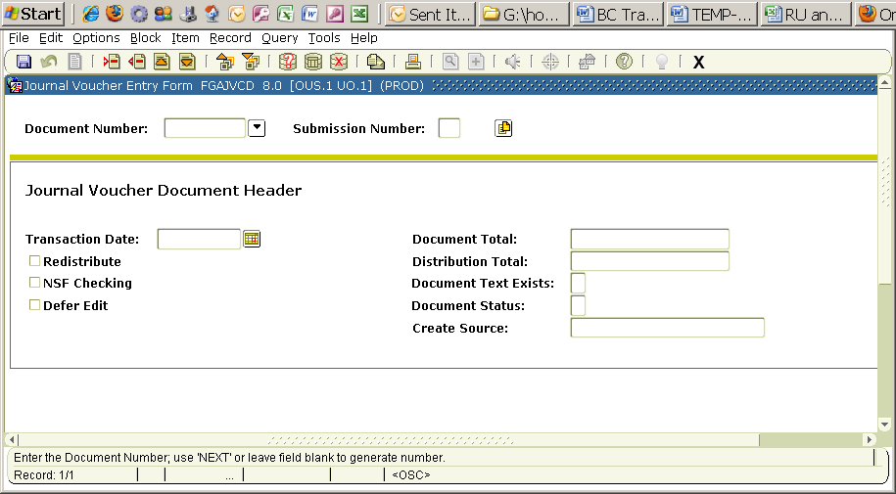
3. Use “Options” to get to Document Text .
4. Record the purpose of the Budget Change, along with your name and phone extension.
5. Save and
6. exit
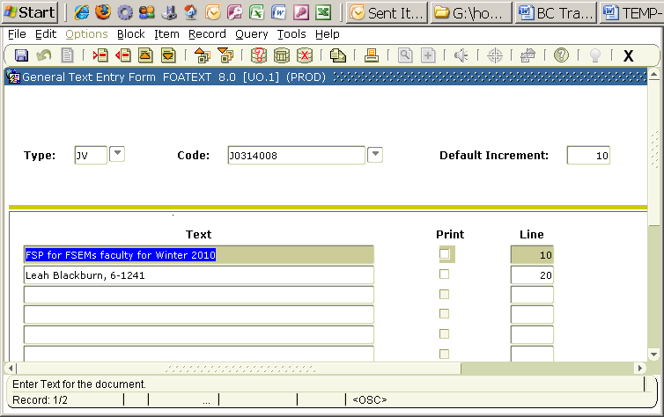
7. Now go to Options and select “Transaction Detail Info”
Once in the screen, enter information where indicated, similar to a JV except D/C is now +/- and you must enter a Budget Period. The Journal Type is the same as a Rule code. You may view all rule codes by clicking the down arrow key next to Journal Type (insert).
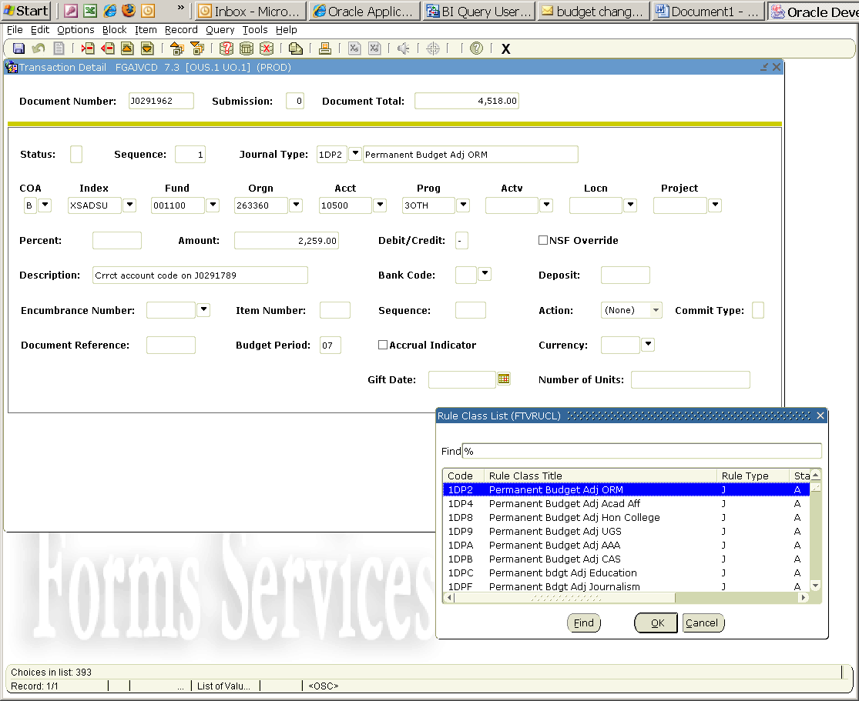
Once all of your entries are in, you should view them for accuracy using the FGIJSUM screen.
Go to “Options” again, and this time select “Access Transactions Summary Info”. You will get the screen shown on the next page. (note: the sample below does not match the transaction above, but is representative of the information on the FGIJSUM screen)

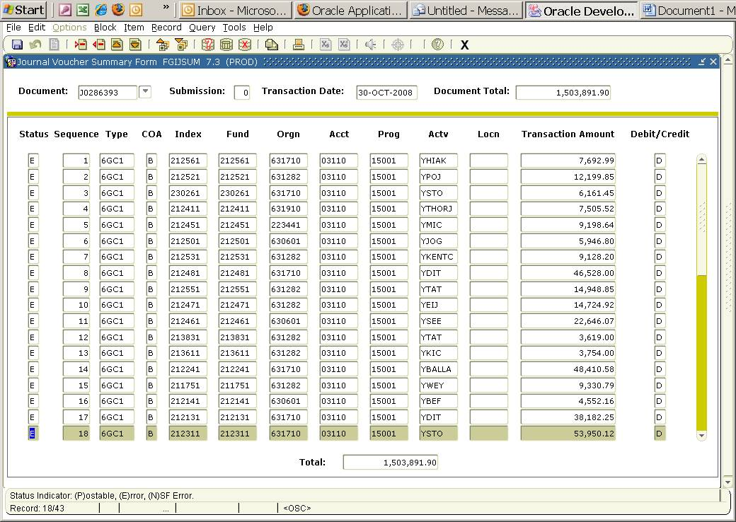
This screen provides you the opportunity to double-check your entries. This is the best screen to print if you wish to keep a hard copy of your transaction.
Pay special attention to the Document Total (8) at the top of the screen (which you entered at the beginning of the budget change) and the Total (9) listed at the bottom. The numbers should be exactly the same.
If they are not, check the entries to find where the input error was made, then Exit this screen to return to the Transaction Detail Screen and make the correction.
If the error was in the Document Total (8), Exit FGIJSUM and use Previous Block commands to return to the FGAJVCD starting screen to make your correction.
Once you have ensured that everything is correct and balanced (and if desired, have printed the document from FGIJSUM), Exit to leave FGIJSUM and return to the Transaction Detail Screen.
10. Go to Options and select Access Completion. A smaller insert screen will appear.

11. Select “Complete”.

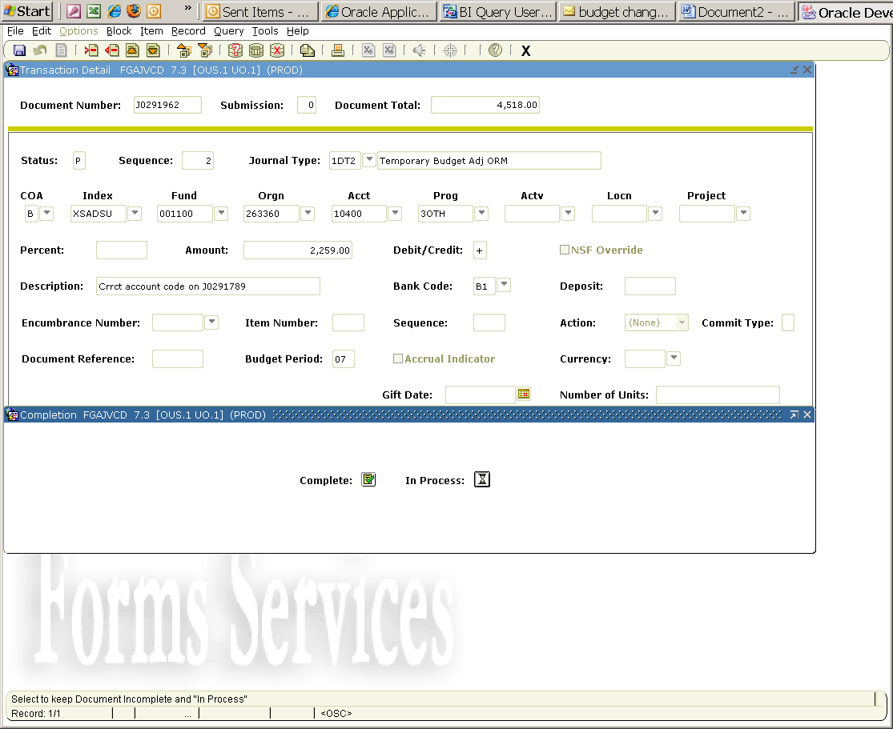
The system will inform you that the BC is complete and forwarded to the reviewal process.
You’re done!
Most budget changes will appear in FIS within the hour unless they have been directed to a queue for further review or if Banner is being used heavily (e.g., during registration).

