**Faculty and OA Salary Increases November 2016**

**Deadline to submit salary increase recommendations: November 17th**

Please refer to <http://hr.uoregon.edu/employee-labor-relations/annual-salary-increases> for information provided by the Office of the Provost and Academic Affairs and Human Resources.

There are two salary increases that will take effect January 1, 2017:

* Across the Board - All faculty members with an appointment in FY 17 are eligible for a 0.75% across-the-board salary increase. This is displayed for your information in the salary increase application.
* Merit Pools
  + For OAs: As noted in the October 10, 2016 memo, CAS will submit the merit increase recommendations for OAs.
  + For faculty: Unit merit funds are distributed to departments and programs. Two merit pools are available: one for TTF and one for career NTTF. Each merit pool is equal to 2.25% of base salary, prorated for FTE. The TTF and NTTF pools cannot be combined; they must be used for the intended employee classification.

Units will provide their faculty merit increase recommendations to CAS via the CASweb application found here: <https://cas-cc-app01.uoregon.edu/secure/salaryincrease/> (or navigate to CASweb 🡪 Reports and Tools 🡪 Salary Increase Tool for 1/1/17 Increases).

Instructions for the tool begin on the next page.

**CAS Timeline/Deadline:**

**November 4th** – Deadline for unit requests to update employee data

**November 10th** – Employee lists available in CASweb application.

**November 10th – November 17th –** Units enter proposed faculty merit increases in the CASweb application.

**Salary Increase Application Instructions**

1. Navigate to the web salary increase application located here: <https://cas-cc-app01.uoregon.edu/secure/salaryincrease/> (or CASweb 🡪 Reports and Tools 🡪 Salary Increase Tool for 1/1/17 Increases).
2. If prompted, log in using your Duck ID.  
      
   **Notes:**

* **You will be automatically shut out of the website after 20 minutes of inactivity.**
* **To use the application off campus, you must use the UO VPN.**

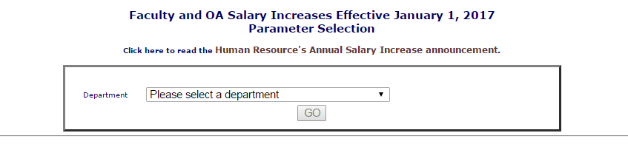

Select your Department or Program and wait for a couple seconds for the options to appear. Select the faculty type you would like to work on and click Go.

* Select the Create Excel Workbook option if you would like to work with the data in Excel before entering it in the application.

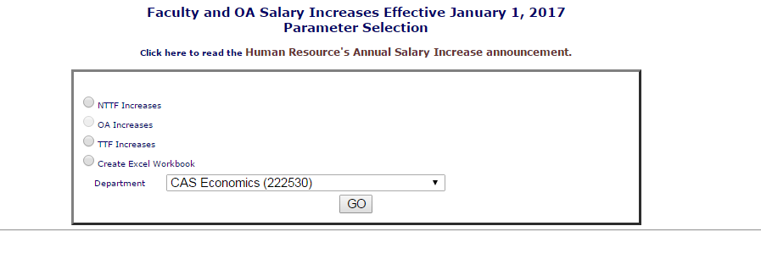

1. In the box at the top of the web page, “Allocation” is equal to the sum of the salaries listed, multiplied by the 2.25% merit pool rate. You may distribute up to this amount to meritorious employees. In order to enter an amount, you must click the “meets expectations” box. This indicates that the faculty member meets expectations, based on reviewed performance.

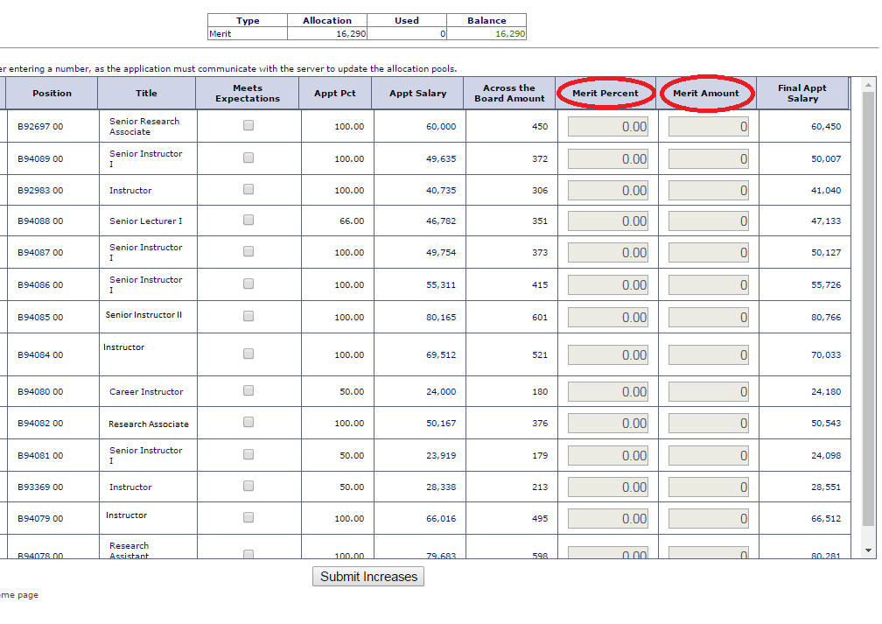

1. You may choose to enter the employee’s merit increase either as a percentage of their Appt Salary OR as a specific dollar amount. To give an employee a 1.25% merit increase, enter 1.25 in the “Merit Percent” column. The “Merit Amount” will then be calculated for you. If you choose to enter a dollar amount for the merit increase in the “Merit Amount” column, the “Merit Percent” will be calculated for you.
2. As you enter your increases, the increase “Used” field at the top of the page will keep a running total of the amount of the pool allocation you have used, and the “Balance” column will display the amount of the pool that remains to be allocated.

If the “Balance” becomes a red number in parentheses, you have exceeded your allocation. You will need to adjust your increase awards until the “Balance” is zero.

1. When you have finished entering your increase percentages/amounts for all eligible employees, click “Submit Increases” at the bottom of the page.

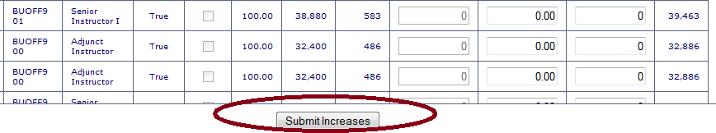

1. If you have exceeded your allocation, you will receive an error message, and you will need to make adjustments.
2. Click on “Return to the Salary Increase home page” at the bottom of the page and repeat this process for each employee group in your Department or Program.
3. After you have entered and submitted the proposed merit increases for your NTTF and TTF, return to the Salary Increase home page and select Create Document for Department Head or Director Signature. Click “Go,” then “Create Word Document.” View and print the file, obtain the department head or program director signature, and submit the signed document to the CAS Dean’s Office.