**Unclassified Salary Increases July 2013**

**Deadline to submit salary increase recommendations: June 7th**

There are two components to the salary increase that will be effective July 1, 2013 – an Across the Board Amount and a Merit Increase:

* Across the Board Amount – All Officers of Administration (OAs) and **Unrepresented** Faculty who were employed on or before 12/31/12 will receive a 1.5% Across the Board Amount, effective July 1, 2013. Unrepresented Faculty who began employment on or before June 30, 2012 will also receive a 1.5% Across the Board Amount, retroactively effective as of January 1, 2013. The current annual rate set forth in the salary increase application for each Unrepresented Faculty member already reflects the January 1st Across the Board Amount. The amount of the July 1, 2013 Across the Board Amount will be separately displayed in the salary increase application for your information.
* Merit Increase – All OAs and **Unrepresented** Faculty are eligible for merit increases, effective July 1, 2013, except those whose contracts state otherwise. Each Department has been allocated 2% of the sum of the annual base salaries for its **eligible** OAs and Faculty to allocate as merit increases. Departments may allocate these funds to eligible employees, by category, in any amount they see fit, subject to approval by the Dean and the Provost. You will enter these merit increases in the online application – the instructions as to how to do so are set forth below. Please refer to communications from CAS regarding the evaluation materials that must be submitted to the Dean’s Office in connection with your merit increases.

**Salary Increase Application Instructions**

1. Navigate to the CASweb salary increase application, located on the CASweb home page and entitled “Unclassified Salary Increase July 2013”.

2. Select your Department or Program.

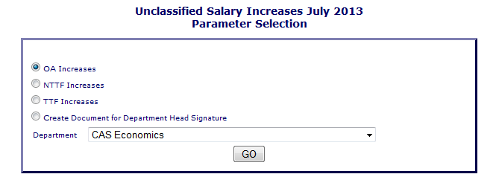

3. Select either “OA Increases,” “NTTF Increases,” or “TTF increases”. Click Go.

|  |  |
| --- | --- |
|  |  |
|  | |

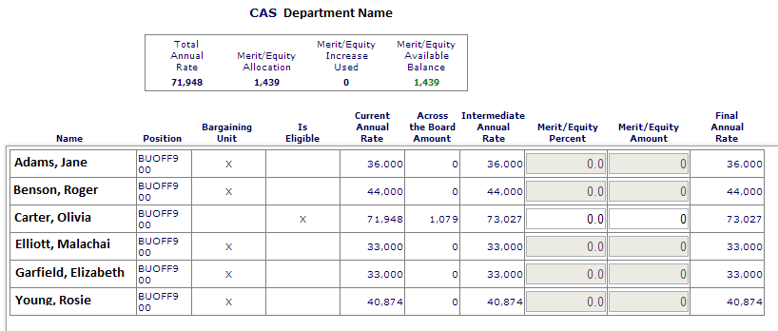

4. In the box at the top of the page, “Total Annual Rate” is equal to the sum of the annual salary rates for all of your **eligible** employees in the category selected. You may distribute up to the “Merit/Equity Allocation” amount to these eligible employees. This amount is equal to 2% of the “Total Annual Rate.”

5. Employees who are eligible to receive a Merit Increase are indicated with an “X” in the “Is Eligible” column. In this example, Olivia Carter is the only employee eligible for a merit increase. Most of your faculty are not likely to be eligible for a merit increase, as most faculty are members of the bargaining unit. Most of your OAs are likely to be eligible for a merit increase.

6. You may choose to enter the employee’s merit increase either as a percentage of their Current Annual Rate OR as a specific dollar amount. To give an employee a 1.25% merit increase, enter 1.25 in the “Merit/Equity Percent” column. The “Merit/Equity Amount” will then be calculated for you. If you choose to enter a dollar amount for the merit increase in the “Merit/Equity Amount” column, the “Merit/Equity Percent” will be calculated for you.

* You do not have to give every eligible employee a merit increase, and you may give individual increases in excess of 2%, so long as the sum of all of your merit increases does not exceed the amount of your “Merit/Equity Allocation”. Any proposed increase above 10% (including the Across the Board component) must be supported with a brief narrative justification based on Department or Program criteria. Such increases will need to be individually approved by the Provost.

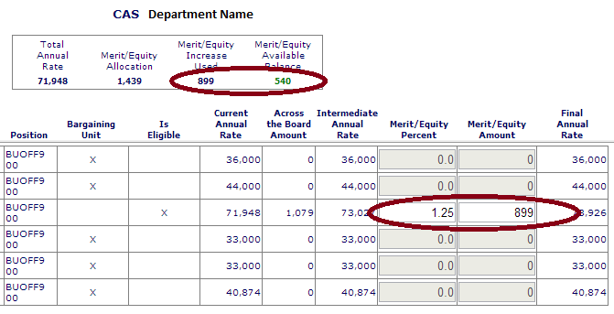

7. As you enter your merit increases, the “Merit/Equity Increase Used” will keep a running total of the amount of the 2% pool you have used, and the “Merit/Equity Available Balance” will display the amount of the pool that remains to be allocated. There is no advantage to your Department or Program not to allocate the full 2%.

If the “Merit/Equity Available Balance” becomes a red number in parentheses, you will have exceeded your 2% allocation. You will need to adjust your increase awards until the “Merit/Equity Available Balance” is green or zero.

8. When you have finished entering your merit increase percentages/amounts for all eligible employees, click “Submit” at the bottom of the page.

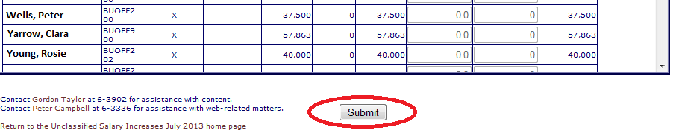

9. If you have exceeded your 2% allocation you will receive an error message “You have exceeded your allocation; please correct. Submit failed”. Please make the necessary adjustments to your merit increase percentages/amounts and click “Submit” again.

10. Click on “Return to the Unclassified Salary Increases July 2013 home page” and repeat this process for each employee group in your Department or Program.

11. Once you have entered and submitted merit increases for all of your employee groups, select “Create Document for Department Head Signature” , click “create word document”, print and obtain the Department or Program Head’s signature and submit to the Dean’s Office.