# TENURE RELATED FACULTY REVIEWS

This document contains many important details concerning reviews for tenure related faculty.   The information you need for reviews is all conveniently located on CAS Web. This document should help you quickly and easily access these resources. You are encouraged to read it carefully.

By October 1, you should consult CAS web <https://casweb.uoregon.edu/> to determine which tenure related faculty are due for various reviews: annual or contract renewal reviews for untenured faculty and 3rd or 6th year Post Tenure Reviews for tenured faculty.

You can access this information by going to the “Reports” link in the left hand column called CASweb resources

. 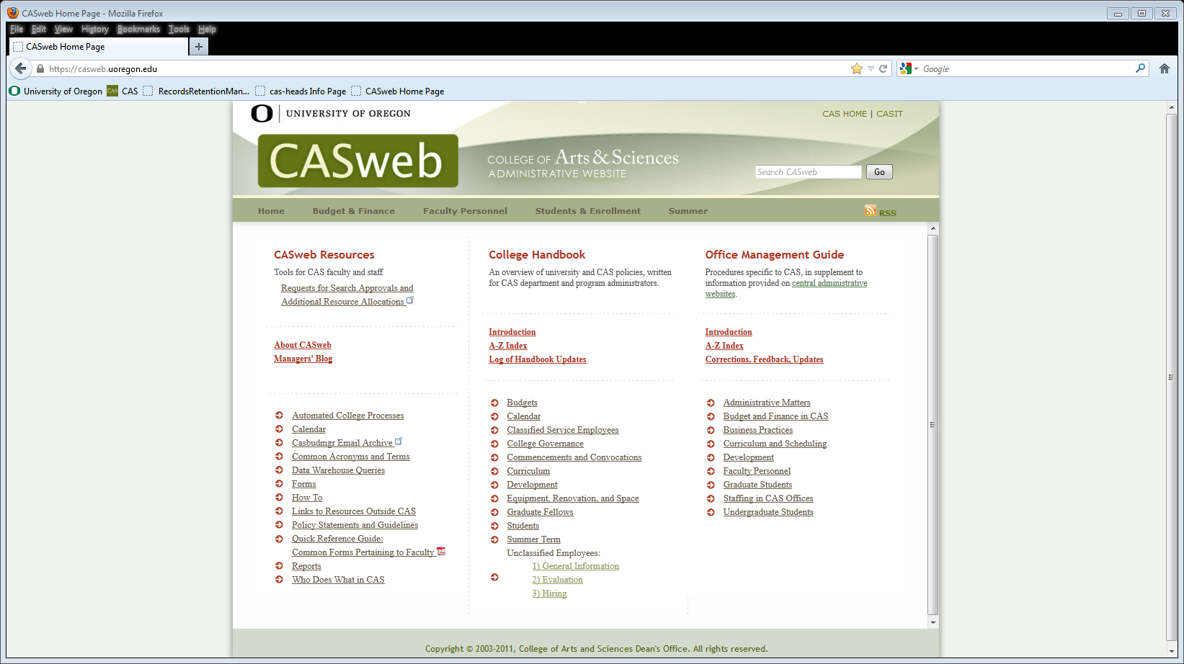

After clicking on Reports, then go to the “Review Schedules for Tenure Related Faculty” which

is under the Faculty heading.

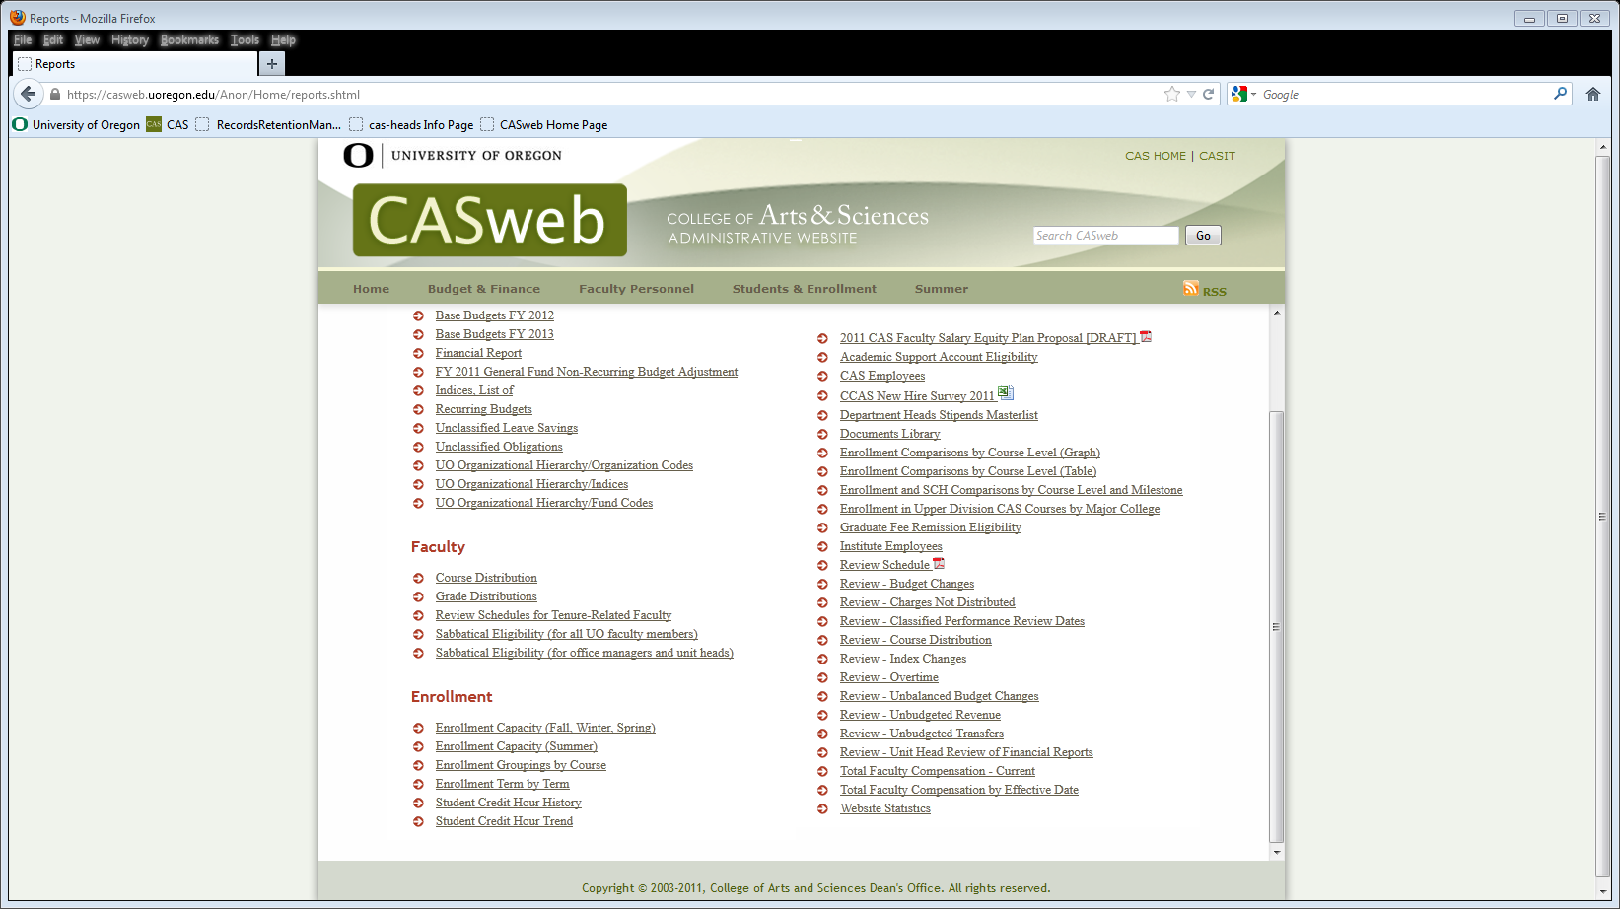

When you go to this link you will be prompted to enter your user name & DUCK ID password.   Please note that your Duck ID user name and password are the ones you use to log in to get your UO e-mail. If you have problems with your Duck user name & ID, please contact Central IT’s Help Desk at 6-4357.

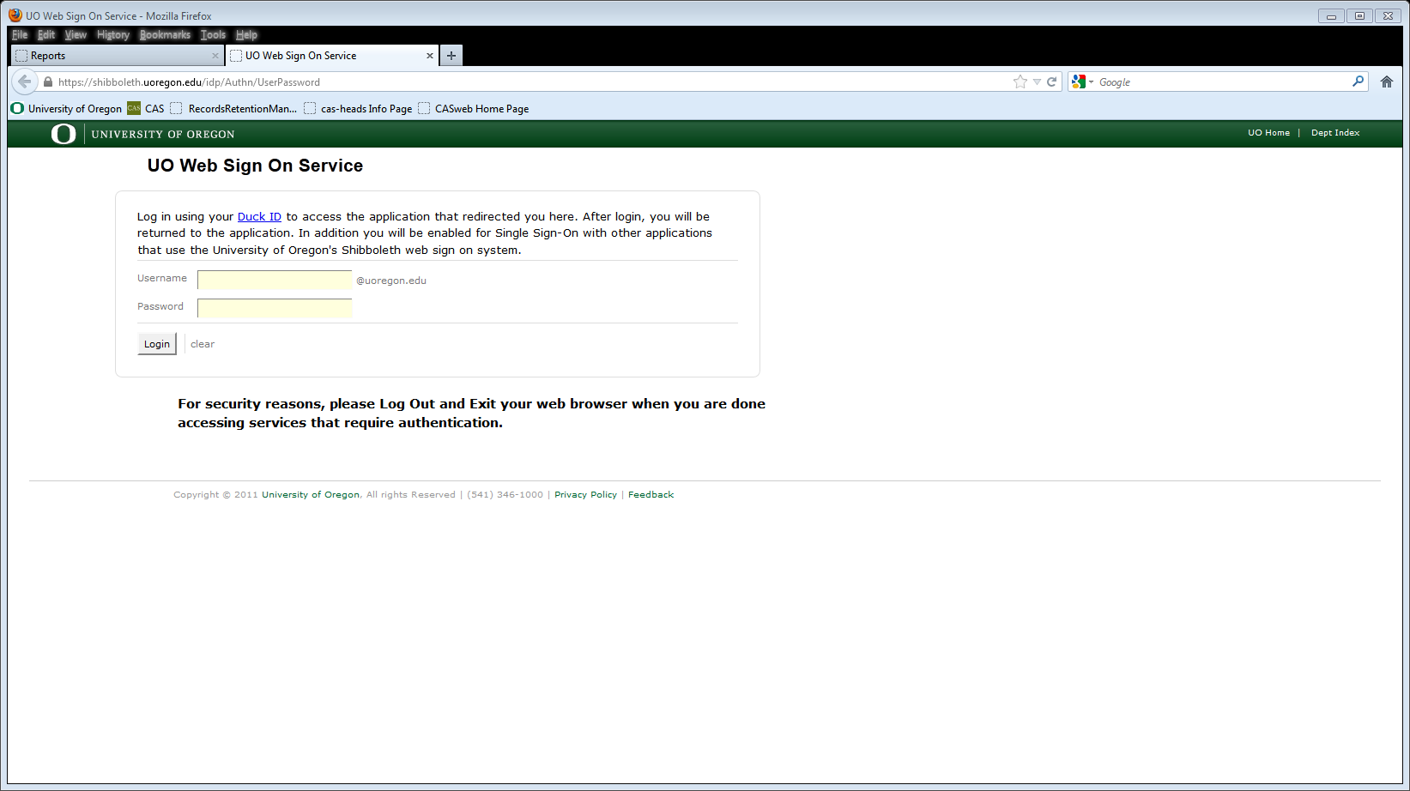

Once you’ve logged in you will then see two links. One for tenure-related faculty reviews by department and the other for tenure-related faculty review by review type.

Please note the following:

* Future scheduled review dates may change pending changes in faculty status such as promotion to full professor or leaves without pay.
* Faculty members whose files will be submitted in the Fall for promotion to Full Professor may appear on a 3rd or 6th year PTR list.   The promotion review takes precedence and you do not need to submit a post tenure review.
* Untenured faculty members coming forward for tenure in advance of the required tenure date, may appear on a list for annual or contract renewal date; the tenure process takes precedence and you do not need to do any other review.

Heads are responsible for completing all reviews listed in the 2013/14 column by the Spring 2014 deadlines.   For AY 2013-14 deadlines are as follows:

Contract renewal reviews: Thursday, April 10, 2014

Post tenure reviews: Tuesday, April 15, 2014

Annual reviews: Thursday, May 1, 2014

Other things to be aware of:

* An asterisk (*) next to the faculty member’s name denotes that the faculty member has a joint appointment and must be reviewed by multiple departments.   The *primary* department assumes responsibility for initiating the review.

* A hash mark (#) next to the faculty name is used to identify administrators (department heads, program directors, associate deans, etc), if that symbol appears, please refer to the posted CAS policy for [Review of Faculty who hold Current or recent Administrative Appointments](https://casweb.uoregon.edu/anon/displaypdf/display.aspx?DocNr=17).

* Full professors and tenured senior instructors who are due for a 6th year Post Tenure Review, ***and therefore eligible for a salary increase***, are listed in **bold** font.

Also note that for 6th year Post Tenure Reviews, UO legislation states that the faculty member to be reviewed will be notified of review **no later than October 15th**.    **Department Heads and Program directors are responsible for notifying affected faculty of scheduled reviews.**

* In the event that adjustments to the schedule are needed please consult with your Associate Dean.

Additional information the CAS policies for Post-Tenure Review of Administrative Faculty and Post-Tenure Review Salary Increases can be found in the Alphabetical list of  CAS policies and guidelines:  <https://casweb.uoregon.edu/anon/home/policiesalpha.shtml>

The UO Post-Tenure Review Policy can be found on the UO website at:  <http://policies.uoregon.edu/policy/by/1/03000-human-resources/post-tenure-review>

For problems or questions concerning contract renewal reviews, please contact Anna Puhn at 6-4441.     For question concerning annual and post tenure reviews please contact Miriam Bolton at 6-3285.