July 24, 2015

TO: Deans, Department Heads, Executive Assistants, and support staff

FROM: Ken Doxsee, Vice Provost for Academic Affairs

Subject: Digital promotion and/or tenure dossiers and supplemental material files for TTF and NTTF

Following successful pilot studies, we have moved to full digital submission for all promotion and/or tenure cases, for both tenure-track (TTF) and non-tenure-track faculty (NTTF). To support preparation of digital dossiers, we have created PDF portfolios – one for TTF and one for NTTF – for the primary dossier, containing several “fillable” forms and the various dossier sections to which the appropriate files may easily be added. We have also created a PDF portfolio for the supplementary file; this file may be used for both TTF and NTTF cases. Given the range of supplementary materials typically provided, this portfolio in essence provides a table of contents behind which documents may be uploaded. Recognizing that some materials may not be conveniently available in digital form, provision of some or all supplementary materials in print form is still permissible.

For planning purposes, it is important for Academic Affairs to have solid information about the number and type of promotion cases it may anticipate. We will typically request this information from each school or college by early in the summer term and will respond by providing the digital dossier portfolios by email. (Units not represented by an academic dean should notify Academic Affairs of anticipated promotion cases and request the digital portfolios.) When dossiers are ready to move to Academic Affairs, we ask that they be provided on a USB thumb drive, delivered in person to Johnson Hall and accompanied by any hard-copy supplementary materials.

The process for constructing a digital promotion dossier is simple, requiring only Adobe Acrobat Pro, which is available at no charge through a UO site license. The digital dossier contains all the tabbed sections of the paper version with which many of you are familiar. The checklist and voting summary can and should be filled out in this document. For each remaining section of the file, simply open the desired section, then add the desired file(s). If a section is not applicable for the specific case being prepared, please add below that section header a page containing the notation "Not Applicable." Please also complete the teaching evaluation checklist (provided under the Teaching Evaluations section header) and include the appropriate materials in the primary and/or supplementary files.

Please note that your experience may vary somewhat depending on your computer operating system and on the version of Adobe Acrobat Pro with which you are working. If you have questions or difficulties, please feel free to contact Ken Doxsee (6-2846; [doxsee@uoregon.edu](mailto:doxsee@uoregon.edu)).

The additional details and screen shots on the following pages may be helpful.

**Creating a digital promotion (and/or tenure) dossier**

* Obtain the digital dossier portfolios (TTF, NTTF, Supplementary file) from Academic Affairs.
* Make a copy of the desired PDF portfolio and name it with the name of the candidate (e.g., Doxsee, Kenneth), then open it. You should see a screen similar to this:

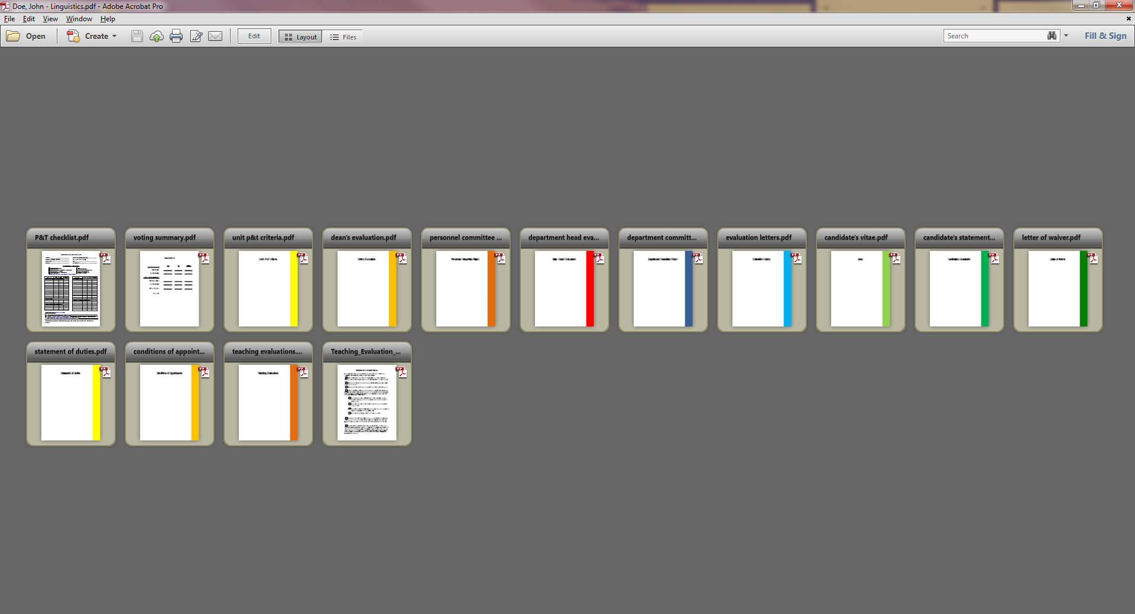

* 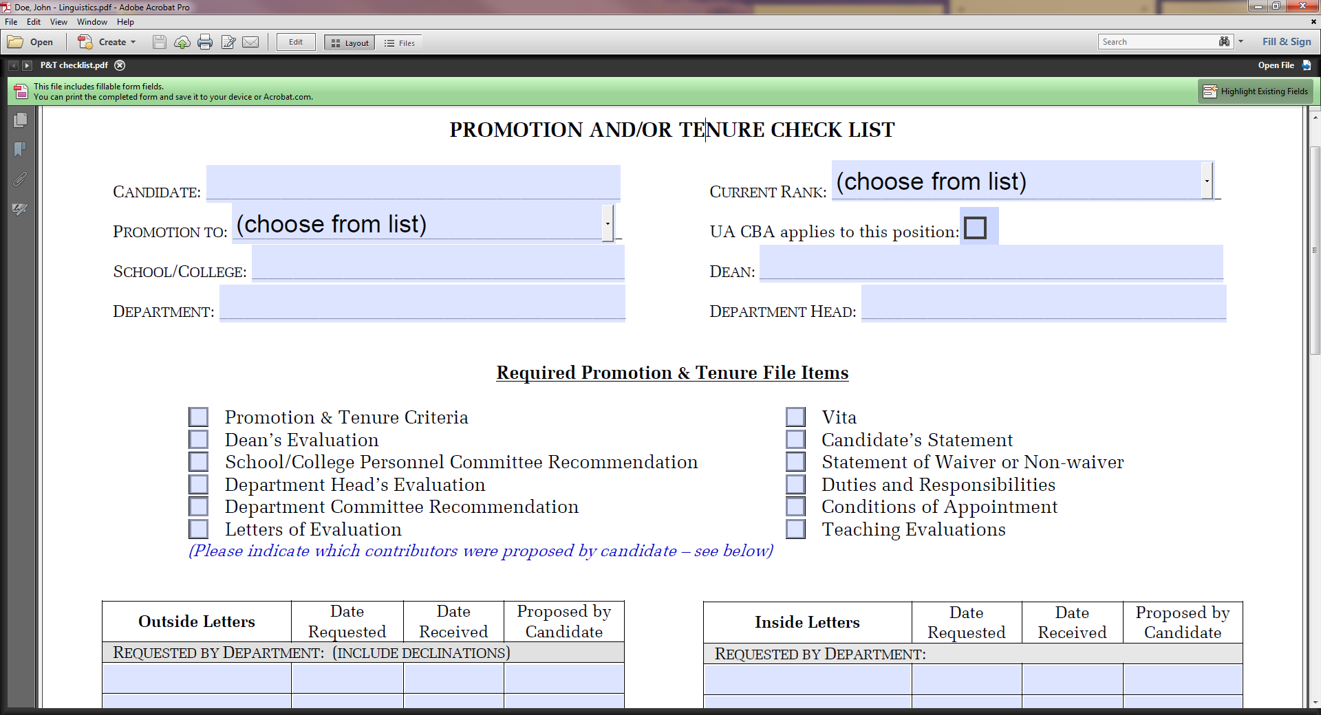Double click on the P&T Check List pdf icon, indicated above by the blue arrow. With some systems this will directly open a fillable form, but others will simply display a larger version of the document. If the latter happens, look for the “Open File” button (usually upper right) and click it; the fillable form should open.
* Provide the requested information, then save. If your system did not open the fillable PDF directly in the previous step, you can simply close the form when it is completed, then save the document. And, if your system says it cannot save the document because it is already open, close the computer window displaying the file, then try saving again. (You can blame Microsoft and Adobe for not playing nicely together for this operational gem.)
* Navigate to the next page of the dossier, the Voting Summary.

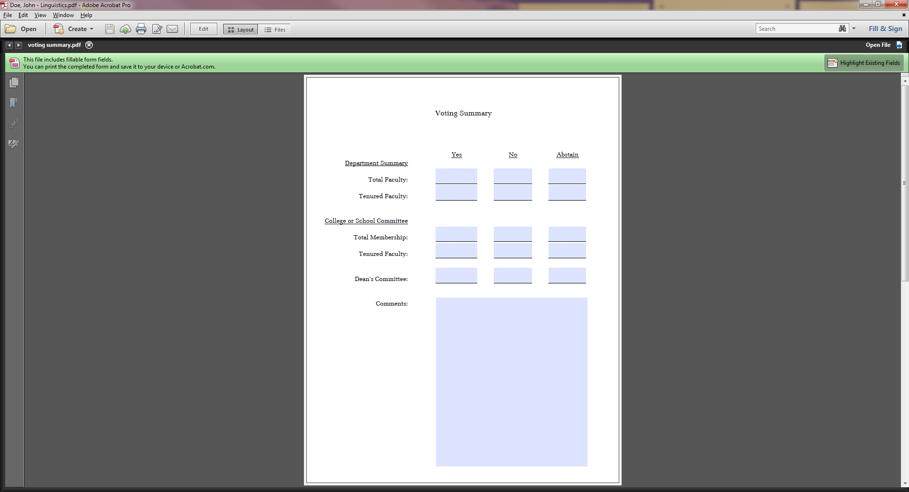

* The Voting Summary is also a fillable form and should be updated when information is received, and then saved.
* Navigate to the next section, the Unit’s P&T Criteria section.

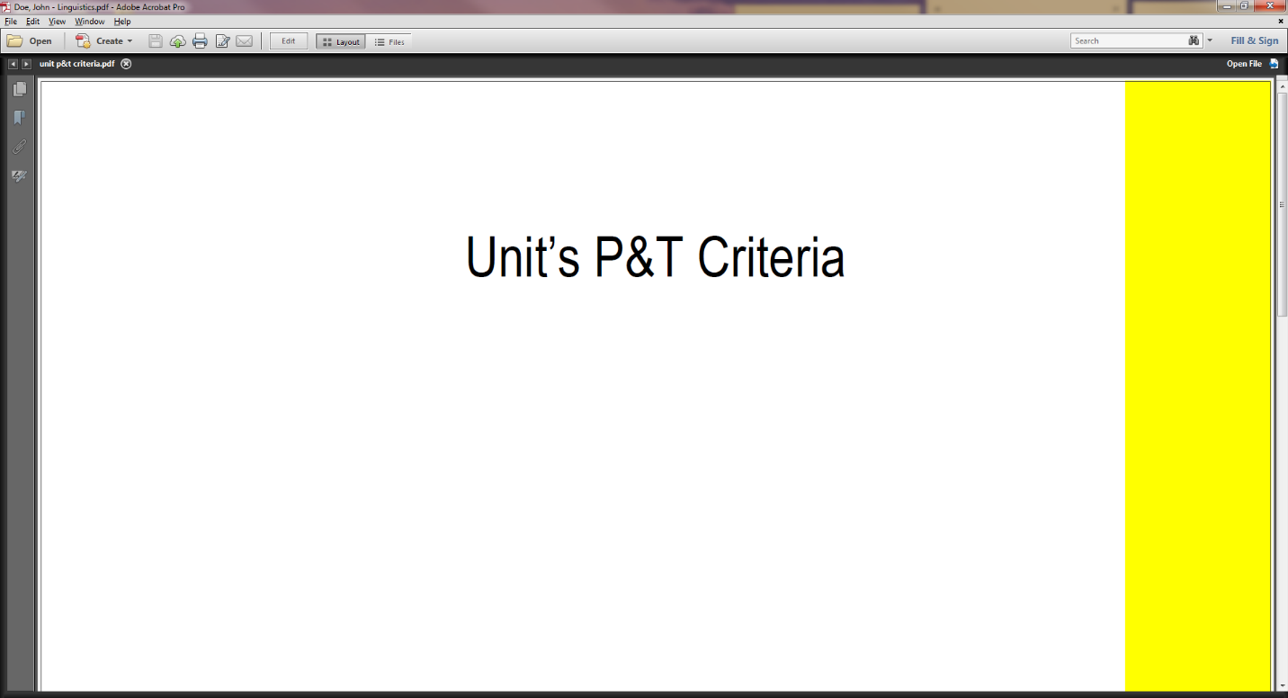

* Insert the appropriate P&T Criteria document beneath the cover page for this section. Details will depend on your system. In Acrobat Pro XI, enter Edit mode; then simply single click on the section page, then choose “Add Files” from the “Add Content” menu and follow the instructions.
* In earlier versions, one option (there are many) is to click the small Thumbnail icon in the margin just below the forward arrow. Then click on the Options icon inside the Thumbnails ribbon. Click on insert pages from the drop down menu. Insert criteria pdf document after the criteria section cover. Save.

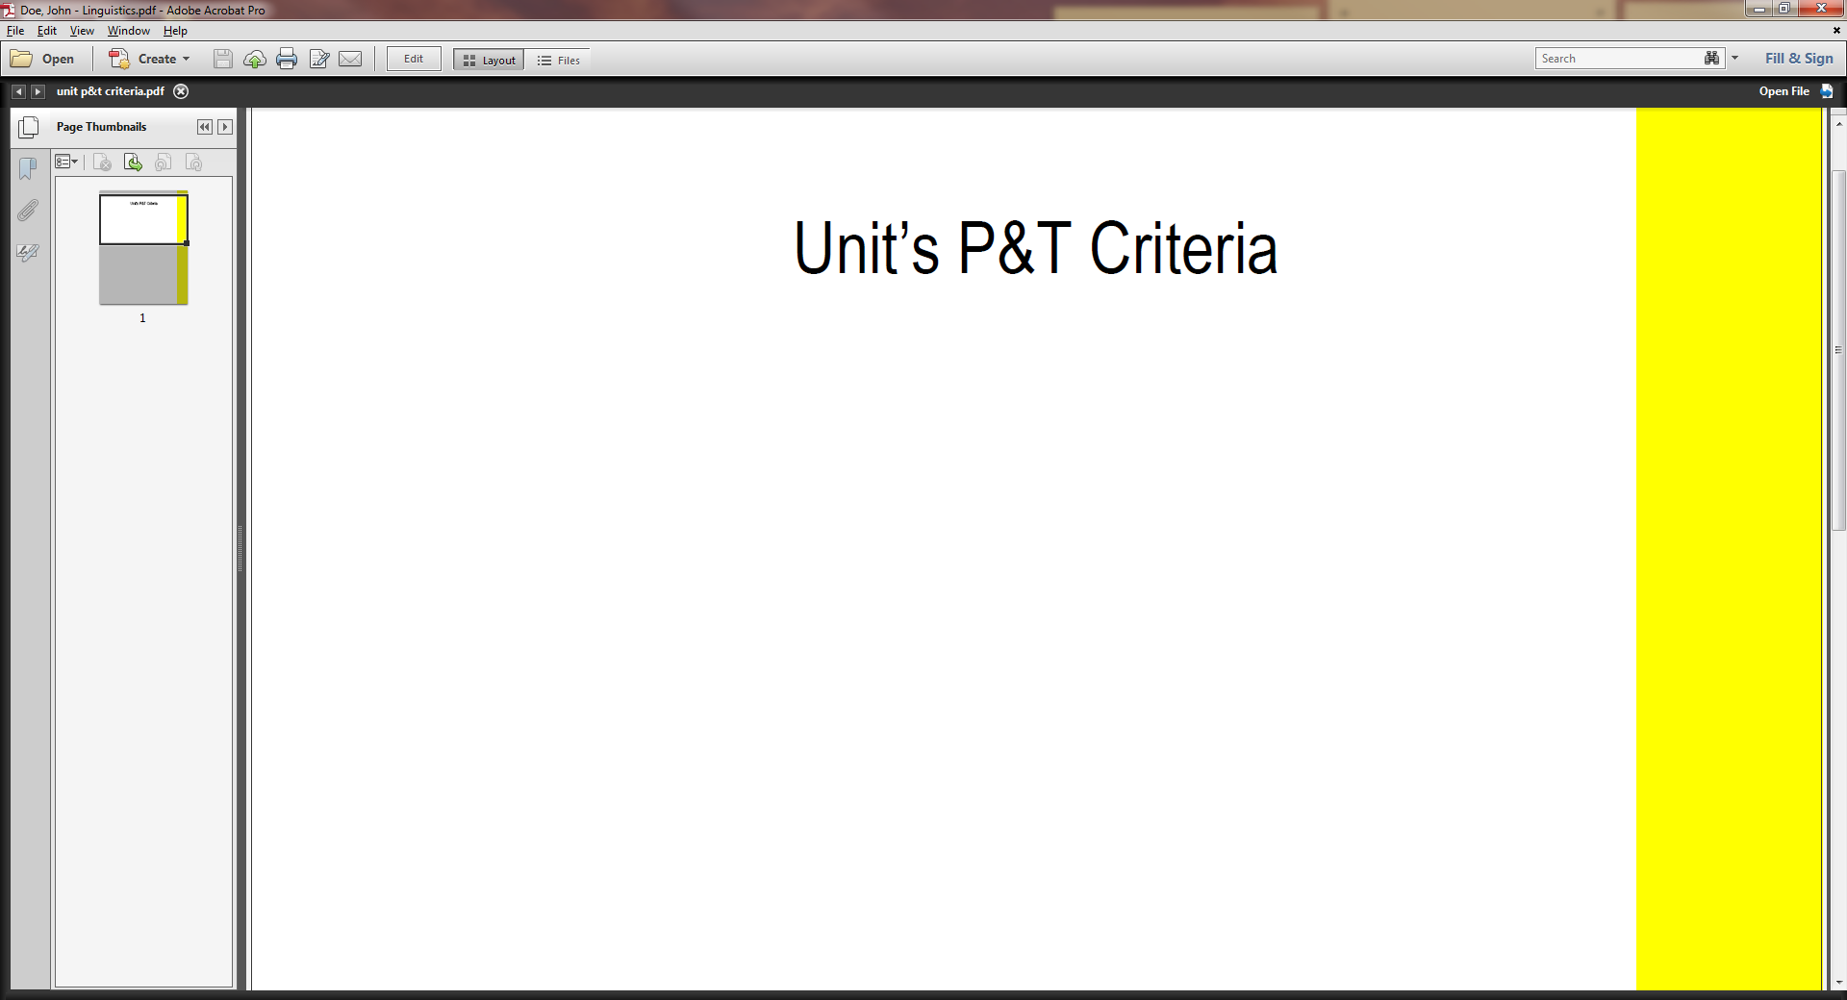

* Navigate to each appropriate section and upload documents. For TTF portfolios, there is a simple checklist under the Evaluation Letters tab to help you identify which documents should be included. Be sure to save regularly.
* As the portfolio moves forward, additional documents can be provided in the same way.
* The academic deans are free to determine the means by which they would like to receive digital dossiers – e.g., on USB “thumb drives,” via a secure web portal, or other means.
* Academic Affairs requests that dossiers be provided on USB thumb drives, delivered in person to Johnson Hall and accompanied by any hard-copy supplementary materials.