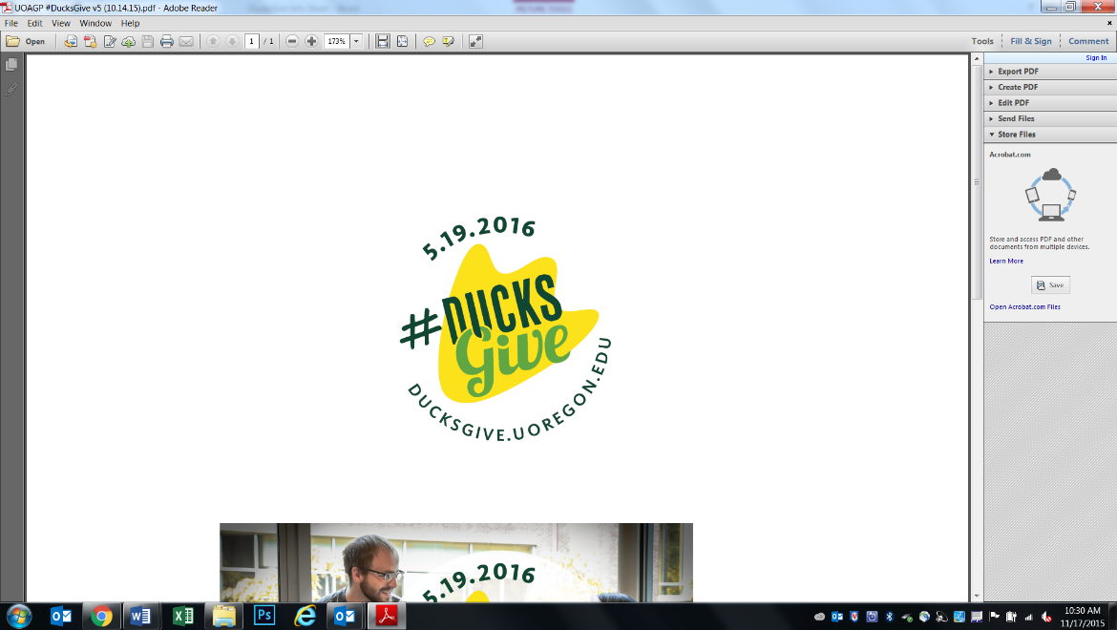#DucksGive Planning Checklist  
for Unit Communicators

This is our recommended minimum action plan to help your unit reach their challenge goals. Please reach out to us if you have questions or ideas you’d like to move forward on – we would love to hear your thoughts! We will be distributing a list of suggested posts and design assets by 4/1 for use on the day and afterwards. The logo file is attached to the main email for use if you need it.

Please do not post anything about Giving Day or #DucksGive publicly before 5/19. We will have a teaser logo and video if you would like to use that during the lead-up to the day.

**Pre-Giving Day Timeline**

*March 28:* Photos due for unit microsite banner image (if you have a preference)

*April 10:* Copy for unit microsite distributed to units by Annual Giving

*April 19:* Your edits to microsite copy due  
 Short video for microsite due

*April 21:* Provide list of potential social media ambassadors to Megan Knowles or Katy George

*May 1:* Final approval of microsite copy  
 Annual Giving sends email to potential social media ambassadors

*May 12:* Share the teaser video on your unit social media accounts

**Giving Day Unit Social Media Schedule**

* Early morning 5/19: Share launch announcement on digital communication pages with launch video link and include unit challenge info and unit specific URL (to be distributed)
* Mid-Afternoon 5/19: Provide update on unit challenge progress
* Celebration post if/when challenge is met; include info on second challenge if applicable
* 1 “last minute” update 7pm-11pm on 5/19 **OR** before 8am on 5/20
* 8AM on 5/20: Thank you/results post – either share main university thank you video or create your own unit-specific image or video

Social media pages to follow:  
FB: University of Oregon  
Insta: @uoregon  
Twitter: @Univ_of_Oregon

Please also encourage any department pages to share your posts.

**Unit Website Recommendations:**

* If you have a rotating slide on your homepage, consider featuring the #DucksGive banner image on 5/19 and a thank you banner after the day. Please include the ducksgive.uoregon.edu URL to direct users to the giving platform.
* Include wrap-up articles on your unit blogs, e-newsletters, and other external communications featuring the total raised for the university and your unit on the day