**Center for Equity Promotion (CEQP) would like to invite faculty, staff, and students to the following colloquium:**

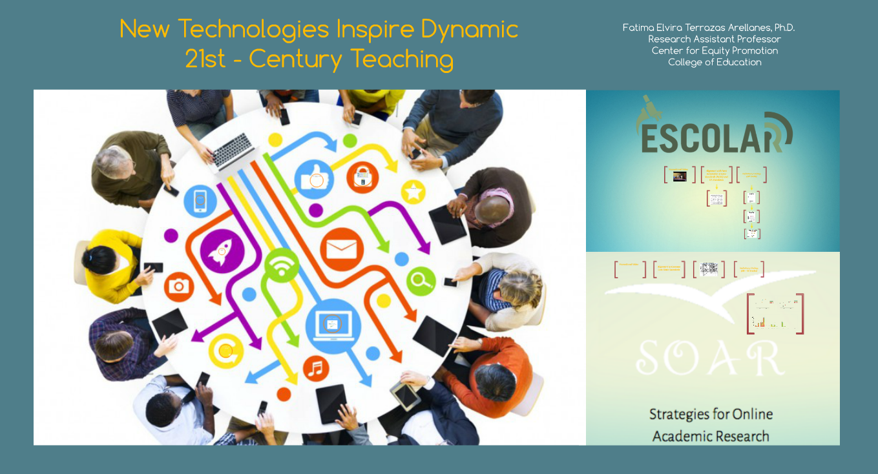

The Internet and mobile devices, such as global positioning system (GPS) navigation devices, tablets, and smart phones, have transformed the way people behave, interact, and communicate with others. These technologies are also changing the way educators think about education and literacy. Schools and universities are making large investments in new technologies, but educators are struggling to keep pace with the speed of technological development and demand (Pilgrim, Bledsoe, & Reily, 2012) and have been unable to impact education systems as expected (Zhao, Zhang, Lei, & Qiu, 2016). In this research presentation, Fatima Terrazas-Arellanes will present her work on applications of new technologies in middle school classrooms. She will discuss how her evidence-based models for online instruction can inspire educators to teach 21st-century skills.

Tuesday, December 1st

HEDCO 240

1:00 – 2:00 pm

2:00 – 2:30 Q&A

*\*coffee and sweet snacks provided*

*Dr. Fatima E. Terrazas Arellanes is a Research Assistant Professor at the Center for Equity Promotion at the University of Oregon College of Education. She earned a Bachelor of Arts degree in Psychology from the Universidad Autonoma de Sinaloa in 2000, a Master of Science degree in Special Education from the University of Oregon in 2008, and a Doctor of Philosophy degree from the University of Oregon School Psychology Program in 2009.*

*She is the Principal Investigator of two federally funded projects focused on technology*

*in education. One study (Project ESCOLAR) supports science learning for students with learning*

*disabilities and the other (Project S-SOAR) develops professional development models to*

*support teaching strategies for conducting research online. In Project ESCOLAR, she also leads efforts to provide Hispanic teachers and students in Mexico with translated instructional websites and resources. In previous studies, she helped develop and evaluate bilingual online science modules for Hispanic English learners (Project COPELLS) and eText supports for improving Hispanic English learners’ reading comprehension (Project ESTRELLAS).*