Assignments:
- Set the global configuration file with your username, email and editor as Notepad++. List all the properties which you just set.
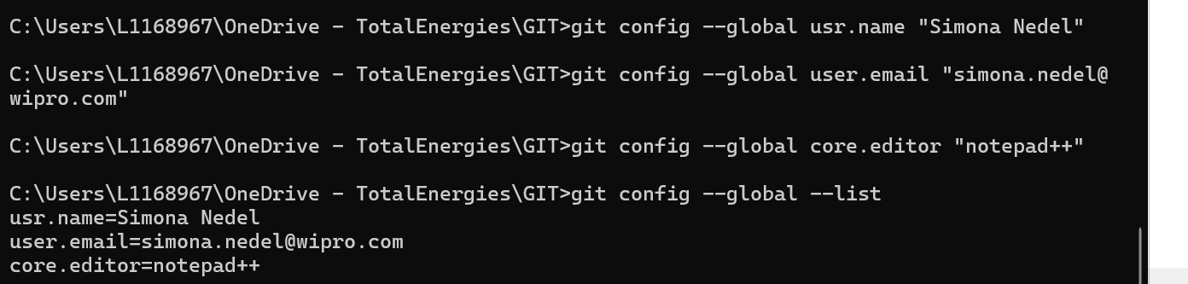
- Create a fresh Git project. Add a file into the project. Commit the changes to the local repository.
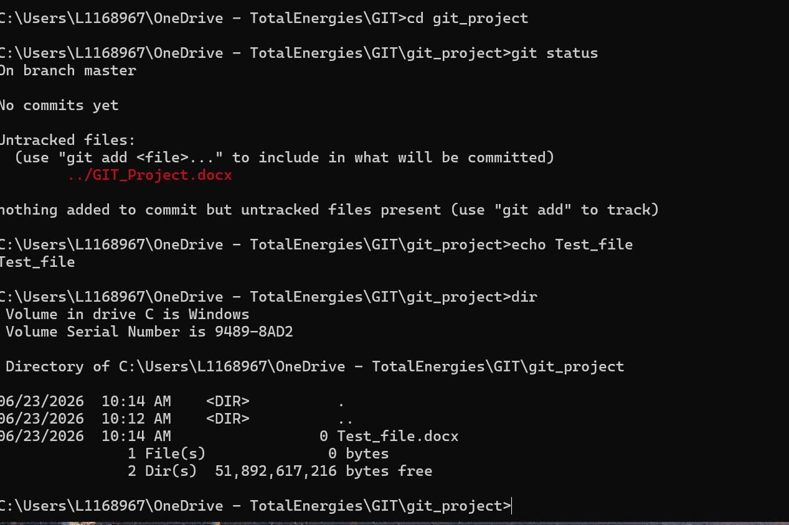

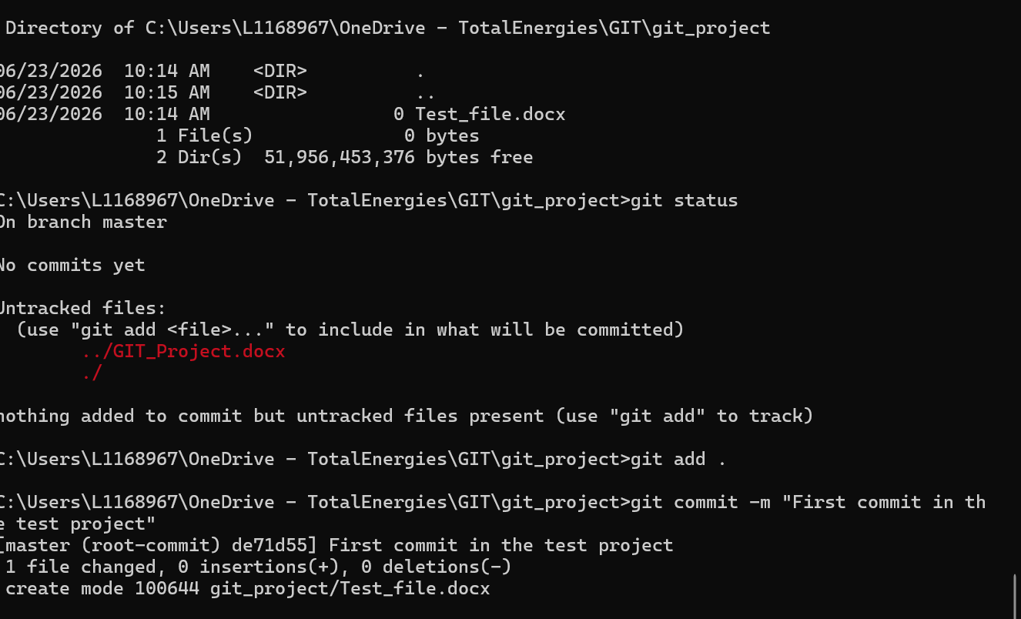
- Create a Github/Gitlab account (Or use the account if already registered). Clone a project from the remote repository to your local repository

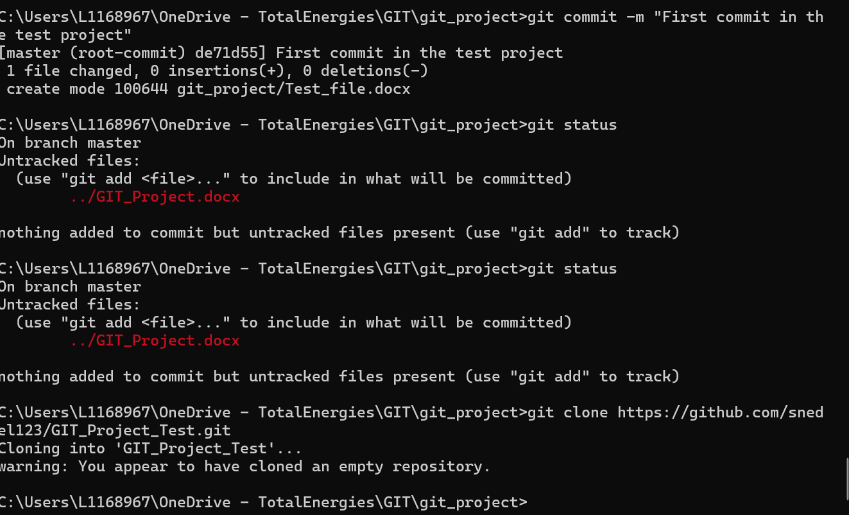

- Push the project created in assignment 2 to the remote repository.

