Grimhaven MUD Game Design
Revision 1.0 draft: 2000.01.31
(This document is a work in progress. I am anticipating a second pass at the Game Design question and as such am drawing this document to explore the changes before committing myself to actual code. – Batopr 10/22/1999)

Copyright © 1999, Grimhaven MUD Development Team
All Rights Reserved.

Table of Contents
Grimhaven MUD Game Design 1
Table of Contents 2
Introduction 10
Some History: 11
Prerequisites and Caveats 11
Thesis Justification 12
Some Basics of Game Design 12
A Quantitative Model 12
Establishing and Maintaining Equilibrium 13
A Basic Definition of Balance 13
Why Balance? 14
Game Design Methodology 14
A Basic Introduction to Combat: 15
The Power Equation: 15
(Equation 1.) SimpAvgDam/Hit 15
(Equation 2.) SimpAvgHits/Rnd 15
(Equation 3.) SimpAvgDam/Rnd 16
(Equation 4.) SimpHP 16
(Equation 5.) SimpSurvRnds 16
(Equation 6.) SimpBalancedCombat 16
(Equation 7.) SimpPower 16
(Equation 8.) SimpPower 16
The Concept of Level 17
Power as a Function of Level 17
(Equation 9.) SimpOffPowForm 17
(Equation 10.) SimpDefPowFormat 19
(Equation 11.) SimpPowerForm 19
Deriving Values for B, C, E and F 19
(Spreadsheet 1.) SimpDefPow, SimpOffPow and SimpPower as a function of level 21
(Equation 12.) SimpDefPow 23
(Equation 13.) SimpOffPow 23
(Equation 14.) Power 23
Basic Extensions of the Simple Combat System 23
A Deeper Analysis of SimpDefPow and SimpOffPow 23
(Equation 15.) SimpDefPow 23
(Equation 16.) SimpOffPow 23
(Equation 17.) SimpDef 24
(Equation 18.) SimpOff 24
(Equation 19.) SimpDefPow 24
(Equation 20.) SimpOffPow 24
Determining n, HP Concerns 24
(Spreadsheet 2.) SimpDef, ActHP and ActDef as a function of level 26
(Equation 21.) ActHP 28
(Equation 22.) ActDef 28
Derivation of ActDam; An Analysis of SimpSurvRnds 28
(Equation 23.) ActDam 29
(Spreadsheet 3.) ActHP, ActDam and SimpSurvRnds as a function of level 30
Derivation of ActOff 31
(Equation 24.) ActOff 31
(Spreadsheet 4.) ActOff and ActDef as a function of level 32
Extending the Basic Combat System 33
PCs and NPCs 33
Equating Systems between PCs and NPCs 33
PC and NPC level 33
PC and NPC HP and Damage 34
(Equation 25.) SimpSurvRnds 35
(Equation 26.) SurvRnds 35
(Equation 27.) SimpBalancedCombat 35
(Equation 28.) BalancedCombat 35
Prologue to Combat Hit Percentage 35
Damage Capacity 36
(Equation 29.) DamCap 36
Combat Hit Percentage 36
(Equation 30.) HitPercForm_{ab} 36
(Equation 31.) HitPerc_{ab} 37
(Equation 32.) DamCap 37
(Spreadsheet 5.) Some Combat Scenarios; HitPerc, SurvRnds and the resulting Power 38
Coming Full Circle with Basic Combat 40
Mob Difficulty and Experience Points 40
A Basic Definition of XP 40
Mob XP Desires 41
Deriving Mob XP 41
(Equation 33.) MobXPForm 41
(Equation 34.) MobXP 42
(Spreadsheet 6.) Level, ActHP, Power and MobXP 43
Discouraging Nibblers; XP Rewards for Partial Kills 45
Prelude to the Kills to Level Equation 46
Deriving PlayTimePerKill 46
(Equation 35.) SimpPlayTimePerKill 46
(Equation 36.) PlayTimePerKill 47
Deriving Kills Per Level 47
(Equation 37.) KillsPerLevelForm 47
(Equation 38.) KillsPerLevel 47
(Spreadsheet 7.) PlayTime as a Function of Level and KillsPerLevel 48
Deriving the XP Tables 49
(Spreadsheet 8.) XPForLevel and KillsPerLevel versus level 49
Introducing Armor into Our System 49
Avoiding the Pitfalls of AD&D 50
A Prelude to Armor Implementation 50
A Basic Overview of Combat Dynamics 51
(Equation 39.) SimpFinesse 51
(Equation 40.) SimpOffSkill 51
(Equation 41.) SimpArmor 52
(Equation 42.) SimpDefSkill 52
(Spreadsheet 9.) SimpFinesse, SimpOffSkill, SimpArmor and SimpDefSkill as Functions of Level 53
A Brief Dissertation on the Meaning of (Spreadsheet 9.) 55
Divvying up SimpArmor 55
(Equation 43.) ActFinesse 55
(Equation 44.) ActArmor 55
A Suit of Armor 55
(Spreadsheet 10.) Percent of ActArmor Found on Any Given Equipment Slot 56
(Spreadsheet 11.) Equipment Armor by Level and Equipment Slot 57
Clothing and Other Worn Equipment 59
(Equation 45.) ActArmCloth 59
(Spreadsheet 12.) Clothing Armor by Level and Equipment Slot 60
Some Simple Refinements of Combat Blows 62
(Equation 46.) HitPerc_{ab} 62
(Equation 47.) RawMiss 62
Parrying 62
(Equation 48.) ParryEligible 63
(Equation 49.) AdjustedMiss 63
Scenarios Involving a Miss 63
(Equation 50.) TrueMiss 64
(Equation 51.) TrueDodge 64
(Equation 52.) TrueDeflect 64
(Spreadsheet 13.) ParryEligible, TrueMiss, TrueDodge and TrueDeflect for Fair-Fights by Level 65
Scenarios Involving a Hit 66
(Equation 53.) TrueSeriousHit 66
(Equation 54.) TrueNormalHit 67
(Equation 55.) TruePartialHit 67
(Spreadsheet 14.) TrueSeriousHit, TrueNormalHit and TruePartialHit for Fair-Fights by Level 68
Blow Breakdown for Dissimilar Level Combatants 69
(Spreadsheet 15.) Some Combat Scenarios; Hit and Miss Breakdown 69
Skill Damage 70
A Prelude to Skill Damage 71
(Equation 56.) SimpSkillDamage 71
(Equation 57.) SimpWeaponDamage 71
(Spreadsheet 16.) WeaponDamage and SimpSkillDamage as a Function of Level 72
Saving Throws 73
SkillDifficulty and MaxSkillPerc 74
(Equation 58.) MaxSkillPerc 74
SkillLearning 75
(Equation 59.) SkillPerc 75
MinSkillLevel and MaxSkillLevel 75
Refinement of SimpSkillDamage 75
(Equation 60.) SkillDamage 76
(Spreadsheet 17.) SkillDamage for SkillDifficulty Ratings by Level (fair-fights) 77
Ramifications of SkillDamage 78
Converting SkillDamage to Other Hindrances 78
(Equation 61.) AvgDamMelee 79
(Equation 62.) AvgDamSkill 79
(Equation 63.) MeleeRoundsLostSkill 79
(Equation 64.) FullRoundsLostSkill 79
(Equation 65.) SkillRoundsLostSkill 80
(Spreadsheet 18.) MeleeRoundsLostSkill, SkillRoundsLostSkill and FullRoundsLostSkill According to SkillDifficulty 80
A Final Note on Skill Damage 80
Refining SimpWeaponDamage 81
(Equation 66.) WeaponDamEq 81
(Equation 67.) WeaponDamExp 81
(Spreadsheet 19.) DamCapExp and DamCapEq versus Level 82
Commentary on Percentage Changes in ActArmor and WeaponDamEq 83
More Refinements for Combat Blows 83
An Introduction to Number of Swings Per Round 83
(Equation 68.) NormPCSwingsPerRound 83
(Equation 69.) DamagePerSwing 84
Weapon Proficiency and Specialization for Players 84
(Equation 70.) SpecBonusSwings 85
WepDamEqPerSwing 85
(Equation 71.) WepDamEqPerSwing20_50 85
(Equation 72.) SwingsPerRound20_50 85
(Equation 73.) SwingsPerRound00_20 86
(Equation 74.) WepDamEqPerSwing00_20 86
(Equation 75.) SwingsPerRound20_50 86
(Equation 76.) WepDamEqPerSwing20_50 86
(Equation 77.) SwingsPerRound 86
(Equation 78.) WepDamEqPerSwing 87
(Spreadsheet 20.) SwingsPerRound and WepDamEqPerSwing by Level 87
WepDamPerSwing 88
(Equation 79.) WepDamPerSwing 88
(Spreadsheet 21.) WeapDamPerSwing as a Function of Level 89
Weapon Proficiency and Specialization for Mobs 89
Combat Use of the Secondary Hand 90
An Overview of the Tradeoffs Involved 90
(Equation 80.) OffHandMultiplier 90
Use of a Shield 91
Dual-Wielding 91
(Spreadsheet 22.) Tradeoffs for Various Uses of Off-Hand 92
Fencing 92
Two-Handed (2H) Weapons 92
(Equation 81.) WepDamEqPerSwing2H 93
Outcomes of the Off Hand Weapon System 93
Implementation Notes 93
Fair-Fights 93
Synergistic Correction 94
(Equation 82.) SynergisticCorrection 95
(Spreadsheet 23.) Analysis of SynergisticCorrection 96
Character Class 97
An Introduction to Character Class 97
The Warrior Class 97
The Bodyguard Class 98
Bodyguard’s HP Bonus 98
(Equation 83.) ActHPBodyguard 98
Bodyguard’s Damage Penalty 98
(Equation 84.) ActDamModifierBodyguard 98
(Equation 85.) ActDamBodyguard 99
(Equation 86.) DamCapBodyguard 99
(Equation 87.) WeaponDamageBodyguard 99
(Equation 88.) WeaponDamExpBodyguard 99
(Spreadsheet 24.) Bodyguard Class vs. Warrior Class 100
Bodyguard Review 100
The Mercenary Class 101
Mercenary’s HP Penalty 101
(Equation 89.) ActHPMercenary 101
Mercenary’s Damage Bonus 101
(Equation 90.) ActDamModifierMercenary 101
(Equation 91.) ActDamMercenary 101
(Equation 92.) DamCapMercenary 102
(Equation 93.) WeaponDamageMercenary 102
(Equation 94.) WeaponDamExpMercenary 102
(Spreadsheet 25.) Mercenary Class vs. Warrior Class 103
Mercenary Review 103
Magic Casters 104
The Warlock Class 104
Warlock HP Penalty 104
(Equation 95.) ActHPWarlock 104
Warlock Armor 105
(Equation 96.) ActArmorWarlockEq 105
(Equation 97.) ActArmorWarlock 105
(Equation 98.) ActArmorWarlockSpell 105
Warlock Success Rates 105
(Equation 99.) ActDefWarlock 105
(Equation 100.) HitPercExponent 106
Warlock Damage 107
(Equation 101.) ActDamWarlock 107
(Equation 102.) DamCapWarlock 108
Warlock Fight Scenarios 108
(Spreadsheet 26.) Warlock Combat Scenarios 109
Breakdown of DamCapWarlock 110
(Equation 103.) WeaponDamageWarlock 110
(Equation 104.) SkillDamageWarlock 110
(Spreadsheet 27.) Warlock Class vs. Warrior Class; Defensive Properties 111
(Spreadsheet 28.) Warlock Class vs. Warrior Class; Offensive Properties 112
Warlock Skills 113
Review of Warlock 113
The Sorcerer Class 113
Sorcerer HP Penalty 114
(Equation 105.) ActHPSorcerer 114
Sorcerer Armor 114
Sorcerer Success Rate 114
Sorcerer Damage 114
(Equation 106.) ActDamSorcerer 115
(Equation 107.) DamCapSorcerer 115
(Spreadsheet 29.) Sorcerer Class vs. Warrior Class 116
Sorcerer Skills 117
The Mage Class 117
Mages by the Numbers 118
Mage Skills 118
Clergy Classes 118
The Missionary Class 119
Missionary HP Penalty 119
(Equation 108.) ActHPMissionary 119
Missionary Armor 119
(Equation 109.) ActArmorMissionaryEq 119
(Equation 110.) ActArmorMissionary 119
(Equation 111.) ActArmorMissionaryPrayer 120
Missionary Success Rates 120
(Equation 112.) ActDefMissionary 120
Missionary Damage 121
(Equation 113.) ActDamMissionary 121
(Equation 114.) DamCapMissionary 121
(Equation 115.) WeaponDamageMissionary 121
(Equation 116.) SkillDamageMissionary 122
(Equation 117.) WeaponDamExpMissionary 122
Missionary Fight Scenarios 122
(Spreadsheet 30.) Missionary Combat Scenarios 123
(Spreadsheet 31.) Missionary vs. Warrior Class; Defensive Properties 124
(Spreadsheet 32.) Missionary vs. Warrior Class; Offensive Properties 125
Missionary Skills 126
Review of Missionary Class 126
The Priest Class 127
Priest HP Penalty 127
(Equation 118.) ActHPPriest 127
Priest Armor 127
Priest Success Rate 127
Priest Damage 128
(Equation 119.) ActDamPriest 128
(Equation 120.) DamCapPriest 128
(Spreadsheet 33.) Priest Class vs. Warrior Class 129
Priest Skills 130
Priest Review 130
The Cleric Class 130
Clerics by the Numbers 131
Cleric Skills 131
Rogue Classes 131
The Thief Class 132
Thief HP Penalty 132
(Equation 121.) ActHPThief 132
Thief Armor 132
(Equation 122.) ActArmorThiefEq 132
(Equation 123.) ActArmorThief 132
(Equation 124.) ActArmorThiefSkill 132
(Equation 125.) ActDefThief 133
Thief Success Rate 133
Thief Damage 134
(Equation 126.) ActDamThief 134
(Equation 127.) DamCapThief 134
(Equation 128.) WeaponDamageThief 134
(Equation 129.) WeaponDamExpThief 135
(Equation 130.) SkillDamageThief 135
Thief Fight Scenarios 135
(Spreadsheet 34.) Thief Combat Scenarios 136
(Spreadsheet 35.) Thief vs. Warrior Class; Defensive Properties 137
(Spreadsheet 36.) Thief vs. Warrior Class; Offensive Properties 138
Thief Skills 138
Thief Review 139
The Thug Class 139
Thugs by the Numbers 140
Thug Skills 140
The Monk Class 140
The “Traditional” Monk and Ramifications Thereof 140
Monk Hit Points 141
Monk Armor 141
(Equation 131.) ActArmorMonkEq 141
(Equation 132.) ActArmorMonkSkill 141
(Equation 133.) ActArmorMonk 141
Monk Success Rate 141
(Equation 134.) ActDefMonk 141
Monk Damage 143
(Equation 135.) ActDamMonk 143
(Equation 136.) DamCapMonk 143
(Equation 137.) MeleeDamageMonk 143
(Equation 138.) SkillDamageMonk 143
Monk Fight Scenarios 143
(Spreadsheet 37.) Monk Combat Scenarios 144
Refining Monk Barehand Damage 144
(Equation 139.) SwingsPerRoundMonk 145
(Equation 140.) MeleeDamPerSwingMonk 145
(Spreadsheet 38.) SwingsPerRoundMonk and MeleeDamPerSwingMonk versus Level (fair-fights) 146
If a Monk were to Use a Shield 148
Monk “Specialization” 148
Monk Comparison 149
(Spreadsheet 39.) Monk vs. Warrior Class; Defensive Properties 149
(Spreadsheet 40.) Monk vs. Warrior Class; Offensive Properties 150
What Monks Are Not 150
Monk Skills 151
Monk Review 152
The Ranger Class 152
Rangers by the Numbers 152
Ranger Skills 152
The Crusader Class 153
Crusaders by the Numbers 153
Crusader Skills 153
Miscellaneous Commentary on Class-Related Concepts 154
Class Conversion 154
Multi-Class 154
Class for Mobs 155
Adjustments to Rounds Lost Equations 155
(Equation 141.) NumRndsBlocked 156
Characteristics 156
Combat Characteristics 156
Other Characteristics 157
Characteristics to Avoid 157
Misconceptions about Characteristics 157
Characteristic System Overview 158
Relationship Between a Characteristic and the Affected Value 158
(Equation 142.) StatPercChange 158
Race and Characteristics 159
Characteristics System in Action 159
Movement, Mana and Piety 159
Rationalizing Movement Limitations 160
Prelude to ActMove 160
Movement Cost Per Step 161
(Equation 143.) AvgMoveCostPerStep 161
(Equation 144.) AvgRoomsTraveled 161
(Equation 145.) ActMoveMovement 161
Movement Cost Per Weapon Swing 161
(Equation 146.) ActMovePerSwing 162
(Equation 147.) ActMoveMelee 162
Movement Cost for Melee and the Off-Hand 162
(Equation 148.) ActMovePerSwing2H 163
Movement Cost for Skills 163
(Equation 149.) ActMovePerSkillRound 163
(Equation 150.) ActMoveSkill 163
Movement Cost for Spells 163
(Equation 151.) ActMovePerSpellRound 163
(Equation 152.) ActMoveSpell 163
ActMove 163
(Equation 153.) ActMove 164
(Spreadsheet 41.) ActMove by Class-Subtype and Level 165
Racial Modifiers 167
Extensions for Non-Fighters 167
Mana 168
(Equation 154.) ManaPerRound 168
(Equation 155.) ActMana 168
(Spreadsheet 42.) Mana by Level 168
Piety 169
(Equation 156.) ActPiety 169
(Equation 157.) PietyPerRound 169
Magic Equipment 169
Economy 170
Mob Wealth 170
(Equation 158.) MobWealth 171
(Spreadsheet 43.) Level, Power and MobWealth 172
Economic Feedback Loops 174
Balance Sheet Values 174
Total Income 175
Shops 175
Equipment Availability 176
Rent and Repair Feedback 176
Advancing Our Economic Understanding 177
Gold Acquired 177
(Equation 159.) MobBooty 177
(Equation 160.) MobLoot 177
(Equation 161.) GoldAcquiredPerLevel 177
(Spreadsheet 44.) GoldAcquiredPerLevel by Level 178
A Preliminary Look at Expenses 178
A Prelude to Equipment Repair 179
Upgrades and Planned Obsolescence 179
Repairs Per Level 180
(Equation 162.) RepairsPerLevel 180
(Equation 163.) DecaysPerLevel 180
KillsPerRepair 181
(Equation 164.) KillsPerDecay 181
(Spreadsheet 45.) KillsPerDecay as a Function of Level 181
Repair Cost Fraction 182
(Equation 165.) RepairCostFraction 182
Level 1 Suit Cost 182
Level 1 Expenses 182
Level 1 Profit 183
Extending the System 183
(Equation 166.) SuitCost 183
(Spreadsheet 46.) Suit Costs 184
A Cost Breakdown 186
(Spreadsheet 47.) Costs Break Down 187
Shifting the Rewards between XP and Wealth 189
Equipment Load and Replacement Rates 190
(Equation 167.) EQLoadRate 190
(Equation 168.) EQReplaceRate 190
(Spreadsheet 48.) EQLoadRate and EQReplaceRate as Functions of Level 191
Weapon Quality Damage 192
Symbol Stress 192
Components 192
Repair 192
Pricing System 192
Armor Pricing 192
Weapon Pricing 192
Component Pricing 192
Symbol Pricing 192
Magic Effects 192
Spells 193
Holy Water 193
Rent Credit 193
The Skill System 193
Disciplines 193
Practices 193
Game Design for Some Specific Skills 193
Chivalry 193
Blur 193
Anticipated Game Design Problems 194
Uselessness of Armor 194
Clumsiness of the Worn Equipment System 194
Synergy and the Ultimate Group 195

Introduction
For any system as complex as a MUD to both maintain long term stability of existing systems, and allow for the addition of new and modification of old systems, it is imperative that the game design be well thought out in a quantitative manner. It is only by devising a systematic approach that details what is expected, and then implementing such a plan that the game maintainers can ever hope to achieve a macroscopic understanding of their game, or properly diagnose problems that occur.
Unfortunately, in the real world, game design tends to fall by the wayside by most implementers. Too often new imps opt to dive into the programming, adding in those neat bells & whistles they’ve always wanted in a mud, while game design (assuming it existed in the base code they started with) is ignored or willfully disregarded.
There is a misconception amongst such implementers that they can “stay in touch” with the game and will be able to head off any problems that new code introduces. In a simple system, this might well be possible. But as a mud becomes larger and larger, and as code elements become increasingly intertwined, it becomes both more likely that a given change will cause problems in other subsystems, and that problems will go unnoticed because the implementers insist that nothing they touched recently should have had any effect.
To further complicate the life of implementers, players of the game often “misreport” problems. That is to say, a player may report that X is broken. A detailed analysis would reveal that indeed X is out of specification, but it is in fact due to a small discrepancy in the intertwined system Y. This is not a criticism of well-meaning players that report problems that are observed. I use this hypothetical example to illustrate that without a thorough understanding of both what the X and Y systems are expected to do, but also how they interact with each other, implementers are lulled into tweaking X rather than fixing the root cause in Y. The result is that Y is left broken (unknowingly), while X is now corrupted to account for this problem.
What problems will changing X now cause? Are the problems in the broken Y limited to those noted in X? Implementers lacking a solid game design simply cannot evaluate these questions, and are forced to firefight as things crop up. The high degree of complexity associated with a MUD environment, and the fact that a player’s life span covers many months means that a mud in such a state will inevitably be forced to make vast, and profound changes in the course of this fire-fighting. Players, of course, do not like it when the “rules” are changed on them, but, of course, the implementers are simply trying to keep some semblance of order to their chaotic system.
Ideally, implementers would create a solid game design at the outset, and then simply use code to implement this design. The theory can be worked out prior to players ever experiencing the new code, and problems can be caught while still in the pen, paper and calculator phase rather than the “You’ve destroyed my character you unfeeling bastard!” phase. Likewise, when the inevitable problem does crop up, implementers are able to check the numbers and use statistics to diagnose problems, and zero in on the proper fix.

Some History:
This realization was made by myself and the other implementers of Grimhaven some time ago, and the problems of a missing or not-adhered-to game design I speak of from first-hand experience. Ultimately, we committed ourselves to reintroducing a solid game design.
Not fully understanding the scope that such a game design would mean, we initially opted to retrofit the new game design into our existing mud. Additionally, since we had existing players, and knew how painful it is to perform a mud-wide conversion of player files, the decision was made to minimize the impact to the players by making the game design of certain elements agree with what was already in place. For instance, the number of HP a player has at a given level was pre-existing, so we simply started with that element as fixed, and ramped up from there.
This was not exactly a mistake, as the system that resulted was highly stable and was an order of magnitude improvement over what went before. However, by accepting these arbitrary constraints, we denied ourselves the ability to get the “best” possible game design. However, this “rough draft” was quite revealing, and it is doubtful that anyone could be expected to get game design right the first time.
This document forms the basis of a second pass at answering the Game Design question. The lessons learned in the first pass will be taken to heart, and we hope to build upon the successes that that first pass resulted in. However, this time around we will not impose arbitrary constraints, and are basically assuming a clean slate. For practical purposes, this means either an equally fresh slate in terms of players (PWipe, yuck!) or at the very least the acceptance of some conversion of players as the migration to the new game design occurs.

Prerequisites and Caveats
Readers of this document are presumed to be relatively familiar with the basic concepts associated with a MUD as well as basic RPG terminology. For the most part, familiarity with other gaming systems is a boon. I am making no effort to provide a glossary of terms as I presume that anyone reading this document has the necessary background knowledge.
Furthermore, Game Design is inherently quantitative. Those with a fear of numbers should be wary when perusing this document. The math will at times get intense, if I lose someone in the numbers, my apology in advance.
For the most part however, if you have an understanding of algebra (solving equations for the unknowns), basic calculus (how simple functions are shaped) and are not lost when presented with a term like “2d6+6” is mentioned, then this document ought to be understandable.

Thesis Justification
The casual reader of this paper is likely to question the need for this level of in-depth analysis. In places, this paper will go into extraordinary depth, often into areas of the Game Dynamics that seldom see much exposure. It is right to question whether spending the amount of time to push as deep as we do into the nitty-gritty details. Can’t we just “wing it”?
The dangers of winging it were explored in the opening few paragraphs. While I personally feel that the rationale there is compelling enough, I will offer one additional argument for a high degree of understanding of the nitty-gritty details. By doing so, any Game system devised can be defended on logical grounds.
Please note that I use the term “logical” as opposed to “instinctual”. Players that feel that the system works against them are going to respond poorly to the “instinctual” arguments. A mathematical rationale for why a player has the HP that they do will be much more widely accepted than one that goes “I just felt that that class should have X HP”. Players that see that things are the way they are because the system has been heavily thought through will complain less often and less loudly, (especially when they can follow the logic and see the assumptions) than those that feel that the “game design” was developed by the implementers after drinking too many beers one night.
Furthermore, I use the term “logical” as opposed to “realistic”. Frequent debates break out over changes that are made on “realistic” grounds. As the Game Designers, we must keep in mind that what is being created is a gaming simulation and not a virtual reality. It’s nice to use reality as a framework, but we must avoid compromising the gaming system. In the final analysis, a game that has a good logical system behind it will be more enjoyable than one that strictly models reality in all its unpleasant and mundane detail.
Thus, we go to this much trouble to delve into the gaming system in order to avoid making seemingly arbitrary decisions that must face constant scrutiny. At the same time, we isolate the critical systems upon which “enjoyability” will be measured from the well-meaning features thrown on top of the Gaming System that may or may not have a beneficial effect on the game. Such thoroughness insures that the core system is stable and defensible (thus letting developers concentrate on creating the features that are desired).

Some Basics of Game Design
It is appropriate to begin a discussion of game design by first establishing what we are attempting to accomplish. There will be some tough decisions along the path ahead, and it is useful to have a yardstick with which we can measure the options to aid in sorting through the confusion.

A Quantitative Model
Game Design is first and foremost establishing quantitative numbers that model how we desire our game system to behave. The root decisions, as seen in the above calculations, often come down to gut instincts and arbitrary decisions. Often, these decisions are simply based on experience as a game implementer.
It is important to understand that while we often start with arbitrary decisions, we also establish how we want systems to behave. These rules of behavior serve to constrain our choices. As systems intermingle, the constraints become tighter and tighter. We cease to be able to make arbitrary decisions. At a certain point, we become tightly bound to the math and must cease to do as we please.

Establishing and Maintaining Equilibrium
Secondly, Game Design deals strongly in establishing the relationships between systems. We must have an understanding of how our systems are setup, as well as how they interrelate or chaos will surely ensue.
The process of establishing equilibrium between a MUD’s systems is generally referred to as balancing. This term has often gotten a bad reputation amongst mud players, primarily due to most MUDs lacking an overall game design, and hence implementers misuse the “balance” phrase to mean stripping away powers from players of a game gone haywire. This is of course unfortunate, for if the true sense of the word is applied, the gaming system is both more stable over the long haul, and more readily understandable by implementers and players alike.

A Basic Definition of Balance
In one sense, balancing a MUD is about insuring that the relative advantages and disadvantages in a given decision are equalized. A decision that leads to more advantage is said to be "over powered" while one that has more disadvantages is thought to be "under powered". However, realize that when evaluating advantages and disadvantages, it is important to maintain perspective. It is entirely possible to devise a balanced decision where one choice leads to immediate rewards, but long-term hardships, and the other is a more even-keeled choice. It's useful to keep the "entire career" in mind and not simply evaluate the instantaneous effect.
In another sense, balance is a state of equilibrium where both players and NPCs are thought to be in synch, neither being evidently stronger than the other is. In this sort of balance, the outcome of any given fight heavily depends on both luck and technique. Players can't affect the random number generators, but the tactics they use will generally skew the outcome of a balanced MUD into their favor.
Furthermore, balance is also an intra-player concept in terms of analyzing whether choices the individual player has to make are even. At the simplest level, this can mean looking at racial and class choices, but translates down into equipment choice, learning paths, and a whole slew of other minor decisions. In a nutshell, balance in this sense, is about evaluating all possible choices, and striving to make all the choices evenly weighted.

Why Balance?
As a game designer, we seek to have all aspects of the game utilized. No coder wishes to develop a new aspect of the game that no one wishes to play with. Where is the reward in that?
However, it also behooves coders to respect what went before. If they add a new aspect of the game that is better than the alternatives, players will shift to that (which is not fair to the developer(s) of the original alternatives). Balance, in a sense, is about not adding things that are better or worse, but about simply extending the number of choices available.
It is a rare game that adds elements that are weaker than the alternatives. Typically, new choices are over-powered because either the coder has not contemplated balance concerns, or has opted to ignore balance-concerns in favor of kudos and praise from a grateful player-base. It is the game designer’s duty to avoid such situations, as it leads to one of three bad consequences.
Consequence 1: Realize an element is overpowered, and go in after the fact to tame down the power to the "balanced state". This of course leads to wide- spread complaints from the players that chose that element (because it was better).
Consequence 2: Do nothing. Typically this is not a decision that is made consciously, usually being the result of not being informed, or of not having enough time to address the problem. The obvious pitfall is that the longer such a state occurs, the more folks will take the stronger option and the harder it will be to change it at a later date.
Consequence 3: Redefine "balance" to take the strength of the new element into account. Balance is simply an equilibrium state where all things are equal. To some degree, nothing prevents a game designer from enhancing all elements of a decision equally to reacquire balance. However, this can only go so far in a gaming system. Coders are limited by the size of their variables, by the amount of data they can track, and by the speed of their hardware to make all the necessary calculations. Also, realize that balance is a concept with tremendous down-stream effects. In some regards, it is possible to simply redefine (upward) all other aspects, but this may not be feasible to do in a timely manner. Do this often enough and I guarantee you will run out of resources (available space, time, or processing power).

Game Design Methodology
Game Design is not a skill most people have naturally. While there are many, many, many MUDs in existence, very few of them are actually "designed". For the most part, the coders simply throw elements together, making random tweaks and adjustments as needed, and listen to feedback from the players. Some MUDs can be "successful" in doing this. But realize all they have managed to accomplish is to achieve an equilibrium state without understanding why they have the equilibrium they do, what the assumptions their game system operates under (except in very vague terms), or what the consequences of changing a given aspect will have on their equilibrium. In short, they are only capable of stumbling forward blindly, and can only safely add "bells and whistle" features without seriously risking a complete breakdown of their equilibrium.
Most multiplayer games, and MUDs in particular, are effectively chaotic systems, in that a small change in one area can propagate through the entire system and have dramatic effect in a wholly unrelated aspect of the game. The more complex the MUD, the greater is the need for understanding the ramifications of any proposed change. While the original DIKU was developed by a group of programmers, most MUDs today are small enough that a single programmer can maintain them. As time passes and MUDs get more involved, their complexity will also grow and they will exceed the capacity for one person to understand all aspects of the system. By that point, it becomes paramount that the overall game design be laid down so that new programmers can be added effectively, and that all can clearly see how given subsystems interact with each other.
In devising the gaming system, it behooves us to start simply, and add more elements as we progress. That is, while we eventually want multiple classes and multiple races and a wide-variety of skills, we are forced to start with a very basic system and get things working at the basic level before we create an overly exotic system. Trying to address too many variables at one time leads to burned out game designers, so isolate the problem, start small and don't add new elements until you are assured that the basic elements are working correctly.

A Basic Introduction to Combat:

The Power Equation:
For DIKU-based MUDs, the game centers on the combat system. Not all MUDs follow this trend (LP being an example), but for our situation, this is a fundamental fact of life. It is therefore appropriate to begin the discussion of Game Design with a basic analysis of combat.
Combat, in its simplest terms, is comprised of two combatants whacking away at each other until one of them falls. Each combatant is rated for how many whacks he can take (Hit points or HP), and how much damage (dam) he inflicts each time he whacks the other guy. (This is heavily simplified!) Furthermore, combat is generally broken down into rounds in which each combatant gets a number of hits per round. Please realize that “simplification” also means ignoring all the complex details that are a necessary part of a good combat system including chance of misses occurring, critical hits, magical effects, etc. etc. For the time being, we are just going to sweep that all under the rug…
The relevant equations for this are:
- SimpAvgDam/Hit
= Simplified Average Damage Per Hit
Generally rated by the combat system based on weapon-type, or racial bare-hand score. (More on this later)
- SimpAvgHits/Rnd
= Simplified Average Hits Per Round
Generally rated by the combat system based on racial speed. (More on this later)
- SimpAvgDam/Rnd
= Simplified Average Damage Per Round
= SimpAvgDam/Hit* SimpAvgHits/Rnd
Since damage is scored in terms of HP removed, we yield:
- SimpHP
= Hit Points
Generally rated by the gaming system based on class. (More on this later)
- SimpSurvRnds
= Simplified Survival Rounds
= SimpHP / (opponents SimpAvgDam/Rnd)
That is to say, the number of rounds of combat I will survive is how many HP I have, divided by how fast my opponent can remove my HP.
We note that a given fight is evenly balanced when:
- SimpBalancedCombat
_{SimpSurvRndsa} = SimpSurvRnds_{b}
_{SimpHPa} / SimpAvgDam/Rnd_{b} = SimpHP_{b} / SimpAvgDam/Rnd_{a}
_{SimpHPa} * SimpAvgDam/Rnd_{a} = SimpHP_{b} * SimpAvgDam/Rnd_{b}
This suggests that there is a simple equation for a person’s “power”.
- SimpPower
= Simplified Power
= SimpHP * SimpAvgDam/Rnd
Of course all we have really stated here is that a person grows in power if they can raise their HP or if they can raise their damage. This is fairly elementary.
It is only a minor leap of understanding to generalize these two terms into a “defense” term and an “offense” term. So that we get:
- SimpPower
= Refined from (Equation 7.)
= simpOffPow * simpDefPow
SimpOffPow deals with things that contribute to offensive capability such as the amount of damage inflicted per hit, number of swings per round, chance of hitting, etc. SimpDefPow will be things that contribute to defensive capability, such as number of HP, amount of armor worn, ability to dodge and deflect blows, and the like. Thus, simpOffPow is the contribution to the power equation from the “simplified offense” (simpOff) function. And similarly, simpDefPower is the contribution to the power equation from the “simplified defense” (simpDef) function.
We will begin to derive these functions momentarily, but it helps to understand how we are breaking things down first. In short, a creature has a “power rating” as given by the power equation. This power rating is made up of that creature’s simpOffPow and simpDefPow scores. SimpOffPow is derived from the creature’s simpOff equation, and it is things like the amount of damage, number of swings, etc that make up simpOff. And likewise for simpDefPow and simpDef…

The Concept of Level
Most MUDs have the concept of “level”. That is, as a character advances, they rise in level. Thus, level is simply a synonym for how advanced that particular character is. The higher the level, the more advanced that person is.
While most MUDs have levels, it is not a universal constant. That is, within one MUD, you can be fairly sure that a Level 10 (abbreviated L10) is more advanced that a L5 in the same MUD. However, there is no good way to compare a L10 in one MUD to a L10 in another.
Levels essentially make discreet “steps” for advancement and serve as goals for the players. Obviously, between the beginning and ending of the game, there should be a fair number of levels, but not so many that there is little to distinguish one level from the next.
There is no correct answer to how many levels a game ought to have. It is essentially a personal preference. For our purposes, we have opted for a system of 50 levels.

Power as a Function of Level
Since we would like for a player to rise in power as they advance, it is a natural extension to think that the power formula ought to be a function of level.
What this means is that as a person advances, they rise in level. As a person gains levels, their simpOffPow and simpDefPow scores are expected to rise. As a result of this, their SimpPower goes up.
The upshot of this is that simpOffPow and/or simpDefPow functions of level. We will come back to this point momentarily, but for the time being, we must simply recognize that power is a function of level.
Let us naively assume:
- SimpOffPowForm
= The format of the simpOffPow equation
= Function of level
And that it takes the form
= A (level)^{B} + C
Where A, and C are some arbitrary scaling constants, and B is some (constant) exponent.
(Side-Note: I experimented with a variety of forms for the simpOffPow formula. I am skipping the intermediate iterations and jumping to what I think is the best of the lot.)
For the most part, we can ignore A as a variable. Factoring out A simply changes the value of C, but it is still some arbitrary constant. On the LHS, factoring A out just scales SimpOffPowForm differently.
The effect of changing C is also of interest. Since we will ultimately like to compare the relative power of high-level players to the power of low-level players (this will be a prime design condition), the value of C is extremely useful in tweaking this relative number. That is to say, if C=0, then a L50 winds up with power=50^{B}, while a L1 has power=1. It is unlikely that we would want to design the system such that high level players have vastly more power than their newbie counterparts (more on this later), we would be forced to choose very small values for B. However, if we boost C, we essentially add to what a L1 has; L1 power=1+C. While we also add this tiny amount to L50’s, it is the former term that will dominate; L50 power=50^{B} + C. The net result is that the relative number (L50 power / L1 power) shrinks; or equivalently, larger values of B can be selected. Apologies for the obtuse math; but simply regard the C factor as a “newbie gift” that is useful to tweak the relative power between high and low level characters.
Lastly, contemplate the B factor. For values of B>1, we realize that a small change in level results in a greater change in power. Small discrepancies get magnified. Conversely, for values of 0<=B<=1, small changes in level are de-emphasized.
We also note that the B value is primarily responsible for how much power a player gains at a given stage in their career. Values of B>1 result in large gains later in the career, while B<1 will cause power to go up quicker in the early levels.
We are then left to debate what sort of a system we would like to create. As we expect that players will make some missteps while adventuring and will vary somewhat from what we will come to regard as “average”, it behooves us to create a system where a minor error is not magnified into a tremendous impact on their character. That is to say, (working backwards) should a player have bad luck when gaining HP, for example, (no fault of their own), we don’t want the derived “level” that results from this lower than norm HP to differ radically from what their true level is. We are thus encouraged to choose a value of B as small as possible.
Along similar lines of reasoning, we ought to devise a system that attracts players, and one of the simplest means of doing this is to make the first few levels fairly easy and rewarding. Since B<1 gives big gains in power over the first few levels, this is yet another reason to strive for low values of B.
However, as a counter-thesis, we should not ignore the effects of the two terms (B & C) acting together. While the case for B<1 has already been thoroughly made, we realize that by boosting C, we can give a generous gift in terms of power which most affects newbies. This cancels some of the arguments for B<1. The bottom line is to strive for a B as small as possible, but to realize that if we raise C, we can also raise B and still have a workable system. Furthermore, as far as the value of B debate goes, I expect there to be a reasonable argument made that “Yes, we’d like to de-emphasize mistakes (B<1), but power should grow logarithmically (growing faster and faster as level increases)”. I have no quantitative argument over which is a better system, so strike the balance that you like best.
If we assume that the damage formula follows the same form, we can make the same arguments and yield the same conclusions. We are not forced to choose the same values for the constants in the two formulas. Thus,
- SimpDefPowFormat
= The format of the simpDefPow equation
= Function of level
= D (level)^{E} + F
= (level)^{E} + F
- SimpPowerForm
= The format of the SimpPower equation
= Function of level
= SimpOffPowForm * SimpDefPowForm
= ((level)^{B} + C) * ((level)^{E} + F)

Deriving Values for B, C, E and F
It is now appropriate to start talking about some desirable qualities and discovering what these desires yield in terms of the formulas.
Firstly, we would like the simpDefPow and simpOffPow formulas to de-emphasize goof-ups. Following the above logic, 0<B<1 and 0<E<1 would be ideal. However, this concern is not paramount as we note that if we give a reasonably large value for C and F, newbies will be rewarded with a sizable bonus up front on their simpDefPow and simpOffPow. We should strive to keep B and E low, but we are free to let them exceed 1.0 if we boost C and F at the same time.
Secondly, we will strive for a relative power between L1 and L50 of 5000. That is, a L50 is 5000 times more powerful than a L1. Obviously, we want high-level players to be (much) more powerful than their newbie counterparts, but we don’t want to foster an atmosphere of elitism. Likewise, if we expect players to explore, we must expect them to occasionally tread into regions for which they are not yet ready. An excessively high value for relative power results in almost assured instant death (and discourages exploration). A value of 5000 seems to be a reasonable, albeit arbitrary, compromise.
(Note: Our original opinion was to make the relative power be 500. It was not until much later in the derivation that we realized the problems with this. Choosing too low a number makes certain things later on (AC, HP, damage) too flat. That is, there is little deviation over a wide range of levels. This was viewed as problematic, hence we boosted our assumption to 5000.)
Thirdly, we do some cursory analysis of the effects of grouping. We ask ourselves how many players of level X would be required to balance the power of a L50 (or any level for that matter). For no particular reason, except gut instinct, we think that 1 L50 equate with 2 characters of roughly L40.
Similarly, we would like the system to yield no dramatic swings in power in any range of 3 levels (or so). For the most part, the intention is to keep L1 and L3 players roughly equivalent. Previous experiments have resulted in vast differences in power over the first few levels resulting in players complaining. Players do not expect there to be tremendous differences in power between small ranges in level, so our system should reflect this.
Likewise, we need to plan for those “ultimate groups”. Eventually, we should expect that enough high-level players will exist and they all team up to see what they can kill as a group. The system should extend far enough that a reasonable challenge could be offered to a group of 10 L50 players.
Many solutions exist for this problem. I have arbitrarily opted to make B=E and C=F so that both equations are equivalent just to simplify things. Some simple algebra then yields:
Power at L50 = 5000 * Power at L1
(50^{B} + C) * (50E + F) = 5000 * (1^{B} + C) * (1E + F)
(50^{B} + C) * (50^{B} + C) = 5000 * (1^{B} + C) * (1^{B} + C)
(50^{B} + C) * (50^{B} + C) = 5000 * (1 + C) * (1 + C)
(50^{B} + C)² = 5000 * (1 + C)²
(50^{B} + C) = sqrt(5000) * (1 + C)
50^{B} = sqrt(5000) * (1 + C) – C
B = log(sqrt(5000) * (1 + C) – C) / log(50)
Thus, we are left an equation with only one unknown, the value of C. As noted earlier, larger values of C help newbies the most. Since we don’t want large shifts in power over the first few levels, we tweak C so that the relative power between L3 and L1 is roughly 2. By trial and error, we settled on C=13. By derivation, B=1.759815.
- SimpDefPow, SimpOffPow and SimpPower as a function of level
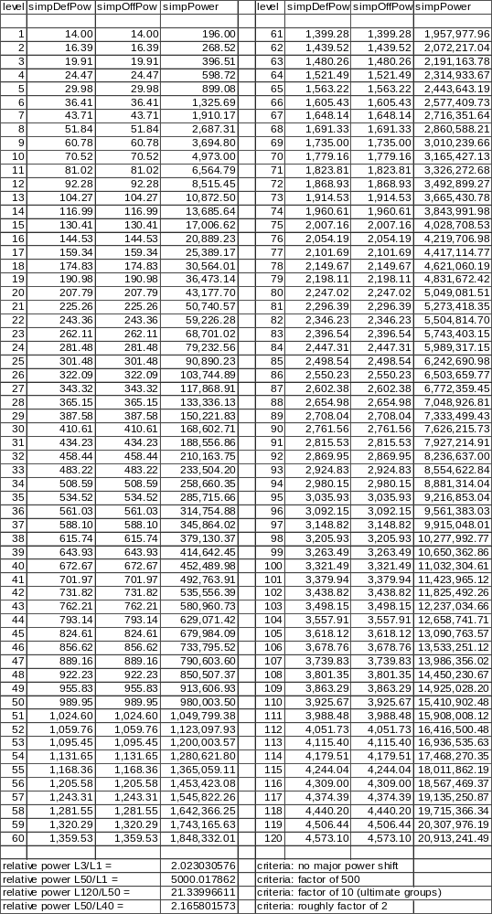
As formulas, we yield:
- SimpDefPow
= SimpDef Power Equation
= Represents simpDef’s contribution to the Power equation
(level)^{1.759815} + 13
- SimpOffPow
= SimpOff Power Equation
= Represents simpOff’s contribution to the Power equation
(level)^{1.759815} + 13
Having done this, we can also derive the power equation.
- Power
= Power Equation
= SimpDefPow * SimpOffPow
= ((level)1.759815 + 13) * ((level)1.759815 + 13)
((level)^{1.759815} + 13)²

Basic Extensions of the Simple Combat System
When we first began discussion of power, we noted that we were going to deal with a heavily simplified view of combat. Realize that what we have done up to this point essentially is to establish the shape and size of the power function. Additionally, we have identified that the power function consists of two pieces, the SimpDefPow formula and the SimpOffPow formula. This was useful for analyzing and understanding power and level and getting a rough feel for some numbers. However, it is meaningless in terms of a practical combat system. We need to start breaking up the simple terms into component pieces and assigning concepts to those components in order to yield anything worthwhile.

A Deeper Analysis of SimpDefPow and SimpOffPow
As previously noted, we have some basic relationships between our terms as follows:
(Equation 14.) Power = SimpDefPow * SimpOffPow
- SimpDefPow
= SimpDef’s contribution to power
= (level)1.759815 + 13
= SimpDef * (constant scalar)
- SimpOffPow
= SimpOff’s contribution to power
= (level)1.759815 + 13
= SimpOff * (constant scalar)
We can further stipulate that simpDef is comprised primarily of the character’s HP (number of hits they can survive) and their “defense ability” (likelihood of avoiding being hit). We’ll represent these two concepts as ActHP (the character’s actual HP) and ActDef (the character’s defense score). Thus:
- SimpDef
= Simplified defense
= ActHP * ActDef
Following similar reasoning, stipulate SimpOff as being comprised of a damage rating (ActDam) and an offensive rating (ActOff). Hence:
- SimpOff
= Simplified offense
= ActDam * ActOff
Combining (Equation 15.) and (Equation 17.), we realize that we can essentially take the raw scores for ActHP and ActDef, multiply them together yielding simpDef and scale it up linearly. The result is the term shown in (Equation 12.). Thus, with only a minor leap of logic, we can take the term achieved in 12, and divvy it out so that a portion is given to actHP and a portion to actDef. There are a number of ways to do this apportionment, but I have chosen one that I think works best. Equations look like:
- SimpDefPow
= Refined from (Equation 15.)
= (level)1.759815 + 13
= SimpDef * (constant scalar)
= ActHP * ActDef * constant
= (ActHP* constant) * (ActDef * constant)
We will presume that this takes the form
= ((level)1.759815 + 13)^{n} * ((level)1.759815 + 13)^{1-n}
A similar argument for offense yields:
- SimpOffPow
= Refined from (Equation 16.)
= (level)1.759815 + 13
= SimpOff * (constant scalar)
= ActDam * ActOff * constant
= (ActDam * constant) * (ActOff * constant)
We will presume that this takes the form
= ((level)1.759815 + 13)^{m} * ((level)1.759815 + 13)^{1-m}
We are left to simply choose values for n and m such that ActHP, ActOff, ActDam, ActDef scale as we desire.

Determining n, HP Concerns
As we find ourselves at the limits of what the equations are able to tell us, we must again explore what we desire in our MUD. Of the four terms, actHP, actDef, actDam, and actOff, it is with the actHP term that we will begin.
We begin by stipulating that we would like a max-level player to have roughly 1500 HP total. This number was arbitrarily chosen, but is based on the following concerns.
First, the number should be large enough that small differences in HP gained per level will be noticed. Secondly, the number should not be so great that the mud enters into the “twink” realm often characterized by MUDs that have players with tens of thousands of HP. Third, the allotment needs to provide newbies with a reasonable cushion of HP that will let them survive the learning curve. Finally, there is a gut instinct amongst the core-audience of MUD players (probably induced by expectations from playing AD&D) that a player should tend to approach about 1500 HP (or so) near max level.
(Historical Note: Around the time of SneezyMUD v2.5, max-level players were each hovering around 3500-5000 HP. Ultimate-group mobs thus were in the 30K+ HP range. There was a general feeling that the current trend was spiraling us toward becoming more and more twinkish. With the advent of v3.0, the max-level HP range was trimmed back to around 500. Over the next few years, it creeped-up slowly to perhaps 800 during v4.5. When the value of 500 was reestablished during v5.0 and v5.1, there was a general complaint about the lack of effect of various factors to significantly alter HP. This led to the push to make the value large enough to illustrate the effects of choices that players make.)
As we desire HP at L50 to be 1500, the equation that results is:
((50)^{1.759815} + 13)^{n} * K = 1500
Furthermore, we want newbies to have a reasonable pad of HP, we stipulate that L1 HP = 100. Thus:
((1)^{1.759815} + 13)^{n} * K = 100
(14)^{n} * K = 100
We solve this one for K:
K = 100/14^{n}
And plug it in to the other equation. Simple algebra follows:
((50)^{1.759815} + 13)^{n} * (100 / 14^{n}) = 1500
((50)^{1.759815} + 13)^{n} / 14^{n}) = 15
(((50)^{1.759815} + 13) / 14)^{n} = 15
n log(((50)^{1.759815} + 13) / 14) = log(15)
n = log(15) / log(((50)^{1.759815} + 13) / 14)
n = 0.635902
And hence:
K = 100/14^{0.635902}
K = 18.67131
The establishment of n also determines the score for actDef.
- SimpDef, ActHP and ActDef as a function of level
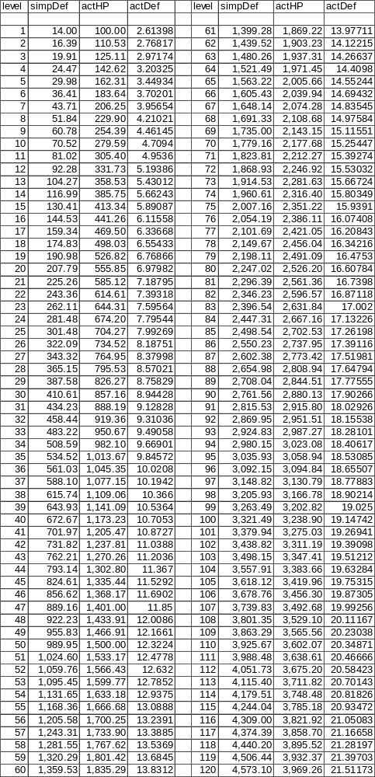
As some simple analysis of what the ramifications of this are, consider:
Newbies start with 100 HP (by design) and gain 10-15 HP per level. The 100 HP start should theoretically satisfy new players that need a learning cushion, while the newbie HP gain rate makes newbies go up in power nicely too.
Meanwhile, a high level player is gaining 30-33 HP per gain at max level. That’s sure to keep the megalomaniacs in the audience happy.
We further note that it is not until L35 that a player crosses into the realm of 1000+ HP. Since this is sure to be a milestone for players, it is good that it comes reasonably late in the player’s career.
Lastly, the ultimate-group mobs characterized by L100-L120 have 3300-4000 HP. This is fairly large (bordering on the twinkish), but should serve to make those L50 groups think once or twice before rocking the mud.
The relevant equations for all this are:
- ActHP
= Actual Hit Points for a character
18.67131 * ((level)^{1.759815} + 13)^{0.635902}
It is possible to further derive this equation, but doing so just makes the terms more complicated, so we’ll leave it as is.
- ActDef
= Actual “defense” for a character
((level)^{1.759815} + 13)^{0.364098}
Having achieved a formula for ActHP and ActDef, we can now move on and analyze the terms related to m, actDam and actOff.

Derivation of ActDam; An Analysis of SimpSurvRnds
Recall the SimpSurvRnds equation, which states that the number of HP a creature has, and the damage its opponent(s) inflict per round determines the number of rounds that creature lasts in combat.
Historically, a “round” of combat is 2-3 seconds long (real time). We desire that a “fair-fight” (more on this later) combat last about 3 minutes, which translates as roughly 60 rounds.
While this desire is mostly instinctual, we have noted problems from deviating in both directions. If combat takes a long time (150+ rounds), players grow bored and the mud suffers from tediousness. If combat is too quick (less than 30 rounds), a single round of combat can cause a tremendous shift in the outcome of the fight. Since NPCs logic during a fight is limited, we should expect that NPCs would make some flawed decisions fighting players. Thus we want combat to be long enough that a bad round or two of combat doesn’t make the fight a foregone conclusion. All things considered, 60 rounds for combat seems to make the most sense as a desired target.
(Note: I briefly toyed with the idea of having combat duration increase with level, so that newbie fights were relatively fast and high level ones were drawn out. It seemed realistic, but it caused some VERY bizarre alterations to have to be introduced to the system. I removed, and am avoiding reintroducing, this concept in order to keep the system simple.)
With the 60 rounds desired for a fair fight stipulated, the following algebra results:
SimpSurvRnds = 60
ActHP / ActDam = 60
ActDam = ActHP / 60
We can then write the ActDam equation as
- ActDam
= Creature’s actual damage
= ActHP / 60
= 18.67131 * ((level)1.759815 + 13)0.635902/ 60.0
0.311189 * ((level)^{1.759815} + 13)^{0.635902}
- ActHP, ActDam and SimpSurvRnds as a function of level
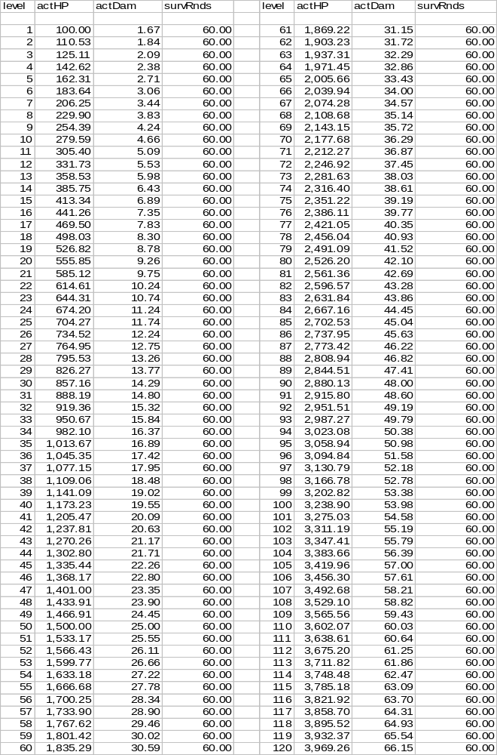

Derivation of ActOff
Since we now have values for m, we can also write the equation for actOff
- ActOff
= actual “offense” for a character
((level)^{1.759815} + 13)^{0.364098}
For reasons that will be made clear later, we desire ActOff and ActDef to match. We are free to multiply either equation by scalar constants, but since we want both functions to yield the same result, these constants must both be the same. With no reason to do otherwise, we set the constants in both equation to 1.0 (which we have not shown).
- ActOff and ActDef as a function of level
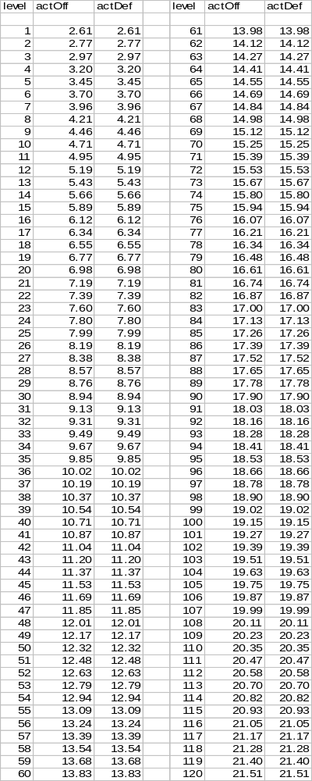

Extending the Basic Combat System

PCs and NPCs
At this stage of the discussion, it is useful to take a breather and insure that everyone is on the same page. To do this, we need to discuss terminology a bit, and to delve slightly deeper into what sort of a system we desire.
Characters in a MUD can be classified as either PCs or NPCs. This basically establishes whether a player is controlling the character’s actions, or if the creature is one that the MUD code is running. NPCs are synonymous with the MUDs monsters (sometimes called mobs).
The features of an advanced MUD tend to muddy the simple terms though. For example, your basic polymorph spell can cause PCs to transform themselves into the form of a mob. Likewise, other spells allow monsters to come under the control of the player. We need to keep these ambiguities in mind as we move forward.

Equating Systems between PCs and NPCs
For any given system we create, we should strive to keep things identical between PCs and NPCs.
This would seem like common sense, and yet, in many circumstances, implementers introduce different systems for the two character types. Anytime this is done, we should sharply analyze the reasons for doing so, as almost assuredly, it means that there is some basic failure or misapplication of the game design.
We have, up to this point, introduced five systems: level, damage, offense, defense and HP. Let’s analyze each in turn as they relate to PCs and NPCs.

PC and NPC level
First, there is level. We have already stated that level is to be defined as how “advanced” a given character is. Following our axiom, PC level and NPC level ought to equate. Obviously, the only equating that can be done is in terms of the combat system. So what we are essentially saying is that a PC and an NPC of the same level ought to be roughly the same difficulty.
This statement frequently raises a great number of questions. Realize that we have not yet introduced a very exotic definition of a “character”. For example, we lack important things like class, skills, race, etc. This leaves us a fairly generic definition of a character. So when we say that we are equating NPC and PC level, don’t flip out trying to rationalize if a mage and a warrior of level X are the same. We will come back to this in a bit, but let’s simply use our generalized definitions of “player” and “mob” for the time being.
And so, what we establish is that a player and a mob of the same level are equal. As game developers, we will analyze what this means, but we should also note that by equating level, things work out very nicely for the players of the MUD. Typically, a MUD will provide a simple “consider” command for players to evaluate NPCs strengths and weaknesses. By devising a system where equal levels equate to equal power, this greatly simplifies these sorts of considerations.
Also, the result is that by equating level, we are essentially making the declaration that we expect and desire players to be fighting like-leveled mobs in single combat.

PC and NPC HP and Damage
Proceeding onwards to the HP and Damage systems, our axiom states that mobs and players ought to have the same HP and do the same damage, at a given level.
Again, the statement is simple common sense from a simple axiom, but frequently, MUDs do not adhere to it. I must confess; Grimhaven was for a long time a violator of this axiom and so I can speak quite knowingly about the problems and the rationalizations for making this mistake.
MUDs lacking a solid game-design frequently find themselves in an unbalanced state. Players are leveling too quickly, or mobs are too easy, or any one of a number of concerns occurs. The common mistake made by implementers in this situation is that mobs need to be increased in power to accommodate. If mobs had 10% more HP, than they wouldn’t get killed so quickly and we wouldn’t have this problem, right? Obviously, this is false logic indicating a basic problem or lack of an overall game design. However, the logic of this sort of statement is compelling to implementers, because it is such an easy “fix” that avoids addressing the bigger questions.
And so, MUDs evolve where the relative values of HP between PCs and NPCs are slightly different. Implementers make fine-tune adjustments to HP (and possibly damage too) to restore an equilibrium state. Hopefully, they are successful, but regardless, it becomes viewed as natural that NPCs and PCs do not need the same values for HP and damage systems.
In general, this is true. Provided the SimpBalancedCombat equation is in balance, PCs and NPCs could be designed with different systems for HP and damage. However, remember what we said before about the possibility of ambiguity between PCs and NPCs. If we have one system of HP/Dam for players and another for monsters, what happens when a monster becomes a “player” and vice versa? Which system should a polymorphed player use? What system do monsters under a player’s control use?
As an example, consider a system that has mobs having more HP than players (and doing less damage consequently). A charmed mob would become a very good tank for a player because of the greater number of HP it possesses. Alternatively, we could convert the mob (upon charm) to be on the player’s scale for HP/damage, but now we are talking about making some very bizarre changes to accommodate such a system.
Furthermore, having separate systems of HP and damage for PCs and NPCs will result in calculations having to frequently be converted. The scale factors will have to be taken into account all over the place, and in general, our formulas will be cluttered needlessly.
Hey, I like a challenge as much as the next guy, but how about we just take the hint and keep things simple by making the HP and damage systems for PCs and NPCs the same. By factoring out any differences in the two systems, this simplifies the SimpSurvRnds and SimpBalancedCombat equations:
- SimpSurvRnds
= Refined from (Equation 5.)
= SimpHP / (opponents SimpAvgDam/Rnd)
= SimpHP / SimpAvgDam/Rnd
Given our more refined combat system, this should in fact be written:
- SurvRnds
= Survival Rounds
= ActHP / ActDam
= This could be derived further after adding level-based terms. Doing so does not add to the clarity though.
Based on the design constraints we used, SurvRnds yields 60 rounds for a fair-fight.
- SimpBalancedCombat
= Refined from (Equation 6.)
_{SimpHPa} * SimpAvgDam/Rnd_{a} = SimpHP_{b} * SimpAvgDam/Rnd_{b}
SimpHP * SimpAvgDam/Rnd = SimpHP * SimpAvgDam/Rnd
This can also be extended to our more exotic system:
- BalancedCombat
= Balanced Combat Equation
_{ActHPa} * ActDam_{a} = ActHP_{b} * ActDam_{b}
Under our simplified definition of mobs and players, this is the rather trivial statement that says balanced combat occurs when both “a” and “b” are the same level. However, don’t dismiss this equation too quickly; it will become much more important once some refinement is done about mobs and players.

Prologue to Combat Hit Percentage
We have previously determined a formula for ActDam; representing how much damage we expect to be inflicted per round of combat. Realizing that our combat system deals with both hits and misses, we should start analyzing combat in terms of the chance of a hit occurring (hit percentage, or HitPerc).
In general, we would like the HitPerc system to be somewhat dependent on level. That is to say, in an even match, both combatants will hit equally as often, but in a skewed battle, the higher-level combatant will hit more often, and conversely, the less skilled combatant hits less often.
Furthermore, we would like HitPerc, for even fights, to be as high as possible. A higher HitPerc translates into more blows landing, and consequently less damage per blow. The more damage a blow does, the more impact each blow has. Since we don’t want a single event to vastly swing the outcome (players like predictability) of fights, this means we want low damage per blow, and therefore, as high a fair-fight HitPerc as we can achieve.
We also want to make sure that HitPerc is always less than 100% for any conceivable fight. Since we have conceptualized a L120 mob (ultimate-group mob), we need to insure that L120 vs. L1 fights yield a hit rate no greater than 100%

Damage Capacity
As we have defined ActDam as the damage that is actually inflicted per round, we can now discuss the DamCap equation. DamCap is simply defined as the amount of damage inflicted by a blow that hits. Algebraically:
DamCap * HitPerc = ActDam
The DamCap term is constant for a given level character. That is, a L10 character will have the same DamCap regardless of whether they are fighting a L5, a L10 or a L100.
- DamCap
= Damage capacity of a character
= The average damage per successful blow that hits
= ActDam / HitPerc

Combat Hit Percentage
Returning our attention to HitPerc, we should now have all the necessary information to establish a proper equation.
We rationalize that HitPerc is simply a comparison between the combatants ActOff and ActDef scores. Thus:
- HitPercForm_{ab}
= Format of HitPerc formula
= (constant) * (ActOff_{a} / (ActOff_{a} + ActDef_{b}))^{n}
As we want the ratio between two players powers to be the ratio between their survival rounds, the following can be said:
_{Powerb}/Power_{a} = ActHP_{b} * DamCap_{b} * ActOff_{b} * ActDef_{b} / (ActHP_{a} * DamCap_{a} * ActOff_{a} * ActDef_{a})
And:
_{SurvRndsb}/SurvRnds_{a} = [ActHP_{b}/(DamCap_{a} * HitPerc_{ab})] / [ActHP_{a}/(DamCap_{b} * HitPerc_{ba})]
Equating the two and canceling common terms:
_{ActOffb} * ActDef_{b} / (ActOff_{a} * ActDef_{a}) = HitPerc_{ba} / HitPerc_{ab}
Plugging in from (Equation 30.):
_{ActOffb} * ActDef_{b} / (ActOff_{a} * ActDef_{a}) = (ActOff_{b} / (ActOff_{b} + ActDef_{a}))^{n} / (ActOff_{a} / (ActOff_{a} + ActDef_{b}))^{n}
Since ActOff_{a} = ActDef_{a} and ActOff_{b} = ActDef_{b}:
_{ActOffb}² / ActOff_{a}² = (ActOff_{b} / (ActOff_{b} + ActOff_{a}))^{n} / (ActOff_{a} / (ActOff_{a} + ActOff_{b}))^{n}
Algebra on the RHS:
_{ActOffb}² / ActOff_{a}² = (ActOff_{b} / ActOff_{a})^{n} * ((ActOff_{a} + ActOff_{b}) / (ActOff_{b} + ActOff_{a}))^{n}
And:
_{ActOffb}² / ActOff_{a}² = (ActOff_{b} / ActOff_{a})^{n} * 1^{n}
Finally:
_{ActOffb}² / ActOff_{a}² = (ActOff_{b} / ActOff_{a})^{n}
Thus we prove that n=2 for the HitPerc equation.
For our worst-case scenario, a L1 vs. L120 fight, we would have ActOff=21.51171 and ActDef=2.613984. We wish the HitPerc to be 1.00 for this situation, hence:
(constant) * (ActOff_{a} / (ActOff_{a} + ActDef_{b}))² = 1.0
constant = 1.0 / (21.51171/(21.51171+2.613984))²
constant = 1.257795
We’ll use a value of constant=1.25 just to insure that there is a slight chance for a miss even in the extreme case.
- HitPerc_{ab}
= Chance of A hitting B
1.25 * (ActOff_{a} / (ActOff_{a} + ActDef_{b}))²
The interesting case is for a fair-fight; ActOff=ActDef for both combatants, so we realize that the two combatants are scoring hits:
HitPerc (fair-fight) = 1.25 * (1/2)²
= 1.25/4
= 31.25% of all swings
This also lets us refine DamCap, since we now know both HitPerc and ActDam for a fair-fight:
- DamCap
= Refined from (Equation 29.)
= ActDam / HitPercab
= [0.311189 * ((level)1.759815 + 13)0.635902]/ 0.3125
0.9958 * ((level)^{1.759815} + 13)^{0.635902}
Unfortunately, there is no good way to show all the possible combat scenarios. I’ve plotted some “interesting test cases” in the forthcoming spreadsheet. Please note that the information is double-line. That is, A hitting B is on line 1; B hitting A is on line 2. The ratio of the survival rounds is plotted, as is the ratio from the power equation. The final column is simply the ratio of the two powers.
- Some Combat Scenarios; HitPerc, SurvRnds and the resulting Power
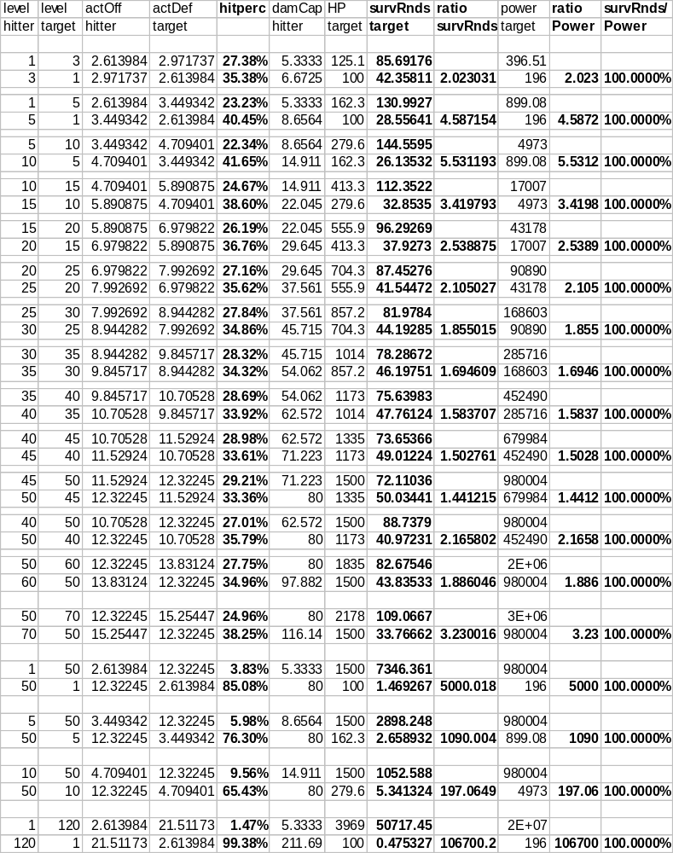Examining the scenarios, we are able to note some interesting factoids.
First, the range of HitPerc in “skewed” fights is reasonable. The L1/L50 fight reveals a 3.83%/85.08% spread, meaning that at least a few shots will score.
The L10/L50 scenario is interesting as it shows the result of an exploring player wandering into the wrong zone. Such a player has 5 rounds to escape, which is hopefully adequate, albeit scary for the player. Obviously, if the level difference is not as extreme (L20/L50 for example), the player has even more rounds of survival before dying.
More traditional fights, in which the combatants are within 10 levels of each other, show a reasonable spread around 31.25%. Players tend to evaluate HitPerc by counting number of blows that hit over a relatively small number of rounds. Generally, HitPercs within 5% of each other are not discernable to players, so it is good that the HitPerc spread is as it is.

Coming Full Circle with Basic Combat
The Power ratio and SurvRnds ratio are exactly identical. This is of course good, as it is what we intended and it brings us full circle. We established the power equation initially, and from there achieved ActDam, ActHP, ActOff and ActDef. From those, we derived HitPerc, which allowed an accurate prediction of SurvRnds. The SurvRnds equation, when taken as a ratio between combatants, can be thought of as a relationship between the combatant’s power values. It is good that the two ratios are the same as it validates all the work that we have performed.

Mob Difficulty and Experience Points
Having adequately modeled the basis of our game design, it is time to move onwards and start to hook other necessary pieces of the MUD into this system. The most logical extension we can make is to start a discussion of the XP system.

A Basic Definition of XP
Recall in the discussions of power, that we are representing power as how advanced a given creature is. Additionally, we have the concept of level denoting discreet milestones along the advancement path. It seems natural that we will need some mechanism for measuring advancement. The term that DIKU MUDs typically apply to this concept is XP.
That is to say, as players fight and defeat various NPCs, they are awarded XP denoting their success. After accumulating sufficient XP, they become eligible for increasingly greater levels. It’s a fairly simple and straightforward system, so I won’t spend too much time on the basics.

Mob XP Desires
Given the definition of power, it seems fairly reasonable to say that the XP a mob awards is directly related to the mob’s power. Let us explore some of our desires for how the XP system should behave…
First, Experience has demonstrated that a mob’s XP ought to exceed its HP. This is simply so that if a character does a minimal amount of damage (1HP), it will be sure to receive at least 1XP.
Additionally, XP should not be exceptionally large for any given level mob. Since players will have to kill multiple creatures per level, and that XP is additive over all levels, this translates into players needing HUGE amounts of XP at the higher levels. If we make the XP per mob too large, player’s necessary XP to level will be much bigger. Assuming that XP is tracked as an integer, we have some limitations on the scale imposed by the hardware architecture. MaxInt is 2³²-1 = 4294967295. We can probably expect that a player, over their entire career, will kill 1000s of mobs. We also want to leave a bit of padding to let players continue to kill things after obtaining L50. So we should strive for mobs having on the order of 100000 XP (100K XP) at L50.
Also, we also seek to encourage players to group together to bring down (larger) foes, and simultaneously discourage the efforts of “plowers” (butchering large numbers of greatly inferior foes). That is to say, if two players combine forces, we assume their combined power is simply the sum of their individual power. (An overly simplified assumption! More on this much later.)
If we seek to encourage grouping, then the XP of the mob that they can kill combined should exceed the sum of the XP that they could kill separately. That is to say, if two players can each kill a mob worth 100 XP solo (total gain of 200), then together, we would like them to be able to kill a single mob worth 200+ XP. They gain more by cooperating, and we encourage grouping.
The flip-side argument is that we want to discourage players from plowing. Fighting numerous, wimpy creatures (sequentially) is inherently less risky as a player can always opt to stop the sequence short if they get into trouble. This isn’t necessarily a bad thing, but we should probably take this risk factor into account and make it so that the XP of a single mob will beat the XP of numerous mobs when Power is kept constant. That is to say, if we determine that 1 L3 = 2 L1 in terms of power, we want L3 XP > 2 * L1 XP. This will encourage players to take on the biggest mob that they feel they can successfully do.

Deriving Mob XP
Let us assume that Mob XP is some function of Power, and takes the form:
- MobXPForm
= Format of Mob XP equation
= K (Power)^{n}
Where K is some scaling constant, and n is some exponential power.
Based on the “grouping benefit” that we desire, let us first stipulate that we want XP to be 10% larger at the point where power has doubled. That is, when power has doubled, XP has gone up by a factor of 2.2. Equations then become:
K (power₁)^{n} / K (power₀)^{n} = XP₁ / XP₀
(power₁)^{n} / (power₀)^{n} = XP₁ / XP₀
(2 * power₀)^{n} / (power₀)^{n} = (2.2 * XP₀) / XP₀
2^{n} * power₀^{n} / power₀^{n} = (2.2 * XP₀) / XP₀
2^{n} = 2.2
n log(2) = log(2.2)
n = log(2.2) / log(2)
n = 1.1375
Furthermore, we have a desire to keep XP > Power at all points. Since XP is an increasing function of power, we simply need to focus on the lowest power. No character can be less than L0, so the relevant equation is:
L0 power = (0^{1.759815} + 13)² = 169
Similarly, the lowest possible HP is for a L0, which we calculate as:
L0 HP = (0^{1.759815} + 13)^{0.635902} * 18.67131
= (13)^{0.635902} * 18.67131
= 95.39678
Since we want L0 XP to be greater than L0 HP, the following occurs:
L0 XP >= L0 HP
K (L0 power)^{1.1375} = L0 HP
K ((0^{1.759815} + 13)²)^{1.1375} = 18.67131 * (0^{1.759815} + 13)^{0.635902}
K ((13)²)^{1.1375} = (13)^{0.635902} * 18.67131
K = (13)^{0.635902} * 18.67131 / (13)^{2.2750}
K = (13)^{0.635902} * 18.67131 / (13)^{2.2750}
K = 0.27881
The equation becomes:
- MobXP
= NPC XP
= K * Power^{n}
= 0.27881 * Power^{1.1375}
= 0.27881 * ((level^{1.759815} + 13) * (level^{1.759815} + 13))^{1.1375}
0.27881 * (level^{1.759815} + 13)^{2.2750}
- Level, ActHP, Power and MobXP
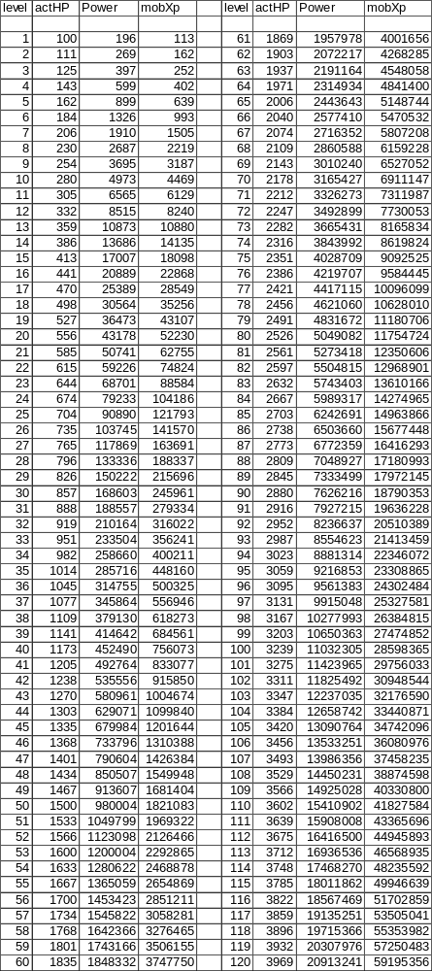
As some basic analysis, we realize that XP exceeds both power and HP at all points. This means that even for the most trivial of damage, a player can always expect to get some XP.
Furthermore, XP does what it is supposed to as power doubles.
Likewise, XP for a L50 mob is 1821083. Let’s take a rough guess and say that the player’s career (gaining from L1-L50) will require 650 * L50 XP (we’ll revisit this assumption in a little while), we get a result of about 1.2 billion XP for the player’s career. Our data type can hold a value of 2³²-1 = 4294967295 (4.3 billion). This yields a spare capacity of roughly 3.1 billion XP, or approximately 1700 mobs of L50, or 50 mobs of L120. It is unlikely that even the most die-hard of players will play their character long enough to kill 1700 L50 creatures after they have maxed to L50. Thus we should not run into any data-overflow problems.

Discouraging Nibblers; XP Rewards for Partial Kills
As a final piece of commentary on the MobXP formula, we have discovered that having XP grow in excess of power has the potential to create a situation where “nibbling” is promoted. Recall, even in extreme combat scenarios (L1 vs. L50 for example), the low level still has a fairly decent (3.83%) chance of hitting the high level. They don’t do tremendous damage, and are unlikely to survive very long. However, because the high level target has a great deal of XP, it is possible that the XP they gain from the small amount of damage they are able to do might exceed the XP they would gain fighting more evenly matched opponents. Players that seek to advance this way have become known as nibblers.
Obviously, the gaming system ought to discourage such an obviously flawed strategy.
Since we know that XP grows as Power^{1.1375}, we conclude that XP ought to be awarded at an equivalent rate. That is to say, if I inflict 50% damage on a creature, I should only receive (0.50)^{1.1375} = 45% of the XP. Obviously, the remaining 55% of the mob’s total XP is awarded while damaging the remaining 50% of the mob’s HP. Said another way, the amount of XP earned for the first few HPs of damage are not worth as much XP as the XP earned as a mob is about to die. We are in effect back-loading the XP award toward the end of the fight, with the “back-loading” factor (nibbler exponent) being 1.1375.
We must note that 1.1375 as the nibbler-exponent makes nibbling break-even. I will get as much XP using the nibble method, as I would get if killing at my level. This is probably satisfactory, as the risk of leaving a bunch of partially injured, angry mobs around is fairly dangerous, and if there is no XP benefit from doing so, players are unlikely to pursue this method of play.
However, there is no compelling reason not to raise the nibbler-exponent above 1.1375 to further discourage this playing style. Doing so not only means that there is a greater risk from the injured mobs, but also makes the XP reward less that what would be gained by fully killing an evenly matched mob. (There is probably a practical upper limit on how high the nibbler-exponent can go given by the requirement that we want every point of damage to yield 1 XP.) In any event, we will use a value of 1.15 as the nibbler-exponent.

Prelude to the Kills to Level Equation
Having established the amount of XP each mob is worth, the next logical step is to establish how many mobs must be fought for a player to gain each successive level. Obviously, not all mobs are the same; lower level ones are easier. But we have previously stated that we have an expectation that players are fighting mobs of their own level. So what we are really trying to establish is how many mobs, of my own level, must I fight in order to advance to the next highest level. This is inherently subjective. Some generalities can be stated however.
First, the number of kills should probably increase with level. Fewer kills needed as a newbie, but more kills needed later on. This serves to make the game fairly easy for new players, sucking them into the game by tossing them a few easy levels. For the long-term player, it draws out the time commitment needed to advance, making achieving high-level more time consuming.
A problem often encountered by MUDs is that of poor distribution of player levels. Players seem to advance quickly to a given level (few players of these levels), then stall (lots of players in these levels), then finally break out and advance onwards toward max level.
Frequently, the cause of this is that the MUD has poor power management. Mobs vs. PC power is skewed toward the PC during the levels that they rise rapidly, and skewed the other way when players hit the wall. Our game design ought to alleviate problems of this sort.
However, we should be careful with how we define the kills system, as choosing a bad system can cause too rapid a change in the kills for each successive level and also create a system with a bad histogram of player levels. For this reason, we are encouraged to choose some sort of linear function.

Deriving PlayTimePerKill
Lastly, the kills to level is one of the governing equations in determining how long it takes for a player to obtain max level. Most implementers have a gut feeling for how long this ought to take, and for our part, we have settled on 35 days of play (840 hours).
We have already stated that 1 round of combat will take roughly 2.5 seconds. Additionally, we can assume (arbitrary) that every round spent fighting also requires 1.5 to 2.0 rounds of recuperation. Furthermore, players will often socialize (wasted time), and setbacks (death, XP loss, etc.) will also occur. As a rule of thumb, we have found that for every round spent fighting, 9 rounds are spent in other activity. This results in
- SimpPlayTimePerKill
= Simplified time spent achieving each successive kill (rule of thumb)
= SurvRnds * 10 * 2.5 secs/round
= SurvRnds * 25 secs/round
The SurvRnds formula is fairly complex, so I won’t confuse the discussion by rewriting it here.
Realize that players are quite capable of gaining XP at a faster rate than what this suggests, and that what this attempts to capture is the long-term view of playtime. Players will not just monotonously kill and recuperate, but will inevitably also socialize, explore and do other activities. Similarly, they will probably die, losing XP, and be forced to recover. This leads to the 25 seconds/round rule-of-thumb for gaining insight into the long-term view of playtime per kill.
Newbies are more likely to maintain the kill/recuperate cycle exclusively rather than get sidetracked socializing. We roughly estimate that newbies only require 10 secs/round, thus we can refine (Equation 35.) and state:
- PlayTimePerKill
= Time spent achieving each successive kill (rule of thumb)
= Refined from (Equation 35.)
= SurvRnds * min(25, level + 9) seconds/round

Deriving Kills Per Level
Given what we stated previously about KillsPerLevel, we can model this equation as:
- KillsPerLevelForm
= K (level) + C
Where K and C are scaling constants.
If we restrict our view to newbie levels, we can establish the value for C. We know each fair-fight kill takes 60 rounds. Further, newbies tend to do the kill/recuperate cycle so we are fairly safe in saying a newbies PlayTimePerKill is only 10 seconds/round. We would like a newbie to be able to gain level 2 with less than an hour of playtime (40 minutes = 2400 seconds). At 10 seconds/round and 60 rounds/kill, we get a value of 600 seconds/kill. Thus, we establish that we want 4 kills for a newbie to advance. The value of C is 4.
We are then left with only one unknown (K). We combine this with the PlayTimePerKill formula, and strive to get the sum, over all 50 levels, to yield the 840 hours of playtime desired. The resulting value was K=1.53548.
(Note: Solving this equation exactly gets rather complex and does not add anything to our understanding. It was simpler for me to spreadsheet (not provided) it and use trial & error to get the final answer above.)
Hence:
- KillsPerLevel
= Kills per Level
= number of mobs of my own level I must kill to gain next level
1.53548 * (level) + 4
- PlayTime as a Function of Level and KillsPerLevel
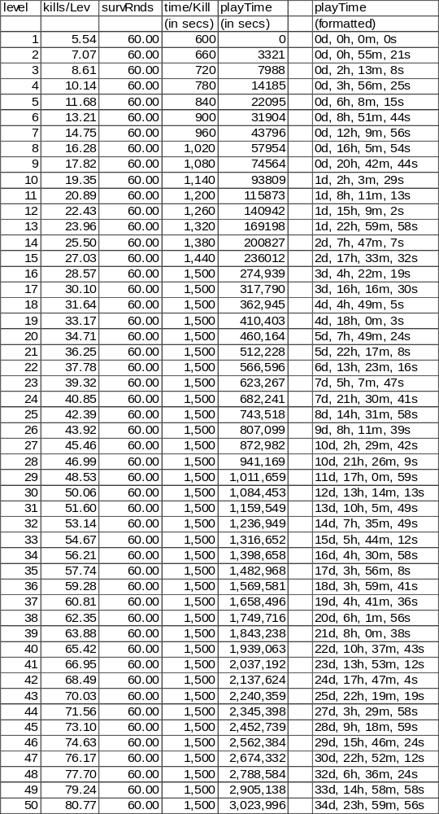

Deriving the XP Tables
The XP required for each successive level can be gotten from summing KillsPerLevel * MobXP for all levels.
- XPForLevel and KillsPerLevel versus level
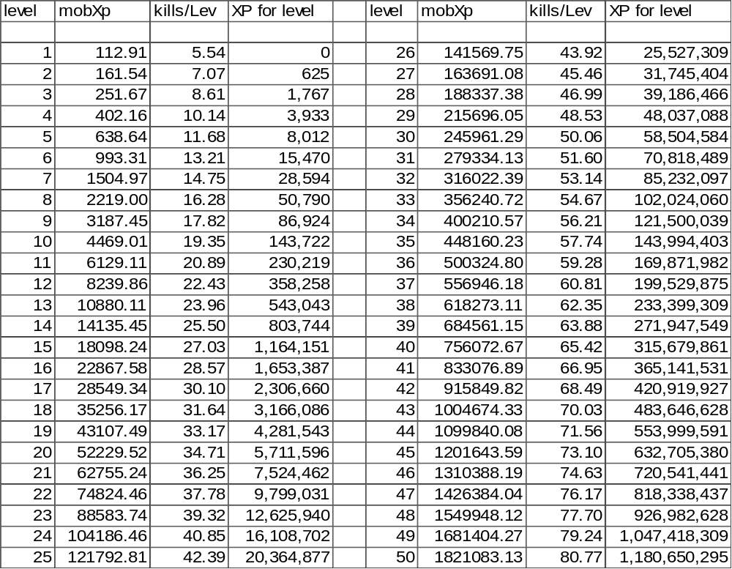
Since players will inevitably want nice, round numbers for the XP for level numbers, we should probably round some of these values up and present them in a reasonably acceptable format. Rounding up the XPForLevel technically alters the KillsPerLevel equation, but since KillsPerLevel was created fairly arbitrarily, we are fairly safe in doing this. We add in slight deviations from our theoretical plot, but we wind up with a nice round 1.2 billion XP to level 50.

Introducing Armor into Our System
As we continue to advance our game design, it is worthwhile to note that we remain somewhat rooted in a theoretical realm, isolated from the concepts and themes with which implementers deal with on a day to day basis. We have a number of nice, fuzzy equations, but if there are no good ways to implement them, they are fairly moot. Let us begin to worry about practical implementation.

Avoiding the Pitfalls of AD&D
Amazingly enough, the RPG that gets most people interested in MUDding in the first place is, in fact, poorly suited to running a MUD. As AD&D aficionados know, AD&D deals with things like AC, tohit modifiers, todam modifiers and the like. Obviously, these concepts were added to AD&D in order to allow the AD&D system to model things using the semi-convoluted system of dice that is its trademark.
As RPGs moved away from paper, pencil and dice toward the computer, many of these terms remained intact and implementers are loathe inventing their own system, so they piggyback on what went before. Unfortunately, many of these systems are ill suited to the realm of bits and bytes because they add needless confusion. This will become even truer as AD&D is relegated to the ash-heap of history and younger players with no concept of E. Gary Gygax, and co. come onto the scene.
For the most part, we should design our MUD to use intuitive and natural frameworks. If players think in terms of “this helm is good for a L10”, then we should be thinking in terms of level-based armor. Too often, however, MUDs continue to hold onto concepts like “AC”. This forces players to do bizarre contortions of trying to determine what AC they want on their helm for their L10 PC. This is senseless; new players to the MUD have enough things to sort out without adding additional concepts that aren’t intuitive.
As we develop systems, we should strive to maintain an intuitive interface for players. Likewise, that same interface should be provided to builders to streamline the building process. If we are going to maintain “armor” or “AC” under the hood, that’s OK, but it should be an implementation detail that is not exposed except in rare circumstances.
Please do not confuse this as an argument for “vague terms”. I am not insisting that raw numbers be concealed behind fuzzy phrasing (“Your helm is very buff.”) as that is a matter of personal choice not predicated on anything related to Game-Design. I am simply encouraging that the system uses something like: “The helm is good for a L10.” rather than “The helm has 65 points of armor”. The former phrasing is completely understandable to any player, while the latter forces players to perform a WTF as they try to understand what a point of armor is, how many they need, and whether this helm has the appropriate amount for their level or not. Confused players are unhappy players.

A Prelude to Armor Implementation
With all that said, it’s time to do exactly what I just encouraged you not to do and devise an “armor” system. This armor system is necessary for reasonable implementation. Provided we conceal the armor system under the façade of the intuitive interface, we avoid hypocrisy. We will use an armor system behind the scenes, and display a level-based interface to players and builders. A builder will create a helm with “L10 armor”, and we will let the mud determine what that means in terms of our internal armor system.
We have previously determined an equation for ActDef=(level^{1.759815} + 13)^{0.364098}. Also recall that this term encapsulates the amount of armor a character has, as well as other things (position, skill, etc.) that contribute to “defense”. Therefore, we must break ActDef into two component pieces, SimpArmor and SimpDefSkill. The two together will combine to create ActDef.
Likewise, on the offensive side we have ActOff=(level^{1.759815} + 13)^{0.364098}, which is also composed of things like position, skill, etc. For the sake of symmetry, we should create two component pieces. The first, SimpOffSkill, counterbalances SimpDefSkill, while the second, SimpFinesse, will counterbalance SimpArmor.
It should not be a major leap of intuition that certain relational concepts, like position should be taken outside the actOff/actDef system. For instance, we will presume that both combatants are standing, on even-terrain with no prevailing hindrances to either party for the sake of the remainder of this discussion. If in fact, one combatant is prone, or uphill of the other, or etc., this should be modeled as a bonus/penalty above and beyond the standard ActOff/ActDef system. Hence, we take these items out of the discussion for the time being.

A Basic Overview of Combat Dynamics
To model reality, we would expect that a given combat swing might result in:
1) An outright miss.
2) The defender dodging the swing.
3) The blow being parried by the defender.
4) The blow landing, but in such a fashion that it is essentially deflected.
5) The blow landing, but the armor partially absorbs the energy.
6) The blow landing without absorption.
The ActOff and ActDef values will dictate the size of these bins, as expressed as a percentage of all swings.
Using the terms already discussed, we will utilize the SimpOffSkill and SimpDefSkill to determine if the blow lands, or if the intended victim is able to escape on skill alone.
Likewise, once we have determined that the blow has landed, it will be up to SimpFinesse and SimpArmor to determine how well the blow hits and what affect it will have on the victim.
Since we have previously made actOff and actDef come out numerically equivalent, and we have parity between a component piece in one and a component piece in the other, it seems fairly reasonable to expect numerical equivalency between SimpFinesse/SimpArmor and SimpOffSkill/SimpDefSkill. We have an arbitrary desire to weigh the importance of equipment higher than that of skill; hence we do the following:
- SimpFinesse
= Simplified Finesse component of ActOff
= (ActOff)^{0.45}
= (((level)1.759815 + 13)0.364098)^{0.45}
(level^{1.759815} + 13)^{0.163844}
- SimpOffSkill
= Simplified offensive skill component of ActOff
= (ActOff)^{0.55}
= (((level)1.759815 + 13)0.364098)^{0.55}
(level^{1.759815} + 13)^{0.200254}
Similarly,
- SimpArmor
= Simplified armor component of ActDef
= (ActDef)^{0.45}
= (((level)1.759815 + 13)0.364098)^{0.45}
(level^{1.759815} + 13)^{0.163844}
- SimpDefSkill
= Simplified defensive skill component of ActDef
= (ActDef)^{0.55}
= (((level)1.759815 + 13)0.364098)^{0.55}
(level^{1.759815} + 13)^{0.200254}
Remember that, like ActOff and ActDef, these values are simply raw numbers. We are still free to throw a constant scaling multiplier into the mix, provided we do so to both sides of the equation.
- SimpFinesse, SimpOffSkill, SimpArmor and SimpDefSkill as Functions of Level
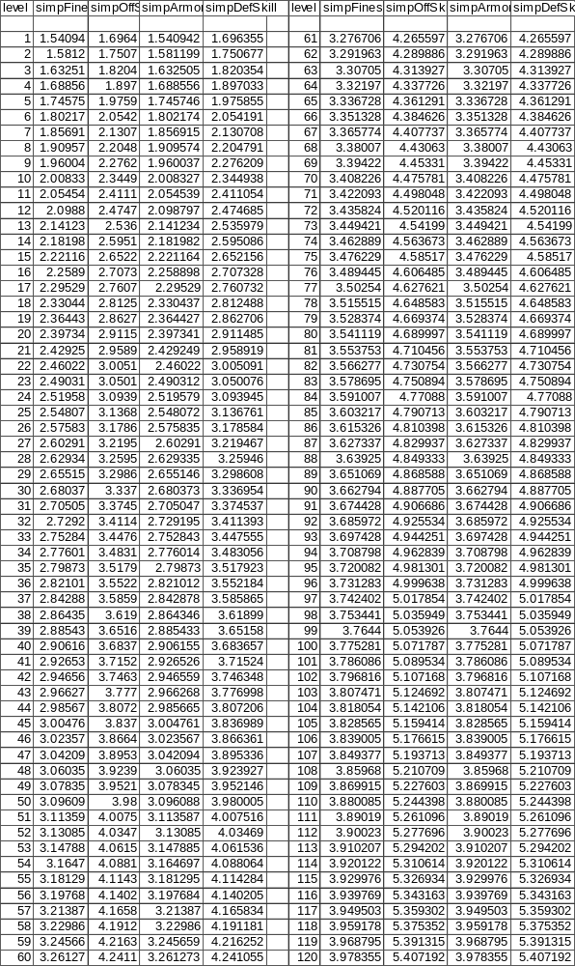

A Brief Dissertation on the Meaning of (Spreadsheet 9.)
Analyzing the table data is still fairly difficult because the quantities have yet to really be associated with real concepts. However, we are able to note a few things.
If we compare the L50 values to their L1 values, we can get a feel for how much of an improvement occurs over the course of the player’s career.
For instance, SimpArmor goes from 1.541 up to 3.096. This is a 100% improvement and implies that high-level armor is 2X more armor than the newbie variety.

Divvying up SimpArmor
On the scale thus far, SimpArmor proceeds from 1.540942 at L1 to 3.096089 at L50. We have a desire to 1) use an integer scale, 2) have enough points to spread a chunk around to each level, and 3) have enough points per level to spread points out to each piece of armor a player might wear.
As such, we choose to multiply SimpArmor by 10000 in order to provide the fine resolution we need. Consequently, the multiplier for SimpFinesse is also 10000. We will call these newly scaled terms ActArmor and ActFinesse.
- ActFinesse
= Actual Finesse component of ActOff
= 10000 * SimpFinesse
= 10000 * (level1.759815 + 13)0.163844
- ActArmor
= Actual armor component of ActDef
= 10000 * SimpArmor
10000 * (level1.759815 + 13)0.163844
Analysis of (Spreadsheet 9.) indicates that doing this yields 402 new points of armor between L1 and L2, and 177 new points of armor between L49 and L50. Since there are 18 places for armor to be worn, this means that each new level will result in at least a few extra points of armor being accumulated on every piece.

A Suit of Armor
A complete set of armor consists of:
1.) Head piece
2.) Neck piece
3.) Body armor
4.) Shield
5.) Back armor
6.) Arm piece – left
7.) Arm piece – right
8.) Wrist piece – left
9.) Wrist piece – right
10.) Glove – left
11.) Glove – right
12.) Ring – left
13.) Ring – right
14.) Waist Piece
15.) Legging – left
16.) Legging – right
17.) Boot – left
18.) Boot – right
Each piece in the suit ought to represent some fraction of the total AC for the suit. These fractions are fairly arbitrarily assigned, but they are constrained by some realistic limits.
- Percent of ActArmor Found on Any Given Equipment Slot
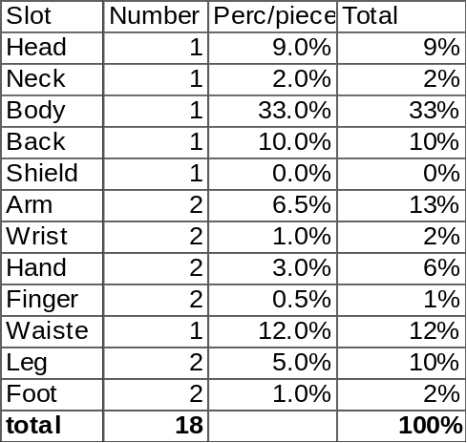
The above numbers were chosen totally arbitrarily.
Note that we don’t assign any armor to the shield. We’ll come back to how a shield should be handled in a bit, but for the time being recognize that it is not a piece of equipment that possesses an “armor” rating.
- Equipment Armor by Level and Equipment Slot
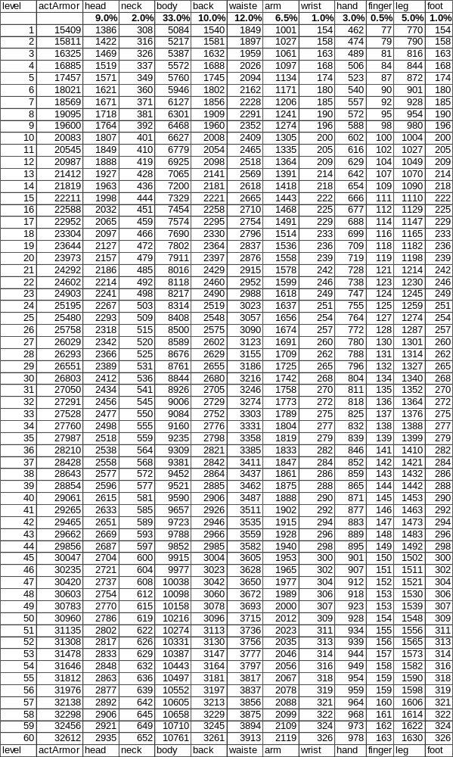

Clothing and Other Worn Equipment
While there is a great demand in a fantasy RPG for equipment that can be classified as armor, we also have to realize that many items of clothing are not manufactured with combat in mind. In fact, from a realistic point-of-view, most items would be made of simple cloth and designed for everyday use rather than the harsh conditions that adventurers are likely to subject them to.
Furthermore, certain classes, developed further on, will clearly be viewed as not being fully decked out in gleaming metal. The archetypical magician in a fantasy setting usually wears nothing more than simple robes.
Therefore, the concept of clothing comes into being. Clothing will be defined as being another type of worn equipment, but which was built with little or no regard for a combat setting. Clothing is, by its nature, also less encumbering.
Since some classes will be required to wear clothing (partially or completely), and we recognize that player’s will also want to enhance their equipment as they progress, clothing will also need to have a level associated with it. Also, while clothing is certainly no equivalent of armor, it does provide some protection over being naked.
We will arbitrarily state that clothing offers 50% the ActArmor of actual armor for a given level. That is to say, if my character were completely outfitted in clothing, I would have an armor rating half that as if I was wearing equivalent level armor. Therefore:
- ActArmCloth
= Armor value while wearing clothing
= 0.5 * ActArmor
= 0.5 * 10000 *
5000 * (level^{1.759815} + 13)^{0.163844}
The armor-value will break down in the same fashion as it does for actual armor.
- Clothing Armor by Level and Equipment Slot
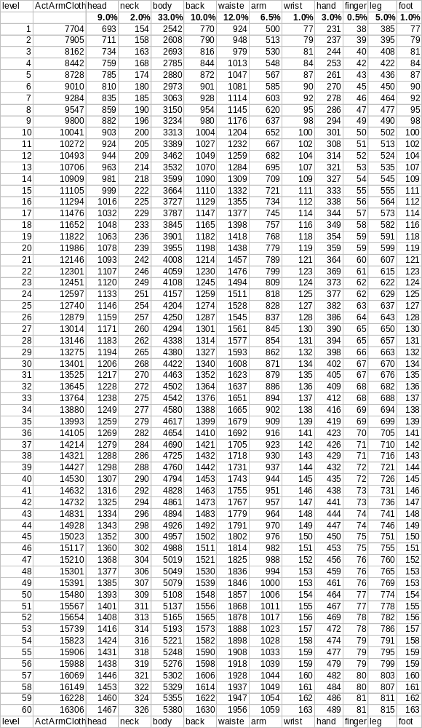
It is an interesting side effect that L50 clothing is about equivalent to L1 armor. That is to say, the finest clothing is able to protect you as well as the shoddiest armor. This may strike some people as wrong, but realize the clothing also affords greater mobility and fewer encumbrances. Also, since players are not exposed to the internal numbers, it is unlikely that they will realize this fact.

Some Simple Refinements of Combat Blows
Recall from our overview earlier, that every given combat swing results in one of six outcomes. They are; miss, dodge, parry, deflection, absorbed hit, and full hit. It is now useful to explore how we might calculate which outcome a given blow falls into.
We have previously established the HitPercFormab equation, which in broad terms yields the percentage of hits that are either absorbed hits, or full hits. We can rewrite this equation in terms of our new symbols as:
- HitPerc_{ab}
= Refined from (Equation 31.)
= 1.25 * (ActOffa / (ActOffa + ActDefb))2
1.25 * ((ActFinesse * SimpOffSkill)_{a} / ((ActFinesse * SimpOffSkill)_{a} + (ActArmor * SimpDefSkill)_{b}))²
The RawMiss chance is simply the opposite of HitPercab.
- RawMiss
= Chance a given blow results in a miss, dodge or deflection.
1.00 – HitPercab

Parrying
While seemingly counter-intuitive, we should begin our analysis with parrying. Arguably, parrying is a special case for a combat blow. Clearly, a parried blow hasn’t hit, but neither has it really missed either. Similarly, there is a “cost” to the intended-target in order to parry the blow.
Let us first define what we mean by “parry”. For the purposes of this discussion, a parry will include any blow that is stopped because of the actions of the victim to block it. This includes both shield-use, as well as the use of a second weapon used defensively.
Recalling that we have previously determined HitPercab to be 31.25% for fair fights. Instinctually, this value seems a bit low. We would clearly like a figure closer to 50%. At the same time, we theorize that in a fight, roughly one blow in three is parry-eligible. Clearly, I can only block a blow that I am able to get my shield in the way of, and instinct indicates that this is about 1/3 of all blows.
Fortunately, the two ideas dovetail nicely. Let us presume that HitPercab is in fact 46.875% for a fair fight. Of these blows, one in three (or 15.625%) is eligible to be parried. Assuming all ParryEligible blows are actually parried, we are left with 31.25% of blows scoring a hit.
Unfortunately, this generates a problem for us. In the above fair-fight scenario, ParryEligible blows amount to half of HitPercab. In certain extreme combat situations, HitPercab will approach 100%. Clearly, ParryEligible cannot account for an additional ½*HitPercab in such a case, as we would need more than 100% of the blows to do so.
However, what is not immediately intuitive is that we do not want to simply scale HitPercab up, but that we want to take a percentage of the RawMiss chances, and assign them to parrying. Remembering that HitPercab, for extreme scenarios, might be 90% or more, if we were to take a naïve approach and make parrying be ½ the value of HitPercab, we would wind up with > 100%. This is obviously not possible.
Taking the reverse approach, the fair-fight RawMiss chance is 68.75%. Since we want 15.625% to come from parrying, this is equivalent to wanting 5/22 or 22.73% of the RawMiss chances to come from parrying. We can use this fraction regardless of the actual RawMiss value.
- ParryEligible
= Number of all blows that are eligible to be parried
5/22 * RawMiss
And we probably want a term to describe the number of misses with parries factored out:
- AdjustedMiss
= Percentage of all blows that are neither hits nor parries.
= 17/22 * RawMiss
We will discuss parrying further in depth later, but for the time being, let us simply leave things as they are.

Scenarios Involving a Miss
Let us explore the “miss” outcomes. It’s important to realize that for all the “miss” scenarios, it really doesn’t matter (in the grand scheme of things) how a blow misses. A decent model of all the possible types of misses permits us to make combat more vibrant and dynamic, but strictly speaking, a miss is a miss. Theoretically, we are pretty much free to divvy up the misses any way we see fit. But let’s try and create something reasonable nonetheless.
First and foremost, a swing has to get reasonably close to the intended victim. Inexperienced combatants (i.e. low-level) should have great difficulty getting their weapon to perform as desired, and thus we would expect that a pure miss is the vast majority of the swings that are AdjustedMiss.
Obviously, the number of TrueMiss swings is some fraction of the AdjustedMiss blows. We’ll use a weighted-average, similar to that in TrueMiss, to determine the percentage. At the same time, we realize that the defender’s skill level plays no part, so we leave it out, and use an arbitrary constant of 1.0 (any value less than L0 SimpDefSkill should be fine) in its place:
- TrueMiss
= Percentage of all swings that result in a missed blow.
= [1.00 – 1.1 * ((ActFinesse * SimpOffSkill)_{a} / ((ActFinesse * SimpOffSkill)_{a} + (ActArmor * 1.00)_{b}))²] * AdjustedMiss
The next option for a swing, is that the swing gets reasonably close to the target, but that the target is able to side-step or otherwise avoid the blow. I choose to model TrueDodge, the number of all swings that can be dodged, as being a percentage of the remaining “missed” swings. I use only the SimpOffSkill and SimpDefSkill to calculate the percentage, and furthermore, I use a form that is reasonably symmetrical with that which we used in the HitPerc formula. However, I’ve changed the multiplier (to 2.5) simply to make the numbers come out “prettier”.
- TrueDodge
= Percentage of all swings that result in a blow that can be dodged
= 2.5 * (SimpOffSkill_{a} / (SimpOffSkill_{a} + SimpDefSkill_{b}))² * (AdjustedMiss – TrueMiss)
Lastly, the swing can be exceptionally well swung, but the defender is crafty or agile enough to cause the blow to deflect harmlessly. Realistically, a defender might raise an arm and cause the swing to graze along the surface, deflecting it away from hitting. Clearly, this requires high SimpDefSkill to do. Likewise, as my ActArmor rating improves, I will feel more secure about using an arm to block a shot. I won’t bother to write out the fully derived form for TrueDeflect, simply because it is easier to regard it as the remainder of all “misses”. That is:
- TrueDeflect
= Percentage of all swings that result in a blow that can be deflected
= RawMiss–TrueMiss-TrueDodge
- ParryEligible, TrueMiss, TrueDodge and TrueDeflect for Fair-Fights by Level
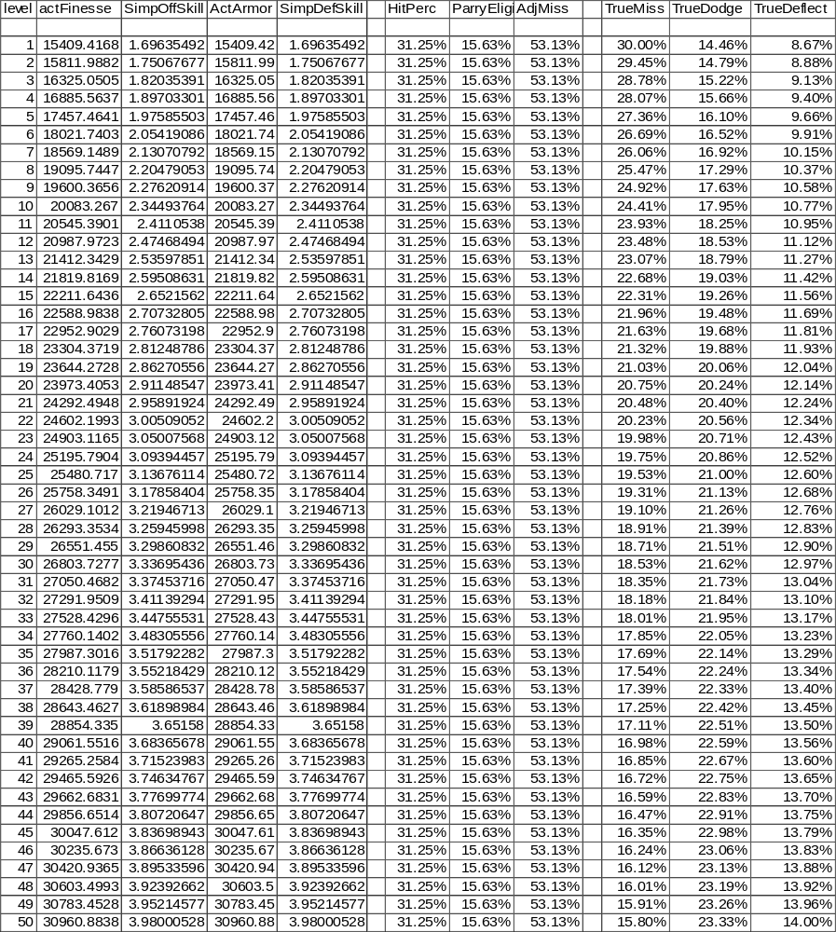
Examining TrueMiss, as we would expect, it declines as the player advances. My accuracy improves, and I am able to get a greater percentage of blows closer to the enemy.
At the same time, greater experience permits the character to dodge and deflect more blows.
Data for fights between dissimilar fights will be presented after the next section.

Scenarios Involving a Hit
As with the “miss” scenarios, a blow that lands has numerous outcomes as well. We do, however, have an additional constraint, as we are bound by the ActDam equation.
We conceptualize three varieties of hits; a normal hit, a serious hit, and a partial hit.
The vast majority of hits should fall into the normal category. A serious hit represents the use of finesse to find a weak spot in the opponent’s defense, and exploit it. Serious hits inflict 50% more damage than normal. Conversely, a partial hit represents a hit that is inferior, and does only 50% the normal damage.
Clearly, serious hits ought to be governed by ActFinesse and ActArmor. We’ll simply use the same format that has worked so well up to now, and simply change the multiplier in order to scale the percentage properly:
- TrueSeriousHit
= Percentage of all swings that result in a serious hit
= 0.2 * (ActFinesse/(ActFinesse + ActArmor))² * HitPercab
Further refinement is possible, but doesn’t significantly simplify understanding or clarity.
Given our constraint dealing with DamCap, we can devise some simple algebra:
TrueSeriousHit * (1.5 * DamCap) + TrueNormalHit * (1.0 * DamCap) + TruePartialHit * (0.5 * DamCap) = ActDam
Rewriting ActDam in terms of DamCap, and factoring out DamCap:
TrueSeriousHit * 1.5 + TrueNormalHit * 1.0 + TruePartialHit * 0.5 = HitPercab
The three TrueXXXHit terms must sum to HitPercab, so we can rewrite things as:
TrueSeriousHit * 1.5 + TrueNormalHit * 1.0 + (HitPercab – TrueNormalHit – TrueSeriousHit) * 0.5 = HitPercab
Simplifying:
TrueSeriousHit + TrueNormalHit * 0.5 = HitPercab * 0.5
Solving for TrueNormalHit:
- TrueNormalHit
= Percentage of all swings that result in a normal hit
= HitPercab – 2 * TrueSeriousHit
Insert standard disclaimer about it being possible to refine this equation further, but yada yada.
And of course, we’ll also state formally something we said earlier:
- TruePartialHit
= Percentage of all swings that result in a partial hit
= HitPercab – TrueSeriousHit - TrueNormalHit
- TrueSeriousHit, TrueNormalHit and TruePartialHit for Fair-Fights by Level
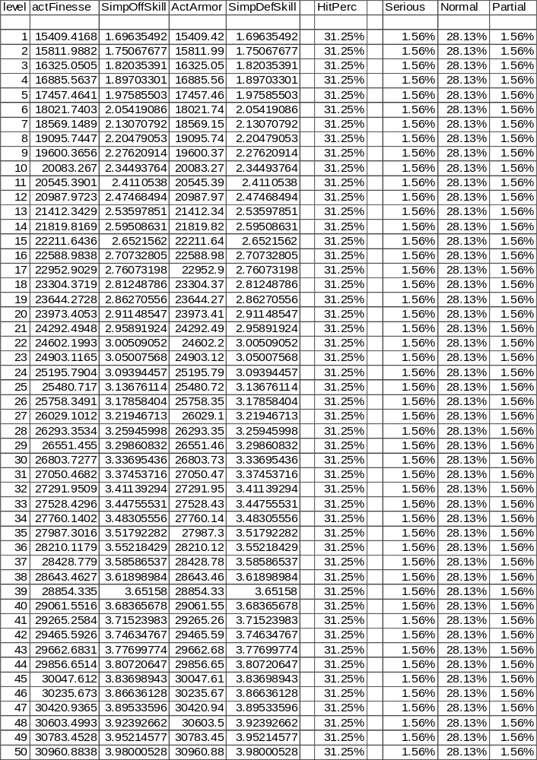
Clearly, for fair-fights, the “hits” breakdown is independent of level.

Blow Breakdown for Dissimilar Level Combatants
Displaying data for non-fair-fights has the traditional problems. Again, I’ll simply reveal some scenarios to give a rough feel for the numbers.
- Some Combat Scenarios; Hit and Miss Breakdown
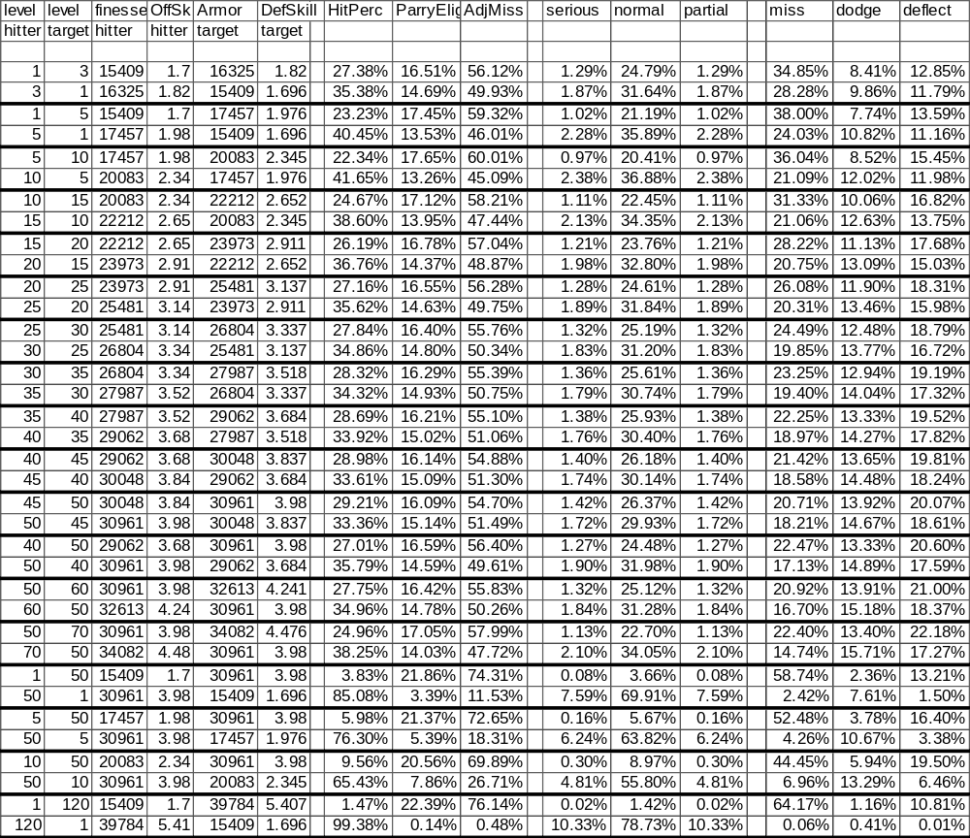
Analysis of the non-equal level combatant’s information reveals some interesting results.
First, the higher level not only hits more often overall (HitPerc), but also achieves more hits of each type (normal, serious, and partial). Obviously, no player will complain about extra normal and serious hits, but may raise an eyebrow about getting more partial hits. However, a hit of any type is better than a miss, and even if it only does half damage, that is still some benefit to the hitter.
Secondly, even in fights between dissimilar levels, the bulk of hits are normal, with an even split between serious and partial hits. OK, so we knew that this would happen from how the math worked out, but it still gives us a warm-fuzzy all over since that seems like the way we want it to be.
Thirdly, more blows from the lower-level character are eligible to be parried. Clearly, this is what we would expect, as the higher skill should permit more blows to be blocked.
For the misses scenarios, we note that the lower-level character always has more TrueMisses than the higher-level character. We rationalize that swinging really bad is something that is based on inexperience, thus higher-level characters ought to do it less often.
However, we note that as a percentage of all blow, the lower level frequently deflects and dodges more swings. This seems counter-intuitive. Shouldn’t the higher-level character dodge and deflect better? Obviously, the answer is yes. But what we realize is that the lower player swings so ineffectively, that more blows are simply going wide of the mark. The higher-level character simply has fewer blows that NEED to be dodged or deflected swung at them.
(Note: OK, this last remark is somewhat a rationalization. However, I did spend much time actually trying to get higher-levels to dodge/deflect more than lower-levels. The only way to do it is to make dodge/deflect be fixed percentages of all misses. This means that we would have to ignore the effects of skill, etc. I feel that skill should play a part, and I think the rationalization is defensible, so the system is constructed that way.)

Skill Damage
Up to this point, we have largely concerned ourselves with only the melee-portion of combat. That is, swinging a weapon, determining if it hits, how well it hits, and what the impact of the hit is on the victim. While melee is the focal point of combat, it is not the only option available to the player.
Clearly, a character can perform other actions while still swinging the weapon. For example, kicking, bashing, pushing, punching, etc. all come to mind. These extra options are generally lumped under the heading of skills, and they form an important component of a well-developed MUD. As such, it is imperative that the game-design account for skills in the overall design philosophy.
I should also point out, I am using “skill-use” in a generic sense. It should be thought to include not just regular skills (kick, bash, backstab, etc.) but also things like spells, prayers and the other various forms of magic.
Having completed our development for basic melee combat, it now makes sense to turn our attention to skills, and in particular skill-related damage.

A Prelude to Skill Damage
From previous discussions, we established a numerical value for ActDam, indicating the total damage we wanted to be inflicted per combat round in order to maintain what we desired for SurvRnds. From there, we went on to derive DamCap.
Clearly, we don’t want to alter what we have said about SurvRnds. However, we need to shoehorn the new concept of skills into what we have developed to date. Fortunately, this is fairly easy to do. We simply need to take a small piece away from DamCap and assign it to “skill damage”. It’s probably easiest to understand if we remember what the relationships between the pieces are:
Imaging that we split DamCap up into two pieces, SimpSkillDamage and WeaponDamage such that:
DamCap = SimpSkillDamage + WeaponDamage
That is to say, DamCap is the sum of two pieces; a term based on equipment, and a term based on skill.
We are left with the simple question of how much damage we wish to come from melee (WeaponDamage) and how much from skill-use (SimpSkillDamage). I choose to make SimpSkillDamage = 1/3 WeaponDamage. Since most skills will require 3 rounds to perform, this basically says that each time a skill is performed; it is like getting an extra round of combat.
Rather trivial algebra yields:
DamCap = WeaponDamage + SimpSkillDamage
DamCap = (3 * SimpSkillDamage) + SimpSkillDamage
DamCap = 4 * SimpSkillDamage
- SimpSkillDamage
= DamPerRnd due to skill use
= DamCap / 4
= 0.9958 * ((level)1.759815 + 13)0.635902 / 4
0.24895 * ((level)^{1.759815} + 13)^{0.635902}
- SimpWeaponDamage
= DamPerRnd due to weapon use
= 3 * SimpSkillDamage
= 3 * 0.24895 * ((level)1.759815 + 13)0.635902
0.74685 * ((level)^{1.759815} + 13)^{0.635902}
- WeaponDamage and SimpSkillDamage as a Function of Level
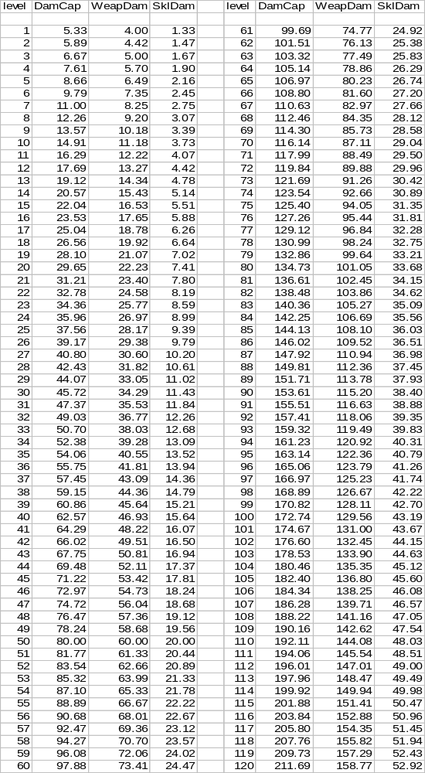
As we can see, SimpSkillDamage is incremental everywhere. Players expect that as they rise in level, they will do more damage with their skills, and this bears that out well.
Also, L50 SimpSkillDamage is only 20.0. Since this is the per-round amount, and we presume that most skills will require 3 rounds to perform, this means that a single skill-use from a L50 will do 60.0 damage. This is not quite enough to kill a L1 player outright (HP=100). Nobody lies to die instantly, so it’s probably a good thing that this is the case.

Saving Throws
It is important to realize that SimpSkillDamage is based upon DamCap that is partially predicated on the value of HitPercab. The ramification of this is that the damage that we have calculated presumes a hit-rate equivalent to HitPercab. Clearly, skill-usage is also going to require some probability of success and failure.
For skills that involve physical attacks, we can rationalize these failures similar to how HitPercab works. Failures simply mean that the attacker missed widely, or that the victim was able to somehow deflect or disrupt the skill from succeeding.
In the case of magic, we lack an obvious frame of reference of how to rationalize failure. For the most part, we’ll avoid coming up with a reason for the failure, and simply state that the game system requires that failure be possible.
Skill failure, whether it be a true skill, or some form of magic, we will lump into the concept of saving throw. That is to say, if the victim “makes a save”, the skill essentially fails.
We must realize that SimpSkillDamage is based on a success rate for skills equivalent to HitPercab. Unfortunately, in the equal-level fight thought to be the norm, HitPercab yields a success of 31.25%. This is acceptable for melee blows, because there are a large number of them reasonably often. But since skills will most likely take 3 rounds to perform, this translates to 1 skill every 7.5-9.0 seconds. I believe players would find it highly objectionable to get one successful skill every 28.8 seconds (9 seconds/use with 31.25% success rate).
Therefore, we will stipulate that SkillPerc, the success rate for skills, will be twice that of HitPercab. That is, for a fair fight, SkillPerc will be on the order of 62.5%, which is much more acceptable.
Since we are doubling the success rate of skills, the only way to maintain the amount of damage we want to inflict on average is to decrease the per-successful-skill-use amount by ½.
Equations for these concepts will be forthcoming. However, let’s explore some obvious ramifications first.
Since SkillPerc is double that of HitPercab, it will have similar performance as HitPercab for fights between greatly dissimilar levels. That is, skills of the higher-level player will success much more often, while the higher-level player will also save much more often against the skills of the lower-level player. This is exactly as we would desire.
Additionally, since HitPercab is designed to yield values between 0% and 100%. By doubling it for SkillPerc, under certain circumstances, we will have > 100% which isn’t really practical in the real world. To avoid this conundrum, and achieve the proper average damage desired, we would have to state that if SkillPerc is > 100%, SkillDamage will be appropriately increased. That is, if we had SkillPerc of 140% for a damage of 10, we would reduce SkillPerc to 100%, and multiply damage by 140% for a total of 14 instead. Another way to say this is, for a scenario in which the combatant levels are very far apart, the high-level character will not only have guaranteed success (100%), but will also do greater than normal damage.
There are a few other main concepts when discussing how SkillPerc should perform.

SkillDifficulty and MaxSkillPerc
First, some skills are easier to perform than others are. Clearly, skills that are easier to perform ought to succeed more often than more difficult skills (assuming equal learning in both skills).
To model this, we’ll introduce the concept of SkillDifficulty. I have also assigned some arbitrary maximum success rates (MaxSkillPerc) to these classifications as follows:
- MaxSkillPerc
= The maximum rate of success for a given skill
= A function of the SkillDifficulty
SkillDifficultyFactor * 2 * HitPercab
Trivial: 100% * 2 * HitPercab
Easy: 90% * 2 * HitPercab
Normal: 80% * 2 * HitPercab
Difficult: 70% * 2 * HitPercab
Dangerous: 60% * 2 * HitPercab
Thus, in a fair-fight where the HitPercab rate is 31.25%, an “easy” skill would succeed 56.25% (31.25% * 2 * 90%) of the time.
The percentages that distinguish the above SkillDifficulties in the above formula will be called the SkillDifficultyFactor. The SkillDifficultyFactor for normal skills is 80%.
We should note that the determination of SkillDifficulty for a given skill is entirely arbitrary. There is nothing (except common sense) that prevents us from saying kick is dangerous, while casting maelstorm is trivial.

SkillLearning
Secondly, skills are learned through practice, so we have an inherent rating for how well learned the skill is. Likewise, as learning is gained in a skill, the success rate is expected to improve.
It is probably simplest to model SkillLearning as a value from 0% to 100% indicating how well learned the skill is. By extension, we’ll stipulate that SkillPerc is simply the maximum value from SkillDifficulty multiplied by the SkillLearning percentage:
- SkillPerc
= Success rate for a skill
= MaxSkillPerc * SkillLearning
(SkillDifficultyFactor * 2 * ) * SkillLearning
Trivial: 100% * 2 * HitPercab * SkillLearning
Easy: 90% * 2 * HitPercab * SkillLearning
Normal: 80% * 2 * HitPercab * SkillLearning
Difficult: 70% * 2 * HitPercab * SkillLearning
Dangerous: 60% * 2 * HitPercab * SkillLearning
For example, a difficult skill that is quarter-learned (25%) would have a SkillPerc of 35% (70% * 2 * 25%) * HitPercab. In a fair-fight, the effective success rate would be 10.94% (31.25% * 35%).

MinSkillLevel and MaxSkillLevel
Thirdly, skills have an intrinsic “level” to them indicating whether they are learned early in a character’s career, or later on. Obviously, we don’t want L50 players continuing to use skills they acquired at L1, but instead, want them to trade up to something bigger and cooler.
We will have to postpone a calculation for SkillLevel until after a more thorough look at how learning occurs. Suffice to say, we can use some knowledge about how learning will occur to mimic a “level”, which hopefully agrees fairly well with the player’s actual level, and this SkillLevel will be plugged into the relevant equation for damage and SkillPerc.
I mention this now as it is an important and basic concept for skills and this is the most practical place to introduce it. We will come back to this point and talk about it more in depth later though.

Refinement of SimpSkillDamage
It should be pretty obvious that if we want our numbers to come out properly, we will have to achieve:
SkillPerc * SkillDamage = HitPercab * SimpSkillDamage
Or rewriting:
SkillDamage = SimpSkillDamage * HitPercab / SkillPerc
SkillDamage = SimpSkillDamage * HitPercab / ((SkillDifficultyFactor * 2 * ) * SkillLearning)
SkillDamage = SimpSkillDamage / (SkillDifficultyFactor*2*SkillLearning)
As we can see, this term factors in SkillLearning. This would imply that a low degree of SkillLearning would yield higher SkillDamage. This would make absolutely no sense. Obviously we don’t want damage-per-success to decrease as a person becomes more learned about the skill.
To avoid such a problem, we’ll instead say that:
- SkillDamage
= Damage inflicted (per round) by a skill
= SimpSkillDamage * HitPercab / MaxSkillPerc
= SimpSkillDamage * HitPercab / (SkillDifficultyFactor * 2 * )
SimpSkillDamage / (SkillDifficultyFactor * 2)
- SkillDamage for SkillDifficulty Ratings by Level (fair-fights)
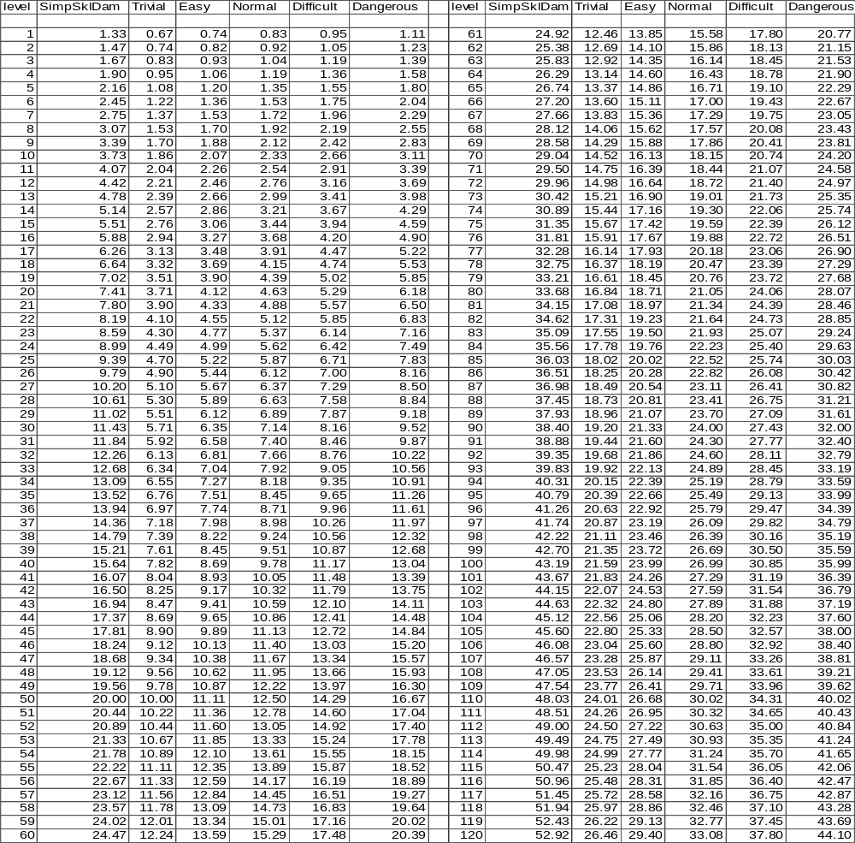
As we can see, the higher the SkillDifficulty, the more damage is done by a skill of a given level. This is obviously desirable, as otherwise there is no reason to use skills that have a chance of failure.
Knowing that the above values are a per-round amount, we also note that a 3-round, L50, dangerous skill does roughly 50 HP of damage. This would not be enough to kill a L1 outright so our desire to avoid instant-death should be roughly intact.
However, there is a potential problem at low level. Obviously, every skill that succeeds needs to do at least 1 damage. Since some of the amounts for L1-L4 are greater than 1.0, we could possibly have a problem. Fortunately, the above values are per-round, and if we make all skills take at least 2 rounds, there will be no problems.

Ramifications of SkillDamage
Realize that what we have said is SkillDamage is based on the skill being fully learned. If a player is in the process of training the skill, their rate of success will be less than MaxSkillPerc, and accordingly, only receive some fraction of the SimpSkillDamage that is intended for them to be inflicting. By not doing the appropriate SimpSkillDamage, they are effectively taking a penalty in their ActDam, which is the same thing as reducing their overall Power. While this is an undeniable truth, a number of factors allow us to justify not worrying about it too much.
First, since we are expecting primarily fair-fights to occur, the impact is probably equal for both combatants. That is, the fact that I am using a skill that is not fully learned is counterbalanced by the fact that my opponent is probably equally handicapped by their skills as well.
Secondly, from experience, players tend to rely on their best skill that is the most learned. Players usually “train” against inferior opponents where the odds are overwhelmingly in their favor. Hence, for the most part, this penalty will only come into play when the fight’s outcome is not in doubt.
Thirdly, the damage of the skill is largely based on the SkillLevel, which we presume is the theoretical level when the skill is fully maxed. Presumably, while they are training the skill, their actual level is somewhat lower than this theoretical SkillLevel. Therefore, they are theoretically inflicting the SkillDamage of a somewhat higher-level person, but doing so less often.
For these reasons, I feel that we can justify ignoring the potential decrease in ActDam from using a non-maxed skill.

Converting SkillDamage to Other Hindrances
While many skills are straightforward “do damage to enemy” skills, there are other broad classifications of skills that hinder the enemy, either reducing the amount of attacks the enemy gets, or preventing the enemy from being able to use its own skills. For example, the standard “bash” skill is typically conceived as knocking the player over and disrupting their skills. Meanwhile, “grapple” generally entraps the enemy and prevents them from hitting back. It would be useful to explore how to convert what we know about SkillDamage to model this arrangement.
Knowing SimpWeaponDamage and HitPercab, we can represent the amount of damage a character is expected to inflict from melee damage alone as:
- AvgDamMelee
= Average, per-round, damage from melee combat
SimpWeaponDamage * HitPercab
An equivalent equation for skills becomes:
- AvgDamSkill
= Average, per-round, damage from skills
SkillDamage * SkillPerc
Our basic question is that if I successfully perform a skill that should do SkillDamage amount of damage, how many rounds of combat is this worth. That is, the number of rounds I ought to lose should be:
- MeleeRoundsLostSkill
= Number of Rounds of melee combat lost from skill
= SkillDamage / AvgDamMelee
= ( / (SkillDifficultyFactor * 2)) / (SimpWeaponDamage * HitPercab)
= ( / (SkillDifficultyFactor * 2)) / ((3 * SimpSkillDamage) * HitPercab)
= SimpSkillDamage / (SkillDifficultyFactor * 6 * SimpSkillDamage * HitPercab)
= 1 / (SkillDifficultyFactor * 6 * HitPercab)
= 1/3 * 1/MaxSkillPerc
Obviously, the number of rounds of melee lost should not be dependant on the level difference between the combatants, so we will use the fair-fight value for HitPercab (31.25% = 5/16).
= 1 / (SkillDifficultyFactor * 6 * 5/16)
8/15 * 1/SkillDifficultyFactor
If we wanted to go one step further and say the skill causes both melee and skill to be lost, then:
- FullRoundsLostSkill
= Number of Rounds of melee and skill combat lost from skill
= SkillDamage / (ActDam)
= SkillDamage / (AvgDamMelee + AvgDamSkill)
= ( / (SkillDifficultyFactor * 2)) / (( * ) + ( * ))
= (SimpSkillDamage) / ((2 * SkillDifficultyFactor) * ((SimpWeaponDamage * HitPercab) + (SkillDamage * SkillPerc)))
= (SimpSkillDamage) / ((2 * SkillDifficultyFactor) * (((3 * SimpSkillDamage) * HitPercab) + (( / (SkillDifficultyFactor * 2)) * ((SkillDifficultyFactor * 2 * ) * SkillLearning))))
= 1 / ((2 * SkillDifficultyFactor * HitPercab) * (3 + ((1/(SkillDifficultyFactor*2)) * ((SkillDifficultyFactor * 2) * SkillLearning))))
= 1 / ((2 * SkillDifficultyFactor * HitPercab) * (3 + SkillLearning))
We’ll presume fully maxed, so that SkillLearning=1.00:
= 1 / ((2 * SkillDifficultyFactor * HitPercab) * (3 + 1.00))
= 1 / ((2 * SkillDifficultyFactor * HitPercab) * 4)
= 1 / (8 * SkillDifficultyFactor * HitPercab)
= 1/4 * 1/MaxSkillPerc
And again using the fair-fight argument as above:
= 1 / (8 * SkillDifficultyFactor * 5/16)
2/5 * 1/SkillDifficultyFactor)
To determine the number of rounds of skills I should lose:
- SkillRoundsLostSkill
= Number of Rounds of skill combat lost from skill
= SkillDamage / AvgDamSkill
= SkillDamage / ( * )
= 1 / SkillPerc
= 1 / ((SkillDifficultyFactor * 2 * ) * SkillLearning)
Again we will assume full learning (SkillLearning=1.00) and make the fair-fight argument (HitPercab=5/16):
= 1 / (SkillDifficultyFactor * 2 * 5/16 * 1.00)
8/5 * 1/SkillDifficultyFactor)
- MeleeRoundsLostSkill, SkillRoundsLostSkill and FullRoundsLostSkill According to SkillDifficulty
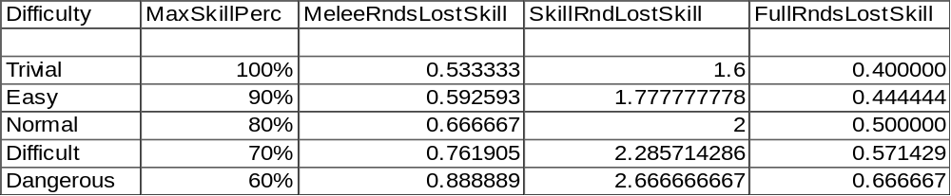
That is to say, assuming a 3-round, trivial skill, we should remove 1.6 (.5333*3) melee rounds, or 4.8 (1.6*3) rounds of skill-use, or 1.2 (0.4*3) rounds of both skill and melee.

A Final Note on Skill Damage
On a final note for this discussion, I realize that what we have done may seem rather trivial. We have constructed the system so that the effect of “damage to opponent” is equivalent to “opponent loses attacks”, “opponent loses skills” and “opponent loses skills and attacks”. On the surface, it would seem like player’s skill use really doesn’t matter.
As we will soon learn, not all characters are the same. For example, some players will likely shift more of their ActDam from melee damage into skill damage, and vice-versa. If I know that my opponent is heavily weighted toward melee damage for instance, it probably makes good tactical sense for me to use skills that shut down my opponent’s ability to swing. By doing this, we ought to be able to out-damage the other guy, and gain the edge we need to achieve victory. Clearly, doing this is a matter of tactics and play-style, which I won’t go into much in depth. Obviously, we want to encourage players to use their smarts, so the system that is being devised will clearly do so.

Refining SimpWeaponDamage
From our earlier discussion of armor, we realized that it was plausible for a player to sacrifice armor in hopes of gaining some other criteria. One obvious situation would be a player that uses substandard armor, but an enhanced weapon. We want to insure that this setup (and the reverse) is not encouraged by our setup.
Following a now familiar pattern, let’s first divvy SimpWeaponDamage up into two component pieces. One piece, WeaponDamExp, will be based upon the player’s experience and/or skill level, while the second, WeaponDamEq, will be equipment based. We would like WeaponDamEq to mirror ActArmor so that the tradeoffs between the two match.
We thus write the following equation, and attempt to solve for K and n:
WeaponDamEq = K * SimpWeaponDamage^{n}
Since we want to equate this to ActArmor:
K * SimpWeaponDamage^{n} = ActArmor
K * [0.74685 * ((level)1.759815 + 13)0.635902]^{n} = 10000 *
K*0.74685^{n} * (level^{1.759815}+13)^{0.635902n} = 10000 *
We can solve for n by examining the parenthetical term alone:
n = .163844/.635902
n = .257656
Realize the scalar multiplier (K) is rather meaningless, so I will not bother to solve for its value. However, the exponent can be utilized, and we can now write:
- WeaponDamEq
= The contribution to SimpWeaponDamage from equipment
= SimpWeaponDamage^{0.257656}
= (0.74685 * ((level)1.759815 + 13)0.635902)^{0.257656}
.927552 * ((level)^{1.759815} + 13)^{.163844}
And consequently:
- WeaponDamExp
= The contribution to SimpWeaponDamage from character’s experience
= SimpWeaponDamage / WeaponDamEq
= SimpWeaponDamage / SimpWeaponDamage^{0.257656}
= SimpWeaponDamage^{0.742344}
= [0.74685 * ((level)1.759815 + 13)0.635902]^{0.742344}
.805187 * ((level)^{1.759815} + 13)^{0.472058}
- DamCapExp and DamCapEq versus Level
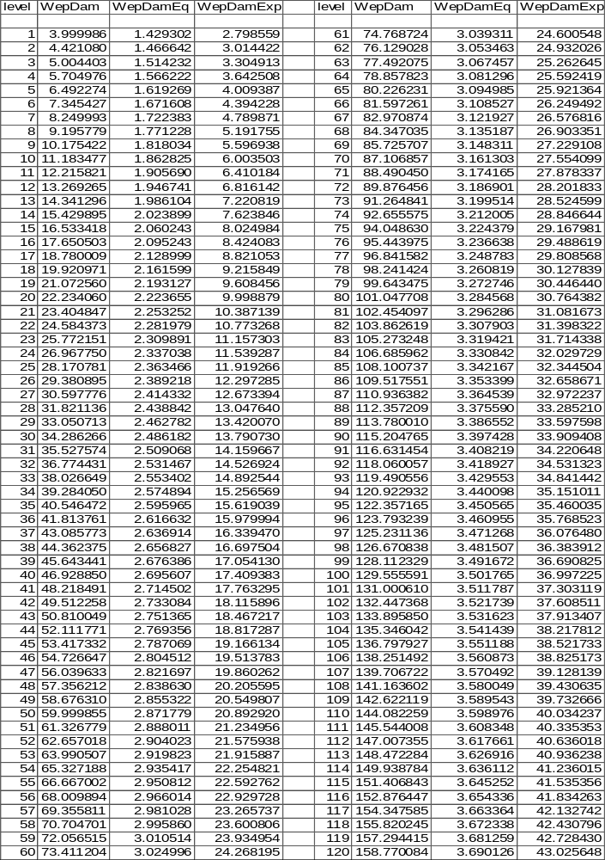
From this, we see that WeaponDamExp plays a large role in determining SimpWeaponDamage. Even if a L50 were to use a L1 weapon, they would have a damage capacity of 29.862 (1.429*20.893), roughly equivalent to the SimpWeaponDamage of a L26. Or said another way, the L50’s SimpWeaponDamage is 29.8 when we expect it to be 60. They are still 50% (30/60) as effective as they should be. Not great, but not horrible either.

Commentary on Percentage Changes in ActArmor and WeaponDamEq
Another interesting fact also emerges from this spreadsheet. As should be obvious, a percentage increase in either WeaponDamEq or ActArmor leads to a corresponding percentage increase in Power. Let us look at the percentage increase of WeaponDamEq vs. ActArmor. (It’s difficult to capture this concept in a spreadsheet, so I’m going to just present some findings.)
Because of how we have structured the two functions, they are numerically equal at the same level. Consequently, their slopes (which can be thought of as a percentage increase) are also the same at all levels. Therefore, the Power I gain from increasing my armor by one level is the same as if I had increased my weapon by one level. Thus, when a player decides to upgrade, weapons and armor are equally favored.
However, the situation for trading off is slightly different. Examining WeaponDamEq, we note that if we ignore scalar multipliers and additive constants, the value increases as: ((level)^{1.759815})^{0.163844} = (level)^{0.28834}. Since the exponent is less than 1.0, we learn that the increase at low level is greater than that at higher levels. The ramification is that, if I sacrifice armor or weapon in order to gain the other, I will be sacrificing more (level-wise) than I am gaining (level-wise).
This is good, as it encourages players to maintain parity between their weapons and armor. For example, a L30 player might opt to use an L35 weapon and L25 armor, but they would find their resulting power is only 99.26% that of a L30 with L30 armor and weapons. Obviously, it’s not a tremendous penalty, but a penalty nonetheless. We, thus, have assurances that players, opting to experiment or simply unable to find proper gear, will neither uncover a loophole that gives them an edge, nor be penalized excessively over characters more properly setup.

More Refinements for Combat Blows

An Introduction to Number of Swings Per Round
The next step in understanding combat is to take a look at how many swings a given player gets per round. Clearly, we remain constrained by the arguments made during the SimpWeaponDamage discussion, so we have to insure that whatever changes we make in the number of swings is counterbalanced by a corresponding change in the damage per blow.
For simplicity, we will conceptualize that the average character two swings per round. This means that the average character has a DamagePerSwing equal to SimpWeaponDamage/2.
- NormPCSwingsPerRound
= SwingsPerRound for our “average” PC
2.0
Clearly, not all characters will have two swings per round. Some racial-types might be “faster” or “slower”. Some body-styles have more limbs to attack with (e.g. octopus).
We capture this idea by stating:
- DamagePerSwing
= Damage capacity per combat swing
= SimpWeaponDamage / SwingsPerRound
The more swings I get, the less damage I get per swing. Said another way, if I have a given mob, and choose to give it more SwingsPerRound without changing its DamagePerSwing, I have effectively raised its SimpWeaponDamage, and in turn its Power. As a consequence, the mob would have to be rated at a higher level.

Weapon Proficiency and Specialization for Players
Many fantasy-RPGs have introduced the idea of proficiency and specialization, and our MUD is no different. For the most part, proficiency is thought of as simply improving one’s skill level with the weapon in question, while specialization typically improves the SwingsPerRound with that weapon. Specialization may not be performed until fully proficient. Given our previous discussion of damage, we our forced to intertwine these concepts.
Proficiency, a skill, which we will discuss in depth later, can be thought of as advancing with level. That is to say, a L1 is not at all proficient, whereas we expect that as level advances, proficiency increase as well. For that matter, we stipulate that full proficiency is achieved at L20. Thus, we state that proficiency has the effect of raising the SimpOffSkill up to the value shown for L30.
Specialization, since it actually increases the number of swings possessed, behaves a bit differently. Following in the wake of proficiency, we stipulate that specialization starts at L20, and proceeds until maxed at L50. Hence, specialization has the effect of raising the SimpOffSkill from the L20 value up through L50.
That is to say, we will implement SimpOffSkill through the concepts of proficiency and specialization. We presume that by knowing how proficient/specialized a character is, we can derive a “level” from this, and plug this “level” into the SimpOffSkill equation.
Furthermore, we desire specialization to impact the PCs SwingsPerRound. As noted previously, the only way this can be done is to alter DamPerSwing so that SimpWeaponDamage remains constant. For the most part, this entails shifting a bit of the damage away from the weapon, in order to provide for an increase in SwingsPerRound. Therefore, we’ll make adjustments in WeaponDamEq (which in turn impacts SimpWeaponDamage), in order to compensate for the change in SwingsPerRound.
Furthermore, we need to realize that:
SimpWeaponDamage = DamPerSwing * SwingsPerRound
Let us start by noting a few values for SimpWeaponDamage. At L20, SimpWeaponDamage is 22.23412. At L50, SimpWeaponDamage is 60.0.
We would like full specialization to grant an extra 0.5 to SwingsPerRound (up to a total of 2.5).
- SpecBonusSwings
= Extra SwingsPerRound due to specialization
0.5
That is to say, at L20, we expect 2.0 SwingsPerRound hence:
SimpWeaponDamage = DamPerSwing * SwingsPerRound
22.23412 = DamPerSwing * 2.0
DamPerSwing = 11.11706
At L50, we expect 2.5 SwingsPerRound:
SimpWeaponDamage = DamPerSwing * SwingsPerRound
60.0 = DamPerSwing * 2.5
DamPerSwing = 24

WepDamEqPerSwing
We previously said that:
SimpWeaponDamage = WeaponDamEq * WeaponDamExp
It will be useful for us to have a per-swing value for WeaponDamEq. We will call this term WepDamEqPerSwing:
WepDamEqPerSwing = WeaponDamEq / SwingsPerRound
At L20:
WepDamEqPerSwing = WeaponDamEq / SwingsPerRound
WepDamEqPerSwing = 2.223658 / 2.0
WepDamEqPerSwing = 1.111829
At L50:
WepDamEqPerSwing = WeaponDamEq / SwingsPerRound
WepDamEqPerSwing = 2.871783 / 2.5
WepDamEqPerSwing = 1.148713
If we let WepDamEqPerSwing increase linearly between L20 and L50, we get:
- WepDamEqPerSwing20_50
= WepDamEqPerSwing (Good only in range L20-L50)
= (level–20)/30 * (L50 WepDamEqPerSwing – L20 WepDamEqPerSwing) + L20 WepDamEqPerSwing
= (level–20)/30 * (1.148713 – 1.111829) + 1.111829
= (level–20)/30 * (0.036884) + 1.111829
And by extension:
- SwingsPerRound20_50
= SwingsPerRound (Good only in range L20-L50)
= WeaponDamEq / WepDamEqPerSwing20_50
To formulize what we have stipulated for the other levels:
- SwingsPerRound00_20
= SwingsPerRound (Good only in range L0-L20)
= NormPCSwingsPerRound
= 2.0
- WepDamEqPerSwing00_20
= DamEqPerSwing (Good only in range L00-L20)
= WeaponDamEq / SwingsPerRound00_20
= WeaponDamEq / 2.0
- SwingsPerRound20_50
= SwingsPerRound (Good only in range L20-L50)
2.5
- WepDamEqPerSwing20_50
= DamEqPerSwing (Good only in range L20-L50)
= WeaponDamEq / SwingsPerRound20_50
= WeaponDamEq / (NormPCSwingsPerRound + SpecBonusSwings)
= WeaponDamEq / 2.5
Obviously, we can combine these functions using copious amounts of min/max functions (frankly, I think it’s more intuitive broken apart as above).
- SwingsPerRound
= number of attacks a PC possesses
= min(max(WeaponDamEq/((WeaponDamEq@L20)/NormPCSwingsPerRound +
min(max(level-20, 0), 30)/30 *
((WeaponDamEq@L50)/ (NormPCSwingsPerRound + SpecBonusSwings) –
(WeaponDamEq@L20)/ NormPCSwingsPerRound)),
NormPCSwingsPerRound), (NormPCSwingsPerRound + SpecBonusSwings))
= min(max(WeaponDamEq/((WeaponDamEq@L20)/ 2.0 +
min(max(level-20, 0), 30)/30 *
((WeaponDamEq@L50)/ (2.0 + 0.5) –
(WeaponDamEq@L20)/ 2.0)),
2.0), (2.0 + 0.5))
= min(max(WeaponDamEq / ((WeaponDamEq@L20)/2 +
min(max(level-20, 0), 30)/30 *
((WeaponDamEq@L50)/ 2.5 –
(WeaponDamEq@L20)/2)),
2.0), 2.5)
Using the numerical values for the constants:
= min(max(WeaponDamEq / ((1.111829) +
min(max(level-20, 0), 30)/30 *
((2.871783)/ 2.5 –
(2.223658)/2)),
2.0), 2.5)
= min(max(WeaponDamEq/(1.111829 +
min(max(level-20, 0), 30)/30 *
(1.148713 – 1.111829)),
2.0), 2.5)
min(max(WeaponDamEq/(1.111829 + min(max(level-20,0),30)/30 * 0.036884), 2.0), 2.5)
And by extension:
- WepDamEqPerSwing
= Damage inflicted per swing that hits
= WeaponDamEq / SwingsPerRound
Thus:
- SwingsPerRound and WepDamEqPerSwing by Level
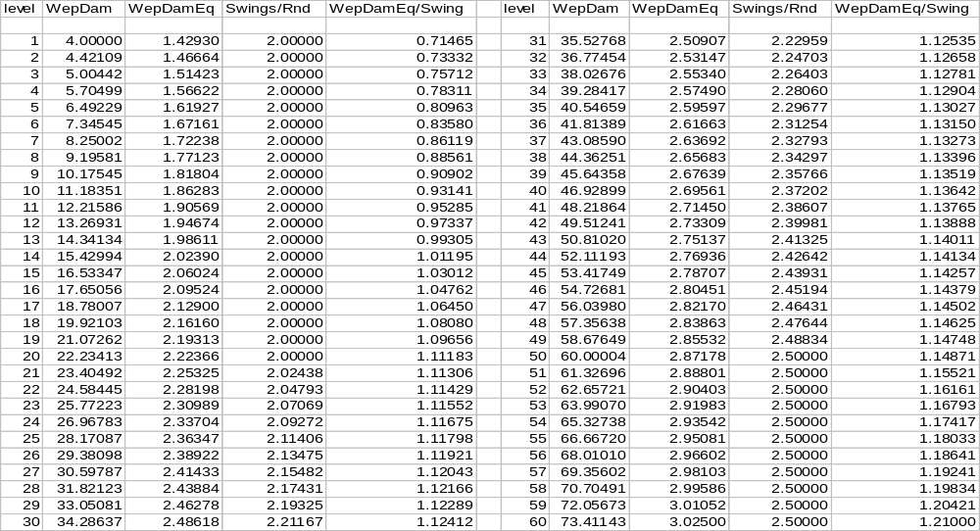
SwingsPerRound, as you will note, not only behaves as designed, hitting the prescribed values at the appropriate times, but also is always increasing. Obviously, we wouldn’t want players to lose any swings as they level, so this is good.
Furthermore, WepDamEqPerSwing is also incremental everywhere. Since we will ultimately model this as the damage a weapon is supposed to do, we are effectively saying that weapon damage increases with level always. Again, this is excellent, as it is exactly what we would want to have happen.
Finally, we should also note that specialization is not really optional. We will discuss skills in depth later on, but one of the underlying principles is interchangeability in skill-path choice. Since the amount of damage a weapon will do (modeled after WepDamEqPerSwing) factors in the effects of specialization, a character that chooses not to specialize will have a WeaponDamEq 80% (2.00/2.5) of appropriate. If we were to backtrack this to the Power equation, we find that failure to specialize would result in having only 85% the desired power. (Derivation to follow) We will have to keep this in mind later on when devising the skill system.
(Optional Derivation:
SimpWeaponDamage = WeaponDamEq * WeaponDamExp
= (0.8 * desired WeaponDamEq) * WeaponDamExp
= 0.8 * desired SimpWeaponDamage
SimpWeaponDamage represents 75% of DamCap, which means we would have .75*.8 + .25 = 85% of the desired DamCap. And by extension, that means 85% of the desired ActDam, SimpOffPow and Power.)

WepDamPerSwing
With the information we now have, we are finally able to write the all-important formula for determining how much a weapon does on a per swing basis.
In a trivial sense, we can write:
- WepDamPerSwing
= Amount of damage inflicted by weapon per successful swing
= SimpWeaponDamage / SwingsPerRound
However, we must remember that SimpWeaponDamage is composed of two pieces, hence:
= (WeaponDamEq * WeaponDamExp) / SwingsPerRound
= WepDamEqPerSwing * WeaponDamExp
Since WepDamPerSwing is the amount of damage inflicted per successful swing, we learn that this amount is dependent partly on level and experience (WeaponDamExp) and partly on the nature of the weapon (WepDamEqPerSwing). The upshot of everything that we have done is that a character gains more damage as they rise in level, their damage also increases as their weapon improves, and furthermore, they gain more swings as they begin to specialize.
- WeapDamPerSwing as a Function of Level
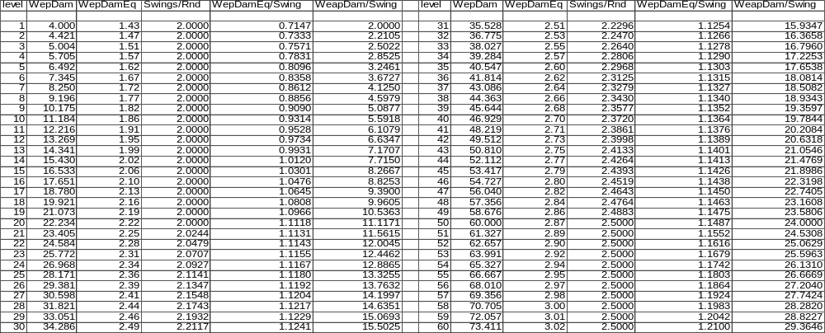
As is evident, the WepDamEqPerSwing value always increases. Hence, a higher-level weapon is always better than a lower level one. Again, this is what we would expect and desire.
Furthermore, we see that a L1 weapon equipped by a L1 character will do an average damage of 2.0 per swing. Obviously, we want every hit to have some noticeable effect, so the fact that it is above 1.0 is good.
A top-of-the-line weapon, L60, damages for 29.36 HP per hit. This means that a single-blow won’t be adequate to kill a L1. Since we don’t desire instant-death, this is a good setup.

Weapon Proficiency and Specialization for Mobs
As a final note on Proficiency and Specialization, we must make a comment about how all of this applies for mobs. Since builders tend to either specify that their mob has X number of hits, or it is specified by the designer of the racial type, it is a good idea that that mob have X always or bug-reports are likely to arise. The ramification is that if number of hits is specified, we need to ignore specialization’s effect on SwingsPerRound.
Furthermore, Proficiency spans L1-L20, and Specialization from L20-L50. This is the full range of player levels, but mobs can extend well into the L50+ range. Since we are using these skills to identify SimpOffSkill, we have a problem. Clearly, we don’t want to add a third, mob-only “skill” that aids in calculating SimpOffSkill for the L50+ range as this would be silly, but neither do we want to limit SimpOffSkill to the L50 value.
For practical purposes we are forced to do the following: if specialization is not maxed, we calculate SimpOffSkill from Proficiency and Specialization as per players, otherwise, we use the greater of the mobs actual level or L50 to derive SimpOffSkill.

Combat Use of the Secondary Hand

An Overview of the Tradeoffs Involved
We have previously given values for the number of ParryEligible blows, as well as the expected ActDam inflicted. We do not wish to favor one style of attacks over the others, so let us explore how to make tradeoffs between the terms.
Since our previous argument to derive ActDam presumed that ParryEligible blows effectively missed their mark, we realize that adopting a posture where ParryEligible blows hit means that the character is in fact taking a greater amount of damage per round. That is to say, if I am not blocking those ParryEligible blows, I am effectively suffering greater damage. The only way that this can be reconciled with the BalancedCombat equation is if I am, in turn, also inflicting more damage than normal.
We realize:
BalancedCombat equation:
_{ActHPa} * ActDam_{a} = ActHP_{b} * ActDam_{b}
_{ActHPa} * ((multiplier for weapon in 2nd hand) * ActDam_{a})= ActHP_{b} * ((multiplier for extra hits from not blocking ParryEligible blows) * ActDam_{b})
Clearly, the multipliers need to be identical. For the fair-fight scenario, since ParryEligible represents an extra 50% of all blows, the weapon in the second hand must represent an extra 50% damage.
Mathematically, this looks like:
- OffHandMultiplier
= Extra damage (for hitter) (as a multiplier) from using weapon in off-hand
= (ParryEligible blows that land on me) / HitPercab
= (5/22 * ) / HitPercab
= (5/22 * (1.00 – )) / HitPercab
= 5/22 * (1/HitPercab – 1)
As an example, let’s imagine a fairly skewed fight in which I am using a 2H weapon and am attacking a much higher-level mob. Because the mob is superior, it hits me 60% of the time (let’s say). Plugging into the above equation:
= 5/22 * (1/HitPercab – 1)
= 5/22 * (1/0.6 – 1)
= 5/22 * 2/3
= 5/33
That is to say, for this example, I only receive an extra 5/33 (or 15%) more damage for the use of my off-hand as a weapon. As noted before, the fair-fight scenario yields OffHandMultiplier=0.5 as desired.
This setup, while correct numerically and properly maintaining BalancedCombat, is somewhat hard to defend rationally. Realize however, the damage from the primary weapon does NOT decrease; only the extra damage from the off-hand weapon depends on the level of the combatants. We can presume that the off-hand is less articulate than the primary, and that the off-hand is simply unable to land as well upon a vastly superior foe.
As a final comment on this subject, we should realize that simple ratios do come into play. If I use my weapon to block half the ParryEligible blows, than I should have an OffHandMultiplier that is half as great.
As previously noted during the discussion about parrying, combatants have the ability to actively block blows. For the most part, we expect that a player will be wielding their best weapon in their primary hand and using it to attack with. However, it is how the character chooses to use their secondary (or off) hand that is of interest.

Use of a Shield
One option is to hold a shield in the off-hand. This is obviously the most defensive of options, and should therefore yield the best chance of blocking an incoming blow.
Strictly speaking, the size of the shield ought to play an important part. However, since our combat system does not model “weapon reach” or otherwise factor in dimensions, we will essentially say that a shield is a shield.
Additionally, our system has no capability for using a shield offensively (swinging it like a chair or club, using it as a battering ram, etc.), thus shield-use has no inherent attack capabilities.
Thus, if a shield is in use, all ParryEligible blows should be blocked and no additional blows should be awarded.

Dual-Wielding
Another option would be to equip a secondary weapon in the off-hand. Doing this yields quite a bit of flexibility for the character. This second weapon could be used as a means to also attack the opponent (attack with both hands), or the character might choose to use the off-hand weapon defensively to parry blows made against it (attack with one hand, parry with the other). Obviously, variations are allowed, so that the off-hand parries some blows and attacks as well.
We will give the character the ability to specify whether they want an offensive or defensive posture (discussed further later on), and we will use this to determine how the off-hand is used.
The off-hand should receive extra swings related to OffHandMultiplier and the normal SwingsPerRound. That is to say, if the OffHandMultiplier says to do an extra 50% damage (as is the fair-fight case), the off-hand should receive 50% of the SwingsPerRound value. A non-specialized, dual wielding, fair-fight would see 2.0 SwingsPerRound with the primary, and 1.0 (= 0.5 * 2.0) SwingsPerRound with the secondary.
Since we will assume that even a character flagged-offensive will parry some blows, and a flagged-defensive character might occasionally take potshots that present themselves, we will assume:
Offensive: Parry 10%, attack 90%
Semi-Offensive: Parry 25%, attack 75%
Normal: Parry 50%, attack 50%
Semi-Defensive: Parry 75%, attack 25%
Defensive: Parry 90%, attack 10%
- Tradeoffs for Various Uses of Off-Hand
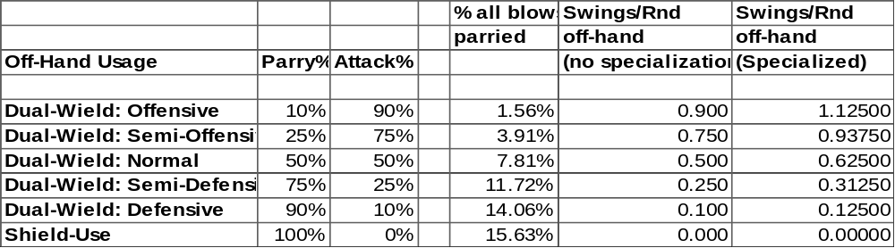

Fencing
The third-option would involve leaving the off-hand empty. A character thus equipped could theoretically use only one “side” of their body, and rather than standing toe-to-toe with my belly-button facing the opponent, a 1-weapon-only character would probably adopt a more traditional fencing posture (one-foot in front, facing semi-sideways). With the off-hand free, the character also has flexibility to use it to grab at their victim or otherwise distract them.
For all intents and purposes, this is a fairly informal style of fighting, more akin to barroom brawling than pitched battles. I have reservations about equating this style of fighting to the others, so I am largely going to simply ignore it.
It’s useful to keep it in mind, as certain classes might adopt it (or be encouraged to it) for roleplay purposes. It’s certainly plausible that thieves and assassins might jump someone armed with only a single dagger.

Two-Handed (2H) Weapons
Finally, a character might opt to use a single weapon that requires both hands. Such 2H-weapons are larger, more unwieldy, and typically do more damage (swing for swing) than their 1H equivalents.
Realistically, a 2H weapon is typically larger and heavier, but neither is it that much slower to swing. We’ll stipulate that a 2H weapon has the same number of swings as the 1H weapon does when in the primary hand.
Unfortunately, this creates a messy situation. Since the person is using a 2H weapon, they need to be getting the normal amount of damage plus the amount we calculated in OffHandMultiplier. Since SwingsPerRound is not allowed to change, this means that the 2H-weapon damage per swing must change depending on the level of the combatants.
Mathematically:
- WepDamEqPerSwing2H
= WepDamEqPerSwing for a 2H weapon
= OffHandMultiplier * WepDamEqPerSwing
Unfortunately, this means that 2H-weapon damage depends on the value of HitPercab. I’ll always get SwingsPerRound with the 2H weapon, but in a fair-fight, the 2H weapon will do 50% more damage per successful swing than a 1H-weapon would do. But if I fight mobs of greater level, the extra damage the 2H-weapon does becomes less and less.

Outcomes of the Off Hand Weapon System
The upshot of all this is that the greatest offensive setup is to use a 2H weapon. Using dual weapons in offensive mode comes close in terms of total damage, but the off-hand weapon will occasionally parry a blow here and there. Still dual wielding, we can downgrade our attack mode and gradually become more and more defensive. Still, dual wielding in defensive mode allows the occasional offensive swing and a few ParryEligible blows will land. The greatest defensive setup would be to replace the offhand weapon with a shield.

Implementation Notes

Fair-Fights
We should not leave the subject of combat before thinking long and hard about the practical ramifications of our fair-fights. Our game design largely presumes that fair-fights should occur most of the time. However, we have kept the systems for mobs and PCs identical.
Since mobs and PCs are perfectly in synch, a fair-fight is basically a 50/50 tossup with the mob winning half the time, and the PC winning otherwise. Obviously, the human brains will probably best our mob AI, and the PC probably has the initiative of when to attack, etc. While these things give the PC a slight edge, game design should not really factor these things into account.
Clearly, PCs will not like fighting in a 50/50 contest. Victory simply awards them modest XP and booty, while failure means possible death and other large penalties.
For this reason, we should hamstring mobs slightly. Obviously, we don’t want to alter the discussions of this document overtly much, but we want to create a game that encourages players to fight like-leveled creatures, and to do this, we need to give players a slight edge.
Giving mobs about 90% of the ActHP that we calculated is probably sufficient to accomplish this. For purposes of this document, I am going to ignore this correction factor, but I am pointing out that it is appropriate to slightly penalize mobs in order to accomplish our larger goals of encouraging fair-fights and making the game fun.
Reducing ActHP for mobs by 10% will have the effect of making the mob last less long in combat. Rather than the 60 rounds of SurvRnds previously calculated, mobs will last 10% fewer rounds. That is to say, on average the PC will last 60 rounds while the mob dies near round 54. All things considered, this gives the PC about 6 rounds worth of padding in the typical fight, which ought to significantly shift the balance into the player’s favor.

Synergistic Correction
For the most part, the discussions thus far have centered on one-on-one fights. Clearly, being a multi-user environment, players will certainly want to group, so we should not overlook the impact of multiple characters combining efforts.
Thus far, we have already built in some generous “grouping rewards”. For instance, the fact that MobXP goes up faster than Power was primarily introduced to encourage people to work together and fight the best creatures they were capable of killing. Built into this system was the fact that two equal players, when grouped, would have twice their normal Power; three such would have 3X the Power, etc.
Unfortunately, as things stand, this is not the case. Consider the situation when two equal players group. With both swinging at the enemy, they effectively inflict twice the normal damage. As a result, the mob lasts half as long as normal. So, rather than being able to tank one mob each if separate, EACH of them can tank TWO fair-fight mobs. This yields a total of 4 kills grouped. Granted, the MobXP would be split two ways for the 4 kills, but this is still twice the amount they would have gotten separately. Throw the above “grouping reward” factor in, and grouping REALLY pays off.
Clearly, we did not intend for grouping to have this effect. Power is supposed to be additive, such that when two people tank, they are equivalent to a single character of twice the Power. In order to accomplish this, we must make a SynergisticCorrection.
The SynergisticCorrection is a scaling factor, such that when multiple people group, they become less than 100% efficient each. As more and more people are thrown at a mob, each person gets a smaller and smaller fraction of their damage. However, the sum of everybody’s damage increases. The group, as a whole, doesn’t suffer from adding new members, but each individual member’s damage declines.
Additionally, the same SynergisticCorrection applies to the tank’s received damage. As more people are thrown into a group, the tank winds up taking more damage. We’ll come back to this in a bit.
The intention of the SynergisticCorrection is to eliminate the geometric growth of Power, and put it back on the additive scale that we desired. That is, we desire that power goes something like:
Power = ActDam_{a} * ActHP_{a} + ActDam_{b} * ActHP_{b} + ActDam_{c} * ActHP_{c} + …
However, without the SynergisticCorrection, we see that it goes like:
Power = (ActDam_{a} + ActDam_{b} + _{ActDamc +} …) * ActHP_{a} +
(ActDam_{a} + ActDam_{b} + ActDam_{c} + …) * ActHP_{b} +
(ActDam_{a} + ActDam_{b} + _{ActDamc} + …) * ActHP_{c} + …
The SynergisticCorrection (K) is simply a multiplier, that when applied to each of the ActDam and ActHP of the group (in the second equation), makes the two equations the same. That is:
(K*ActDam_{a} + K*ActDam_{b} + K*ActDam_{c +} …) * K*ActHP_{a} +
(K*ActDam_{a} + K*ActDam_{b} + K*ActDam_{c +} …) * K*ActHP_{b} +
(K*ActDam_{a} + K*ActDam_{b} + K*ActDam_{c +} …) * K*ActHP_{c} + …
= ActDam_{a} * ActHP_{a} + ActDam_{b} * ActHP_{b} + ActDam_{c} * ActHP_{c} + …
Factoring:
K*(ActDam_{a} + ActDam_{b} + ActDam_{c +} …) * K*ActHP_{a} +
K*(ActDam_{a} + ActDam_{b} + ActDam_{c +} …) * K*ActHP_{b} +
K*(ActDam_{a} + ActDam_{b} + ActDam_{c +} …) * K*ActHP_{c} + …
= ActDam_{a} * ActHP_{a} + ActDam_{b} * ActHP_{b} + ActDam_{c} * ActHP_{c} + …
And again:
K² *(ActDam_{a} + ActDam_{b} + ActDam_{c +} …) * ActHP_{a} +
K² *(ActDam_{a} + ActDam_{b} + ActDam_{c +} …) * ActHP_{b} +
K² *(ActDam_{a} + ActDam_{b} + ActDam_{c +} …) * ActHP_{c} + …
= ActDam_{a} * ActHP_{a} + ActDam_{b} * ActHP_{b} + ActDam_{c} * ActHP_{c} + …
And solving for K:
- SynergisticCorrection
= A correction term applied to multi-person groups
= sqrt((ActDam_{a} * ActHP_{a} + ActDam_{b} * ActHP_{b} + ActDam_{c} * ActHP_{c} + …) / (ActHP_{a} * (ActDam_{a} + ActDam_{b} + ActDam_{c +} …) +
_{ActHPb} * (ActDam_{a} + ActDam_{b} + ActDam_{c +} …) +
_{ActHPb} * (ActDam_{a} + ActDam_{b} + ActDam_{c +} …)))
Technically, we could use separate correction terms, one for ActDam and one for ActHP. The products of the two separate ones would still have to be K². I chose not to do this though.
The result of this is that SynergisticCorrection has a value of 1.0 for a one-person group. For groups larger than one, SynergisticCorrection has a value less than 1.0.
Effectively, what this means is that in a group, each member gets SynergisticCorrection (as a percent) of their true damage. Obviously, we can’t change a person’s ActHP, but what we can do is change the rate at which a group takes damage. For simplicity, I opted not to change the HitPercab and instead simply let the damage the tank receives go up accordingly. That is:
Each hitter inflicts:
Corrected Damage Inflicted = ActDam * SynergisticCorrection
Each Tank receives:
Corrected Damage received = ActDam / SynergisticCorrection
Clearly, this is somewhat objectionable, and the only rationalization that can be offered is that it is necessary from a mathematical standpoint to make Power additive, and that it is somewhat reasonable to reduce efficiency for a multi-person group (Coordinating moves and all that).
- Analysis of SynergisticCorrection
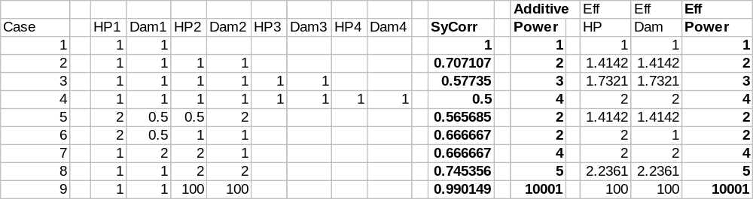
The above spreadsheet is a bit obtuse. Vertically, I've displayed 8 different test scenarios. Each test scenario shows up to 4 (we can have more, but I didn’t bother to plot it) different people in a group. The relative powers for HP and Dam of each of the 4 people are shown. For instance, test case #1 is a 1-person group, with the person evenly balanced between HP and Dam. Test case #4 is a 4-person group, with everyone being evenly balanced.
For each test case, I calculated the SynergisticCorrection, shown in the middle column. The “Additive Power” column is what would result if we summed HP*Dam for each of the group members. This is what we stated would be the desired power. The “Eff HP” and “Eff Dam” columns represent the effective HP and dam for this group. That is, it’s the sum of the HP or Dam, scaled by SynergisticCorrection. “Eff Power” is the effective power, which is simply “Eff HP” * “Eff Dam”.
You’ll note that Eff Power and Additive Power are identical, this proves that the correction factor we made results in the proper adjustment.
The points of interest are that the more people that are added to a group, the lower the value for SynergisticCorrection (Cases #1-4). Coordination becomes increasingly more difficult with more people involved.
Likewise, if one of the members is unbalanced (e.g. twice the HP, half the damage), SynergisticCorrection becomes less and less (a bigger correction). (C.f. case #2, case #5, case #6)
However, if the group is vastly dissimilar (C.f. case #8, case #9), the SynergisticCorrection approaches 1.0 (no correction). Clearly, the low-level group member doesn’t do very much, and the system is telling us that the situation is reasonably identical to the high-level person being alone.

Character Class
We have, up until now, been using a fairly generic definition for characters. We have come quite far using this simplified definition. However, it is now time to begin enhancing our definition and exploring the results. We will start by introducing the concept of class.

An Introduction to Character Class
Simply speaking, character class is equivalent to the person’s chosen profession. Being a fantasy-based RPG, we expect to see some characters become warriors. Others will pursue a career in magic, or perhaps religion. Still others might be attracted to the black-careers of thieving and the like.
Furthermore, players often have different perceptions about how a class should be designed. For example, some folks may feel that a given class ought to be successful playing entirely solo without the aid of other group mates. Others may feel that the same class is an obvious “support” character that is meant to enhance the power of other members in its group, but is fairly weak when standing on its own. The former interpretation would lead to a class fairly well balanced between HP, melee damage and skill damage, while the group-centric view probably sacrifices HP in order to enhance damage capacity and ability to lend support to someone else that is fighting.
Experience has demonstrated that there is no good middle ground on this problem. Trying to appease all interpretations just leads to a watered-down class that is no good at anything. We’ll avoid this pitfall by splitting the various classes into three parts. One geared toward soloing, one that is group-oriented with an emphasis on offensive capabilities, and a third that is group-oriented but more focused on the defense of the group.
Clearly, each type of character will differ slightly based on how we perceive the class, so we should explore each class in depth.

The Warrior Class
The warrior class is conceived of as a fighter that is evenly balanced and fully capable of going it alone.
The warrior class is probably the simplest to devise since it is essentially identical to the generalized definition of “character” that we have devised to date. In fact, for simplicity, the warrior will have the values determined to date for all equations.
Warrior-classed characters will have fairly even HP, AC, weapon and skill development over their entire career.
The warrior class is designed to be successful when soloing. The HP and damage factors should be structured such that the warrior class is able to play without seeking out other players for assistance.
In a group, the warrior class will be reasonably effective as well. It doesn’t have the specializations that define the other classes, but by being well balanced, the warrior class makes an effective backup or substitute for any position that the group finds lacking.
The warrior class will have offensive skills that allow it to damage opponents. Likewise, warriors will also have abilities allowing the warrior to disrupt or distract opponents preventing them from using skills or blocking their melee capacity.

The Bodyguard Class
The bodyguard class is also a fighter-subtype, but it is conceived of as being group-oriented and with an emphasis on defensive actions. In a word, bodyguards are “tanks”.
Compared to the warrior class, bodyguards have a greater number of HP, but inflict less melee damage per round. Bodyguard’s skills are geared toward disrupting the opponent and preventing the opponent from successfully executing offensive and skill attacks. Additionally, bodyguard’s skills focus upon defending other group mates and making sure that the enemy stays engaged with the bodyguard.
If playing solo, bodyguards mainly rely on being able to outlast their opponents. Their greater HP gives them more staying power, and their basic strategy involves keeping the enemy’s ability to inflict damage to a minimum.
In a group, bodyguards typically assume the role of tank. They have the greatest amount of ActHP of any class. Bodyguards are also extremely effective at putting themselves in the line of fire. Hence, enemies find it hard to ignore a bodyguard to attack the other members of a bodyguard’s group.

Bodyguard’s HP Bonus
Bodyguards will have 20% more ActHP than an equivalent level warrior.
- ActHPBodyguard
= 1.2 * ActHP
= 1.2 * 18.67131 * ((level)1.759815 + 13)0.635902
= 22.40558 * ((level)^{1.759815} + 13)^{0.635902}

Bodyguard’s Damage Penalty
To keep Power in balance, bodyguards will have a penalty on their ActDam. In order to maintain parity, this penalty will be equivalent to:
- ActDamModifierBodyguard
= Multiplier for ActDam for the bodyguard class
= ActHP / ActHPBodyguard
= 1.00 / 1.2
= 5/6
That is to say:
- ActDamBodyguard
= Value for ActDam for bodyguard class
= ActDam * ActDamModifierBodyguard
5/6 * ActDam
We will stipulate that HitPercab for bodyguards remains the same as for warriors. Thus the derivation for DamCap remains fairly straightforward:
- DamCapBodyguard
= Value for DamCap for bodyguard class
= DamCap * ActDamModifierBodyguard
5/6 * DamCap
As we recall, SimpWeaponDamage represents 75% of DamCap, while SimpSkillDamage represents the other 25%. We do not want bodyguard’s skills to be impacted, so this means that the penalty must be entirely born by SimpWeaponDamage:
DamCapBodyguard = WeaponDamageBodyguard + SimpSkillDamage
(5/6 * ) = WeaponDamageBodyguard + (1/4 * DamCap)
By rewriting:
- WeaponDamageBodyguard
= Value for SimpWeaponDamage for bodyguard class
= (5/6 * ) - (1/4 * DamCap)
= 7/12 * DamCap
= 7/12 * (4/3 * SimpWeaponDamage)
7/9 * SimpWeaponDamage
We will want bodyguards to have the same number of swings per round as warriors; hence, SwingsPerRound is the same for bodyguards. Additionally, we won’t be placing any restriction on the weapon used by bodyguards, so we stipulate that WeaponDamEq remains constant. As a consequence, there is no change in WepDamEqPerSwing. Therefore, we conclude that the WeaponDamageBodyguard penalty is entirely handled by the Exp term:
WeaponDamageBodyguard = 7/9 * SimpWeaponDamage
WeaponDamageBodyguard = 7/9 * (WeaponDamEq * WeaponDamExp)
Thus, we realize:
- WeaponDamExpBodyguard
= Value for WeaponDamExp for bodyguard class
= 7/9 * WeaponDamExp
= 0.7778 * WeaponDamExp
Stated simply, in order to maintain the Power equation, bodyguards will gain 20% more ActHP over warriors, but suffer a 22.22% penalty to WeaponDamExp, which translates into 22.22% less SimpWeaponDamage as well.
- Bodyguard Class vs. Warrior Class
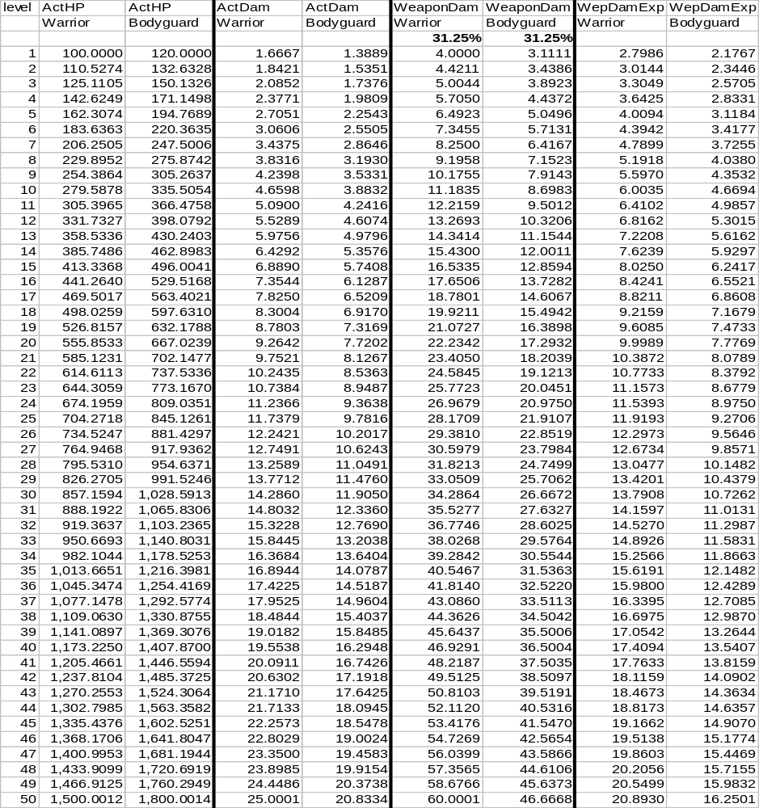

Bodyguard Review
Bodyguards are essentially simple warriors that possess more HP and a lesser damage. Beyond that, the changes are cosmetic and are made for the sake of role-playing.
While bodyguard’s value in the Power equation remains unchanged compared to warriors, it must be noted that the SurvRnds is slightly altered. Because bodyguard damage is lower, bodyguards take 6/5 the time to kill a warrior. Likewise, bodyguard’s higher HP make them less vulnerable, and they take 6/5 the amount of time to die as well. Overall, a bodyguard vs. warrior fair-fight will require 72 rounds (vs. 60 for two warriors).

The Mercenary Class
The mercenary class is also a fighter-subtype, but is conceived of as being group-oriented and with an emphasis on offensive actions. In a word, mercenaries are “hitters”.
Compared to the warrior class, mercenaries have lower HP, but inflict greater melee damage per round. Mercenary’s skills are geared toward inflicting as much damage as possible, as well as toward encouraging the enemy to attack someone else other than the mercenary.
Mercenaries fare reasonably well when fighting one-on-one. They are unable to last extraordinarily long, and they must adopt a strategy that lets them inflict as much damage as possible in as quick an amount of time.
In a group, mercenaries are almost always seen hitting behind bodyguards or warriors. Mercenaries have the least amount of ActHP of all the fighter-subclasses, but are rewarded with the ability to do great amounts of damage, and skills that discourage opponents from targeting the mercenary.

Mercenary’s HP Penalty
Mercenaries will have 20% less ActHP than an equivalent level warrior.
- ActHPMercenary
= 0.8 * ActHP
= 0.8 * 18.67131 * ((level)1.759815 + 13)0.635902
= 14.93705 * ((level)^{1.759815} + 13)^{0.635902}

Mercenary’s Damage Bonus
To keep Power in balance, mercenaries will receive a bonus on their ActDam. In order to maintain parity, this bonus will be equivalent to:
- ActDamModifierMercenary
= Multiplier for ActDam for the mercenary class
= ActHP / ActHPMercenary
= 1.00 / 0.8
= 5/4
That is to say:
- ActDamMercenary
= Value for ActDam for mercenary class
= ActDam * ActDamModifierMercenary
5/4 * ActDam
We will stipulate that HitPercab for mercenaries remains the same as for warriors. Thus the derivation for DamCap remains fairly straightforward:
- DamCapMercenary
= Value for DamCap for mercenary class
= DamCap * ActDamModifierMercenary
5/4 * DamCap
As we recall, SimpWeaponDamage represents 75% of DamCap, while SimpSkillDamage represents the other 25%. We do not want mercenary’s skills to be impacted, so this means that the bonus must be entirely found in SimpWeaponDamage:
DamCapMercenary = WeaponDamageMercenary + SimpSkillDamage
(5/4 * ) = WeaponDamageMercenary + (1/4 * DamCap)
By rewriting:
- WeaponDamageMercenary
= Value for SimpWeaponDamage for mercenary class
= (5/4 * ) - (1/4 * DamCap)
= DamCap
= (4/3 * SimpWeaponDamage)
We will want mercenaries to have the same number of swings per round as warriors; hence, SwingsPerRound is the same for mercenaries. Additionally, we won’t be placing any restriction on the weapon used by mercenaries, so we stipulate that WeaponDamEq remains constant. As a consequence, there is no change in WepDamEqPerSwing. Therefore, we conclude that the WeaponDamageMercenary bonus is entirely handled by the Exp term:
WeaponDamageMercenary = 4/3 * SimpWeaponDamage
WeaponDamageMercenary = 4/3 * (WeaponDamEq * WeaponDamExp)
Thus, we realize:
- WeaponDamExpMercenary
= Value for WeaponDamExp for mercenary class
= 4/3 * WeaponDamExp
= 1.3333 * WeaponDamExp
Stated simply, in order to maintain the Power equation, mercenaries will have 20% less ActHP than warriors, but be rewarded with a 33.33% increase in their WeaponDamExp, which translates into 33.33% more SimpWeaponDamage as well.
- Mercenary Class vs. Warrior Class
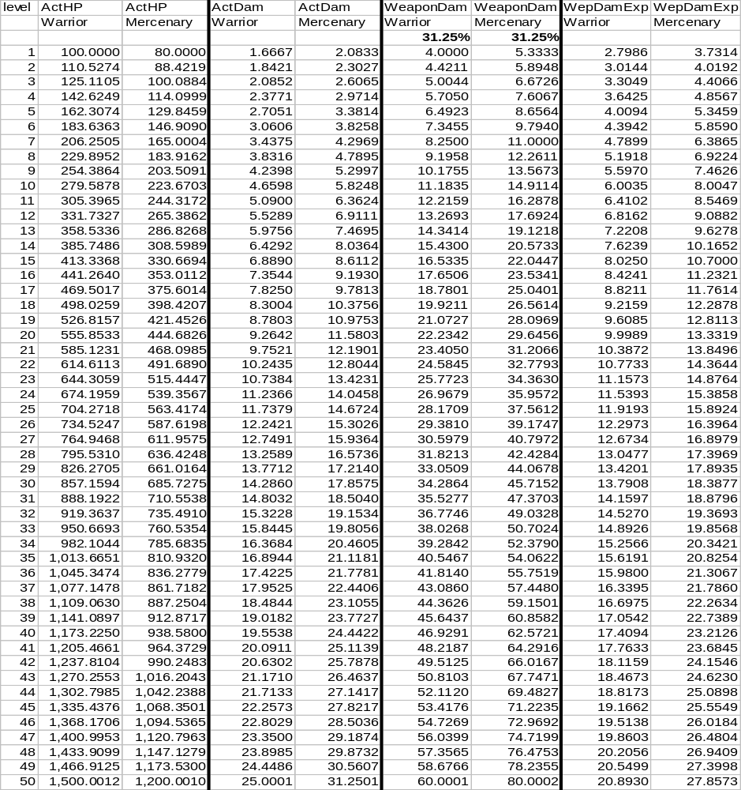

Mercenary Review
Mercenaries are essentially simple warriors that possess fewer HP and a greater damage. Beyond that, the changes are cosmetic and are made for the sake of role-playing.
While mercenary’s value in the Power equation remains unchanged compared to warriors, it must be noted that the SurvRnds is slightly altered. Because mercenary damage is higher, mercenaries are able to kill warriors in 4/5 the time. Likewise, mercenary’s lower HP make them vulnerable, and they die in 4/5 the time as well. Overall, a mercenary vs. warrior fair-fight will only require 48 rounds (vs. 60 for two warriors).

Magic Casters
Being a fantasy-based RPG, it is natural to expect magic to play an important part of the game. The magic casting classes are granted the greatest control over the forces of magic within our game.
Casters, in general, tend to be the physically weakest class, although they make up for this with the power of their magic.
Like fighters, magic casters will be broken into three distinct subtypes based on anticipated play styles. Warlocks/Witches will adopt the solo play style. Mages will adopt a group-based, defensive play style. And Sorcerers will fill out the subtype with a group-based, offensive play style.

The Warlock Class
The warlock class is a caster-subtype conceived of as evenly balanced and capable of fighting one-on-one. Female warlocks will, of course, be known as witches.
Being a caster-subtype, warlocks will have fewer HP than an equivalent warrior, and also be permitted less armor from equipment. The class is primarily focused on magical forms of attacks, and our combat system largely assumes that warlocks will fight from a distance in an “engaged” state if possible.
However, with the presence of all these penalties, the resulting benefit when it comes to skill damage is impressive. That is to say, these penalties allow warlock’s magic to be some of the singly most devastating forms of attacks in the game.

Warlock HP Penalty
Because casters are thought of as physically weak, warlocks will have 50% less ActHP than an equivalent level warrior.
- ActHPWarlock
= The ActHP value for the warlock class
= 0.5 * ActHP
= 0.5 * 18.67131 * ((level)1.759815 + 13)0.635902
= 9.33566 * ((level)^{1.759815} + 13)^{0.635902}
In order to preserve the Power equation, by reducing HP by a factor of 2, we must now increase other aspects of the warlock.

Warlock Armor
Since casters need to be more nimble in order to make all the arcane gestures necessary for spell casting, warlocks will be limited to wearing strictly clothing (as opposed to armor). Since clothing has an ActArmor 50% that of armor, this means:
- ActArmorWarlockEq
= Contribution to ActArmor from equipment for the warlock class
0.5 * ActArmor
= 0.5 * 10000 *
= 5000 * (level^{1.759815} + 13)^{0.163844}
However, warlocks will also possess magical abilities by which they can enhance their own armor rating. Overall, we would like for a fully spelled up warlock to have 1.414 (=sqrt(2)) more armor than an equivalent warrior.
- ActArmorWarlock
= Value for ActArmor for the warlock class
sqrt(2) * ActArmor
This implies that the value for warlock armor coming from spells is:
- ActArmorWarlockSpell
= Contribution to ActArmor from spells for the warlock class
= ActArmorWarlock - ActArmorWarlockEq
= (sqrt(2) * ) – (0.5 * )
= (sqrt(2) – 0.5) * ActArmor
= 0.914214 * ActArmor
= 0.914214 * 10000 *
= 9142.14 * (level^{1.759815} + 13)^{0.163844}

Warlock Success Rates
We opt to leave SimpOffSkill and SimpDefSkill alone for warlocks. However, because of the warlock’s overall higher ActArmor, the resulting ActDef is higher:
- ActDefWarlock
= ActDef score for the warlock class
= SimpDefSkillWarlock * ActArmorWarlock
= (SimpDefSkill) * (sqrt(2) * )
= sqrt(2) * (SimpDefSkill * ActArmor)
= sqrt(2) * ActDef
Returning briefly to the derivation of (Equation 31.) for HitPercab, we essentially stated that the ratio for SurvRnds and the ratio between Power must match. We had HitPercFormab and were seeking to solve for the exponent n that would permit this. Along the way, we stated that ActOff_{a} = ActDef_{a} and ActOff_{b} = ActDef_{b}. For warlocks, this is no longer the case. Hence, we should not assume that the HitPercab achieved earlier applies.
Instead, let’s solve more generically. From before, this is still true:
_{ActOffb} * ActDef_{b} / (ActOff_{a} * ActDef_{a}) = (ActOff_{b} / (ActOff_{b} + ActDef_{a}))^{n} / (ActOff_{a} / (ActOff_{a} + ActDef_{b}))^{n}
Taking the log of both sides:
log[ActOff_{b} * ActDef_{b} / (ActOff_{a} * ActDef_{a})] = n * log[(ActOff_{b} / (ActOff_{b} + ActDef_{a})) / (ActOff_{a} / (ActOff_{a} + ActDef_{b}))]
Solving for n, which we will call the HitPercExponent:
- HitPercExponent
= Exponent to be used as the value of “n” in HitPercFormab
= log[ActOff_{b} * ActDef_{b} / (ActOff_{a} * ActDef_{a})] / log[(ActOff_{b} / (ActOff_{b} + ActDef_{a})) / (ActOff_{a} / (ActOff_{a} + ActDef_{b}))]
Presuming a fair-fight between a warlock and a warrior, we can solve this equation.
Warlock (a) hitting Warrior (b):
HitPercExponent
= log[ActOff_{b} * ActDef_{b} / (ActOff_{a} * ActDef_{a})] / log[(ActOff_{b} / (ActOff_{b} + ActDef_{a})) / (ActOff_{a} / (ActOff_{a} + ActDef_{b}))]
Substituting values for warrior and warlock:
= log[ActOff * ActDef / (ActOff * (sqrt(2) * ActDef))] / log[(ActOff / (ActOff + (sqrt(2) * ActDef))) / (ActOff / (ActOff + ActDef))]
Realizing that ActOff = ActDef:
= log[ActOff * ActOff / (ActOff * (sqrt(2) * ActOff))] / log[(ActOff / (ActOff + (sqrt(2) * ActOff))) / (ActOff / (ActOff + ActOff))]
Factoring out ActOff:
= log[1 * 1 / (1 * (sqrt(2) * 1))] / log[(1 / (1 + (sqrt(2) * 1))) / (1 / (1 + 1))]
= log[1/sqrt(2)] / log[(1 / (1 + sqrt(2))) / (1 / 2)]
= log[1/sqrt(2)] / log[2/(1 + sqrt(2))]
= -0.150515 / -0.081746
= 1.841259
By extension then:
HitPercab (warlock hitting warrior)
= 1.25 * (ActOff_{a} / (ActOff_{a} + ActDef_{b}))^{n}
= 1.25 * (ActOff_{a} / (ActOff_{a} + ActDef_{b}))^{1.841259}
Presuming a fair-fight:
= 1.25 * (ActOff / (ActOff + ActDef))^{1.841259}
= 1.25 * (ActOff / (ActOff + ActOff))^{1.841259}
= 1.25 * (1/2)^{1.841259}
= 34.8848%
For the reverse scenario, warrior (a) hitting warlock (b):
HitPercExponent
= log[ActOff_{b} * ActDef_{b} / (ActOff_{a} * ActDef_{a})] / log[(ActOff_{b} / (ActOff_{b} + ActDef_{a})) / (ActOff_{a} / (ActOff_{a} + ActDef_{b}))]
= log[ActOff * (sqrt(2) * ActDef) / (ActOff * ActDef)] / log[(ActOff / (ActOff + ActDef)) / (ActOff / (ActOff + (sqrt(2) * ActDef)))]
= log[ActOff * (sqrt(2) * ActOff) / (ActOff * ActOff)] / log[(ActOff / (ActOff + ActOff)) / (ActOff / (ActOff + (sqrt(2) * ActOff)))]
= log[1 * (sqrt(2) * 1) / (1 * 1)] / log[(1 / (1 + 1)) / (1 / (1 + (sqrt(2) * 1)))]
= log[sqrt(2)] / log[(1/2) / (1/(1 + sqrt(2)))]
= .150515 / 0.081746
= 1.841259
By extension then:
HitPercab (warrior hitting warlock)
= 1.25 * (ActOff_{a} / (ActOff_{a} + ActDef_{b}))^{n}
= 1.25 * (ActOff_{a} / (ActOff_{a} + ActDef_{b}))^{1.841259}
Presuming a fair-fight:
= 1.25 * (ActOff / (ActOff + (sqrt(2) * ActDef)))^{1.841259}
= 1.25 * (ActOff / (ActOff + (sqrt(2) * ActOff)))^{1.841259}
= 1.25 * (1/(1+sqrt(2)))^{1.841259}
= 24.6673%
The conclusion here is that, because warlock’s spells give them a higher than normal amount of armor, they are tougher to hit. A warrior in a fair fight will hit them 24.6673% of the time (compared to 31.25% for 2 warriors fighting).
What is less intuitive is the fact that warlock’s increased amount of armor also grants them the ability to hit more often. Warlocks have a fair-fight success rate of 34.8848%. This is a necessary outcome due to the math, although it is not immediately apparent why better armor should make a person hit more often. Fortunately, since “magic” is inherently involved in the warlock case, we are pretty much free to explain it away as simply a side-effect of the magic that the warlock employs.
As a final note on success rate, realize that warlocks will be principally oriented toward doing damage from their skills. Remember that what we did previously was to raise the success rate of skills, and lower the damage. We’ll come back to this momentarily, but it’s a good thing to remember in this section of warlock development.

Warlock Damage
Thus far, we have decreased a warlock’s HP by a factor of 2, and raised warlock armor by a factor of sqrt(2). We must maintain the Power equation’s numerical value, therefore, the warlock’s damage must be increased by a factor of sqrt(2) as well.
- ActDamWarlock
= ActDam value for warlock class
sqrt(2) * ActDam
Following the procedure previously established.
- DamCapWarlock
= DamCap value for warlock class
= ActDamWarlock / HitPercab
= (sqrt(2) * ActDam)/ HitPercab
= sqrt(2) * (ActDam/HitPercab)
sqrt(2) * DamCap
= sqrt(2) * 0.9958 * ((level)1.759815 + 13)0.635902
= 1.408279 * ((level)^{1.759815} + 13)^{0.635902}

Warlock Fight Scenarios
Since the changes for warlocks are not perfectly intuitive, I believe we should revisit the combat scenarios spreadsheet [(Spreadsheet 5.)]. I’ve put the warlock in red.
- Warlock Combat Scenarios
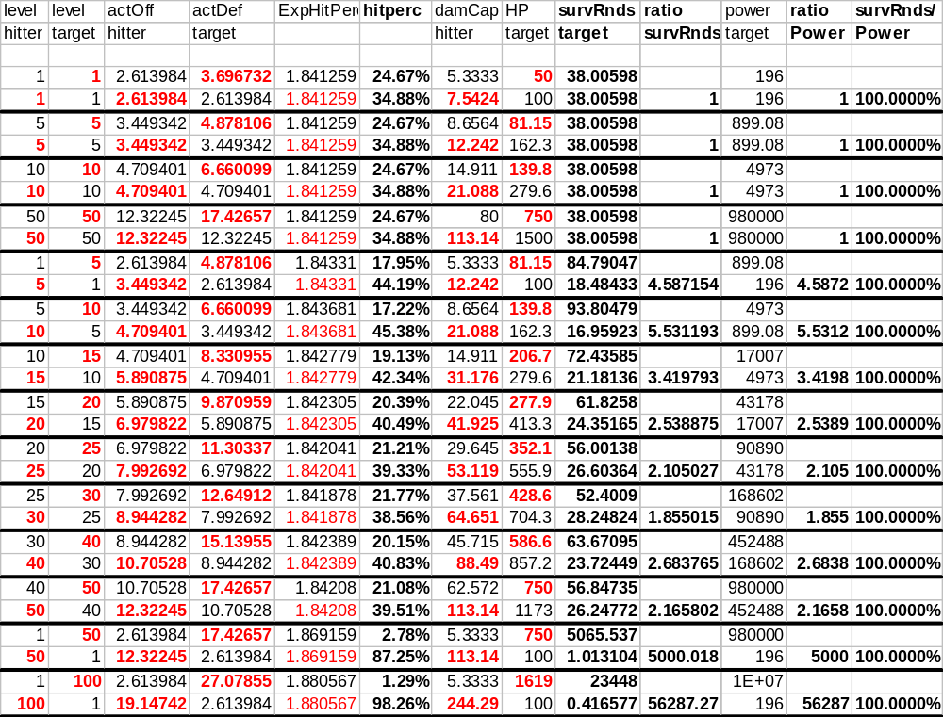
There are a couple of interesting things to note about this chart.
First, the Power ratio and SurvRnds ratio remain constant. Obviously, we want this to happen.
Secondly, the HitPercab values for a fair-fight are as we identified them to be above. However, the SurvRnds for a fair-fight are reduced. It takes 38.01 rounds on average (vs. 60 for 2 warriors). Battles with a warlock are fast and furious. The warrior is inflicting the same damage (less often) against a foe with radically less HP. The warlock is simply doing the more damage, slightly more often. This reduces the amount of time a fight takes.
It is important to also remember that success rates for skills are doubled (and damage is halved) in relation to HitPercab. Warlocks in a fair fight (using an easy difficulty skill) should expect to succeed 69.76% of the time.

Breakdown of DamCapWarlock
For warrior, we broke DamCap into a melee component and a skill based component. Since we have also stated that warlocks will do most of their fighting using spells, this means that they will not have the opportunity to be doing any melee damage. Consequently, all of DamCapWarlock is regarded as skill damage:
- WeaponDamageWarlock
= Value of SimpWeaponDamage for warlock class
= 0
- SkillDamageWarlock
= Value of SkillDamage for warlock class
= DamCapWarlock
= sqrt(2) * DamCap
= sqrt(2) * (4 * SkillDamage)
= 4 * sqrt(2) * SkillDamage
- Warlock Class vs. Warrior Class; Defensive Properties
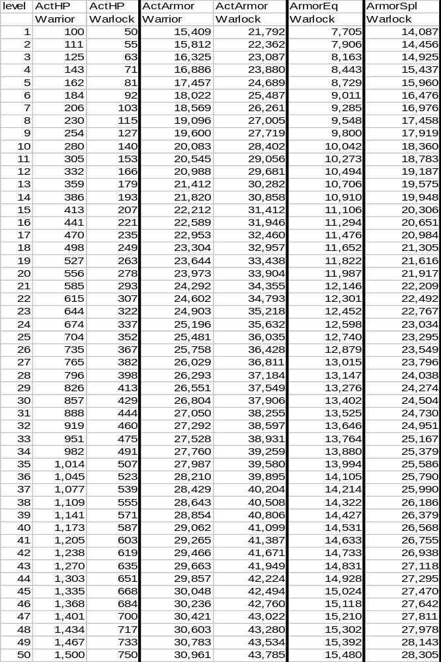
You’ll note that warlock HP is half that of a warrior.
Also, warlocks possess almost as much armor strictly from their skills as warriors have from actual equipment. Even though warlocks are restricted on equipment choice, the extra bit they get from wearing clothing makes their effective armor much superior to that of a warrior.
- Warlock Class vs. Warrior Class; Offensive Properties
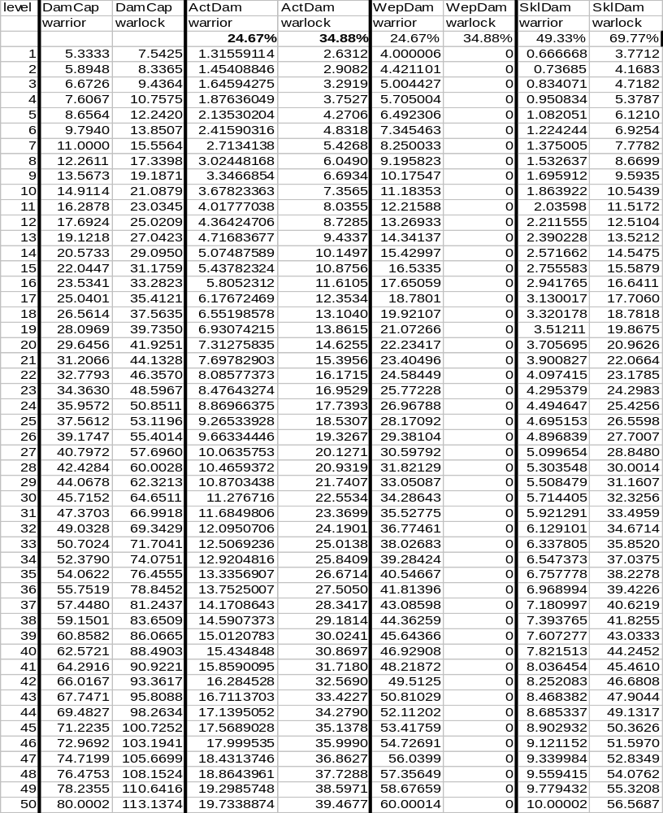
I’ve put the success rates for the two classes near the top of the appropriate columns. As before, SkillDamage was halved and the success rate was doubled.
The interesting things of note are that the warlock is doing nearly ½ again as much damage per successful round (DamCap) as the warrior. When success rates are factored in, the warlock is doing twice the effective damage (ActDam) of the warrior.
The basic raw-damage comparison is also somewhat interesting. While the warlock is not using any sort of weapon, the warlock’s spells are doing roughly the same damage as the warrior is able to achieve with weapons alone. At L50, the warrior does 70 dam/round (assuming all swings and skills hit), whereas a warlock is getting 56.6 dam/round (assuming skill success).

Warlock Skills
In general, a discussion of a class’s skills is not an intrinsic part of the overall game design. The skills given to a class do more to help conceptualize it than they do to insure overall harmony and equality. However, I don’t want to leave the class topic without throwing out some general ideas that came to mind while developing the numerical system.
Since warlocks are a “solo” caster, their magic would probably be directly offensive in nature. That is, the warlock casts a spell meant to directly harm the intended victim. There are many such examples, so I won’t bother to list them. These kinds of spells probably make up the bulk of the warlock’s repertoire.
The warlocks also need some defensive magic for themselves. Since warlocks are going to be on the front line, using the traditional “cast-it, and it decays after a little while” type defense would be fairly high maintenance. I would envision a “permanent” spell effect giving them defense. The warlock would have the ability to raise or lower this “shield” at will. With shields up, protection is greatest, but mana (more on this later) regeneration would suffer.
Being that warlocks are solo-oriented, the class should probably lack the “protect others” and “enhance others” magics. If they possess such spells at all, it would be wise to make success-rate or relative effectiveness suffer. These sorts of spells are not the class’s primary focus, and should be de-emphasized.

Review of Warlock
The upshot of all these manipulations is the development of a caster class that is extremely comparable to the warrior class.
From the perspective of Power, the two classes are exactly the same. Of course, they should be or one class would be “better”.
As far as penalties and bonuses go, warlocks possess fewer HP, but have the advantage of having greater effective armor and doing greater damage. Additionally, warlocks have shifted all their damage capacity into their skills. We presume that they are not using a weapon, and thereby permit them to possess an incredibly high damage capacity.

The Sorcerer Class
The sorcerer class is a caster-subtype conceived of as group-oriented and with leanings toward offensive magics.
Sorcerers are fairly similar to warlocks over the first few levels. However, as they are group oriented, and a caster, their play-style will tend to involve firing off spells from well behind the lines. As a consequence, HP will be of little value, and the mage class will shrug off the advantage of greater HP in order to raise their “damage” capacity.
Sorcerers differ from warlocks slightly in that their magics are more aligned toward an indirect offense. That is to say, rather than firing spells directly at the opponent, the sorcerer is more inclined to give “power ups” to the other members of the sorcerer’s group so that their abilities are enhanced.
In a one-on-one situation, sorcerers are in a disadvantage. They will have a modest number of HP, and some degree of magical armor, but their skills are oriented toward letting someone else do the fighting for them. Sorcerers will doubtless have some direct-offensive magics at their disposal, so they are not complete fodder, but a sorcerer in a one-on-one had better hope for a decent advantage at the outset.
In a group, sorcerers truly shine. Sorcerers are able to both bang away at an enemy from a distance, as well as enhance their groupmate’s natural power. Sorcerers are the heavy guns, although to be best used, they must be adequately protected.

Sorcerer HP Penalty
As with all the casting classes, sorcerers will have fewer HP than an equivalent warrior. Additionally, because sorcerers are group-oriented, they have little need for HP. We will arbitrarily decide that sorcerers will have the HP of a warlock over the first 20 levels. Thereafter, HP gain will be half that as for warlock.
- ActHPSorcerer
= ActHP value for sorcerers
= ActHPWarlock(up to L20) + max((ActHPWarlock – (ActHPWarlock at L20))/2, 0)

Sorcerer Armor
Sorcerer armor will be identical in all respects to that of the warlock.

Sorcerer Success Rate
Sorcerer success rate will be identical in all respects to that of warlock.

Sorcerer Damage
Being otherwise identical to warlocks, in order to preserve the Power equation, sorcerer damage must make up the difference for the penalty on HP that sorcerers have as compared to warlocks.
- ActDamSorcerer
= Value of ActDam for sorcerer class
= ActDamWarlock * (ActHPWarlock / ActHPSorcerer)
= (sqrt(2) * ) * (1/2 * ActHP) / ActHPSorcerer
= sqrt(2)/2 * (ActHP/ActHPSorcerer) * ActDam
Since over the first few levels, sorcerer and warlock HP are identical, so are their values for ActDam. In the later levels, as sorcerers suffer fewer HP, they gain increased damage. As should be self-apparent, this also exists:
- DamCapSorcerer
= Value of DamCap for sorcerer class
= DamCapWarlock * (ActHPWarlock / ActHPSorcerer)
= (sqrt(2) * ) * (1/2 * ActHP) / ActHPSorcerer
= sqrt(2)/2 * (ActHP/ActHPSorcerer) * DamCap
Like warlocks, sorcerers will be presumed to be casting full time so that all of their damage will be from their skills.
- Sorcerer Class vs. Warrior Class
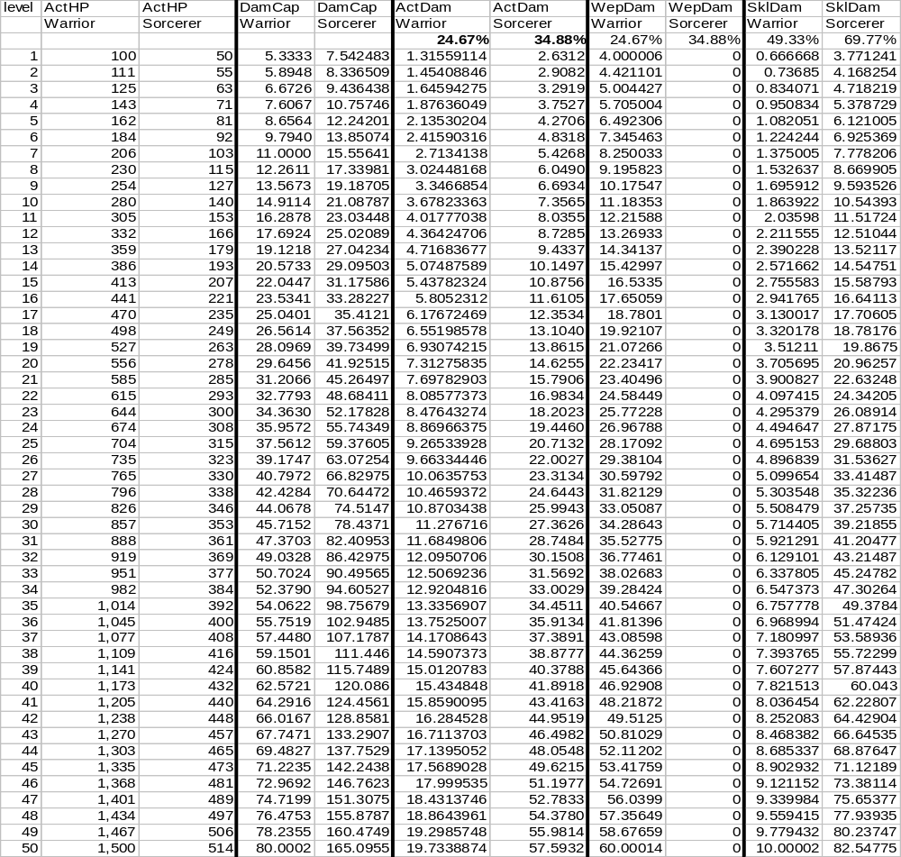
From this chart, we can see that sorcerers, near the end of their career, have 1/3 the HP as warriors. Recalling that warlocks have 750 HP at L50, we also note that sorcerers are even lower than that.
However, the ActDam values are also interesting. Sorcerers do THREE TIMES the damage per round than an equivalent warrior by the end of their careers. Additionally, all of this damage is in their skills.
The change in ActDam and HP has a corresponding effect on SurvRnds. By L50, a sorcerer vs. warrior fight requires only 26.04 rounds (proof not displayed here).

Sorcerer Skills
In general, a discussion of a class’s skills is not an intrinsic part of the overall game design. The skills given to a class do more to help conceptualize it than they do to insure overall harmony and equality. However, I don’t want to leave the class topic without throwing out some general ideas that came to mind while developing the numerical system.
Since sorcerers are group oriented, their spells should primarily be geared toward letting the other group mates fight better. Obvious ideas along this line of thinking include spells that let someone do more damage per swing, or that let that person hit more often. That is to say, the sorcerer’s “damage” is utilized indirectly. The sorcerer passes his damage capacity to someone else to use for the sorcerer.
Sorcerers also need defensive magics and it is probably appropriate for them to use something similar to what was developed for warlocks in terms of a “shield” for the sorcerer to use.
In terms of protecting the group, defense is not the sorcerer’s primary area of focus (mages). If the ability is given, it should be de-emphasized.
Direct attacks are also not the sorcerer’s primary area of focus (warlocks). The class can probably not be made successful without some direct attack styles, but again, they should be kept limited.

The Mage Class
The mage class is a caster-subtype conceived of as group-oriented and with leanings toward defensive magics.
As mages are principally oriented toward defense (of the group), their skills should reflect this. They will have a small assortment of offensive spells, and a like-assortment of self-preservation spells. But they will also possess a number of spells capable of benefiting the frontline members of their party. Rather than directly injuring the enemy, mage’s energy would be directed toward enhancing the tank’s ability to defend itself.
In a one-on-one situation, mages are in a disadvantage. They will have a modest number of HP, and some degree of magical armor, but their skills are oriented toward letting someone else do the fighting for them. Mages will doubtless have some direct-offensive magics at their disposal, so they are not complete fodder, but a mage in a one-on-one had better hope for a decent advantage at the outset.
In a group, mages truly shine. While they don’t employ the big and exciting bangs of sorcerers and warlocks, mages are able to keep their group mates alive long enough to take care of the big and nasties. It may not seem as exciting, but there are plenty of fighters that would prefer the extra insurance of not being hit as often or as hard. Mages are an insecure warrior’s best friend!

Mages by the Numbers
For the most part, mages are numerically identical to sorcerers in everyway. The primary difference is in how they utilize their “damage”.
All formulas that apply for sorcerers apply equally for mages.

Mage Skills
In general, a discussion of a class’s skills is not an intrinsic part of the overall game design. The skills given to a class do more to help conceptualize it than they do to insure overall harmony and equality. However, I don’t want to leave the class topic without throwing out some general ideas that came to mind while developing the numerical system.
Since mages are group oriented, their spells should primarily be geared toward letting the other group mates fight better. The obvious ideas along these lines are spells that prevent the front-line attackers from taking damage. That is, spells that lower the person’s chance of being hit, or spells that soak up damage incurred. In essence, the mage should be using his “damage” in order to let another attacker survive longer in combat.
Mages also need self-defensive magics and it is probably appropriate for them to use something similar to what was developed for warlocks in terms of a “shield” for the mage to use.
Giving the mage the ability to power up (sorcerer) or directly attack (warlock) should be avoided, except that some crossover is probably necessary to make the class a success.

Clergy Classes
In a similar fashion to the magic casters, the various gods and deities express their benevolence or displeasure through the various practitioners of the theological classes. “Prayers” are the equivalent of “magic”, although we are free to establish different rules for the two and thereby differentiate the two for roleplay purposes.
The clergy (as the three classes will be called when lumped together) are fairly similar to the casting classes in their play style choices. Missionaries will adopt a play style capable of solo-play. Priests will be in the group-oriented, offensive role. Clerics will adopt the traditional group-oriented defensive role.
Clergy is fairly similar to casters numerically as well. They will be somewhat stronger physically than casters, although still less than the fighter-subtypes. Based on their physical penalty, clergy’s skill damage will be enhanced.
If looking purely at the numbers, clergy are largely the “lite” variety of casters. They sacrifice some of the raw damage potential that the casters possess, but have greater values in the more tangible aspects like hit points, armor usage, etc. However, we should not quickly dismiss these classes, as the roleplay opportunities they present make these classes highly viable, and by being somewhere midway between pure-caster and pure-fighter, the perceived disadvantages of the two extremes are lessened.

The Missionary Class
The missionary class is a clergy-subtype conceived of as evenly balanced and capable of fighting solo.
As with all of the clergy classes, missionaries will have fewer hit points than an equivalent warrior, and be somewhat restricted in armor choices as well.
The missionaries primary focus is in employing divine acts (prayers) to directly attack the missionary’s foes. Like casters, the missionary will be encouraged to fight from an “engaged” state, foregoing melee damage and concentrating on skill damage instead.

Missionary HP Penalty
Missionaries physical weakness leaves them with only 70% of the ActHP that an equivalent level warrior would have.
- ActHPMissionary
= The ActHP value for the missionary class
= 0.7 * ActHP
= 0.7 * 18.67131 * ((level)1.759815 + 13)0.635902
= 13.069917 * ((level)^{1.759815} + 13)^{0.635902}

Missionary Armor
Missionaries need to be somewhat nimble to make the holy gestures necessary to invoke their prayers. As such, they should be constrained on their choice of equipment and rely primarily on clothing. Overall, we would like missionaries to have 71% of the warrior’s ActArmor from equipment:
- ActArmorMissionaryEq
= Contribution to ActArmor from equipment for the missionary class
0.71 * ActArmor
= 0.71 * 10000 *
= 7100 * (level^{1.759815} + 13)^{0.163844}
To achieve this 71% value for ActArmorMissionaryEq, we are essentially allowing missionaries to choose armor for the head (9%) and body (33%), but restricting them to clothing for the remaining slots.
We also would like missionary’s overall armor to be sqrt(10/7) greater than that of a warrior:
- ActArmorMissionary
= Value for ActArmor for the missionary class
sqrt(10/7) * ActArmor
Therefore, the difference represents the armor that the missionary receives from skills:
- ActArmorMissionaryPrayer
= Contribution to ActArmor from prayers for the missionary class
= ActArmorMissionary - ActArmorMissionaryEq
= (sqrt(10/7) * ) – (0.71 * )
= (sqrt(10/7) – 0.71) * ActArmor
= 0.485229 * ActArmor
= 0.485229 * 10000 *
= 4852.29 * (level^{1.759815} + 13)^{0.163844}

Missionary Success Rates
The discussion for missionary success rate proceeds fairly closely to what was done previously for warlocks.
We again leave SimpOffSkill and SimpDefSkill alone. The higher ActArmor translates into a higher ActDef again:
- ActDefMissionary
= ActDef score for the missionary class
= SimpDefSkillMissionary * ActArmorMissionary
= (SimpDefSkill) * (sqrt(10/7) * )
= sqrt(10/7) * (SimpDefSkill * ActArmor)
= sqrt(10/7) * ActDef
Using this value and solving for HitPercExponent:
Missionary hitting Warrior:
= log[ActOff_{b} * ActDef_{b} / (ActOff_{a} * ActDef_{a})] / log[(ActOff_{b} / (ActOff_{b} + ActDef_{a})) / (ActOff_{a} / (ActOff_{a} + ActDef_{b}))]
= log[ActOff * ActDef / (ActOff * (sqrt(10/7) * ActDef))] / log[(ActOff / (ActOff + (sqrt(10/7) * ActDef))) / (ActOff / (ActOff + ActDef))]
= log[ActOff * ActOff / (ActOff * (sqrt(10/7) * ActOff))] / log[(ActOff / (ActOff + (sqrt(10/7) * ActOff))) / (ActOff / (ActOff + ActOff))]
= log[1 * 1 / (1 * (sqrt(10/7) * 1))] / log[(1 / (1 + (sqrt(10/7) * 1))) / (1 / (1 + 1))]
= log[1/sqrt(10/7)] / log[(1 /(1 + sqrt(10/7))) / (1 / 2)]
= log[1/sqrt(10/7)] / log[2 /(1 + sqrt(10/7))]
= -0.07745/-0.04045
= 1.914745
By extension then:
HitPercab (missionary hitting warrior)
= 1.25 * (ActOff_{a} / (ActOff_{a} + ActDef_{b}))^{n}
= 1.25 * (ActOff_{a} / (ActOff_{a} + ActDef_{b}))^{1.914745}
Presuming a fair-fight:
= 1.25 * (ActOff / (ActOff + ActDef))^{1.914745}
= 1.25 * (ActOff / (ActOff + ActOff))^{1.914745}
= 1.25 * (1/2)^{1.914745}
= 33.1523%
Warrior hitting Missionary:
= log[ActOff_{b} * ActDef_{b} / (ActOff_{a} * ActDef_{a})] / log[(ActOff_{b} / (ActOff_{b} + ActDef_{a})) / (ActOff_{a} / (ActOff_{a} + ActDef_{b}))]
= log[ActOff * (sqrt(10/7) * ActDef) / (ActOff * ActDef)] / log[(ActOff / (ActOff + ActDef)) / (ActOff / (ActOff + (sqrt(10/7) * ActDef)))]
= log[ActOff * (sqrt(10/7) * ActOff) / (ActOff * ActOff)] / log[(ActOff / (ActOff + ActOff)) / (ActOff / (ActOff + (sqrt(10/7) * ActOff)))]
= log[1 * (sqrt(10/7) * 1) / (1 * 1)] / log[(1 / (1 + 1)) / (1 / (1 + (sqrt(10/7) * 1)))]
= log[sqrt(10/7)] / log[(1/2) / (1 / (1 + sqrt(10/7)))]
= log[sqrt(10/7)] / log[(1 + sqrt(10/7))/2]
= 0.07745/0.04045
= 1.914745
By extension then:
HitPercab (missionary hitting warrior)
= 1.25 * (ActOff_{a} / (ActOff_{a} + ActDef_{b}))^{n}
= 1.25 * (ActOff_{a} / (ActOff_{a} + ActDef_{b}))^{1.914745}
Presuming a fair-fight:
= 1.25 * (ActOff / (ActOff + (sqrt(10/7) * ActDef)))^{1.914745}
= 1.25 * (ActOff / (ActOff + (sqrt(10/7) * ActOff)))^{1.914745}
= 1.25 * (1/(1+sqrt(10/7)))^{1.914745}
= 27.7372%
Again, we see that the missionary’s greater armor decreases the missionary’s chance of being hit to 27.7% (compared to 31.25% had it been 2 warriors). Likewise, the missionary also hits a warrior in a fair-fight 33.2% of the time.

Missionary Damage
For the most part, we will make equivalent arguments as we did for warlocks. To satisfy the Power equation, damage will have to be raised. Since HP has a factor of 7/10 on it, and armor has been incremented by sqrt(10/7), this means the remaining factor is also sqrt(10/7):
- ActDamMissionary
= ActDam value for missionary class
sqrt(10/7) * ActDam
- DamCapMissionary
= DamCap value for missionary class
sqrt(10/7) * DamCap
Given that missionaries are solo-oriented, it makes sense to see them in a front-line role to some degree. We will split their damage evenly between melee and skills:
- WeaponDamageMissionary
= Value of SimpWeaponDamage for missionary class
= 50% of missionary damage inflicted
= 0.5 * sqrt(10/7) *
= 0.5 * sqrt(10/7) * (4/3 * SimpWeaponDamage)
= 2/3 * sqrt(10/7) * SimpWeaponDamage
= 0.796819 * SimpWeaponDamage
- SkillDamageMissionary
= Value of SkillDamage for missionary class
= 50% of missionary damage inflicted
= 0.5 * sqrt(10/7) *
= 0.5 * sqrt(10/7) * (4 * SkillDamage)
= 2 * sqrt(10/7) * SkillDamage
= 2.390457 * SkillDamage
The upshot of this is that we expect missionaries to be praying while they are fighting.
Since WeaponDamageMissionary is 79.7% that of SimpWeaponDamage, we must find a means to bring this about. Recalling that SimpWeaponDamage is comprised of WeaponDamExp and WeaponDamEq, we simply opt to manipulate the component piece appropriately. As WeaponDamEq is more a property of the weapon being used, we decide to roll the change into the other term entirely:
- WeaponDamExpMissionary
= Value of WeaponDamExp for the missionary class
= 0.796819 * WeaponDamExp
This effectively means that a missionary, using the same exact weapon as a warrior, will always do roughly 20% less damage with that weapon per swing.

Missionary Fight Scenarios
Since the changes for missionaries are not perfectly intuitive, I believe we should revisit the combat scenarios spreadsheet [(Spreadsheet 5.)]. I’ve put the missionary in red.
- Missionary Combat Scenarios
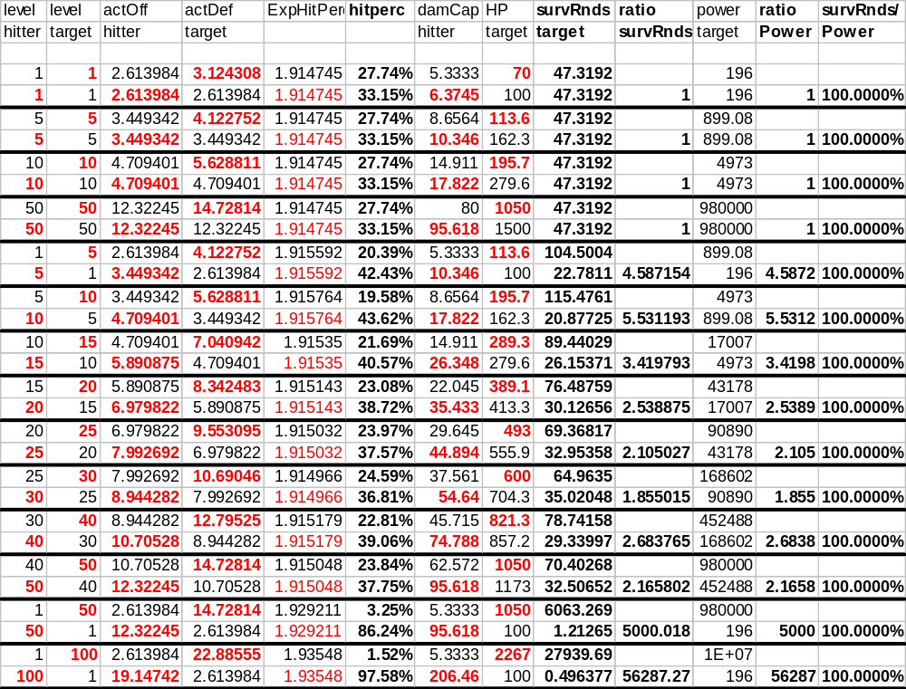
It is interesting to note that the changes manage to preserve the relationship between Power and SurvRnds. This is, of course, essential.
Secondly, note that a fair-fight occupies a constant 47.32 rounds at all levels. This compares with a fair-fight between warriors of 60 rounds.
Furthermore, the success rates for a fair-fight (against a warrior) becomes 27.74%/33.15%. Since skill success rates are roughly double these numbers, this implies that missionaries will have a 66.3% success rate with easy-skills in a fair fight.
- Missionary vs. Warrior Class; Defensive Properties
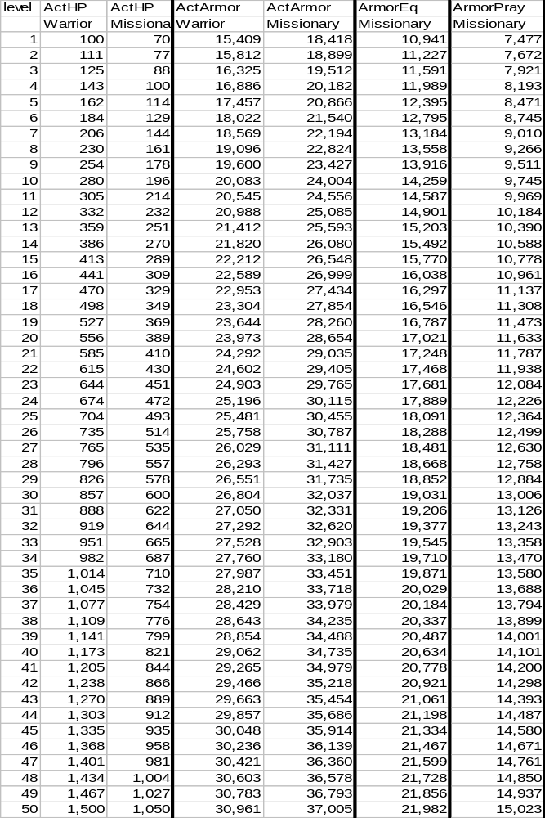
- Missionary vs. Warrior Class; Offensive Properties
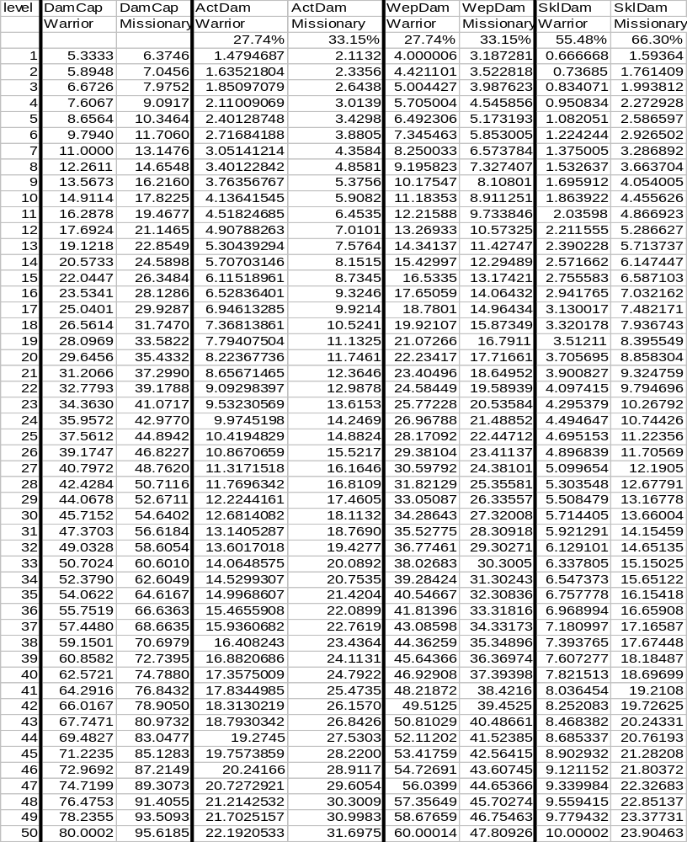
As per the design, we notice that missionaries have higher potential damage (DamCap) and higher effective damage (ActDam).
Additionally, we see that missionary’s weapon damage is roughly comparable to warriors. At L50, a successful round from a missionary yields 47.8 damage where a warrior would be doing 60.0.
Similarly, missionaries have higher skill damage. A L50 missionary will be doing 2.4 times the damage of a warrior for each successful skill use. Additionally, the missionary has a higher success rate (66.3% vs. 55.5%).

Missionary Skills
In general, a discussion of a class’s skills is not an intrinsic part of the overall game design. The skills given to a class do more to help conceptualize it than they do to insure overall harmony and equality. However, I don’t want to leave the class topic without throwing out some general ideas that came to mind while developing the numerical system.
Being that the missionary is defined as solo-oriented, it makes sense to grant missionaries a large number of directly offensive prayers. That is, the missionary possesses a great many prayers meant to be invoked upon the enemy to damage the enemy.
As we’ve also noted, the missionary needs a mechanism to protect him in terms of armor. We’ll simply borrow a page from the casters and grant them some sort of automated “shield” (wrapped, of course, in appropriate clergy-based terminology rather than magic).
Likewise, the missionary needs the ability to hit more often and be hit less often, so some sort of prayer(s) will be required to bring this about.
In terms of healing prayers, the missionary probably has a reasonable ability to heal himself. However, given the solo-nature of the class, and the fact that healing-others is a non-primary area of focus, we should seriously de-emphasize the missionary’s ability to heal other people. Clearly, healing is part of the preconceived definition of clergy people will have, but we should restrain ourselves as much as possible to give clerics an obvious role to play.
Similarly, the missionary is primarily solo and, as such, should not have strong prayers that enhance other’s abilities to fight. Deity-inspired power-ups should remain mostly in a priest’s bag of tricks.

Review of Missionary Class
The missionary is, in large part, a mix between caster and fighter. The missionary has some ability to invoke prayers, and is also expected to be a second- or third-rate fighter.
While the missionary has lower weapon damage, we’ve also stated that the missionary has the ability to hit more often (33.15% vs. 31.25%), and be hit less often (27.74% vs. 31.25%). In terms of just melee alone, the missionary compares relatively favorably.
Missionaries have fewer HPs (compared to warriors), but make up for it with the ability to throw around some meaningful prayers. This gives them great flexibility in combat.

The Priest Class
The priest class is a clergy-subtype conceived of as group-oriented and with a focus on offensive capabilities.
Priests will be (numerically) similar to missionaries over the first few levels, but around L20 and because of their group-orientation they will forego some degree of HP development to enhance their prayer damage capability instead.
Priests, like sorcerers, will employ largely indirect offensive maneuvers. Members of the priest’s group will receive enhancements and be better at the things that they do because of the priest’s prayers.
Priest’s, in a one-on-one situation, will fair reasonably OK. In the early levels, they follow closely in the footsteps of missionaries, a class designed to succeed in the one-on-one. In the later levels their focus shifts toward helping others that fight in the same cause as the priest. This shift somewhat hampers a priest forced into a solo scenario. However, priests will have a reasonable number of HPs, and maintain some emphasis on melee fighting, and as a consequence should do fairly well.
Priests shine in group-situations and are designed exclusively with the intent of making the group as a whole more powerful and successful. Priests are also remarkably well rounded as they have some degree of focus on melee fighting, some minor ability to throw offensive prayers at the enemy, and a modest ability to heal group mates. This allows priests to serve in a backstop role for many other classes; or, to fill in for a group that finds itself completely lacking in terms of melee ability, spell casting or healing potential.

Priest HP Penalty
Similar to what was done for sorcerers, we will state that a priest has the HP of a missionary through L20, and thereafter, gains at half the rate as missionaries.
- ActHPPriest
= ActHP value for priests
= ActHPMissionary(up to L20) + 0.5 * max(ActHPMissionary – (ActHPMissionary at L20), 0)

Priest Armor
Priests will have equivalent armor as missionary’s. The breakdown and distribution will be identical.

Priest Success Rate
Priest success rate will also be equivalent as missionary’s.

Priest Damage
As before with sorcerers, the penalty imposed by the reduction in priest’s HP must be reflected in an increase in priest’s damage (compared to missionary’s). This generalizes as:
- ActDamPriest
= Value of ActDam for priest class
= ActDamMissionary * (ActHPMissionary / ActHPPriest)
= ActDamMissionary * (ActHPMissionary / ActHPPriest)
= (sqrt(10/7) * ) * (0.7 * ActHP) / ActHPPriest
= sqrt(10/7) * 0.7 * (ActHP/ActHPSorcerer) * ActDam
Likewise:
- DamCapPriest
= Value of DamCap for priest class
= DamCapMissionary * (ActHPMissionary / ActHPPriest)
= (sqrt(10/7) * ) * (0.7 * ActHP) / ActHPPriest
= sqrt(10/7) * 0.7 * (ActHP/ActHPSorcerer) * DamCap
This is naturally the same as the values for missionary for the first 20 levels, but thereafter slowly increases faster and faster (as ActHPPriest is penalized).
- Priest Class vs. Warrior Class
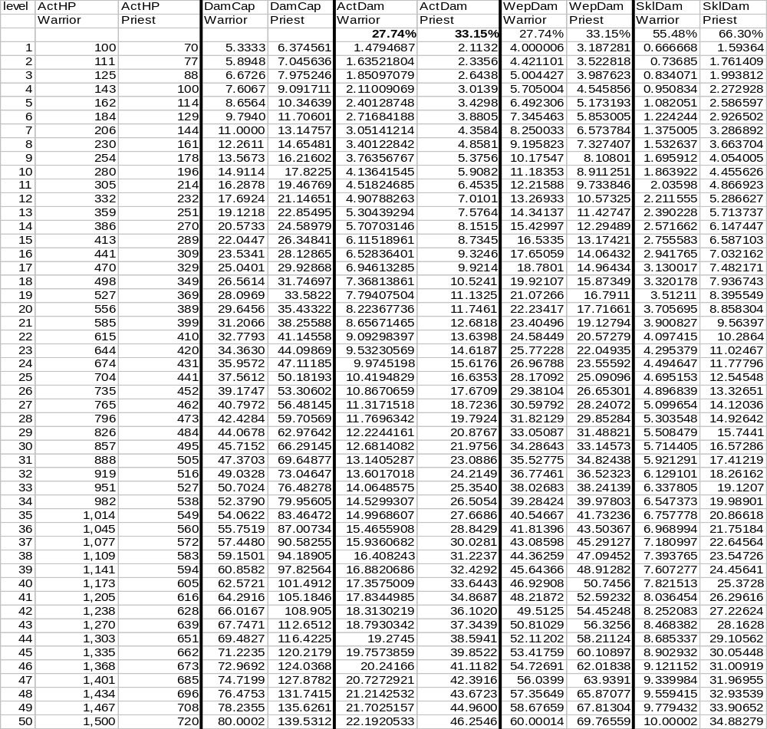
Near the end of their careers, priests have ½ the HP of an equivalent warrior.
The priest has roughly half the HP of the warrior by L50, however, this is counterbalanced by the priest’s higher ActDam. On average, the priest is inflicting 2.085 times more damage per round as the warrior (46.3 vs. 22.2).
In terms of melee, it is interesting to note that by L50, the warrior and the priest are roughly comparable (69.8 to 60.0) in terms of raw damage. The priest is also hitting more often too (33.15% to 31.25%).
On the skill front, the priest is doing 3.5 times more damage per successful prayer as the warrior is getting from his skills. And again, the priest is more successful at succeeding at the prayers than is the warrior at his skills.

Priest Skills
The standard caveat about skills and this document applies.
Being group and offensive oriented, the priest’s skills should be primarily focused on providing indirect benefits to other members in the party allowing them to do more damage or hit more often. That is to say, the “damage” calculated for the priest should really be converted into either a bonus to be applied to someone else in the group when hitting, or applied as letting someone else hit more successfully.
Having the skill damage be associated with direct attacks on the enemy (missionary) or with healing of the group’s primary tank (cleric) might be permissible, but realize it is a secondary focus and detracts from the strengths of other class’s abilities.
Priests do need the same armor enhancements as missionaries.
Likewise, as a portion of the priest’s damage is melee related, priests will need weapon skills.
Being group-oriented, we can, to some degree, justify more group-protective and group-healing prayers than we could have for missionaries.

Priest Review
Priests are, above all else, extremely versatile. Being a clergy-subtype, they are by nature a combination fighter and caster. They have reasonably good armor, melee damage and skill damage. This makes them very well balanced and able to flesh out a group in many different ways.
However, priests do not excel in any particular field. They have lower HP than warriors, have modest restrictions on the armor they can wear, and don’t have the massive damage from prayers that casters receive.
Priests, like the other clergy, are overall, well rounded.

The Cleric Class
The cleric class is a clergy-subtype conceived of as group-oriented and with leanings toward defensive prayers.
As defense is the cleric’s primary focus, they typically take up the role of defending and healing their group. They have some offensive capability, but for the most part take little part in battle, preferring to concentrate on defense and restoration.
In a one-on-one scenario, the cleric is in for a battle of attrition. Having little in the way of offensive capabilities, the cleric’s primary hope is to restore his own damage, while the enemy is slowly drained from what damage the cleric does manage to inflict.
The cleric is very desirable for a group though. Aiding defensively and restoring the primary hitters and tanks is what a cleric excels at. There are few fighters that do not recognize the advantage of these skills, and this puts the cleric in high-demand.

Clerics by the Numbers
For the most part, clerics are numerically identical to priests in everyway. The primary difference is in how they utilize their “damage”.
All formulas that apply for priests apply equally for clerics.

Cleric Skills
In general, a discussion of a class’s skills is not an intrinsic part of the overall game design. The skills given to a class do more to help conceptualize it than they do to insure overall harmony and equality. However, I don’t want to leave the class topic without throwing out some general ideas that came to mind while developing the numerical system.
Cleric skills concentrate primarily on the defense and restoration of the group. For the most part, this means they have a number of prayers designed to prevent others from being hit, and to restore the damage that does sneak through.
Clerics have a small assortment of direct-offensive prayers (missionary) and a handful of power-ups (cleric), but these are fairly restricted.
Clerics do require self-defensive prayers for their armor.
Likewise, clerics are moderately involved in the melee portion of a fight so need some weapon skills.

Rogue Classes
The rogue classes consist of those members of society that have difficulty conforming to society’s rules. The rogue classes typically are weaker than fighters, and lack any training in magic or prayer. They hold their own primarily by not playing by the normal rules and using every trick and underhanded maneuver at their disposal to gain an edge.
Rogues come in two basic subtypes. Thieves are your basic solo rogue-class. Meanwhile, thugs represent a rogue that has opted to band with others to gain power and wealth.

The Thief Class
The thief class is a rogue-subclass designed to be evenly balanced and capable of playing solo.
Thieves, being a rogue class, will lack any distinction when it comes to combat numbers. They lack the physical stamina of the warriors, and are not strong enough to effectively use all types of armor. Likewise, they possess no intrinsic magic or prayer capability. However, they feel no dishonor about using certain moves that most fighter types shun.

Thief HP Penalty
As compared to warriors, thieves suffer a modest penalty on HP. Thieves will have 85% the ActHP of warriors.
- ActHPThief
= The ActHP value for the thief class
= 0.85 * ActHP
= 0.85 * 18.67131 * ((level)1.759815 + 13)0.635902
= 15.87061 * ((level)^{1.759815} + 13)^{0.635902}

Thief Armor
Thief’s skills require a certain degree of nimbleness. As a consequence, thieves lean more toward easily flowing armor as opposed to heavy metal armors. Arbitrarily, we want thieves to have 82% the ActArmor as warriors:
- ActArmorThiefEq
= Contribution to ActArmor from equipment for the thief class
0.82 * ActArmor
= 0.82 * 10000 *
= 8200 * (level^{1.759815} + 13)^{0.163844}
To achieve this 82% value for ActArmorThiefEq, we will essentially allow thieves to choose armor for the head (9%), body (33%), waist (12%) and back (10%).
Thieves, being more nimble, will also possess some natural skills that aid them in dodging more blows successfully. All in all, we would like thieves to have a total effective armor equivalent to 1.1 times that of warriors:
- ActArmorThief
= Value for ActArmor for the thief class
1.1 * ActArmor
Which implies:
- ActArmorThiefSkill
= Contribution to ActArmor from skills for the thief class
= ActArmorThief - ActArmorThiefEq
= (1.1 * ) – (0.82 * )
= (1.1 – 0.82) * ActArmor
0.28 * ActArmor
Of course, the upshot of higher effective armor is a corresponding increase in the ActDef score:
- ActDefThief
= ActDef score for the thief class
= SimpDefSkillThief * ActArmorThief
= (SimpDefSkill) * (1.1 * )
= 1.1 * (SimpDefSkill * ActArmor)
= 1.1 * ActDef

Thief Success Rate
Because of thief’s higher armor, their success rates are slightly altered. Referring to the previous method for establishing HitPercExponent:
Thief hitting warrior:
= log[ActOff_{b} * ActDef_{b} / (ActOff_{a} * ActDef_{a})] / log[(ActOff_{b} / (ActOff_{b} + ActDef_{a})) / (ActOff_{a} / (ActOff_{a} + ActDef_{b}))]
= log[ActOff * ActDef / (ActOff * (1.1 * ActDef))] / log[(ActOff / (ActOff + (1.1 * ActDef))) / (ActOff / (ActOff + ActDef))]
= log[ActOff * ActOff / (ActOff * (1.1 * ActOff))] / log[(ActOff / (ActOff + (1.1 * ActOff))) / (ActOff / (ActOff + ActOff))]
= log[1 * 1 / (1 * (1.1 * 1))] / log[(1 / (1 + (1.1 * 1))) / (1 / (1 + 1))]
= log[1 / 1.1] / log[(1/2.1) / (1/2)]
= log[1/1.1] / log[2/2.1]
= -0.04139 / -0.02119
= 1.953471
By extension then:
HitPercab (thief hitting warrior)
= 1.25 * (ActOff_{a} / (ActOff_{a} + ActDef_{b}))^{n}
= 1.25 * (ActOff_{a} / (ActOff_{a} + ActDef_{b}))^{1.953471}
Presuming a fair-fight:
= 1.25 * (ActOff / (ActOff + ActDef))^{1.953471}
= 1.25 * (ActOff / (ActOff + ActOff))^{1.953471}
= 1.25 * (1/2)^{1.953471}
= 32.2743%
Warrior hitting thief:
= log[ActOff_{b} * ActDef_{b} / (ActOff_{a} * ActDef_{a})] / log[(ActOff_{b} / (ActOff_{b} + ActDef_{a})) / (ActOff_{a} / (ActOff_{a} + ActDef_{b}))]
= log[ActOff * (1.1 * ActDef) / (ActOff * ActDef)] / log[(ActOff / (ActOff + ActDef)) / (ActOff / (ActOff + (1.1 * ActDef)))]
= log[ActOff * (1.1 * ActOff) / (ActOff * ActOff)] / log[(ActOff / (ActOff + ActOff)) / (ActOff / (ActOff + (1.1 * ActOff)))]
= log[1 * (1.1 * 1) / (1 * 1)] / log[(1 / (1 + 1)) / (1 / (1 + (1.1 * 1)))]
= log[1.1] / log[(1 / 2) / (1 / (1 + 1.1))]
= log[1.1] / log[2.1 / 2]
= 0.041393 / 0.021189
= 1.953471
By extension then:
HitPercab (warrior hitting thief)
= 1.25 * (ActOff_{a} / (ActOff_{a} + ActDef_{b}))^{n}
= 1.25 * (ActOff_{a} / (ActOff_{a} + ActDef_{b}))^{1.953471}
Presuming a fair-fight:
= 1.25 * (ActOff / (ActOff + (1.1 * ActDef)))^{1.953471}
= 1.25 * (ActOff / (ActOff + (1.1 * ActOff)))^{1.953471}
= 1.25 * (1/2.1) ^{1.953471}
= 29.3403%
The lesson here is that the thief has a marginally superior hit rate (32.27% vs. the warrior’s 31.25%), but the higher armor’s true benefit is to lessen the chance of the thief of getting hit to 29.34% (vs. 31.25% for a warrior).

Thief Damage
To maintain the Power equation, the thief’s damage will have to counterbalance the penalty on thief’s HP and bonus on armor. Essentially:
Power = HP * Armor * Damage
Damage = Power / HP / Armor
Damage = 100% / 85% / 110%
Damage = 106.9519%
That is to say, thief damage will be about 7% higher in order to keep thieves at the same level of Power as warriors. Therefore:
- ActDamThief
= ActDam value for thief class
1.069519 * ActDam
- DamCapThief
= DamCap value for thief class
1.069519 * DamCap
Since we do not wish the thief class to be superior in regards to weapons (compared to warriors), we will declare that 70% of thief’s damage is weapon related:
- WeaponDamageThief
= Value of SimpWeaponDamage for thief class
= 70% of thief damage inflicted
= 7/10 * DamCapThief
= 7/10 * 1.069519 *
= 7/10 * 1.069519 * (4/3 * SimpWeaponDamage)
= 14/15 * 1.069519 * SimpWeaponDamage
= 0.998217 * SimpWeaponDamage
As in the case of missionaries, a means to reduce thief’s weapon damage needs to be determined:
- WeaponDamExpThief
= Value of WeaponDamExp for the thief class
= 0.998217 * WeaponDamExp
The upshot of this is that thieves do (within 1%) almost the same exact damage as a warrior when looking at weapons alone. Warriors will have a slight edge, but it is probably not worth speaking about.
Since WeaponDamageThief is established, we can proceed to assign the remaining damage for thieves to their skills:
- SkillDamageThief
= Value of SkillDamage for thief class
= 30% of thief damage inflicted
= 3/10 * 1.069519 *
= 3/10 * 1.069519 * (4 * SkillDamage)
= 6/5 * 1.069519 * SkillDamage
= 1.283422 * SkillDamage
Since thieves need slightly higher overall damage, and none of it is in their weapons, it rolls entirely into the thief’s skills. Thief’s skills do 28.3% more damage than an equivalent warrior’s skills do.

Thief Fight Scenarios
Since the changes for thieves are not perfectly intuitive, I believe we should revisit the combat scenarios spreadsheet [(Spreadsheet 5.)]. I’ve put the thief in red.
- Thief Combat Scenarios
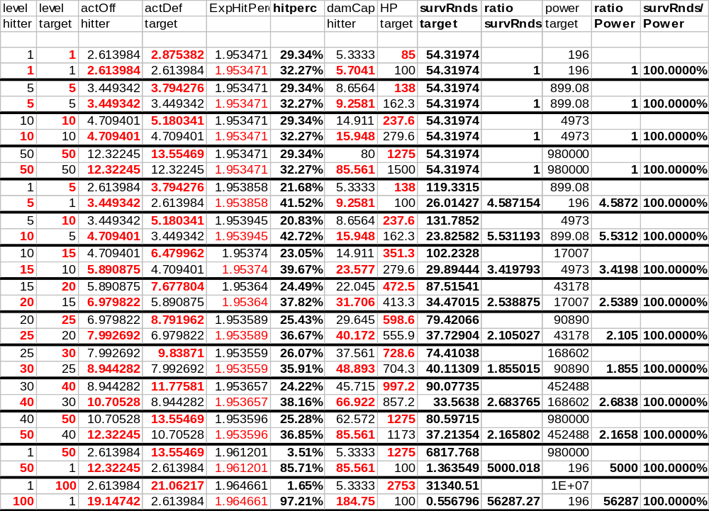
The lessons of this chart are about what we have come to expect. The Power and SurvRnds ratios are preserved. And the hit rates for a fair-fight are as indicated previously. Furthermore, fair-fights only occupy 54.3 rounds (compared to 60 for two warriors). This is due to the thief’s higher damage, and the thief’s lower HP.
- Thief vs. Warrior Class; Defensive Properties
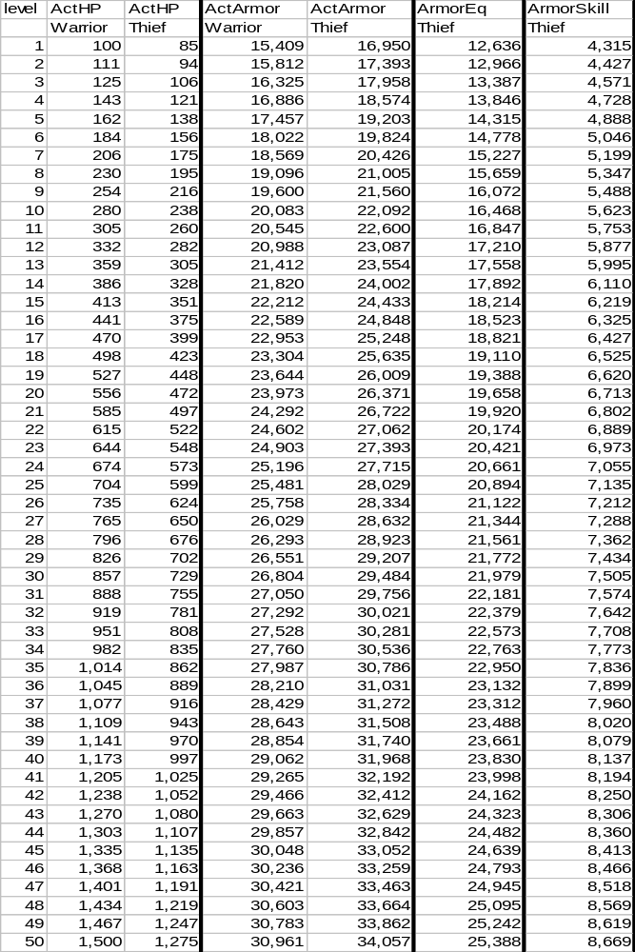
Defensively speaking, thieves compare well to warriors. They have a few less HP overall, and their equipment-based armor is somewhat lacking, but they make up for some of this with skill-based defensive armor.
- Thief vs. Warrior Class; Offensive Properties
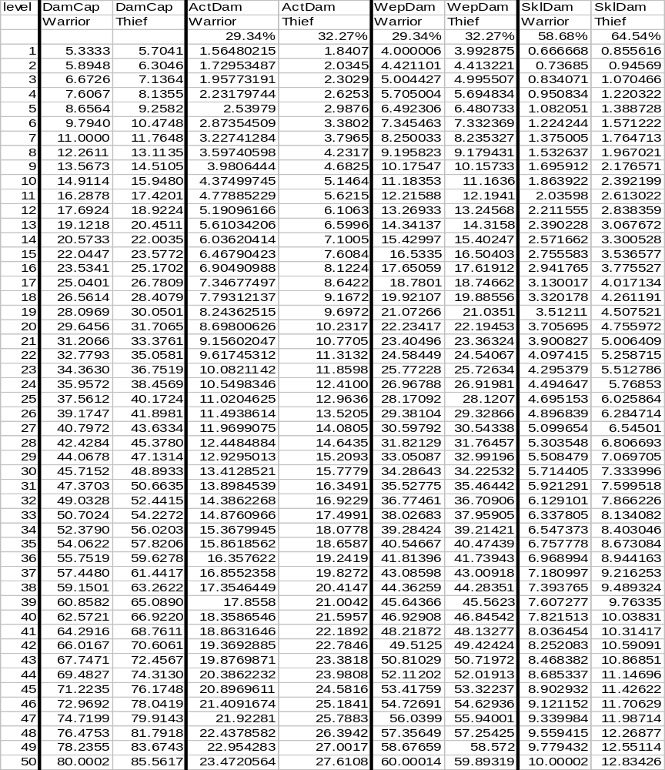
Offensively speaking, thieves are not that dissimilar to warriors either. They have equivalent weapon damage, and their skill damage is modestly superior.

Thief Skills
The standard disclaimer concerning skills and this document applies.
Numerically speaking for the most part, thieves are reasonably indistinguishable from warriors. Some numbers have been tweaked slightly, but no more so than what we have done for other classes. Thief’s chief distinguishing factor will be their skills.
In non-combat aspects, thieves will have the to-be-expected assortment of skills for getting into and out of places without being seen, opening things that they are not supposed to, and otherwise doing thief-like things.
However, preconceptions about how thieves should behave in combat are less intuitive, other than to say that they probably use every (dirty) trick in the book. Naturally, their skills probably include backstabbing, throat cutting, sand-in-the-eyes and leg sweeps.
Additionally, it probably makes sense for thieves to be more acrobatic. Leaping, diving and rolling away from their opponent’s blows in order to avoid being skewered seem a natural way for thieves to fight.
Naturally, thieves would not neglect the obvious melee skills such as kick. They might even extend upon them in a more-underhanded manner, e.g. kick-in-the-crotch. Obviously, we wouldn’t want a generic kick from a thief to do more than that of a warrior, so unless there is an obvious reason why the thief is able to get more damage out of the blow, we should not simply have thieves using warrior skill do more damage.

Thief Review
As noted, thieves do not differ radically from warriors. They possess no magic or prayers, and are fairly similar in terms of effective armor, HP and damage.
For the most part, thieves will fill an important role-playing nitch for players that would like to explore the realm of roguery without suffering dramatic penalties. Looking strictly at combat, a thief and a warrior compare fairly evenly and players that opt to play thieves should not find themselves coming up short.
However, thief’s broader range of non-combat skills probably makes them slightly more versatile than a warrior. Navigating traps, and performing other thief-like operations certainly gives them an edge over warriors. This is of course a subjective evaluation, and I must state that “game design” should probably not attempt to evaluate skills that lend to role-play for a given class.
Thief’s combat skills should also be geared toward quick-strike attacks and/or hit-and-fade maneuvers. This is to say, the thief probably would attempt to slip up on an enemy, strike fast, and then disappear into the gloom, possibly repeating these steps over and over as long as possible. This is not to say that thieves shun the more traditional hack-and-slash style of the warriors. Thieves can certainly fight in pitched battles, but the hit-and-fade option is certainly a roleplay-worthy style as well.

The Thug Class
The thug class is a rogue-subclass designed with an orientation toward grouping.
Thugs have an assortment of thief-like non-combat skills, while their combat skills tend to be geared toward incapacitating an enemy to let the group slip by unmolested, or perhaps to weaken an enemy at a critical moment in a fight.

Thugs by the Numbers
As thugs are thought to be second-rate fighters and have no reason to not be fighting, we will NOT penalize their HP (compared to thieves). As a result, numerically speaking, thieves and thugs are identical.

Thug Skills
Thug skills will probably be fairly similar to thieves, especially over the first few levels. However, whereas thieves are going to specialize more on how to get the thief into, and out of, tight spaces by himself without being seen, the thug will be concentrating more on the direct, group-oriented approach.
For example, a thief might simply sneak by an enemy and be on his way, while the thug would need to sneak up on an enemy, knock him cold and thereby let his group slip past.
Likewise, while a thief might adopt the direct approach of simply slitting an enemy’s throat and being done with it, the thug will be inclined to pin an enemy’s hands (taking the thug out of action while he pins), leaving the enemy open for finishing blows by other members of the thief’s group.
The thug, like the thief, also has the hit-and-fade options available as a fighting style (as well as the traditional hack-and-slash).
As a rule, the thug is simply a group-oriented thief.

The Monk Class
The monk class is in some ways a simple fighter subclass, although it deviates more drastically than the other fighter subclasses do, and, because of the roleplay nature of the class, is probably best thought of entirely separately.
From an RPG perspective, the monk class combines many of the martial arts moves favored by eastern cultures. Tradition has them fighting largely barehanded, and without the benefit of armor.

The “Traditional” Monk and Ramifications Thereof
In our previous handling of warriors, we established the above value for SwingsPerRound presuming that the warrior would have a single 1H weapon and be using a shield. Allowances and corrections were made for the use of two 1H weapons or a single 2H weapon.
Clearly, our image of monks does not include the use of shields, and it would be a bad assumption to make that a monk player “wants” to use a shield when they play.
Because of this, it is appropriate to relate the monk to a 2H-weapon using warrior. Likewise, all ParryEligible hits will land upon a 2H-weapon wielding player.

Monk Hit Points
Monks will have the same HP as warriors.

Monk Armor
Monks should be restricted to wearing only clothing. Since clothing has an ActArmor 50% that of armor, this means:
- ActArmorMonkEq
= Contribution to ActArmor from equipment for the monk class
0.5 * ActArmor
= 0.5 * 10000 *
= 5000 * (level^{1.759815} + 13)^{0.163844}
However, since monks are perceived of as nimble and agile, we will assume that monks possess some skills to raise their effective armor. This is somewhat the same argument as was made for thieves, however, we desire monks to be even more skilled at dodging. Recalling that ActArmorThiefSkill = 0.28 * , we desire monk’s value to be slightly better. Arbitrarily, we settle upon:
- ActArmorMonkSkill
= Contribution to ActArmor from skills for the monk class
0.4 * ActArmor
As a result:
- ActArmorMonk
= Value for ActArmor for the monk class
= ActArmorMonkEq + ActArmorMonk
= (0.5 * ) + (0.4 * )
0.9 * ActArmor
Consequently, monk’s total effective armor is 90% that of an equivalent warrior.

Monk Success Rate
As before, the monk’s lower armor becomes a lower ActDef score, which in turn leads to different success rates. The process for calculating these follows directly from the previous classes, so I am skipping many intermediate steps:
- ActDefMonk
= ActDef score for the monk class
= 0.9 * ActDef
HitPercExponent (monk hitting warrior):
= log[ActOff_{b} * ActDef_{b} / (ActOff_{a} * ActDef_{a})] / log[(ActOff_{b} / (ActOff_{b} + ActDef_{a})) / (ActOff_{a} / (ActOff_{a} + ActDef_{b}))]
= log[ActOff * ActDef / (ActOff * (0.9 * ActDef))] / log[(ActOff / (ActOff + (0.9 * ActDef))) / (ActOff / (ActOff + ActDef))]
= log[1/0.9] / log[2/1.9]
= 0.045757 / 0.022276
= 2.05408
HitPercab (monk hitting warrior):
= 1.25 * (ActOff_{a} / (ActOff_{a} + ActDef_{b}))^{2.05408}
Presuming a fair-fight:
= 1.25 * (ActOff / (ActOff + ActDef))^{2.05408}
= 1.25 * (1/2)^{2.05408}
= 30.1003%
HitPercExponent (warrior hitting monk):
= log[ActOff_{b} * ActDef_{b} / (ActOff_{a} * ActDef_{a})] / log[(ActOff_{b} / (ActOff_{b} + ActDef_{a})) / (ActOff_{a} / (ActOff_{a} + ActDef_{b}))]
= log[ActOff * (0.9 * ActDef) / (ActOff * ActDef)] / log[(ActOff / (ActOff + ActDef)) / (ActOff / (ActOff + (0.9 * ActDef)))]
= log[0.9] / log[1.9/2]
= 0.045757 / 0.022276
= 2.05408
HitPercab (warrior hitting monk):
= 1.25 * (ActOff_{a} / (ActOff_{a} + ActDef_{b}))^{2.05408}
Presuming a fair-fight:
= 1.25 * (ActOff / (ActOff + (0.9 * ActDef)))^{2.05408}
= 1.25 * (1/1.9)^{2.05408}
= 33.4447%
However, these values ignore the shield-based correction we noted above. All ParryEligible blows will land on a monk. That is to say, 5/22 * additional blows will land. For the above case:
warrior’s RawMiss
= 100% - HitPercab
= 100% - 33.4447%
= 66.5553%
Of which, 5/22 hit:
= 5/22 * 66.5553%
= 15.1262%
This means, in total, the monk is hit 48.5709% of the time in a fair-fight.

Monk Damage
Following reasoning established for other classes, the reduction in monk’s armor must be balanced by a corresponding rise in damage.
Additionally, we need to account for the barehand correction. In theory, this barehand correction would simply mirror the damage correction we made for 2H-weapons (i.e. it would be OffHandMultiplier).
Therefore:
- ActDamMonk
= ActDam value for monk class
= ActDam * (correction due to HP) * (correction for barehand)
= ActDam * (1/0.9) * (1.0 + OffHandMultiplier)
= ActDam * (1.1111) * (1.0 + OffHandMultiplier)
= 1.1111 * ActDam * (1.0 + OffHandMultiplier)
- DamCapMonk
= DamCap value for monk class
= 1.1111 * DamCap * (1.0 + OffHandMultiplier)
This damage will be equally distributed between melee and skills. Hence:
- MeleeDamageMonk
= Value of SimpWeaponDamage for monk class
1.1111 * SimpWeaponDamage * (1.0 + OffHandMultiplier)
- SkillDamageMonk
= Value of SkillDamage for monk class
= 1.1111 * SkillDamage * (1.0 + OffHandMultiplier)

Monk Fight Scenarios
Since the changes for monks are not perfectly intuitive, I believe we should revisit the combat scenarios spreadsheet [(Spreadsheet 5.)]. I’ve put the monk in red.
Note: For comparison with the other combat scenarios, this presumes the monk is shield-using and therefore DamCap and the HitPercab values are not what we would expect to see with a truly barehand monk]
- Monk Combat Scenarios
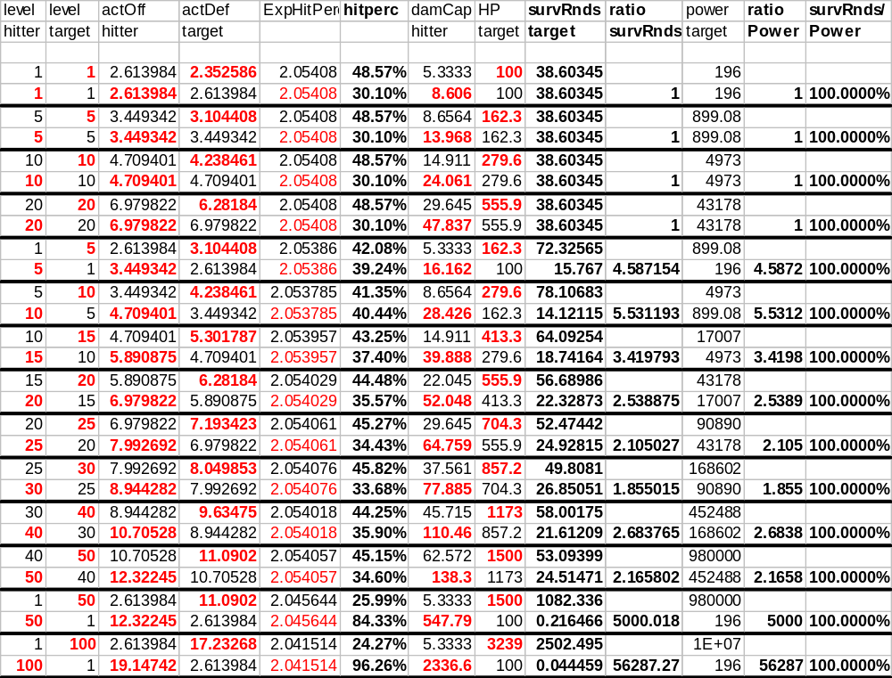
By now, the conclusions to be derived from this data should be fairly apparent. The most interesting is that fair-fights occupy 38.06 rounds.
One new quirk is introduced by the barehand correction though. We can see how the value for DamCapMonk is changing based on the level of the victim. The fair-fight value is 1.5X more than the equivalent warrior. In the later cases, where the victim is of lower level, DamCapMonk is greater than it was for the same level monk in a fair-fight.

Refining Monk Barehand Damage
Since monks are defined as being masters of barehand fighting, we should delve a bit deeper into this concept. Conceptually, we would like monks to have a flurry of attacks, perhaps twice the number of swings, as a warrior would receive in a single round. The upshot of this decision is that monks have their own values for the number of attacks per round and the damage per attack.
Clearly, the two terms must combine (product) to form MeleeDamageMonk. Additionally, we would like SwingsPerRoundMonk to be 5.0 at L50 (an arbitrary boundary condition).
With these constraints in mind, and with a bit of manipulation:
- SwingsPerRoundMonk
= the SwingsPerRound equation for the monk class
= constant * sqrt(MeleeDamageMonk)
The boundary condition is used to solve for the constant:
= [5.0/(sqrt(MeleeDamageMonk) @ L50)] * sqrt(MeleeDamageMonk)
= [5.0/(sqrt(1.1111 * SimpWeaponDamage * (1.0 + OffHandMultiplier)) @ L50)] * sqrt(MeleeDamageMonk)
We will assume the constant is based on a fair-fight, which makes OffHandMultiplier=0.5:
= [5.0/sqrt(1.1111 * SimpWeaponDamage@L50 * (1.0 + 0.5)] * sqrt(MeleeDamageMonk)
= [5.0/sqrt(1.6667 * SimpWeaponDamage@L50] * sqrt(MeleeDamageMonk)
= [5.0/sqrt(1.6667 * (0.74685 * ((level)1.759815 + 13)0.635902)@L50] * sqrt(MeleeDamageMonk)
= [5.0/sqrt(1.244754 * (50^{1.759815} + 13)^{0.635902})] * sqrt(MeleeDamageMonk)
= [5.0/sqrt(100)] * sqrt(MeleeDamageMonk)
= [5.0/10.0] * sqrt(MeleeDamageMonk)
0.5 * sqrt(MeleeDamageMonk)
If we further assume that the number of swings a monk gets does not depend on the level difference, we can again assume a fair fight, and simplify the sqrt() term further:
= 0.5 * sqrt(1.1111 * SimpWeaponDamage * (1.0 + OffHandMultiplier))
= 0.5 * sqrt(1.1111 * SimpWeaponDamage * 1.5)
= 0.5 * sqrt(1.6667 * SimpWeaponDamage)
= 0.5 * sqrt(1.6667) * sqrt(SimpWeaponDamage)
= 0.5 * sqrt(1.6667) * sqrt(SimpWeaponDamage)
0.645497 * sqrt(SimpWeaponDamage)
= 0.645497 * sqrt(0.74685 * ((level)1.759815 + 13)0.635902)
= 0.645497 * sqrt(0.74685) * ((level)^{1.759815} + 13)^{0.317951}
= 0.557843 * ((level)^{1.759815} + 13)^{0.317951}
Knowing this, then it is easy to invert the function and arrive at:
- MeleeDamPerSwingMonk
= The equivalent to WepDamPerSwing for the monk class
= MeleeDamageMonk / SwingsPerRoundMonk
We should avoid simplifying this more mathematically as MeleeDamageMonk depends on the levels of the combatants, whereas SwingsPerRoundMonk does not.
We can therefore show:
- SwingsPerRoundMonk and MeleeDamPerSwingMonk versus Level (fair-fights)
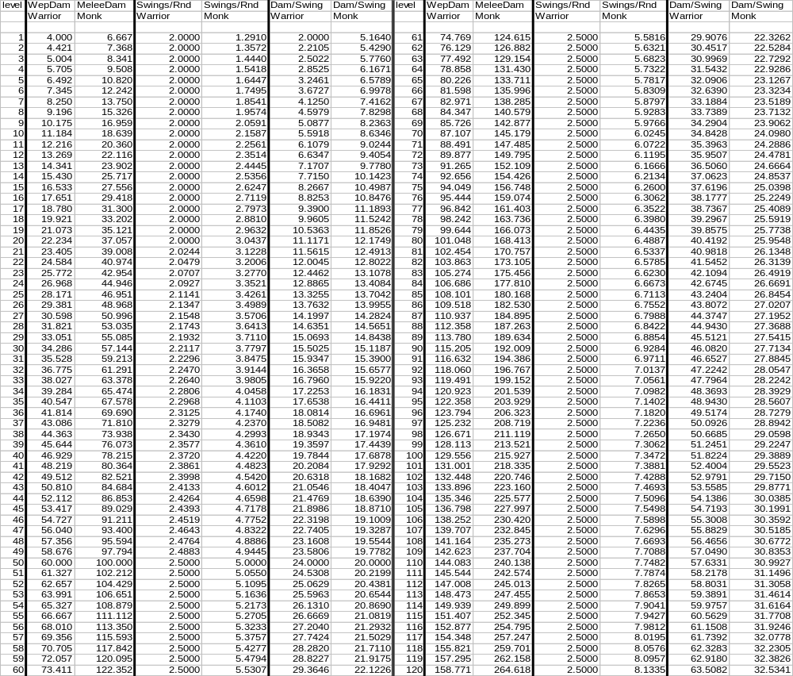
As stated previously, the monk always has a higher overall damage capacity.
During the early level, the monk is swinging fairly infrequently, although doing more damage per successful hit than an equivalent warrior. Around L10, this situation reverses itself and the monk begins to swing more often than the warrior, however, the per-hit amount is not as great.
Monk PCs will approach having 5.0 attacks per round, as desired, although the increase with each successive level is less and less. Monk mobs might receive 8+ attacks per round, which is quite a bit, but not overly excessive.

If a Monk were to Use a Shield
Obviously, the barehand correction on damage that we made above complicates monks somewhat. While we did the right thing by equating the monk to the 2H-weapon using warrior for damage, it complicates comparisons somewhat.
If we were to try to compare the monk to our more traditional view of a warrior, we would have to think of the monk using a shield. Obviously, by using a shield, the monk would lose the use of one hand and this would cut SwingsPerRoundMonk by 1/3 (primary hand gets 2/3 of all attacks, secondary gets 1/3). Consequently, damage would also be 2/3 as great as well.

Monk “Specialization”
Monks, because of their specialized melee, lack the “specialization skills” that increase the number of attacks that other classes receive. However, since we are allowing for SwingsPerRoundMonk to be increasing in some fashion, we are simply replacing specialization with some other skill for monks. There is no need for monks to have a separate specialization skill as whatever skill(s) control the increase of SwingsPerRoundMonk already handles this feature.

Monk Comparison
- Monk vs. Warrior Class; Defensive Properties
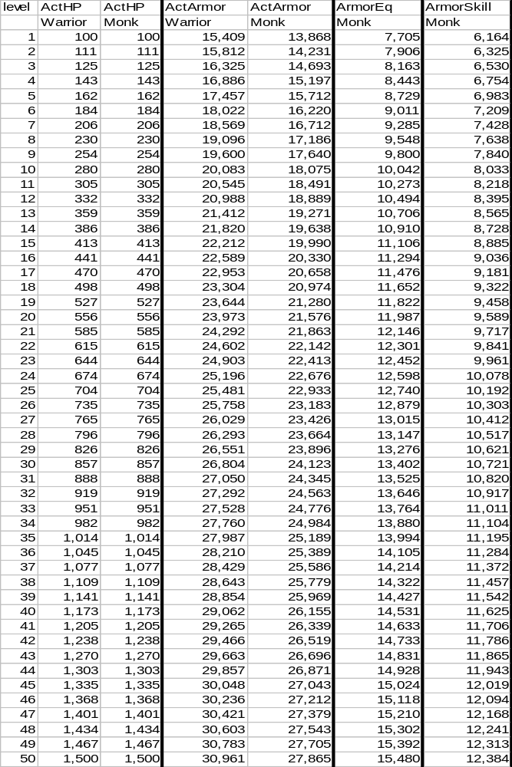
- Monk vs. Warrior Class; Offensive Properties
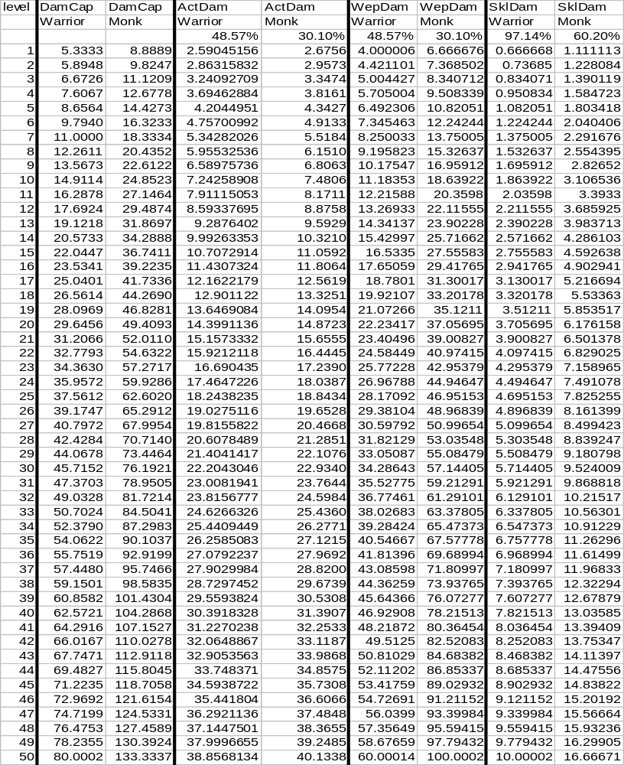

What Monks Are Not
Because monks are typically thought of in terms of eastern cultures and people’s perceptions tend to vary, it is probably worthwhile to diverge briefly and talk about what aspects of eastern culture the class is not attempting to capture. In the course of this discussion, certain alternative classes may be mentioned. These classes are, of course, viable in their own right, although this document does not attempt to refine these quasi-classes.
First off, the monk class is not a thief subtype. While “ninjas” are appropriately eastern, they are distinct from monks. Yes, both monks and ninjas wear light armor or clothing and often are well trained in hand-to-hand combat, but acts of stealth and attack that characterize ninjas do not properly belong in a monk class.
Secondly, monks are not weapons masters. While they certainly will use weapons from time to time, we should avoid making them into “samurai”. Clearly, martial-art weapons like bo-sticks, numchucks and the like would be apropos for monks, but the focus of the monk should be to use bare hand attacks as much as possible. Likewise, monks tend to forego heavy armor, which would also be the hallmark of a “samurai”.
Finally, while oriental culture still is imbued with vast amounts of mysticism (acupuncture, chi, yin/yang, etc.), our intention is not to create a “magi”. Monks would certainly have different forms of knowledge at their disposal, some of which might resemble magic, but we should restrain ourselves and keep the class fairly firmly rooted in the natural world.

Monk Skills
The standard disclaimer concerning skills and this document applies.
Monk skills should probably in the footsteps of various forms of martial arts. Moves from kung fu, judo, jujitsu, etc. should all be represented. In fact, any bare hand maneuver conceivable is probably fair game.
Although such arts typically involve numerous, fast attacks, it is probably not feasible to have monks use skills that occupy 1-round apiece due to typing speeds, lag, etc. However, since most of these arts also teach discipline, it may be appropriate to create “combinations” of moves, each step of which takes only a round, but requires multiple-rounds to complete. That is, a kick-kick-punch combination in which they kick in the first 2 rounds, and punch in the third could be conceived of. Ideally, each step (each kick, each punch) would have its own success and damage checks, and the whole process (the 3 round duration move) would be executed with a single command.
Lastly, since monks have a degree of mysticism about them, granting them some innate self-healing abilities is probably appropriate. Obviously, we do not seek to give monks any significant magical/spiritual qualities, yet some healing ability seems to be part of people’s preconception for a monk class so should be factored in.
As we previously pointed out, having eliminated “ninja” (eastern thief), “samurai” (eastern ‘warrior’) and “magi” (eastern magician) traits from the monk, and by applying some basic healing powers in the class, this sets the monk up as more of an eastern-clergy than an eastern-warrior. Given that our own definition of missionaries makes them fairly good replacements for warriors, it may be worthwhile to maintain this fact. However, I think if monks are declared as officially a clergy-subclass rather than as a fighter-subclass, there would be numerous complaints, despite the obvious overlaps.

Monk Review
As we have seen, monks do not differ dramatically from warriors in the basic numbers used. HP is an exact match, and armor and damage are roughly 10% different.
However, looking only at the sheer numbers conceals the role-play alterations. Use of bare-hand attacks as opposed to weapon use is a significant change. Likewise, by being restricted to clothing monks will appear to suffer dramatic penalties on armor although skills largely make up for this. Also, by adding martial-arts moves, monks will have radically different skills at their disposal.
The upshot is that monks become an effective alternative to warriors for a player that wishes to roleplay (or experiment with) such a character.

The Ranger Class
Rangers are another roleplay specialized class that is for the most part a fighter-subclass when looking purely at the numbers.
The traditional role of the ranger is that of woodsman fighter. Rangers typically are quite knowledgeable about nature, and are quite capable of creating various creations out of the natural surroundings.
Rangers typically forego the heavy battle-armors of other fighter-subtypes opting for more simple leathers and the like. Traditionally, rangers also shun metallic armor.

Rangers by the Numbers
For all practical purposes, rangers will be numerically equivalent to warriors. Changes for this class will be largely cosmetic and skills-oriented.
Note that I am not imposing a numeric armor restriction on rangers. That is to say, we presume that rangers are wearing a complete set of “armor”, however we will restrict them from using “armor” that is metallic or otherwise anti-ranger.

Ranger Skills
Rangers possess all the basic combat skills that apply for warriors and other fighter-subclasses. Similarly, there is little compelling reason not to allow rangers from training any of the advanced warrior skills. However, we should keep in mind that rangers should be distinct from the basic warrior, thus some sort of tradeoff should occur between advanced ranger-only skills and the more typical advanced-warrior skills.
Typically, rangers have an affinity for bows. It is highly appropriate to give rangers every advantage (marksmanship, range, etc.) over other classes where ranged-combat is concerned.
Rangers, being oriented toward the great outdoors, also tend to possess the basic skills necessary for hunting and gathering. This probably includes certain thief-crossover skills like concealment, hiding, stalking and ambush, as these are all necessary for gathering fresh game. However, these skills should be de-emphasized and kept in the context of hunting for game in the forest rather than assassinating someone.
Since rangers are nature-oriented, they are generally knowledgeable about natural remedies and such. We should avoid giving rangers blatantly magical skills, but some ability to create salves and ointments to deal with an assortment of simple day-to-day problems probably exists for the ranger.

The Crusader Class
[Note: As this document is geared with a global audience in mind, I am opting to present the class as “Crusader” in order to avoid confusion about the name. Grimhaven, for some years, has called this class “Deikhan” and this will not be changing. As people unfamiliar with Grimhaven would not understand the meaning of “Deikhan”, I decided to use the more generic term here for clarity.]
The crusader class is yet another roleplay-oriented, fighter-subclass. The class is primarily a “religious” warrior. That is to say, it is a warrior that has taken up a religious cause and fights (or defends) against enemies of the faith. Typically, the deity whom they follow blesses crusaders and crusaders have an assortment of deity-inspired abilities.
Crusaders have a compelling need to avoid dishonoring themselves or their cause. This imposes some constraints on what actions they should and should not be allowed to perform. Or more properly, certain actions, while technically permitted, should exact a high spiritual cost (and/or deity disfavor) until proper penance is undergone.

Crusaders by the Numbers
Numerically speaking, crusaders will be equivalent to warriors.

Crusader Skills
Crusaders have the normal assortment of basic warrior skills. Like rangers, crusaders should also be permitted the advanced learning of warriors, but at the cost of foregoing certain of their crusader-only talents.
As defenders of the faith, crusaders are naturally drawn to “holy” weapons. Such a holy weapon should probably figure prominently in the crusader’s career. Certainly, the acquisition of holy weapons is a major achievement and necessary event for the crusader to partake in, and it seems a natural extension to make the holy weapon a catalyst for some of the deity-actions to occur through.
Deities typically provide modest protections and enhancements for their crusaders to use in the act of fighting against the enemies of the faith. Care should be taken to keep from intruding too far into the realm of the clergy, but a variety of simple (and probably self-only) prayers should be obtainable.
Typically, crusaders are the masters of mounted combat. Every advantage should be afforded to crusaders when fighting from atop a steed. Likewise, crusaders should probably have a variety of skills oriented toward finding and maintaining an appropriate mount for their holy war.

Miscellaneous Commentary on Class-Related Concepts

Class Conversion
We have a number of classes that diverge from another class at a certain point in the career. For example, mages and sorcerers are equivalent to warlocks in the early levels. Priests and clerics deviate from missionaries in the same way.
Since the class is numerically (and probably skill-wise) identical, there is no compelling reason to force the player to decide their career at the outset. In fact, allowing fewer initial class choices simplifies the life of a newbie to some degree. However, this does require that players have the ability to “convert” to the other classes.
I will refrain from expanding on this idea in depth. Suffice to say that if conversion were adopted, a player would play a “clergyman” for the first few levels. At some critical point in the clergyman’s career, they would be forced to decide whether to become a true missionary, a priest, or a cleric.
For the warrior/bodyguard/mercenary, missionary/cleric/priest, warlock/mage/sorcerer combos, this offers obvious ideas. Before leaving the subject, I should also point out that crusaders need a “cause” to fight in, and it might be role-play advantageous to have crusaders form by “converting” from a warrior at some critical point in the player’s career.

Multi-Class
[Grimhaven has had an on-again, off-again history of supporting multi-class. Since the topic will doubtless come up, I am addressing it.]
During the development of the above classes, I realized that there would be no good way of creating multi-classed characters.
Obviously, certain combinations would conflict just on play-style. For example, a sorcerer (offensive-group caster) and a bodyguard (defensive-group fighter) would have competing visions, as one is oriented toward attack, and other defense.
Likewise, the traditional method of simply averaging numbers would get fairly messy. Sure, we could assign the average HP for the two classes, but for things like AC, how do you impose the average for a warlock/warrior fairly? Half the equipment of a warlock/warrior must be cloth and the other may be armor? The clumsiness of the equipment system is strained enough for single-class characters without imposing additional problems on it.
Furthermore, because some classes emphasize melee over skill, this creates some basic imbalances. Warlocks and warriors fight in distinctively different ways (one goes toe-to-toe, the other engages with spells from a distance). No obvious combination of the two exists for a multi-class, and we’d probably be forced to make the multi choose to go into a pure warrior-combat-mode, or warlock-combat-mode. Such a multi would either have to slug it out with a weapon, or opt for the spells-approach.
Not to mention, the simple “average the two” method for creating a multi-class stats would not yield good values according to the Power equation. For example, imagine that a warrior has 3 qualities (e.g. HP, dam and AC), which we rate at 1.0, 1.0, and 1.0. When we multiply together, the warrior’s “power” is 1.0. Another class might have ratings of 2.0, 1.0 and 0.5, which also yielded a “power” of 1.0 when multiplied together. Taking simple averages would give: 1.5, 1.0 and 0.75 for the 3 qualities and the product of these three numbers does not give us our desired power.
Realizing all of the problems that multi-class would present, I am encouraging game designers to give serious thought to such combination classes. In point of fact, the amount of thinking that ought to go into the problem is probably greater than the effort it would take to create a reasonable “hybrid” single-class. That is to say, rather than naively allowing a warlock/warrior to be created and solving the various problems, we would be better off devising an entirely new (single) class, solving the math problems, and adding on appropriate aspects of the two original classes to position this new class midway between the other two classes.

Class for Mobs
Given that a number of our classes are oriented toward a group-play-style, we should keep this in mind when treating the class for mobs. Unless the game is sufficiently advanced that mobs form groups and use synergy just like players, mobs should probably NOT adopt the group-oriented classes (sorcerer, mage, priest, cleric, thug, mercenary, bodyguard). Obviously, we have tried to make the class equivalent to the solo-variety class. However, we must be realistic about things and acknowledge that lower HP and skills oriented toward aiding a (non-existent) group would make such a mob too juicy a target for players not to exploit.

Adjustments to Rounds Lost Equations
We have previously discussed scenarios in which a character opts to use a skill that does not damage an opponent, but instead causes the victim to lose a certain number of rounds of melee blows, skill attempts, or both. The changes made for classes complicate the previous setup somewhat.
Taking another look at BalancedCombat:
_{ActHPa} * ActDam_{a} = ActHP_{b} * ActDam_{b}
If A uses a skill as a hindrance, they are effectively reducing their ActDam. For BalancedCombat to work out, the hindrance must amount to the same penalty on the other side.
For instance, let’s assume I am a warrior so that I am getting 25% of my damage from my skills. If I hinder my enemy, BalancedCombat states that I trade my skill damage to block 25% of the enemy’s ActDam. A 4-round skill will keep an enemy from doing anything (melee and skills) for 1 full round. Let’s further state that my enemy is a missionary, so that they are getting 50% of damage from melee and 50% from skills. That 4-round hindrance skill would amount to blocking 2-rounds of melee, or 2-rounds of skills.
We can generalize this by saying that:
- NumRndsBlocked
= Number of rounds lost by victim due to use of a hindrance skill
= (percentage of my ActDam that skills represent) / (percentage of victim’s ActDam that thing hindered represents)
We also need to account for the difficulty of the skill by adding in a term using MaxSkillPerc, and if we do so, we can see the previously determined terms for MeleeRoundsLostSkill, FullRoundsLostSkill, and SkillRoundsLostSkill. However, this more generalized equation deals with the fact that the emphasis on damage from skill varies from class to class.

Characteristics
Having enhanced our definition of a character by adding class, we now proceed to add characteristics to our character. Characteristics represent the vital statistics of a player and help to individualize a person. For example, not all warriors are the same, some are stronger than others, some are more agile, some use their wits, and so on. Characteristics attempt to capture this concept and provides for some customization and fine-tuning.

Combat Characteristics
As we have a very well established combat system, we are able to speak logically about certain aspects that would play an important part in our overall game design. These would include:

Constitution: impacting a person’s ActHP
Might: impacting a person’s DamCap via DamagePerSwing (or damage per skill)
Speed: impacting a person’s DamCap via SwingsPerRound (or skills per round)
Agility: impacting HitPercab via ActArmor
Finesse: impacting HitPercab via ActFinesse
Obviously, if characteristics give someone 10% more ActHP, than the inverse penalty must also apply. That character would need a lower DamCap, hit less often, or is hit more often in order to preserve BalancedCombat.
Obviously, we have a mathematical need to change the above factors (regardless of class). However, since some classes favor melee over skill (or converse), we need characteristics that generalize the intention. A “mighty” warrior will hit harder with their weapon, while a “mighty” sorcerer will cast more powerful spells. We do not want any class thinking that any of the combat characteristics are unnecessary for their class.

Other Characteristics
For historical reasons, other characteristics have also come into existence. Since these have no impact on the combat system, we can pretty much set them to one side and just make note of their existence.

Strength: Physical brawn indicating how much weight you can carry
Dexterity: Indicates how much volume can be manipulated
Intelligence: Makes it possible to learn more skills
Wisdom: Allows greater learning in known skills
Clearly, we do not want to allow players to trade off their “other” characteristics for “combat” characteristics, as this would impact Power.

Characteristics to Avoid
Some game designs provide additional characteristics. While some of these could be classified as “other characteristics”, I think it is better if they are simply avoided.

Charisma: A person’s natural ability to influence people. This is almost impossible to represent in an RPG. A player’s ability to influence other PCs is based on the real person, not the game characteristic.
Karma/Luck: Typically, this affects things like saving throws, etc. In our system, failing the HitPercab roll for a skill is a “save” so we should not have a separate characteristic for this event.
Perception: Ability to notice things. This is almost impossible to represent well, as it causes us to “hide” things from some people and not others thereby aggravating some players.

Misconceptions about Characteristics
The complexity of a fantasy RPG greatly complicates characteristics. Not only will we have to deal with standard humans, but we will often have mythical creatures as well.
How do we relate the “strength” of an ogre to that of a giant and also handle humans as well? Obviously, at some point we need to establish absolute hard limits at both ends. Such and such a value is the strength of the ultra-giant, and this value is what the feeble kitten has. Somewhere within those outside limits is what we expect typical humans to possess.
Defining the range between the absolute min and max values is somewhat problematic. Obviously, we need a fairly large range, especially given that players will only occupy a narrow band of the total. However, too large a spread causes fairly bad things to happen when synergy is taken into account. For example, lets say I choose a characteristic setup that gives me twice the HP, and half the damage. If someone else elects half the HP and twice the damage, we could group together and be quite more powerful than two evenly balanced players.

Characteristic System Overview
For historical reasons, characteristics tend to be geared toward a 3-18 system. Unfortunately, such numbers have numerous problems. Firstly, there are only 16 possible values meaning the resolution is very coarse. Secondly, if humans are 3-18, what values apply for non-humans? We would presume that the human values are in the middle of the full range, so we either have a complete range of 0-21 or have negative values sometimes.
Instead, let us devise a 0-200 system. Humans will be in the range 66-134, with a score of 100 being assumed to be average. This leaves adequate space above and below to place the other creatures that inhabit our game.
We will need to insure that the full range (66-134) for humans creates a noticeable change in the appropriate value. Since we will most likely be concealing the actual numbers used for things like armor, damage etc, we need to be sure that players will notice the difference that changing their characteristics make.
Thus, we stipulate that min-human (66) should be 2/3 the value of avg-human (100). Because the change has to be inverted for the other direction, a max-human (134) stat would be 1.5 the value of avg-human. With a little math, we see that a max-human is 2.25X (= 1.5/0.67) better than a min-human stat.

Relationship Between a Characteristic and the Affected Value
If we generalize this logic, we are simply saying that every 33.333-point (= 100/3) change in characteristic results in a 1.5X factor on what it affects. Mathematically, this is a simple geometric growth problem. Each successive point of characteristic is a certain (constant) percentage change increase in the value. The percentage change can be calculated by solving:
StatPercChange^{33.3333} = 1.5
That is to say, what is the percentage change per point required that causes my value to grow to 1.5X my current value over 100/3 points? The solution is simply:
- StatPercChange
= Percentage change in value affected per point of characteristic change
= 1.5^{(1/33.3333)}
= 1.5^{(3/100)}
1.012238
Therefore, each successive point of stat means the value of what it affects changes by 1.2238%.
If we preserve the inverse relationship, than we are free to trade points in characteristics evenly. That is, being an average person, I might start with a 100 in con and speed. I could choose to reduce con to 66, freeing up 34 (100-66) points, bringing speed up to 134 (100+34). As a result, I get 2/3 (approximately) the ActHP, but possess 1.5 (approximately) the SwingsPerRound. My HP has decreased but my damage has risen and BalancedCombat is maintained.
If instead, I might opt to take only 17 points from con for speed. Using StatPercChange, this means that ActHP suffers by:
(1/StatPercChange)¹⁷ = (1/1.012238)¹⁷ = 0.813193
And SwingsPerRound increases by:
(StatPercChange)¹⁷ = (1.012238)¹⁷ = 1.229721
Thus, if we presume that our “typical” value represents a characteristic of value 100, we can calculate the correction by taking StatPercChange to a power where the power is the number of points away from 100 that the actual characteristic is. If my characteristic is n points above 100, the affected value is multiplied by StatPercChange^{n}. If my characteristic is n points below 100, the affected value is multiplied by (1/StatPercChange)^{n}.

Race and Characteristics
As we have previously noted, a fantasy RPG provides a numerous and varied number of inhabitants. Fortunately, our system accounts for this. We are free to create creatures with characteristics anywhere in our range (or even beyond it, but this should probably be avoided).
However, because the combat characteristics impact Power, we need to insure that the benefits are balanced by detriments. If we assume that ogre might is centered on a value of 140, then other ogre combat stats will have to absorb a 40 point penalty (perhaps speed is only 60).
Except for the constraint of a 100 average value for combat characteristics, any race may be created.

Characteristics System in Action
The net effect of this system is that the game designer is free to set the average value for each characteristic on a race-by-race basis. Additionally, the designer can define a range of values around this average. For example, human strength is 100+-33 (range of 67-133), whereas ogre strength is 140+-20 (range of 120-160). Thus, the game designer has vast controls over the macroscopic racial picture in terms of characteristics.
Within the range for each stat, each PC is free to tweak their individual preferences. Perhaps the player wants +20 might and –20 finesse. These adjustments are applied to the average values (set by the designer) to yield the person’s actual characteristic. Obviously, since gnome’s racial might differs from cyclop’s racial might, a cyclops PC with +20 might will not be the same as a gnome PC with +20 might. The player has the final decision about what race to play, and can fine tune based on how they wish to play their character.

Movement, Mana and Piety
As we have established that combat is the mechanism in which people gain experience and advance, it is appropriate for us to take a close look at combat and insure that it will occur in the way that we intend for it. Obviously, ActHP is constructed so that combat is balanced and requires the appropriate number of rounds.
But, to a very large extent, we assume that fair-fights occur and shuffle dissimilar level fights to the back of our minds. In our construction of MobXP, we made these values grow slightly faster than was dictated so as to encourage players to fight the largest creature that they could comfortably do.
However, we also want to discourage the act of “plowing” where a player simply assaults large numbers of inferior foes. Clearly, there is little real risk in such action. The player takes minimal damage from each enemy, and can, most likely, stop at the point that their health gets low. Obviously, attacking inferior foes will result in less XP and wealth due to how those values are calculated, but this doesn’t seem to sufficiently dissuade players from the activity.
As game designers, we do not want high-level players sweeping our newbie areas clean of enemies as this limits what is available for low-levels to fight. Thus, we build on the ideas of ActHP in order to place other limits on how combat will occur.

Rationalizing Movement Limitations
Just as players face an ActHP induced, medical limitation on how long they may remain in combat, they should also face an endurance limitation. Obviously, the drawbacks are not as severe. Running out of HP entails death or unconsciousness, where running out of movement leaves you unable to continue fighting.
Looking again at (Spreadsheet 5.) and the related formulas, we remember that the typical fair-fight lasts around 60 rounds. Interestingly, if I were to fight someone of half my power, my enemy would last for about 40 SurvRnds. Obviously, I could kill two such foes, although it would take me about 80 rounds. More analysis of (Spreadsheet 5.) shows that as the plowing gets worse and worse (higher ratios of SurvRnds), the total number of rounds to kill all the foes necessary to equate to a single fair-fight also lengthens.
The ramification of this is that we can discourage plowing by using movement to limit how long a person can fight for. For example, let’s say that attacking a creature at 1/3 my Power yields SurvRnds of 35 rounds. To make up the XP of a single fair-fight, I would have to fight 3 such mobs (total of 105 rounds of combat). Clearly, if my movement ran out around round 80, this strategy would not work. Obviously, I would still be able to plow, but I would still need to regenerate moves after about two fights.

Prelude to ActMove
Our target is to have ActMove run out after 75 or so rounds. However, there are a few things to keep in mind before continuing on.
First, players will expect ActMove to increase with level and age. Since SurvRnds remains constant, the only way that this can happen is if the associated cost per round also rises with level. That is to say, a higher-level expends more (absolute) ActMove per round of combat than a lower-level player, but has a higher total as well.
Secondly, ActMove tends to get used for a variety of miscellaneous uses. Various skills use movement to perform, and of course travel also consumes a small amount per step. For the most part, we don’t want these miscellaneous uses to significantly impact the combat use of ActMove; therefore we need to make them fairly inexpensive as compared to the cost of combat.
Thirdly, we need the ActMove limitation to apply regardless of character class. The obvious implementation for ActMove cost is to apply a movement cost per weapon swing, but we need to remember that a casting class must also be limited to a set duration of combat in the same manner. If we decide that the act of casting does not require as much cost in terms of ActMove as melee combat does, than the consequence that must be applied is that casters do not have as great a total ActMove as fighters. Both classes must be equally limited in terms of total duration in combat.
Taken all together, it is probably simplest to devise simple costs for each action, and then to award a player the total ActMove appropriate to properly limit them based on those costs.

Movement Cost Per Step
On the whole, we should assume that a player uses around 3 movement per step and will travel multiple steps between combats.
Since the dynamics of the game usually has low-level mobs found close together, and high-level mobs spread apart, the higher-level players are forced to travel further between fights. There is a natural rise with level of this cost.
All in all, we will assume that newbies travel 2-3 steps between fights and L50s must go 100. Mathematically, this suggests:
- AvgMoveCostPerStep
= Typical cost in movement per room traveled
3
- AvgRoomsTraveled
= Typical number of rooms traveled between fights
2 * level
- ActMoveMovement
= Component of ActMove awarded to cover movement related costs
= AvgMoveCostPerStep * AvgRoomsTraveled
= (3) * (2 * level)
6 * level

Movement Cost Per Weapon Swing
Clearly, swinging a weapon is an exhausting activity, especially as compared to simple movement. Moreover, as noted earlier, as game designers, we really don’t care about limiting travel, but limiting combat is another matter. Therefore, we want the cost per swing to be the dominant factor to take into account.
As noted previously, to justify giving out more movement points as a person level, we must make the cost level based.
We must realize that players will not always do as the mathematical model suggests. While we assume that L10 players will use L10 weapons and do L10 damage, in the real world things are another matter. We will almost certainly see players use weapons of varying level.
In such a situation, the player will be doing some different amount of damage than predicted. Since we previously validated the Power equation for a person doing a different amount of damage, we can make a logical deduction. If the movement cost of combat is related to damage in some manner, than a person that swaps weapons (thus changing damage and movement costs) is still OK.
That is to say, players expect that it requires less endurance to swing a lower level sword than a higher one. If we don’t correlate damage and movement costs, than we risk a situation in which a player could effectively plow (perhaps a high-level player using low-level weapons). We avoid this possibility by correlating damage and movement cost.
Furthermore, since we are dealing with a per swing amount, rather than a per round amount, it makes sense to use DamagePerSwing rather than DamCap.
- ActMovePerSwing
= Typical movement cost per swing of a weapon
= DamagePerSwing / 2
Since we know we want to allow for 75 rounds of combat total, and previously calculated SwingsPerRound, we establish:
- ActMoveMelee
= Component of ActMove awarded to cover melee combat
= 75 * SwingsPerRound * ActMovePerSwing
We should not that SwingsPerRound is a fairly ugly, level-based function built around the idea of specializing in a weapon later in the career. Since we are using it here, this means that ActMoveMelee will also grow in weird ways once specializing is assumed to have begun.

Movement Cost for Melee and the Off-Hand
Interestingly, the quirk of combat system as it pertains to use of the second hand factor away nicely. Were a person to dual wield, they would receive extra swings with their offhand related to SwingsPerRound and OffHandMultiplier. Conveniently, while the foe dies faster from the extra damage, this is in exact proportion to the extra SwingsPerRound. That is to say, regardless of how many hands you use to fight with, it still takes the same total number of swing attempts to kill a mob. Dual wielding simply accelerates the combat, but our movement constraint need not change at all.
However, an adjustment is required for the use of 2H-weapons. Because 2H-weapons use the same total number of swings as 1H-weapons, but do more damage, we need to account for this. Fortunately, we simply have to raise the movement cost per swing by the same amount as the damage, so:
- ActMovePerSwing2H
= Typical movement cost per swing of a 2H-weapon
= ActMovePerSwing * (1 + OffHandMultiplier)
Unfortunately, this latter equation means that the per-swing-movement-cost of a 2H-weapon depends on the level of the enemy (due to OffHandMultiplier). Like the other quirks due to OffHandMultiplier, this cannot be helped. Simply put, when fighting a superior foe, the extra damage from the off-hand drops, but so does the movement cost per swing.

Movement Cost for Skills
Similar arguments for skill use apply, and we will arbitrarily state that skills should have:
- ActMovePerSkillRound
= Typical movement cost for a skill (per round)
= DamCap / 4
As we still want a target of total movement covering 75 rounds, this results in:
- ActMoveSkill
= Component of ActMove awarded to cover skill-based combat
= 75 * ActMovePerSkillRound

Movement Cost for Spells
While spells and prayers are technically “skills”, it is likely that people will have a perception that they require less exhertion:
- ActMovePerSpellRound
= Typical movement cost for a skill (per round)
= DamCap / 5
As we still want a target of total movement covering 75 rounds, this results in:
- ActMoveSpell
= Component of ActMove awarded to cover spell-based combat
= 75 * ActMovePerSpellRound

ActMove
The amount of movement consumed during combat is simply the sum of all the ways that a person will perform combat. For examples, fighters swing and use skills, but should not be given a spell based allowance. Conversely, casters should probably possess spell allowances but no melee or skill allowances. Rounding things out, clergy would have both melee and spell based allowances.
If we add the combat related allowance and the movement related allowance together, we get a total allowance, which is the amount of movement we want our players to have in order to insure the proper combat scenarios:
- ActMove
= Amount of movement points a character should possess
= ActMoveMovement + ActMoveMelee + ActMoveSkill + ActMoveSpell
- ActMove by Class-Subtype and Level
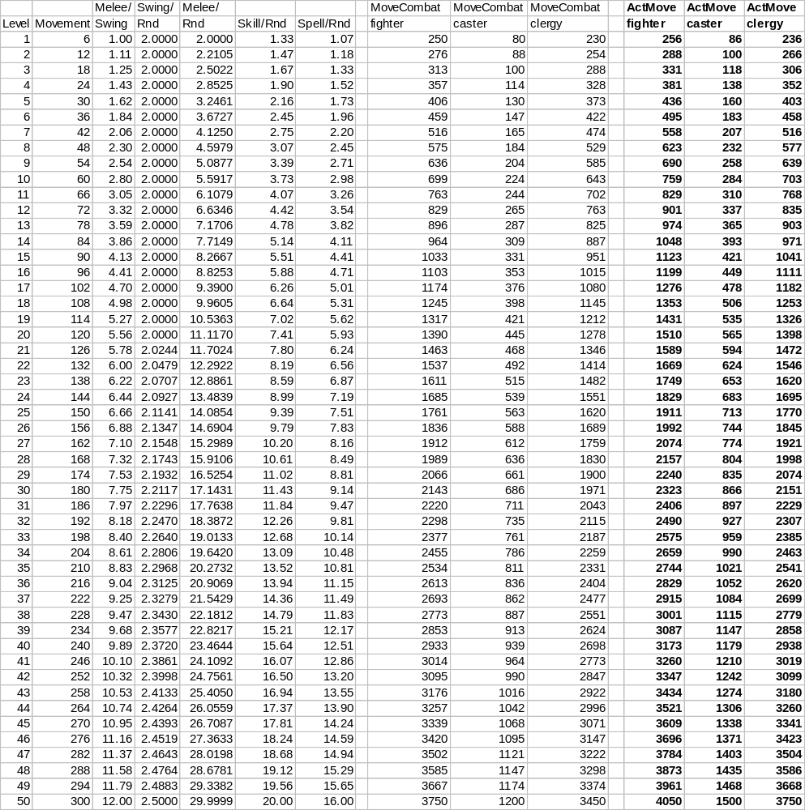
The upshot of this is shown in (Spreadsheet 41.).
The MoveCombat columns above attempt to show the total allowance being given based on class-subtype. This value is essentially just 75 rounds multiplied by the sum of the appropriate per-round amounts. That is, MoveCombat for fighters is 75 * (Melee/Rnd + Skill/Rnd).
All in all, the movement allowance is MUCH less than the combat allowance at all levels. We used some fairly general statements about how far players would have to travel between fights, which will be almost impossible to validate. Even if a person travels 2-3 times as far as we think they will, they are not significantly impacting their combat chances.
We also note that low-level players have a few hundred movement-points total, and that high-levels have a few thousand. These numbers do not seem overtly disconcerting.

Racial Modifiers
To further complicate matters as an optional enhancement, players will certainly expect that certain races use more or less movement per action (and/or have move total ActMove). As previously noted, movement is used as a limitation, so we should not create races that use less move per action AND have more total as this would invalidate the use of movement as a limitation.
For the most part, we appease the player’s perception that movement costs should be race based by throwing in arbitrary racial multipliers onto each factor (movement, swings, etc.) However, they also carry through to the calculation of a player’s total ActMove. If it takes that character less to perform a certain action, they are getting less of an allowance for that action.
Because of this, I am going to ignore “race” for the purpose of this movement discussion. Obviously, we are free to scale costs and allowances by any constant we wish, but to avoid confusion I won’t do so.

Extensions for Non-Fighters
Following similar reasoning, we ought to be able to construct systems for caster’s mana and clergy’s piety that will have similar effects as warrior’s movement. That is to say, we can construct ActMana and ActPiety such that they restrict casters/clergy to 75 rounds in combat.
In fact, if we again look at (Spreadsheet 41.), we can see the big discrepancy that casters movement has when compared to fighters. Players will almost certainly complain about this. We have no compelling reason to force casters to budget both movement AND mana. Each has the same goal. If we presume that a caster will not enter physical combat and that the mana system is properly constructed to limit casters to 75 rounds of combat, than we can safely relax the movement restriction on casters. That is to say, casters have more than enough movement for the fight, but their mana will run out if they attempt to plow.

Mana
Using equivalent reasoning as before, we base mana costs on the value of DamCap. In this fashion a low-level spell will cost less than a high level one:
- ManaPerRound
= Mana cost per round of spell casting
= DamCap / 2
By extension given the 75 round limit we desire:
- ActMana
= Player’s total allowance of mana
= 75 * ManaPerRound
- Mana by Level
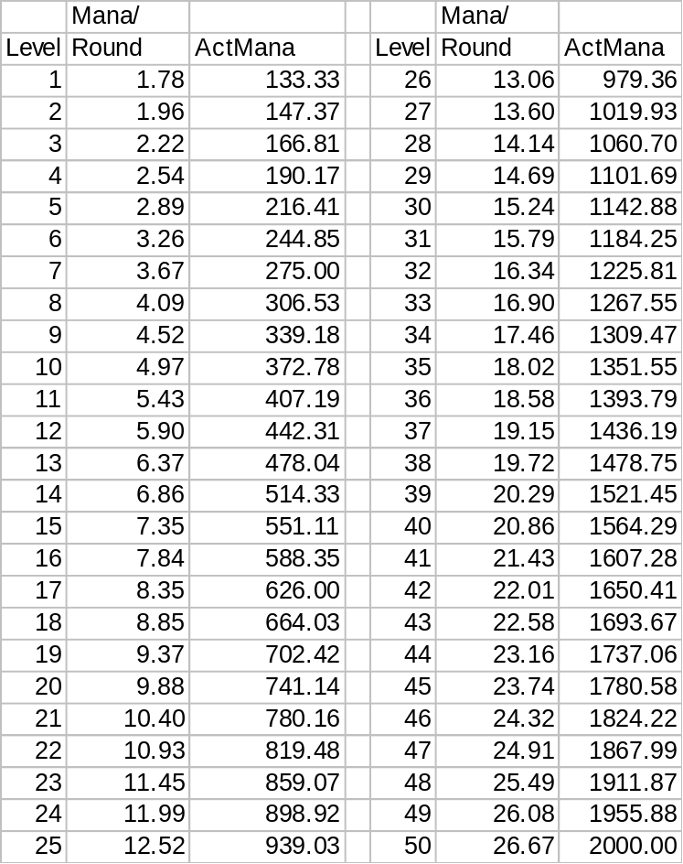
From this we learn that casters have from 133-2000 total points of mana. These numbers do not seem disconcertingly high or low. There is a gradual upward trend in ActMana so that each level gained awards more mana to the caster as well.
Under the hood, we also note the per-round mana casting costs. Higher level spells cost more to cast. Or said another way, high-level casters could cast a LOT of low level spells before running out of mana. Of course since those low-level spells do very little damage, everything works out OK.

Piety
Clergy use piety in the same way as casters use mana. In order to differentiate the two systems as more than just s semantic change, it was decided to make piety use a 0-100 scale for the maximum piety at all times. So instead of spells having a constant cost, but players having variable (increasing with level) total mana, prayers have a variable (decreasing with level) cost, but constant total piety.
Basically, if we read the above (Spreadsheet 42.) and convert to percentages, we represent our piety system properly. For example, a person always has 100.0 total piety points:
- ActPiety
= Player’s total allowance of piety
= 100.0
The piety cost is then simply the ManaPerRound for the level of the prayer being invoked divided by the character’s ActMana, expressed as a percentage to put it in terms of ‘piety’:
- PietyPerRound
= Piety cost per round of praying
= ManaPerRound / ActMana * ActPiety
Logically then, the PietyPerRound for a prayer of my level is always 1/75 of my total piety. Therefore, the cost is 1.3333 piety per round for a prayer of my level. As another example, the a L25 prayer can be invoked by a L50 for a piety cost of 0.626 per round (= 12.52/2000 * 100).

Magic Equipment
One of the hallmarks of DIKU MUDs is the presence of stat-altering equipment. Players will almost certainly expect equipment that awards additional mana, piety or movement, so we should spend a moment and state the ramifications.
Realize that the fundamental purpose of mana, movement and piety is to restrict how long a player is able to remain in combat. These values are not as critical as say ActHP, but they do serve the purpose of discouraging players from plowing. If I have to regenerate after 10 spell casts to fix my mana, I may as well be casting against the toughest mob I can safely kill when I do it.
However, unlike ActHP, having extra movement, mana or piety does not impact my Power. It’s presumed that characters are performing skills of their level, and the allowances are sufficient to allow them to. Having extra movement, mana or piety might let me perform skills over my level, but since it’s also presumed that a person only knows certain skills at a certain point, this is somewhat moot.
At worst, a player might design their character to gain skills at a fast rate, and play to acquire +stat gear. They would be able consistently perform skills above expectations, thereby having greater SkillDamage than anticipated. Depending on the class, and how easy it is to accomplish this, there is a possible loophole created.
However, on the whole, +stat gear relaxes a restriction on players that merely discourages plowing. Sure, a player could acquire +stat gear and then go plowing, but so what? We devised the system to discourage the activity, not prevent it.
For the most part, +stat gear of this type is safe to introduce into the game in moderation. Provided that there is not a movement that acquires +stat gear in order to plow, or that advocates the fast-skills and +stat option of play, there is no real problem that a game designer needs to worry about. If either trend does crop up, this probably indicates that there is too much +stat gear, and something needs to be done.

Economy
More often than not, game development proceeds in complete ignorance of the economy. As we will most certainly want to provide items that impact Power for sale, we cannot hope to setup a cohesive game design and not address the economy in some fashion.
Obviously, since our system assumes that players will be using certain weapons, certain armor and certain gear, we clearly need to integrate our game design with the economy.

Mob Wealth
An appropriate starting point is simply to determine how much MobWealth each kill ought to be worth. It is reasonably intuitive to state that MobWealth ought to be a function of Power.
A creature that is twice as difficult to kill ought to be worth twice the booty. If it’s not, then players will simply go whack some low-level mobs in order to raise funds.
However, going too far in the other extreme is also bad. If mobs of twice the Power are worth significantly more than twice the gold, then there is a real incentive to kill higher-level mobs. The only way to do this would be to group. Obviously, we don’t want to require grouping, and a large (wealth) benefit for high Power mobs should be avoided.
Likewise, if double the Power leads to greatly more wealth, than it is more than likely that high Power characters will be awash in wealth. A high-level player could give away a “trivial” amount of their wealth to make a low-level player fantastically “rich”. Such a system encourages newbies to leech off of high-level players and generally creates a situation that is not desirable.
While it might seem that we want to model MobWealth in a similar fashion to MobXP (grows 2.2X for every doubling in Power), this in fact causes the economy to swing dramatically. Due to this larger doubling, the MobXP@L50 is 16000 times larger than MobXP@L1. If we were to use this for wealth, then we would be awarding 16K talens to a L50 for every talen that a L1 makes. As we will see, higher incomes translate into higher expenses. Accordingly, at high levels, things have gone through the roof and we get costs that are unpalatable. Similarly, since gold, unlike XP, can be traded freely from player to player, we should strive to keep the economy constrained as much as possible.
Therefore, we devise that MobWealth is simply a scalar multiple of Power. As mobs become tougher to kill, they become accordingly richer. However, there is no gold-incentive for killing weaker/stronger mobs.
[Note: There are many solutions to how to construct a balanced economy. Like the combat system, much iteration was tried, and I am merely presenting an end-case that seems to be a good balance of the various concerns that lie ahead. Feel free to deviate if you choose.]
The only significant boundary condition we need is to insure that low-level mobs have a handful of talens (on the order of 5-10). Because we know that Power@L1 is 196, I choose a scalar of 20:
- MobWealth
= Amount of wealth a mob should carry
= Power / 20
= ((level)1.759815 + 13)2 / 20
= 0.05 * (level^{1.759815} + 13)²
- Level, Power and MobWealth
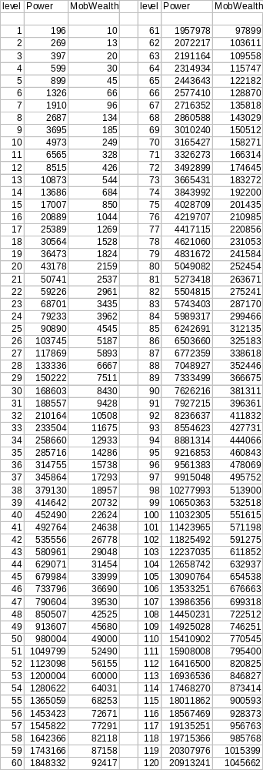
As we can see, newbie mobs carry around 10 talens, while at L50 that amount has grown to 49K. Like Power, the L50 amount is 5000 times greater than the L1 amount.
The highest-level mobs have a million gold! Given the other numbers for this economy, this is a tremendous amount certain to appease the lucky group (probably 10+ PC’s) able to kill such a mob.

Economic Feedback Loops
Like in the real world, the macro-economy is amazingly diverse and difficult to control. As game designers, we should avoid looking at specific individuals when evaluating the economy. Obviously, no individual should be able to impact the ideal free-market. However, too often implementers make drastic sweeping changes based on how well a handful of players are doing.
We are fortunate to be computer-modeling our economy, as it allows us to easily gather vast amounts of data about the economy. Without too much trouble, we can easily make it so that every action that gives or drains money from a player is classified, and we can keep running balance sheets either globally or level-by-level or even class-by-class.
Adding only minimal complexity, multipliers can be introduced to increase or decrease the amount of money flowing into/out of the economy from each action. The game designer simply needs to identify the desired state of the economy in terms of “repair costs should be 10% of my total costs”, and then provide a way for the multipliers to adjust based on the balance sheets.
Simply put, it is better to have an economy that automatically adjusts based on well specified target goals for gold availability and costs than to simply “wing it” and make drastic manual corrections when problems are noticed.

Balance Sheet Values
I will preface by saying that what follows is simply what I have found to work fairly well empirically. This is NOT an absolute discussion, and individual implementers should feel free to make adjustments in the desires that they choose. I am offering it primarily to give people some ideas of a starting place.
Each gold transaction is classified as one of:

Internal transfer: moving money from my person to my bank account.
Income: Money picked up off the ground or from a corpse.
Gamble: Money made at the casino.
Junk: Money awarded for junking items at a junkyard.
Rent: Money spent renting goods.
Repair: Money spent repairing goods.
Shop: Money spent in shops on miscellaneous.
Shop-components: Money spent in shops on components.
Shop-armor: Money spent in shops on armor or weapons.
Shop-pets: Money spent in shops buying pets.
Hospital: Money spent healing.
Data is collected globally and not broken down by class or level. I presently do not feel it is appropriate to make class or level distinctions as this would most likely result in some arbitrary skewing. Why should it cost a L5 ranger 100 talens to repair a helm, and a L10 cleric repairing the exact same helm be charged 200?
For the most part, we can ignore mobs entirely. Obviously, money very rarely moves between mobs to begin with, but realize that the economy we want to keep close tabs on begins and ends where a pc is not one-side of the transaction.
Also, we should collect two figures for each transaction, a net amount and a gross amount. Every transaction (income or drain) adds to the net amount, but only those transactions that increase the player’s wealth contribute to the gross. The total amount ever made can be viewed from the gross, the net amount is viewed in the net, and we can derive the total amount ever drained by subtracting one from the other.

Total Income
Overall, players should make a small profit. We want them to build a small fortune over time, as this is a worthwhile goal for an RPG. We stipulate that we want the total net amount for all transactions divided by the total gross amount for all transactions to be roughly 1-2%. That is, for every 100 talens gained by PCs, they are keeping 1-2 of them.
Since the source of most of the money in the game is off of kills, we can fairly easily tweak MobWealth to achieve our values. If players are making too much, we can scale it up by a constant amount, and if too little, it can be scaled down.

Shops
Standard DIKU code allows for profit ratios to be specified so that shopkeepers always sell an item for more than they will buy it for. Unfortunately, this does not go quite far enough. Too often players will discover certain items that they will acquire in the field and bring back to sell. In a badly skewed economy, players will sell items to the shops more often than they buy things and the shop becomes a source of revenue.
In a realistic sense, shopkeepers set up shops to make money. If things kept being sold without ever being bought, supply and demand should kick in and the price ought to plummet. Devising a sophisticated market where each individual item has fluctuating prices is rather difficult, especially in light of relatively small player bases, etc. However, if we evaluate “shops” in their entirety, things get a bit simpler.
We simply stipulate that we want shops to have a 5% overall profit rate (for the shop). Therefore, for every 100 talens of items the shop sells to players, it will buy 95 talens worth of the player’s goods. There is no requirement that the same items that are sold are bought. Nor do we care (overly much) that one shop makes money while another loses money. We are simply looking at the total amount of money spent and acquired in shops and saying that, on the whole, shops slightly drain money from players.
Experimentation showed that it was not necessary to adjust the price that shops sell items to players for. Simply adjusting the price that the shop would pay for an item that a player wanted to sell was sufficient.
Additionally, this had the effect of keeping the selling price (to stores) fairly low. Pleasantly, this encouraged a secondary auction market. I might buy a sword (new) from a store for 100 talens. After leveling, I might wish to upgrade. If the store only buys it back for 15 talens, then I might seek other players looking for a second-hand bargain via private auction.

Equipment Availability
Aside from finding gold directly on a mob, the other chief way players make money is from finding equipment and selling it. The importance of finding booty (equipment) as opposed to loot (money) is an appropriate area of concern. Too much booty feeds the equipment market and allows players to acquire gear, either replacement or upgrade, easily. Knowing, and adjusting the availability of gear is important to a well-balanced economy.
We established that selling armor and equipment to stores should amount to no more than 25% of a player’s total gross income. A global modifier was established to control the success of loading equipment or other booty on mobs. The availability of equipment is scaled up and down to keep booty income in line with what is desired.
Keep in mind the other modifiers. If we had an economy in equilibrium, but too much money was booty oriented, the equipment modifier would drop and less equipment would be available. Since less equipment is available, less is being sold to the shops and the shop modifier would adjust (upwards) meaning that each item sold gives out slightly more gold. Also, the total income modifier will correct to insure that players still make a profit. Players won’t be profiting as much from booty, but the loot modifier will increase.

Rent and Repair Feedback
Two large drains in the economy are the areas of rent and repair.
The first thing that should be established is what percentage of all drains the two should represent. For instance, maybe rent and repair should represent 70% of all money I spend. The remainder is spread to things like purchasing food, or upgrading items at the shops.
Concurrently, establishing the individual percentages for each area should be done. For instance, perhaps repair should be 50% of my costs, while daily rent should only be 20%.
We can sum up all areas of the economy and determine the total drain in a player’s life, these can be compared to the individual drains for rent and repair, and the costs can be scaled up and down to insure the appropriate percentages are achieved.
I will come back to this discussion after we talk about rent and repair systems more in depth.

Advancing Our Economic Understanding
Let us proceed by combining what we already know and seeing where it leads us.

Gold Acquired
Realize that MobWealth is the total amount of wealth the mob possesses. However, wealth can either be in the form of coins (MobLoot), or held in the form of equipment (MobBooty) that can be hauled back to civilization and sold. During the shops feedback discussion we stated that booty would amount to about 25% of a player’s total income.
- MobBooty
= Amount of wealth held by a mob in the form of booty
1/4 * MobWealth
Therefore, the remainder of MobWealth must be in the forms of gold:
- MobLoot
= Amount of wealth held by a mob in the form of coins
= MobWealth - MobBooty
= MobWealth - (1/4 * )
3/4 * MobWealth
Since we also know KillsPerLevel, and if we assume that all booty is sold, we can combine to yield:
- GoldAcquiredPerLevel
= Total amount of wealth acquired per level
MobWealth * KillsPerLevel
- GoldAcquiredPerLevel by Level
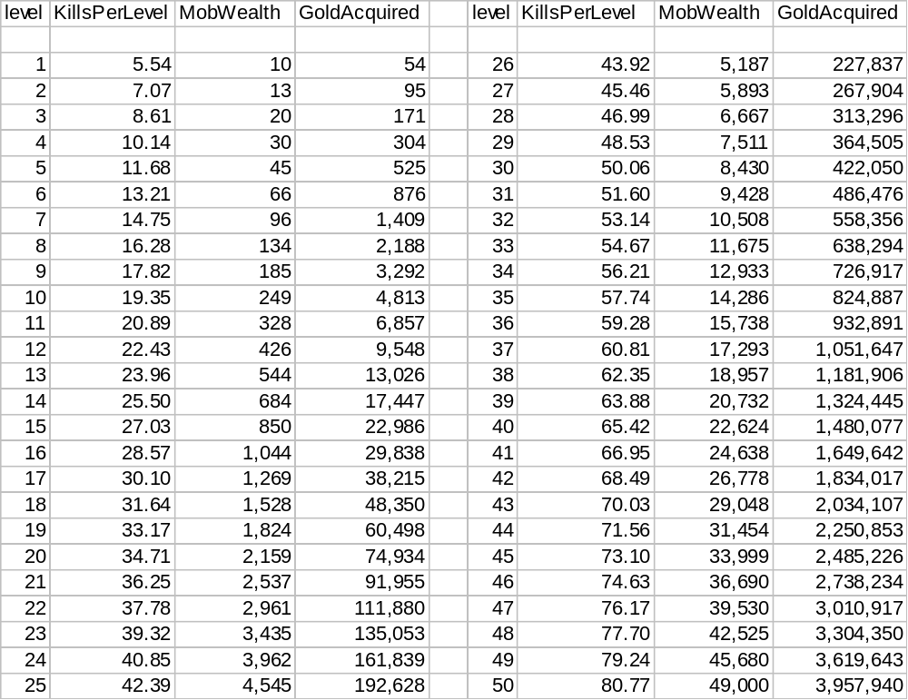
What we see from this is the amount of gold that a player of a given level will acquire during that level. That is, during the time that a player is a L10, we expect that they will make about 4813 talens.
Obviously, a L1’s short (only 5.5 kills) career and low wealth per mob translates into virtually no gold acquired. Meanwhile, the reverse case for a L50 yields nearly 4 million coins for L50 alone.

A Preliminary Look at Expenses
For the economy to work well, we need to insure that the economy drains money at about the same rate (slightly less) than it adds it. We know that the feedback loops will fine tune the economy to yield the 2% income profit ratio desired, so we are fairly safe in simply devising drains to equal our faucets and letting the feedback loops tweak as needed.
Expenses will come in two flavors, upgrades and fees.
Obviously, as a player advances they will want to acquire better and better items and build their net assets. Such items we will call upgrades. Obviously, the game design assumes that the player is improving his lot. E.g. getting better weapons doing more damage, wearing better armor protecting better, etc. Nevertheless, paying for the upgrades is a significant expense.
The second kind of expense, fees, represents those unrecoverable expenses that are the cost of going adventuring. Buying food to keep you alive, repairing gear that gets damaged, paying informants, hiring helpers, etc. all qualify as fees.
Fees should be broken into two parts, combat and non-combat. Obviously, non-combat fees, like buying bags or food, do not really vary from class to class. However, the way combat fees are spent does vary because each class fights in a different manner. For instance, a fighter will need to pay to repair his equipment and perhaps some hospital costs. A caster, on the other hand, will consume precious components in the course of casting (and may also need repair or the hospital). Since we do not want the economy to unduly penalize any one class, we should strive to keep the combat fees identical for all classes.
Therefore, the sum of a person’s combat-fees, non-combat-fees, and upgrades should equal their GoldAcquiredPerLevel. While the actual line items in each category may change depending on class, each class should be expected to pay about the same amount for each type of expense.

A Prelude to Equipment Repair

Upgrades and Planned Obsolescence
Clearly, upgrade expenses are simply the differential. That is to say, if I own a sword worth 100, and want a mace worth 120, I need only chip in 20 gold to make the purchase.
The problem with this is that if items retain their value, than the cost of goods must grow geometrically. That is, if we say that upgrades amount to 10% of a person’s income (as an example), then the price of level X gear is 10% of GoldAcquiredPerLevel at level (X-1) + 10% of GoldAcquiredPerLevel at level (X-2) + … + GoldAcquiredPerLevel at level 1. Since the price compounds in this manner, it would be extraordinarily huge at high levels.
In itself, having high cost armor isn’t inherently bad. It would force people to upgrade along obvious paths simply because trading up more than a few levels worth of gear at once would be prohibitively expensive.
However, since most gear will enter the shop-market by being acquired by adventurers and sold to the shop, a massive flaw is revealed. If equipment value becomes extraordinarily high, then finding equipment becomes more lucrative.
We would have two problems. First, players would be hunting equipment because it pays so much better. Why kill a L50 mob for a few thousand gold apiece when I can go whack a few L40’s with equipment worth a few million?
Second, finding and selling equipment would basically destroy our economy by heaping massive money on a person. Even if we solve the first problem by somehow tweaking the shop profit ratios appropriately, the auction market will nullify this. For instance, if I sell L50 gear for 50K to the shop, and the shop turns around and asks 1 million for it, it won’t be long before auctions take place. Sellers make much more than the shop pays, and buyers pay much less than they would from the shop.
The only obvious solution to this dilemma is to escape the geometric-growth assumption. That is to say, at the point I am ready to upgrade, the value of my present gear is essentially worthless. With essentially no trade-in value, then the cost of equipment closely mimics how the gold curves behave.
The obvious ramification of this plan is that gear must degrade, gradually becoming worthless. The period over which this degradation occurs must match the period over which an upgrade happens. In general, we want folks trading up their equipment once per level; therefore we are also saying that a given piece of equipment becomes worthless in the time it takes to gain a level.

Repairs Per Level
The obvious mechanism to have items degrade to worthlessness is to have them become damaged in the course of adventuring. Obviously, players will want to repair this damage, so some capability for repairing items must be present as well.
[Note: I will again reiterate that the economy has numerous “solutions”, all of which are valid. What I present is simply what I think is a good blend of the various numbers.]
To begin with, let us arbitrarily state that we want there to be 2.5 repairs per level:
- RepairsPerLevel
= Total number of complete repairs per level
2.5
That is to say, over the course of a given level, I am forced to repair my entire set of equipment 2.5 times. My helm needs 2.5 repairs, my suit needs 2.5 repairs, etc.
This number is entirely arbitrary, although we want to have it reasonably large so that players think that armor is in fact ‘repairable’. However, making it too large upsets the FightsPerRepair value.
Realize that when the equipment is new, it essentially has an “extra repair” in it. That is, my helm starts new, decays, is repaired fully (1.0), decays, repaired fully (1.0), decays, repaired partially (0.5), decays and is dead. The item is able to decay (RepairsPerLevel+1) time. As this is the case, it is probably more useful to speak of:
- DecaysPerLevel
= Total number of complete decays per level
RepairsPerLevel+1
= 2.5 + 1
3.5

KillsPerRepair
Since we know how many KillsPerLevel, it is a simple matter to determine the number of fights a person has between repairs:
- KillsPerDecay
= Number of fights between successive repairs
= KillsPerLevel / DecaysPerLevel
= (1.53548 * (level) + 4) / (3.5)
- KillsPerDecay as a Function of Level
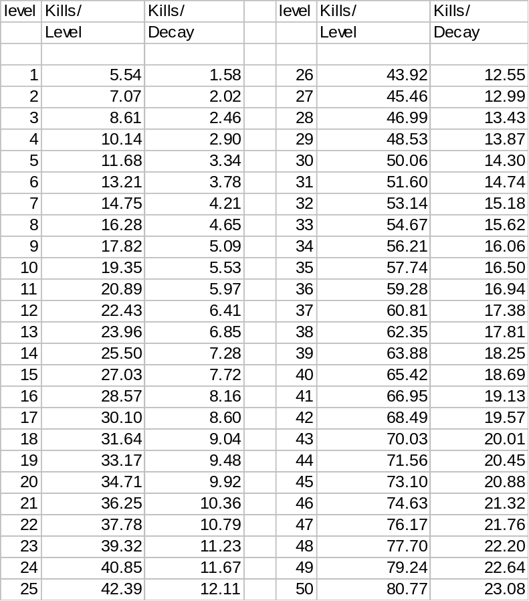
Clearly, we always want KillsPerDecay to be greater than 1.0, otherwise, a suit of equipment would completely decay in a single fight (leading to massive complaints). As we can see, the lowest value it reaches is at L1, where we can go just over one fight without repairing our gear. Obviously, this isn’t great, but it’s somewhat justifiable as it teaches newbies (early) about repairing their gear.
Since having to rush back to civilization to find a repair shop is somewhat of a hassle, as players rise in level and venture further abroad, it would be good if they can remain in the field longer without needing to repair. Thankfully, KillsPerDecay rises with level. A L50 can go more than 23 fights without needing to stop and repair their equipment.
Furthermore, since each of the above “kills” is thought to be a fair-fight, thought to last 60 rounds each, thought to be about 2-3 seconds per round, we establish that each fight is 2.5 minutes long. Newbies will have to repair about every 5 minutes, however, they are also leveling phenomenally fast, so this situation doesn’t persist for too long. This newbie situation is a worst-case scenario using theoretical values for time. For practical purposes, the value is probably closer to every 15 or so minutes (not great, but not horrendous), while high-levels can play for many hours (roughly) without needing to repair.

Repair Cost Fraction
Pushing onward, we can next define the fraction of the full price that a single repair should cost. That is to say, if an item costs 100 gold new, what should it cost to fully repair it?
Interestingly, if this fraction is exactly the inverse of RepairsPerLevel (and since an item decays to nothing over a single level), then the total lifetime cost to repair the item equals the item’s price. Although I can make no logical argument that this should be so, I like the elegance of it, so:
- RepairCostFraction
= Cost to fully repair an item in terms of the item’s value
= 1 / 2.5
= 0.4
In theory, this number can be whatever the game designer wants. However, large values for RepairCostFraction seems to heavily weigh expenses toward repair (to the detriment of upgrades). Obviously, having repair costs exceed the GoldAcquiredPerLevel means a deficit situation for players and speaks badly of the game design. Not to mention, if repairs are a significant fraction of the item’s total cost, the perception that it is “better” to just go replace the item rather than repair it grows.
Conversely, too low a value for RepairCostFraction raises the price of a suit of equipment. If we charge nothing for repair, then all of GoldAcquiredPerLevel must be used in upgrading. Obviously, having really expensive equipment suits also seems silly.

Level 1 Suit Cost
As there are multiple pieces of equipment in a suit of equipment, we want to insure that each piece is valuable. That is, each piece should be worth at least 1 piece of gold.
I choose to make the L1 suit cost 20 talens.

Level 1 Expenses
Since Level 1s will be given a suit of equipment to start with, they have no expenses related to upgrading.
However, during their L1 career, they will have to repair their L1 suit RepairsPerLevel times. Each repair will cost them RepairCostFraction times the price of the L1 suit.
Since we opted for elegance, RepairCostFraction and RepairsPerLevel cancel each other out, and the L1 has repair expenses equal to the price of their suit. This will be true regardless of our level, so I will just state that repair costs at any level equal the cost of the suit.

Level 1 Profit
First, we know GoldAcquiredPerLevel@L1 will be acquired during L1. Secondly, their L1 gear is adequately durable to let the player reach L2. Therefore, the player’s total repair costs is simply the cost of the L1 suit, 20 talens.
Therefore, the difference is the amount the L1 makes obtaining L2. We would like this amount to be the cost of the next suit. So:
L1Profit = GoldAcquiredPerLevel@L1 - L1SuitCost
L2SuitCost = L1Profit
L2SuitCost = GoldAcquiredPerLevel@L1 - L1SuitCost

Extending the System
We can simply iterate this process and yield the SuitCost for any level we choose. Since this is basically an iterative equation, it quickly becomes messy, so I will forego any attempt to write it down in terms of level alone.
That is to say:
L3SuitCost = GoldAcquiredPerLevel@L2 - L2SuitCost
L4SuitCost = GoldAcquiredPerLevel@L3 - L3SuitCost
L5SuitCost = GoldAcquiredPerLevel@L4 - L4SuitCost
And so on…
- SuitCost
= The price of a full suit of equipment for a given level
= (GoldAcquiredPerLevel - SuitCost) [for previous level]
Obviously, this is non-intuitive. Hopefully, this spreadsheet will educate:
- Suit Costs
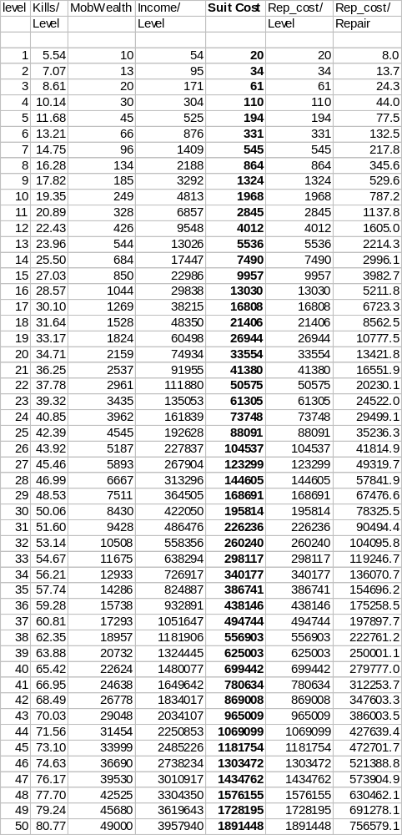
As you can see, SuitCost starts out fairly low at only 20 talens. For the first few levels, the price (almost) doubles each level.
By level 50, this trend has attenuated somewhat. The L50 SuitCost is only about 10% more expensive than the L49, although that 10% represents 160K talens. The L50 SuitCost is quite expensive, coming in at close to 2 million coins.
The net effect is to make it fairly difficult for a person to leapfrog upgrades. Suits more than a few levels above a person cost more than a person makes during that entire level.

A Cost Breakdown
It is somewhat interesting to further break down the costs, by fight, repair and level.
- Costs Break Down
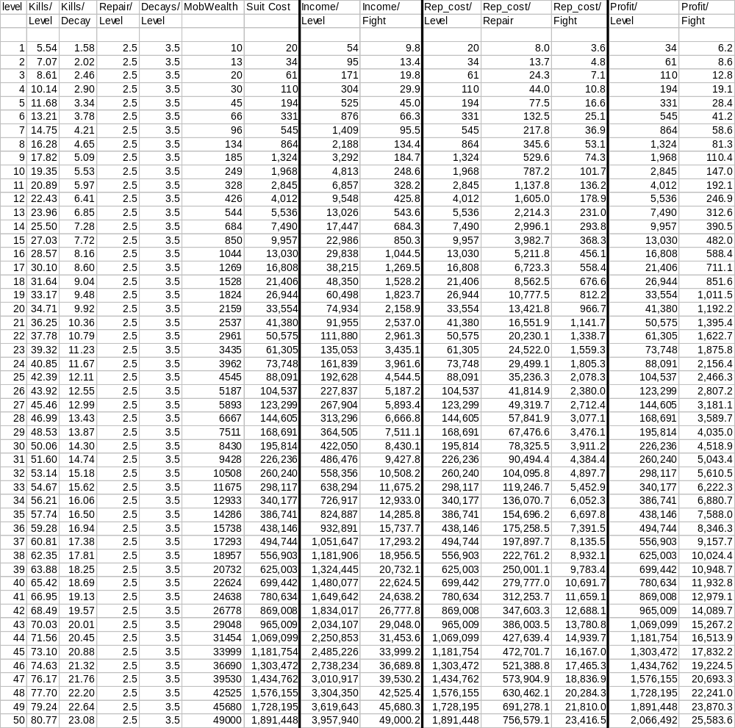
Obviously, some of these columns we’ve seen before.
The Profit/Level column, which is simply the Income/Level – Repair_cost/Level is also the SuitCost for the next level.
One curious thing to keep an eye on is the Co-Ed Naked MUD Fighting scenario. Recall from the discussions of our simple combat setup, a L50 warrior fighting in L1 gear (or alternatively, naked) would be roughly equal to a L25 fighter. Killing a L25 yields 4545 talens per fight. Since they would be naked, there would be no repair costs accrued, for a total profit of 4545/fight. Contrast this value with the 25584/fight profit the L50 would make if in an appropriate L50 fair-fight using equipment. Therefore, it’s more profitable to fight in proper equipment (and deal with the repair).
[Actually, this last remark may boil down to the constraint that we never want SuitCost to double from one level to the next. I never actually proved that this was the case, but it’s probably a reasonable statement.]

Shifting the Rewards between XP and Wealth
[This needs work, this is just working notes so I remember.]
Lower (or 0) gold, becomes higher XP. This balances rewards so that a good XP mob is a bad gold mob and vice versa. Is this attainable?
However, …
Lower XP means more kills needed to level. Since we still want the same net profit, it works out that lower XP should make gold go down too…
Math:
Mob has n more XP than normal.
We must kill 1/n the normal number of mobs.
With 1/nth the kills, our repair costs are 1/nth as well.
With 1/nth the kills, we might have extra value/cost in suit (buy an extra, or sell with worth still in it). Suit profit is SuitCost(1-1/n)
To maintain profit, we must multiply gold on the mob by K, such that:
KI/n + S(1-1/n) – R/n – S_ = I – S_ - R
S = SuitCost at my level, S_ SuitCost at next level, R is repair costs, I is income/level.
I(K/n – 1) = R(1/n-1) + S(1/n-1)
K = [(R(1/n-1) + S(1/n-1))/I + 1]*n
For values of n ~= 1, the R and S terms disappear, and K is linear with n. Give more XP, must give more gold as well. Logical, but Weird!

Equipment Load and Replacement Rates
Since we know how much MobBooty must be found on each kill, and we know the SuitCost value, we can calculate a load rate.
- EQLoadRate
= Percentage of a full suit that must load each kill
= MobBooty / SuitCost
That is to say, knowing that MobWealth@L4 is roughly 30 gold, MobBooty@L4 is about 7.5 talens. Since SuitCost at L4 is 110 talens, we can see that we should find about 6.8% (= 7.5/110) of a suit on each mob we kill.
Obviously, this doesn’t mean that 6.8% of the mobs have a complete suit. Simply, every mob of that level has a 6.8% chance of loading each item in that suit. In all likelihood, each mob will have a handful of pieces.
Along similar lines, if we know that a suit of equipment is only good for a single level, and we know how many KillsPerLevel there are, then we can derive the necessary replacement rate for equipment. The replacement rate is simply the critical value, under which, items are not loading fast enough to cover the obsolescence factor, and over which implies that more items are being loaded than are necessary for our adventurers.
- EQReplaceRate
= Load rate necessary for players to find EQ to replace damage items
= 1/KillsPerLevel
- EQLoadRate and EQReplaceRate as Functions of Level
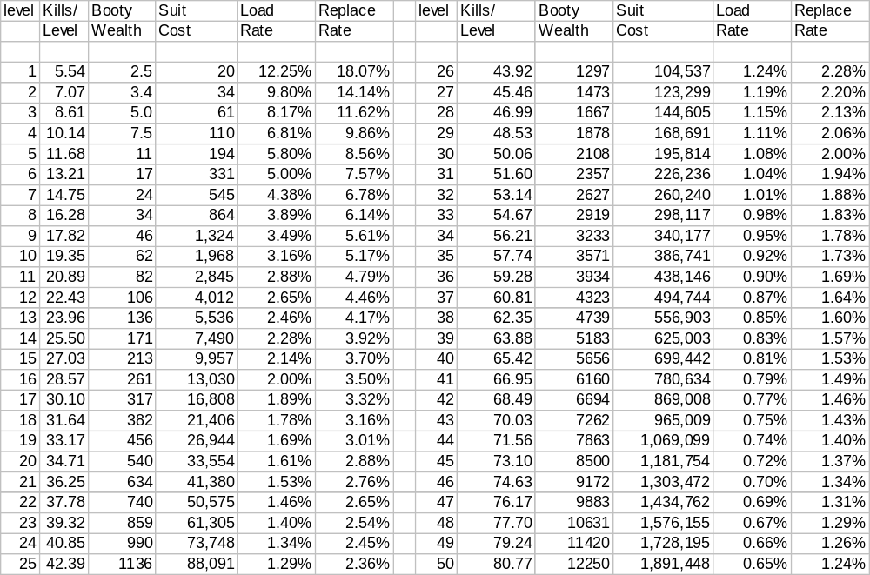
From this we can see that as we rise in level, the chance of finding gear (EQLoadRate) decreases. On the other hand, each piece that is found is worth a considerable sum of money so there is some parity.
Intuitively, the more KillsPerLevel there are, the less equipment we need to find on any one given mob. Hence, we see that EQReplaceRate drops as we go up in level.
Of great significance is the comparison between EQLoadRate and EQReplaceRate. Since the EQLoadRate is less than the EQReplaceRate, this means that killing a level’s worth of mobs does NOT provide sufficient gear to completely replace the adventurer’s equipment. A person will only find about ½ the amount of gear that they will need to in order to make up for their gear becoming junk.
On the surface, this would seem like a bad situation. Of course, if not corrected for, bad things will most certainly occur (As we will come to see, corrective action can be made). However, it has the pleasant effect of keeping equipment rare and precious. Players will be required to keep their gear in decent working order because there is no guarantee that they will be able to easily find a suitable replacement.

A Break Down of SuitCost
While it is nice to speak abstractly about the cost of a suit of equipment, in reality, a suit is composed of numerous pieces of equipment and so we must subdivide the price based on this.
As we learned earlier, a suit of armor has 17 pieces of equipment, plus a shield, plus a weapon. C.f. Percent of ActArmor Found on Any Given Equipment Slot
For the equipment alone, it seems natural to base the price of each piece on the amount of protection it provides. The more protection we get from that piece, the more that piece costs.
Likewise, as the decision to use a second weapon or a shield is reasonably balanced, we should insure that price does not factor into the equation overly much. That is to say, a weapon and a shield should be priced identically.
It remains to be decided the relationship between equipment and the held-items. Arbitrarily, I opt to make the held-items 20% of the total suit-cost (10% for each hand). Therefore:
- Cost Breakdown by Equipment Slot
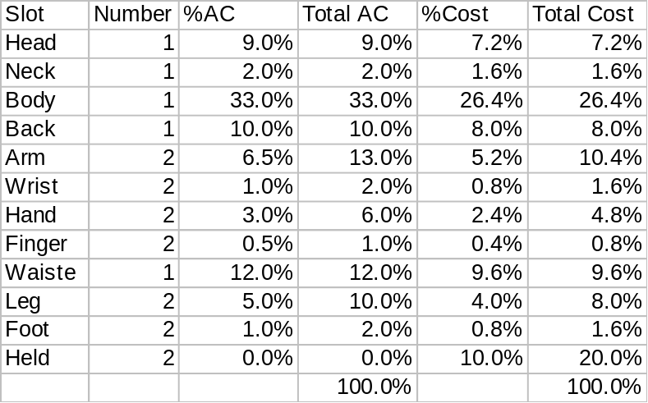
Since we know the SuitCost for all levels, we can further refine this.
- Equipment Cost Breakdown by Slot and Level:
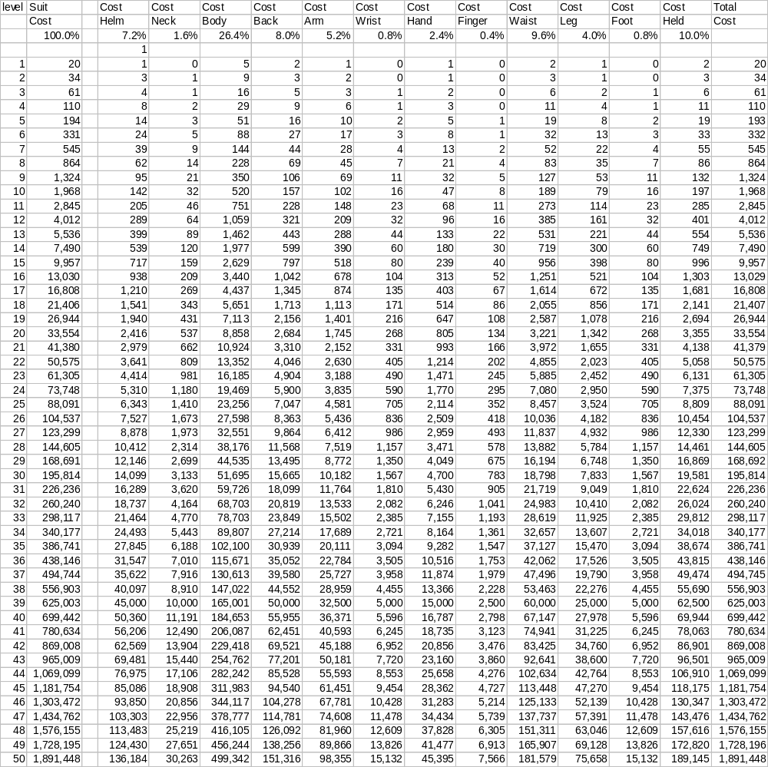

Weapon Quality Damage
Normal

Symbol Stress
Normal

Components
Normal

Repair
Normal

Pricing System

Armor Pricing
Normal

Weapon Pricing
Normal

Component Pricing
Normal

Symbol Pricing
Normal

Magic Effects
+tohit, +todam

Spells
Normal

Holy Water
Normal

Rent Credit
Normal

The Skill System
Normal

Disciplines
Normal

Practices
Normal

Game Design for Some Specific Skills

Chivalry
Mounted = loss of attacks
Chiv = greater damage &| greater defense

Blur
Probably get rid of this skill

Anticipated Game Design Problems
Nothing ever works out perfectly in a system as complex as a MUD. I think it is important to be mindful of the tradeoffs that we have made along the way, and highlight some of the potential weaknesses and problem areas.

Uselessness of Armor
If we examine (Spreadsheet 11.), we note that the relative scores between L1 ActArmor and L50 ActArmor have a ratio of about 2:1. Effectively, this means that the protection afforded by a newbie suit is only ½ that of the best armor in the game.
Since the cost of equipment will be somewhat an issue for players, it is quite possible that some players will realize that sacrificing some AC to save a buck is cost-effective. It is quite plausible to see players experimenting by sacrificing armor in order to get a better weapon.
[Needs more data from systems not yet developed]

Clumsiness of the Worn Equipment System
The development of clothing and armor and the relationships between them are pretty much contrived. It was necessary to restrict the armor from equipment on certain classes, and by using two types of equipment we manufactured the results that we desired. Furthermore, we have placed entirely arbitrary restrictions on various classes over which slots may have armor and which must be clothing in order to enforce these desired limitations.
In an ideal world, we might conceive a system of encumbrance whereby anyone could wear any worn equipment that would fit. The makeup of the equipment would impose limitations, either by not being flexible enough to accommodate certain actions, or by it possessing some physical liability that disrupts skills, magics or communing with one’s deity.
Such a system would require a highly developed framework. For example, items would each have to each be rated for their individual composition (75% steel, 25% glass). Each material type would have to have characteristic properties defined for it (weight, flexibility, effects on magic, etc.). And every action would have to have in depth understanding of what limbs are required to perform the action in question. Platemail leggings and leather sleeves might allow me to punch well, but not to kick.
Needless to say, such a system would be unimaginably complex. The “fantasy” environment further complicates matters since there are no firm guidelines. Is plasma armor quiet or noisy? Can centaurs kick if they are wearing plate leggings on their hindquarters? Do metallic boots interfere significantly with a mage’s ability to cast?
If such a system could be created, it would be far superior to the simplistic system mentioned here for worn equipment. However, the amount of time it would require for debugging and testing makes deployment somewhat problematic. The simplistic system is adequate for our purposes, and there is no reason to suppose that transitioning (at a later date) to a more complex encumbrance system is precluded.

Synergy and the Ultimate Group
When power was originally conceived, we assumed that we would ultimately see small- to medium-sized groups of high-level players. If we take another look at (Spreadsheet 1.), we can see that the relative power between L50 and L120 is around 20:1.
While we do make a SynergisticCorrection adjustment, in reality, it probably does not require 20 L50’s to topple a single L120. Despite our best efforts, the system is complex enough to allow for one player’s strengths to offset another’s weaknesses and synergy to creep in.
We should not worry too greatly about this. If players interact to beat the system, it is certainly not a problem. In fact, doing so enhances the community and the overall enjoyability of the game.
While it would seem like the 20:1 ratio is obscenely high, we must recognize that using synergy, the big bad L120s can probably be toppled by a group of only 10-15 using a solid play strategy.
Likewise, we should recognize the impact synergy would have on playtime per level. If we reexamine (Spreadsheet 7.), we can see that it should take around 35 days of play to achieve L50. Since the effective power of a synergistic group exceeds that of an additive one, we expect that players could conceivably gain XP at a faster rate than what we anticipated.
The bottom line is that we should refrain from judging the “worth” of our system solely on how fast a given character is able to obtain L50, or how few L50s it took to kill Mighty Herclopuloid. The goal is simply to provide entertainment and a challenge, and provided that the gaming system does both, it can be regarded as a success.

