**Министерство образования Российской Федерации**

**Пензенский государственный университет**

**Кафедра «Вычислительная техника»**

**ОТЧЁТ**

**По лабораторной работе №5**

**По дисциплине: «Программирование»**

**На тему: «Основы разработки графических интерфейсов средствами Win32 API»**

**Выполнил:**

**Студент группы 23ВА1**

**Якунин Д.В.**

**Принял:**

**Евсеева Ю. И**

**Гудков А.А.**

***Пенза 2024***

**Цель работы:** Изучить основы разработки графических интерфейсов средствами Win32 API

**Ход работы:**

**Задание :** Разработать графический интерфейс к программе из лабораторной работы № 4.

**Результат:**

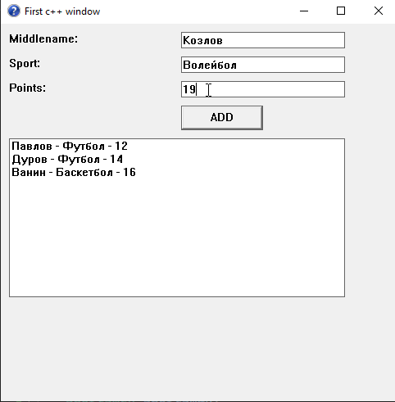

**Вывод:** Изучил основы разработки графических интерфейсов.

Приложение 1. Код программы

#include <windows.h>

#include <string>

#include <list>

#include <algorithm>

#define OnButtonClicked 1

using namespace std;

typedef struct {

wchar_t middlename[256];

wchar_t sport[256];

int points;

} Sportsmen;

LRESULT CALLBACK SofwareMainProcedure(HWND hWnd, UINT msg, WPARAM wp, LPARAM lp);

WNDCLASS NewWindowClass(HBRUSH BGColor, HCURSOR Cursor, HINSTANCE hinst, HICON Icon, LPCWSTR Name, WNDPROC Procedure);

std::list<Sportsmen> sportsmen;

HWND g_hMiddlenameameEdit, g_hSportEdit, g_hPointsEdit, g_hListBox;

void MainWndAddWidget(HWND hWnd);

void add_Element() {

Sportsmen sportsman;

GetWindowTextW(g_hMiddlenameameEdit, sportsman.middlename, 256);

GetWindowTextW(g_hSportEdit, sportsman.sport, 256);

wchar_t pointsTxt[256];

GetWindowTextW(g_hPointsEdit, pointsTxt, 256);

sportsman.points = std::wcstof(pointsTxt, nullptr);

sportsmen.push_back(sportsman);

SendMessageW(g_hListBox, LB_RESETCONTENT, 0, 0);

for (const Sportsmen& sp : sportsmen) {

std::wstring info = sp.middlename;

info += L" - ";

info += sp.sport;

info += L" - ";

info += std::to_wstring(sp.points);

SendMessageW(g_hListBox, LB_ADDSTRING, 0, reinterpret_cast<LPARAM>(info.c_str()));

}

SetWindowTextW(g_hMiddlenameameEdit, L"");

SetWindowTextW(g_hSportEdit, L"");

SetWindowTextW(g_hPointsEdit, L"");

}

int WINAPI WinMain(HINSTANCE hinst, HINSTANCE hPrevIns, LPSTR args, int ncmdshow) {

WNDCLASS SoftwreMainClass = NewWindowClass((HBRUSH)COLOR_WINDOW, LoadCursor(NULL, IDC_ARROW), hinst, LoadIcon(NULL, IDI_QUESTION), L"MainWindClass", SofwareMainProcedure);

if (!RegisterClassW(&SoftwreMainClass)) { return -1; }

MSG SofwareMainMassage = { 0 };

CreateWindow(L"MainWindClass", L"First c++ window", WS_OVERLAPPEDWINDOW | WS_VISIBLE, 100, 100, 500, 500, NULL, NULL, NULL, NULL);

while (GetMessage(&SofwareMainMassage, NULL, NULL, NULL)) {

TranslateMessage(&SofwareMainMassage);

DispatchMessage(&SofwareMainMassage);

}

return 0;

}

WNDCLASS NewWindowClass(HBRUSH BGColor, HCURSOR Cursor, HINSTANCE hinst, HICON Icon,LPCWSTR Name, WNDPROC Procedure){

WNDCLASS NMC = {0};

NMC.hCursor = Cursor;

NMC.hIcon = Icon;

NMC.hInstance = hinst;

NMC.lpszClassName = Name;

NMC.hbrBackground = BGColor;

NMC.lpfnWndProc = Procedure;

return NMC;

}

LRESULT CALLBACK SofwareMainProcedure(HWND hWnd, UINT msg, WPARAM wp, LPARAM lp) {

switch (msg) {

case WM_COMMAND:

if (LOWORD(wp) == OnButtonClicked) {

add_Element();

}

break;

case WM_CREATE:

MainWndAddWidget(hWnd);

break;

case WM_DESTROY:

PostQuitMessage(0);

break;

default: return DefWindowProc(hWnd, msg, wp, lp);

}

}

void MainWndAddWidget(HWND hWnd) {

CreateWindowW(L"STATIC", L"Middlename:", WS_VISIBLE | WS_CHILD, 10, 10, 150, 20, hWnd, NULL, NULL, NULL);

CreateWindowW(L"STATIC", L"Sport:", WS_VISIBLE | WS_CHILD, 10, 40, 200, 20, hWnd, NULL, NULL, NULL);

CreateWindowW(L"STATIC", L"Points:", WS_VISIBLE | WS_CHILD, 10, 70, 150, 20, hWnd, NULL, NULL, NULL);

g_hMiddlenameameEdit = CreateWindowW(L"EDIT", L"", WS_VISIBLE | WS_CHILD | WS_BORDER, 220, 10, 200, 20, hWnd, NULL, NULL, NULL);

g_hSportEdit = CreateWindowW(L"EDIT", L"", WS_VISIBLE | WS_CHILD | WS_BORDER, 220, 40, 200, 20, hWnd, NULL, NULL, NULL);

g_hPointsEdit = CreateWindowW(L"EDIT", L"", WS_VISIBLE | WS_CHILD | WS_BORDER, 220, 70, 200, 20, hWnd, NULL, NULL, NULL);

CreateWindowW(L"BUTTON", L"ADD", WS_VISIBLE | WS_CHILD | BS_DEFPUSHBUTTON, 220, 100, 100, 30, hWnd, (HMENU)OnButtonClicked, NULL, NULL);

g_hListBox = CreateWindowW(L"LISTBOX", L"", WS_VISIBLE | WS_CHILD | WS_BORDER | LBS_NOTIFY | LBS_DISABLENOSCROLL, 10, 140, 410, 200, hWnd, NULL, NULL, NULL);

}