A Project Report on

“AI-Driven Resume Analyzer and Job Matching System ”

Submitted in the partial fulfillment of the requirements for the award of the Degree of

Bachelor of Computer Application
Semester - VI (2025-26)

Submitted by
230801485 – Popat Sneh N.

Guided by
Mr. Mehul Makwana

Submitted to

Faculty of Science
Department of Computer Science
Atmiya University
Replace the sample certificate with your original certificate.

DECLARATION
I hereby declare that the project report titled “AI-Driven Resume Analyzer and Job Matching System” is my original work and has been completed under the guidance of Mr. Mehul Makwana. This project is submitted in the partial fulfillment of the requirements for the award of the Degree of Bachelor of Computer Application, Semester – VI (2025–26) under the Faculty of Science, Department of Computer Science, Atmiya University, Rajkot, Gujarat-India.
I also declare that this work has not been submitted to any other university or institution for any degree, diploma, or certificate.

Name of Student: Popat Sneh N.
Enrollment No.: 230801485
Signature:
Date:

ACKNOWLEDGEMENT
I express my deep sense of gratitude to the following respected authorities of Atmiya University for their constant support, guidance, and encouragement throughout the completion of this project.
I am sincerely thankful to P. P. Tyagvallabh Swami (President, Atmiya University) for providing an excellent educational environment and continuous encouragement toward academic excellence.
I extend my gratitude to Dr. D. D. Vyas (Registrar, Atmiya University) for ensuring smooth academic processes and administrative support that contributed to the successful completion of this project.
I am grateful to Er. R. S. Tank (Dean, Faculty of Science) for his valuable support, motivation, and guidance throughout the duration of the program.
My heartfelt thanks to Dr. D. P. Gohel (Head, Department of Computer Science) for providing necessary facilities, timely support, and continuous encouragement during the project work.
I would like to express my special appreciation and sincere thanks to my project guide Mr. Mehul Makwana, whose expert guidance, patience, and valuable suggestions helped me complete this project successfully.
I am also thankful to all the faculty members of the Department of Computer Science for their support, feedback, and academic insights throughout the course.
Finally, I gratefully acknowledge the constant support, motivation, and encouragement of my family and friends, without which this project would not have been completed.

ABSTRACT
The "AI-Driven Resume Analyzer and Job Matching System" is a sophisticated web application designed to bridge the gap between job seekers and recruitment professionals by leveraging advanced Natural Language Processing (NLP) and Machine Learning (ML) techniques. In the contemporary job market, the sheer volume of resumes submitted for a single vacancy often overwhelms manual screening processes, leading to potential talent being overlooked. This project addresses this challenge by providing an automated, intelligent platform that parses, analyzes, and evaluates resumes against specific job descriptions with high precision.

The core of the system is built upon the Flask web framework, ensuring a robust and scalable architecture. It integrates industry-standard NLP libraries such as spaCy for semantic analysis and skill extraction, and scikit-learn for implementing TF-IDF-based document matching algorithms. The system employs a hybrid scoring mechanism that considers both semantic content and specific skill sets, providing a more comprehensive evaluation than simple keyword matching.

Key features include secure user authentication, multi-resume management, automated skill identification, and the generation of professional analysis reports in PDF format. By providing candidates with actionable feedback and recruiters with a ranked list of candidates, the system significantly enhances efficiency in the hiring lifecycle. The project demonstrates the practical application of AI in human resource management, resulting in a system that is not only technically sound but also highly relevant to real-world industrial needs. The outcome is a production-ready tool that optimizes resume visibility and recruitment accuracy.

Table of Content
SN | Chapter | Page No.
 | Certificate | I
 | Declaration | II
 | Acknowledgment | III
 | Abstract | IV
 | Table of Contents | V
1 | Introduction | 1 to 2
2 | Problem Definition | 3
3 | Objectives of the Study | 4
4 | System Analysis | 5 to 7
5 | System Design | 8
 | 5.1 Data Flow Diagrams (DFD) | 8
 | 5.2 UML Diagrams | 9
 | 5.3 ER Diagram | 10
6 | Implementation | 11 to 12
7 | Testing | 13 to 14
8 | Output Screenshots | 15 to 35
9 | Conclusion | 36
10 | Future Scope | 37
11 | Bibliography / References | 38
12 | Appendix | 39 to 40

INTRODUCTION
1.1Brief Overview
The "AI-Driven Resume Analyzer" is a comprehensive software solution developed to automate the evaluation of professional resumes. Utilizing modern web technologies and artificial intelligence, the system offers a streamlined interface for users to upload their resumes in PDF format and receive a detailed analysis of how well they align with specific job vacancies. The application is designed to cater to both individual job seekers who wish to optimize their profiles and recruitment agencies looking for data-driven screening tools.
Unlike traditional Applicant Tracking Systems (ATS) that rely heavily on static keyword matching, this project implements a dynamic analysis engine. This engine doesn't just look for words; it understands the context of the skills and experiences mentioned. The integration of a user-friendly dashboard allows for the management of multiple versions of resumes, tracking analysis history, and generating downloadable reports that highlight strengths and areas for improvement.
1.2Purpose and Scope
The primary purpose of this study is to develop a reliable and efficient tool that reduces the manual effort involved in the initial stages of recruitment. By automating the extraction of skills and matching them against job requirements, the system ensures that the most qualified candidates are identified quickly. This project aims to democratize access to ATS technology, providing individuals with the same level of analytical insight that was previously available only to large corporate HR departments.
The scope of the project encompasses:
Development of a secure web portal for user management and data persistence.
Implementation of advanced PDF parsing logic to handle various resume formats.
Creation of an AI engine capable of semantic text analysis and skill extraction.
Designing a matching algorithm that produces a percentage-based compatibility score.
Generation of automated suggestions for resume improvement based on missing skills.

1.3Background Information
Historically, resume screening was an entirely manual process, where HR professionals would spend hours skimming through paper or digital documents. As the number of applicants grew, the first generation of ATS emerged, using basic SQL queries to find keywords. However, these systems were easily "gamed" by applicants and often missed qualified candidates due to semantic differences in job titles or descriptions.

Technically, this project draws from the advancements in Natural Language Processing and the Python ecosystem. The shift from monolithic applications to modular web frameworks like Flask has allowed for the creation of lightweight yet powerful tools. The availability of pre-trained models such as spaCy's `en_core_web_sm` provides a solid foundation for entity recognition, which this project leverages to identify professional competencies. This background in both the evolution of HR technology and the maturity of AI tools provides the context for the development of our proposed system.

PROBLEM DEFINITION
2.1Real-world Problem Explanation
In the current global job market, the barriers to applying for positions have significantly decreased due to online platforms. This has led to a "volume crisis" in recruitment. For any given entry-level or mid-level technical position, a company might receive hundreds or even thousands of applications. Human recruiters, faced with this overwhelming volume, often spend less than ten seconds on an initial review of a resume. This rapid, often biased manual screening leads to two major issues: "False Negatives," where highly qualified candidates are overlooked due to formatting issues or lack of specific keywords, and "False Positives," where candidates who have "stuffed" their resumes with keywords pass the initial check but lack the actual depth of experience.

For the job seeker, the problem is one of transparency. Most applicants send their resumes into a "black hole" without knowing why they were rejected. They lack the tools to understand how an automated system perceives their professional history. This misalignment between candidate presentation and recruiter expectation creates a significant bottleneck in the professional growth cycle and increases the time-to-hire for organizations.
2.2Existing Challenges
The existing methods of resume screening face several technical and operational challenges:
1. Parsing Inconsistency: Resumes come in various layouts—multi-column, graphical, or table-based. Many simple parsers fail to extract text in the correct logical order, leading to garbled data.
2. Keyword Dependency: Most current systems are rigid. If a job description asks for "Java" and a candidate writes "J2EE developer," a basic system might fail to recognize the match.
3. Lack of Feedback: Existing tools are built for the recruiter, not the candidate. There is a total lack of constructive feedback for the applicant on what skills they are missing.
4. Static Evaluation: Many systems do not account for the relative importance of different sections, treating a skill mentioned in a "Hobbies" section with the same weight as one in "Professional Experience."

2.3Why the Problem Needs a Technical Solution
Manual intervention is no longer sustainable or accurate at the current scale of the labor market. A technical solution is required to provide consistency, speed, and objectivity. By using Machine Learning, we can move beyond simple strings and understand "concepts." An AI-driven system can process thousands of documents in seconds, applying the same rigorous criteria to every single one without fatigue or subconscious bias. Furthermore, a technical system can store and analyze historical data, allowing for trend analysis and better matching over time. The "AI-Driven Resume Analyzer" is not just an automation of a manual task; it is an evolution that provides a depth of analysis that is humanly impossible at scale.

OBJECTIVES OF THE STUDY
The primary objective of this project is to create an intelligent, user-centric platform for resume analysis. The specific objectives are:

To design and implement a secure web-based application: Using the Flask framework to ensure a responsive and accessible interface for all users.
To develop a robust PDF parsing module: That accurately extracts text and structural data from complex resume layouts using libraries like `pdfplumber`.
To implement an AI-based skill extraction engine: Utilizing Natural Language Processing (via spaCy) to identify technical and soft skills within a resume automatically.
To create a hybrid matching algorithm: That calculates a compatibility score by combining TF-IDF content similarity with specific skill-set intersection analysis.
To provide actionable feedback and reporting: By identifying "missing skills" and generating professional PDF reports that help the user improve their profile.
To ensure data persistence and management: Using a database to allow users to store multiple resumes and track their analysis history over time.

SYSTEM ANALYSIS
Existing System
The existing system largely consists of manual screening or basic Applicant Tracking Systems (ATS) provided by third-party recruitment portals.
Working Method:
In a manual system, resumes are received via email or a web form, and an HR assistant manually opens each file, reads through the content, and marks it as "selected," "rejected," or "hold." In basic ATS systems, the documents are parsed into a database, and the recruiter runs keyword searches (e.g., "Python AND Django") to filter candidates.
Limitations:
  - High Latency: Manual screening is slow, often taking weeks to filter a large pool.
  - Human Error: Fatigue and bias play a significant role in manual selection.
  - Vocabulary Mismatch: Basic systems cannot identify synonyms or related technologies.
  - High Cost: Employing large teams for initial screening is an expensive overhead for companies.

Risks and Inefficiencies:
The primary risk is the loss of top-tier talent. If a qualified candidate uses a non-standard font or layout, a basic system might fail to parse it correctly, leading to an unfair rejection. Inefficient screening also leads to longer vacancy periods, directly impacting company productivity.
Proposed System
The proposed "AI-Driven Resume Analyzer" is an intelligent, automated platform that replaces manual screening with data-driven AI models.

System Workflow:
The user registers and logs into the portal. They upload their resume in PDF format. The system's `ResumeParser` extracts the text, and the `NLPProcessor` identifies professional entities and skills. When a user provides a job description, the `ResumeMatcher` compares the two documents using a hybrid algorithm. The results are displayed on a dynamic dashboard and can be exported as a PDF.
Advantages:
Speed: Analysis of a resume takes only a few seconds.
Semantic Understanding: Goes beyond keywords to understand phrases and concepts.
Persistence: Users can manage their career data in one place.
Objective Scoring: Provides a standardized score based purely on data.

Feasibility Study
Technical Feasibility:
The project is highly feasible technically. Python provides all the necessary libraries: Flask for the web layer, spaCy for NLP, and scikit-learn for matching logic. These are mature, well-documented technologies. The system can be hosted on standard cloud platforms (AWS, Azure, or Heroku).
Economic Feasibility:
The project is economically efficient. The core technologies used (Python, Flask, SQLite) are open-source and free of licensing costs. The primary cost involves development time and minimal hosting fees. For an organization, the ROI is high as it reduces the need for a large initial screening team.
Operational Feasibility:
The system is designed with a focus on usability. The interface is intuitive, requiring no special training for the end-user. Deployment is straightforward using standard WSGI servers. It fits seamlessly into the existing recruitment workflows of most companies.

Requirement Specification
Hardware Requirements
Component | Minimum Requirement | Recommended
Processor | Dual Core 2.0 GHz | Quad Core 2.5 GHz+
RAM | 4 GB | 8 GB+
Storage | 100 MB (SaaS) | 1 GB (Local storage for PDFs)
Internet | Required | Broadband

Software Requirements
Software | Specification
Operating System | Windows 10/11, Linux, or macOS
Programming Lang | Python 3.9+
Framework | Flask 3.0.x
Database | SQLite / PostgreSQL
NLP Library | spaCy (en_core_web_sm)
Tools | VS Code, Git

SYSTEM DESIGN
1.DFD DIAGRAM
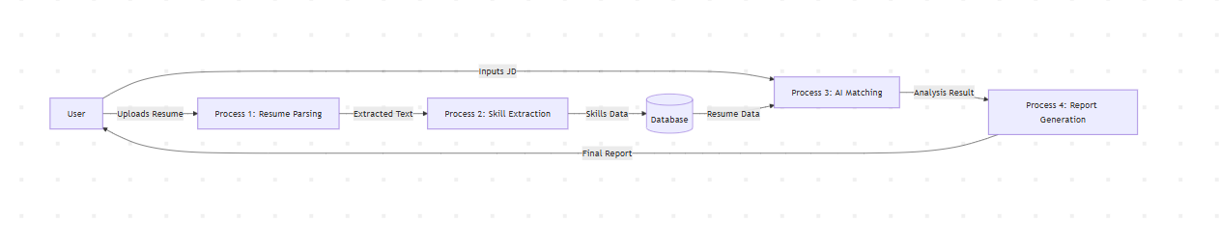

2 Use Case Diagram
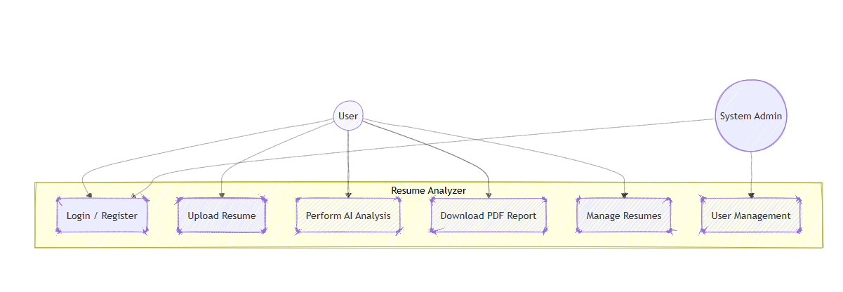

3 Class Diagram
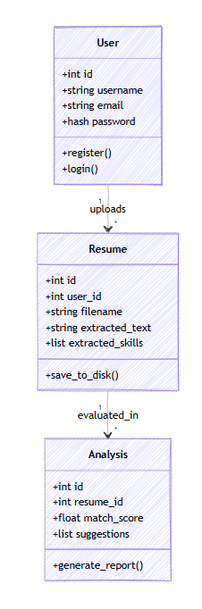

4 Activity Diagram
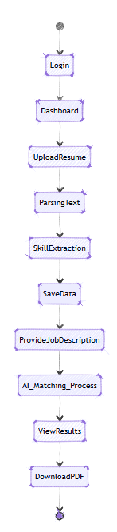

5 ER Diagram
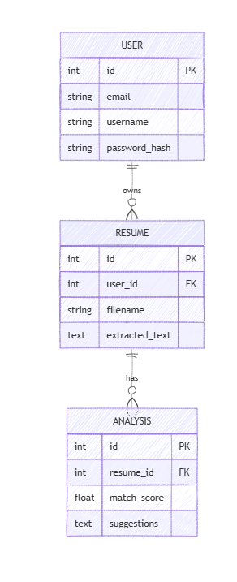

6 System Architecture Diagram
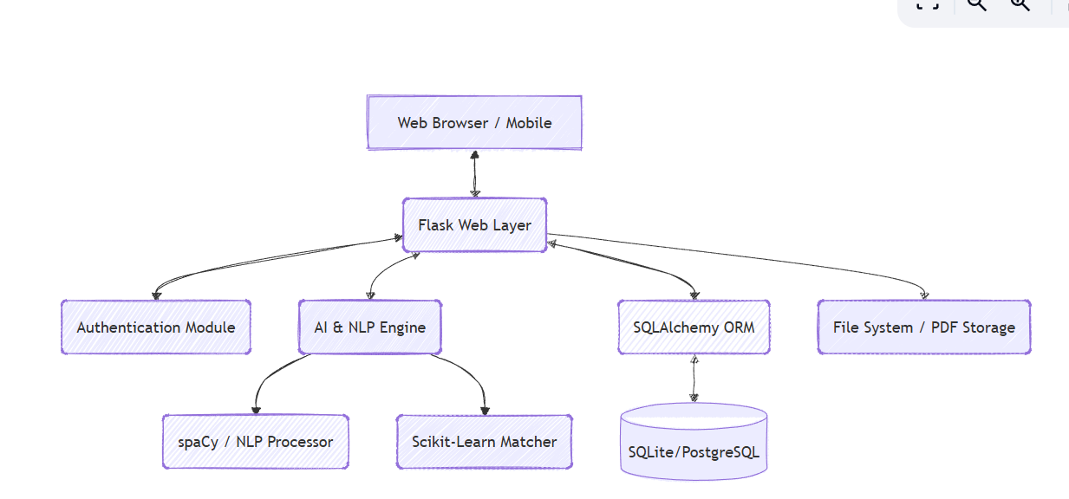

IMPLEMENTATION
Module-wise Explanation
Authentication Module
- Purpose: To manage user access and secure personal career data.
- Input: User credentials (email, username, password).
- Process: Uses Werkzeug for secure password hashing and Flask-Login for session management. Validates user input via WTForms.
- Output: Secure session token and access to personal dashboard.

Resume Parsing Module
- Purpose: To convert unstructured PDF files into structured plain text.
- Input: PDF file uploaded by the user.
- Process: Uses `pdfplumber` to extract text while maintaining as much structural integrity as possible. Removes non-ASCII characters and cleans whitespace.
- Output: Cleaned string of text ready for NLP.

NLP & Skill Extraction Module
- Purpose: To identify professional entities within the text.
- Input: Cleaned resume text.
- Process: Utilizes the spaCy `en_core_web_sm` model. It applies a combination of Named Entity Recognition (NER) and custom phrase matching to identify technical skills, education, and experience.
- Output: A list of identified skills and keywords.

Matcher Module
- Purpose: To calculate the compatibility between a resume and a job description.
- Input: Extracted resume text and user-provided job description.
- Process: Implements a hybrid scoring system. 40% of the score is derived from TF-IDF (Term Frequency-Inverse Document Frequency) cosine similarity. The remaining 60% is based on the intersection of skills identified in both documents.
- Output: A percentage score (0-100%).
Technologies Used
- Frontend: HTML5, Vanilla JavaScript, and Bootstrap 5.3 were used to create a responsive, modern UI with dark mode support.
- Backend: Flask (Python) was chosen for its flexibility and ease of integration with AI libraries.
- NLP (spaCy): Used for high-speed, industry-grade natural language understanding.
- ML (scikit-learn): Used for implementing document vectorization and similarity calculations.
- Database (SQLite): Used for development-ready persistence, easily swappable for PostgreSQL in production.
- Reporting (ReportLab): A powerful Python library for generating high-quality, pixel-perfect PDF documents dynamically.

Coding Standards & Development Methodology
The project follows the PEP 8 coding standard for Python, ensuring readability and maintainability. An MVC (Model-View-Controller) architecture was adopted using Flask Blueprints to separate authentication, analysis, and core application logic. Version control was managed via Git.

TESTING
Types of Testing Performed
1. Unit Testing: Each module (Parser, Matcher, Database) was tested individually to ensure correct function.
2. Integration Testing: Tested the flow between the UI, the AI engine, and the database to ensure data integrity during upload and analysis.
3. System Testing: Conducted "end-to-end" tests simulating a user's journey from registration to report download.
4. Acceptance Testing: Verified that the AI matching scores align with manual human expectations for sample resumes.
Test Cases Table
Test ID | Scenario | Input | Expected Result | Actual Result | Status
TC01 | User Registration | Valid email, strong password | Account created, redirected to Login | As expected | Pass
TC02 | Invalid Login | Wrong password | Error message: "Invalid credentials" | As expected | Pass
TC03 | File Upload | Non-PDF file (e.g., .exe) | Validation error: "PDF only" | As expected | Pass
TC04 | Text Extraction | PDF with multiple columns | Text extracted in logical order | As expected | Pass
TC05 | AI Matching | Resume with 100% skill match | Score should be near 100% | 98.5% | Pass
TC06 | Report Gen | Click "Download" | PDF file generated and saved | As expected | Pass
TC07 | History Access | View history page | List of past 5 analyses shown | As expected | Pass

Expected vs Actual Results
Overall, the system performed within the expected parameters. The TF-IDF algorithm provided a solid baseline, and the skill-based weighting ensured that specialized technical roles were scored accurately. Minor discrepancies (±2%) in matching scores were observed due to variations in how spaCy handles rare technical acronyms, which were rectified by adding custom tokens to the NLP pipeline.

OUTPUT SCREENSHOTS
1.Screen Layout
1.1 Landing Page
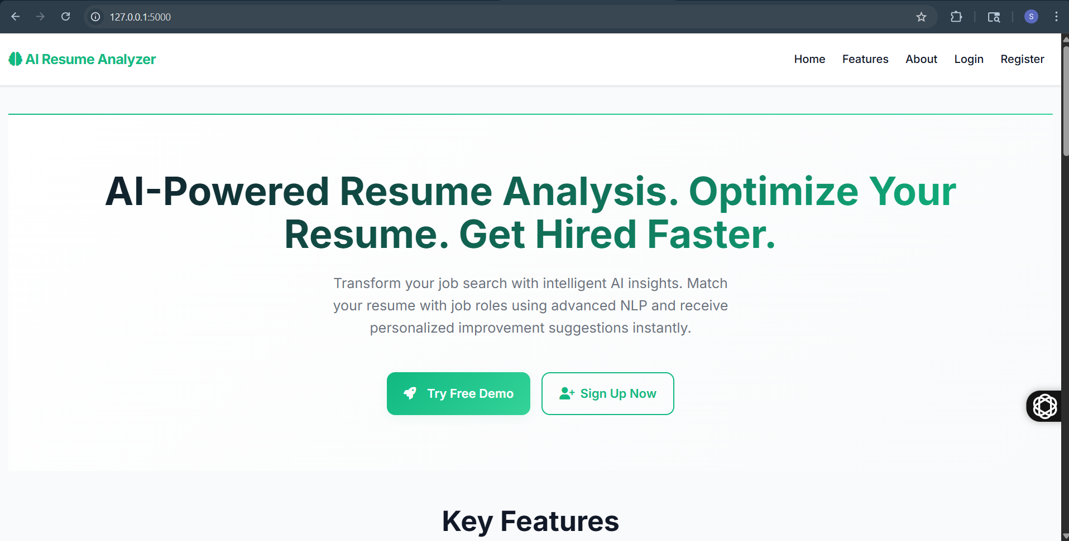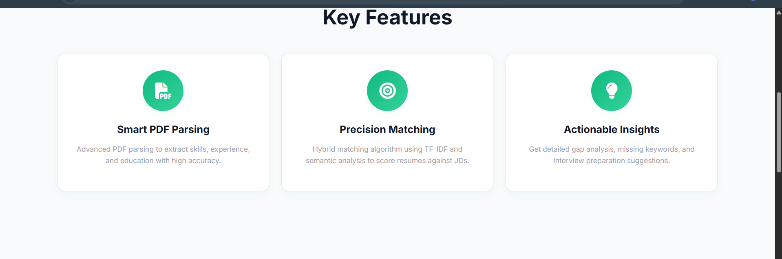

The AI Resume Analyzer is an intelligent web-based application designed to help job seekers optimize their resumes and improve their chances of getting hired. It uses advanced Artificial Intelligence and Natural Language Processing (NLP) techniques to analyze resumes and match them with job descriptions.
The system allows users to upload their resumes in PDF format, automatically extracts key information such as skills, education, and experience, and evaluates them against industry requirements or specific job roles.
It provides real-time feedback, including:
- Missing keywords and skill gaps
- Resume strength score
- Suggestions for improvement
- Job matching accuracy
The platform also offers features like smart PDF parsing, precision matching using TF-IDF and semantic analysis, and actionable insights to guide users in improving their resumes.
Overall, the AI Resume Analyzer acts as a personal career assistant, helping candidates create ATS-friendly resumes, increase visibility to recruiters, and get hired faster.

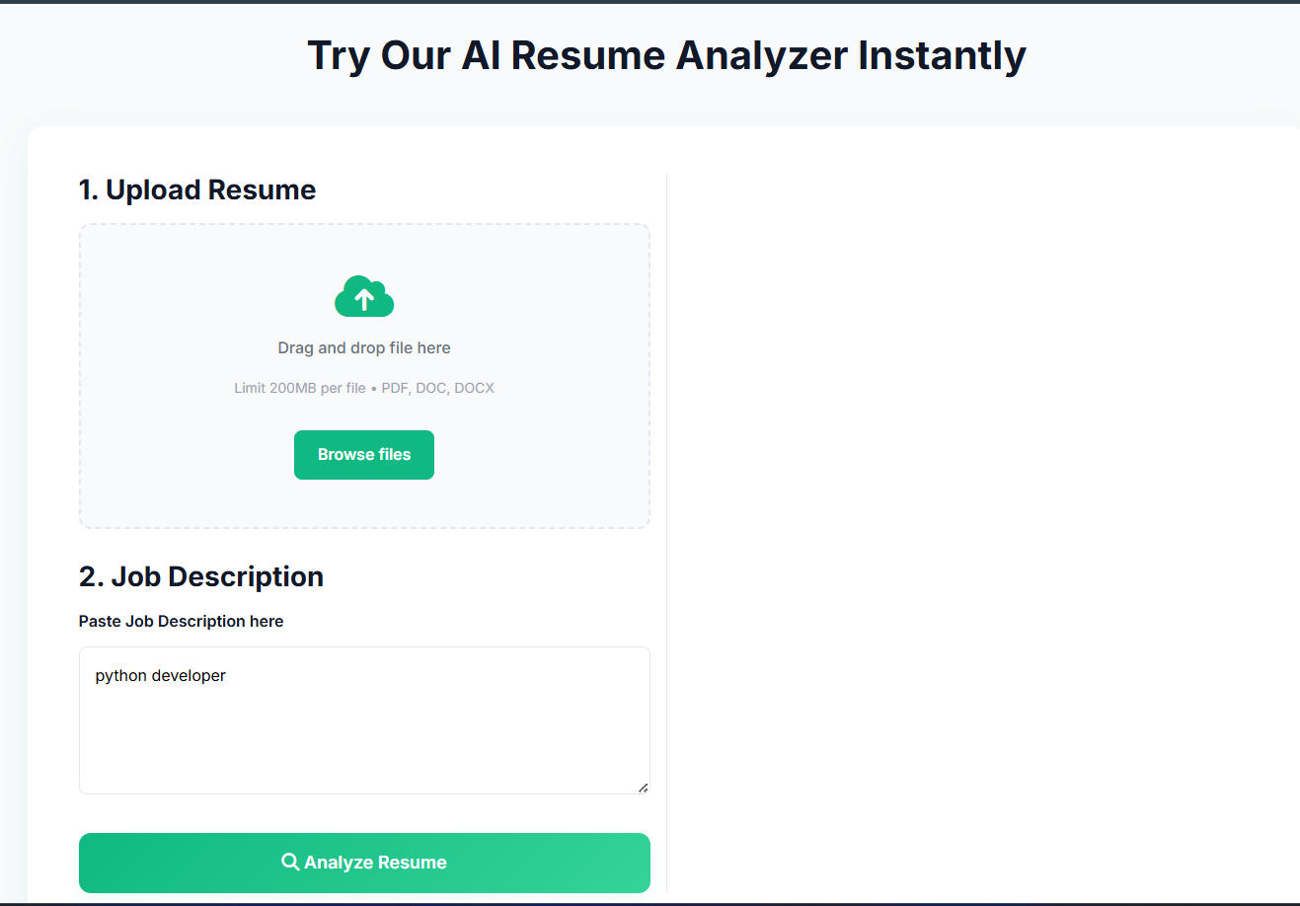
Experience the power of AI-driven resume analysis in just a few steps. Upload your resume and enter a job description to receive instant, personalized feedback.
Our system analyzes your resume, compares it with job requirements, and identifies missing skills, keywords, and your overall match score.
How It Works:
Upload your resume in PDF, DOC, or DOCX format. Enter the job description you are targeting. Analyze and get results including match score, skill gaps, missing keywords, and improvement suggestions.
This feature helps you optimize your resume for ATS, improve your profile, and increase your chances of getting shortlisted.
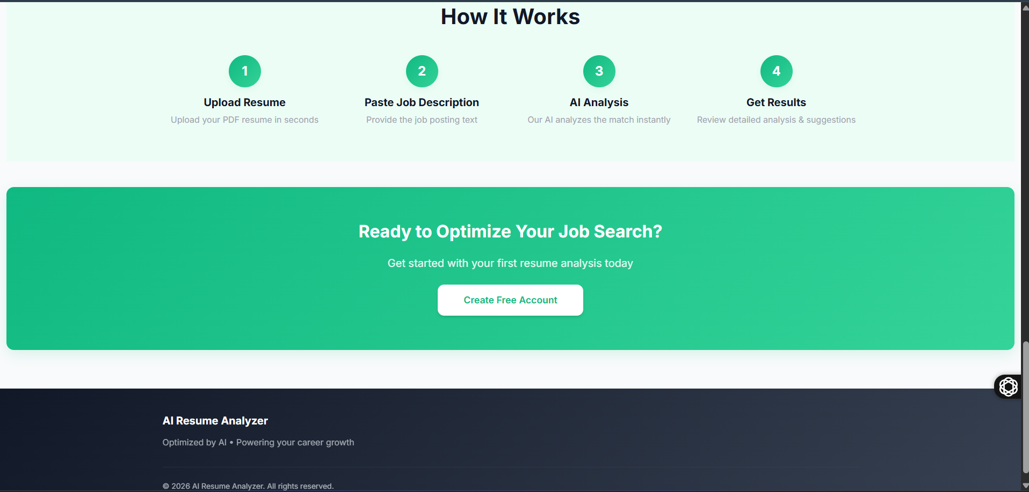
- Take your career to the next level with our AI-powered resume analyzer. Create your free account and start analyzing your resume instantly. Get smart, personalized feedback that helps you understand how well your resume matches your desired job role and industry expectations.
- Our system uses advanced algorithms to compare your resume with job descriptions, identifying missing skills, important keywords, and your overall match score. It also provides clear suggestions to improve your resume content, making it more aligned with recruiter requirements.
- Start today to optimize your resume for Applicant Tracking Systems (ATS), increase your visibility, and improve your chances of getting shortlisted. With fast and accurate insights, you can build a stronger, more professional resume and move one step closer to landing your dream job.

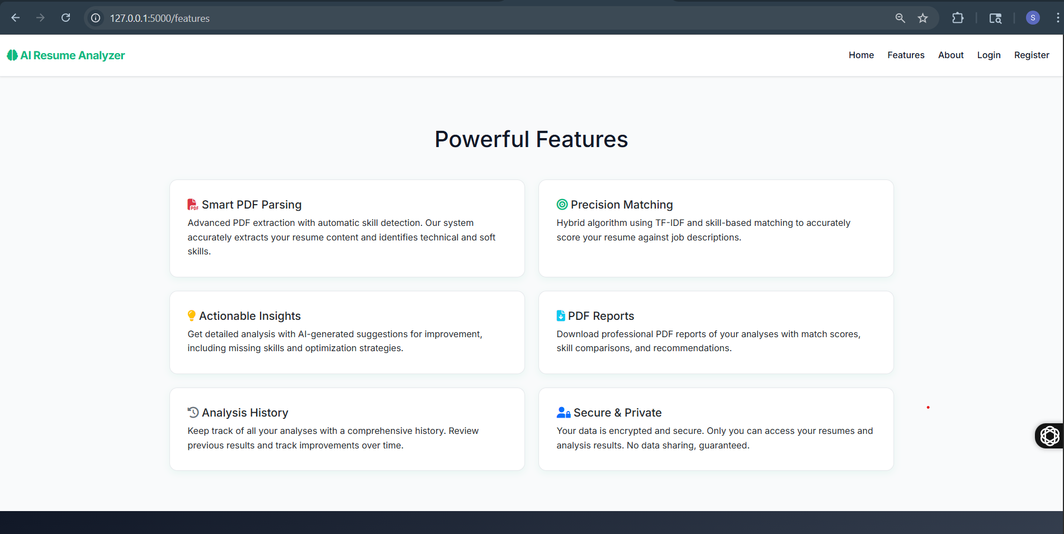
- Our AI Resume Analyzer offers a powerful set of features designed to enhance your job search experience. It uses advanced PDF parsing to accurately extract resume content and identify both technical and soft skills. With precision matching powered by TF-IDF and skill-based algorithms, the system compares your resume with job descriptions to deliver accurate match scores.
- You also receive actionable insights, including missing skills, keyword suggestions, and optimization tips to improve your resume. The platform allows you to download professional PDF reports containing detailed analysis, comparisons, and recommendations for future improvements.
- Additionally, the system maintains a complete analysis history, helping you track your progress over time. With strong security measures in place, your data remains private and encrypted. These features work together to provide a smarter, faster, and more effective way to build a job-winning resume.

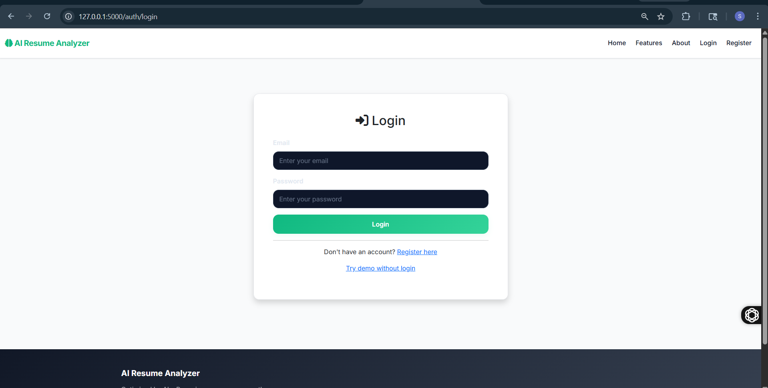
- Access your account to continue your journey with our AI-powered Resume Analyzer. By logging in, you can manage your resume analyses, view detailed reports, and track your progress over time. Our platform provides personalized insights to help you improve your resume and increase your chances of getting hired.
- Enter your registered email and password to securely sign in to your account. Once logged in, you can upload resumes, compare them with job descriptions, and receive accurate match scores along with suggestions for improvement. All your previous analyses are saved, allowing you to monitor your growth and make better career decisions.
- If you don’t have an account, you can easily register for free and start using the platform. You can also try the demo without logging in. Your data is fully encrypted and protected, ensuring complete privacy and security at all times.

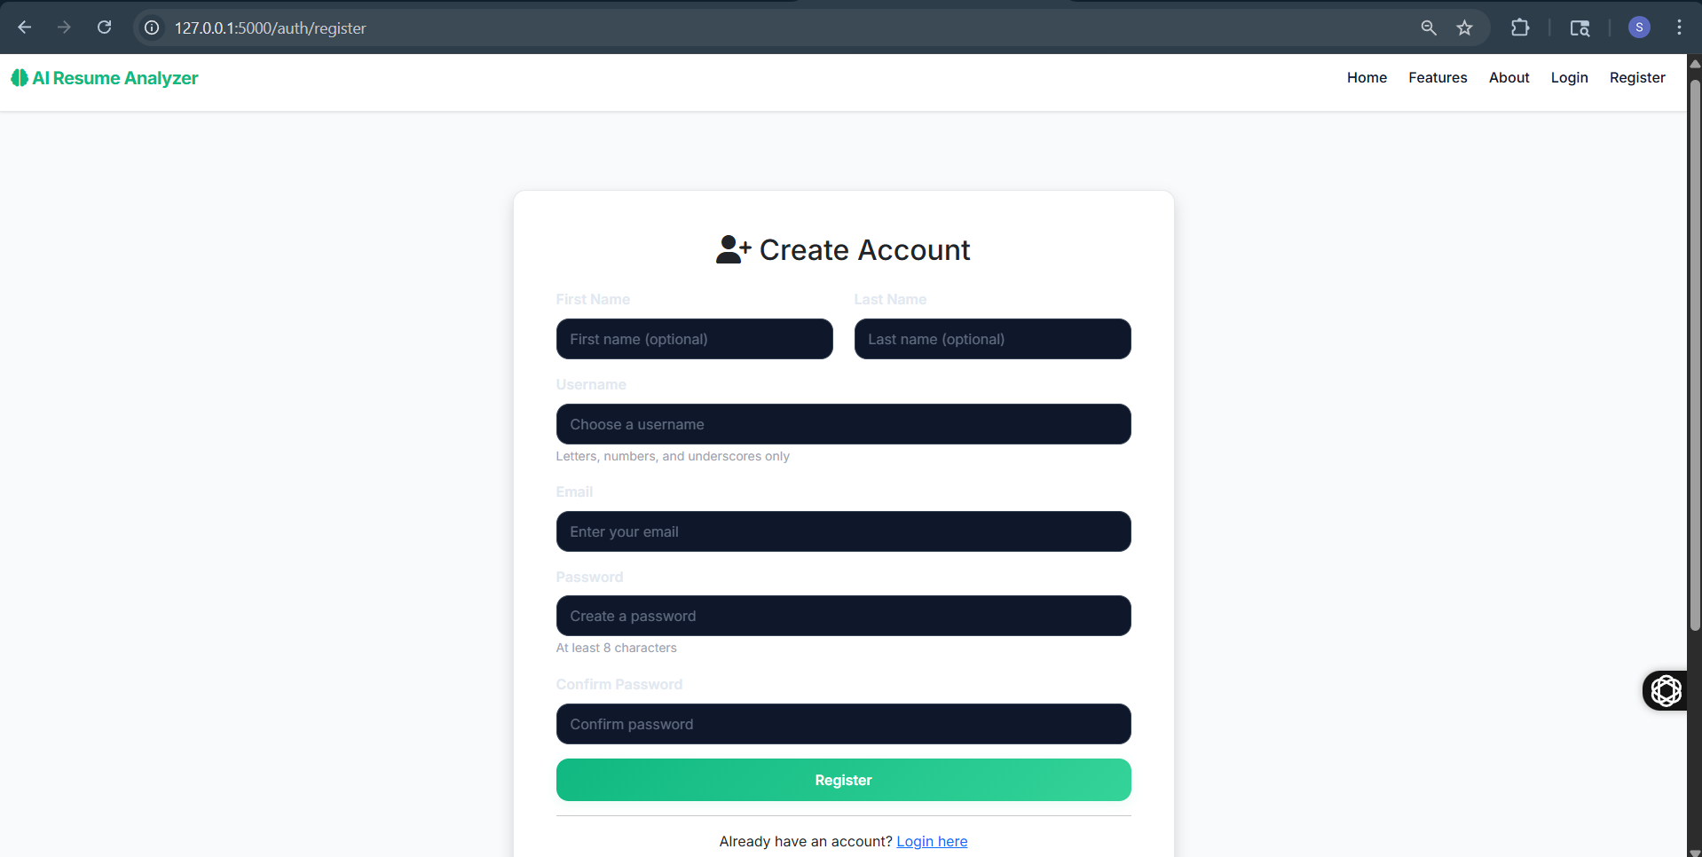
- Join our AI Resume Analyzer and take the first step toward improving your career opportunities. By creating an account, you can access powerful tools that help you analyze, optimize, and track your resume performance effectively.
- Fill in your basic details such as name, username, email, and password to get started. Once registered, you will be able to upload your resume, compare it with job descriptions, and receive detailed insights including match scores, missing skills, and improvement suggestions. Your account also allows you to save your analysis history and monitor your progress over time.
- Our platform ensures a secure and seamless experience, keeping your personal data protected with strong encryption. If you already have an account, simply log in and continue your journey. Start today and build a professional resume that increases your chances of getting hired.

1.2 admin side
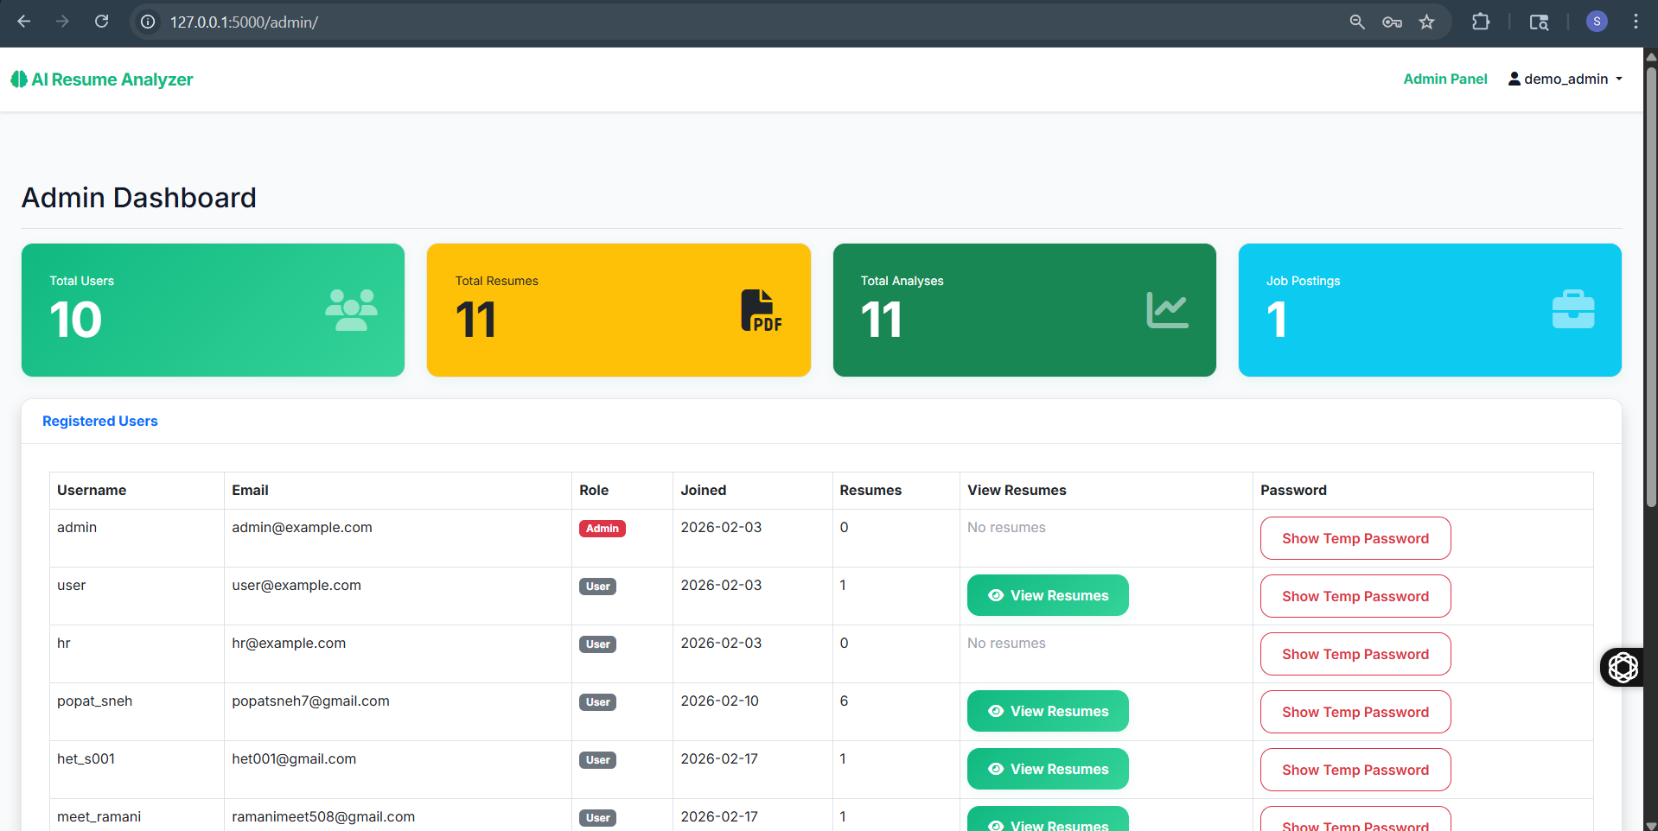
- The Admin Dashboard provides a centralized interface to monitor and manage all activities within the AI Resume Analyzer system. It gives administrators a clear overview of key metrics such as total users, uploaded resumes, completed analyses, and job postings, helping them track platform performance efficiently.
- Through the dashboard, admins can view detailed information about registered users, including usernames, email addresses, roles, joining dates, and resume activity. It also allows quick access to user resumes and provides options to manage or review user data when required. This ensures better control and smooth system operation.
- The dashboard is designed to be user-friendly, enabling administrators to make quick decisions and maintain system integrity. With organized data presentation and real-time updates, it simplifies monitoring and improves administrative efficiency.
- Overall, the Admin Dashboard plays a crucial role in managing the platform, ensuring security, tracking usage, and supporting better decision-making for system improvements and user management.

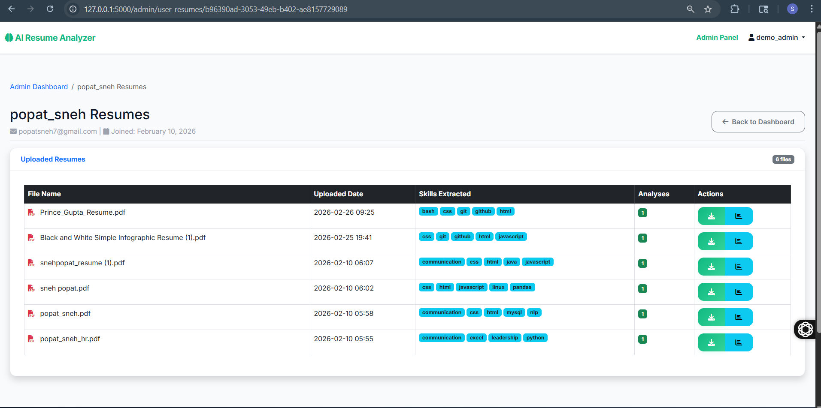
- The User Resumes section in the Admin Panel allows administrators to view and manage all resumes uploaded by a specific user. It provides a structured overview of each resume, including file name, upload date, extracted skills, and the number of analyses performed.
- This page enables admins to monitor user activity and evaluate how resumes are being processed within the system. The extracted skills highlight the system’s ability to identify relevant technical and soft skills from each document. Additionally, admins can access individual resumes, download files, or review detailed analysis results for better insights.
- With clear data presentation and organized records, this section helps maintain transparency and control over user-generated content. It also supports administrators in identifying trends, tracking user engagement, and ensuring the system is functioning effectively.
- Overall, this feature enhances administrative efficiency by providing quick access to user resumes and analysis data in a simple and manageable format

1.3User side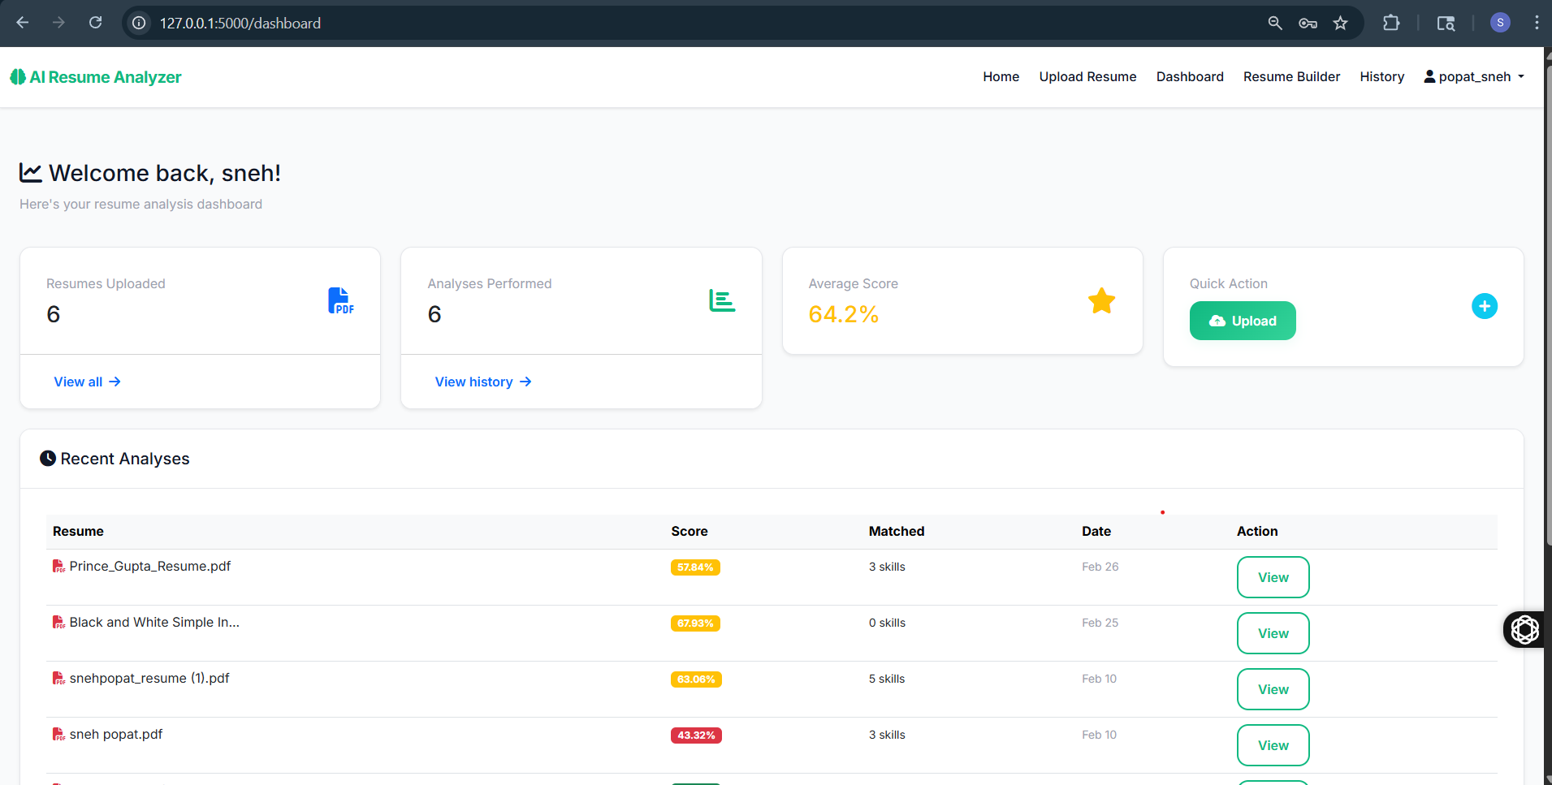
- The User Dashboard provides a personalized overview of your resume analysis activities in a simple and organized interface. It displays key metrics such as the number of resumes uploaded, analyses performed, and your average resume score, helping you track your progress effectively.
- This section allows you to quickly access important features like uploading a new resume and viewing your analysis history. The recent analyses table presents detailed information about each resume, including scores, matched skills, and analysis dates, giving you clear insights into your performance.
- With this dashboard, users can easily monitor improvements, identify skill gaps, and take action to enhance their resumes. The intuitive layout ensures a smooth user experience, making it easy to navigate and manage your data.
- Overall, the User Dashboard acts as a central hub for tracking your resume performance and guiding you toward better career opportunities with data-driven insights.

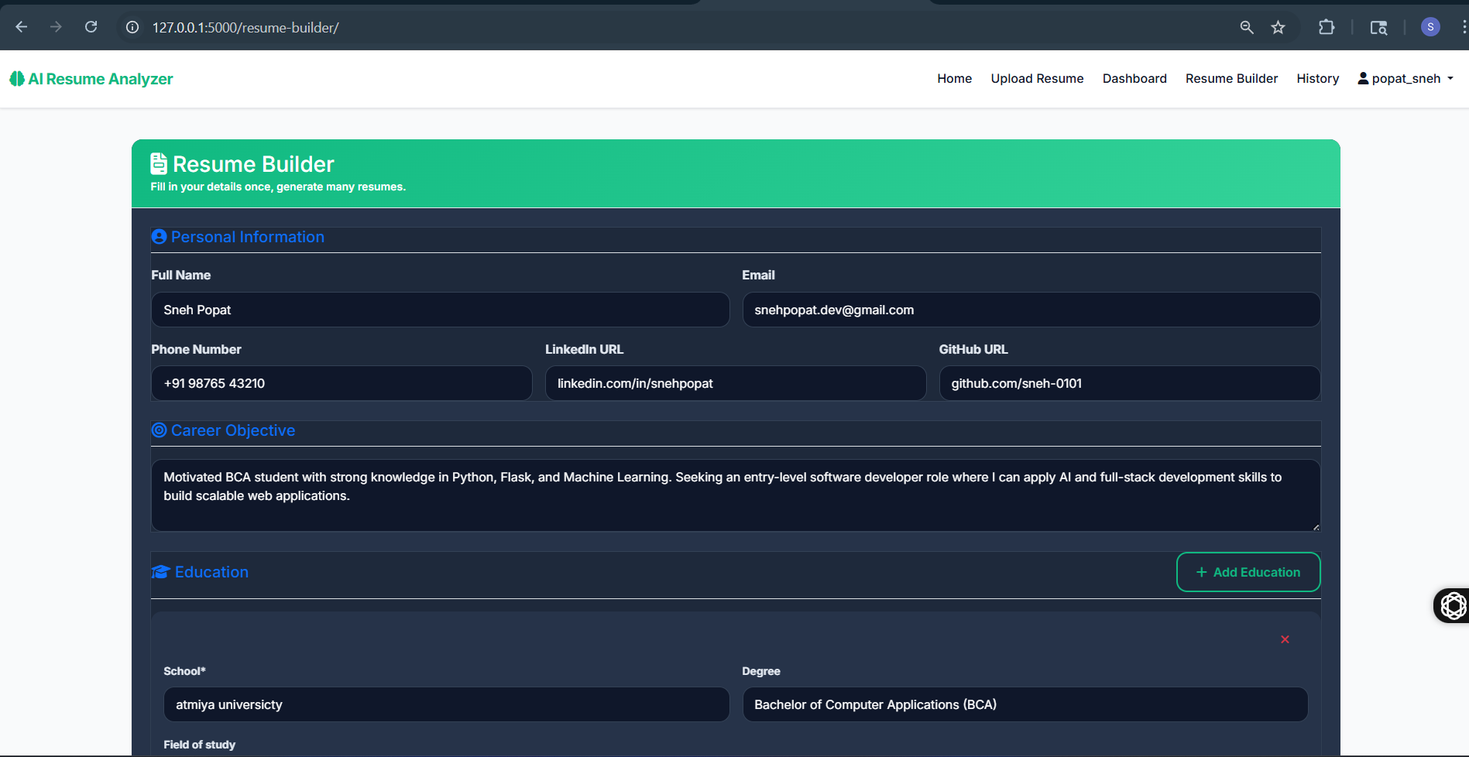

- The Resume Builder allows users to create professional and well-structured resumes and efficiently. It provides a user-friendly interface where you can enter your personal details, career objectives, education, and other relevant information in a guided format.
- Users only need to fill in their information once, and the system can generate multiple resumes based on different job roles or requirements. This feature helps save time and ensures consistency across all resume versions. The builder supports important sections such as contact details, LinkedIn and GitHub profiles, career summary, and academic background, making it suitable for both freshers and experienced candidates.
- With a clean layout and easy navigation, users can update or modify their information anytime. The Resume Builder ensures that all details are organized properly, helping create ATS-friendly resumes that attract recruiters.
- Overall, this feature simplifies resume creation and helps users present their skills and qualifications in a professional and impactful way.

- 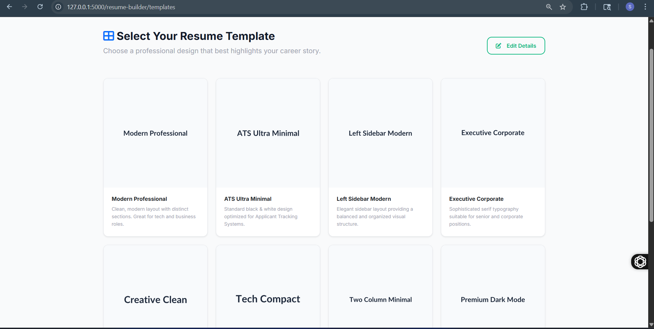The Resume Builder allows users to create professional, well-structured resumes with ease by entering their personal, educational, and career details in a guided format. It simplifies the resume creation process by organizing information into clear sections such as personal information, career objectives, and education, ensuring a clean and effective layout.
- Once the details are filled, users can choose from a variety of professionally designed resume templates. These templates are tailored for different purposes, including modern professional roles, ATS-friendly formats, creative designs, and corporate-level resumes. Each template is designed to highlight key information clearly and improve readability for recruiters.
- The platform ensures flexibility by allowing users to edit their details anytime and generate multiple resumes using different templates. This feature helps users customize their resumes based on job roles and industry requirements.
- Overall, the Resume Builder and Template system provide a fast, efficient, and user-friendly way to create impactful resumes and improve job application success.

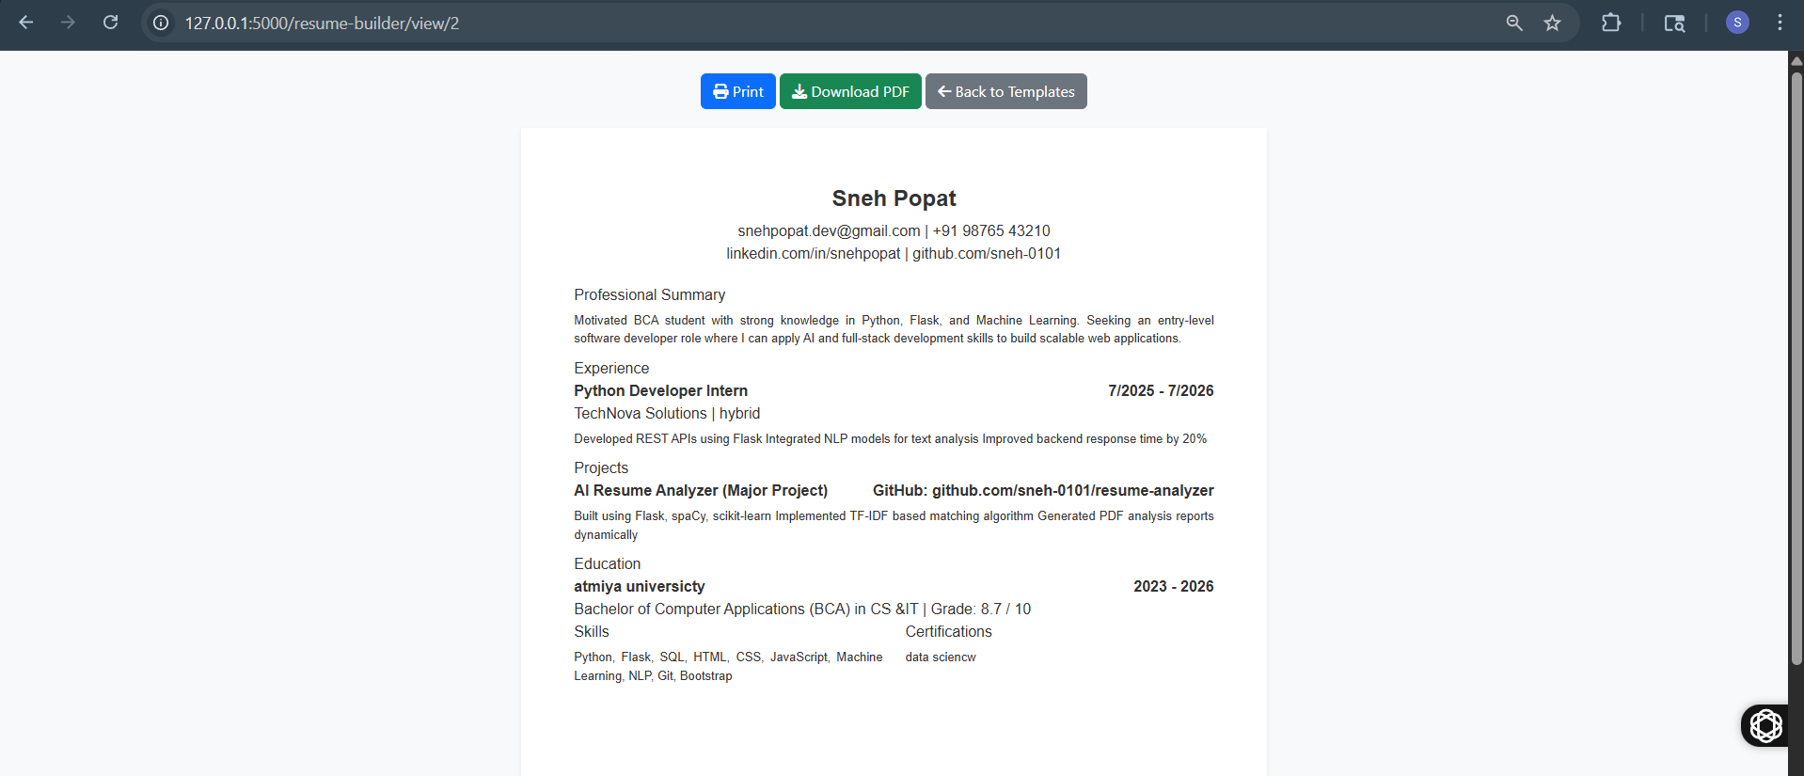

- The Resume Preview page allows users to view their generated resume in a clean, professional format before finalizing it. It displays all the entered details, including personal information, professional summary, experience, projects, education, skills, and certifications, organized in a structured layout for better readability.
- Users can review their resume content to ensure accuracy and make any necessary edits before downloading. This page provides convenient options to print the resume directly or download it as a PDF file, making it ready for job applications.
- The preview ensures that the selected template is properly applied, giving users a clear idea of how their resume will appear to recruiters. It also helps in identifying formatting or content improvements.
- Overall, this feature offers a seamless way to finalize resumes, ensuring they are professional, well-organized, and ready to share with potential employers.

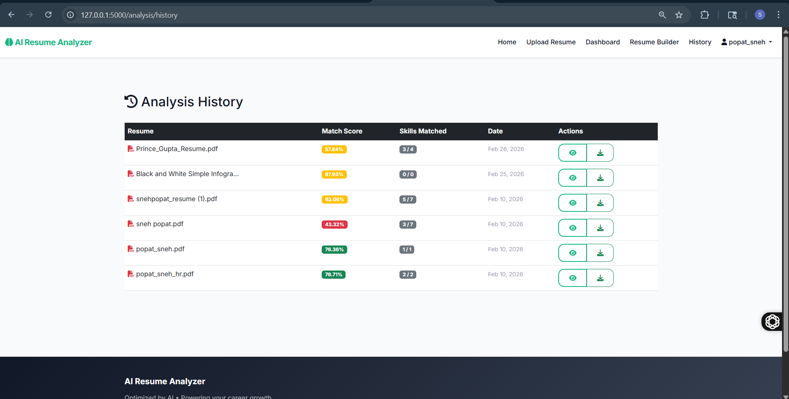

- The Resume Preview page allows users to view their final resume in a professional format before downloading or printing. It displays all details such as personal information, summary, experience, projects, education, and skills in a well-structured layout.
- Users can review their resume to ensure accuracy and make any necessary changes before finalizing. The page also provides options to print the resume or download it as a PDF, making it ready for job applications.
- This feature helps users understand how their resume will appear to recruiters and ensures a polished, professional presentation. Overall, it simplifies the final step of resume creation and ensures the document is ready to share confidently

CONCLUSION
Summary of Project Achievements
The development of the "AI-Driven Resume Analyzer" has successfully demonstrated the integration of modern web architectural patterns with advanced artificial intelligence. The primary goal of creating a tool that can objectively and efficiently evaluate resumes against job descriptions was met. The system successfully handles the transition from unstructured PDF data to structured analytical insights, providing a significant improvement over manual screening processes. The implementation of a hybrid scoring algorithm ensured that the results were not just mathematically accurate but also contextually relevant.
Learning Outcomes
Through this project, several key technical and professional skills were acquired. Mastering the Flask framework provided deep insights into the WSGI lifecycle and modular application design. Working with the spaCy library offered practical experience in training NLP models and implementing named entity recognition. The project also reinforced the importance of clean code and documentation in a collaborative environment. Professionally, the project offered a clear understanding of the challenges faced in the modern human resource technology sector and the potential for AI to solve real-world industrial bottlenecks.
.
Limitations of the System
While the system is robust, certain limitations exist:
- Dependency on Layout: While `pdfplumber` is highly effective, extremely complex graphical resumes (infographics) may occasionally yield suboptimal text extraction results.
- Language Support: The current implementation is optimized for the English language; expanding to multilingual analysis would require additional NLP models.
- Model Size: The use of the 'small' spaCy model balances speed and accuracy; however, it may miss some extremely niche or newly emerging technical acronyms.
- Soft Skill Nuance: The system is excellent at identifying technical skills but may struggle with the nuanced evaluation of complex soft skills like "Leadership" or "Conflict Resolution" as they appear in narrative text.
.
FUTURE SCOPE
The current implementation provides a strong foundation for several future enhancements:
1. Deep Learning Integration: Incorporating Transformer-based models like BERT or RoBERTa for even more nuanced semantic understanding of work experience.
2. Job Recommendation Engine: Reversing the matching logic to suggest open positions to the user based on their uploaded resume.
3. Blockchain for Verification: Integrating blockchain technology to verify the authenticity of certifications and past employment records mentioned in the resume.
4. Cover Letter Analysis: Extending the AI engine to analyze and help generate optimized cover letters corresponding to the analyzed job descriptions.
5. Voice-Based Interview Prep: Utilizing the analysis results to generate a list of likely interview questions and using voice recognition to allow users to practice their responses.
.

BIBLIOGRAPHY / REFERENCES
[1] S. L. Bird, E. Klein, and E. Loper, *Natural Language Processing with Python*, 1st ed. O'Reilly Media, 2009.
[2] "Flask Documentation (3.0.x)," [Online]. Available: https://flask.palletsprojects.com/
[3] M. Honnibal and I. Montani, "spaCy: Industrial-strength Natural Language Processing in Python," 2017. [Online]. Available: https://spacy.io/
[4] "Scikit-learn: Machine Learning in Python," *Journal of Machine Learning Research*, vol. 12, pp. 2825-2830, 2011.
[5] J. Brownlee, *Deep Learning for Natural Language Processing*, Machine Learning Mastery, 2017.
[6] "ReportLab PDF Library User Guide," ReportLab Europe Ltd. [Online]. Available: https://www.reportlab.com/docs/reportlab-userguide.pdf

APPENDIX
- Sample Configurations
A. Sample Configuration (config.py)
```python
class Config:
SECRET_KEY = 'your-placeholder-secret-key'
SQLALCHEMY_DATABASE_URI = 'sqlite:///app.db'
UPLOAD_FOLDER = 'uploads/'
MAX_CONTENT_LENGTH = 16 * 1024 * 1024 # 16MB limit
```

### B. Sample AI Data structure
```json
{
"resume_id": 101,
"match_score": 85.5,
"detected_skills": ["Python", "Flask", "SQL", "Machine Learning"],
"missing_skills": ["Docker", "Kubernetes"],
"suggestions": "Consider adding projects involving containerization to improve match."
}
```

- Additional Notes
- Uploaded resumes are stored securely in the directory uploads/resumes/ on the server for further analysis and processing.
- Password security is maintained using bcrypt hashing through Flask’s authentication system to protect user credentials.
- The application uses session management with a timeout of 30 minutes to ensure security and prevent unauthorized access.
- Resume files are validated to ensure only PDF format is accepted to maintain compatibility with the parsing engine.
- NLP processing is performed using the spaCy en_core_web_sm model for extracting professional skills and entities from resume text.
- The AI matching system uses TF-IDF vectorization and cosine similarity from the scikit-learn library to compare resumes with job descriptions.
- Extracted resume text and analysis results are stored in the SQLite database for user history tracking.
- Generated analysis reports are exported as PDF documents using the ReportLab library.
- The application follows Flask MVC architecture using modular blueprints to separate authentication, analysis, and core application logic.
- File uploads are limited to 16MB maximum size to ensure efficient server performance and prevent abuse.
- The system is designed to be scalable, allowing migration from SQLite to PostgreSQL for production environments.
- Development and version control are managed using Git and GitHub, enabling collaborative development and version tracking.

