Mini-MySQL

Banner ID: B00968316

[GitLab Assignment Link: https://git.cs.dal.ca/snehp/csci5408_f23_b00968316_snehjayeshbhai_patel](https://git.cs.dal.ca/snehp/csci5408_f23_b00968316_snehjayeshbhai_patel/-/blob/main/Lab3/lab3.sql)

Table of Contents

Learning Objective-1 3

Summary 3

**Task A** 7

**Authentication** 8

**Task 2** 9

**Create Database** 9

**Use Database** 10

**Create Table** 10

**Insert** 11

**Select** 12

Delete 13

**Update** 13

Logs 14

**Task 3** 15

**Transaction** 15

Test cases 17

List of Figures

Figure 1 Authentication 9

Figure 2UserData.txt 9

Figure 3 UserData.txt Location 9

Figure 4 SignUp 10

Figure 5 Authentication 10

Figure 6 Authentication Failed 10

Figure 7 Captcha Faile 10

Figure 8 Create Database 11

Figure 9 Database Location 11

Figure 10 create database Error 11

Figure 11 Use database 12

Figure 12 Create table 12

Figure 13 create table error 1 12

Figure 14 create table error 2 12

Figure 15 create Table Location 13

Figure 16 Insert query 13

Figure 17 Insert Query Error 13

Figure 18 Select 1 14

Figure 19 Select 2 14

Figure 20 Select 3 14

Figure 21 Select 4 14

Figure 22 Select 5 14

Figure 23 Delete 1 15

Figure 24 Update Query 15

Figure 25 Transaction 1 17

Figure 26 Transaction 2 17

Figure 27 Exit 18

# **Task A**

* This is the first output we get after we run the program.

Figure Authentication

* When we enter 2 it will ask for the username and password
* And, it will ask for the Captcha.
* If the Captcha is correct the username and the password will save in the userData.txt file in which the pass is hashed using MD5 algorithm

Figure UserData.txt

Figure UserData.txt Location

## **Authentication**

* First, we have to sign up so that the user data can be stored in the userData.txt file.
* A black rectangular object with white text

  Description automatically generatedAfter signing up successfully we have to Login.

Figure SignUp

* While logging in if the username and password is not in the userData.txt it will not login.
* Authentication will also failed if the Captcha is Wrong.

Figure Authentication

Figure Authentication Failed

Figure Captcha Faile

# **Task 2**

## **Create Database**

* In order to create a table we can use “create database” Query to create a Data base
* This Query will create a folder in ./DBMS folder.

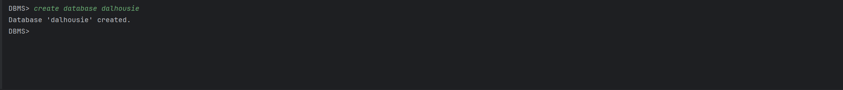

Figure Create Database

Figure Database Location

* If the database is already created in past it will give error



Figure create database Error

## **Use Database**

* We can use the database by writing “use” Query.



Figure Use database

## **Create Table**

* In Order to Create a table we can use “**create table tableName (Column1, Column2,…)”** Query
* It will create a .txt file in a database folder.
* It will give error if there is any syntax error.
* If the Table is already there it gives “Already Exist Error”.



Figure Create table



Figure create table error 1

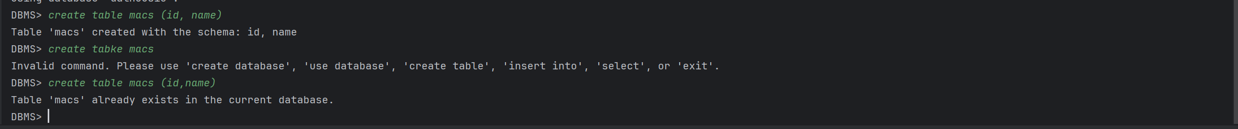

Figure create table error 2

Figure create Table Location

## **Insert**

* In order to insert the values in the table then we can use “insert into tableName Values(value1,value2,value3,…)
* It will give Error if there is any Synatax or the number of schema is not equal to values.



Figure Insert query



Figure Insert Query Error

## **Select**

* We can Display the the data stored in the table using Select Query As shown in figure
* We can use all the possible uses of Select Query like displaying a paticular column
* Where clause can also be used in select query.



Figure Select 1



Figure Select 2



Figure Select 3

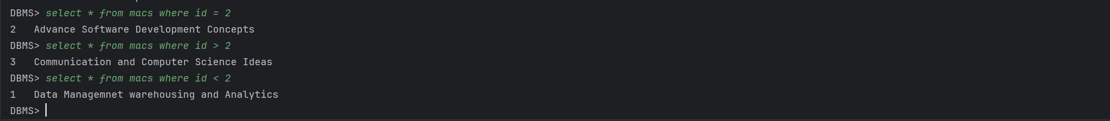

Figure Select 4



Figure Select 5

## Delete

* We can delete a particular row in a table using Delete Query.

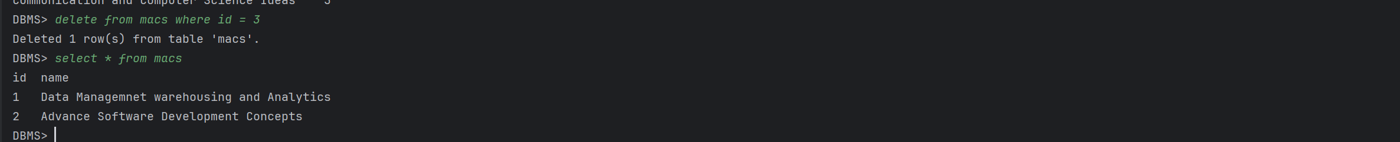

Figure Delete 1

## **Update**

* We can Update a particular row using a Update query.

Figure Update Query

## Logs

All the logs are maintained in a log.txt File with the Query And time Stamp

# **Task 3**

## **Transaction**

* Transaction can start using start transaction.
* It will create a Buffer folder in which all the changes are made until the commit happens.
* If the rollback happens then the buffer data will get deleted

Figure Transaction 1

Figure Transaction 2

**Exit**

* When we write exit it will close the console

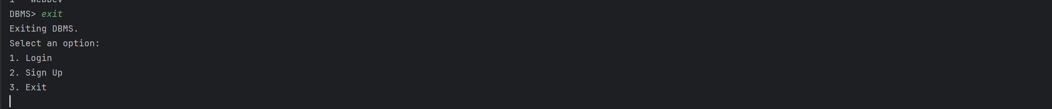

Figure Exit

# Test cases

* These are the Test cases for every Query which are failing.





























# References

[1]“World Economic Forum,” *World Economic Forum*. [Online]<https://www.weforum.org/publications/federated-data-systems-balancing-innovation-and-trust-in-the-use-of-sensitive-data> (accessed Oct. 29, 2023).

[2]

“Transaction recovery in federated distributed database systems,” ieeexplore.ieee.org. <https://ieeexplore.ieee.org/document/7068178> (accessed Oct. 28, 2023).

‌

‌