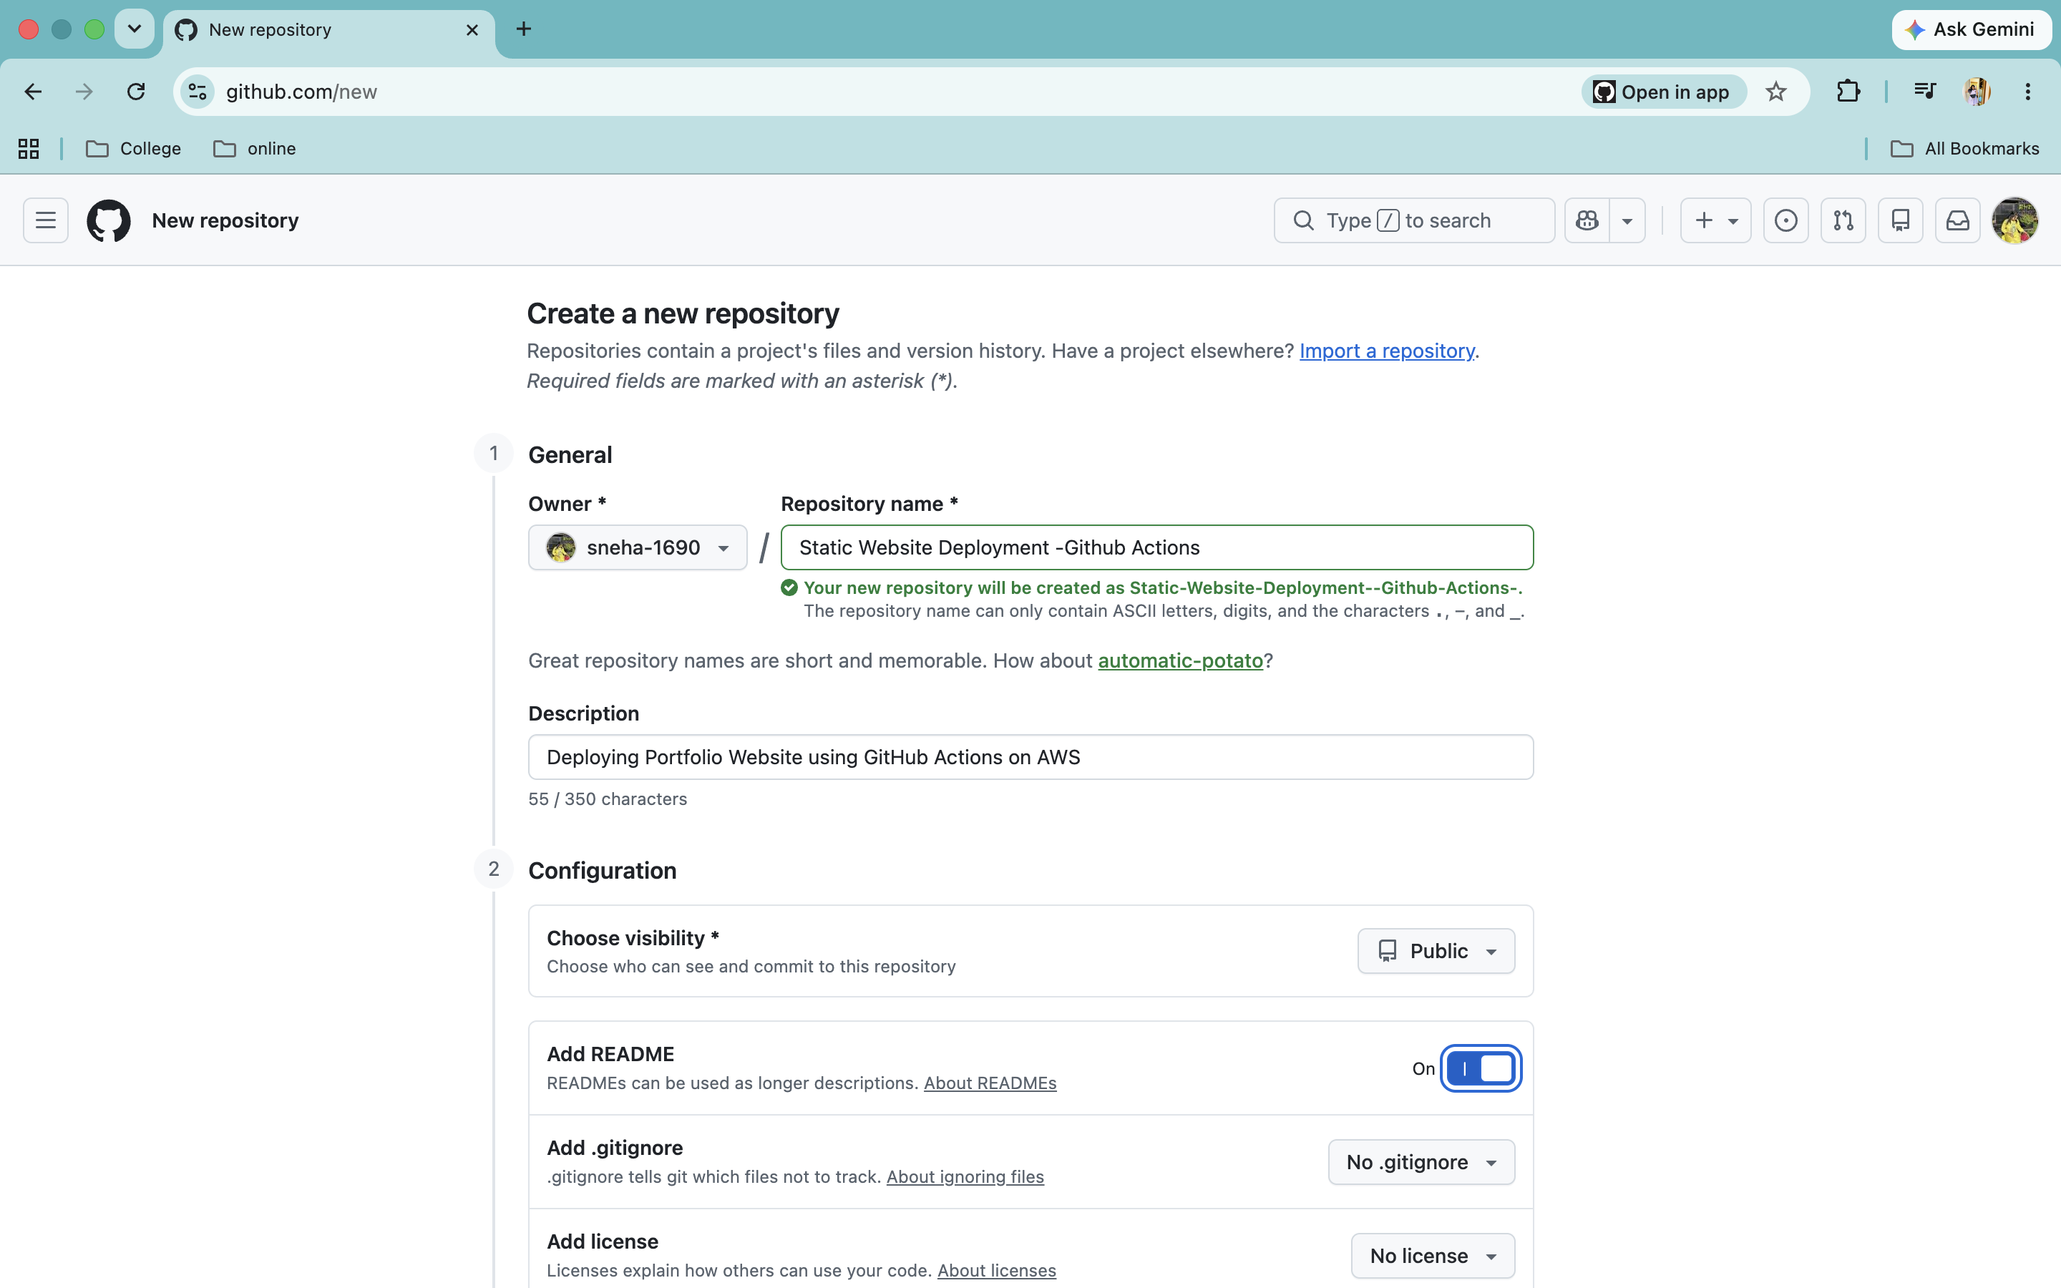
- Create a GitHub repository

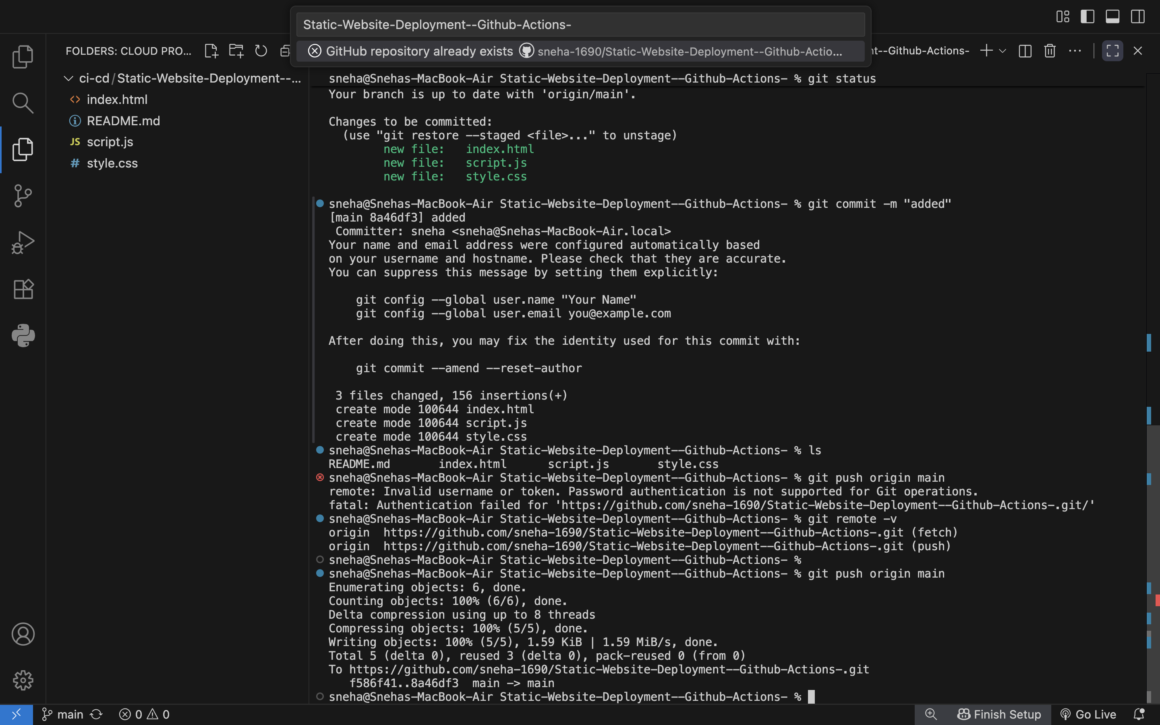
- Clone Repository to pull and push the code/files
- Push Static website(code) to GitHub

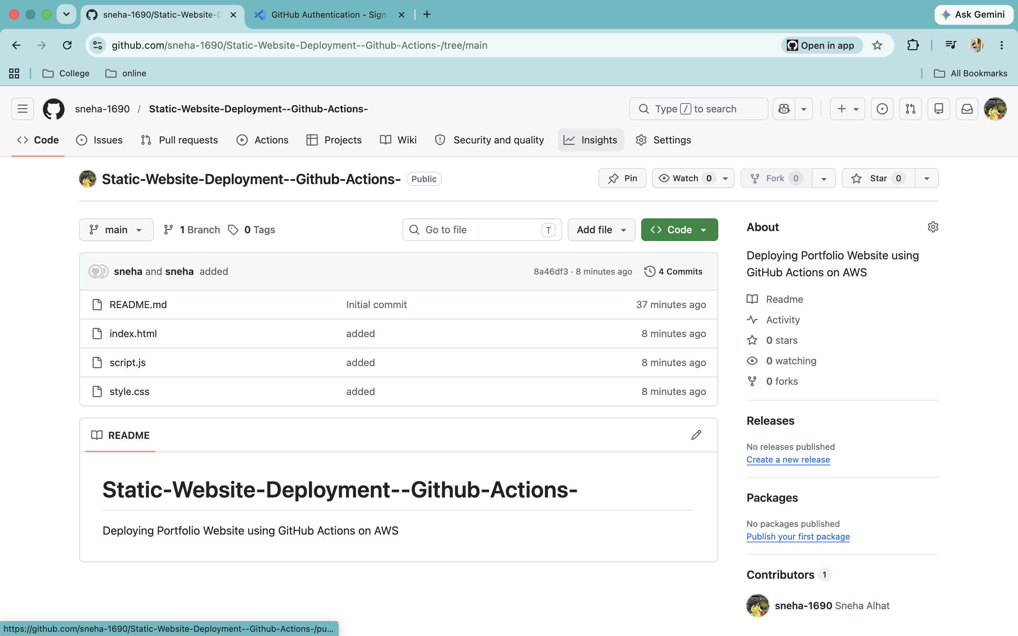
4. Website files are added to repository

5.Create a s3 bucket to store a file
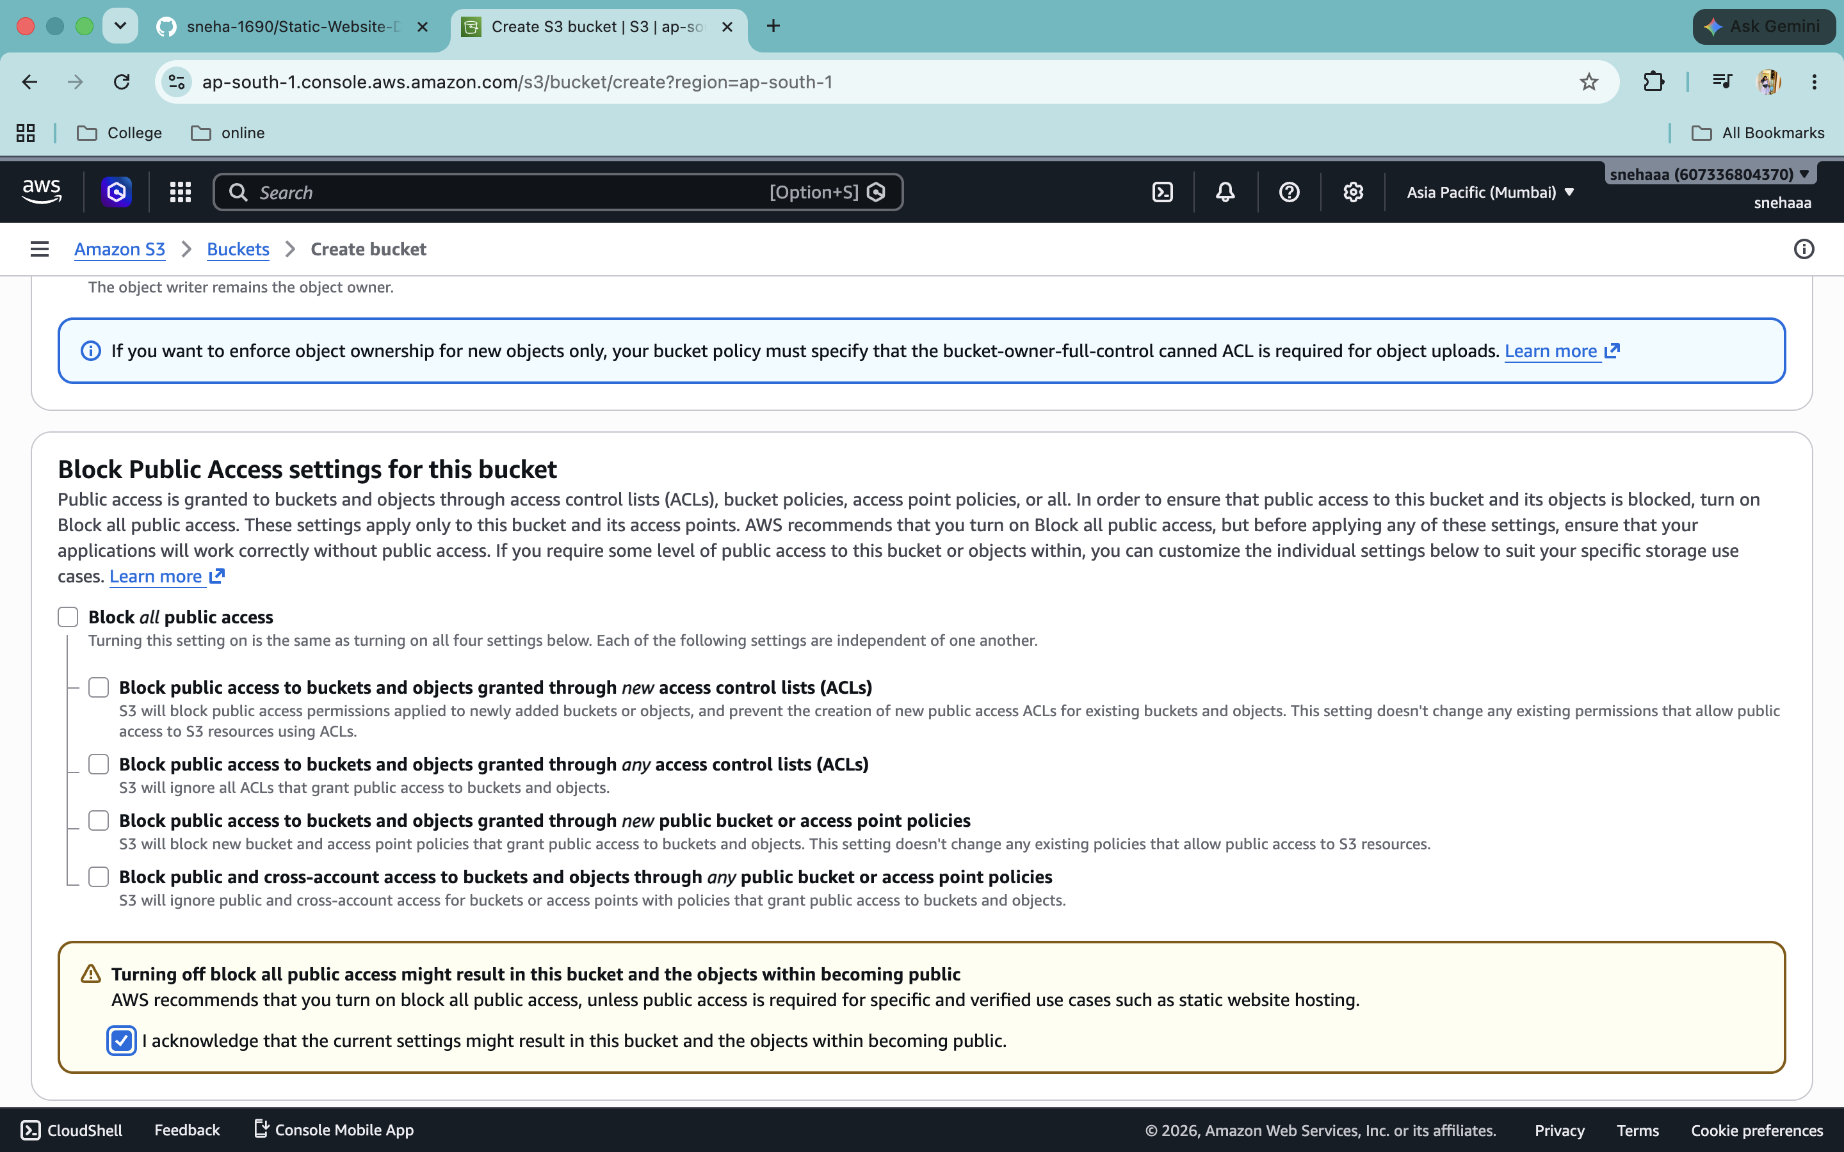
6. Give public access to bucket
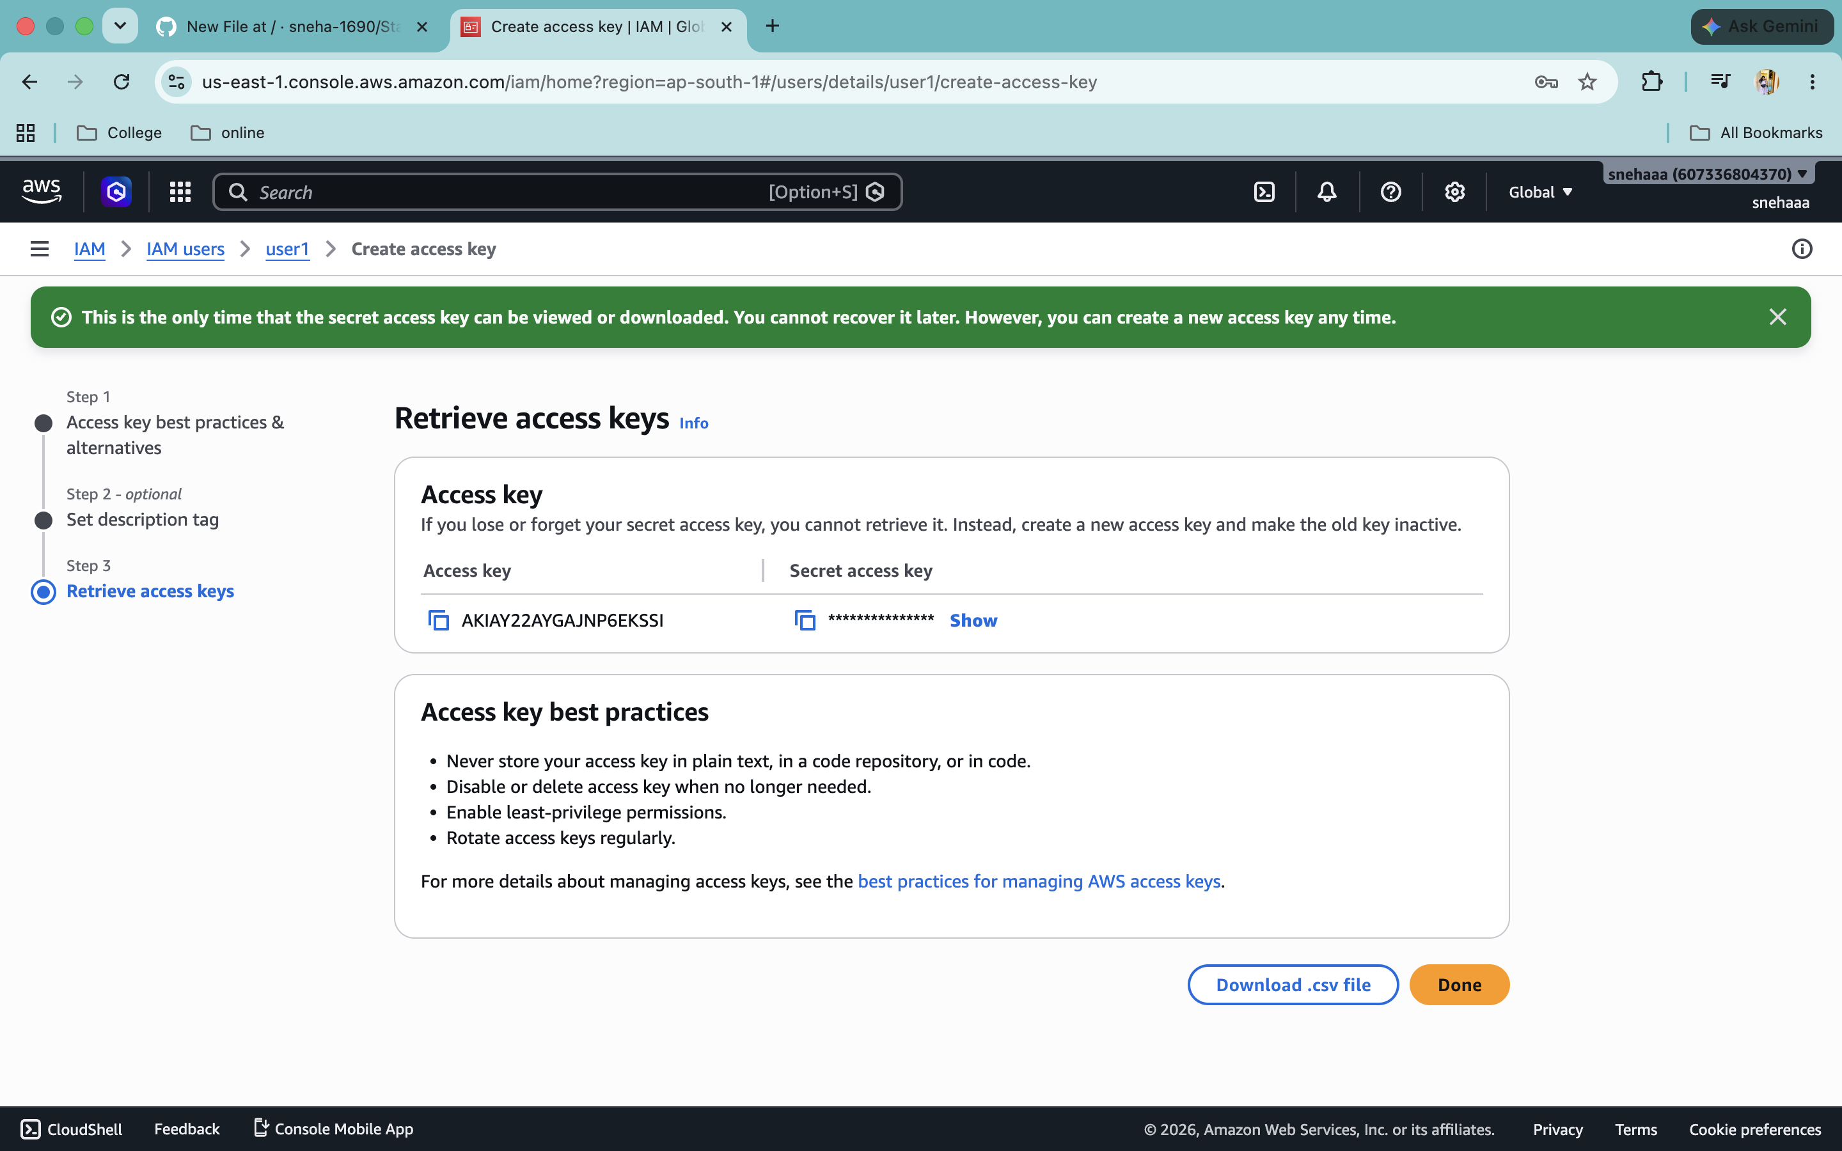
7. Create Access key form the IAM user for credentials (to access aws account)

8. Create two Secrets to store access key
1.one for access key
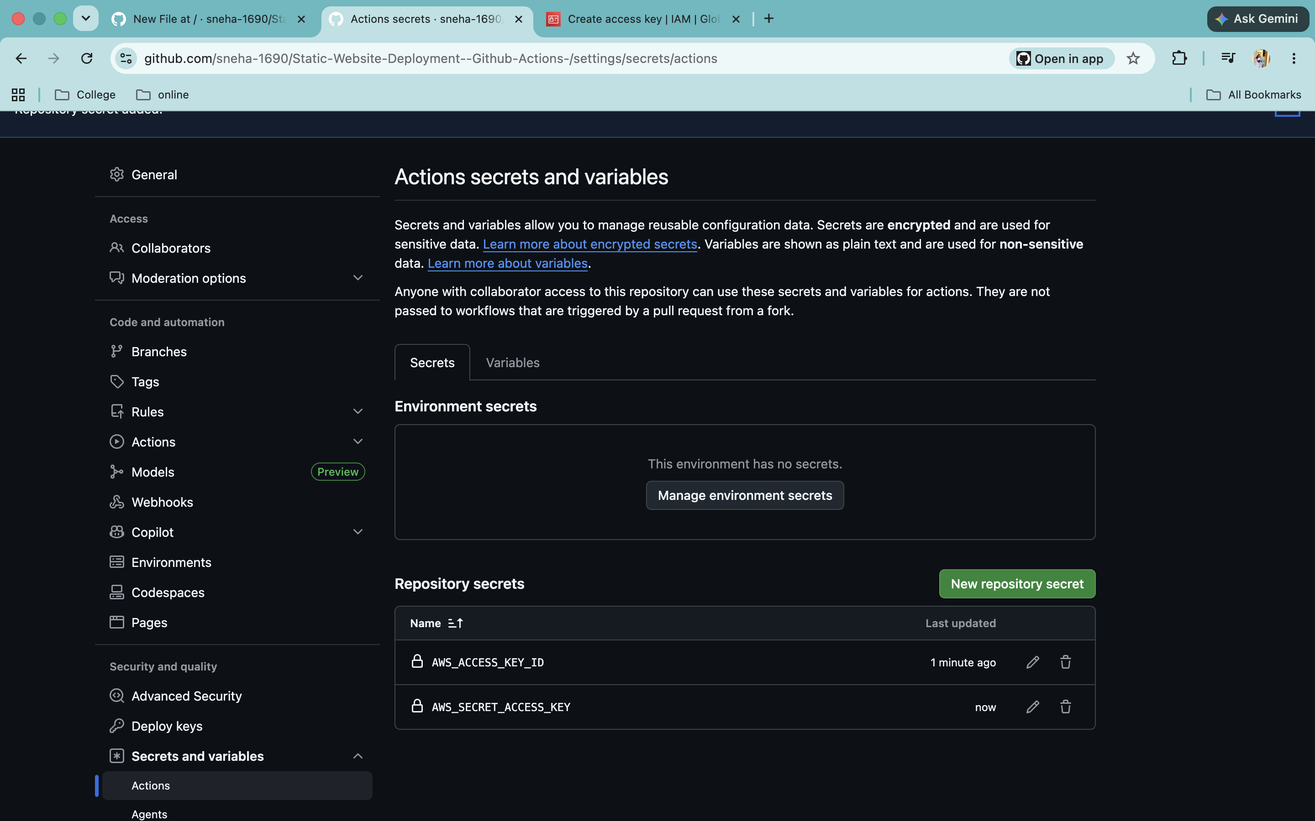
2.one for Secrete access key
9. Go to Actions and create a yml file for workflow
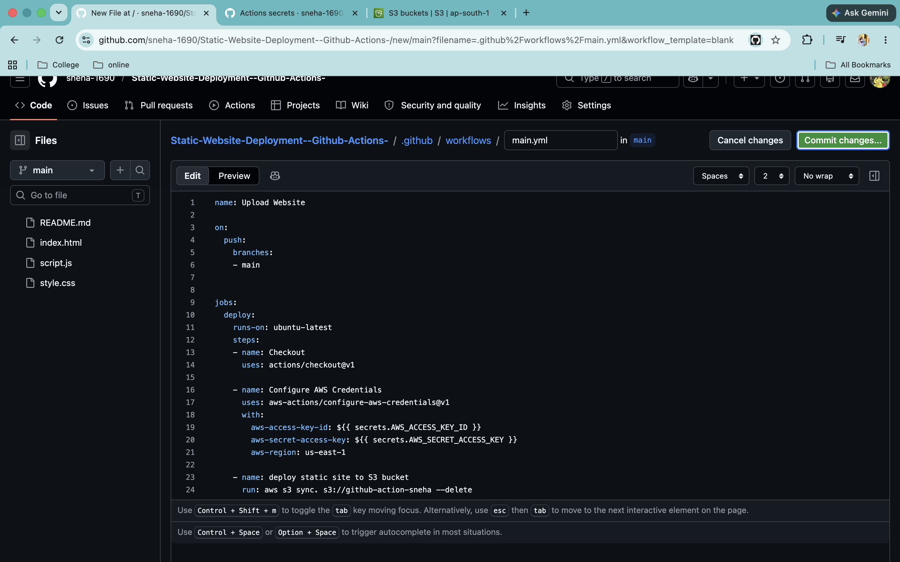
(This file will have workflow like what to do and when to do)
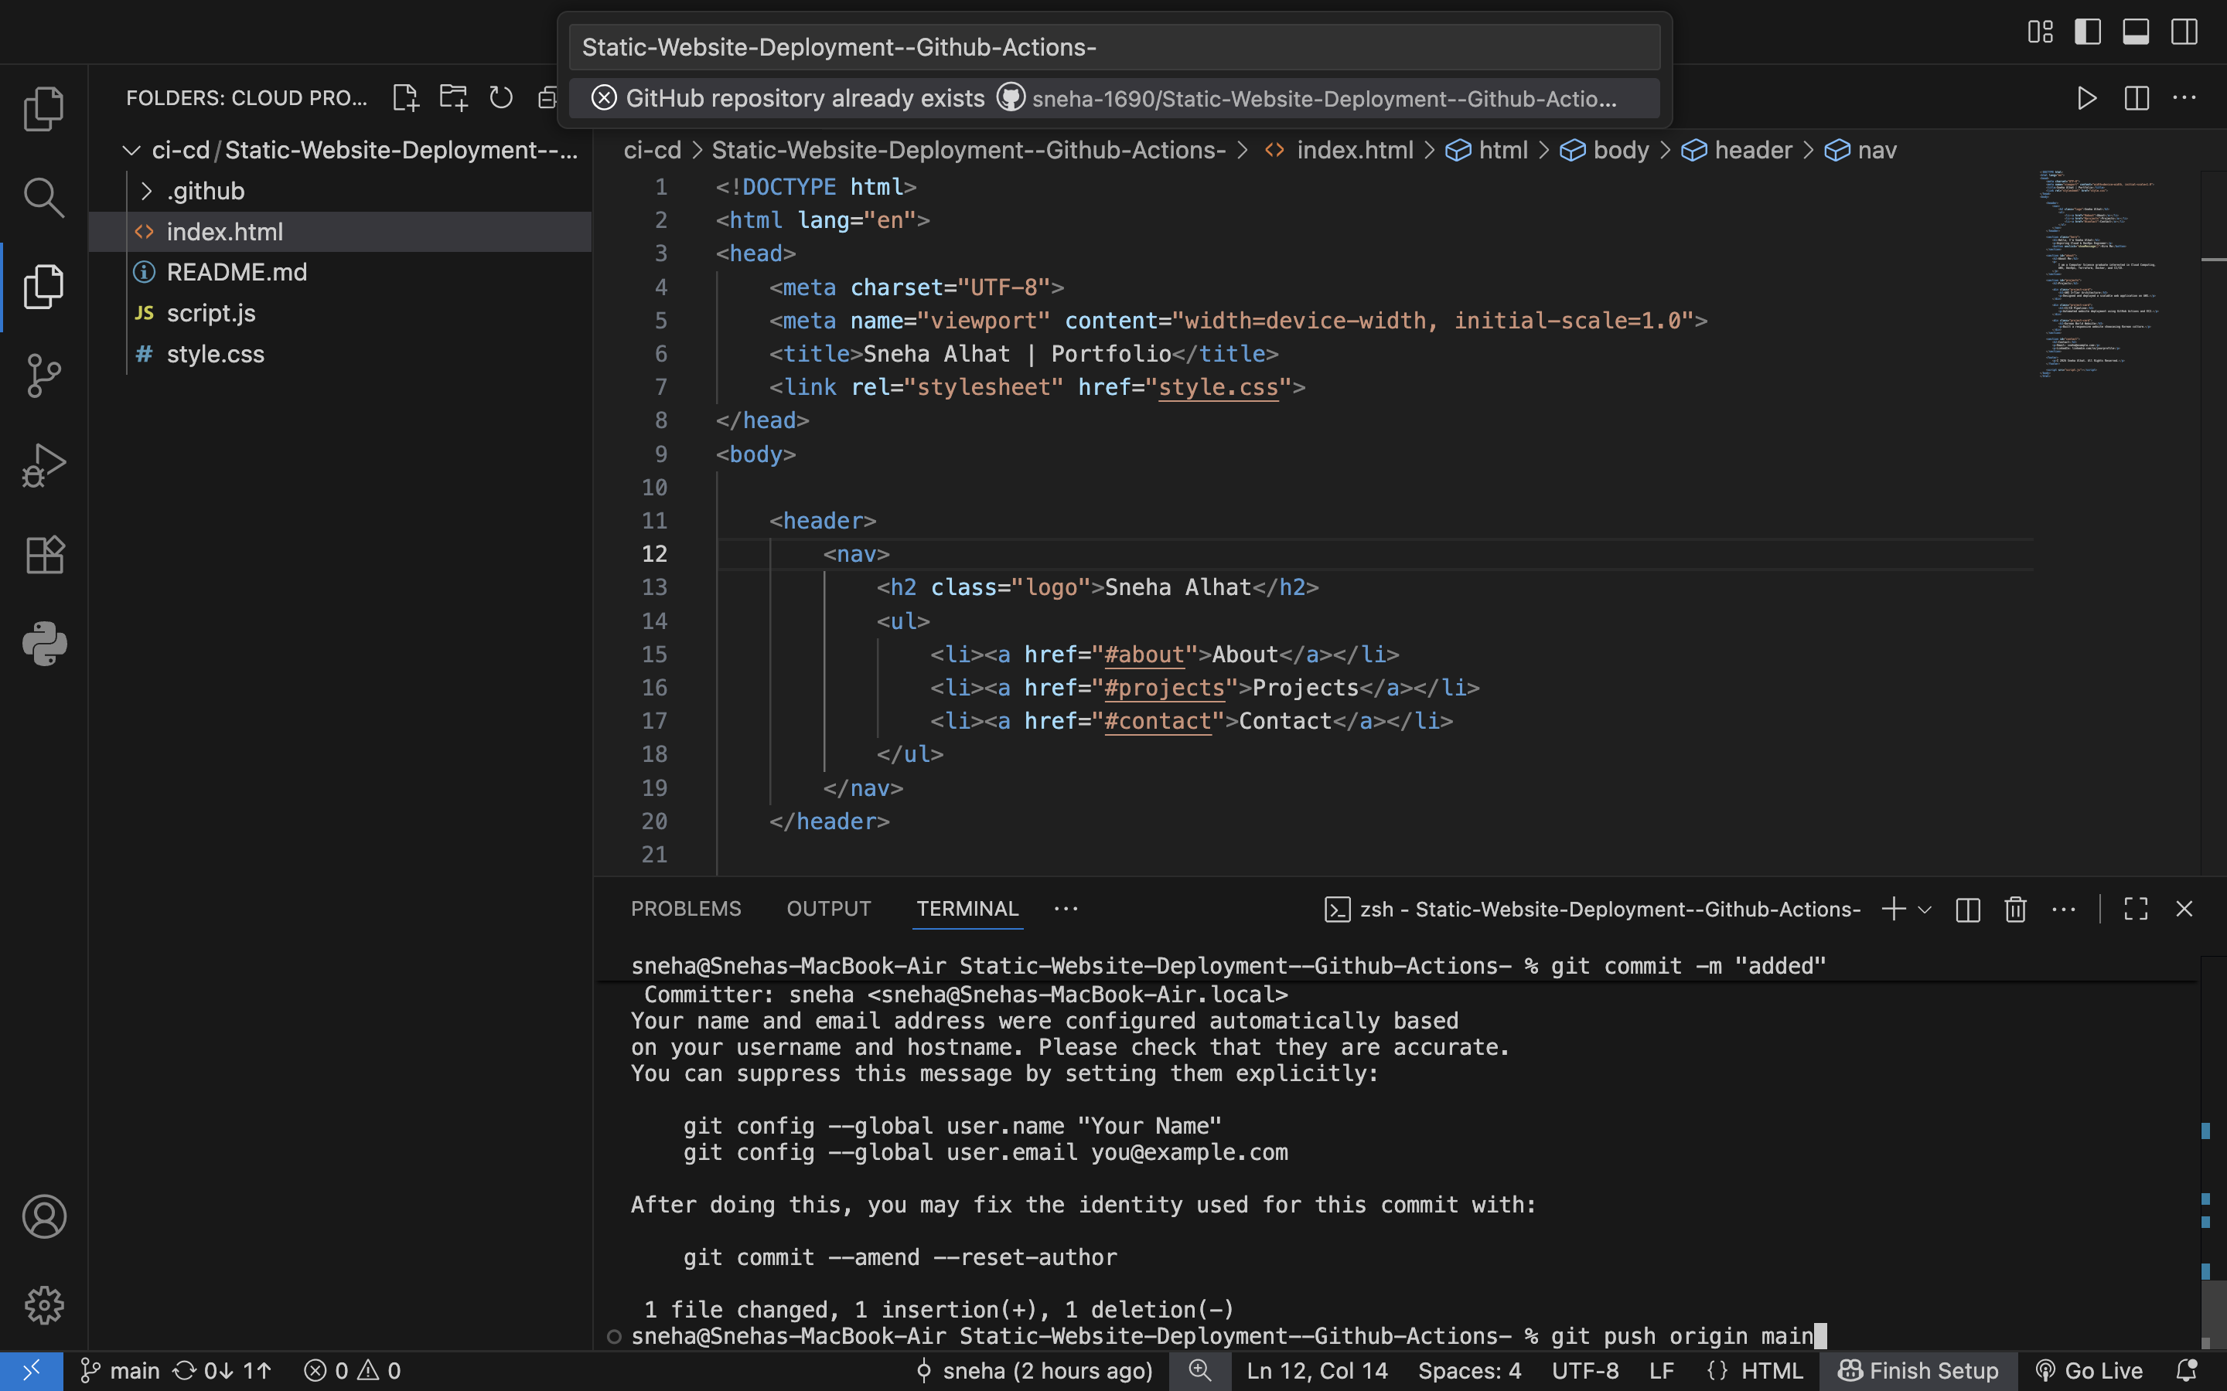
10. Pull the file and update something and push again

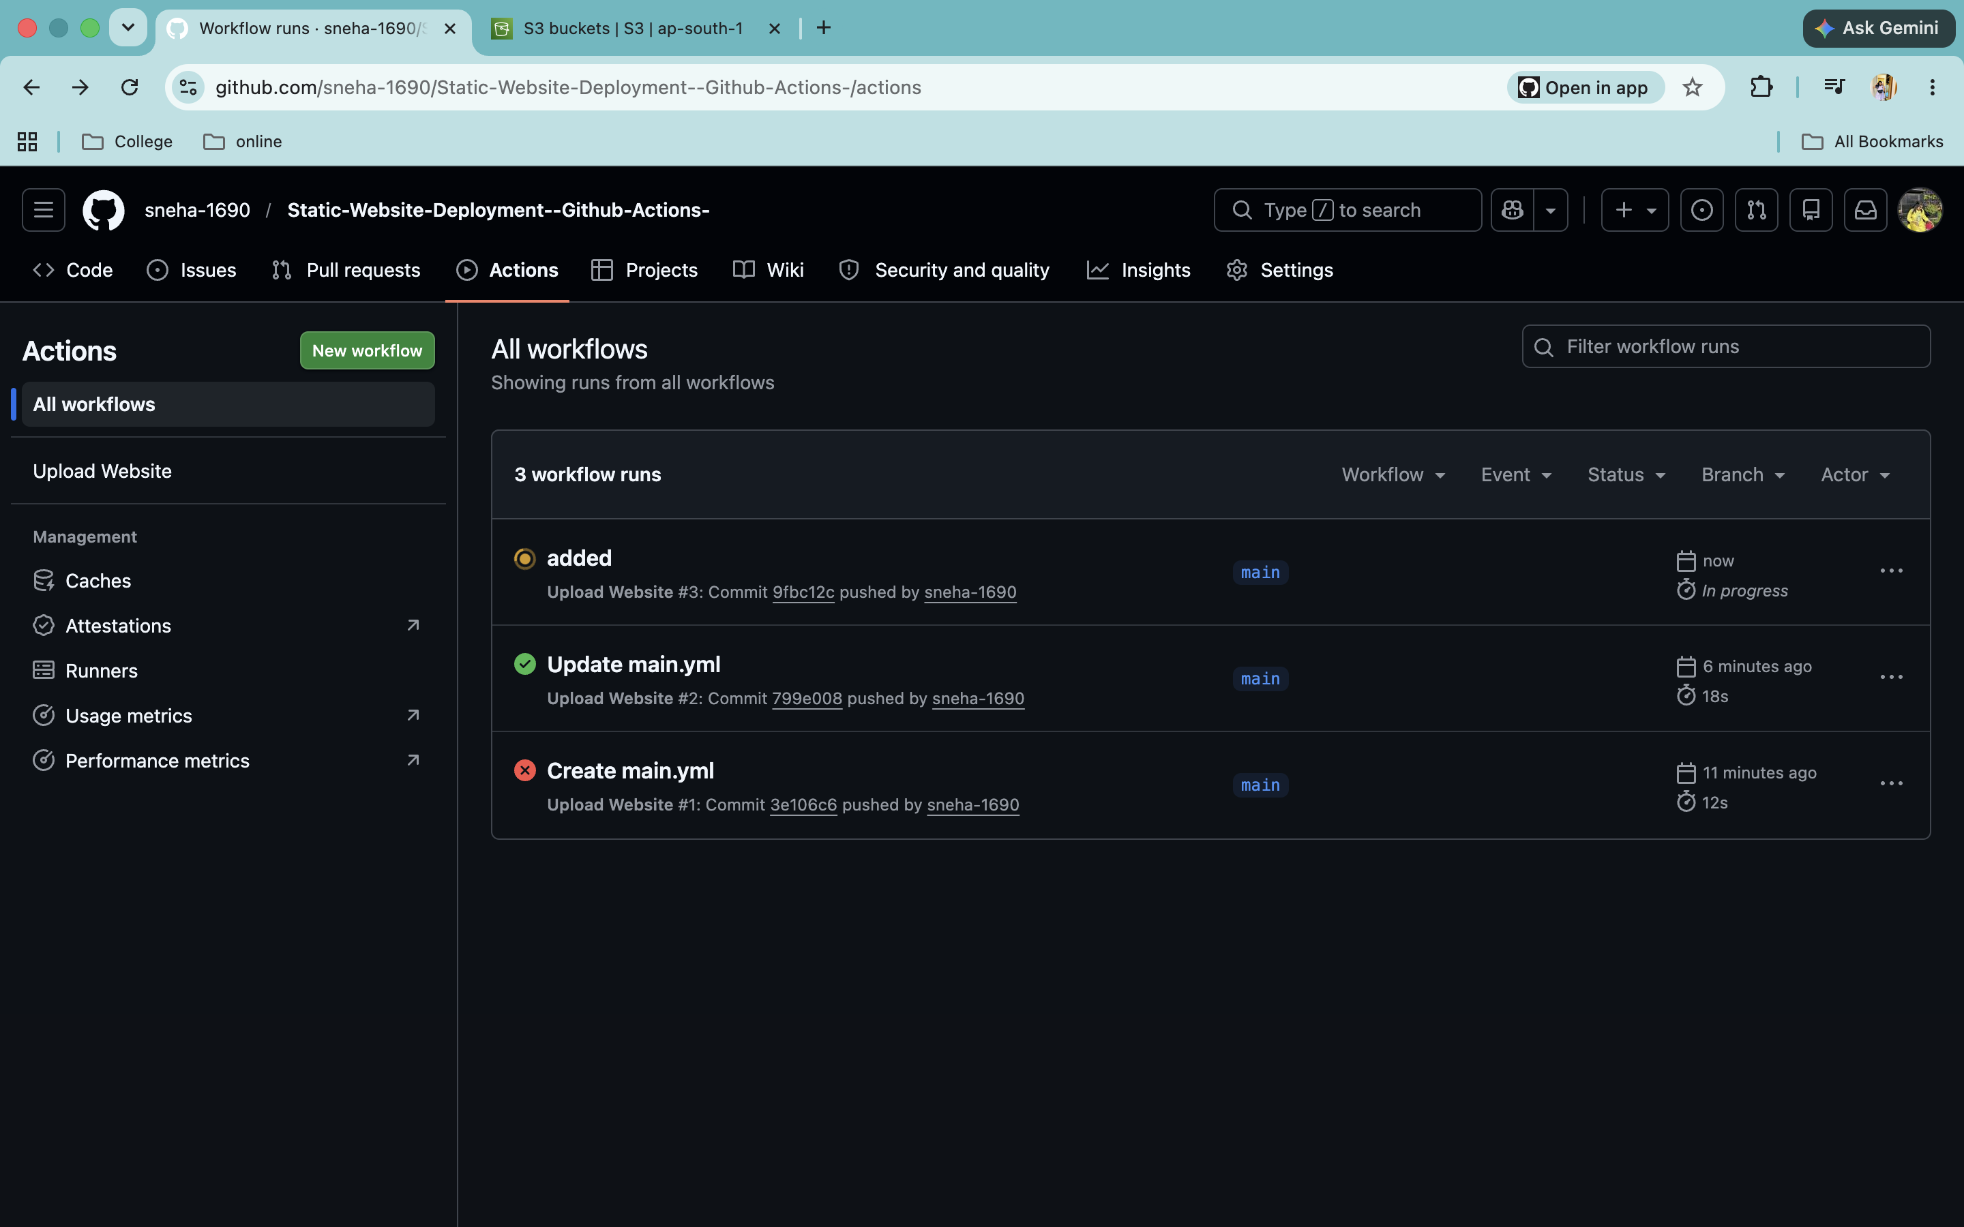
11. After pushing the files again deployment will be start

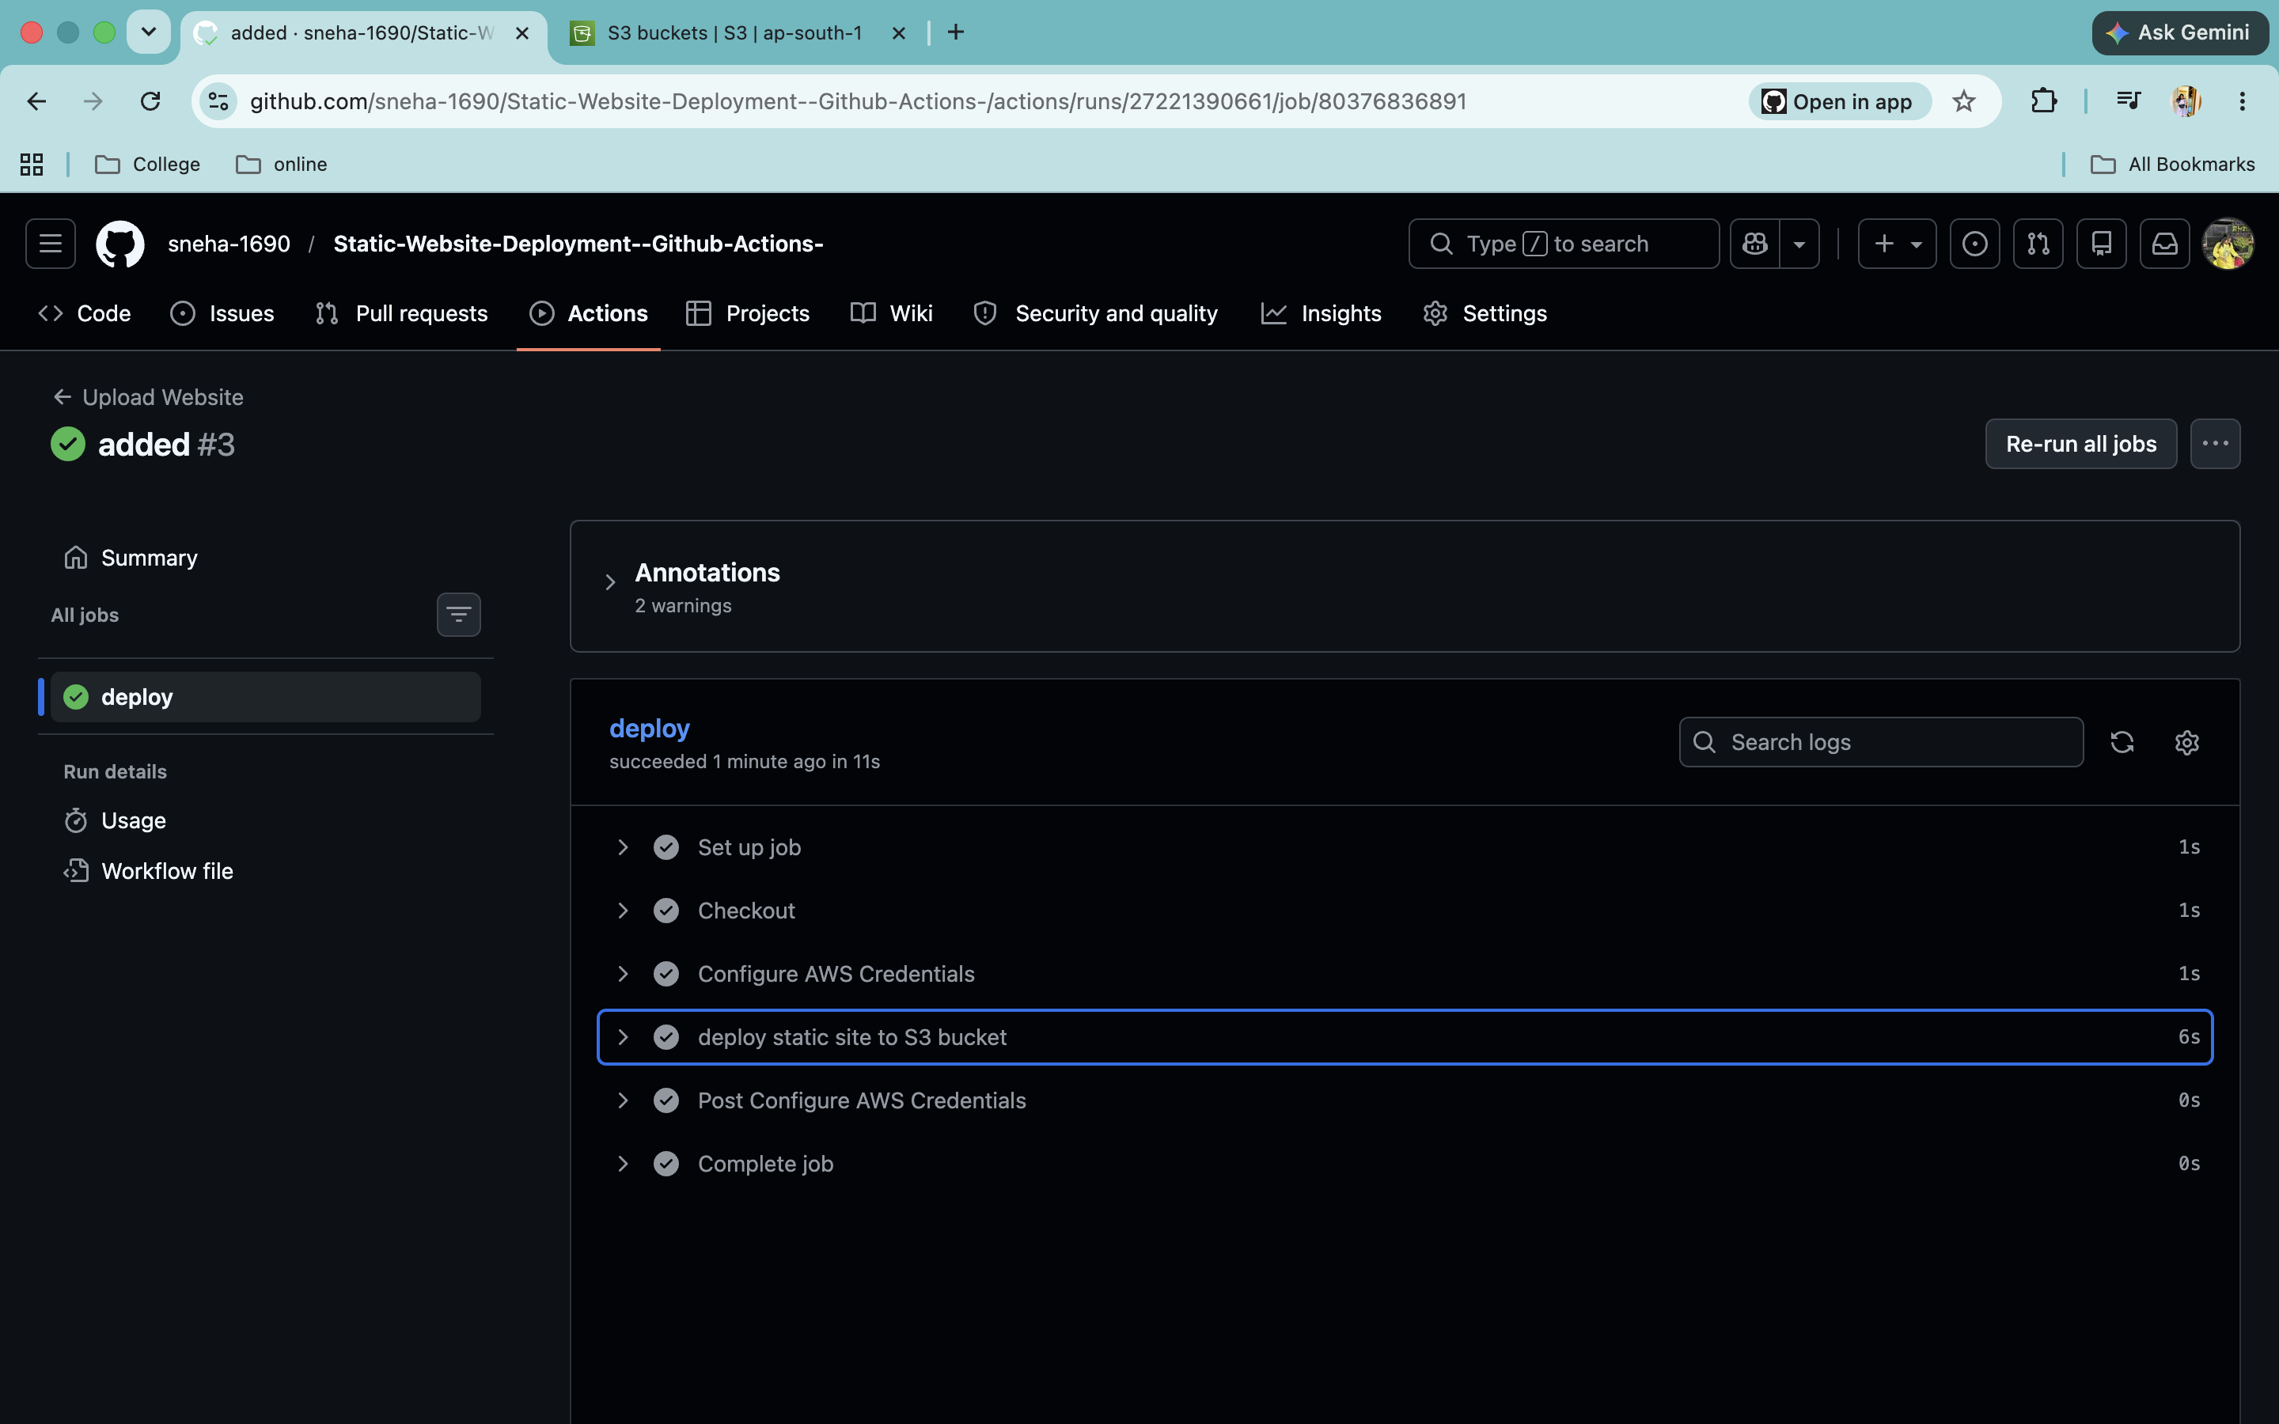
12. Deployment is done without any error
13. Files are deploy to the s3 bucket

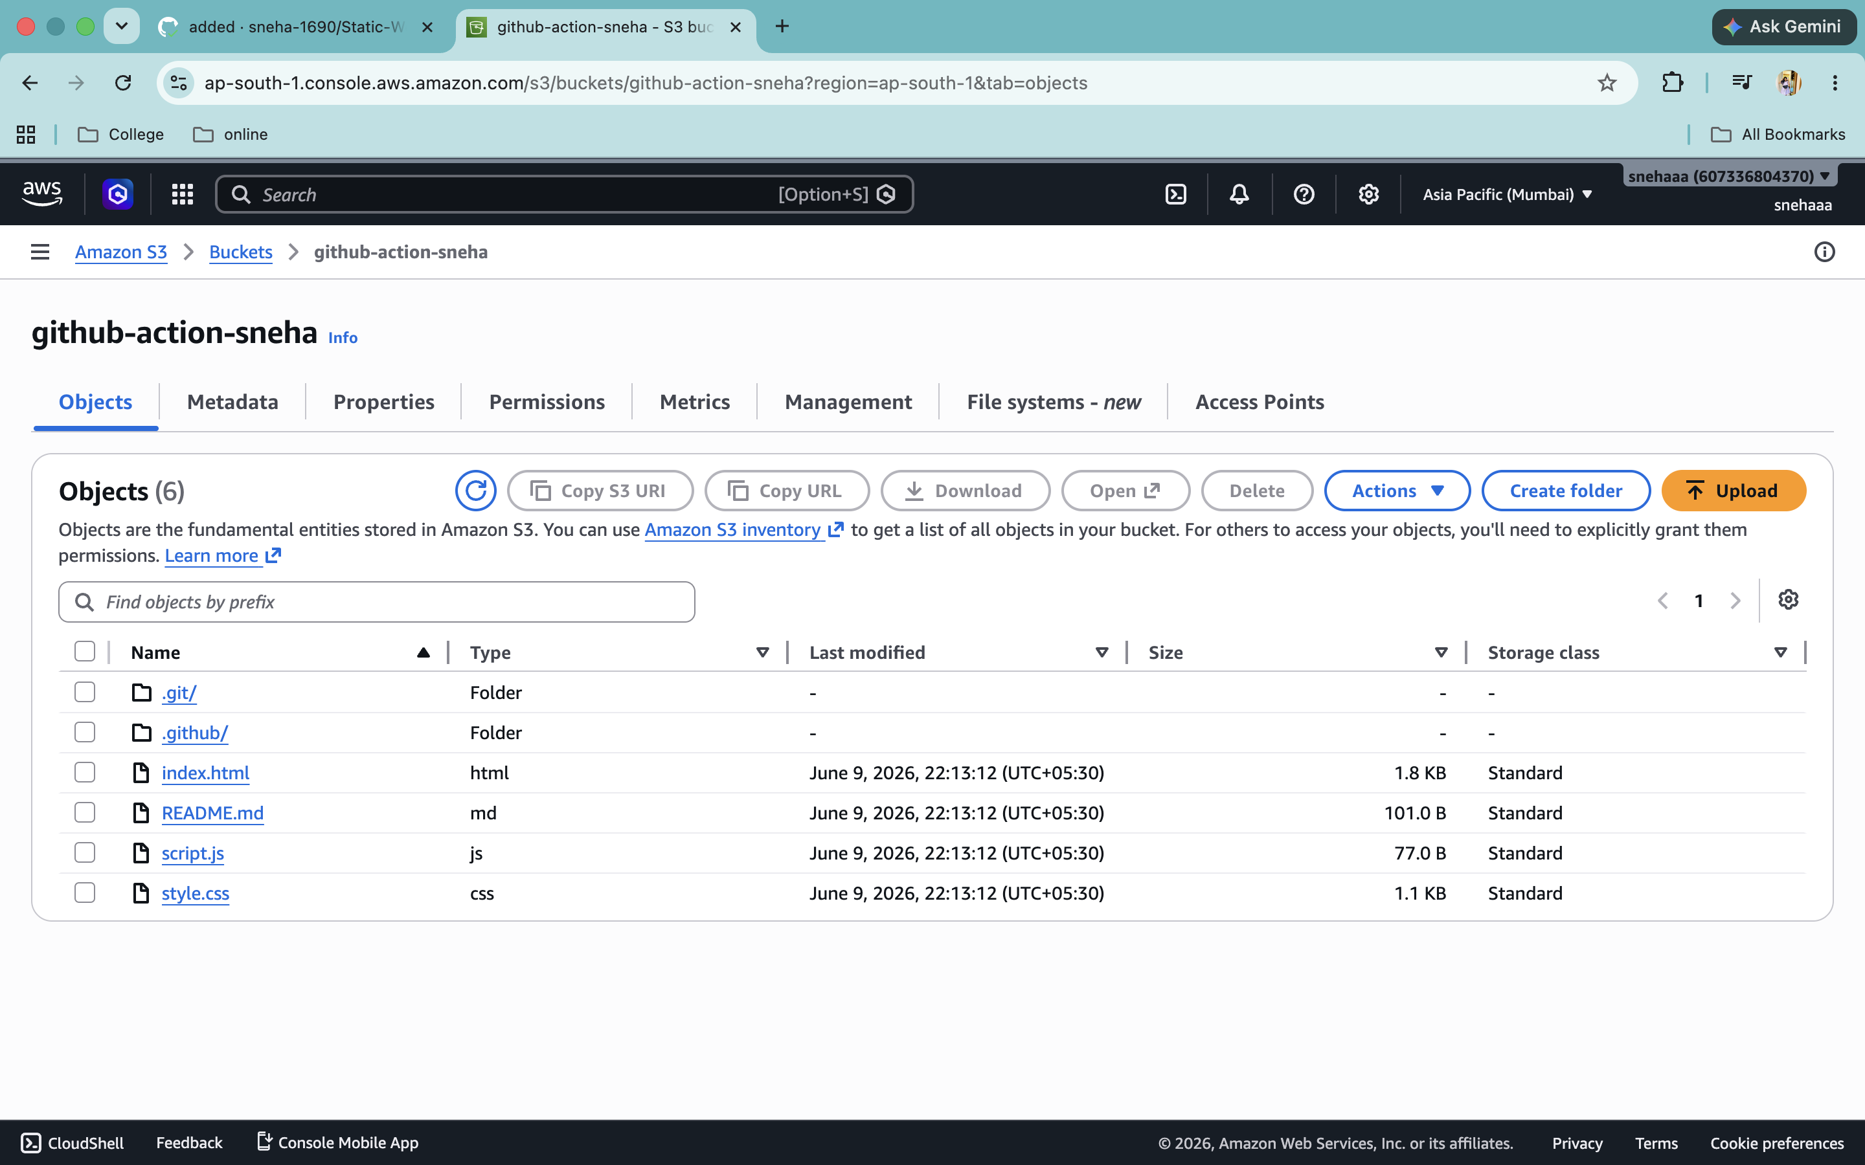
14. Receive all the files

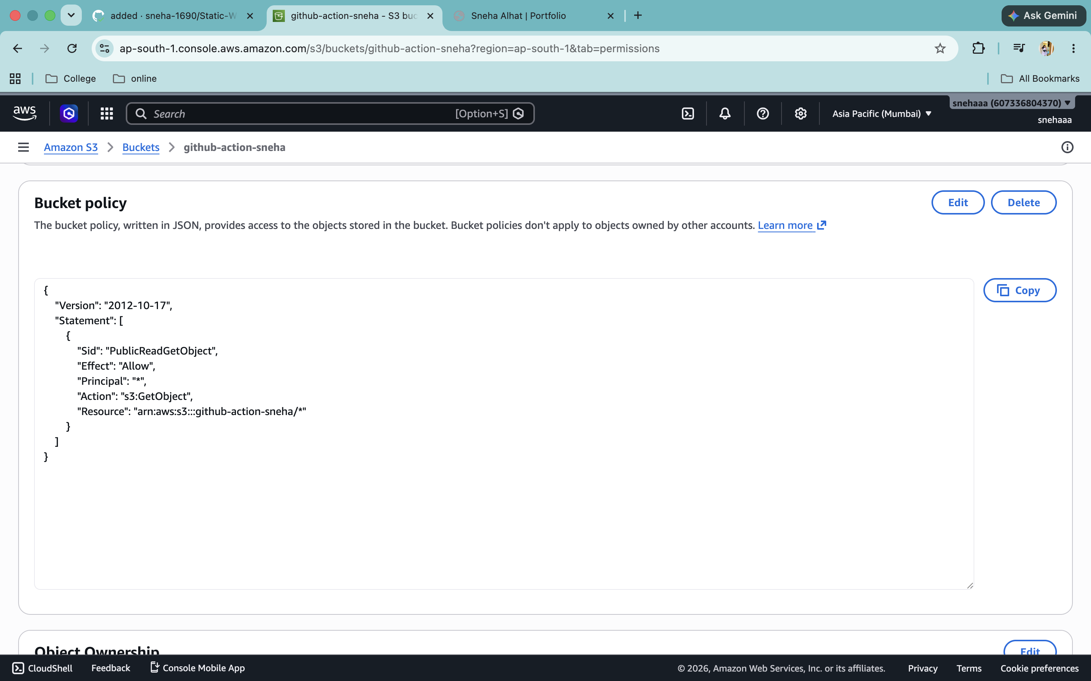
15.Edit bucket Policy

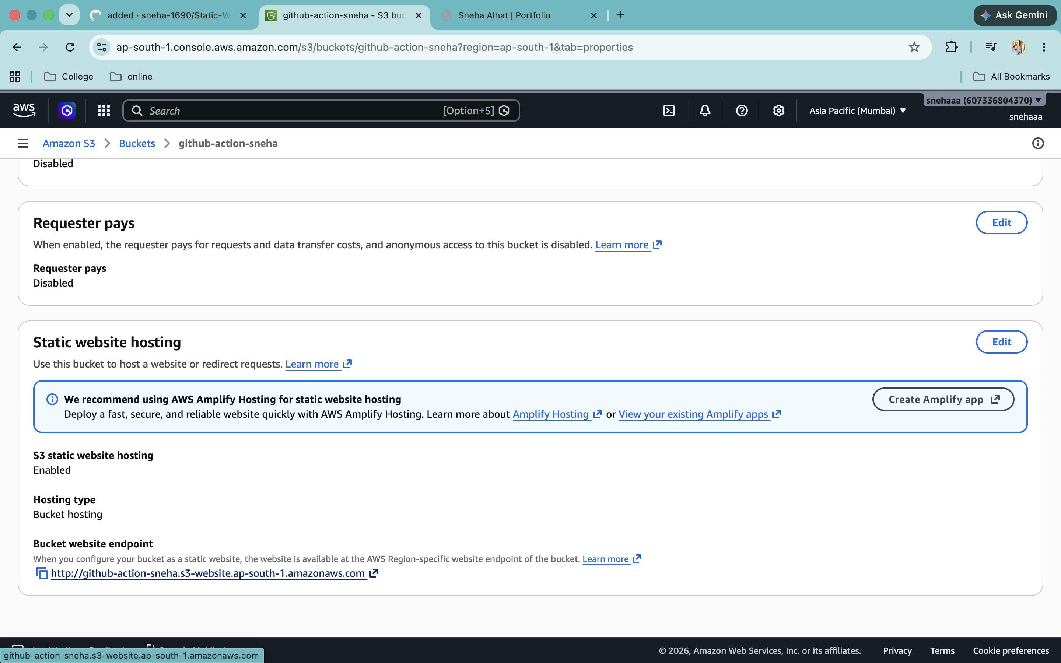
16. With this link you can now access website publicy

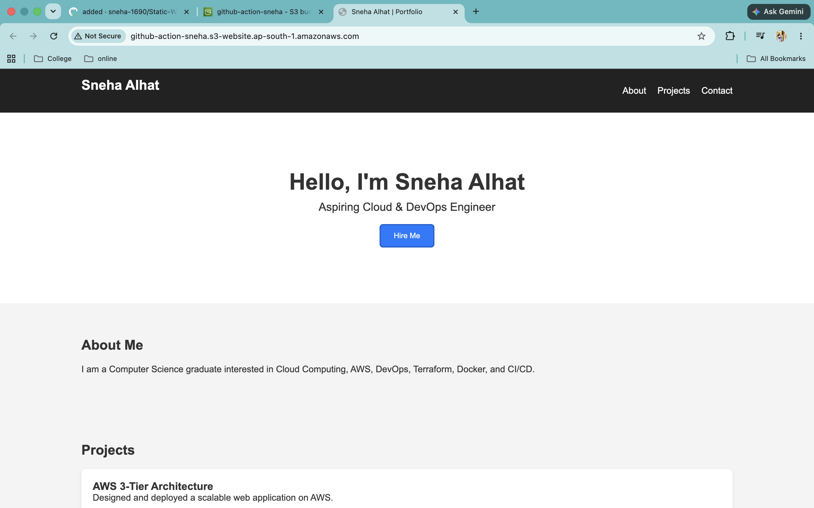
17. Website is Live now

